Le passé composé et l'imparfait

A review for intermediate learners of French

Kim Weiss

EDTECH 511

Boise State University

March 2014

Table of Contents

Introduction 2

Equipment Requirements 2

Microsoft® Windows® 2

Mac OS 2

Linux (running Adobe Flash 11) 2

Getting Started 3

Normal Running of the Courseware 3

Overview 3

Review 3

Quiz 5

Troubleshooting 7

Appendix 8

Media Attributions 8

Final Reflection 8

# Introduction

This project is designed to provide a review of two tenses in French: the *passé composé* and the *imparfait*. While most learners of French as a second language learn how to use these tenses in beginning French classes, students often confuse the tenses well into advanced levels of the language. The module created for this project is designed to help learners review the differences between these two tenses, as well as to test their understanding of how to use each tense in a variety of contexts.

The learning module is geared toward an intermediate learner of French—a student who has a good vocabulary base and who is already familiar with basic French grammar, including how to conjugate verbs in several commonly-used tenses. This can include learners of any age, including high school, university, or even learners who have taught themselves French outside of a formal learning environment.

For this specific project, the content is presented in English because of the audience who will be looking at this version of the project. A live version created for a real course would include all content in French, with the expectation that the learner would have that amount of vocabulary to be able to complete the exercise completely in French.

# Equipment Requirements

The system requirements for Adobe Flash 13 (the current version at the time of this writing) include[1]:

## Microsoft® Windows®

* 2.33GHz or faster x86-compatible processor, or Intel® Atom™ 1.6GHz or faster processor for netbooks
* Microsoft® Windows® XP (32 bit), Windows Server 2008 (32 bit), Windows Vista® (32 bit), Windows 7 (32 bit and 64 bit), Windows 8 (32 bit and 64 bit), or Windows Server 2012 (64 bit)
* Internet Explorer 8.0 or later, Mozilla Firefox 17 or later, Google Chrome, or Opera 11
* 512MB of RAM (1GB of RAM recommended for netbooks); 128MB of graphics memory

## Mac OS

* Intel Core™ Duo 1.83GHz or faster processor
* Mac OS X v10.6, v10.7, v10.8, or v10.9
* Safari 5.0 or later, Mozilla Firefox 17, Google Chrome, or Opera 11
* 512MB of RAM; 128MB of graphics memory

## Linux (running Adobe Flash 11)

* 2.33GHz or faster x86-compatible processor, or Intel Atom 1.6GHz or faster processor for netbooks
* Red Hat® Enterprise Linux® (RHEL) 5.6 or later (32 bit and 64 bit), openSUSE® 11.3 or later (32 bit and 64 bit), or Ubuntu 10.04 or later (32 bit and 64 bit)
* Mozilla Firefox 17 or Google Chrome
* 512MB of RAM; 128MB of graphics memory

The learning module is provided via a link on a web page, so broadband Internet access is also required to complete the exercise. A mouse or other pointing device is required. Speakers or headphones may be used, but are not required for successful completion of the training module.

# Getting Started

The learner will need to log into a computer and connect to the Internet. Once online, the learner will use a browser to open the training module using a link provided by their instructor. The module is currently available at <http://edtech2.boisestate.edu/kimweiss/511/project/project_kimweiss.html>.

# Normal Running of the Courseware

The time required to complete the module is dependent on the learner's familiarity with the concepts. A learner who already has a good understanding of the differences between the verbs can complete the module in approximately 10-15 minutes. The learner does have the option of reviewing concepts as well as completing the assessment portion of the module as many times as they wish, in which case it would take longer to complete.

For the most part, navigation is set up as a one-way path. The learner will watch and read the pages that review the concepts covered, and move forward when they feel they understand the concepts sufficiently.

## Overview

The first slide is a title slide that automatically moves to the overview slide after it has finished playing. The overview slide explains the purpose of the module, and it gives the learner the choice to complete the review components, or to jump to the quiz.

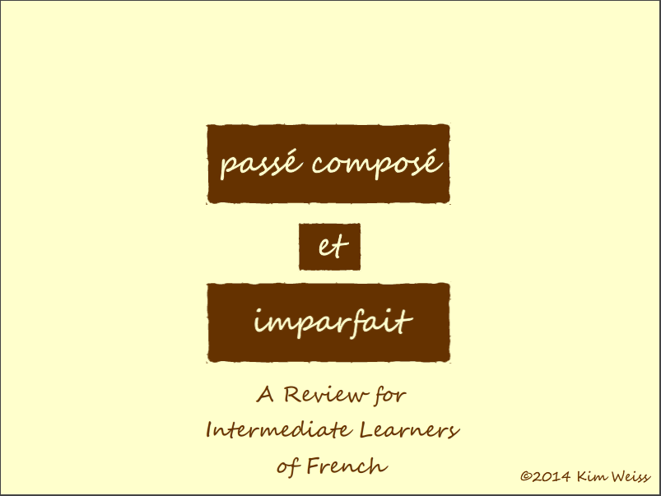 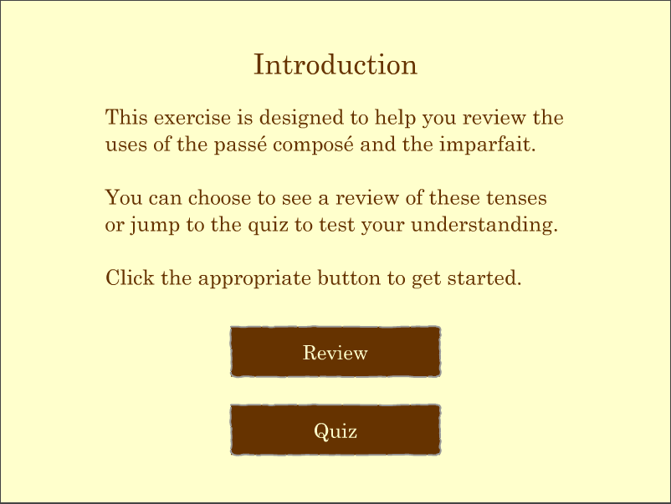

The option of jumping to the quiz allows the learner to complete a pretest of their understanding prior to completing the review exercises, as well as confirming their understanding after the review steps are completed.

## Review

The review steps are set up both to remind the learner how each tense is conjugated, as well as to present a list of contexts where each tense is most appropriate. The content in each slide plays on its own, with a navigation button to the next slide available only after sufficient time has passed to read the content of each slide.

The *passé composé* is presented first.

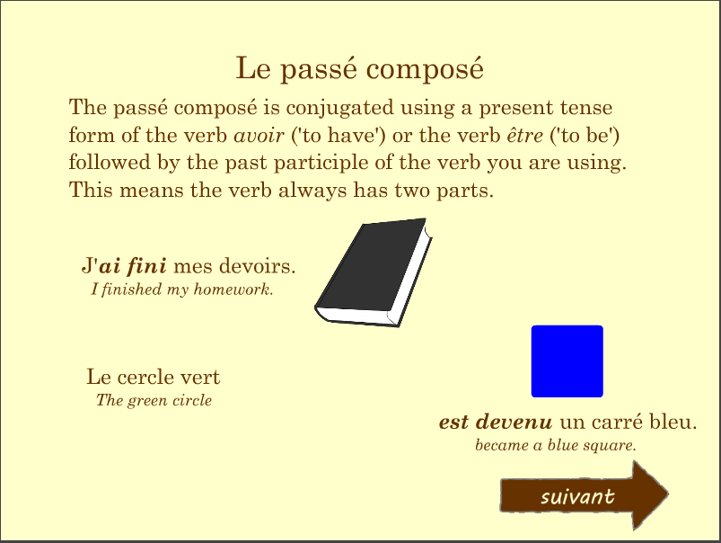 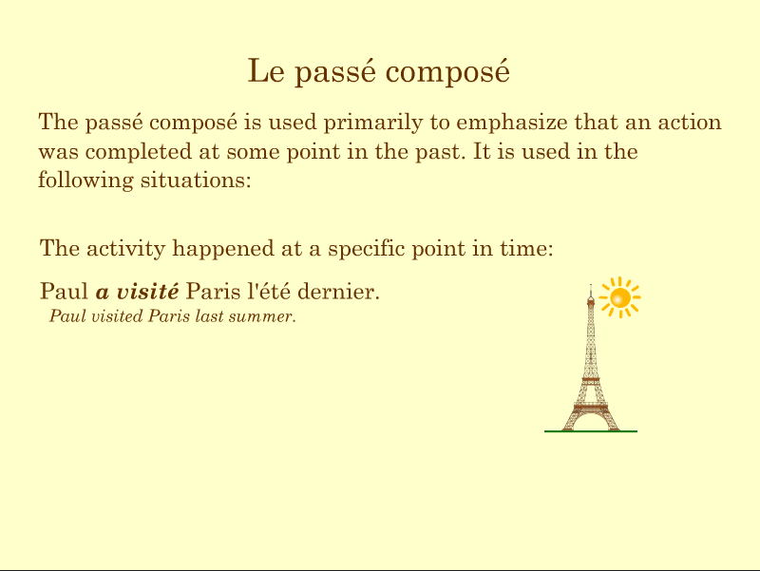

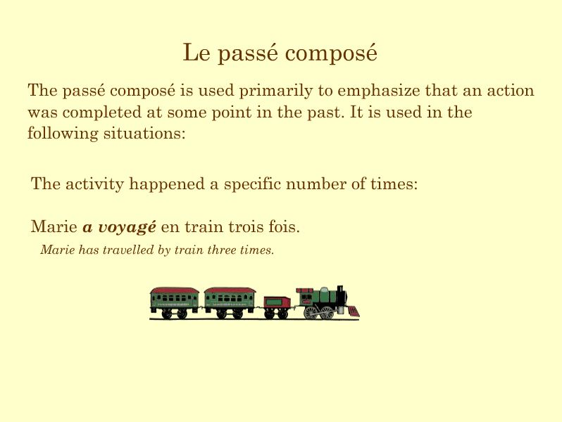 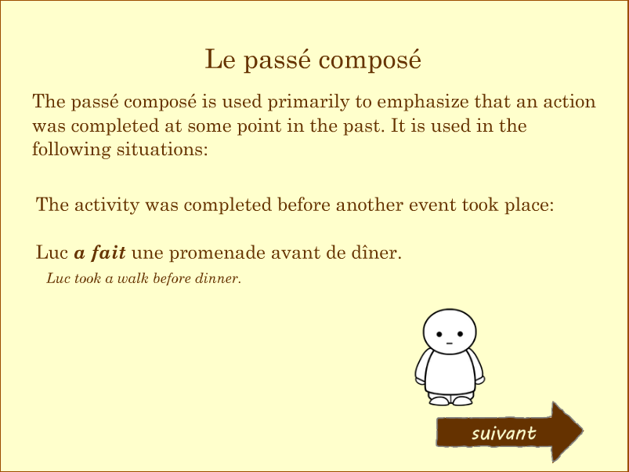

After the review of the *passé composé*, the module moves through a review of the *imparfait*, using the same general format:

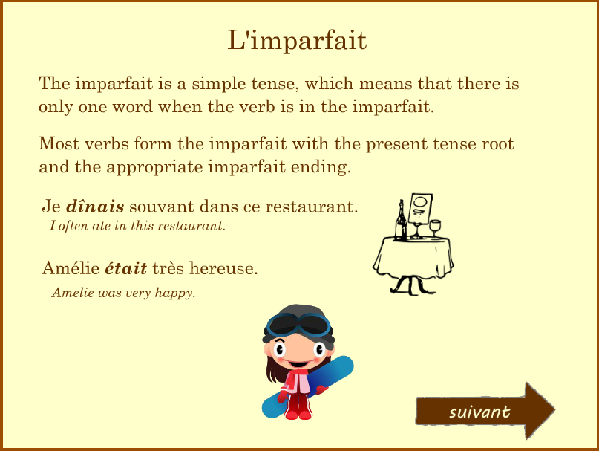 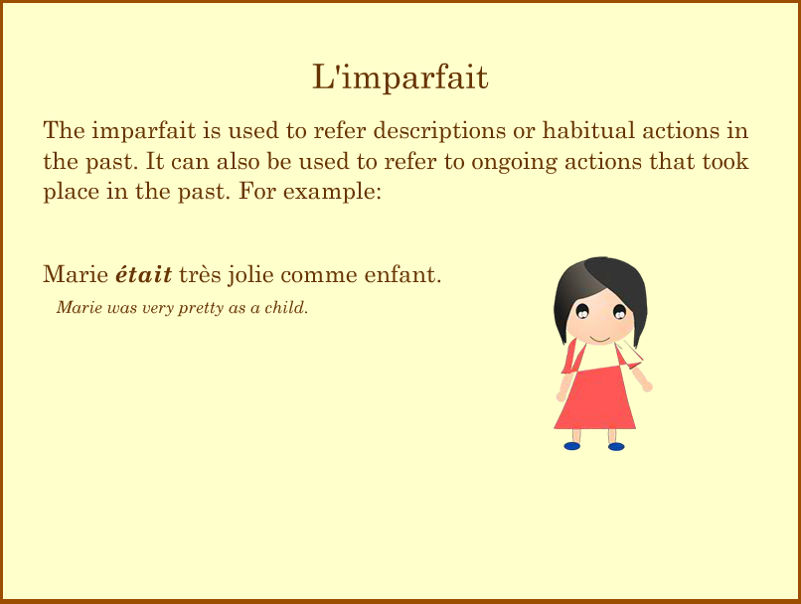

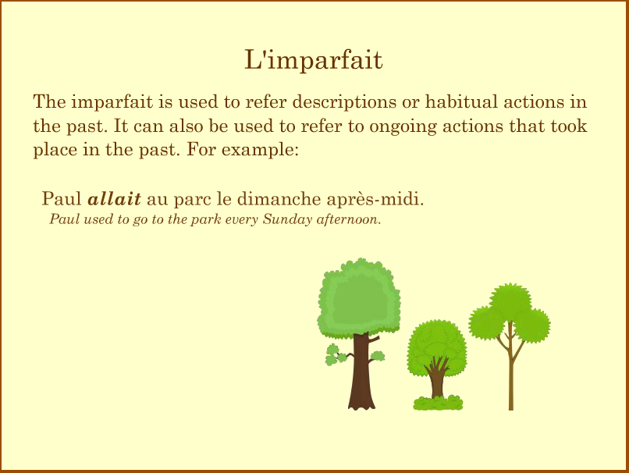 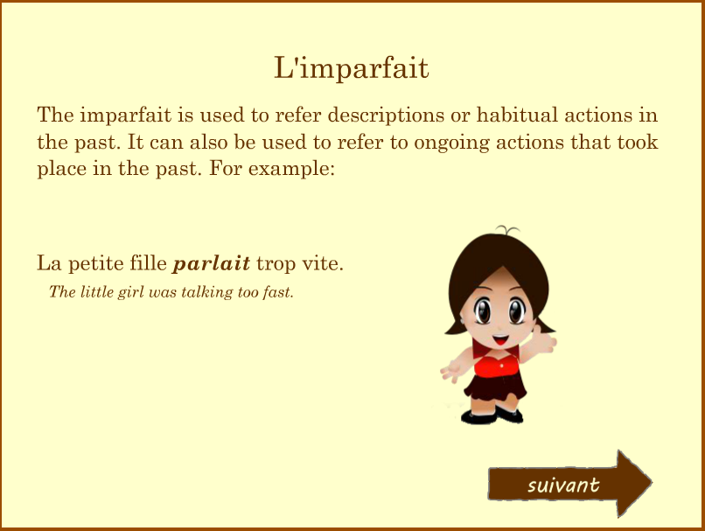

The final slide of the review explains how the tenses can be used together in the same sentence:

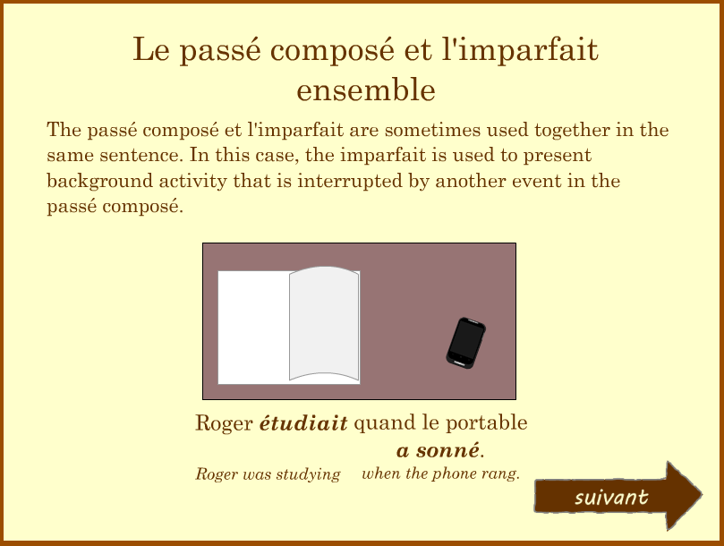

## Quiz

After the review has completed, the learner is given the choice between continuing onto the quiz or repeating the review content.

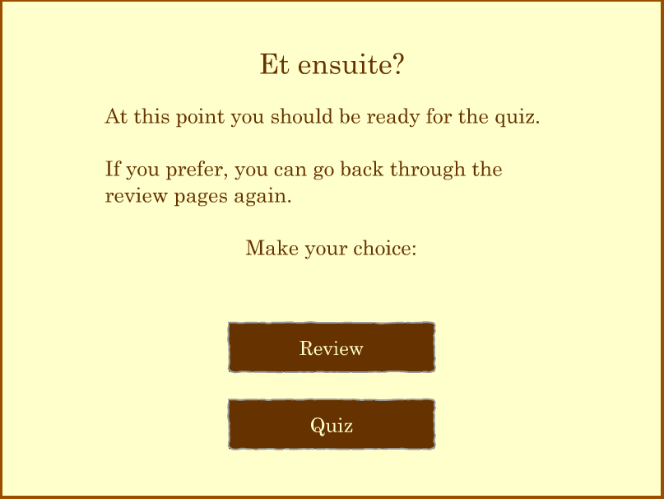

The quiz itself is composed of ten questions. For each question, a complete sentence is provided, with blanks where the verbs should be. In addition, the verbs required for each sentence are provided in both tenses, already conjugated correctly for the sentence provided. The first eight sentences include a single verb which should be in either the *passé composé* or the *imparfait*, as required by the context. The last two sentences include two verbs.

The learner is required to drag the correct verb for that sentence onto the blank provided in the sentence. If the answer is incorrect, the learner is given feedback that they have selected the wrong answer, and the question resets.

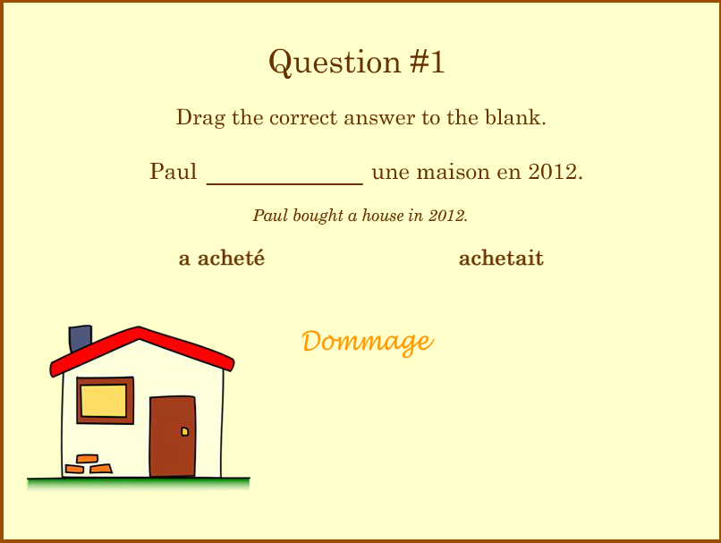 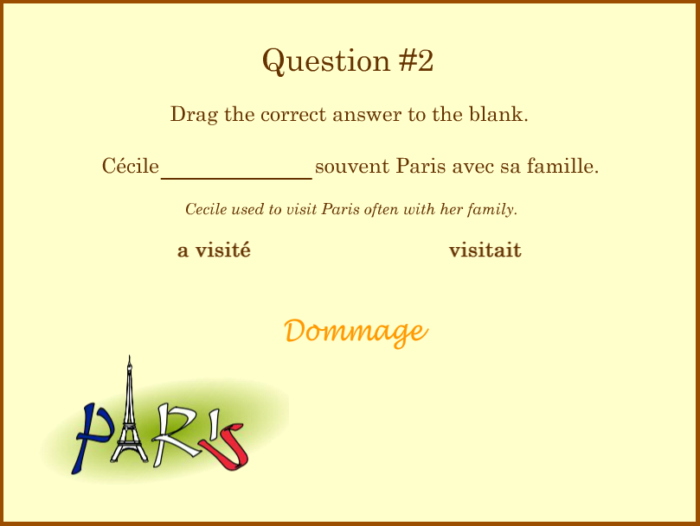

If the learner chooses the correct verb, they receive feedback to that effect, and they can proceed to the next question.

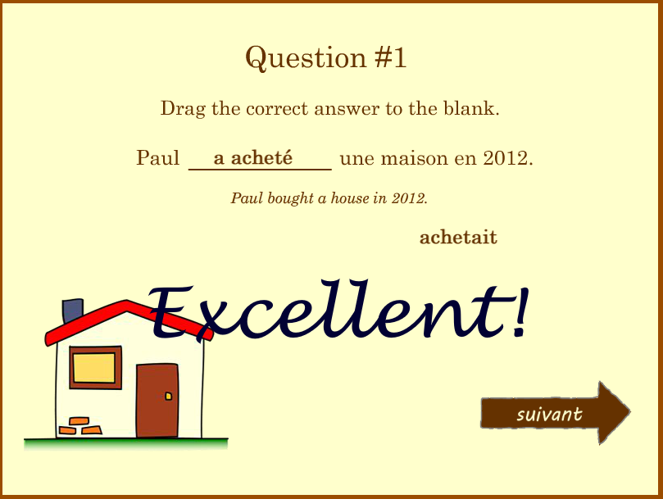 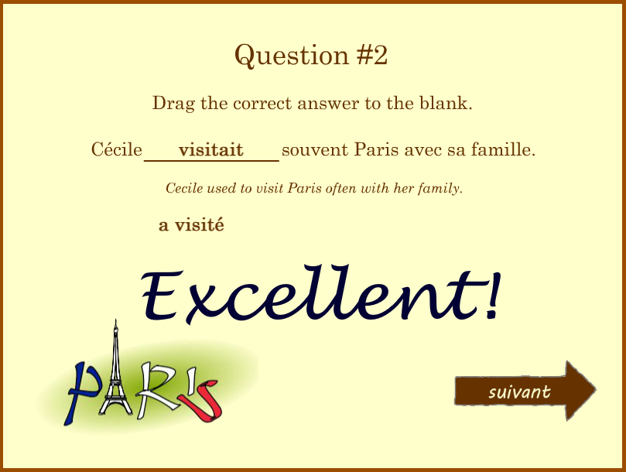

For the last two questions, the learner is given four verb forms: two forms for each of two blanks in the sentence. They must get both answers correct before they can move on.

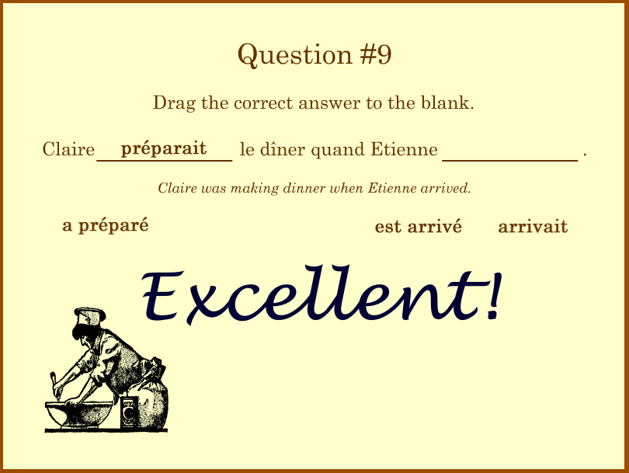 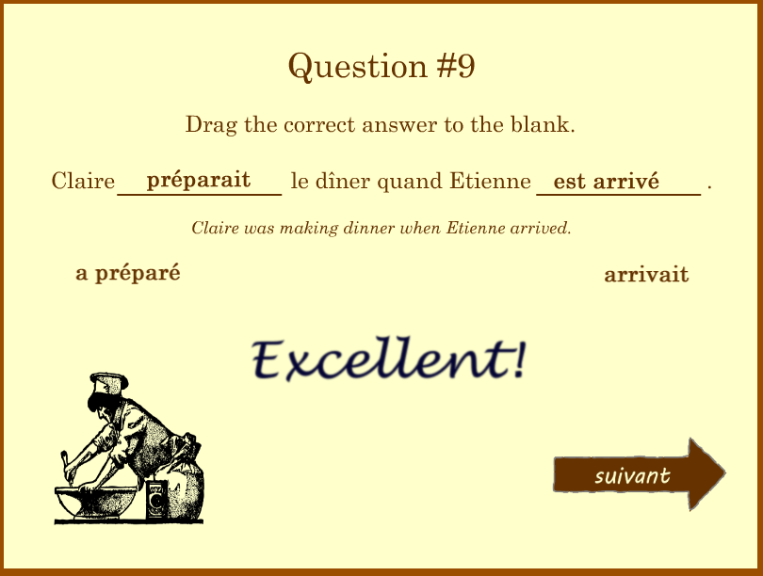



After each question has been answered correctly, the final slide displays a final feedback message, with an option to start the training over again.

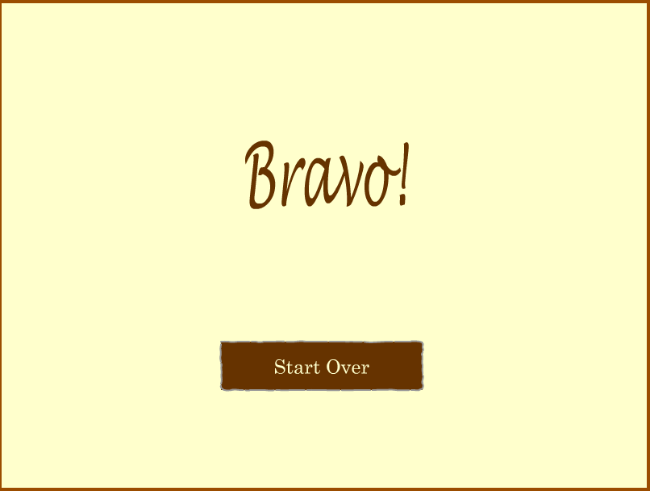

# Troubleshooting

The learner may have difficulty completing the training module if they are using a device that does not support Adobe Flash, such as a smartphone or tablet. The learner should have access to a desktop or notebook computer to complete the training.

If the module does not open or if there are problems running the module, verify that the computer is using the most recent version of Adobe Flash. The download site for Adobe Flash is <http://get.adobe.com/flashplayer>.

The learner may have problems completing the quiz portion of the module if they do not understand that they must select the correct answer(s) to each question before they can move onto the next question. The NEXT arrow will not appear until the question has been answered correctly.

# Appendix

## Media Attributions

The media content included in the training module come from the following sources:

Graphics: All pictures come from [OpenClipArt.org](http://OpenClipArt.org), which collects and distributes clipart under [CC0 1.0 Universal (CC0 1.0), Public Domain Dedication](http://creativecommons.org/publicdomain/zero/1.0/). See <http://openclipart.org/share>.

Audio: Except as noted below, all audio tracks are derived from content posted to <http://Freesound.org>, including:

* S: [Applause and audience.flac](http://www.freesound.org/people/billox30/sounds/166904/) by [billox30](http://www.freesound.org/people/billox30/) | License: Creative Commons 0
* S: [bird chirps5.wav](http://www.freesound.org/people/keweldog/sounds/184870/) by [keweldog](http://www.freesound.org/people/keweldog/) | License: Creative Commons 0
* S: [book slam](http://www.freesound.org/people/Mydo1/sounds/198960/) by [Mydo1](http://www.freesound.org/people/Mydo1/) | License: Creative Commons 0
* S: [Girl Laugh.wav](http://www.freesound.org/people/lmbubec/sounds/119450/) by [lmbubec](http://www.freesound.org/people/lmbubec/) | License: Creative Commons 0
* S: [Girl, female, laughing, giggling.wav](http://www.freesound.org/people/MentalSanityOff/sounds/218308/) by [MentalSanityOff](http://www.freesound.org/people/MentalSanityOff/) | License: Creative Commons 0
* S: [Page Turn](http://www.freesound.org/people/davidbain/sounds/136778/) by [davidbain](http://www.freesound.org/people/davidbain/) | License: Creative Commons 0
* S: [slide_whistle_up_01.wav](http://www.freesound.org/people/joedeshon/sounds/79677/) by [joedeshon](http://www.freesound.org/people/joedeshon/) | License: Attribution
* S: [Steps Parquet And Concrete.wav](http://www.freesound.org/people/tjandrasounds/sounds/196701/) by [tjandrasounds](http://www.freesound.org/people/tjandrasounds/) | License: Creative Commons 0
* S: [Train.wav](http://www.freesound.org/people/foxen10/sounds/149022/) by [foxen10](http://www.freesound.org/people/foxen10/) | License: Creative Commons 0
* S: [trillo1.mp3](http://www.freesound.org/people/gambler9/sounds/85088/) by [gambler9](http://www.freesound.org/people/gambler9/) | License: Creative Commons 0
* S: [Une adorable petite fille débordante dimagination.wav](http://www.freesound.org/people/macabeu22/sounds/86261/) by [macabeu22](http://www.freesound.org/people/macabeu22/) | License: Creative Commons 0
* S: [wooden staff.wav](http://www.freesound.org/people/Jaturo/sounds/156491/) by [Jaturo](http://www.freesound.org/people/Jaturo/) | License: Creative Commons 0

Sounds were also derived from:

* FrenchAccordion-BriseNapolitaine, downloaded from https://archive.org/details/FrenchAccordion-BriseNapolitaine
* La Marseillaise, downloaded from [*http://en.wikisource.org/wiki/La_Marseillaise*](http://en.wikisource.org/wiki/La_Marseillaise).

## Final Reflection

I believe that this is a good representation of a training module that could be incorporated into a larger unit. It is somewhat limited in scope, however, and it does not include all of the elements I intended to incorporate based on my original proposal for this project.

With more time and resources, the following elements should be included:

* Audio tracks by native speakers who could speak each of the sentences provided in the review, as well as allow the learner to hear the completed sentences in the quiz.
* A more in-depth evaluation of the learner's understanding of the differences between the tenses, including a small module that would simply ask the learner to match the tense to a given context, without actually completing a sentence.
* A pool of questions that could be used to generate a subset of questions when the learner is ready to complete the quiz or assessment, with the questions in a random order. This would allow a more robust review of the concepts because the student would be less likely to simply memorize the correct responses in repeating the quiz.
* A wider variety of feedback responses for correct and incorrect answers. This could include creating a script that would pull a random response from a set of possible responses.
* A formal assessment that would score the learner as he or she completes the assessment.

It would also be worthwhile to create a mobile-friendly module similar to this one that would allow the learner to complete the review on a wider variety of devices. Given that many students have Internet-enabled phones, the ability to do short review modules while waiting at a doctor's office or commuting to class would increase the learner's access to this content.

1. System requirements are taken from Adobe's website, available at <http://www.adobe.com/products/flashplayer/tech-specs.html>.