**PART 1 – Selection Methods Validation**

We first tested our implementation of fitness proportional selection at the extremes and verified that the behaviors are consistent with our expectations. We checked that when the number of elite individuals are the same as the population size, there is no change through the generations regardless of variation parameters. This is expected since elite individuals are exempt from mutation and crossover (Figure 1).

Figure 1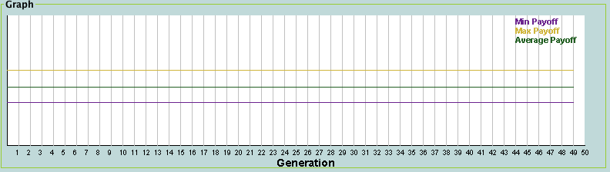

Next, we tested the effects ofturning off mutation and crossover and found that the population either converges or oscillates between two phenotypes. In Figure 2, the minimum and maximum payoffs are the same, indicating that one individual, most likely the fittest, has been replicated to fill the population.

Figure 2

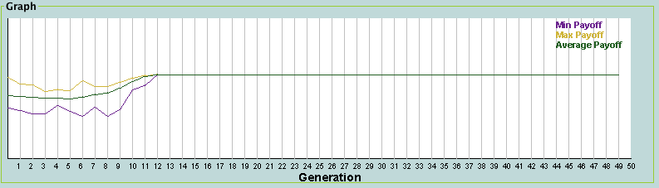

Figure 3 demonstrates the oscillating behavior of the population through generations. This is a sign that the universal stochastic portion of the selection method is working since it for sub-populations above a certain size, a certain number of individuals are guaranteed to be parents.

Figure 3

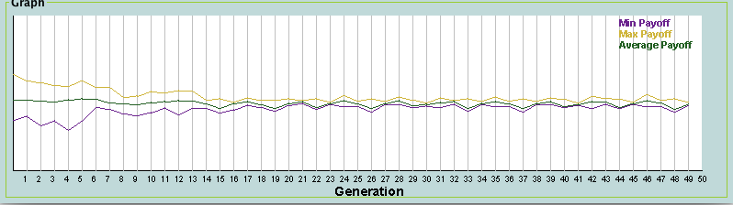

The effects of sigma scaling can be observed in Figure 4 which roughly shows the selection strength getting stronger as the variance between the individuals decreased. This allows for a prolonged period of diversity in the beginning of the simulation, and a faster convergence when a likely solution has been found.

Figure 4

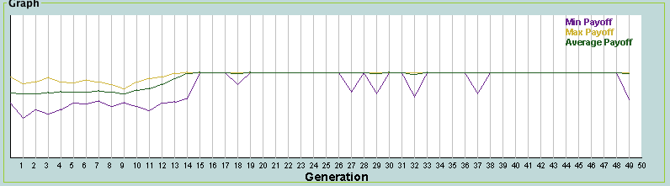

Our tests of the analogous edge cases for Tournament Selection again yielded expected results. Figure 5 shows the effect of having a tournament size of 1. As expected, there is no convergence, and the only change in fitness comes from variation.

Figure 5

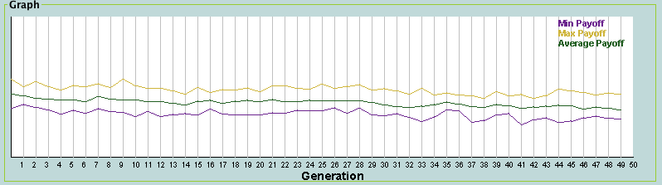

On the other extreme, when we tested with a tournament size that is equal to the population size, we found immediate convergence, as shown in Figure 6. This has the effect of choosing the best individual to be the parent for all children, so to only changes in fitness over time comes from random generation of children that happen to have a greater fitness.

Figure 6

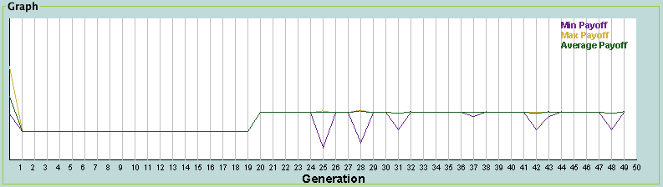

We tested the correctness of both of these selection methods by testing them with different evaluation methods. With reasonable variation and selection parameters, the final populations all resembled the expected.

When the population played against All Defect, the population evolved to always defect, which is expected. When it played All Cooperate, it evolved to again always defect. When it played against tit-for-tat, the final population resembled tit-for-tat. These tell us that our selection methods are valid and functional.

**PART 2 – Starting with All Defect**

When we altered to code so that the initial population is made entirely of individuals that always defect, we were still able to reach tit-for-tat in a lot of the cases. One particularly good set of parameters is pictured in Figure 7.

Figure 7

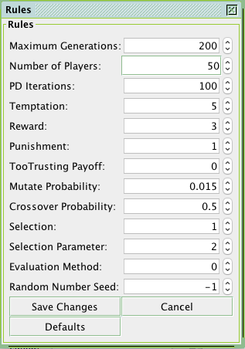

With higher than default mutation rates, and a reasonable selection method that included two elite individuals, our final population strongly resembled tit-for-tat, and it did not take much more than 50 generations to get close (figure 8). In this scenario, improvement is completely dependent on mutation, but raising the mutation rate too high meant that we will always have individuals that are significantly worse than the average.

Figure 8

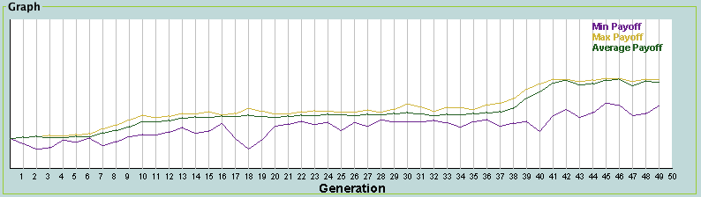

When working with this initial population, we need to make sure that the selection strength is not too strong in the beginning since this will force the population into converging to All Defect. Because mutation rates need to be somewhat high, low selection strength can cause the population to be corrupted after they’ve reached a possibly good configuration.