**STATE OF MAINE**

**IMMUNIZATION REQUIREMENTS**

**FOR SCHOOL CHILDREN**

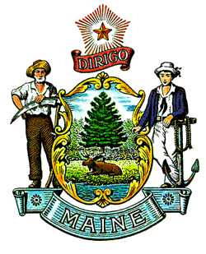

**05-071 CODE OF MAINE RULES**

**CHAPTER 126**

**Department of Education**

**and**

**10-144 CODE OF MAINE RULES**

**CHAPTER 261**

**Department of Health and Human Services**

**Maine Center for Disease Control and Prevention**

**Last Amended: May 10, 2018**