|  |  |  |
| --- | --- | --- |
| **Name** | **:** | **Patel Jenishkumar Kishorbhai** |
| **Cource** | **:** | **M.Sc. ICT(Sem-1)** |
| **Roll No** | **:** | **50** |
| **Subject** | **:** | **Application Development Using React.js** |
| **Practical Assignment 2** | | |

**1. Create a simple HTML form with fields for name, email, and a submit button. Field name and email should have relevant validation. Use jQuery to prevent the form from submitting when the submit button is clicked and instead display an alert with the form data. &**

**5. Implement a simple client-side validation using jQuery. Check if a text input field is empty when a form is submitted. If it&#39;s empty, display an error message next to the input field.**

**Output :**

|  |
| --- |
|  |
|  |
|  |

**2. Create an HTML page that includes two dropdown menus (combos): one for selecting states and another for displaying cities. When the user selects a state from the primary combo, the secondary combo (cities) should dynamically update to display cities relevant to the selected state.**

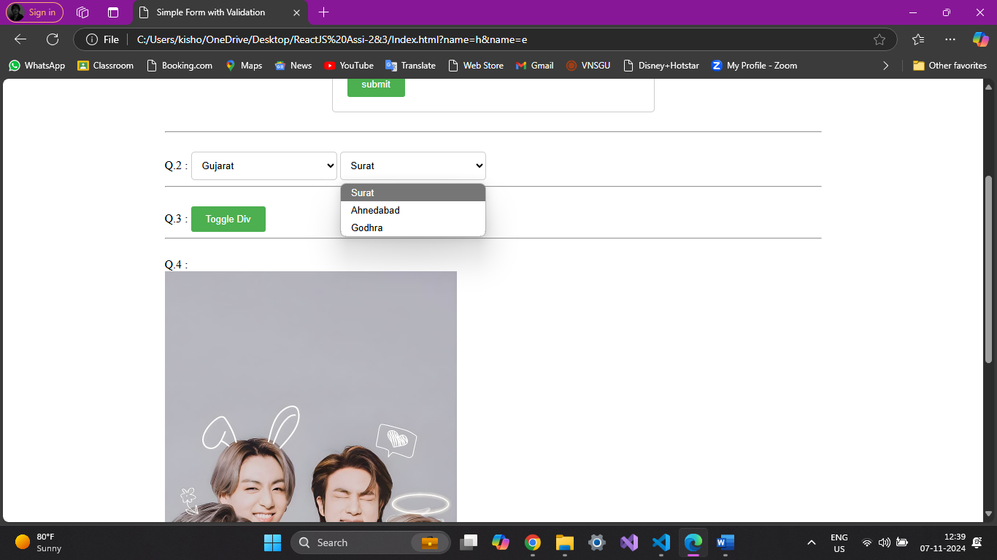

**3. Write jQuery code to toggle the visibility of a div element when a button is clicked. The div should start as hidden, and clicking the button should alternate between showing and hiding it.**

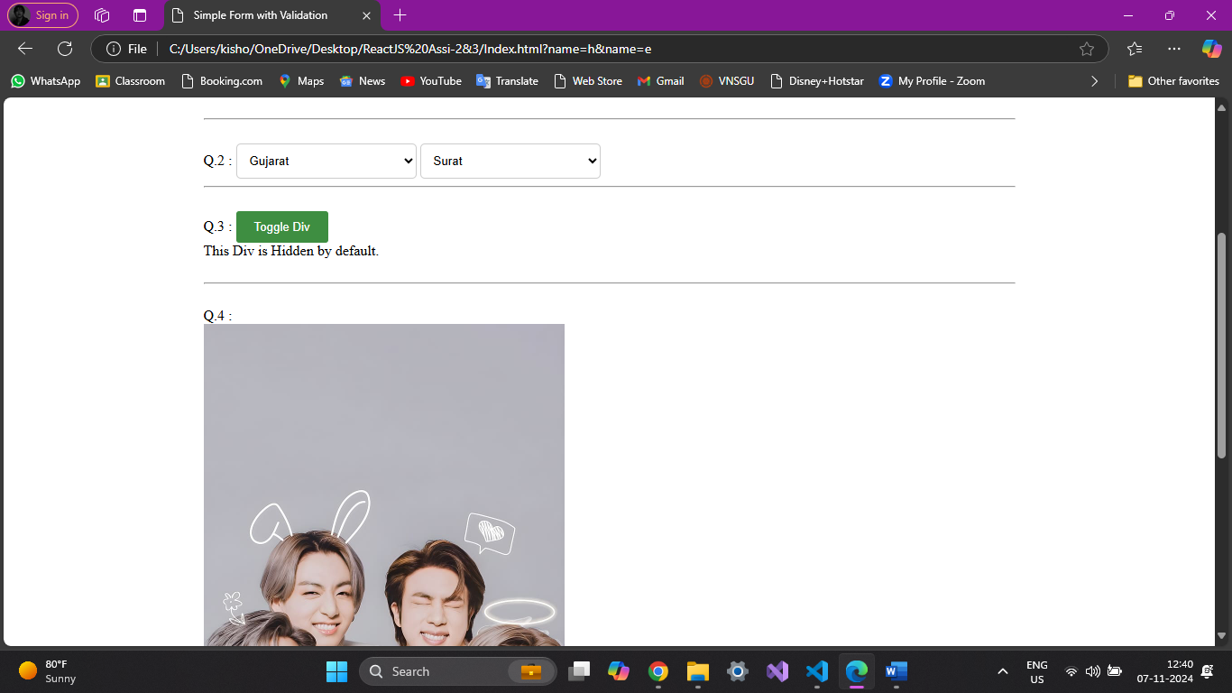

**4. Create a basic image slider using jQuery. Users should be able to click &quot;Next&quot; and &quot;Previous&quot; buttons to navigate between a series of images displayed on a webpage.**

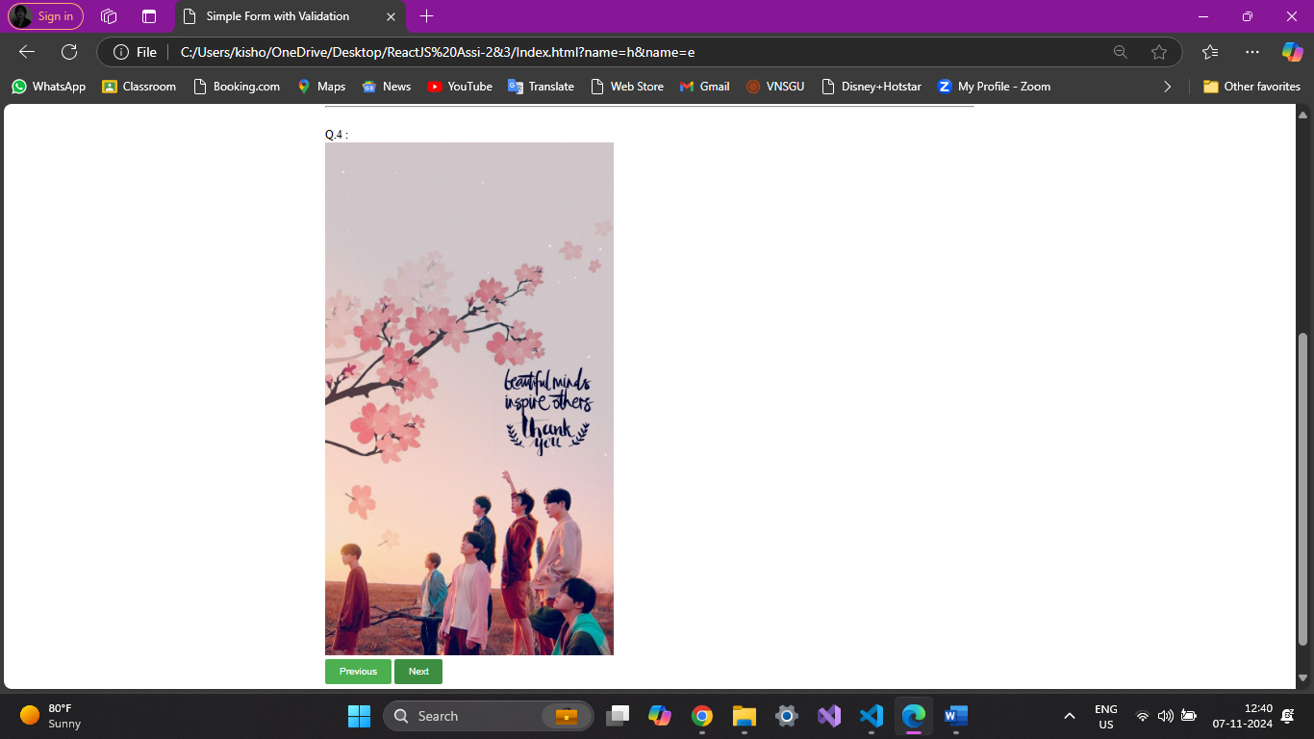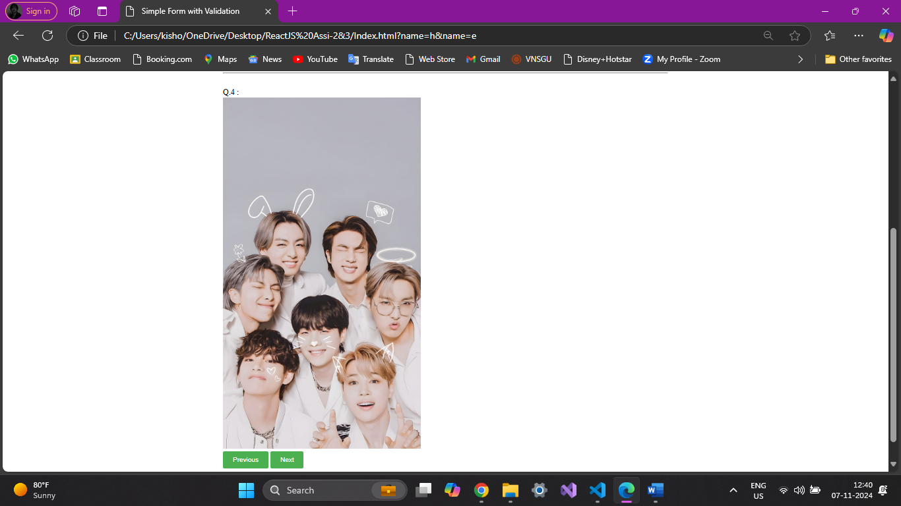

**Code :**

**Index.html**

<!DOCTYPE html>

<html>

<head>

    <title>Simple Form with Validation</title>

    <script src="jquery.js"></script>

    <link rel="stylesheet" href="style.css">

    <script>

        $(document).ready(function () {

            $('#myForm').submit(function (event) {

                event.preventDefault();

                var name = $("#name").val();

                var email = $('#email').val();

                if (name === "") {

                    $("#nameError").text("please enter your name.");

                    return false;

                }else{

                    $("#nameError").text("");

                    alert("Form Submitted Successfully");

                }

                if (email === "") {

                    alert("Please enter your Email Address.");

                    return false;

                }

                var pattern = /^[^\s@]+@[^\s@]+\.[^\s@]+$/;

                if (!pattern.test(email)) {

                    alert("Please Enter a valid email address.");

                    return false;

                }

                alert("Name : " + name + "\nEmail : " + email);

            });

            const states = {

                "Gujarat" : ["Surat", "Ahnedabad", "Godhra"],

                "Rajasthan" : ["Jaipur", "Ranuja", "Udaipur"],

                "Maharastra" : ["Mumbai", "Pune", "Nagpur"]

            };

            function populateCities(state){

                const citiesDropdown = $('#cities');

                citiesDropdown.empty();

                if(states[state]){

                    $.each(states[state], function(index, city){

                        citiesDropdown.append($("<option></option>").val(city).text(city));

                    });

                }

            }

            $("#states").change(function(){

                const selectedState = $(this).val();

                populateCities(selectedState);

            });

            populateCities($("#states").val());

            $("#toggleButton").click(function(){

                $('#hiddenDiv').toggle();

            });

            let slideIndex = 0;

            const slides = $(".slider img");

            const slideCount = slides.length;

            function showSlide(index){

                slides.hide();

                slides.eq(index).show();

            }

            $("#next").click(function(){

                slideIndex = (slideIndex+1)%slideCount;

                showSlide(slideIndex);

            });

            $("#prev").click(function(){

                slideIndex = (slideIndex-1+slideCount)%slideCount;

                showSlide(slideIndex);

            });

            showSlide(slideIndex);

        });

    </script>

</head>

<body>

    <br>

    <form id="myForm">Q.1 & 5:

        <br>

        <label for="name">Name :</label>

        <span id="nameError"></span><br>

        <input type="text" id="name" name="name"><br><br>

        <label for="email">Email :</label>

        <input type="text" id="email" name="name"><br><br>

        <input type="submit" value="submit">

    </form>

    <hr>

    Q.2 :

    <select id="states">States :

        <option value="">Select State</option>

        <option value="Gujarat">Gujarat</option>

        <option value="Rajasthan">Rajasthan</option>

        <option value="Maharastra">Maharastra</option>

    </select>

    <select id="cities">Select City :</select>

    <hr>

    Q.3 :

    <input type="submit" id="toggleButton" value="Toggle Div">

    <div id="hiddenDiv" style="display: none;">This Div is Hidden by default. </div>

    Q.4 :

    <div class="slider">

        <img src="images/bts1.jpg" alt="BTS1">

        <img src="images/bts2.jpg" alt="BTS2">

        <img src="images/bts3.jpg" alt="BTS3">

    </div>

    <input type="submit" id="prev" value="Previous">

    <input type="submit" id="next" value="Next">

    <br>

    <hr>

    <br>

</body>

</html>

**Style.css :**

body{

    max-width: 900px;

    margin: 0 auto;

    padding: 20px;

}

form{

    max-width: 400px;

    margin: 0 auto;

    padding: 20px;

    border: 1px solid #ccc;

    border-radius: 5px;

}

label{

    display: block;

    margin-bottom: 5px;

    font-weight: bold;

}

input[type="text"], textarea{

    width: 100%;

    padding: 10px;

    border: 1px solid #ccc;

    border-radius: 3px;

}

input[type="submit"]{

    background-color: #4CAF50;

    color: white;

    padding: 10px 20px;

    border: none;

    border-radius: 3px;

    cursor: pointer;

}

input[type="submit"]:hover{

    background-color: #3e8e41;

}

select{

    padding: 10px;

    border: 1px solid #ccc;

    border-radius: 5px;

    width: 200px;

}

option{

    padding: 5px;

}

.slider{

    width: 400px;

    overflow: hidden;

}

.slider img{

    width: 100%;

}