Deploying Health Insurance Claim System with Blockchain in Tertiary Hospitals: Multicenter Prospective study

MinDong Sung, M.D. 1

Yu Rang Park, Ph.D. 1

1 Department of Biomedical Systems Informatics, Yonsei University College of Medicine, Seoul, South Korea

**Abstract**

Frauds have plagued the healthcare insurance domain, despite attempts at prevention. Blockchain technology, which is decentralized and immutable, is gaining attention. We developed a healthcare insurance claim system applying blockchain, and performed a proof-of-concept study in three tertiary South Korean hospitals, where patient satisfaction was measured using this application. The 300 participants could read and issue medical documents or claim insurance through the application. We surveyed patient satisfaction with the Post-Study System Usability Questionnaire (PSSUQ), and insurance claim as well as past claim experiences through the application. The PSSUQ scores were higher for participants who claimed insurance than for those who did not. Overall, 72 participants claimed insurance using this application, and 159 reported past claims experience. Participants reported submitting claims using our application was quicker and less burden than past experiences. This system could be expanded to other hospitals, simplifying the claims process, thereby saving patients’ time and effort.

**Keywords: blockchain, health insurance, prospective**

# Introduction

The insurance domain is an important economic sector, composed of a high number of complex business processes which produce a large amount of operational data. In particular, the size of the health and medical insurance industry in the US market, measured by revenue, is $1.1 trillion in 2021. In addition, the size of the health and medical insurance industry is expected to increase by 6.6% during 2021.1 AsAs the scale of the insurance industry has increased, the scale of insurance fraud remains large, despite the many attempts to prevent such fraud. For example, Medicare, a national health insurance program in the United States, suffered a loss of approximately $2.6 billion in 2019 from criminal fines, civil monetary penalties, fees associated with property forfeiture, and penalties and damages obtained and otherwise creditable to miscellaneous receipts.2 Additionally, approximately 75% of insurance industry professionals believe that 10% or more or all insurance claims have some element of fraud.3

To prevent insurance fraud, document authenticity is becoming increasingly important. Currently, the document providers watermark the document to verify its authenticity and may provide additional authenticity verification services, such as verification digit codes or barcodes. Users can avail of these services to verify the document’s authenticity. However, not all documents and providers use these codes or provide these services.

The insurance claim process is a time-and labor-intensive process. In Korea, approximately 77% of adults are insured in medical indemnity insurance programs. These users have claimed insurance through insurance planners (52.2%) or by visiting in person (13.6%). Unclaimed rates of medical indemnity insurance were 4.1%, 14.6%, and 20.5% for admissions, outpatient clinics, and prescriptions, respectively. The majority (90%) of users reported not claiming insurance because it was a small amount compared to their time-and-labor consumption.4

Blockchain is considered a promising technology, and it is defined as a decentralized, distributed, immutable ledger recording system.5 These characteristics of the blockchain can help prevent insurance claim fraud, and mitigate the labor-intensive and time-consuming aspects of claiming insurance. In the U.S., the Office of the National Coordinator for Health Information Technology (ONC) believes blockchain technology has the potential to address the interoperability challenges present in health information technology (IT) systems and to enable healthcare stakeholders to share electronic health data.6 Additionally, many healthcare and insurance domains have attempted to apply the blockchain system in their systems.

Therefore, in this study, we developed a healthcare insurance claim system using the blockchain and Fast Healthcare Interoperability Resources (FHIR) architecture. We performed a proof-of-concept study in three tertiary hospitals in South Korea and measured patient satisfaction using this application.

# Results

## The service model

We deployed our healthcare insurance claim system in three tertiary academic hospitals in South Korea. The total service model is shown in Figure 1. Patients can (1) read their own medical documents without visiting the hospital, (2) issue medical documents, and (3) claim insurance by submitting the issued medical document. When the claim is requested, the hospital-side server sends the metadata of the document to the blockchain, and the insurance company side server can compare the hash of the document which was handed by the patients’ application and the hash from the blockchain.

## Survey

A total of 300 patients completed a Post-Study System Usability Questionnaire (PSSUQ) survey, as well as other questions about insurance claim experience with both this application and previous claim experiences. All participants were enrolled in the three tertiary academic hospitals in South Korea, and each institute enrolled 100 patients. Females constituted the majority of participants from each institute, comprising 66%, 72%, and 69% for each hospital, respectively. In addition, most respondents were in their 20-30s. The number of patients who used this application to claim their insurance was 73 (24.33%), which showed no significant difference among hospitals ($χ_{2, N=300}^{2}=2.43$, p = 0.297). (Table 1)

The average of the general PSSUQ score is 4.75, 95% C.I. [4.64, 4.87]. The averages for the subclasses are: 4.8, 95% C.I. [4.75, 4.85] for System Usefulness; 4.49, 95% C.I. [4.43, 4.54] for Information Quality; and 4.54, 95% C.I. [4.46, 4.62] for Interface Quality. Comparing the patients who claimed insurance and those who did not, all PSSUQ scales, including system usefulness (0.48, 95% C.I. [0.26, 0.71], t(130.05) = 4.20, p < 0.001), information quality (0.59, 95% C.I. [0.34, 0.84] , t(119.17) = 4.65, p < 0.001), interface quality (0.39, 95% C.I. [0.19, 0.59] t(122.08) = 3.81, p = 0.0002), and global score (0.53, 95% C.I. [0.28, 0.77], t(140.89) = 4.19, p < 0.001) are higher for the patients who claimed insurance than for those who did not. (Figure 2)

In all, 73 (24.33%) patients used this application to claim insurance. Of these, 59 (80.82%) patients completed the claims process within 30 minutes (Table 2). It cost less than $5, $5 - 10, and more than $10 to claim insurance for 36 (49.32%), 27 (36.99%), and 2 (2.74%) patients, respectively. Regarding the number of documents needed, 31 (42.47%) and 27 (36.99%) patients answered that they needed 0-1 and 2-3 documents when filing their claim, respectively. (Table 3)

A total of 159 patients (53%) answered questions regarding their past insurance claims experience. Among them, 96 (60.38%) claimed medical indemnity insurance using our system. For a comparison between their past and current claims experiences, only medical indemnity insurance experience was considered. Of those who claimed insurance, 30 (18.87%) filed their claim through smartphones, 22 (13.84%) did so through insurance planners, and or 17 (10.69%) by fax. In addition, 47 (29.56%) patients required less than 6 hours when they filed a claim; however, 27 (16.98%) patients required more than 24 hours (Table 2). The cost was not significantly different between systems (fisher’s exact test, p = 0.181); however, the number of documents required to file a claim was significantly different (fisher’s exact test, p < 0.001) (Table 3).

# Discussion

In this study, an insurance claim system was developed using blockchain and FHIR architecture, and it was subsequently deployed in three tertiary academic hospitals. We surveyed patients regarding their satisfaction with using this application, details of their experience filing an insurance claim using this application, and past experiences regarding claiming insurance. Patients who used this application to claim insurance were more satisfied with the application than those who used it solely to view their own medical records. This is the first study to deploy an insurance claim application based on blockchain technology in large tertiary hospitals, as previous studies have only demonstrated the efficacy of prototypes of the system. In addition, we translated the medical document with FHIR, and demonstrated that our system could be expanded to any hospital or insurance company.

Some prior studies attempted to apply blockchain technology to the health care or insurance domains. The most popular such domain is the electronic medical record (EMR) system. MedRec7is an Ethereum-based system that manages authorization, permissions, and the entry, retrieval, updating, and sharing of data in EMRs. The FHIRchain8, which refers to a combination of FHIR and blockchain, is an electronic medical record system which meets the ONC requirements of blockchain. OmniPHR9,10was introduced as a distributed architecture model of personal health records (PHRs). In addition, Sung et al.11 applied a blockchain medical record monitoring system in primary clinics, although it was not used to handle all of the medical record data, but instead simply changed the records when necessary. In addition, clinical trial systems have attempted to employ blockchain technology, however these applications require transparency and traceability. Wong et al.12 introduced a proof-of-concept for blockchain clinical trial architecture, which included randomizing patients, recording case report forms (CRF), analyzing results, reporting adverse events, and summarizing patient data. Alternatively, in the auto insurance domain, Roriz et al.13 developed a blockchain architecture prototype to avoid insurance fraud, particularly what is known as “double dipping,” when a claim is filed with two different insurance companies. Their system included the creation and termination of insurance policies, the creation of claims, and a record of the life of a vehicle. Within the medical domain, MIStore14 is a prototype blockchain-based medical insurance storage system based on Ethereum. Most of studies were prototype and did not applied to real-world situation. However, this study applied the blockchain system in three tertiary hospitals and surveyed the patients’ satisfaction.

Patients who filed a claim using this application reported higher PSSUQ scores than those who just used the application, not filed a claim. That is, patients who filed a claim using the application were more satisfied with it than those who used it solely to view medical documents. The current system tended to take less time to file a claim than past system did. According to survey, in the past, taking less than 6 hours to claim insurance comprised only 43.4% in the answered population; however, all the time answered about this application takes less than 1 hours. In addition, while the cost was not significantly different between the two systems, the current system required fewer documents when claiming insurance. These demonstrate that this system can simplify the insurance claim process, thereby saving patients’ time and effort.

Insurance fraud is generally divided into hard and soft fraud, based on whether the fraud was pre-planned.15 This blockchain system cannot prevent all insurance fraud. For example, the blockchain cannot prevent the health provider from recording false information in the blockchain, which is classified as hard fraud. However, document-related fraud can be prevented using this system, which provides patients and insurance companies with a convenient way to claim insurance. The economic model introduced by Park et al.16 demonstrated that the adoption of blockchain technology, which enables market participants to share medical information effectively, reduces information asymmetry in the health insurance market, and subsequently prevents soft insurance fraud.

In the era of big data, privacy prevention has been emphasized. Moreover, strict privacy prevention is particularly necessary in the medical field. Conventionally, to ensure the privacy of patients, they must obtain requisite documents themselves and submit them to insurance companies. The insurance companies should then match the original document in the hospital to verify its authenticity. A system based on blockchain technology can instill trust in these processes, enabling claims to be made through existing applications that benefit patients and insurance companies. In addition, such a system is more protective of privacy, as it does not expose patient information.

EvolutionWith the evolution of medical informatics, medical documents can be transferred to the patient. This could improve patient empowerment17, which is defined as “the process that helps people gain control over their own lives and increases their capacity to act on issues that they themselves define as important”18. For healthcare providers, electronic medical record submission has been permitted. For example, the Center for Medicare and Medicaid Services allows healthcare providers — not patients —to electronically submit medical documents through their electronic submission of Medical Documentation (esMD) system.19 For individual patients, the documents should be submitted through people. Even the document is issued by internet or mobile application, most documents should be delivered by hands or fax. Blockchain technology, which not only provides authentic medical documents but also provides verification of those documents, can enhance the patient’s ability to use their medical documents in an official capacity. For example, they can submit the document to the insurance company or the other hospitals they visited. The hospital/company or the individual who is supplied with the document can trust its authenticity. Moreover, according to,20 treatment by fraud and abuse penetration was associated with worse treatment outcomes. These attempts to eliminate insurance fraud can help to improved beneficiary health. This would provide a more advanced form of patient empowerment; because not only do patients extend their authority over their own health information, but they also could get the better outcomes.

There are a few limitations to the present research. First, the survey cohort was somewhat skewed, as the majority of participants were in their 30s. The lower the patient’s age, the more convenient they found using the application. However, other age groups were also included in the study, and the PSSUQ score for these groups did not decrease. Second, the study did not show that the frequency of insurance fraud events decreased with blockchain technology. However, the survey demonstrated that the patients were satisfied with the system, and that the duration to file a claim and number of documents required decreased with its use. Third, we only surveyed hospital users. Further research should be conducted from the point of view of those who use insurance companies to file claims. Finally, this system does not include all the services that are generally provided by an insurance company; it only provides the ability to file a claim and to verify the issued document. This system could therefore be extended to include more services. One option would be to have insurance payments be automated by smart contracts. In addition, individual identification could also be automated using Decentralized Identifiers (DID). Lastly, hashed data could be used by insurance companies, and the collected data could be used to find patterns of insurance fraud.

# Conclusion

In this study, we applied a healthcare insurance claim system to tertiary academic hospitals in South Korea. Our system could be expanded to other hospitals, which would simplify the process of filing insurance claims, thereby saving the patient’s time and effort.

**Acknowledgements**

**Author Contributions** The authors made the following contributions. MinDong Sung, M.D.: Conceptualization, Methodology, Investigation, Writing – original draft, Writing - Review & Editing; Yu Rang Park, Ph.D: Conceptualization, Methodology, Writing - Review & Editing, Project administration, Supervision.

**Competing Interests**

# References

1. IBISWorld. Health & Medical Insurance in the US - Market Size 2005–2027. Published online 2021. Accessed April 28, 2021. <https://www.ibisworld.com/industry-statistics/market-size/health-medical-insurance-united-states/>

2. The Department of Health and Human Services and The Department of Justice. Health Care Fraud and Abuse Control Program Annual Report for Fiscal Year 2019. Published online 2020.

3. Metz J. Pandemic Fires Up Insurance Fraud, Here’s What To Watch For. Published online 2021. Accessed April 26, 2021. <https://www.forbes.com/advisor/car-insurance/pandemic-insurance-fraud/>

4. Yong Woon C, Dong Kyum K. *Current Status and Countermeasures for Non-claiming Indemnity Medical Insurance*. KIRI (Korea Insurance Research Institute); 2018. <http://www.kiri.or.kr/pdf/전문자료/KIRI_20181005_93447.pdf>

5. Vazirani AA, O’Donoghue O, Brindley D, Meinert E. Blockchain vehicles for efficient medical record management. *npj Digital Medicine*. 2020;3(1). doi:[10.1038/s41746-019-0211-0](https://doi.org/10.1038/s41746-019-0211-0)

6. Office of the National Coordinator for Health Information Technology, Services USD of H, Human. *Blockchain and Health IT: Algorithms, Privacy, and Data*.; 2016. <https://www.healthit.gov/sites/default/files/1-78-blockchainandhealthitalgorithmsprivacydata_whitepaper.pdf>

7. Azaria A, Ekblaw A, Vieira T, Lippman A. Medrec: Using blockchain for medical data access and permission management. In: *2016 2nd International Conference on Open and Big Data (OBD)*. IEEE; 2016:25-30.

8. Zhang P, White J, Schmidt DC, Lenz G, Rosenbloom ST. FHIRChain: Applying blockchain to securely and scalably share clinical data. *Computational and Structural Biotechnology Journal*. 2018;16:267-278. doi:[10.1016/j.csbj.2018.07.004](https://doi.org/10.1016/j.csbj.2018.07.004)

9. Roehrs A, Costa CA da, da Rosa Righi R, Silva VF da, Goldim JR, Schmidt DC. Analyzing the performance of a blockchain-based personal health record implementation. 2019;92:103140. doi:[10.1016/j.jbi.2019.103140](https://doi.org/10.1016/j.jbi.2019.103140)

10. Roehrs A, Costa CA da, da Rosa Righi R. OmniPHR: A distributed architecture model to integrate personal health records. 2017;71:70-81. doi:<https://doi.org/10.1016/j.jbi.2017.05.012>

11. Sung M, Park S, Jung S, Lee E, Lee J, Park YR. Developing a mobile app for monitoring medical record changes using blockchain: Development and usability study. *Journal of Medical Internet Research*. 2020;22(8):e19657. doi:[10.2196/19657](https://doi.org/10.2196/19657)

12. Wong DR, Bhattacharya S, Butte AJ. Prototype of running clinical trials in an untrustworthy environment using blockchain. *Nature Communications*. 2019;10(1). doi:[10.1038/s41467-019-08874-y](https://doi.org/10.1038/s41467-019-08874-y)

13. Roriz R, Pereira JL. Avoiding insurance fraud: A blockchain-based solution for the vehicle sector. *Procedia Computer Science*. 2019;164:211-218. doi:[10.1016/j.procs.2019.12.174](https://doi.org/10.1016/j.procs.2019.12.174)

14. Zhou L, Wang L, Sun Y. MIStore: A blockchain-based medical insurance storage system. *Journal of Medical Systems*. 2018;42(8). doi:[10.1007/s10916-018-0996-4](https://doi.org/10.1007/s10916-018-0996-4)

15. Viaene S, Dedene G. Insurance Fraud: Issues and Challenges. *Geneva Papers on Risk and Insurance: Issues and Practice*. 2004;29(2):313-333. doi:[10.1111/j.1468-0440.2004.00290.x](https://doi.org/10.1111/j.1468-0440.2004.00290.x)

16. Park D, Ryu D. Blockchain in health insurance: Sharing medical information and preventing insurance fraud. *Korean Journal of Financial Studies*. 2019;48(4):417-447. doi:[10.26845/kjfs.2019.08.48.4.417](https://doi.org/10.26845/kjfs.2019.08.48.4.417)

17. Anthony ES. The Cures Act Final Rule: Interoperability-Focused Policies that Empower Patients and Support Providers. Published online 2020. Accessed May 6, 2021. <https://www.healthit.gov/buzz-blog/21st-century-cures-act/the-cures-final-rule>

18. European Patients Forum. *Toolkit for Patient Organisations on Patient Empowerment*.; 2017. <https://www.eu-patient.eu/globalassets/library/publications/patient-empowerment---toolkit.pdf>

19. The Centers for Medicare and Medicaid Services. Electronic Submission of Medical Documentation (esMD).

20. Nicholas LH, Hanson C, Segal JB, Eisenberg MD. Association between treatment by fraud and abuse perpetrators and health outcomes among medicare beneficiaries. *JAMA Internal Medicine*. 2020;180(1):62. doi:[10.1001/jamainternmed.2019.4771](https://doi.org/10.1001/jamainternmed.2019.4771)

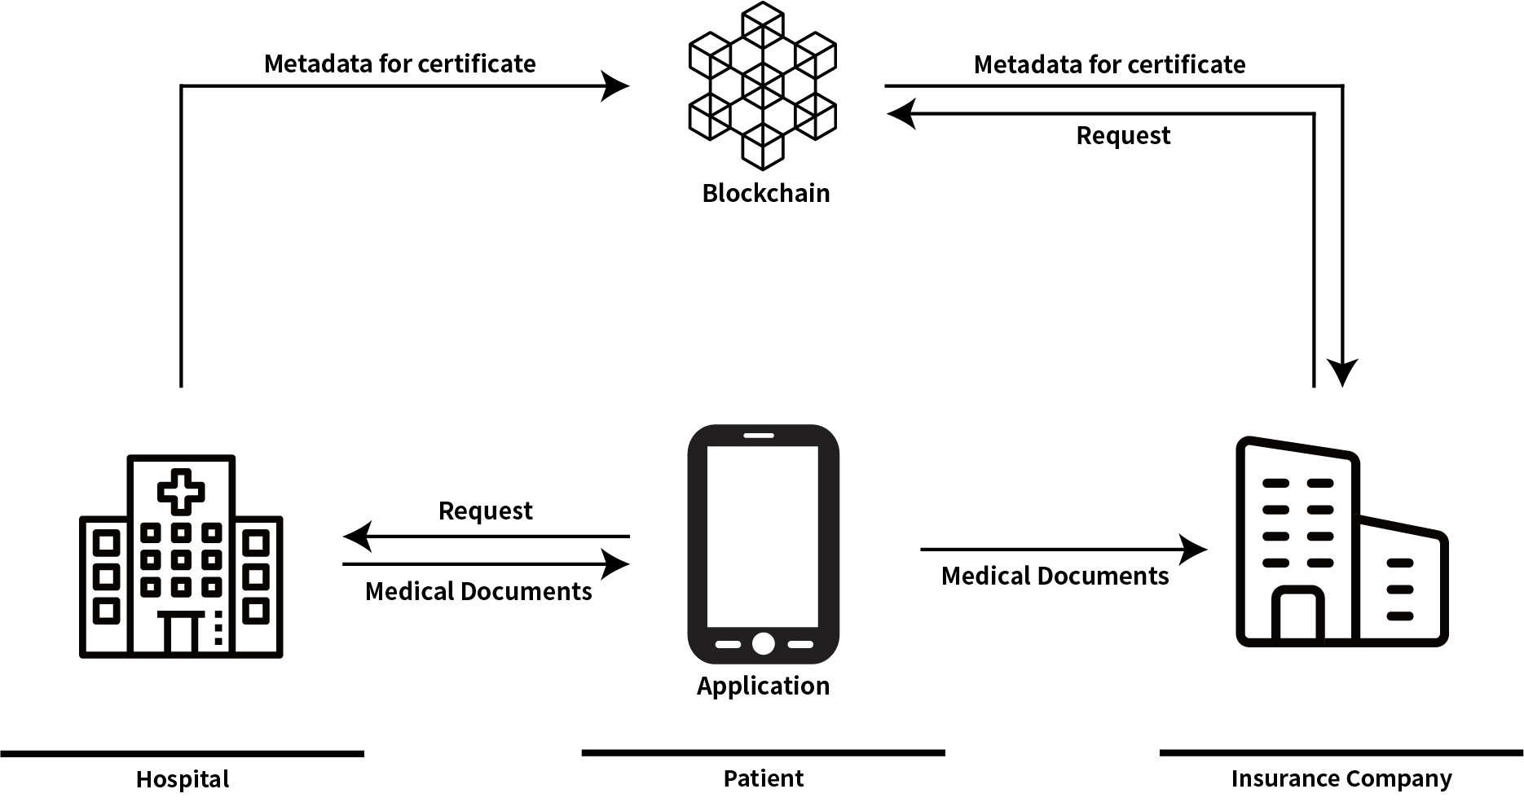

Figure 1: The Service Model architecture of the system

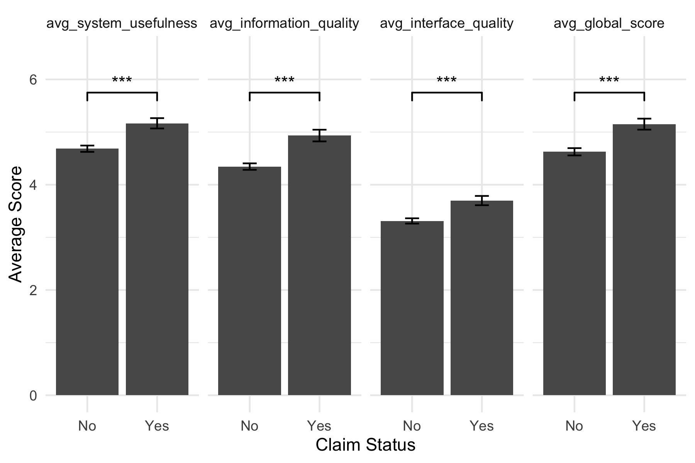

Figure 2: The PSSUQ scores grouped by the insurance claim status

Table 1: The Demographic of the patient enrolled in the survey study

|  | Hospital A | Hospital B | Hospital C | p |
| --- | --- | --- | --- | --- |
| N | 100 | 100 | 100 |  |
| Female, n(%) | 66 | 72 | 69 | 0.657 |
| Age range, n(%) |  |  |  | 0.001 |
| 20s | 39 | 11 | 20 |  |
| 30s | 28 | 41 | 48 |  |
| 40s | 16 | 25 | 14 |  |
| 50s | 11 | 14 | 13 |  |
| 60s | 6 | 7 | 3 |  |
| 70s | 0 | 2 | 2 |  |
| Claim insurance, n(%)a | 28 | 26 | 19 | 0.297 |
| Past Experience, n(%)b | 67 | 49 | 43 | 0.002 |
| aThe patients who use this application to claim insurance | | | | |
| bThe patients who answered past experience of insurance claim | | | | |

Table 2: Compare the time to claim insurance between the past experience and this application

| Current(N=73)a | | Past(N=159)b | |
| --- | --- | --- | --- |
| Attributes | N(%) | Attributes | N(%) |
| less than 5 mins | 33 (45.21) | less than 6 hours | 69 (43.4) |
| less than 30 mins | 26 (35.62) | less than 24 hours | 34 (21.38) |
| more than 1 hour | 2 (2.74) | more than 24 hour | 43 (27.04) |
| have no idea | 11 (15.07) | have no idea | 13 (8.18) |
| aThe result of the survey how long does it take to claim in the application | | | |
| bThe result of survey about past experience claim insurance | | | |

Table 3: Compare the cost and the number of documents needed to claim insurance between the past experience and this application

| Items | Attributes | Current (N=73) | Past (N=159) | P |
| --- | --- | --- | --- | --- |
| Cost | less than 5$ | 32 (43.84) | 36 (22.64) | 0.181 |
| 5$ ~ 10$ | 6 (8.22) | 17 (10.69) |  |
| more than 10$ | 13 (17.81) | 23 (14.47) |  |
| Num of Documents | 0-1 | 31 (42.47) | 17 (10.69) | 0.000 |
| 2-3 | 27 (36.99) | 56 (35.22) |  |
| 4-5 | 2 (2.74) | 13 (8.18) |  |
| 6-7 | 1 (1.37) | 3 (1.89) |  |
| 8-9 | 0 (0) | 0 (0) |  |
| more than 10 | 1 (1.37) | 2 (1.26) |  |