PTGS_BC — Bayesian-Computing Polygenic Transcriptomic Scores
Analytical models, simulations, decisions, and roadmap — engagement summary
Prepared 2026-09-04 · Updated 2026-09-22 · Kim Lab · package ptgs_bc v0.1.0 · github.com/kimjhusa5803/ptgs_bc

Contents
- 1. Executive summary
- 2. Scope — the two projects
- 3. PTGS_BC — the analytical model
- 4. Simulation of data
- 5. Results
- 6. Consolidated key decisions
- 7. Clarifying questions asked and how they were resolved
- 8. Potential weaknesses of the current results and models
- 9. Future suggestions
- 10. Appendix — environment and repository

1. Executive summary
This document summarizes two related efforts. The primary, analytically focused project is PTGS_BC: developing Bayesian-computing polygenic transcriptomic scores (PTGS) built on genetically regulated expression (GReX) and benchmarking them against an elastic-net baseline. The second is C_Research_Analytics, a multi-surface workflow platform (context only; it contains no analytical models). The remainder concentrates on the PTGS_BC models, simulations, decisions, results, weaknesses, and future work.
Core idea: score a trait as a weighted sum of predicted gene-expression levels (GReX) rather than SNPs (following Liang et al., Genome Biology 2022, “PTRS”). Every score-builder runs through one shared 5-fold nested cross-validation harness: an elastic-net baseline (the reference method) and a family of Bayesian shrinkage-prior builders (“BC” = Bayesian Computing, via NumPyro). A TWAS data simulator tests the method under realistic, correlated GReX. The strategic decision remains: do not try to prove one method universally superior — run several and select the winner for the expected data regime, guided by simulation.
Update (2026-09-22): the Bayesian prior library has grown from three priors to seven (three original plus four new: graph_horseshoe, group_horseshoe, spike_slab, graph_spike_slab), directly motivated by a discovery-focused reframing of the project's goal — identifying which gene/tissue distinguishes a GLP-1 receptor agonist (mono-agonist) from a dual GIP/GLP-1 receptor agonist (e.g. tirzepatide) — rather than purely maximizing predictive accuracy. Empirically, correlation-aware CONTINUOUS shrinkage (graph_horseshoe) was a null result even with the oracle correlation matrix; pathway-informed shrinkage (group_horseshoe) was a clear, robust win. This motivated two new spike-and-slab priors that give a genuine per-gene posterior inclusion probability (PIP) — the first priors in this package suited to gene-level discovery claims rather than prediction alone. Real, multi-tissue GReX for the local cohort is planned as the next input once the real-data comparison design is finalized (Section 9).

2. Scope — the two projects
Project | Nature | What it is | Role here
PTGS_BC | Analytical / statistical method | Bayesian vs. elastic-net PTGS on GReX, now with 7 interchangeable priors | Main focus (models, simulation, results, decisions)
C_Research_Analytics | Workflow-engineering platform | One analysis delivered across shell → notebook → Nextflow → WDL | Context only (architectural, no analytical content)

3. PTGS_BC — the analytical model

3.1 Concept and rationale
- PTGS = polygenic score on GReX (predicted expression from genotype via TWAS/PrediXcan weights), not on SNPs.
- Motivation (from the PTRS reference): better cross-ancestry portability (gene effects more conserved than SNP effects), far fewer features (~10k genes vs. millions of SNPs), and biological interpretability.
- Input to this project is GReX itself (already computed for the local cohort, multi-tissue) plus a trait and covariates; the score-building layer is what we develop. GReX estimation itself is out of scope — see Section 9 for how its uncertainty can nonetheless be characterized and eventually used.

3.2 Architecture — shared harness + pluggable builders
The score-construction step is pluggable; everything else (fold generation, covariate handling, scoring, and the performance metric) is shared, so every method differs only in how gene weights are estimated. That is what keeps every comparison fair.
- Shared: nested-CV harness, GReX→score computation, metrics, results objects, and comparison figures.
- Builder A (baseline): elastic net (the reference method).
- Builder B (BC): Bayesian regression, now under any of seven registered shrinkage priors (Section 3.4).
- Package layout is two-layer: an installable Python package (methodology) + numbered notebooks (analysis), now 01–06.

3.3 Baseline builder — elastic net
- Sparse regularized regression over the predicted-expression features, tuning the penalty by inner CV (ElasticNetCV / LogisticRegressionCV).
- Decision: widen the l1_ratio grid toward ridge (0.05…1.0) because correlated TWAS genes benefit from elastic net’s grouping effect; pure lasso arbitrarily drops one of a correlated set.
- Selection metric aligned to the outcome metric (partial R² / AUC) via covariate residualization.

3.4 Bayesian-computing (BC) builder and its prior library
- Replaces the elastic-net penalty with a shrinkage prior and infers the full posterior; the score uses posterior-mean gene weights (posterior SDs, and now posterior inclusion probabilities for two priors, are retained as information the baseline cannot provide).
- Engine: NumPyro (JAX) — chosen for scalability at ~10k genes × nested CV, GPU capability, and being Python-native.
- Inference: NUTS by default (target_accept = 0.9 for the horseshoe family’s funnel geometry); SVI (variational) reserved as the scalability escape hatch.
- Global shrinkage scale tau0 (or, for the two spike-and-slab priors, the inclusion probability pi0) is derived from an interpretable sparsity guess p0, rather than fixed arbitrarily — the same p0 ergonomics apply across every prior.

3.4.1 Original three priors (2026-09-04)
- regularized_horseshoe (default): the regularized/Finnish horseshoe (Piironen–Vehtari) — heavy shrinkage plus a slab that caps large effects.
- horseshoe: the classic Carvalho–Polson–Scott horseshoe.
- bayesian_lasso: a Laplace prior, the Bayesian analog of the elastic-net L1 term.
- All three are iid across genes — no gene-gene correlation or grouping structure. This was the acknowledged gap that motivated the four new priors below.

3.4.2 New (2026-09-22): correlation-aware and pathway-informed priors
- graph_horseshoe: the regularized horseshoe’s latent draw is correlated across genes via a gene-gene correlation matrix (a Cholesky factor of hyper["corr"]) instead of iid. corr can be the closed-form population oracle (only computable for the synthetic TWAS simulator) or a Ledoit-Wolf estimate from training GReX (structure.estimate_gene_correlation, or BayesBuilder(corr_estimate=True) for leakage-safe per-fold estimation inside nested CV).
- group_horseshoe: a shared group-level (e.g. pathway) local scale (hyper["groups"]), so a known-informative gene group (such as a candidate GIP/GLP-1 signaling gene set) is shrunk together rather than gene-by-gene.

3.4.3 New (2026-09-22): spike-and-slab priors (discovery-focused)
Motivated directly by the empirical finding in Section 5.2: correlation should matter more for discrete SELECTION (independent inclusion indicators arbitrarily split credit between correlated genes) than for continuous shrinkage. NUTS cannot sample a true discrete inclusion indicator, and a literal Ising/Markov-random-field prior on such indicators has an intractable normalizing constant in general — both new priors use the standard NUTS-native continuous relaxation instead of either.
- spike_slab: a George & McCulloch-style continuous two-component Gaussian mixture per gene (near-zero “spike” vs. diffuse “slab”), marginalizing the discrete indicator (numpyro.distributions.MixtureSameFamily). Gives a genuine per-gene posterior inclusion probability (priors.spike_slab_pip, stored in ScoreBundle.extras["pip"]) — no horseshoe-family prior provides this.
- graph_spike_slab: spike_slab whose per-gene inclusion PROBABILITY (not the weight itself) is correlated via hyper["corr"], reusing graph_horseshoe’s exact Cholesky-correlated-latent mechanism applied to the mixing logit — a deliberate substitution for a true Ising/MRF prior, avoiding its intractability while still pulling correlated genes toward joint inclusion or exclusion.
- Verified via a full nested_cv/run_benchmark integration run with real NUTS sampling, not just eager-mode unit tests — the earlier graph_horseshoe/group_horseshoe pass had found two real bugs (a result-name collision, a JAX-tracing crash) that only appeared under actual NUTS execution.

3.5 Evaluation — nested cross-validation and metric
- 5-fold NESTED CV: outer folds estimate unbiased test performance; each builder tunes itself in the inner folds (no leakage). All arms use identical fold assignments — the paired design that makes every comparison fair.
- Primary metric: partial R² for a continuous trait (variance explained beyond covariates); AUC for a binary trait. The trait family is general (gaussian | binomial).

3.6 Hyperparameter tuning and optimization plots (original)
Both original arms were tuned, and the optimization visualized so the variation across the tuned parameters is explicit. These plots (from the 2026-09-04 baseline, still valid) are embedded in notebooks 02 (elastic net) and 03 (Bayesian).
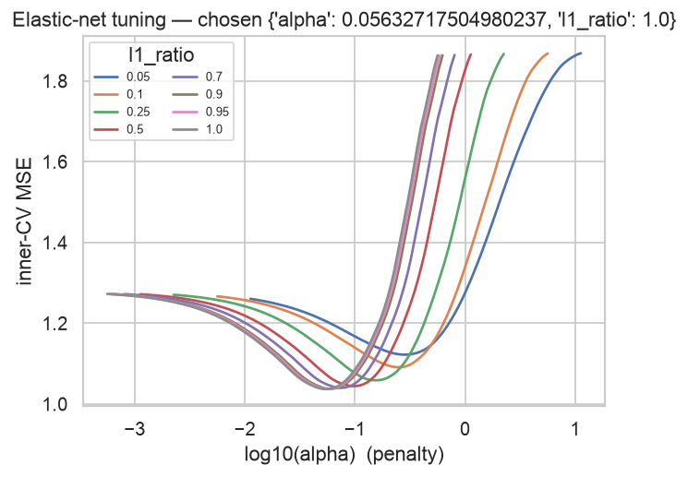
Figure 1. Elastic-net inner-CV surface: MSE vs. log(alpha), one line per l1_ratio; the minimum of the lowest curve is the selected penalty.

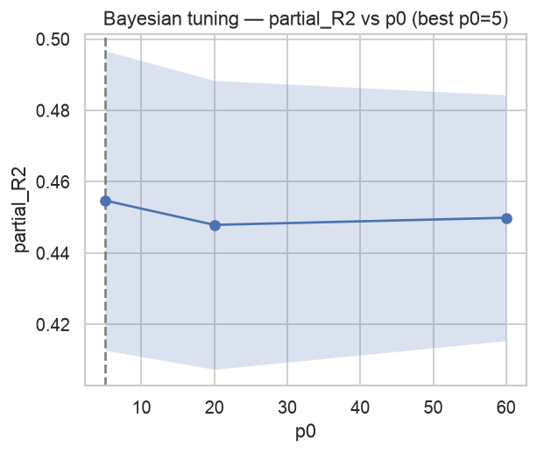
Figure 2. Bayesian tuning: nested-CV performance vs. the sparsity guess p0 (which sets the global scale tau0).

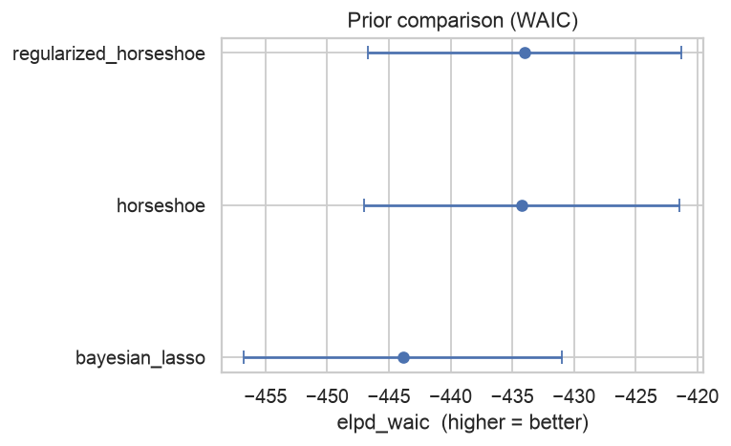
Figure 3. Prior-family comparison by WAIC (elpd_waic ± SE; higher is better) among the three original priors. The regularized horseshoe ranks first, the Bayesian lasso last.

4. Simulation of data
Evaluation follows a phased roadmap; only the data source changes, the harness and builders are constant. See docs/ROADMAP.md for the authoritative, continuously updated version of this plan.

4.1 Phase 0 — independent (iid) mock
- GReX drawn as independent standard-normal features; a sparse set of causal genes drives the trait.
- Purpose: wiring / smoke-test only. Limitation: genes are independent, so shrinkage methods look similar (there is no collinearity to exploit).

4.2 Phase 1 — TWAS-structured GReX simulator
A self-contained synthetic version of the twas_sim generative model (Wang et al., Bioinformatics 2023), corroborated by the TWAS power studies He (Genetic Epidemiology 2022) and Cao (PLoS Genetics 2021).
- One SNP array with AR(1) linkage disequilibrium (LD) between neighboring SNPs.
- Each gene takes a cis-window of SNPs; adjacent genes’ windows overlap — shared SNPs plus LD induce gene-gene correlation (the structure the iid mock lacks).
- Sparse cis-eQTL weights on part of each window; GReX_g = standardized (window · eQTL weights), with optional prediction noise for an imperfect eQTL model.
- Trait from a sparse causal-gene set, scaled to a target proportion of variance explained (PVE); gaussian or binomial. Ground-truth gene weights are returned.

4.3 Phase 1.5/1.6 — structured priors that USE the correlation (new, 2026-09-22)
simulate_twas.py was extended to expose each gene’s window/eQTL metadata in its meta output and gained true_grex_correlation — a closed-form (not simulated) population correlation matrix, validated against Monte Carlo, used as the “oracle” input for graph_horseshoe/graph_spike_slab. A new structure.py module adds estimate_gene_correlation (Ledoit-Wolf, works on any real GReX) and perturb_group (corrupts a group vector to test pathway-misspecification robustness).

4.4 Phase 2 — real local GReX + phenotype (planned)
- The controlled-access cohort’s multi-tissue GReX + phenotype, entered through io.load_dataset.
- Data policy is mock-local: develop and test on simulated data locally; run on real data in the governed cloud environment (code moves via Git, data never moves).
- Current models are single-tissue; the practical real-data workflow is to run each model independently per tissue and compare gene/PIP rankings across tissues (see Section 9 for the planned multi-tissue extension).

5. Results

5.1 Original results (2026-09-04): iid mock vs. TWAS-structured GReX
On the iid mock the two original arms are effectively tied (no correlation for shrinkage to exploit); the meaningful comparison appears on TWAS-simulated, correlated GReX.
Regime | Elastic net (partial R²) | Bayesian (partial R²) | Winner
p = 100 < n = 300 | 0.072 ± 0.050 | 0.056 ± 0.046 | Elastic net
p = 250 ≫ n = 180, sparse + strong | 0.321 ± 0.090 | 0.333 ± 0.075 | Bayesian (higher mean, lower variance, 3/5 folds)

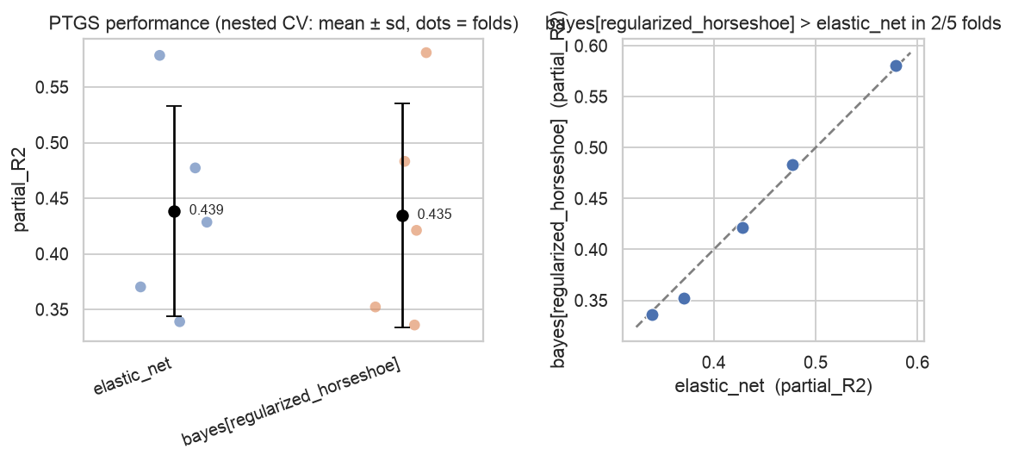
Figure 4. iid mock. Left: per-arm mean ± sd with fold dots. Right: per-fold elastic-net vs. Bayesian with a y=x line. The arms are comparable (~0.44 partial R²).

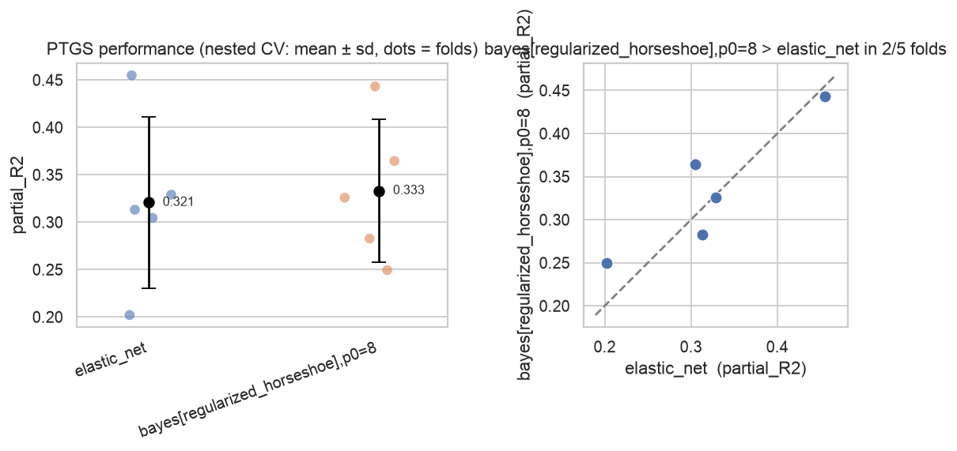
Figure 5. TWAS GReX, p ≫ n regime. The Bayesian (regularized-horseshoe) arm shows a higher mean and a tighter spread than elastic net, and wins 3 of 5 folds.

5.2 New results (2026-09-22): correlation-aware and pathway-informed priors
Notebooks 05 (graph_horseshoe) and 06 (group_horseshoe) were executed end-to-end at full scale (real NUTS sampling, same dimensions as the original notebook 01).
Prior / scenario | Mean partial R² | vs. regularized_horseshoe / elastic net
regularized_horseshoe (p=250,n=180) | 0.2473 | reference
graph_horseshoe, oracle correlation | 0.2442 | statistically indistinguishable
graph_horseshoe, estimated correlation | 0.2509 | statistically indistinguishable
elastic_net | 0.2427 | statistically indistinguishable
group_horseshoe, perfect pathway group (p=150,n=200) | 0.3244 | clear win vs. 0.2931 / 0.2771
group_horseshoe, corrupted group (40% dropped, 10% false) | 0.2985 | edge nearly vanishes vs. 0.2931

Interpretation: correlating the CONTINUOUS shrinkage geometry (graph_horseshoe) did not help — even with the oracle correlation matrix, results were within noise of plain regularized_horseshoe and elastic net, and the WAIC comparison agreed (within 1 standard error). Correlation estimation itself was accurate (Ledoit-Wolf RMSE=0.037 vs. the closed-form oracle), so this is not an estimation-quality artifact — the mechanism itself does not move the needle in this regime. By contrast, group_horseshoe — encoding WHICH genes share strength, not how they correlate — showed a clear, robust win that degraded gracefully (not catastrophically) as the group was corrupted. This asymmetry directly motivated the spike-and-slab priors in Section 3.4.3: correlation-awareness attached to an explicit selection mechanism should matter more than correlation-awareness attached to continuous shrinkage alone.

5.3 spike_slab / graph_spike_slab — integration-verified, not yet notebook-scale
Both new spike-and-slab priors were verified through a full nested_cv/run_benchmark integration run with real NUTS sampling (reduced dimensions/MCMC settings for speed) and confirmed to produce a finite, [0,1]-bounded posterior inclusion probability per gene that directionally recovers the true causal genes in a quick check. Unlike Sections 5.1–5.2, this is integration-level verification only — a dedicated, full-scale notebook demonstration (comparable to notebooks 05/06) has not yet been built; these are backend models prepared ahead of the planned real-GReX comparison (Section 9).

6. Consolidated key decisions

6.1 Analytical-model and evaluation decisions
Topic | Decision
Score features | Build the score on GReX (predicted expression), not directly on SNPs, following the PTRS reference.
Comparison design | Every builder runs on one shared nested-CV harness with identical folds — comparisons are always paired.
Bayesian engine | NumPyro (JAX); NUTS default, SVI as the scale escape hatch.
Default prior | regularized_horseshoe, chosen as the safest “no external info” Bayesian arm.
Correlation mechanism (2026-09-22) | Prefer NUTS-native continuous relaxations over a literal discrete/Ising mechanism throughout — correlated latent draws (graph_horseshoe/graph_spike_slab) and marginalized mixtures (spike_slab family), never a true discrete indicator or MRF pseudo-likelihood.
Discovery output (2026-09-22) | Only spike_slab/graph_spike_slab produce a genuine posterior inclusion probability; this is now the preferred family when the goal is gene-level attribution rather than pure prediction.
Cross-ancestry hierarchical shrinkage | Explicitly POSTPONED (2026-09-22, user decision) until the current correlation/discovery-focused objective is complete.
Cross-tissue joint modeling | Deferred (2026-09-22); current models run per-tissue independently. Will be reconsidered once the current objective is reached.

6.2 Simulation decisions
Topic | Decision
Phase 0 | iid mock — wiring/smoke only.
Phase 1 | TWAS simulator (twas_sim-style: AR(1) LD, overlapping cis-windows, sparse eQTL weights) is the meaningful comparison regime.
Oracle correlation | Computed in closed form from the simulator’s own window/eQTL metadata (exact, not Monte Carlo) — avoids RNG-stream reproducibility issues across differing simulation parameters.
Real correlation estimator | Ledoit-Wolf shrinkage (structure.estimate_gene_correlation) chosen for the p≫n regime; a sparse graphical-lasso alternative is identified but not yet built.
Phase 2 | Real local GReX + phenotype via io.load_dataset, developed locally and executed in the governed cloud environment.

6.3 Engineering / project decisions (brief)
- Two-layer package (installable ptgs_bc + numbered notebooks); folder c_ptgs_bc, repo/package ptgs_bc.
- Data policy mock-local; strengthened .gitignore so real GReX/genotypes/phenotypes can never be committed.
- Apache-2.0 license; GitHub over SSH (kimjhusa5803); released and tagged v0.1.0.
- New priors/tests verified via BOTH eager-mode unit tests AND at least one real NUTS integration run — a lesson learned 2026-09-22: two real bugs (a result-name collision, a JAX-tracing crash in a discrete-shape computation) only manifested under actual NUTS execution, not under eager-mode unit tests.

7. Clarifying questions asked and how they were resolved
Key decision points raised during development and their resolutions.
Question | Resolution
What does ‘BC’ mean? | Bayesian Computing (the approach), not a disease abbreviation.
Which Bayesian package? | NumPyro (recommended); PyMC fallback; Stan/brms as a correctness oracle.
Does gene-gene correlation matter for a novel PTGS method? | Not on its own — graph_horseshoe (2026-09-22) showed reshaping continuous shrinkage geometry via correlation is a null result even with the oracle matrix. It matters more when attached to a selection mechanism (spike-and-slab).
Should the correlation-aware spike-and-slab use a literal discrete/Ising mechanism? | No — NUTS cannot sample true discrete indicators and a literal Ising/MRF prior has an intractable normalizing constant; a continuous relaxation (correlated inclusion-probability logits) was used instead, reusing graph_horseshoe’s existing Cholesky mechanism.
Should cross-ancestry shrinkage be built now? | No — explicitly postponed by the user until the current correlation/discovery objective is complete.
Is this project's correlation work done once graph_horseshoe/group_horseshoe exist? | No — open items remain: distinguishing LD-artifact correlation from real biology, scaling past a dense p×p matrix at genome-wide gene counts, trying estimators other than Ledoit-Wolf, and blending GReX-based with knowledge-based (pathway/PPI) correlation into one input.

8. Potential weaknesses of the current results and models
- Bayesian arms remain preliminary: a single MCMC chain (no R-hat/ESS/divergence convergence check across chains), modest warmup/sample counts chosen for speed, and scoring uses only the posterior-mean point estimate (uncertainty is computed but mostly unused, except for the new pip output).
- The TWAS simulator is a synthetic approximation: AR(1) LD (not a real reference LD panel), continuous MVN ‘genotypes’ (not 0/1/2 dosages), and simplified expression heritability / eQTL prediction error; induced gene-gene correlation is local and modest.
- Comparison margins are small and often within one standard error, from a single seed and 3–5 outer folds — not yet statistically robust; no replication across seeds/scenarios or formal paired test.
- graph_horseshoe's null result may be regime-specific: only one correlation strength/window-overlap setting and one gene count were tested. It has not been ruled out for near-collinear predictors or much larger gene counts.
- Every correlation mechanism built so far treats all correlation identically — it does not distinguish LD/shared-eQTL-driven correlation (potentially a reference-panel artifact) from genuine co-regulation biology, unlike FOCUS/cTWAS-style fine-mapping.
- graph_horseshoe/graph_spike_slab use a dense p×p correlation matrix and a Cholesky factorization — this does not scale to real genome-wide gene counts (~10k+); a sparse/regional approach will be required for real data.
- Only one correlation estimator (Ledoit-Wolf) has been tried; it produces a dense estimate even though the true structure (shared cis-windows) is naturally sparse.
- Knowledge-based correlation (pathway/PPI) is not yet directly usable by graph_horseshoe/graph_spike_slab — their corr input must be a valid positive-semidefinite correlation matrix, and a raw pathway-membership adjacency matrix is not automatically PSD.
- GReX itself is treated as fixed/observed everywhere, by every builder including the four new priors (errors-in-variables is not yet modeled).
- The two spike-and-slab priors use a continuous relaxation, not a true discrete selection mechanism — a deliberate tractability trade-off, but the posterior inclusion probability it produces is therefore an approximation to, not identical to, a literal spike-and-slab's PIP.
- No ancestry/portability modeling yet — the central selling point of the PTRS reference is not exercised; explicitly postponed per the user's decision.
- All models remain single-tissue; multi-tissue joint modeling (needed to fully exploit having multi-tissue GReX) is deferred.
- Scale not yet demonstrated at realistic gene counts (~10k) for any of the seven priors — NUTS-vs-SVI feasibility, and the dense-correlation priors' tractability specifically, are both untested at that size.

9. Future suggestions
- Apply the full 7-prior library to the real, multi-tissue cohort GReX once provided: run per tissue, and compare group_horseshoe/spike_slab/graph_spike_slab gene rankings and PIPs across tissues for the GLP-1RA-vs-tirzepatide discovery question.
- Build a knowledge+GReX blended correlation utility for graph_horseshoe/graph_spike_slab — a convex combination of an empirical correlation estimate and a knowledge-derived (pathway/PPI) similarity kernel, re-projected to a valid correlation matrix.
- Propagate GReX estimation uncertainty (errors-in-variables). Candidate sources identified: the prediction model's own cross-validated R², cis-heritability (h²_cis) as a theoretical ceiling, the eQTL weight posterior if available, bootstrap of the reference training panel, cross-reference-panel disagreement, and reference-panel sample size per tissue. A cheap near-term step: use CV-R²/h²_cis as a per-gene prior-scale modifier before the full treatment is built.
- Add a sparse/regional correlation approach (graphical lasso, or per-locus fine-mapping in the style of FOCUS/cTWAS) so graph_horseshoe/graph_spike_slab can scale to real genome-wide gene counts.
- Distinguish LD/shared-eQTL-driven correlation from genuine co-regulation — borrow the FOCUS/cTWAS idea of modeling correlation explicitly as a confounder to control for, not just information to exploit.
- Validate spike_slab/graph_spike_slab at full notebook scale (comparable to notebooks 05/06), including a robustness check analogous to group_horseshoe's corrupted-group demonstration.
- Build multi-tissue Dataset support and a hierarchical tissue-selection prior, once the current correlation/discovery objective is complete (deferred per the user's explicit decision, 2026-09-22).
- Harden the Bayesian arms generally: multiple chains with R-hat/ESS/divergence gating, more draws, target_accept tuning; exploit posterior uncertainty beyond the point estimate (credible intervals; possibly stacking).
- Establish statistical robustness: replicate across seeds and scenarios, add a paired test (e.g., Wilcoxon over folds), and a power analysis grounded in the He/Cao references.
- Progress to Phase 2 (real local GReX) via the cloud-dev-workflow, and firm up io.load_dataset for the real, multi-tissue file formats.
- Cross-ancestry hierarchical shrinkage: postponed — revisit only once the current objective is complete, per the user's explicit instruction.

10. Appendix — environment and repository
- Package: ptgs_bc v0.1.0 (installable; src layout, version unchanged by the 2026-09-22 additions). Repo: github.com/kimjhusa5803/ptgs_bc (private, SSH), tag v0.1.0.
- Structure: src/ptgs_bc/ (io, simulate, simulate_twas, structure [new], cv, score, metrics, builders/{elastic_net,bayes}, priors [7 registered], tuning, benchmark, viz, results, cli) + notebooks/ 01–06 + scripts/ + tests/.
- Status (2026-09-22): 32 fast tests pass (up from 17); notebooks 01–06 run end-to-end on mock/TWAS data at full scale; spike_slab/graph_spike_slab verified via integration run only (no dedicated notebook yet); NumPyro/JAX + seaborn + scikit-learn (Ledoit-Wolf) in the dev environment.
- Docs: README, docs/ROADMAP.md (phased plan + ‘use both’ strategy, kept current as of 2026-09-22), docs/Model_Selection_Guide_2026-09-22.docx (per-model real-GReX use-case guide).

