COMP-3721 Assignment #2

Name: Jihyo Kim

Student ID: A01017545

Set: 3M

(1) [8 marks] Draw the following line coding schemes, as defined in Forouzan, B.A., Data Communications and Networking, 5th Ed. New York, NY: McGraw-Hill, 2013, for the 16-bit data stream 1001110001101110. Use +V for the positive voltage, -V for the negative voltage. If applicable, assume that the previous data bit transmitted prior to this 16-bit data stream was 0 at +V.

a) [2 marks] Polar NRZ-L  
b) [2 marks] Polar NRZ-I  
c) [2 marks] Polar biphase Differential Manchester d) [2 marks] Bipolar Pseudoternary

(2) [10 marks] Suppose the following composite analog signal has a bandwidth of 240 kHz and is sampled for digital transmission using Pulse Code Modulation (PCM).

𝑠(𝑡) = sin(2𝜋𝑓𝑡) + 1/3 sin(6𝜋𝑓𝑡) + 0.2 sin(10𝜋𝑓𝑡)

a) [4 marks] Determine the minimum sampling rate required such that the original analog signal can be accurately reproduced.

b) [1 mark] If 16 uniform levels are used to quantize each sample obtained in (a), determine the data rate, in bps, of the PCM signal.

c) [2 marks] Determine the SNR required, in dB, if the PCM signal obtained in (b) is to be transmitted over a noisy channel with a bandwidth of 0.5 MHz.

d) [3 marks] Assuming all other factors remain the same, determine the SNR increase required, in dB, to allow the doubling of the PCM signal data rate obtained in (b).

(3) [16 marks] Quadrature amplitude modulation (QAM) is a modulation technique that transmits data by changing the amplitude of two carrier signals that are 90° out-of-phase with each other. Consider the following 8-QAM modulation scheme defined by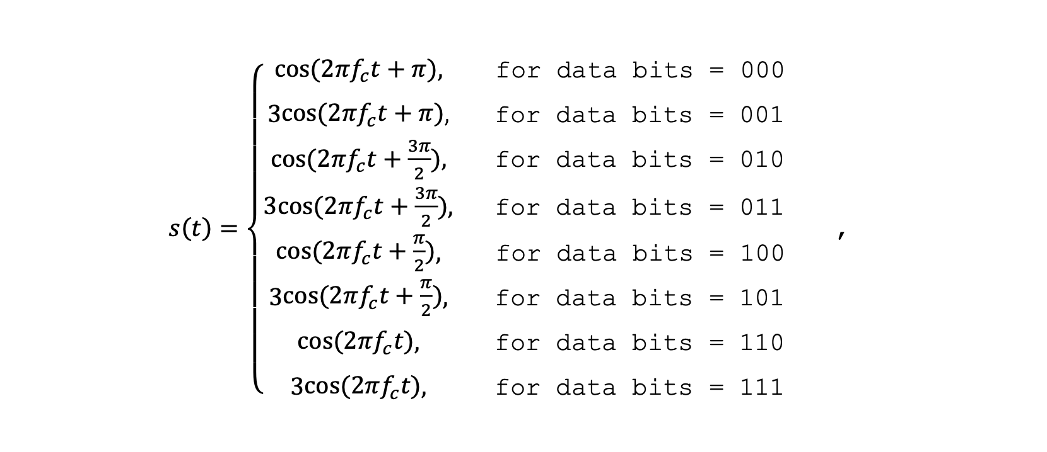

where 𝑓𝑐 is the carrier frequency. Assume 𝑓𝑐 = 8 Hz and the baud rate = 4 symbols/s.

a)  [9 marks] Complete the following signal  
for this modulation scheme. Label the axes and for each symbol, indicate the associated data bits.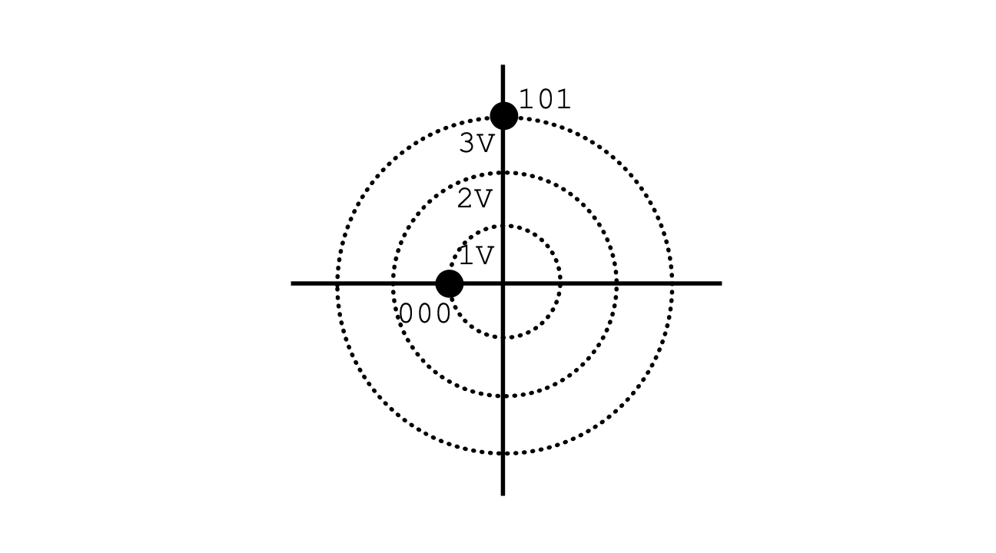   
b)  [1 mark] Determine the period of the carrier signal.   
c)  [1 mark] Determine the symbol duration.   
d)  [4 marks] Plot the modulated signal for the data stream   
101110000111. Clearly indicate the beginning and the end of   
each symbol and the associated data bits in the plot.   
e)  [1 mark] Determine the bit rate of the modulated signal.

(4) [6 marks] Consider the following analog signal, 𝑠(𝑡), with minimum  
and maximum amplitudes of -8 V and +8 V, respectively. The signal, 𝑠(𝑡), is sampled for digital transmission using Pulse Code  
Modulation (PCM) with a sampling rate of 400 samples/s and

8 uniform quantization levels.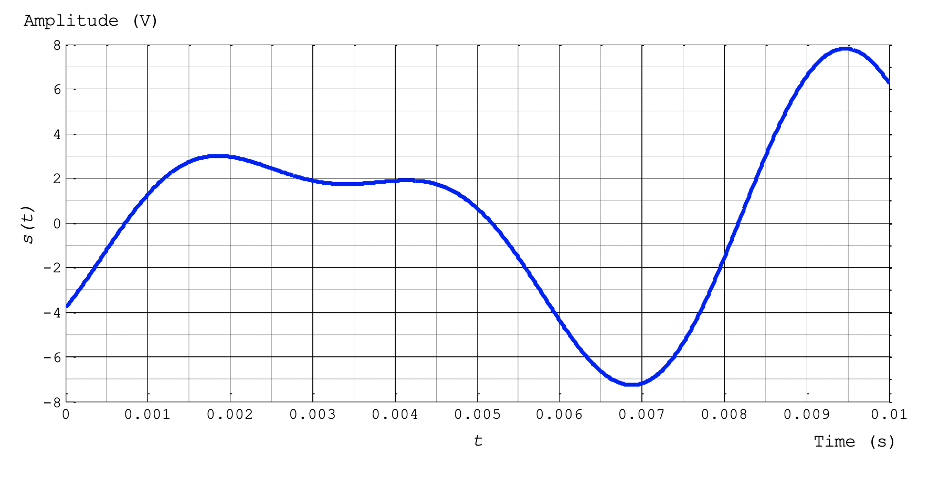

Assuming that the first sample is taken at 0.001 s, determine both the quantization codes and the resulting encoded words of the PCM signal for 𝑡 = [0, 0.01] s.