Name Jihyo Kim

Student #: A01017545

Set: 3M

**Homework 2 – Continuous Probability Distributions  
Due: Monday, March 23, at beginning of lecture as a hard copy and in Learning Hub**

In this assignment, you are going to write some functions that model a company that serves customers who wait in line to be served. In this model, customers arrive randomly, and the time between arrivals is given by an exponential random variable. A single employee works behind the counter. When a customer arrives, the customer joins the line, and is served as soon as the employee is available. (If there is no one waiting in line when the customer arrives, the customer can be served right away.) The time it takes for the employee to serve a customer is given by an exponential random variable. You will be using the **rexp** command from Lab 8.

**Deliverables: put all of your functions in a single .R file and submit this file to the Homework 2 assignment folder in the lab section of Learning Hub. During lecture, submit a hard copy of all of your answers, labelled and in order. If a question required you to write code and produce output, include both as part of your answer to the question.**

1. Write a function **serviceTimes(m, serviceRate)** that simulates the amount of time required to serve each of **m** customers, where customers’ service times are given by an exponential random variable with a mean of **serviceRate** customers per minute. Your function should display **m** waiting times in a column. Here is sample output for **m=10**, se**rviceRate=2**:

> serviceTimes(10,2)

serviceTimes

[1,] 1.15307378

[2,] 1.45776391

[3,] 0.24764138

[4,] 0.03504833

[5,] 0.79514273

[6,] 0.71050671

[7,] 0.04377933

[8,] 0.24973909

[9,] 0.58719730

[10,] 0.27182870

This output tells us that it took 1.15307378 minutes for the employee to serve the first customer, 1.45776391 minutes for the employee to serve the second customer, and so on.

Give your code as well as five outputs, in the format above, for **m=10**, **serviceRate=0.5**.

serviceTimes = function(m, serviceRate) {

serviceTimes = rexp(m, serviceRate)

return(cbind(serviceTimes))

}

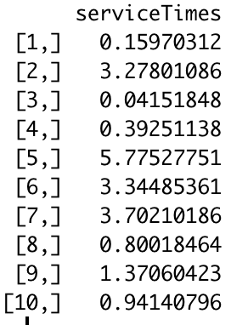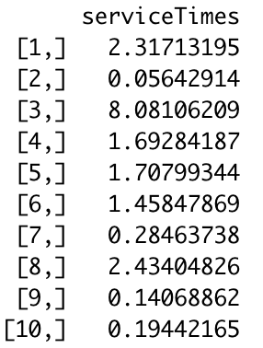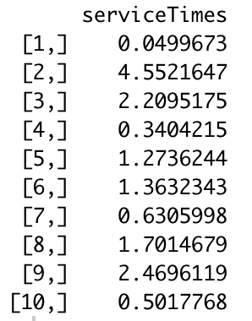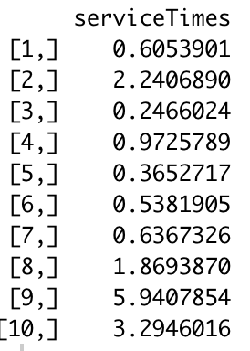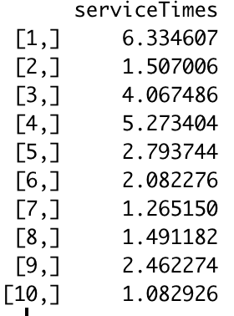

1. Write a function **arrivalTimes(m, arrivalRate)** that simulates the times at which each of **m** customers arrives, in which the times between customer arrivals are given by an exponential random variable with a mean of **arrivalRate** customers per minute. Your function should display **m** arrival times in a column. Here is sample output for **m=6**, **arrivalRate=2**:

> arrivalTimes(8,2)

arrivalTimes

[1,] 0.04288892

[2,] 0.54436434

[3,] 1.33194177

[4,] 1.50225896

[5,] 1.84386065

[6,] 2.11011307

This output tells us that the first customer arrived 0.04288892 minutes after the simulation began; the second customer arrived 0.54436434 minutes after the simulation began, and so on.

Give your code as well as five outputs, in the format above, for **m=10**, **arrivalRate=0.5**.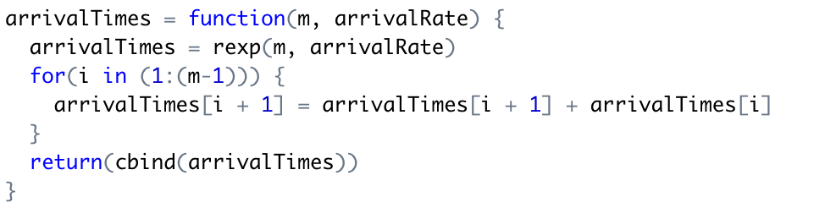

|  |  |  |
| --- | --- | --- |
|  |  |  |
|  |  |  |

1. Write a function **waitTimes(m,arrivalRate, serviceRate)** that simulates the above scenario for **m** customers. Your function should return a table with **m** rows (one per customer) and 4 columns representing the customer’s arrival time, the waiting time, the service time, and the leaving time. Here is sample output for **m=10**, **arrivalRate=2, serviceRate=2**:

> waitTimes(10,2,2)

arrivalTimes waitingTimes serviceTimes leavingTimes

[1,] 1.189972 0.0000000 0.32533094 1.515303

[2,] 1.673284 0.0000000 0.18265110 1.855935

[3,] 2.704157 0.0000000 0.77071556 3.474873

[4,] 3.285888 0.1889851 0.66268414 4.137557

[5,] 3.374407 0.7631502 0.07007636 4.207633

[6,] 3.424170 0.7834631 2.36004076 6.567674

[7,] 3.650064 2.9176095 0.03032166 6.597996

[8,] 3.960727 2.6372685 0.71567576 7.313671

[9,] 4.163052 3.1506189 0.71615614 8.029827

[10,] 4.630638 3.3991892 0.90227294 8.932100

This output tells us that our first customer arrived 1.189972 minutes after the simulation began. There was no one waiting when our first customer arrived, so they didn’t have to wait at all (waiting time was 0.000000 minutes) and were served right away. It took the employee 0.32533094 minutes to serve this customer, and the customer left 1.515303 minutes after the simulation began.

Give your code as well as five outputs, in the format above, for **m=10**, **arrivalRate=0.4**, **serviceRate=0.5**.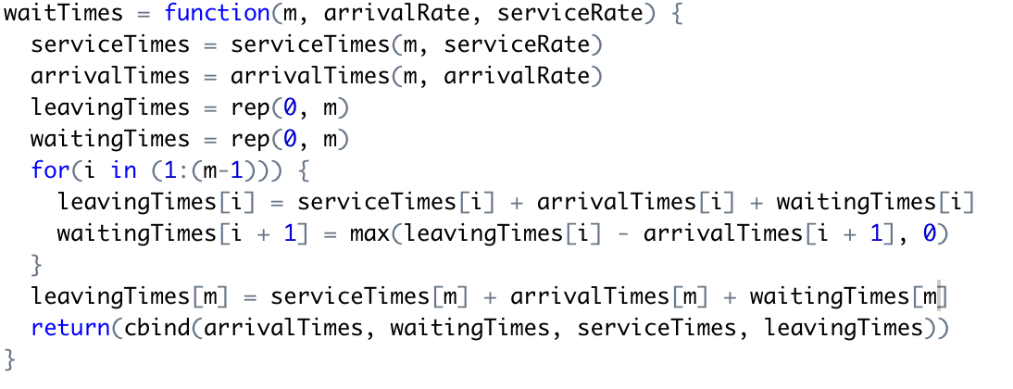

|  |  |  |
| --- | --- | --- |
|  |  |  |
|  |  |  |

1. Now we will simulate **n** such scenarios, and we will also keep track of how often some customers have to wait a long time to be served.

Write a function **simulateWaits(m, arrivalRate, serviceRate, n, maxWait)** that simulates **waitTimes(m, arrivalRate, serviceRate) n** times, and returns the proportion of the time that at least one of the **m** customers had to wait longer than **maxWait**.

Here is sample output for **m=10**, **arrivalRate=2, serviceRate=2,** **n=100000**, **maxWait=5**:

> simulateWaits(10,2,2,100000,5)

[1] 0.01859

This tells us that when ten customers both arrive and are served at the rate of 2 per minute, then 1.859% of the time, at least one will have to wait more than 5 minutes.

Give your code as well as your output for **m=20**, **n=100000**, **maxWait=20,** and values of **arrivalRate** and **serviceRate** given in the table below. Complete the table and submit it as part of the answer to this question.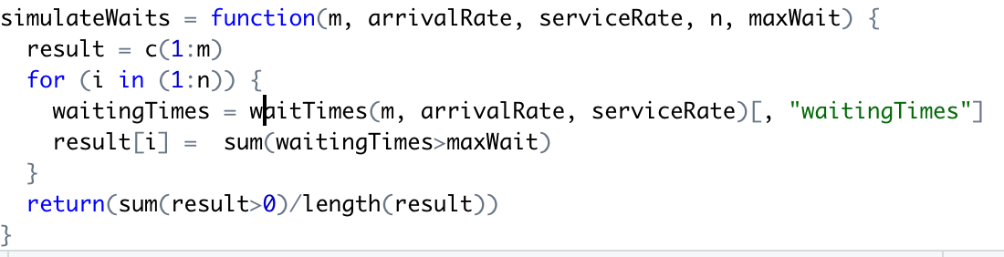

|  |  |  |  |
| --- | --- | --- | --- |
| **arrivalRate\serviceRate** | **0.3** | **0.5** | **0.6** |
| **0.2** | 0.18917 | 0.00521 | 0.00077 |
| **0.4** | 0.60202 | 0.05732 | 0.01148 |
| **0.6** | 0.84375 | 0.19088 | 0.05503 |
| **0.8** | 0.93685 | 0.35754 | 0.13877 |

1. One of the decisions every small business must make is how many staff to hire. Businesses want to hire enough people to function properly, but not so many that they don’t have enough work to keep their staff busy. In the case of a business that serves customers, the business doesn’t want customers waiting too long for service – but at the same time, it doesn’t want employees sitting around with nothing to do. And if all or most customers are served quickly, it’s likely that staff have too much down time.
   1. Which of the businesses in Question 4 should give their counter staff additional work to do? Give the arrival and service rates of at least one such business, and justify your recommendation. A business that should give their employees additional work is the one with arrival rate of 0.2 and service rate of 0.6. The simulation shows that customers of the business don’t have to wait long to be served. This is likely to mean that the business has a small number of customers, or the employees don’t have much work to do except for serving customers. Therefore, the business should give their employees extra work.
   2. Consumer research has found that if customers have to wait more than 20 minutes for service, they are likely to take their business elsewhere (as well as tell people about the terrible service they got). Which of the businesses in Question 4 should hire additional staff? Give the arrival and service rates of at least one such business, and justify your recommendation. The businesses should hire more staffs are ones with arrival rate of 0.8 and 0.6 and service rate of 0.3. The simulation shows that more than 80 percents of customers of the two businesses had to wait more than 20 minutes. Therefore, they should hire more staffs to serve their customers faster.

**To submit: answers to all questions, as a hard copy. Be sure to include your full name, your A0 number, and your set letter on the front page of your assignment. In addition, please submit your .R script in the Homework 2 folder in Learning Hub.**