Name: Jihyo Kim

Student Number: A01017545

Set: 3M

**1-a.** 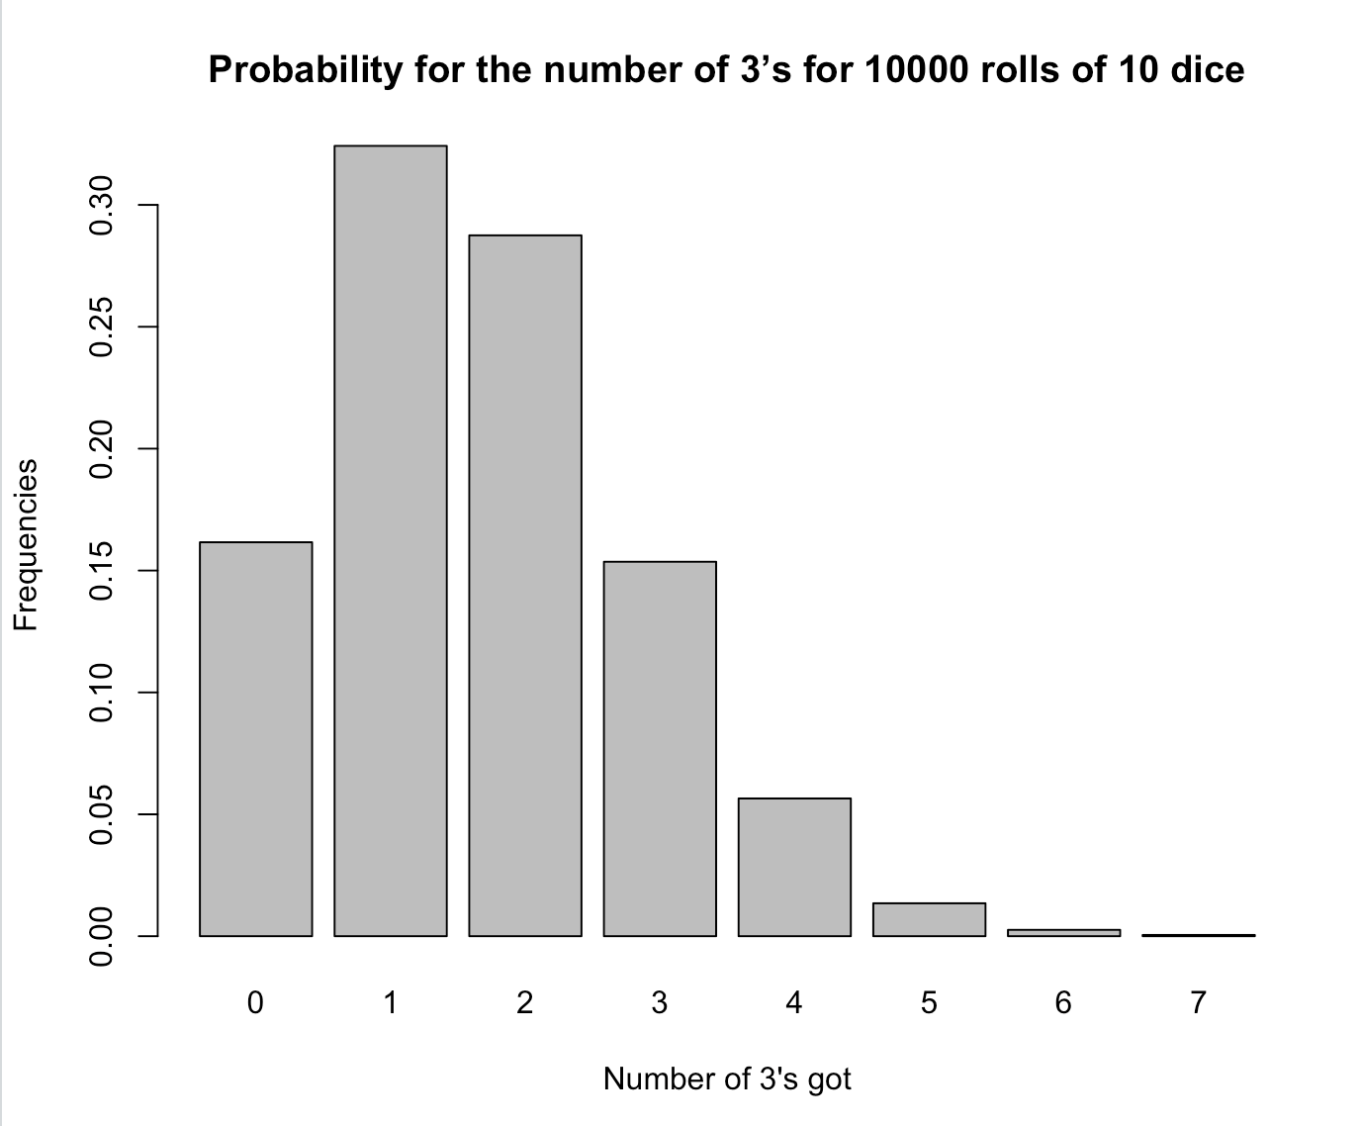

**1-b.**



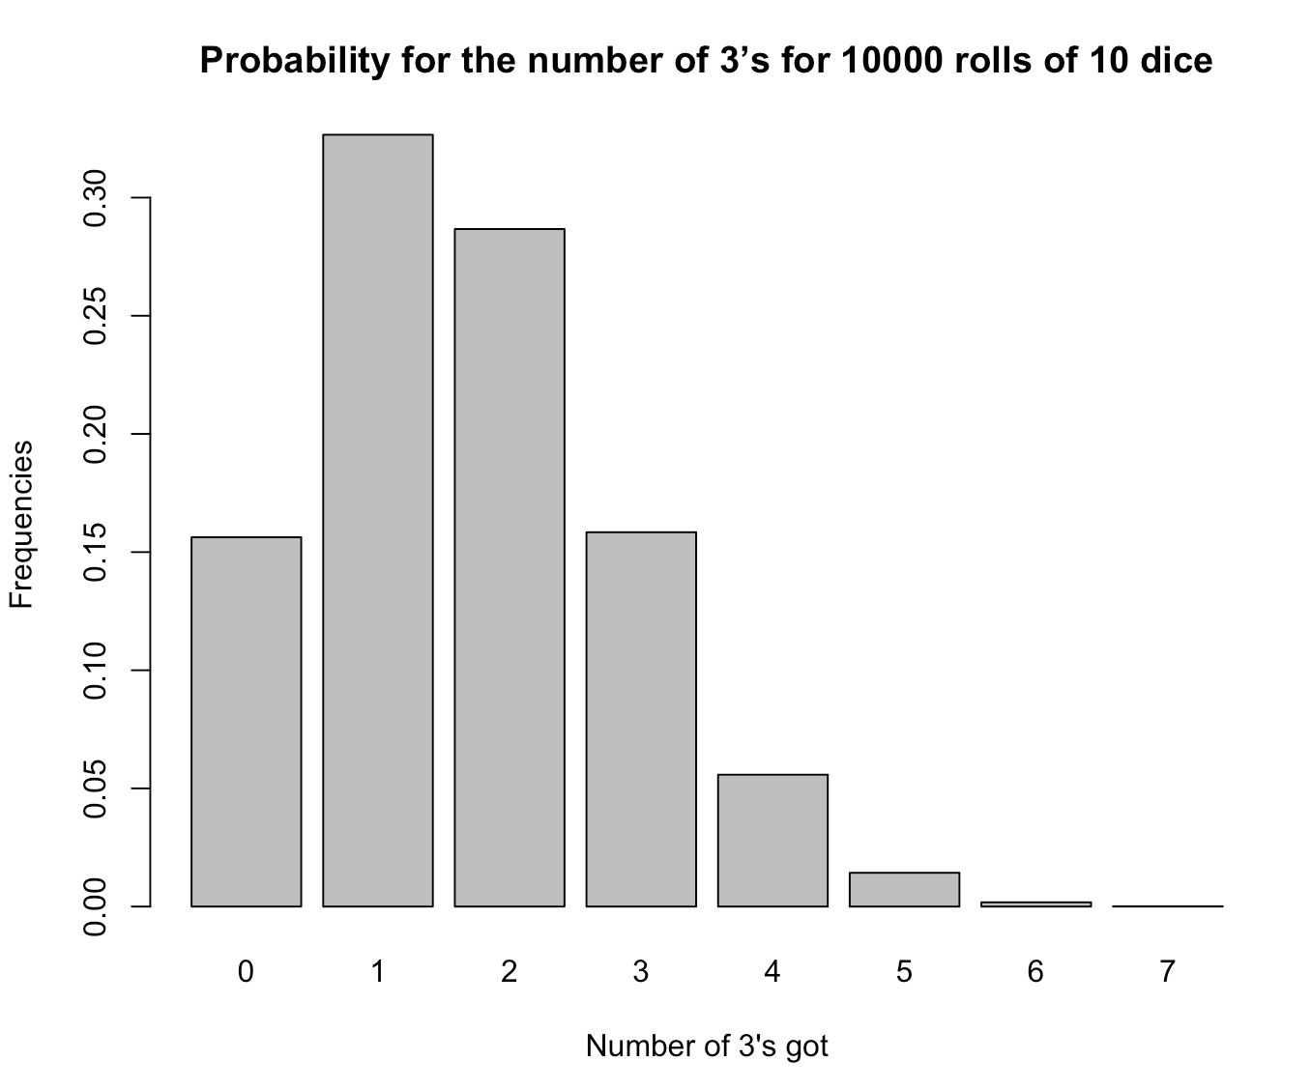

**2.**

The both bar graphs are very similar as well as the values.

**3-a.**

dbinom(100, 300, 1/3)

**3-b.**

pbinom(100, 300, 1/3)

**3-c.**

pbinom(99, 300, 1/3)

**3-d.**

1 - pbinom(109, 300, 1/3)

**3-e.**

pbinom(110, 300, 1/3) - pbinom(89, 300, 1/3)

**4.**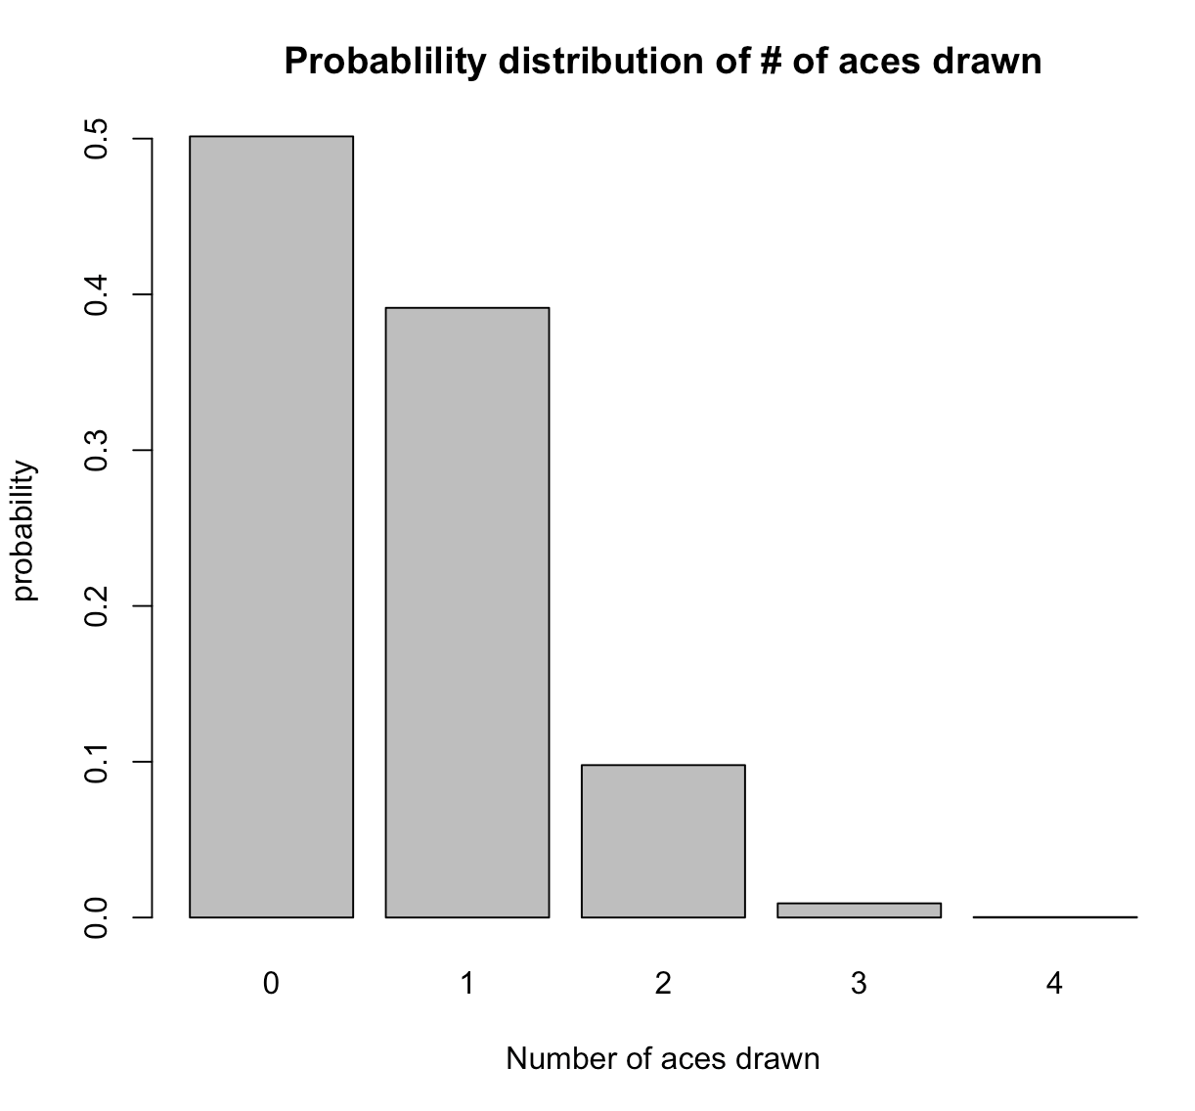



**5-a.**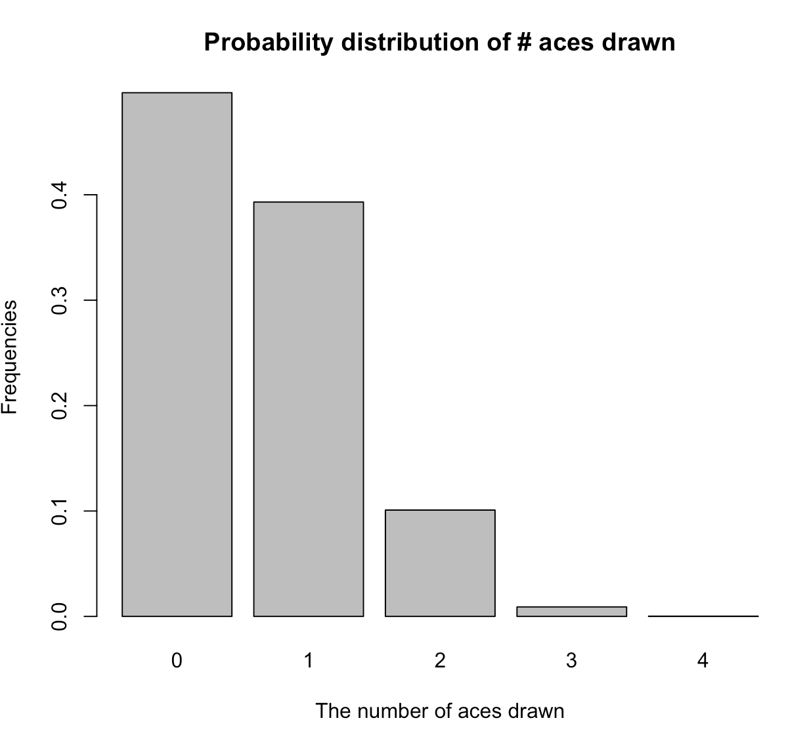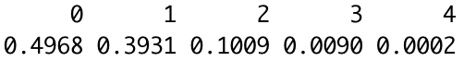

**5-b.**

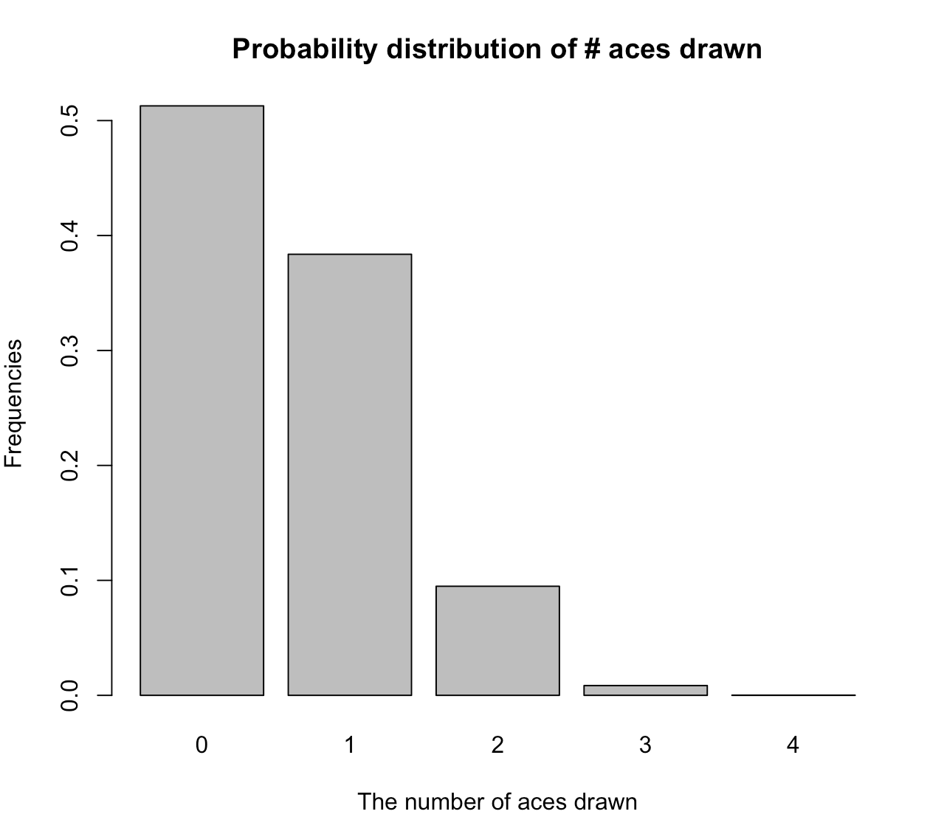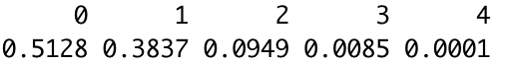

**6.**

1. and (b) both yield the very similar results.

**7-a**

dhyper(100, 333, 666, 300)

**7-b**

phyper(100, 333, 666, 300)

**7-c**

phyper(99, 333, 666, 300)

**7-d**

1 - phyper(109, 333, 666, 300)

**7-e**

phyper(110, 333, 666, 300) - phyper(89, 333, 666, 300)

**8.**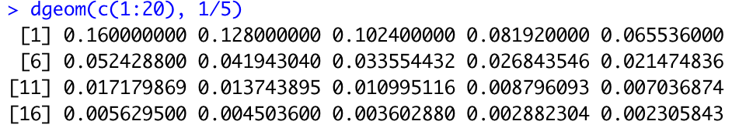

**9-a, 9-b**

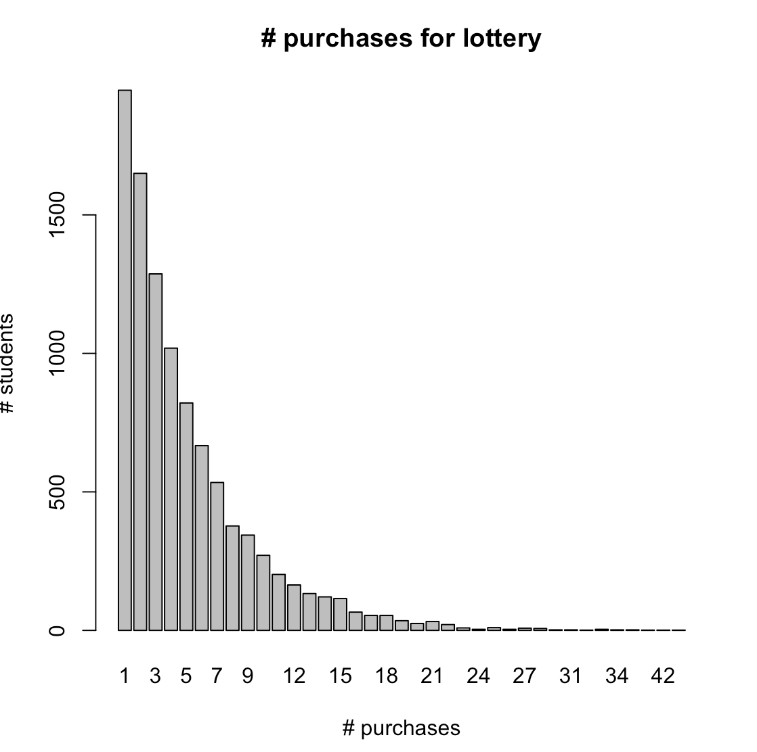

**10.**

(a) and (b) both yield very similar results.

**11-a.**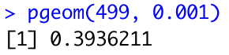

**11-b.**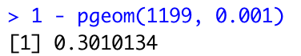

**1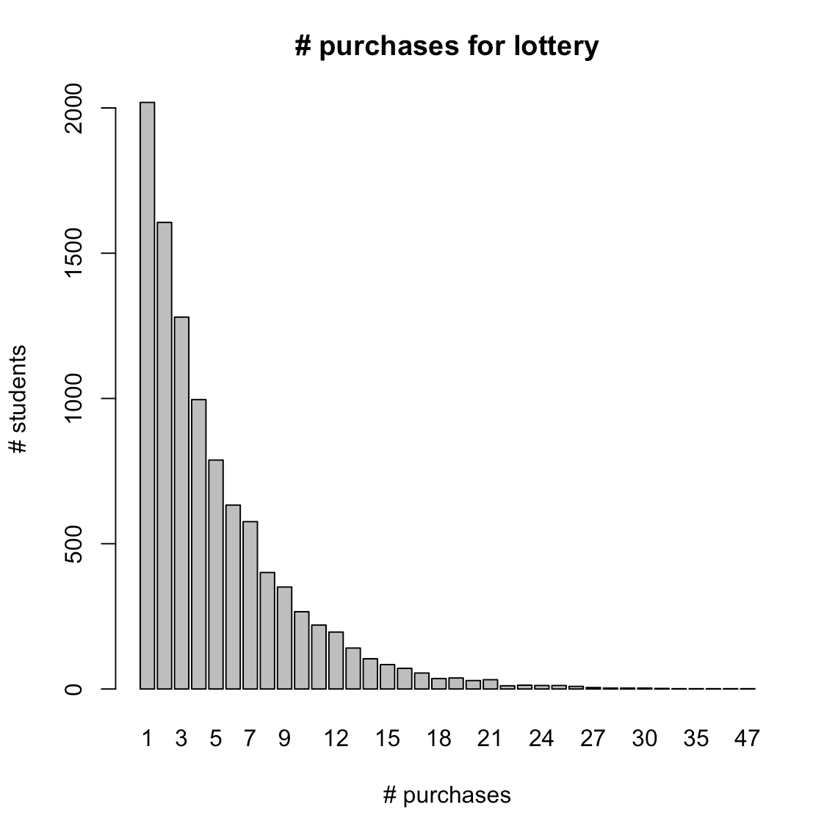1-c.**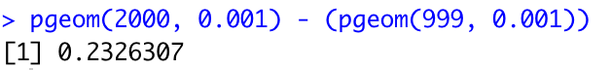

**12.**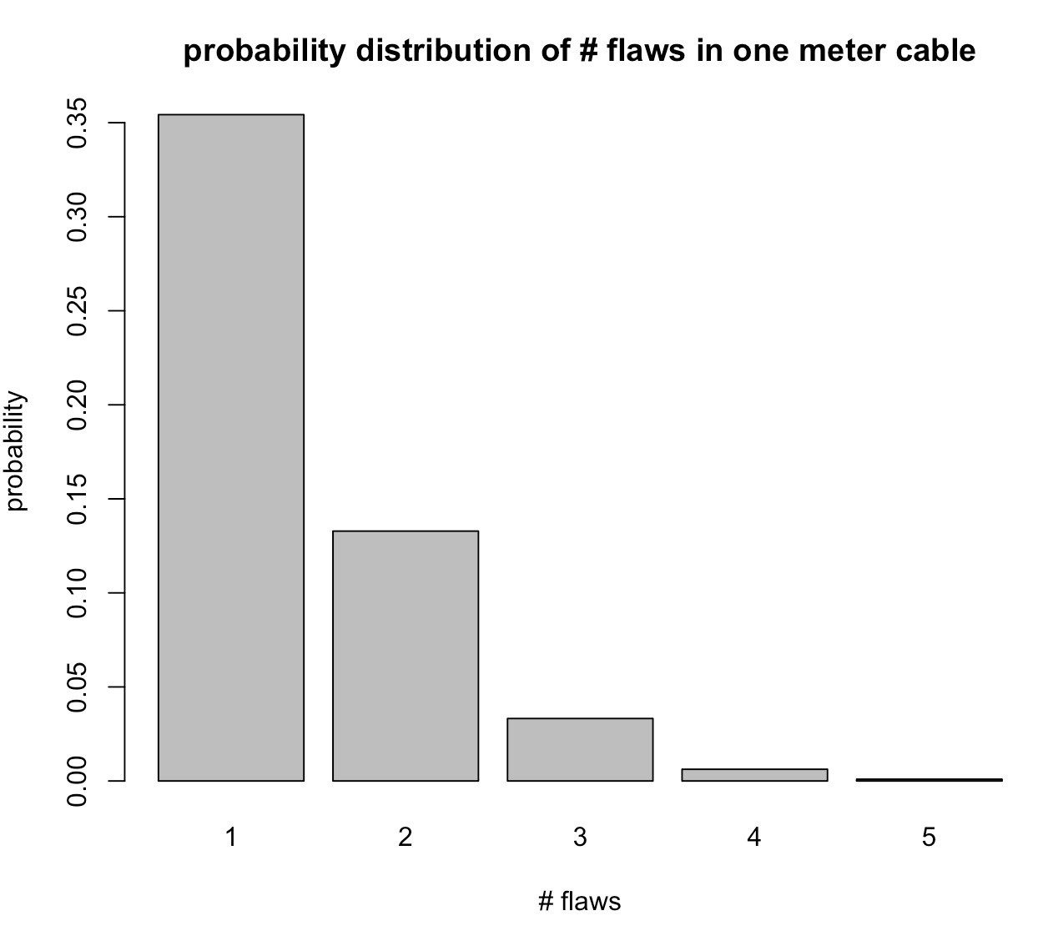

**13.**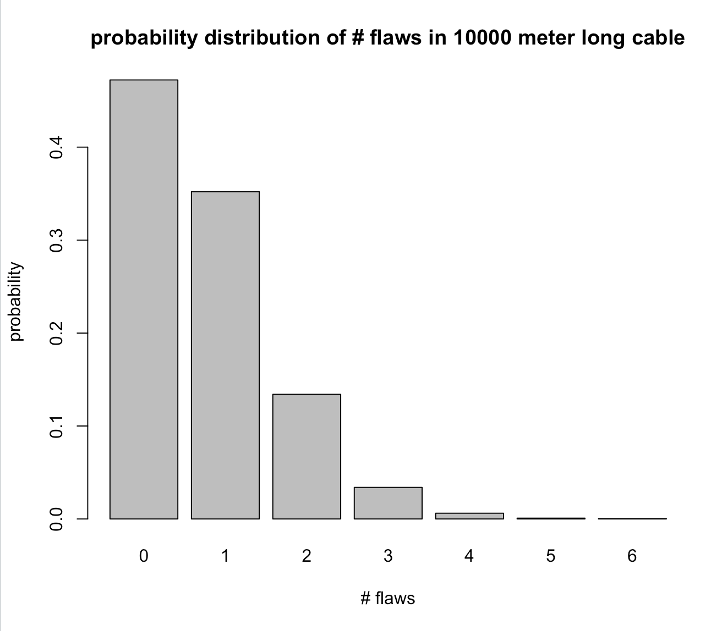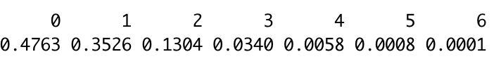

**14.**

Both yield similar results

**15-a.**

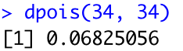

**15-b.**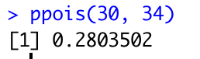

**15-c.**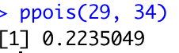

**15-d.**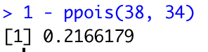

**15-e.**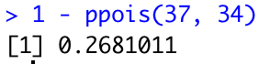

**15-f.**

**15-g.**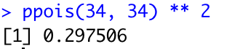

**15-h.**