1.

mean (m=1): 3.4785

sd (m=1) : 0.5331529

mean (m=2): 3.4785

sd (m=2) : 0.5331529

mean (m=10): 3.50509

sd (m=10) : 0.5455042

mean (m=50): 3.499644

sd (m=50) : 0.239115

mean (m=100): 3.498774

sd (m=100) : 0.17135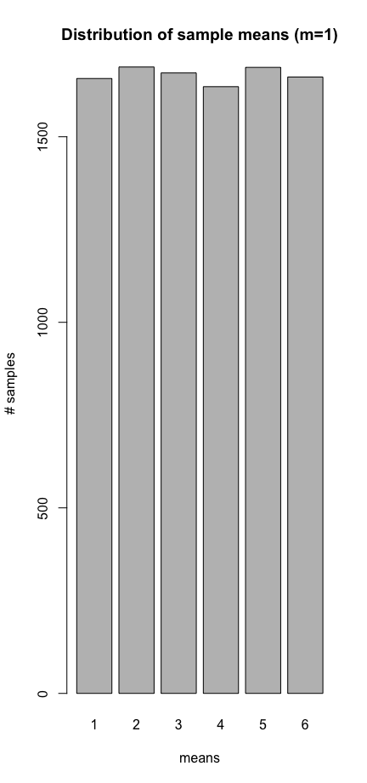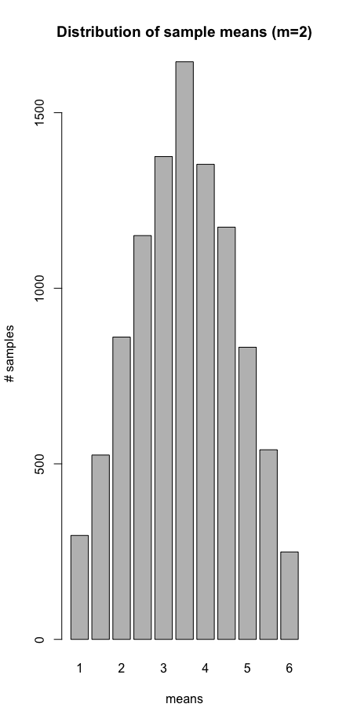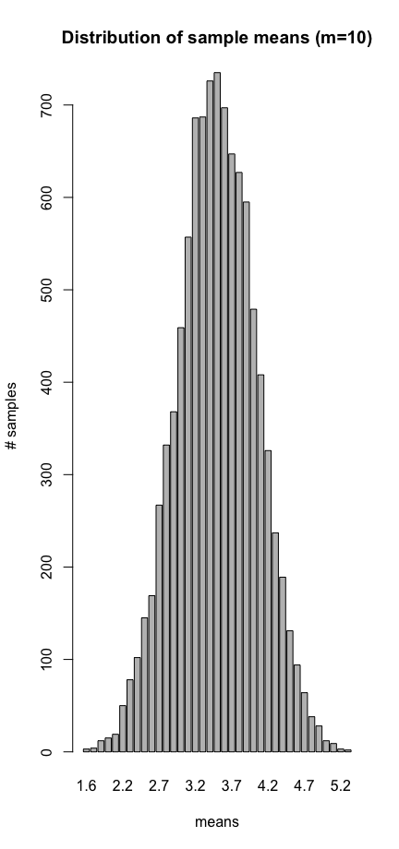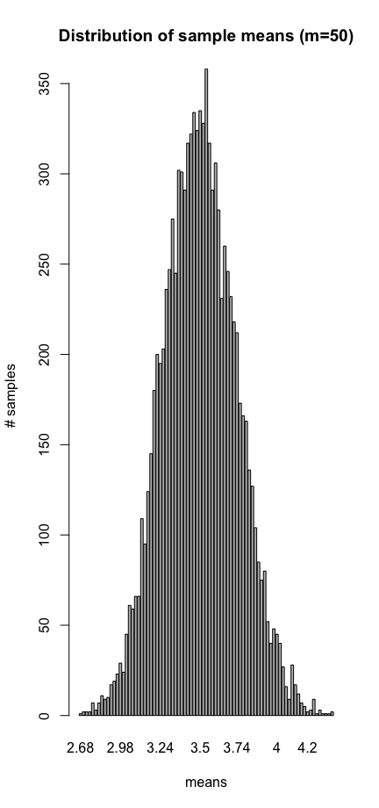

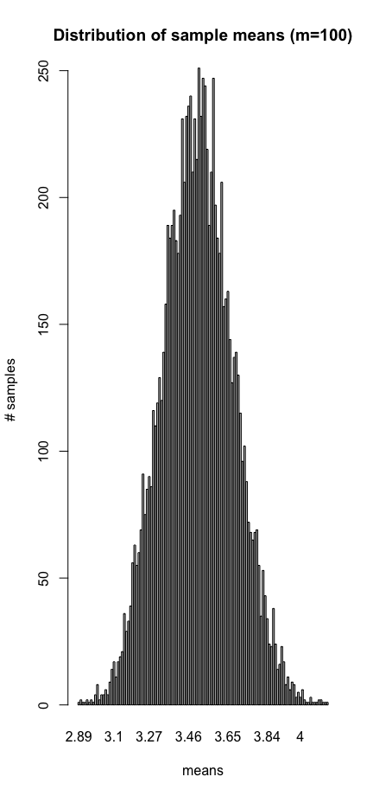

Observation: As ‘m’ increases, the standard deviation decreases, and the means get more clustered towards centre.

2.

The distributions look uniform. As ’n’ goes up the distribution gets more uniform

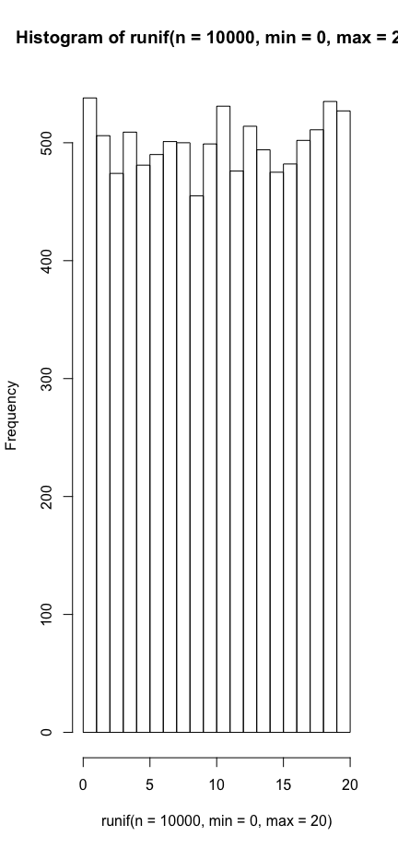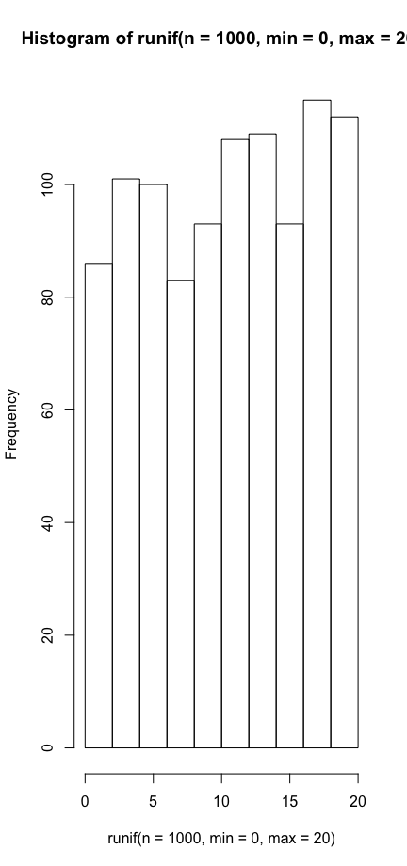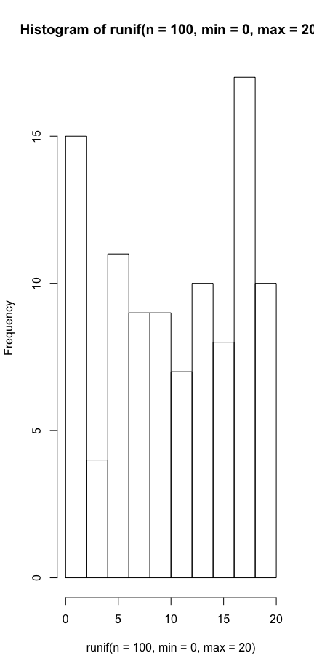

3.

sum(runif(n=10000, min=0, max=20) < 10) / 1000 => 0.5029

Around 50% of the people waited less than 10 minutes. The answer makes sense as 10 minutes is a half of 20 minutes and the distributions are almost uniform.

4.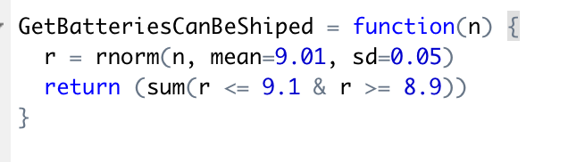

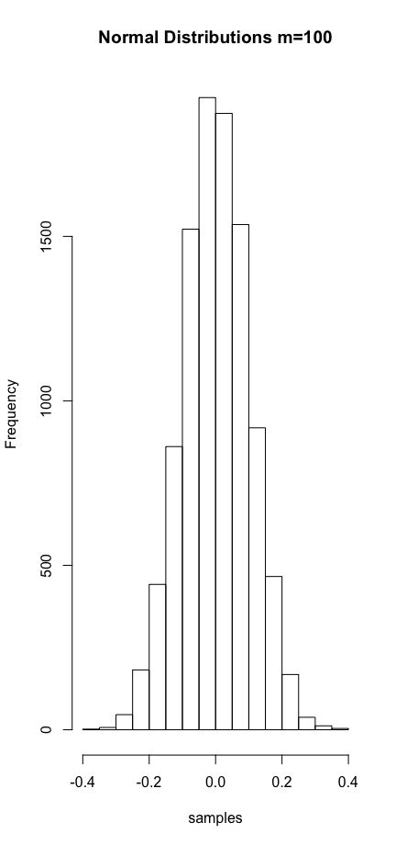

n=100, 93

n=1000, 951

n=10000, 9551

5.

m=1)

mean: -0.025236

sd: 1.0064

m=2)

mean: 0.020857

sd: 0.71485

m=10)

mean: -0.0013373

sd: 0.31816

m=50)

mean: 0.00078631

sd: 0.14251

m=100)

mean: 0.00078242

sd: 0.099916