1. Give the command that creates a dataset called fast runners consisting of runners who completed the race in under 4000 seconds. Hint: your command should be of the form
2. fastrunners = filter(TenMilesRace, time < 4000)

2. Give the commands you use to create the following filtered datasets

1. The female runners: femalerunners = filter(TenMileRace, sex == “F”)
2. The foreign runners: foreignrunners = filter(TenMileRace, stri_length(state) > 2)

3. Now give the commands to create a breakdown of the runners by state.

1. table(TenMileRace$state)

4. Give the R command or commands that find the number of male runners who finished the race in less time than the fastest female runner. Provide the output of your command(s) as well. Your command(s) should not require have any numbers as inputs - all arguments should be variables.

* maleRunners = filter(TenMileRace, sex == “M”)
* fastestFemaleRunnerTime = min(femalerunners$time)
* filter(maleRunners, time < fastestFemaleRunnerTime)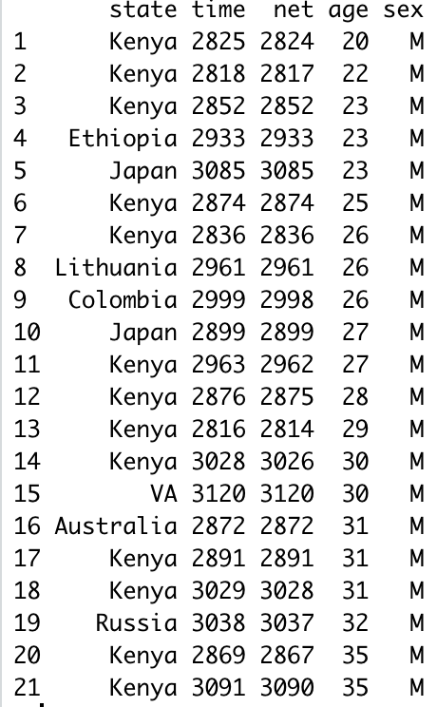

5. Create a series of commands that vies the range of “typical” runners. Include the output. As before, your command(s) should not require have any numbers (except 0.05 and 1) as inputs. all arguments should be variables. Create a histogram of these typical runners, and include your histogram in your file ( You can save your histogram by selecting Export -> save as image.)

a.

* racetimes = sort(racetimes)
* Top5 = quantile(racetimes, 0.05)
* Bottom5 = quantile(racetimes, 1 - 0.05)
* typicalRaceTimes = filter(TenMileRace, time > top5 && time < bottom5)
* hist(typicalRaceTimes$time)