Name Jihyo Kim, Set: 3M

Student Number: A01017545

1. Read over the documentation for the pie command and create the following pie chart. Copy the pie chart into a Word document and include the command you used to produce it.

percents<-c(10,30,5,35,20)

homeType<-c("on campus", "with parents", "alone", "with roommates", "with spouse”)

colors <- c("red", "yellow", "green", "cyan", “blue")

pie(percents,homeType,colors)

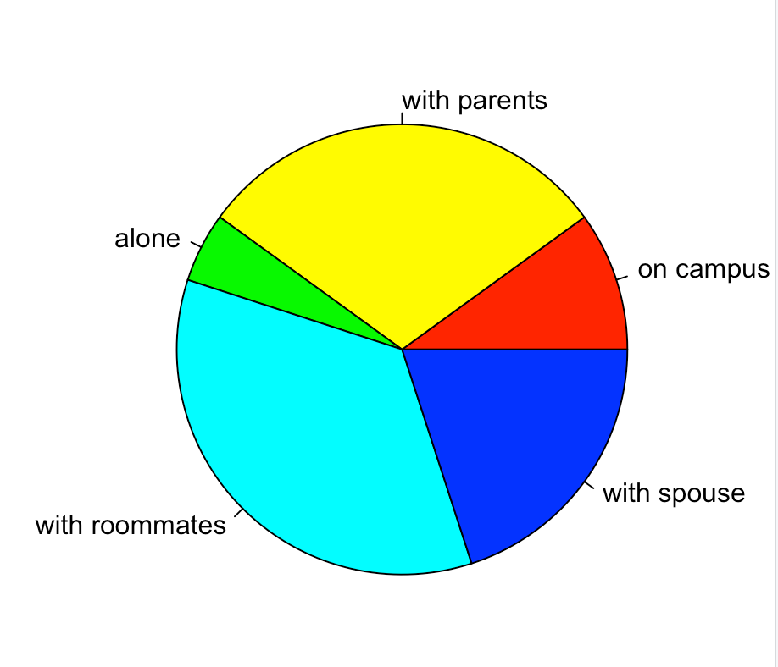

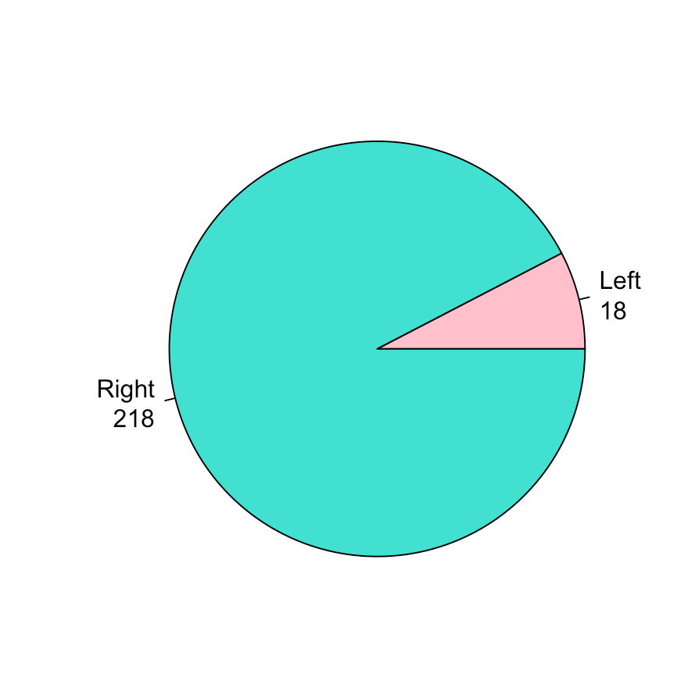

2. Create the following pie chart. Include the command you used. (Hint; the colours include are pink and turquoise.) Save the pie chart using the Export command above your chart. Copy the pie chart into a Word document and include the command you used to produce it.

hands<-survey$W.Hnd

tab<-able(hands)

lbls <-paste(rownames(tab), sep=“\n”, tab)

pie(tab, lbls, col=c("pink", "turquoise"))

3. Read the documentation for the barplot() command and produce the following barplot

barplot(tab), barplot(tab, horiz=TRUE)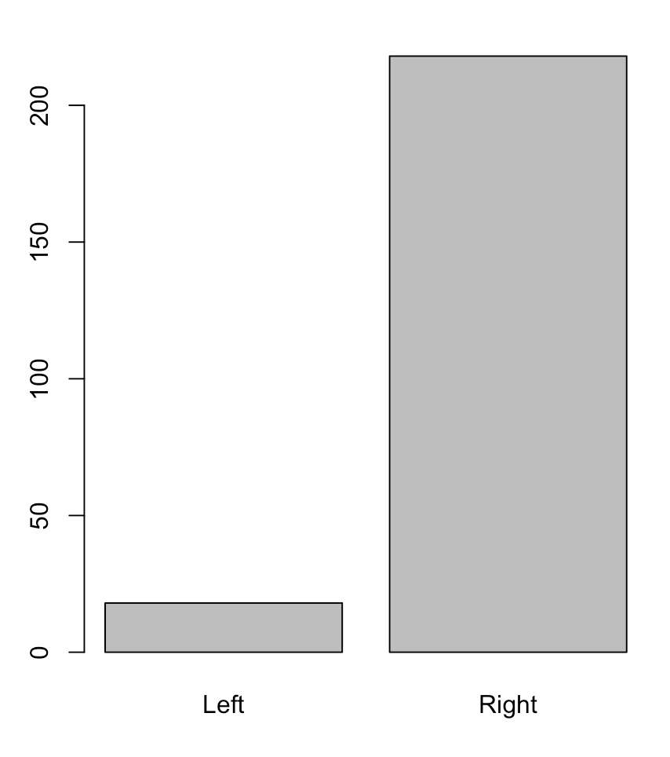

4. Give the command you used to produce the following stem plot

stem(surv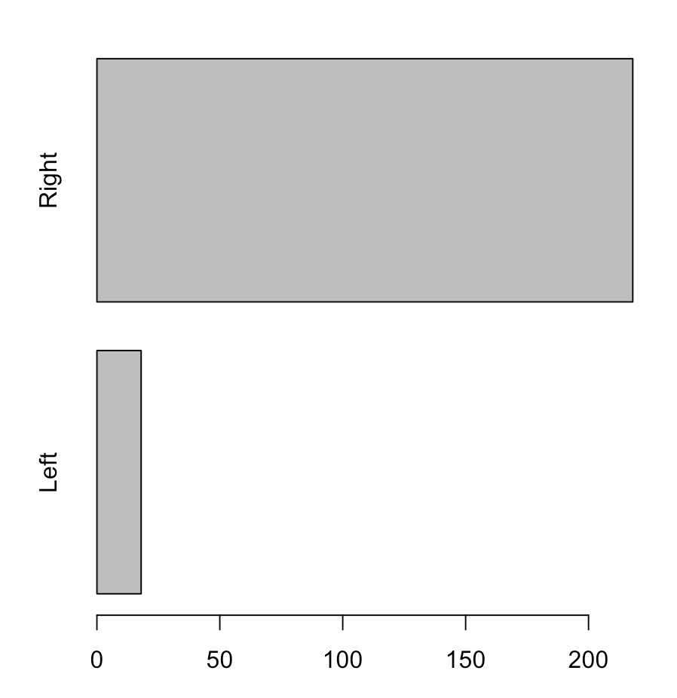ey$Height, scale=2)

5. Based on the back-to-back stem plots for men’s and women’s heights, what is one difference between the datasets that is immediately apparent? Explain, making reference to the plot

The one difference between the datasets is that mens are generally taller than women. For example, the tallest women in the dataset is 180cm, whereas 180cm is the most common height among men, and there are even some men taller than 180cm

6. Using the survey data, create two frequency tables for students ages; one for male students and one for female students. Choose a reasonable number of bins, and use the same bins for both groups. Include the tables as well as the commands you used to create them. Based on your tables. does it look lie the distribution of ages differs significantly be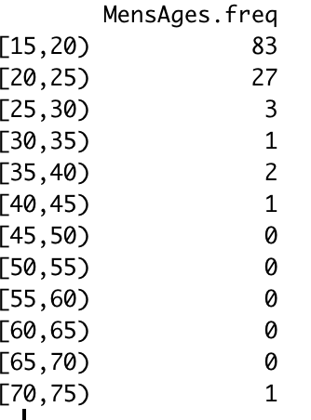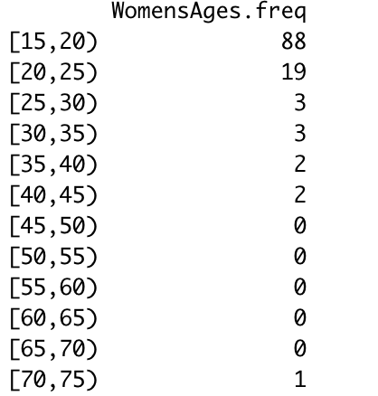tween male and female students? Explain

Commands

MensAges = males$Age

WomensAges = females$Age

breaks = seq(15, 75, by = 5)

MensAges.cut = cut(MensAges, breaks, right=FALSE)

MensAges.freq = table(MensAges.cut)

WomensAges.cut = cut(WomensAges, breaks, right=FALSE)

WomensAges.freq = table(WomensAges.cut)

The distributions do not look different significantly.

7. Go to the Help tab and look up the hist function. Produce the following histogram.

Include the histogram as well as the command(s) you used to produce it

> breaks = seq(150, 200, by=2.5)

> hist(numHeights, breaks=breaks)

8. Read the help file for the plot() function and create the following ogive. Include the command you used.

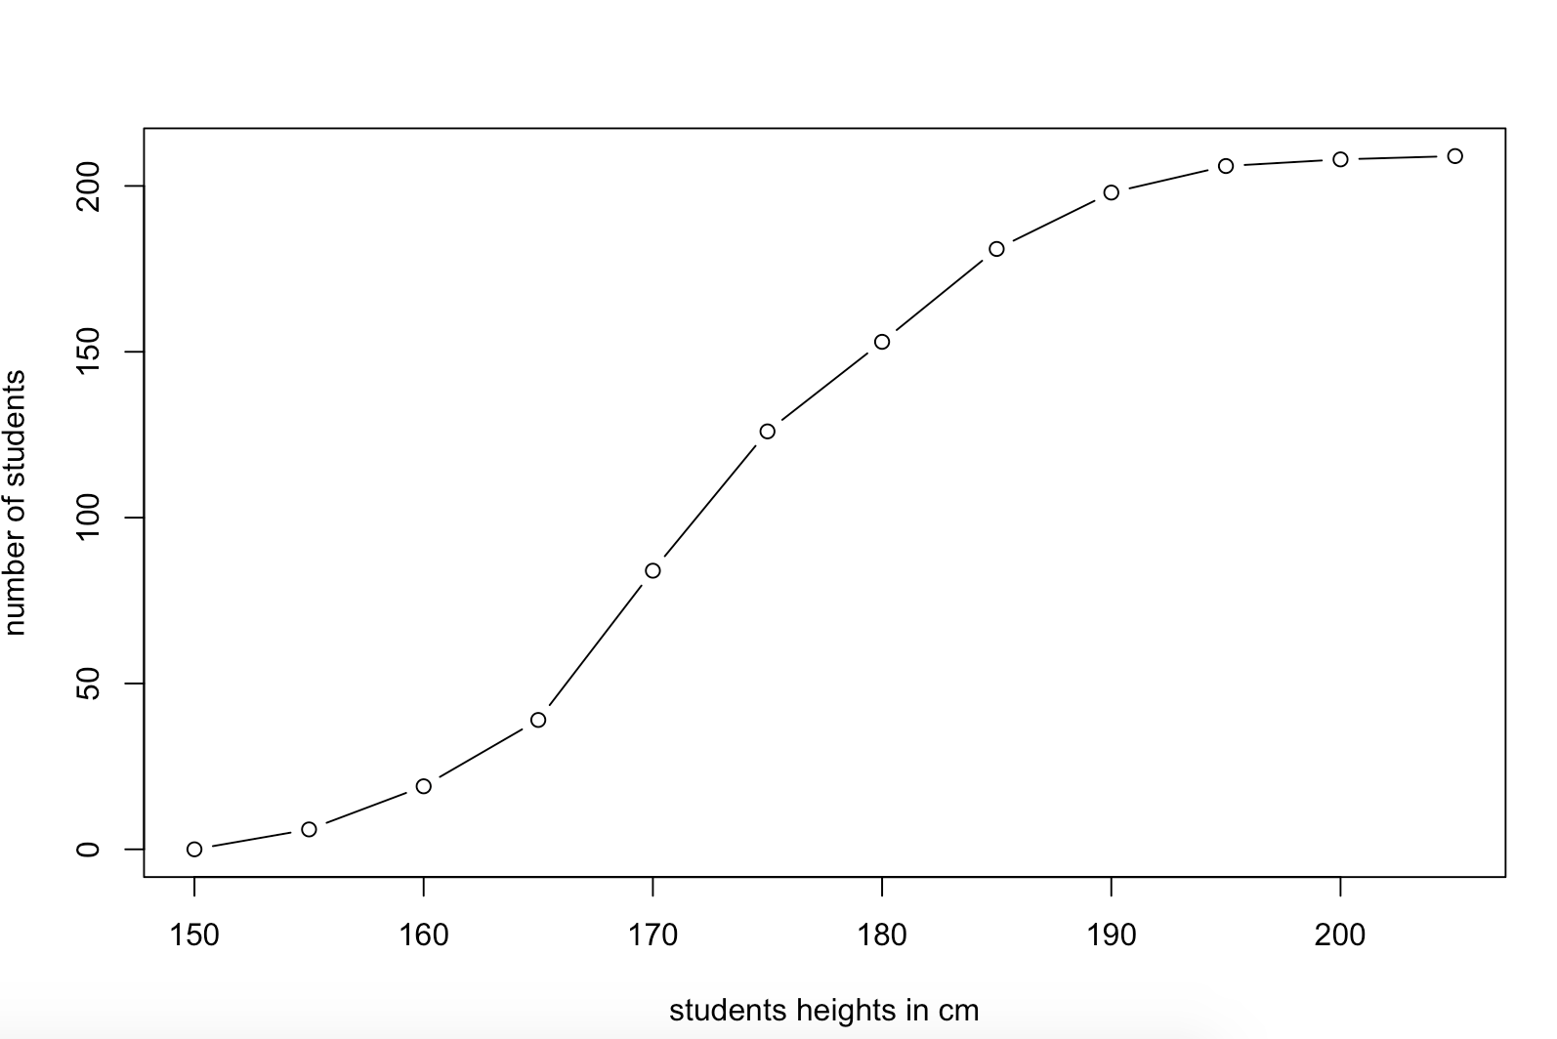plot(breaks, freqs, type="b", xlab="students heights in cm", ylab=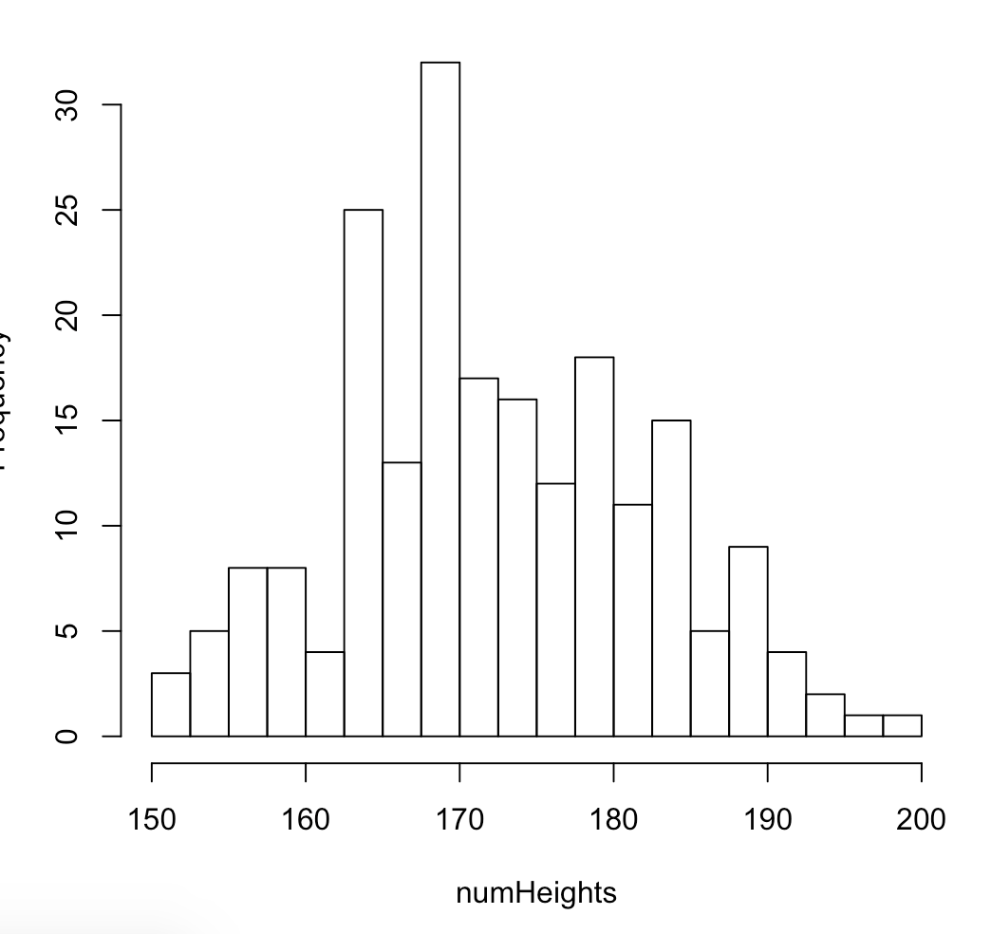"number of students")

9. Use the help function to give descriptive axis labels and a tile to the scatter above. Include your scatterplot and the command(s) you used to produce it

xyplot(survey$Wr.Hnd ~ survey$Height, ylab="Span of writing hand in cm", xlab="Students Heights")

10. Create two new scatterplots: one that plots Wr.Hnd against NW.Hnd, and one that plots Height against Pulse. Both plots should have descriptive titles and axis labels. Include your plots along with the command(s) used to produce them, and answer the following questions: How do the graphs compare to one another, and to the Wr.Hnd vs Height graphs? What does this tell you about the creation between each of the three variable pairs?

xyplot(survey$Wr.Hnd ~ survey$NW.Hnd, xlab = "No-writing hand (cm)", ylab = "writing hand (cm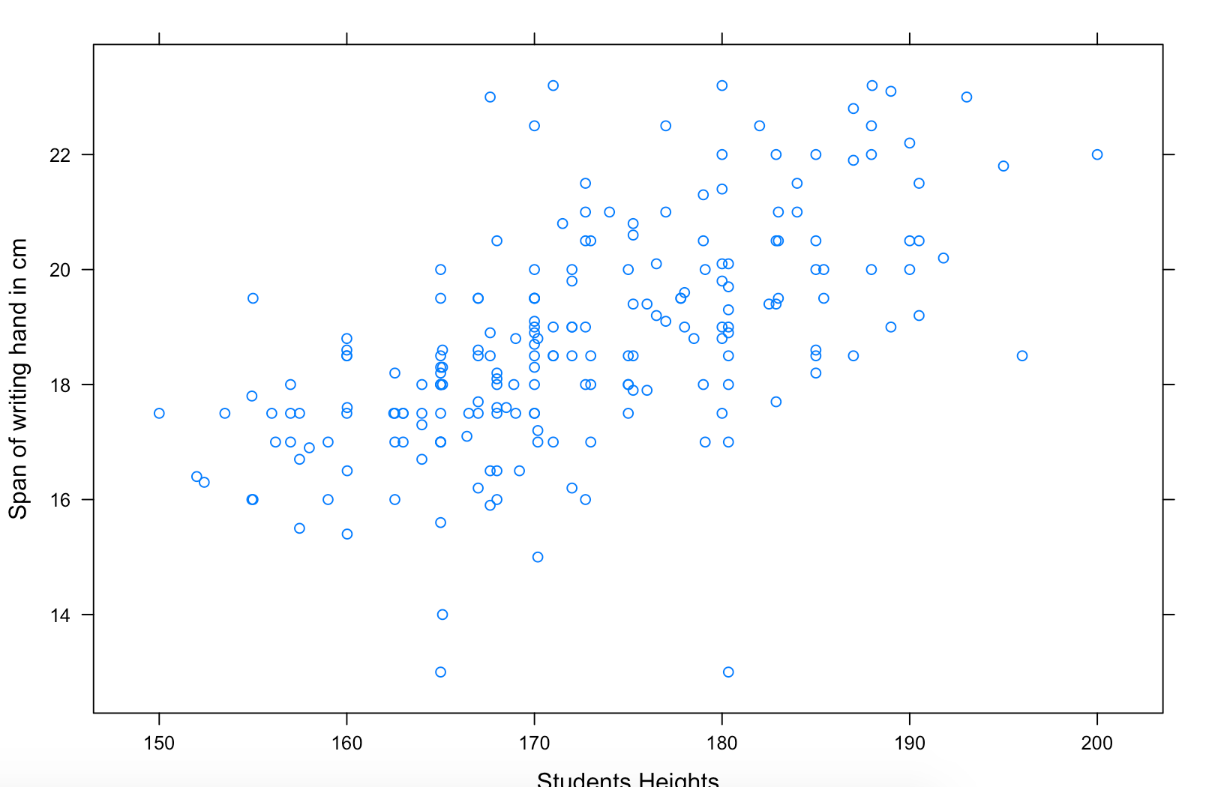)", main="Span of Writing hand vs No-Writing hand”)

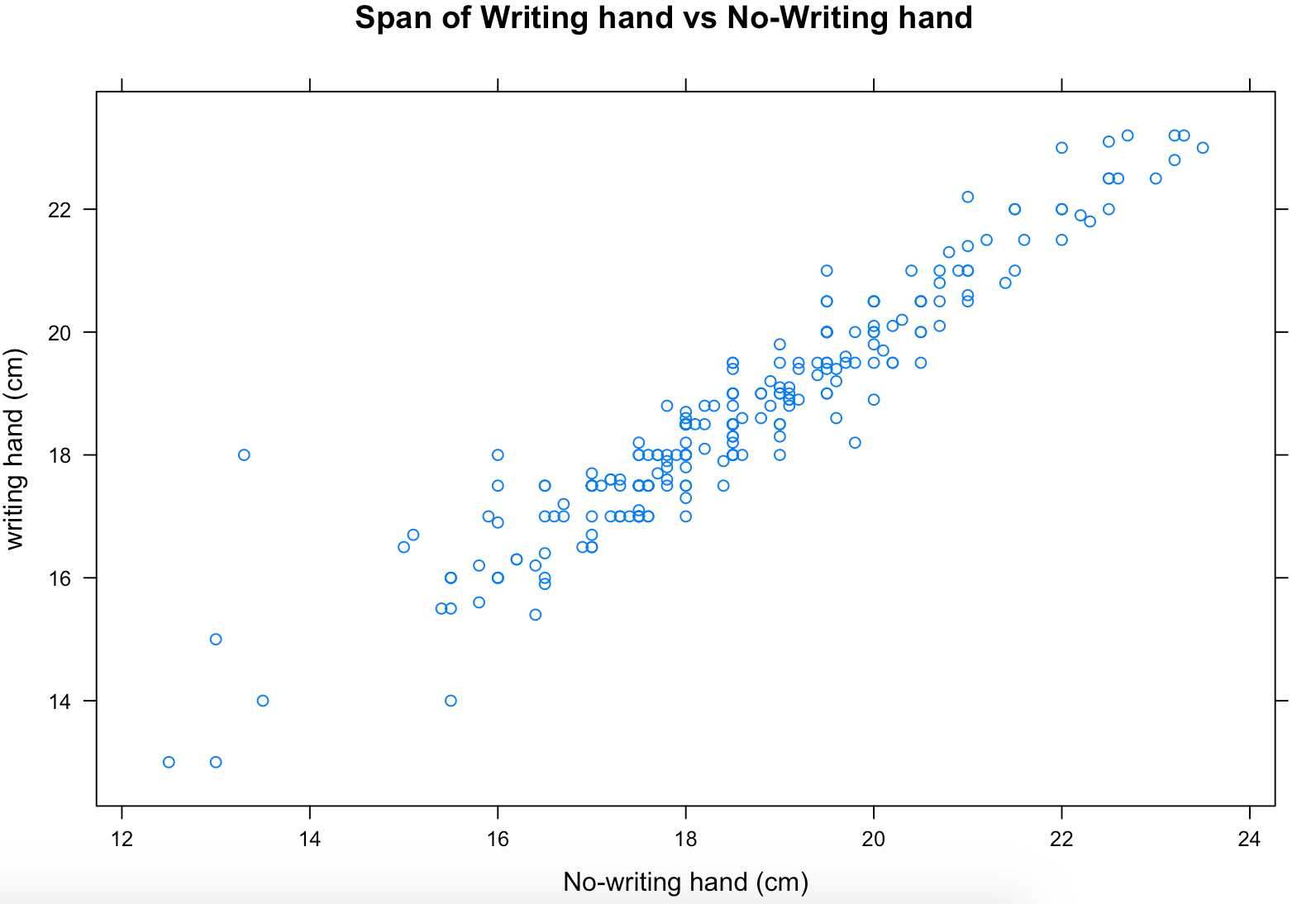

xyplot(survey$Height ~ survey$Pulse, xlab = "Pulse (bps)", ylab = "Height (in cm)", main="Height vs Pulse")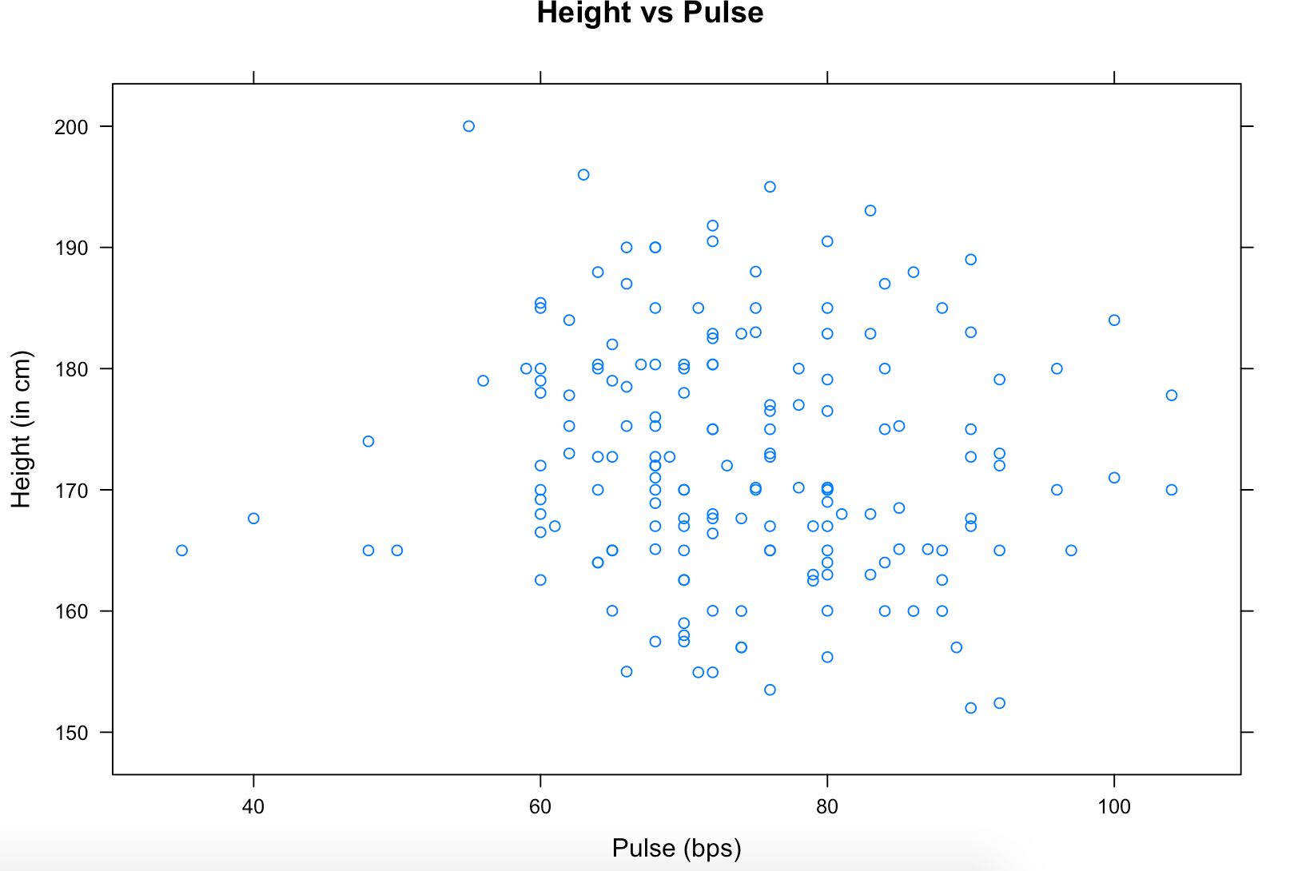

According to the first plot (span of writing hands vs heights), the correlation between to the inputs is not quite obvious, but it seems that taller students have bigger spans of their writing hands. According to the second plot (span of writing hands vs non writing hands), the correlation is pretty noticeable that students have similar length of their left and right hands. Lastly, the third plot (height vs pulse) does not show any correlation between the two inputs.