Name: Jihyo Kim

Student Number: A01017545

Set: 3M

1.

**2 1 2 2 1 1 2 1 1 1**

**heads (1): 6 times**

**tails (2): 4 times**

2.

**CoinResults = function(n)**

**{**

**return(sample(c("Heads", "Tails"), n, replace=TRUE))**

**}**

**ProbHeads = function(n)**

**{**

**coinList <- CoinResults(n)**

**numHeads <- sum(coinList=="Heads")**

**return(numHeads / n)**

**}**

**> ProbHeads(100)**

> **[1] 0.47**

3.

|  |  |  |  |  |
| --- | --- | --- | --- | --- |
| n \ m | 10 | 100 | 1000 | 10000 |
| 10 | 0.8, 0.2 | 0.9, 0.1 | 1, 0 | 1, 0 |
| 100 | 0.64 0.42 | 0.63 0.36 | 0.66 0.36 | 0.72 0.32 |
| 1000 | 0.522 0.482 | 0.558 0.464 | 0.558 0.464 | 0.561 0.444 |
| 10000 | 0.5041 0.4935 | 0.5185 0.4869 | 0.5162 0.4851 | 0.5192 0.4823 |

As ‘m’ increases, the max probability increases, while min probability decreases

As ’n’ increases, the difference between the max and min probabilities decreases

4.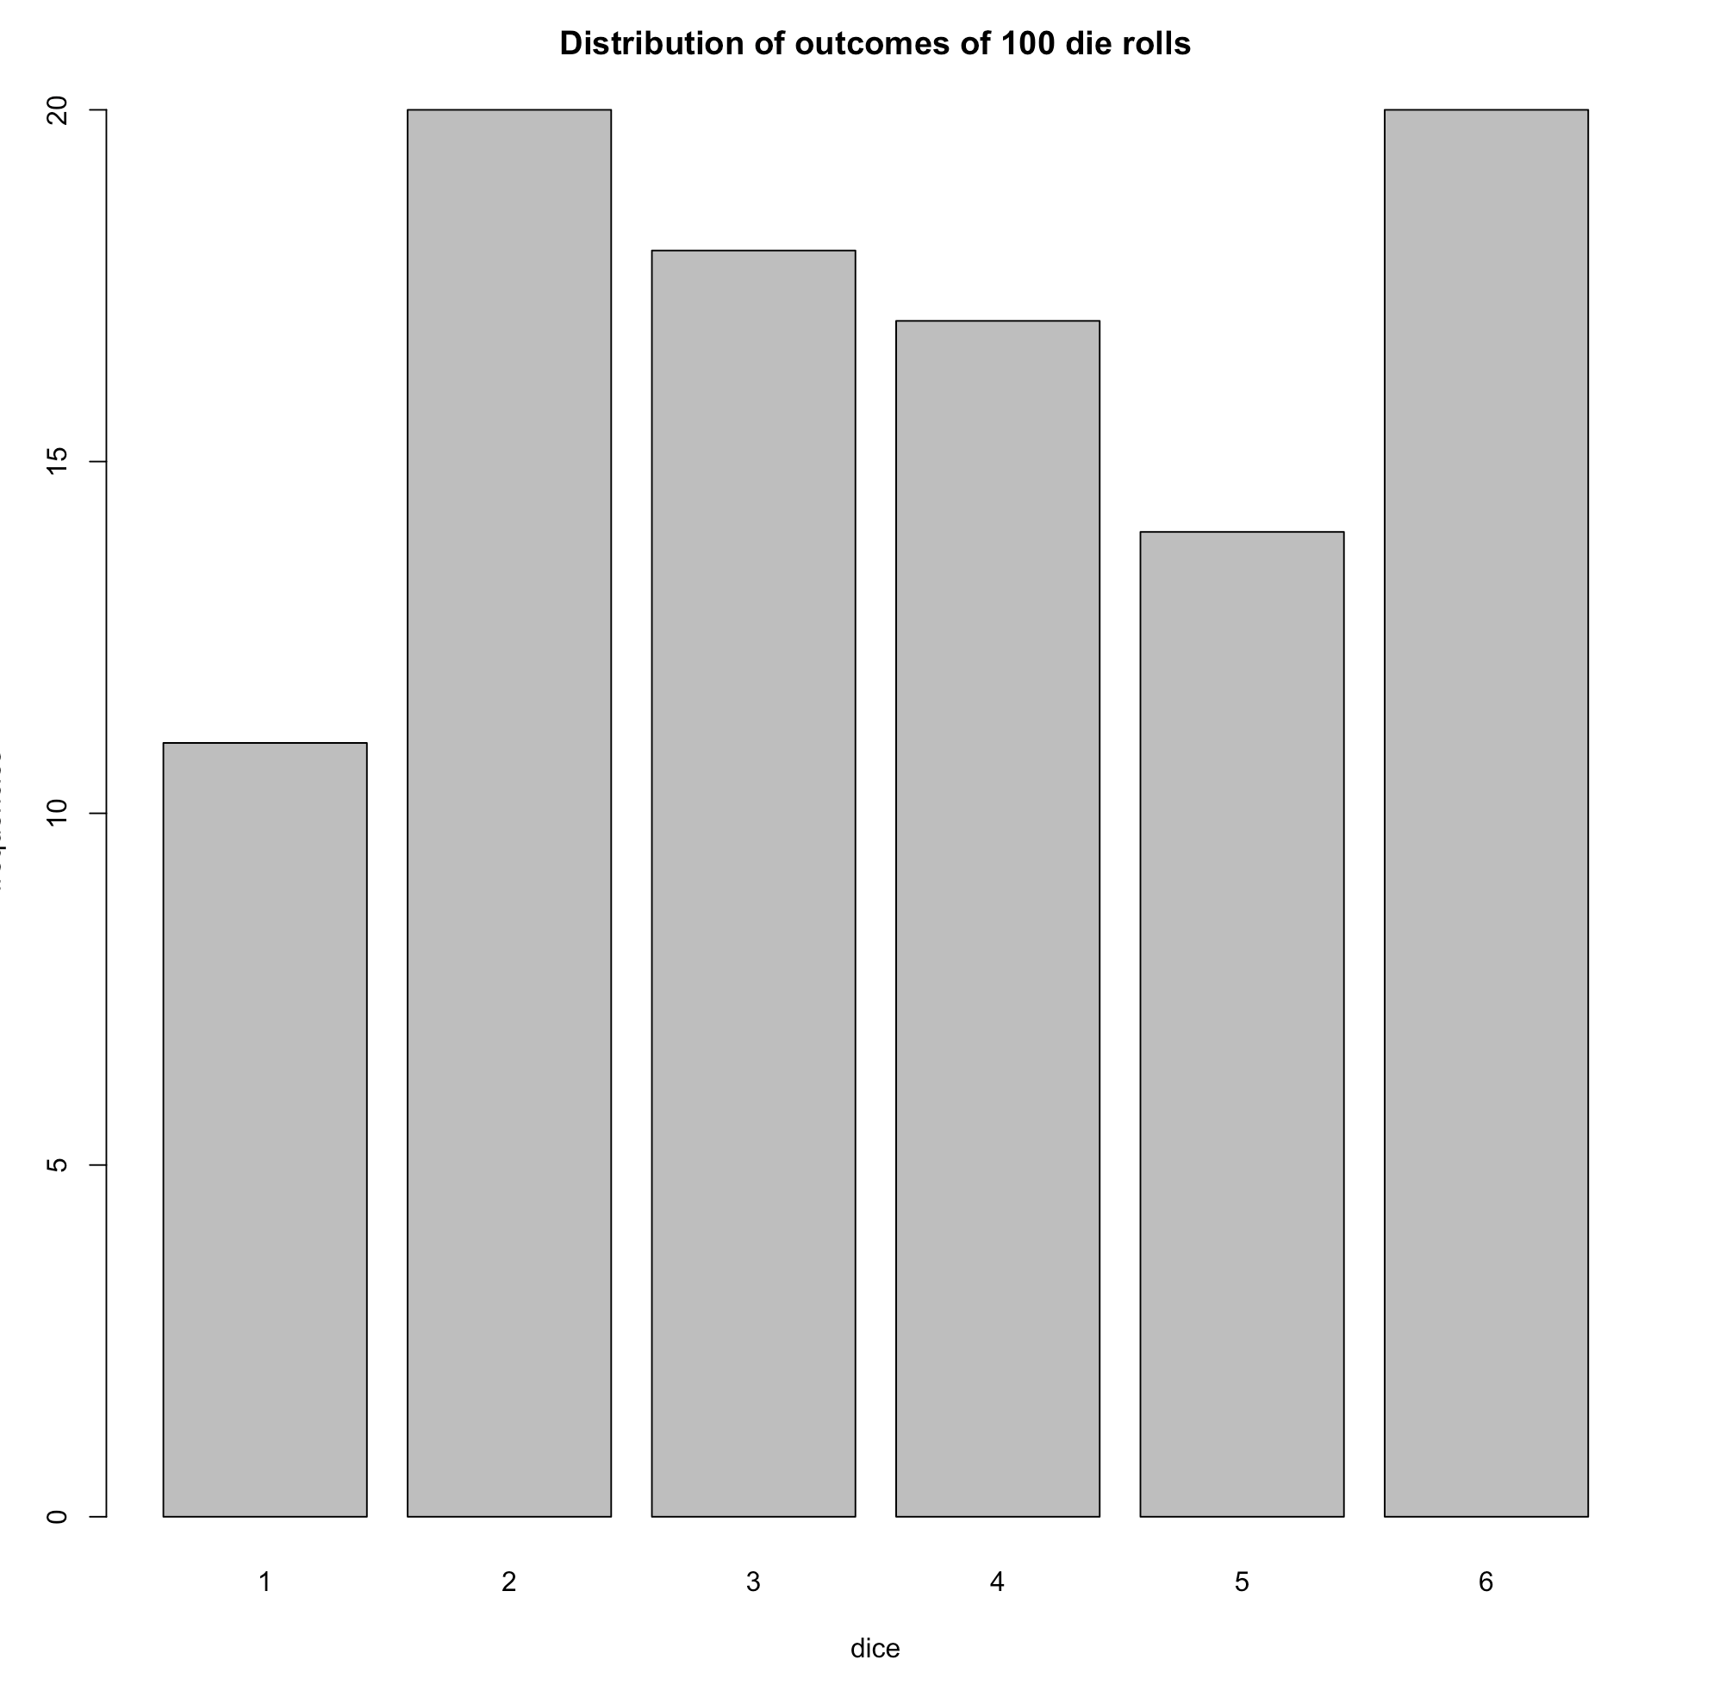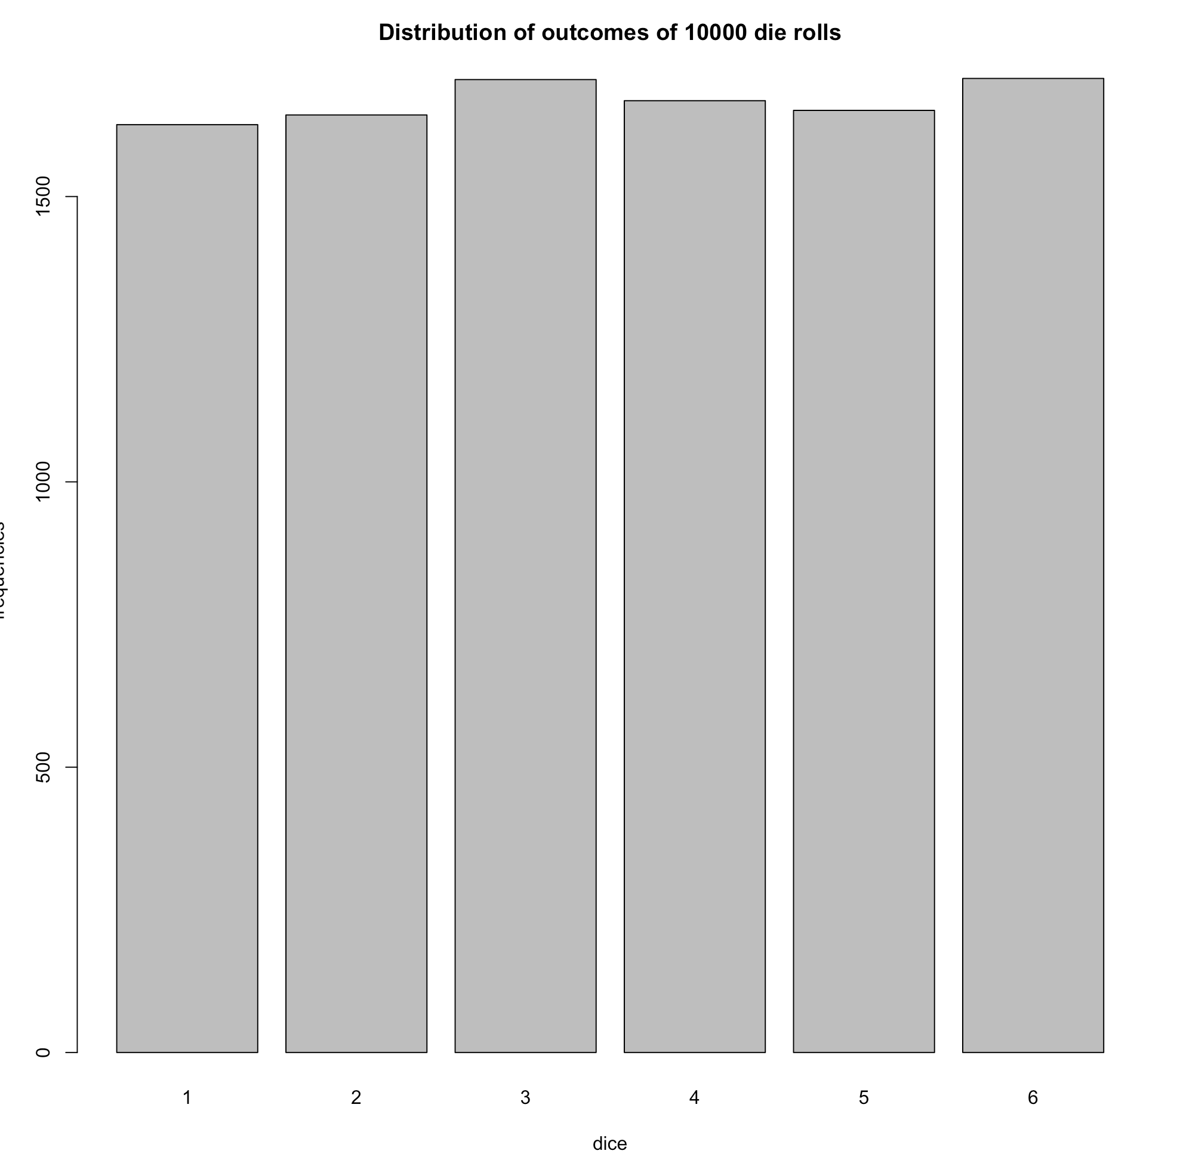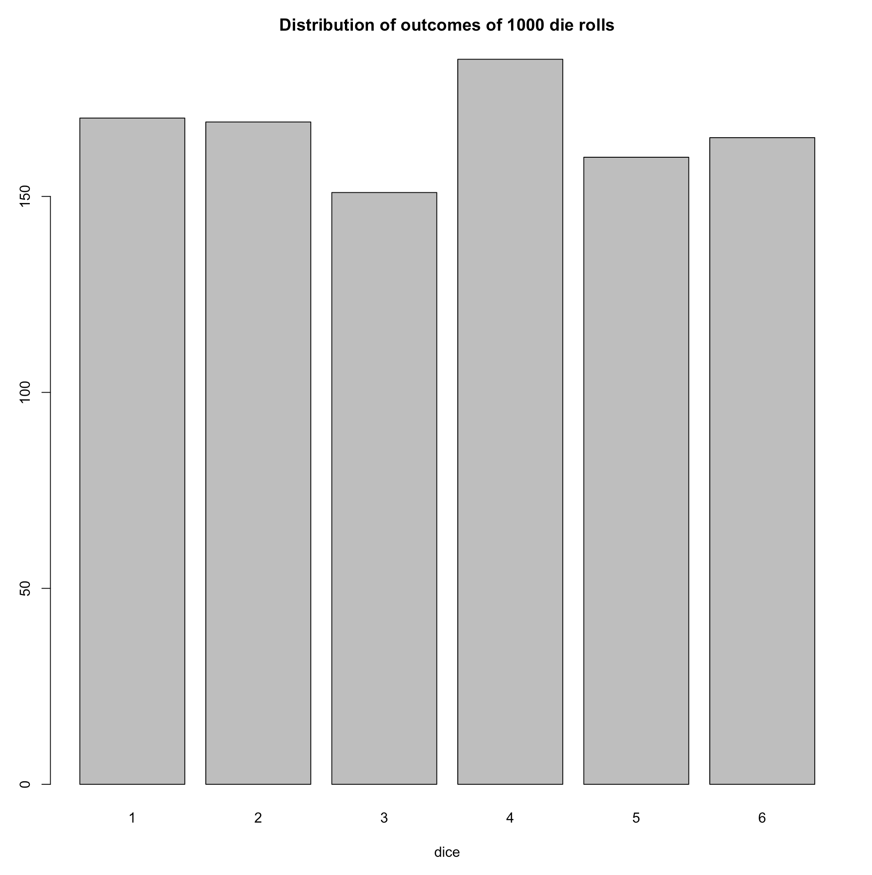

5.

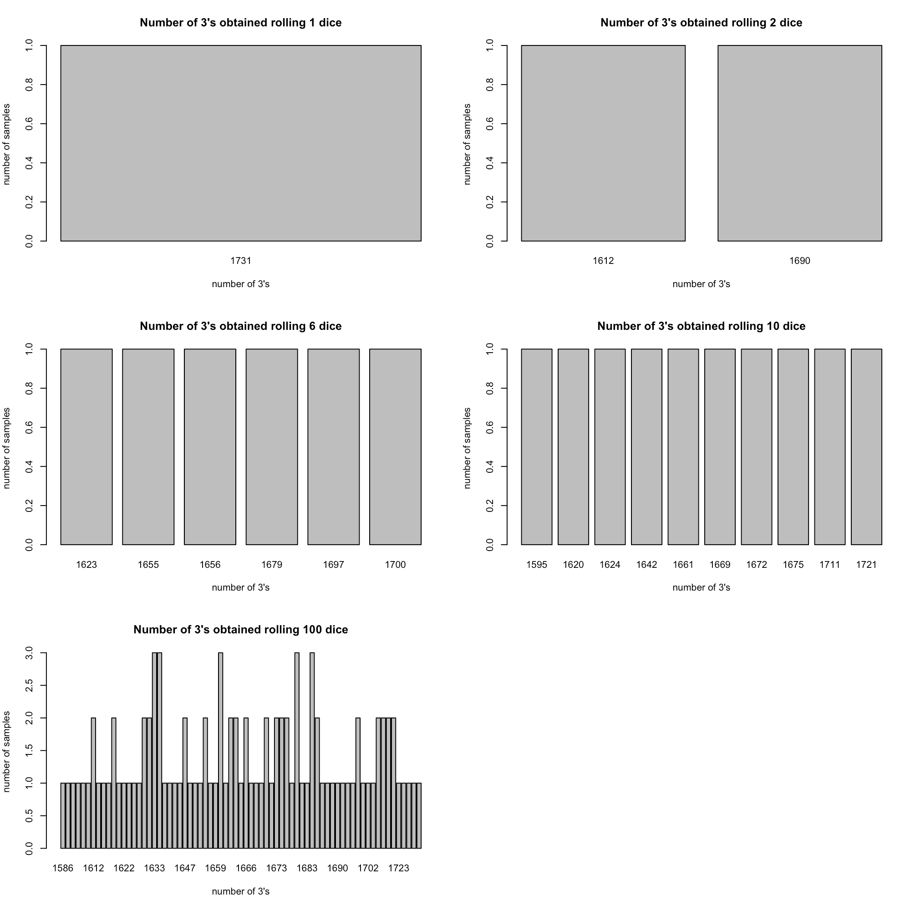

6.

See the table below

7.

|  |  |  |
| --- | --- | --- |
| m | With replacement | Without replacement |
| 1 |  |  |
| 5 |  |  |
| 10 |  |  |
| 30 |  |  |
| 50 |  |  |

**On both with replacement and without replacement, as the m increases, data is more likely to be distributed in the middle. Its noticeable that, the graphs with replacement have more outliers than the ones without replacement.**