NAME:__________________________________ SET: ______

Quiz #4
Central Limit Theorem and Confidence Intervals

- For women aged 18-24, systolic blood pressures (in mmHg) have a mean of 114.9 and a standard deviation of 13.2.

  - If a woman aged 18-24 is selected at random, what is the probability her systolic blood pressure is above 120mmHg?

  - If 41 women aged 18-24 are selected at random, what is the probability their mean systolic blood pressure is above 120 mmHg?

- The lengths of twelve new movies, in minutes, are given in the table below:

110 | 96 | 125 | 105 | 132 | 120 | 136 | 154 | 143 | 110 | 117 | 129

- Explain why, before producing a confidence interval for this particular set of data, you would create a Q-Q plot.

- A Q-Q plot for this data set is given below:

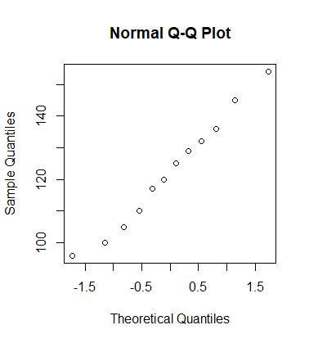
What does the QQ plot tell you about the set of movie times? Explain briefly.

- Construct a 98% confidence interval for the mean length of new movies. Include a sentence as part of your conclusion.

- How large a sample of new movies would we need in order to estimate the mean length of new movies within 5 minutes with 95% confidence?

