VR Project Proposal: Extensions to Portal Navigation Andres Sewell, Kim Peterson, Dakota Mumford

We would like to implement and evaluate a portal-based method [4] for navigating in VR (both wayfinding and travel). We plan to extend the previous work developed for Dr. Cho's PORTAL project [3]. We want to provide users with the ability to interact with objects that are located at a position beyond arm’s reach and the ability to teleport to the position where the objects are located. This effectively extends the teleport capability to include instantaneous navigation to arbitrary locations throughout the VR environment. The navigation process includes a novel and intuitive method of wayfinding that allows the user to initially select a location, then refine the specific point for arrival, and then spawn a portal at the selected destination.

This project investigates two potential additions to Dr. Cho’s work:

* A navigation process with a method of travel 'at scale'. This will allow the user to create portals of arbitrary sizes, and to have their body be scaled up or down accordingly. For example, a user could shrink to the size of a pocket watch to perform a repair. Or perhaps the user could transport to the area around a person's heart to perform surgery.
* A method for storing and recalling portal positions around the environment. Either automatically as the user travels from place to place or as an explicit operation.

We plan to include a simple evaluation using the Usefulness/Ease of Use rubric of the Technology Acceptance Model (TAM) [2].

Navigation and manipulating objects are fundamental tasks for anyone operating in virtual reality [1]. Moving around in an artificial environment while stationary in the real environment creates a disparity between what the user sees and what the user physically experiences. This disparity results in some degree of motion sickness [5]. The effect is generally mild, but can be a significant detriment for the user depending on the method of travel and if there is frequent or lengthy travel. Teleportation is a navigation technique that tends to minimize motion sickness [7], and for that reason is used as the method of moving about for this project.

In order to successfully teleport in the virtual environment, the user needs some way to determine where to go [6]. This project introduces a two-step process for precisely identifying a destination. The process starts with the user identifying an initial location by using a pointer device. If the intended destination is within visual range the user points the pointer at that intended location. If the intended destination is not in visual range the user points the pointer at the intended location on a map. With the pointer pointing at the intended destination, the user presses a button on a hand controller, and a portal opens immediately in front of the user. The portal shows a view at the designated destination. If the view seen in the portal is the destination intended by the user, the user can move forward, temporarily teleporting to the destination. If the view seen in the portal is not the intended destination, the user can move the portal by using a joystick controller; rotating the portal orientation left and right with the left/right joystick control, and moving the portal forward and backward with the forward/back joystick control. When the intended destination is seen in the Portal, the user can move forward, temporarily teleporting to the destination.

When the user is temporarily teleported to the Portal destination, they can interact with the environment there, and within limits (that are yet to be determined), can pick up objects and bring them back to the starting location. The user can teleport permanently to the destination by pressing a button on the hand controller. The user teleports back to the starting location by pressing some other button on the hand controller. The specific controls to be used to initiate portal mode, manipulate a pointer, display a map, rotate and move the portal, teleport permanently to the destination and return to the starting point/close the portal, or exit portal mode, are to be determined as the project is developed.

A portal “at scale” operates when a user initiates portal mode and points the pointer at an object that is within reach and is small (smaller than a threshold value that is yet to be determined). That object is the “designated object”. When portal “at scale” is initiated, the user is shrunk to a scale that would make the designated object fit within a 10X10X10 meter cube. The user remains in a position to keep the designated object in the user's visual field of regard. The user then operates portal mode as described above to navigate to the location of interest and manipulate objects there as desired. The user exits the portal “at scale” to return to their original size by pressing the same button that is used to exit portal mode.

Appendix

Example of Positioning

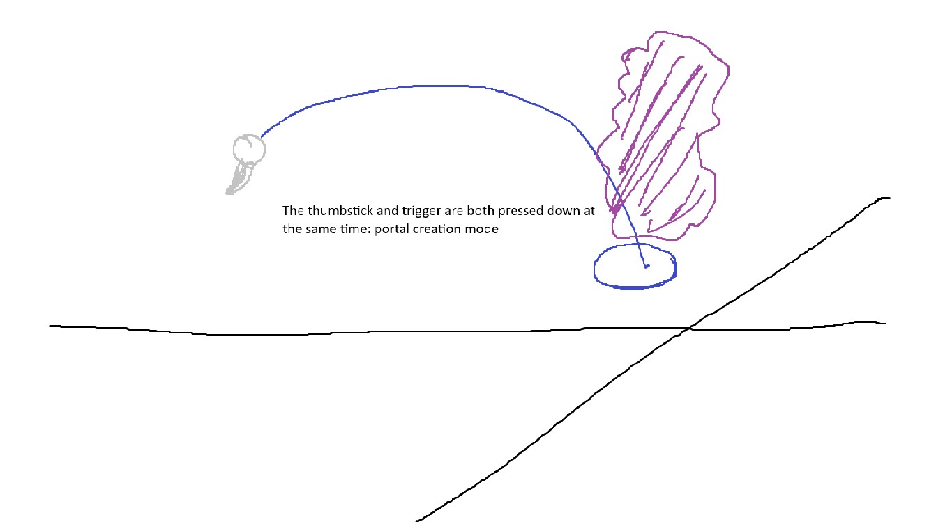

Example of Scaling

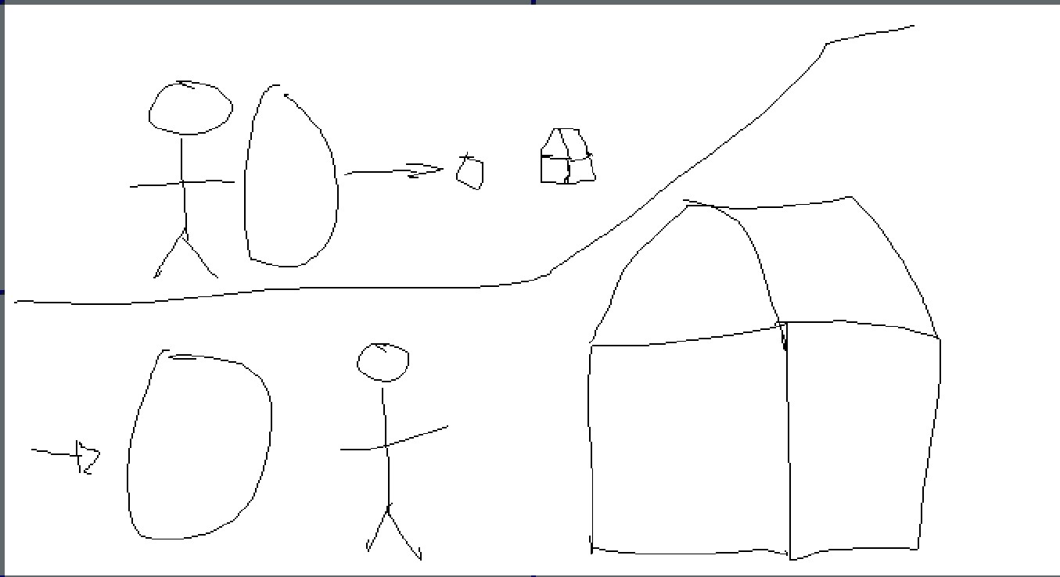

References

[1] Costas Boletsis and Dimitra Chasanidou. “A typology of virtual reality locomotion techniques”. In: Multimodal Technologies and Interaction 6.9 (2022), p. 72.

[2] Fred D Davis. “User acceptance of information systems: the technology acceptance model (TAM)”. In: (1987). url: https://deepblue.lib.umich.edu/bitstream/handle/2027.42/35547/b1409190.0001.001.pdf?seque.

[3] Dongyun Han, Donghoon Kim, and Isaac Cho. “Portal: Portal widget for remote target acquisition and control in immersive virtual environments”. In: Proceedings of the 28th ACM Symposium on Virtual Reality Software and Technology. 2022, pp. 1–11.

[4] Kiyoshi Kiyokawa and Haruo Takemura. “A tunnel window and its variations: Seamless teleportation techniques in a virtual environment”. In: HCI International. Citeseer. 2005.

[5] Xiaolong Liu et al. “Automatic portals layout for VR navigation”. In: Virtual Reality 28.1 (2024), pp. 1–16.

[6] Andrii Matviienko et al. “Skyport: Investigating 3d teleportation methods in virtual environments”. In: Proceedings of the 2022 CHI Conference on Human Factors in Computing Systems. 2022, pp. 1–11.

[7] Aniruddha Prithul, Isayas Berhe Adhanom, and Eelke Folmer. “Teleportation in virtual reality; A mini-review”. In: Frontiers in Virtual Reality 2 (2021), p. 730792.

Websites:

* The Portal video: <https://www.youtube.com/watch?v=PkGjYig8avo>
* The Portal website: <https://github.com/daniel-ilett/portals-urp>