import pandas as pd
import numpy as np
import os
import re
from datetime import datetime
import joblib
import matplotlib.pyplot as plt
from sklearn.metrics import mean_absolute_error, r2_score
from google.colab import drive

# ==========================================
# 1. 환경 세팅 및 데이터 로드
# ==========================================
drive.mount('/content/drive')
base_path = '/content/drive/MyDrive/NASA_Battery'
csv_folder_path = os.path.join(base_path, 'data')
metadata_path = os.path.join(base_path, 'metadata.csv')

metadata = pd.read_csv(metadata_path)
metadata['Capacity'] = pd.to_numeric(metadata['Capacity'], errors='coerce')
metadata = metadata.dropna(subset=['Capacity']).reset_index(drop=True)

def parse_nasa_time(time_str):
clean_str = re.sub(r'[\[\]]', '', str(time_str))
y, m, d, h, minute, s = [int(float(x)) for x in clean_str.split()]
return datetime(y, m, d, h, minute, s)

def extract_segmented_features_all(battery_list, meta_df, data_path):
all_data = []
for battery_id in battery_list:
df_meta = meta_df[(meta_df['battery_id'] == battery_id) & (meta_df['type'] == 'discharge')].copy()
df_meta['Parsed_Time'] = [parse_nasa_time(t) for t in df_meta['start_time']]
df_meta = df_meta.sort_values('Parsed_Time').reset_index(drop=True)
if len(df_meta) == 0: continue

first_cap = 2.0
eol_threshold = first_cap * 0.70

eol_idx = len(df_meta) - 1
for idx, cap in enumerate(df_meta['Capacity']):
if cap < eol_threshold:
eol_idx = idx
break

battery_results = []
for i, row in df_meta.iterrows():
file_path = os.path.join(data_path, row['filename'])
if not os.path.exists(file_path): continue
df = pd.read_csv(file_path)
if len(df) < 50: continue

t_0 = 0
t_1m = (df['Time'] - 60.0).abs().idxmin()
t_5m = (df['Time'] - 300.0).abs().idxmin()
t_10m = (df['Time'] - 600.0).abs().idxmin()

ocv = df['Voltage_measured'].iloc[t_0]
amb_temp = df['Temperature_measured'].iloc[t_0]

v_drop_1m = ocv - df['Voltage_measured'].iloc[t_1m]
temp_slope_1m = df['Temperature_measured'].iloc[t_1m] - amb_temp
v_drop_5m = ocv - df['Voltage_measured'].iloc[t_5m]
temp_slope_5m = df['Temperature_measured'].iloc[t_5m] - amb_temp
v_drop_10m = ocv - df['Voltage_measured'].iloc[t_10m]
temp_slope_10m = df['Temperature_measured'].iloc[t_10m] - amb_temp

soh_ratio = float(row['Capacity']) / first_cap
if soh_ratio > 1.2 or soh_ratio < 0:
continue

max_temp = df['Temperature_measured'].max()
rul_cycles = max(0, eol_idx - i)

battery_results.append([
ocv, amb_temp, v_drop_1m, temp_slope_1m, v_drop_5m, temp_slope_5m, v_drop_10m, temp_slope_10m,
soh_ratio, max_temp, rul_cycles
])

df_batt = pd.DataFrame(battery_results, columns=[
'OCV', 'Amb_Temp', 'V_Drop_1m', 'Temp_Slope_1m', 'V_Drop_5m', 'Temp_Slope_5m', 'V_Drop_10m', 'Temp_Slope_10m',
'Target_SOH', 'Target_Max_Temp', 'Target_RUL'
])
all_data.append(df_batt)
return pd.concat(all_data, ignore_index=True)

# ==========================================
# 2. 저장된 통합 AI 엔진 불러오기
# ==========================================
model_path = os.path.join(base_path, 'bms_ultimate_realtime_engine.pkl')
bms_ultimate_engine = joblib.load(model_path)
print(f"✅ AI 모델 로드 완료: {model_path}")

# ==========================================
# 3. 3대 환경 테스트 및 3x3 그래프/텍스트 출력
# ==========================================
test_environments = [
('Low Temp (4°C)', 'B0041'),
('Room Temp (24°C)', 'B0018'),
('High Temp (43°C)', 'B0031')
]

print("\n🕵️‍♂️ 3대 가혹 환경 개별 블라인드 테스트 결과 요약\n" + "="*50)

plt.style.use('ggplot')
fig, axes = plt.subplots(3, 3, figsize=(18, 15))
fig.suptitle("AI BMS Performance Validation (Optimized for Generalization)", fontsize=20, fontweight='bold', y=0.98)

for row_idx, (env_name, batt_id) in enumerate(test_environments):
df_test = extract_segmented_features_all([batt_id], metadata, csv_folder_path)
if len(df_test) == 0:
print(f"⚠️ {batt_id} 데이터를 찾을 수 없습니다.")
continue

X_test = df_test[bms_ultimate_engine['f_10m']]
y_true_soh = df_test['Target_SOH'] * 100
y_true_rul = df_test['Target_RUL']
y_true_temp = df_test['Target_Max_Temp']

# 물리적 한계선(Clipping) 유지
pred_soh = np.clip(bms_ultimate_engine['soh_10m'].predict(X_test) * 100, 0, 100)
pred_rul = np.clip(bms_ultimate_engine['rul_10m'].predict(X_test), 0, 150)
pred_temp = bms_ultimate_engine['temp_10m'].predict(X_test)

# MAE 및 R2 계산
mae_soh = mean_absolute_error(y_true_soh, pred_soh)
r2_soh = r2_score(y_true_soh, pred_soh)
mae_rul = mean_absolute_error(y_true_rul, pred_rul)
mae_temp = mean_absolute_error(y_true_temp, pred_temp)

# 콘솔 텍스트 출력
print(f"📌 [{env_name} - {batt_id} 배터리]")
print(f" - SOH 예측 오차 : MAE {mae_soh:.2f}% (R2: {r2_soh:.3f})")
print(f" - 잔여 수명 오차 : MAE {mae_rul:.1f} Cycles")
print(f" - 최고 온도 오차 : MAE {mae_temp:.2f} °C\n")

# [1열] SOH 예측
ax = axes[row_idx, 0]
ax.scatter(y_true_soh, pred_soh, alpha=0.6, color='blue', edgecolors='black')
ax.plot([70, 100], [70, 100], 'r--', lw=2)
ax.set_title(f"[{env_name}] SOH Prediction\n(MAE: {mae_soh:.2f}%, R2: {r2_soh:.3f})", fontsize=14)
ax.set_xlabel("Actual SOH (%)")
ax.set_ylabel("Predicted SOH (%)")
ax.set_xlim(65, 105); ax.set_ylim(65, 105)

# [2열] RUL 예측
ax = axes[row_idx, 1]
ax.scatter(y_true_rul, pred_rul, alpha=0.6, color='purple', edgecolors='black')
ax.plot([0, 160], [0, 160], 'r--', lw=2)
ax.set_title(f"[{env_name}] RUL Prediction\n(MAE: {mae_rul:.1f} cycles)", fontsize=14)
ax.set_xlabel("Actual RUL (Cycles)")
ax.set_ylabel("Predicted RUL (Cycles)")
ax.set_xlim(-10, 160); ax.set_ylim(-10, 160)

# [3열] 과열 예측
ax = axes[row_idx, 2]
ax.scatter(y_true_temp, pred_temp, alpha=0.6, color='red', edgecolors='black')
min_t = min(y_true_temp.min(), pred_temp.min()) - 2
max_t = max(y_true_temp.max(), pred_temp.max()) + 2
ax.plot([min_t, max_t], [min_t, max_t], 'r--', lw=2)
ax.set_title(f"[{env_name}] Max Temp Prediction\n(MAE: {mae_temp:.2f} °C)", fontsize=14)
ax.set_xlabel("Actual Temp (°C)")
ax.set_ylabel("Predicted Temp (°C)")
ax.set_xlim(min_t, max_t); ax.set_ylim(min_t, max_t)

plt.tight_layout(rect=[0, 0.03, 1, 0.95])
plt.show()

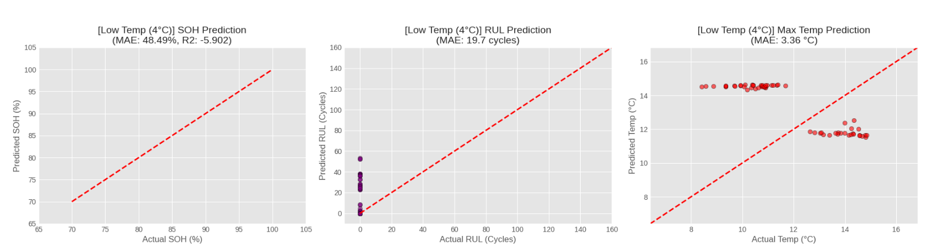

[Low Temp (4°C) - B0041 배터리]
- SOH 예측 오차 : MAE 48.49% (R2: -5.902)
- 잔여 수명 오차 : MAE 19.7 Cycles
- 최고 온도 오차 : MAE 3.36 °C
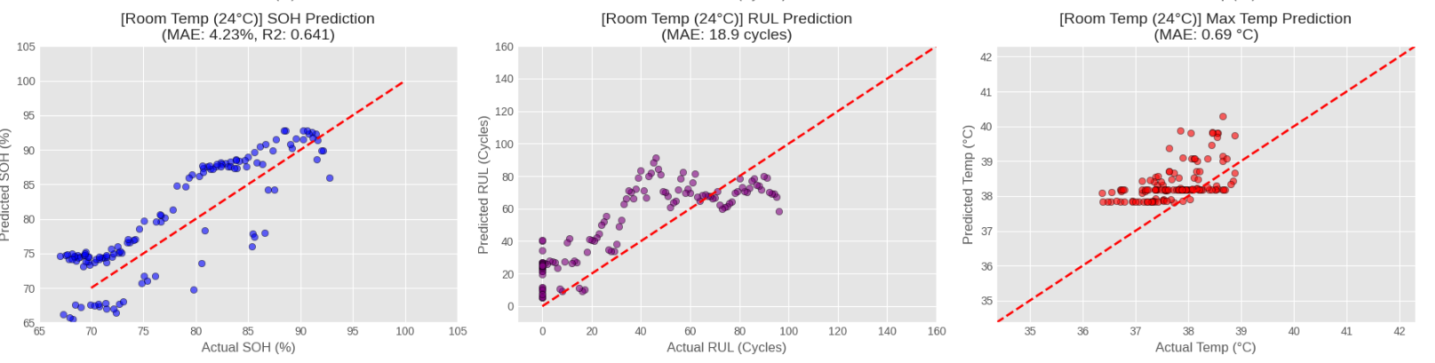
📌 [Room Temp (24°C) - B0018 배터리]
- SOH 예측 오차 : MAE 4.23% (R2: 0.641)
- 잔여 수명 오차 : MAE 18.9 Cycles
- 최고 온도 오차 : MAE 0.69 °C

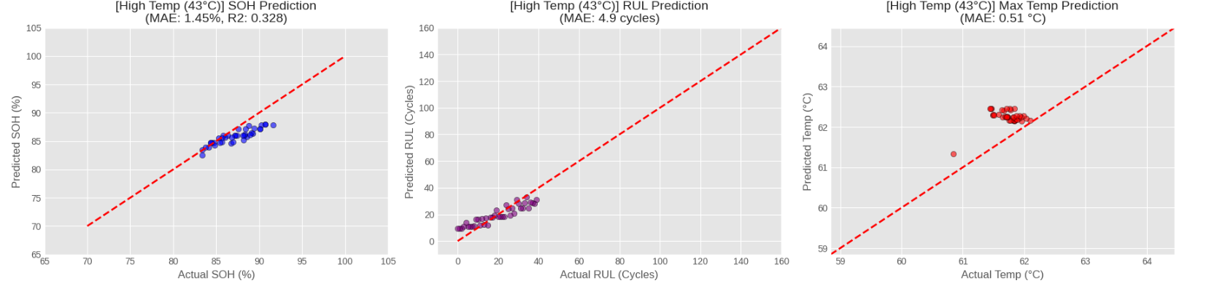📌 [High Temp (43°C) - B0031 배터리]
- SOH 예측 오차 : MAE 1.45% (R2: 0.328)
- 잔여 수명 오차 : MAE 4.9 Cycles
- 최고 온도 오차 : MAE 0.51 °C

