**Bank Account Web App**

Team 7

Kevin Kim

Luke Dam

July 22, 2018

Table of Contents

Project Overview 2

Functional Requirements / Use Cases 4

Database Design 6

Project Design 7

Work Assignments 8

# Project Overview

This application is a simulation of an online bank application. It allows a user all common functionalities such as paying and transferring money and viewing different accounts. It is a demonstration of understanding real life application using web development.

The development environment for this application is with Visual Studio 2017, and with the user friendly database designer Microsoft SQL Server Management Studio 2017. The SQL server be of version 2016.

The technologies used for this application is C# with visual studio, Web Forms ADO.NET datasets, and collections.

# Functional Requirements / Use Cases

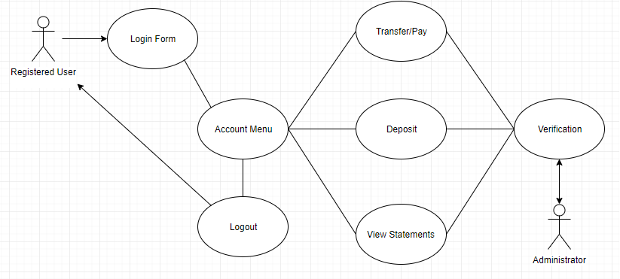

Figure 2. Use case diagram for the banking system proposed

**Login Form**

Only applies to already registered users. It is a form that allows a user to enter username and password and this info is passed using a session.

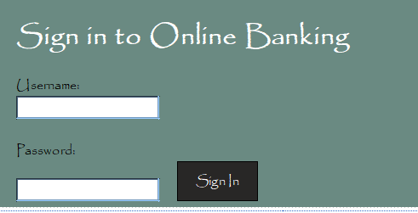

Figure 3. Login Form

**Account Menu**

After successful login by checking username/password database verification, the user is prompted with their name and 4 selections: withdraw, deposit, view statements and logout.

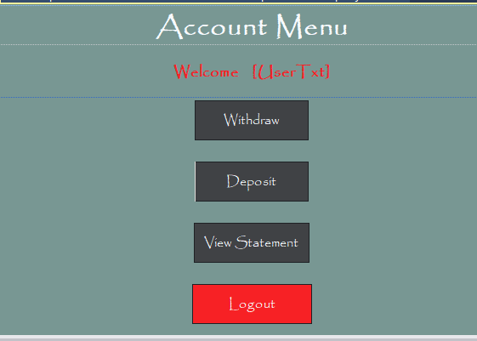

Figure 4. Account Menu

**Deposit/View Statements**

The deposit option allows a logged in user to add funds to their chequing account balance, using a credit card or some other common type of card/prepaid.

The view statement option allows a detailed report of their account, such as the balance of both chequing account and the credit account.

**Transfer/Pay**

The transfer/pay option allows them to choose the amount from their chequing account to pay for their credit account as well as transfer money to an existing user. This credit account will have a pay by due date.

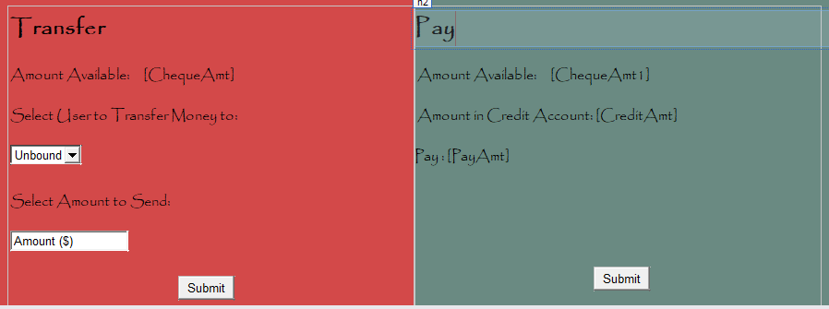

Figure 5. Transfer and Pay Design Page

# Database Design

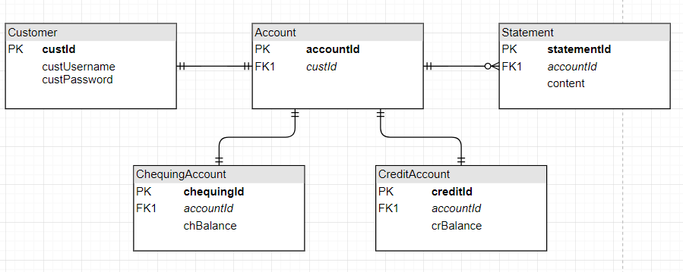

Figure 6: Entity-Relation Diagram of the proposed application

# Project Design

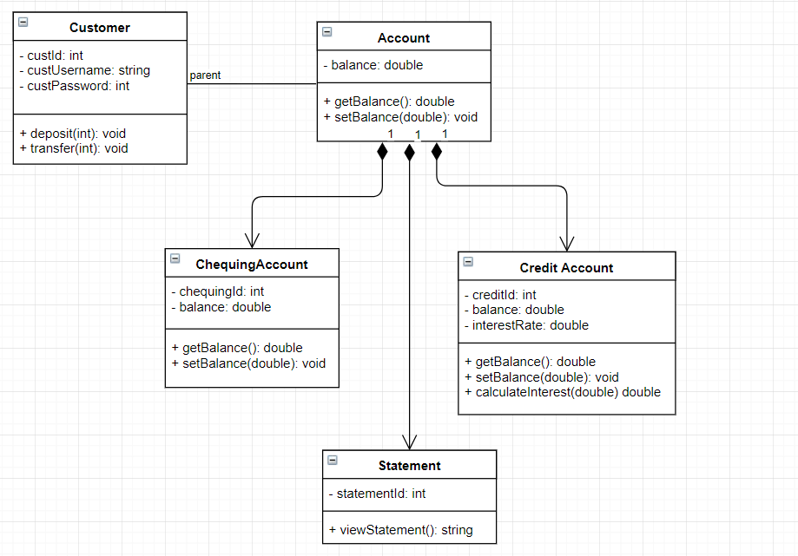

Figure 7: UML diagram of the proposed application (class diagram)

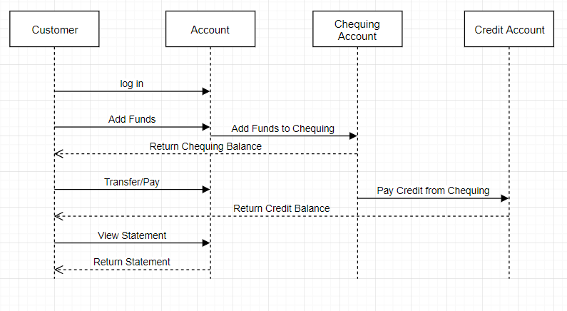

Figure 8: Sequence diagram of the proposed application

# Work Assignments

|  |  |
| --- | --- |
| UI and Functional design | Luke Dam |
| Database design: Customer, ChequingAccount, CreditAccount, Statement | Kevin Kim |
| Database connection: ADO.NET | Kevin Kim / Luke Dam |
| Applications of Collections(arrays, dictionaries, hashmap) | Kevin Kim / Luke Dam |