NIT1104 Computer Networks
Assessment 3 – Group Project
Western Victoria Regional Telehealth Network
Technical Design Report
Group Number: [33]
Team Members
Student Name | Student ID
Hoang Gia Phat Nguyen | s8174754
Lê Kim Kha Nguyễn | s8199557
Matthew Pomar | s8209322
Submission Date: [18/05/26]
Session: [10]

Executive Summary

Project Overview
This report presents the technical network design developed for Western Victoria Health Services (WVHS), a regional healthcare provider operating across three different locations: the Ballarat Central Diagnostic Hub, the Ararat Medical Clinic, and the Horsham Medical Clinic. The primary goal of the project was to design and implement a secure, reliable, and scalable wide area network (WAN) capable of supporting critical healthcare services including telehealth video consultations, secure medical imaging transfers, electronic health record (EHR) access, and administration systems. By connecting remote clinics directly to the Ballarat hub, the network enables faster specialist consultations, reduces diagnostic delays, and improves overall patient care outcomes across the Western Victoria region.

Network Design Approach
The network was designed using a hub and branch topology, with Ballarat acting as the central hub and Ararat and Horsham as branch sites connected via dedicated WAN serial links. IP addressing was planned using the base network 10.7.33.0/24, with Variable Length Subnet Masking (VLSM) applied to allocate address space efficiently based on the host requirements of each site. A /27 subnet was allocated to the Ballarat Central Hub to accommodate its larger number of devices across four departments -- Radiology, Cardiology, Administration, and the Server Network. /28 subnets were assigned to the smaller Ararat and Horsham clinics. Point-to-point WAN links between sites were assigned /30 subnets, minimising address waste on connections that require only two usable host addresses.
EIGRP (Enhanced Interior Gateway Routing Protocol) was selected as the dynamic routing protocol due to its fast convergence, low processing overhead, and suitability for small Cisco-based enterprise networks. EIGRP enables routers at all three sites to automatically exchange routing information, ensuring continuous connectivity without manual route management. This is critical in a healthcare context where network downtime could directly impact patient care.

Key Technical Decisions
- VLSM subnetting was used over fixed length subnetting to minimise IP address waste and support future growth at each site.
- EIGRP was chosen over OSPF, RIP, and static routing for its fast convergence, low overhead in a threerouter network, and native compatibility with Cisco hardware.
- /30 WAN subnets were applied to point-to-point serial links between Ballarat and Ararat and Ballarat and Horsham, following WAN design standards.
- Hardware selection included Cisco 2911 and 1941 routers alongside Cisco 2960 switches and wireless access points, providing a realistic and appropriate platform for the healthcare environment.

Challenges Encountered
During the Packet Tracer implementation, two notable challenges were encountered. The first involved wireless connectivity, where laptops at Ararat and Horsham were connecting to the wrong wireless access point because both WAPs were using the default SSID. This was resolved by renaming each WAP to a unique location-specific SSID, after which laptops correctly associated with their local access point. The second challenge involved a misconfigured IP address on a device that caused ping tests to fail unexpectedly. The issue was identified by checking the device's IP configuration directly, correcting the address, and re-running the ping to confirm connectivity was restored.

Key Outcomes and Verification Results
Connectivity testing was completed successfully across all three sites. Ping tests confirmed that devices at Ararat and Horsham could reach servers at the Ballarat hub, including the PACS server and File Server. Traceroute testing between Ararat and Horsham confirmed that inter-branch traffic correctly routes through Ballarat as expected in a hub and branch topology. Routing tables on all three routers were verified using the show ip route command, confirming that EIGRP had correctly established neighbour relationships and that every router had learned the full set of routes across the network with no missing or unexpected entries.

1. IP Address Planning & Subnetting1.1 Network Requirements Analysis
The following analysis identifies the number of devices required at each site and department, incorporates a growth capacity buffer, and determines the appropriate subnet size for each location.

Site 1 - Ballarat Central Diagnostic Hub (Network Hub)
Radiology: 2 radiologist workstations, 2 imaging servers, 1 PACS system (5 devices)
Cardiology: 2 specialist workstations, 1 ECG analysis server (3 devices)
Administration: 3 admin PCs, 2 network printers, 1 file server (6 devices)
IT Infrastructure: 2 network management workstations (2 devices)

Site 2 - Ararat Medical Clinic
Clinical Area: 2 doctor workstations, 1 nurse station PC, 1 examination room laptop (4 devices)
Reception: 2 reception PCs, 1 network printer (3 devices)

Site 3 - Horsham Medical Clinic
Clinical Area: 3 doctor workstations, 1 nurse station PC, 2 examination room laptops (6 devices)
Reception: 2 reception PCs, 1 network printer (3 devices)

30% Growth Capacity
To ensure the network can accommodate future expansion without requiring redesign, a 30% growth buffer was applied to the current device count at each site. Growth figures were rounded up to the nearest whole device. This informed the minimum number of usable host addresses required when selecting subnet sizes, as shown in the table below.
Site / Department | Current devices | +30% growth | Required hosts | Subnet size
Ballarat Central Diagnostic Hub (Site 1)
Radiology | 5 | 7 | 7
Cardiology | 3 | 4 | 4
Administration | 6 | 8 | 8
IT Infrastructure | 2 | 3 | 3
Ballarat total | 16 | 21 | 21 | /27 (30 usable hosts)
Ararat Medical Clinic (Site 2)
Clinical Area | 4 | 6 | 6
Reception | 3 | 4 | 4
Ararat total | 7 | 10 | 10 | /28 (14 usable hosts)
Horsham Medical Clinic (Site 3)
Clinical Area | 6 | 8 | 8
Site / Department | Current devices | +30% growth | Required hosts | Subnet size
Reception | 3 | 4 | 4
Horsham total | 9 | 12 | 12 | /28 (14 usable hosts)
Grand total | 32 | 42 | 42 | —

Subnet Size Justification
Ballarat requires a minimum of 21 host addresses after applying the growth buffer. A /27 subnet provides 30 usable host addresses, comfortably accommodating current and future devices across all four departments within a single LAN. Ararat requires 10 host addresses with growth, and Horsham requires 12 — both sites are assigned /28 subnets providing 14 usable host addresses, leaving sufficient headroom for expansion. Point-to-point WAN serial links between sites are allocated /30 subnets, which provide exactly 2 usable host addresses and minimise address waste on connections that do not require additional hosts.

1.2 IP Addressing Table
Subnet Name | Network Address | CIDR | Subnet Mask | First Host | Last Host | Broadcast | Gateway | Usable Hosts
Site 1 -  Administration | 10.7.33.0 | /28 | 255.255.255.224 | 10.7.33.1 | 10.7.33.14 | 10.7.33.15 | 10.7.33.1 | 14
Site 1 –  Cardiology,  Radiology,  Infrastructure | 10.7.33.16 | /27 | 255.255.255.224 | 10.7.33.17 | 10.7.33.30 | 10.7.33.31 | 10.7.33.20 | 14
Site 2 - Ararat Clinic | 10.7.33.32 | /28 | 255.255.255.240 | 10.7.33.33 | 10.7.33.46 | 10.7.33.47 | 10.7.33.33 | 14
Site 3 -  Horsham  Clinic | 10.7.33.48 | /28 | 255.255.255.240 | 10.7.33.49 | 10.7.33.62 | 10.7.33.63 | 10.7.33.49 | 14
WAN:  BallaratArarat | 10.7.33.64 | /30 | 255.255.255.252 | 10.7.33.65 | 10.7.33.66 | 10.7.33.67 | N/A | 2
WAN:  Ballarat-  Horsham | 10.7.33.68 | /30 | 255.255.255.252 | 10.7.33.69 | 10.7.33.70 | 10.7.33.71 | N/A | 2

Base Network: 10.7.33.0/24

1.3 VLSM Design Justification
VLSM was used because the three sites don't all need the same number of IP addresses, so it made more sense to size each subnet based on what each site requires. If every site used the same subnet size, a lot of addresses would be wasted at the smaller clinics. Instead, Ballarat was assigned a /27 subnet with 30 usable addresses, which covers its 16 devices across four departments and leaves enough room for the 30% growth requirement, bringing the projected total to 21 hosts. Ararat and Horsham were each assigned /28 subnets with 14 usable addresses, enough for 10 and 12 hosts respectively once growth is factored in. The WAN links between sites were assigned /30 subnets since point-to-point connections only ever need two usable addresses, one for each end of the link.

Keeping address waste low was a priority throughout the design, which is a core principle of VLSM and a widely followed industry best practice. The goal was to pick the smallest subnet that still met the projected host count at each site. A /26 at Ballarat would have provided 62 usable addresses, far more than needed. The /27 leaves only 9 addresses spare after accounting for growth, making it a much more efficient choice. The same logic applied to the branch clinics -- a /29 would only provide 6 usable hosts, which isn't enough for Horsham once growth is applied, so /28 was the correct choice. This approach keeps the overall address space from 10.7.33.0/24 largely intact, preserving room for future sites if the network needs to expand.

The subnets were allocated largest first, starting with Ballarat before moving to the smaller clinics, with WAN links planned last. This follows standard VLSM design practice and keeps the address space clean and straightforward to extend in the future. Gateways were assigned to the first usable address in each subnet, which is a common industry convention that maintains consistency across all three sites. Wildcard masks were also calculated for each subnet by subtracting the subnet mask from 255.255.255.255 and were used in the EIGRP configuration to ensure each subnet was correctly advertised between the Ballarat, Ararat, and Horsham routers.

2. Network Topology Design 2.1 Logical Network Topology
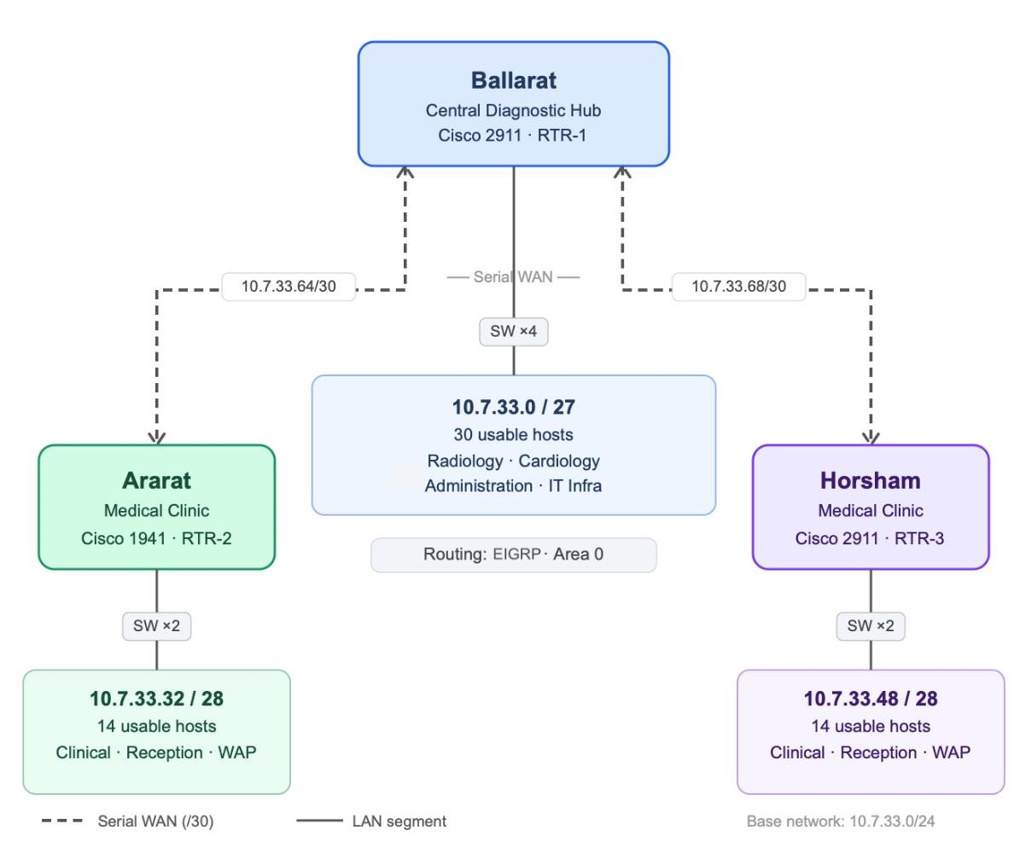

Modelling For Logical Design (Diagram)

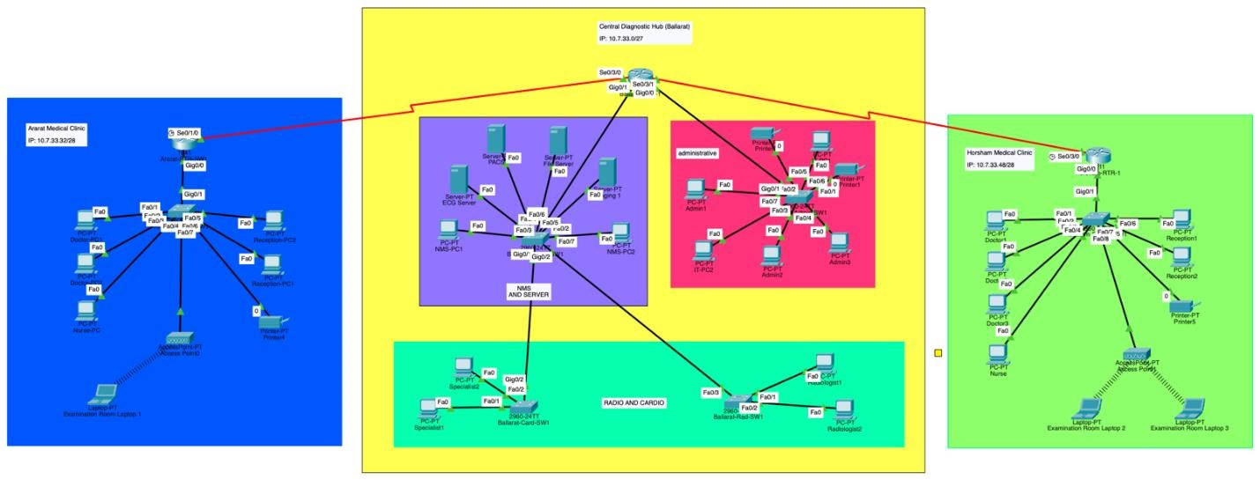
Design in Cisco Packet Tracer

2.2 Physical Network Topology
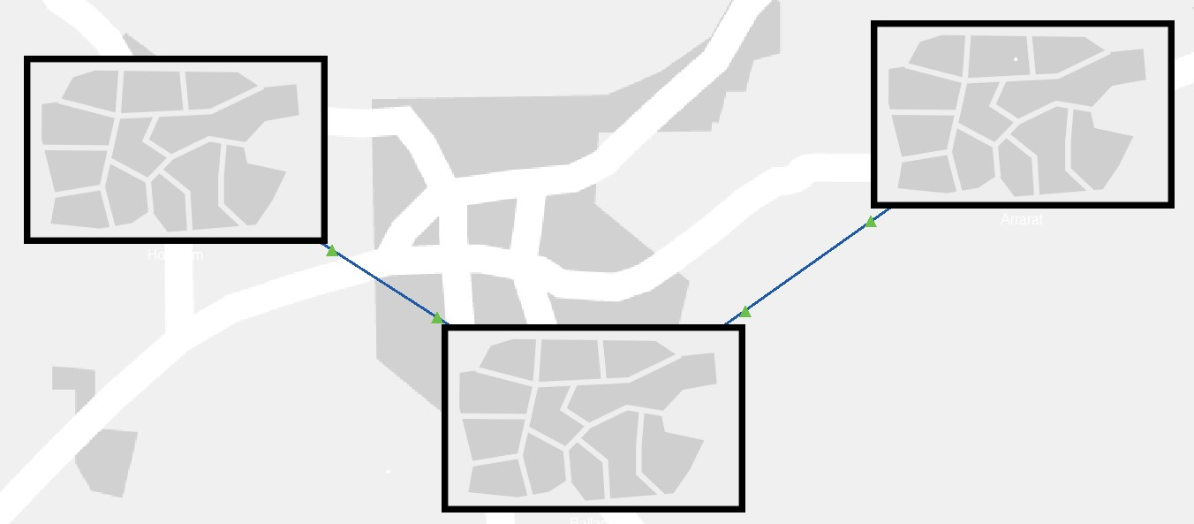
Physical Topology of the WHVS
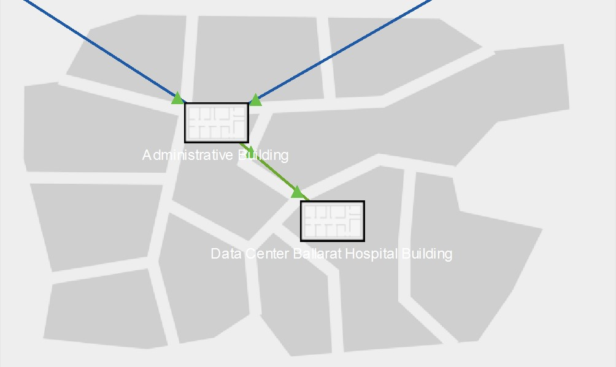
Physical Topology for Ballarat’s Site
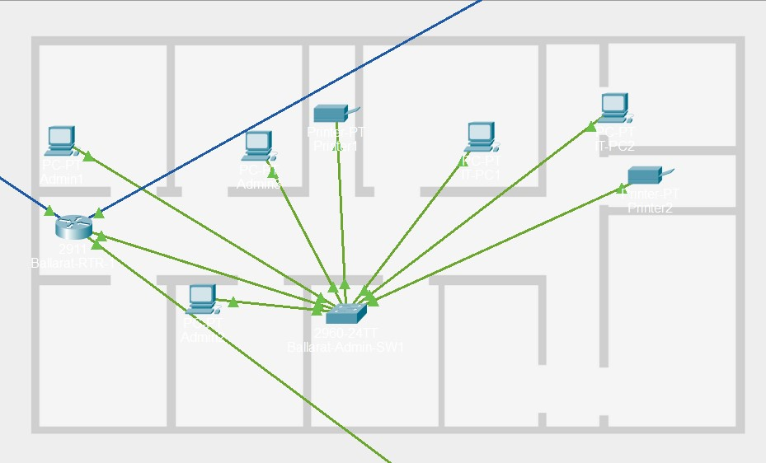
Data Centre Physical Topology (Ballarat)

2.3 Design Rationale

Routers were placed at each site to handle inter-site routing across the WAN serial links, with Cisco 2911 routers assigned to Ballarat and Horsham due to their higher device counts and traffic demands, and a Cisco 1941 at Ararat given its smaller scale. Each site was given Cisco 2960 switches to manage local LAN traffic, with Ballarat receiving four -- one per department. Wireless access points were installed at the Ararat and Horsham clinics, enabling greater flexibility and mobility for device usage throughout the facilities.

The design follows a two-layer hierarchical model. Switches form the access layer, connecting end devices such as workstations, printers, and servers, while routers operate at the core layer managing inter-site routing via EIGRP. A full distribution layer was not necessary given the scale of each site. Device naming follows a consistent location-based convention throughout, with each device labelled to reflect its site and role -- for example, Ballarat-Core-Router, AraratClinic-SW1, and Horsham-Clinic-AP -- keeping the network easy to navigate, troubleshoot, and hand over to other administrators.

3. Cisco Packet Tracer Implementation

3.1 Router Configuration Summary
• Security configurations (passwords, encryption)
The network uses three routers across the three sites, each chosen to match the size and traffic demands of its location. Ballarat and Horsham both run Cisco 2911 routers, which support multiple Gigabit Ethernet interfaces and serial WAN modules, making them well suited to handle the higher device counts and heavier traffic at those sites. At Ballarat specifically, the router manages traffic across four departments while maintaining two active WAN links to Ararat and Horsham at the same time. Ararat runs the lighter Cisco 1941, which is more than capable of handling a smaller clinic with fewer devices and a single WAN connection back to Ballarat, while keeping hardware costs reasonable across the overall design.

Interface IP Assignments
Router | Interface | IP Address | Role
Ballarat | Gi0/0 | 10.7.33.1 | LAN – Server/NMS Switch
Ballarat | Gi0/1 | 10.7.33.20 | LAN – Administration Switch
Ballarat | Se0/3/0 | 10.7.33.65 | WAN – Link to Ararat
Ballarat | Se0/3/1 | 10.7.33.69 | WAN – Link to Horsham
Ararat | Gi0/0 | 10.7.33.33 | LAN – Clinic Switch
Ararat | Se0/1/0 | 10.7.33.66 | WAN – Link to Ballarat
Horsham | Gi0/0 | 10.7.33.49 | LAN – Clinic Switch
Horsham | Se0/3/0 | 10.7.33.70 | WAN – Link to Ballarat

Routing Protocol

EIGRP was chosen as the routing protocol across all three sites. Unlike static routing, which requires manual updates every time something changes, EIGRP handles route updates automatically by exchanging routing information between the Ballarat, Ararat, and Horsham routers without any manual intervention. EIGRP was selected over OSPF because it converges faster and carries less processing overhead in a small three router network like this one. Since all three routers are Cisco devices, the fact that EIGRP is a Cisco proprietary protocol is not a limitation and makes it a natural fit for this environment. If a WAN link were to go down, EIGRP detects the failure and reroutes traffic quickly, reducing the risk of clinics losing access to the Ballarat hub during critical operations like telehealth consultations or medical imaging transfers.

Static routing was ruled out because it relies entirely on manual configuration, meaning any change to the network would require an administrator to update every router by hand, increasing the chance of human error and making the network harder to maintain over time. RIP was also considered but rejected due to its slower convergence time and limited scalability, both of which make it a poor fit for a network where downtime has real consequences for patient care.

Security Configurations

Basic security measures were applied to all three routers to control access and protect device configurations. An enable secret was configured to restrict access to privileged mode, ensuring that only authorised users can make changes to the router. Console passwords were set on each router to secure physical access via the console port, and VTY line passwords were configured to secure remote access connections over the network. Password encryption was enabled using the service password-encryption command, which encrypts all passwords stored in the running configuration so they cannot be read as plain text. A login banner was also added to each router displaying an authorised access warning to anyone attempting to connect. These configurations were verified on all three routers and saved using the write memory command to ensure settings persist after a restart.

3.2 Switch Configuration Summary
All three sites use Cisco 2960 switches to handle local LAN traffic. Ballarat has four switches, each named to reflect their department role -- Ballarat-NMS-SW1, Ballarat-Admin-SW1, Ballarat-Card-SW1, and Ballarat-Rad-SW1. Ararat and Horsham each have a single switch, named Ararat-Clinic-SW1 and Horsham-Clinic-SW1 respectively. At Ararat and Horsham, a wireless access point with respective custom SSIDs is also connected through the switch to support laptops and mobile devices within the clinic.

The switches were configured with their default settings, operating in access mode with no VLAN segmentation applied. As noted in the design rationale, VLANs were not required because each site already operates within its own dedicated subnet, which provides sufficient logical separation between sites without the added complexity of VLAN tagging. All active ports were connected and verified as up during testing, with unused ports remaining in a down state. Spanning Tree Protocol (STP) was running in PVST mode on all switches, which is the default behaviour on Cisco 2960 devices. This helps prevent network loops in the event of any unintended redundant connections within a site.

3.3 Network Connectivity Screenshots
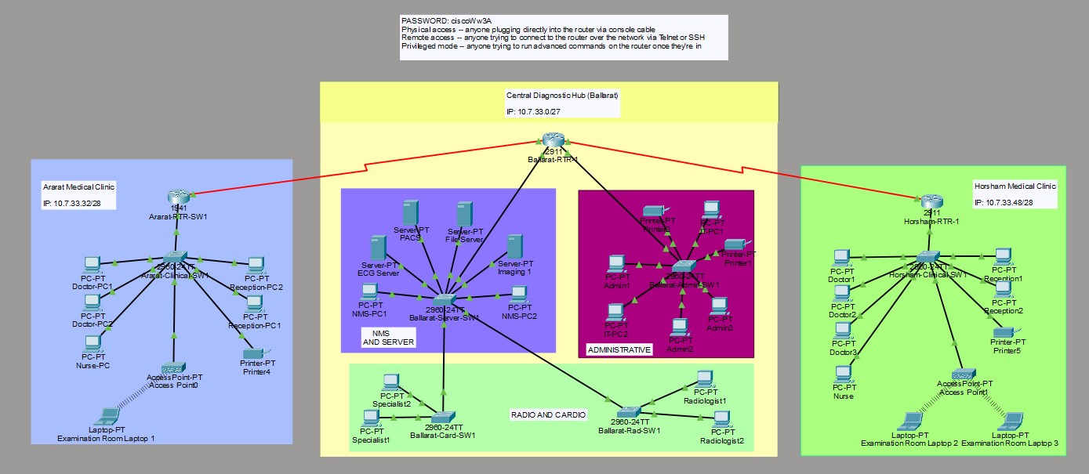

Overall Network Topology with green indicators

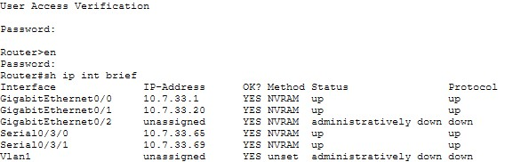

Router Interface Configuration (Ballarat)

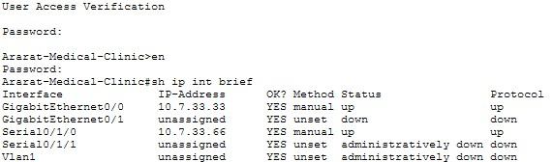

Router Interface Configuration (Ararat)
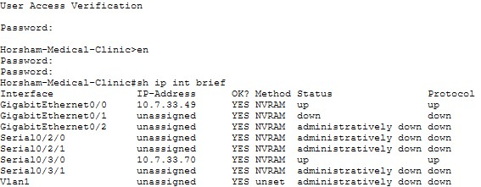

Router Interface Configuration (Horsham)

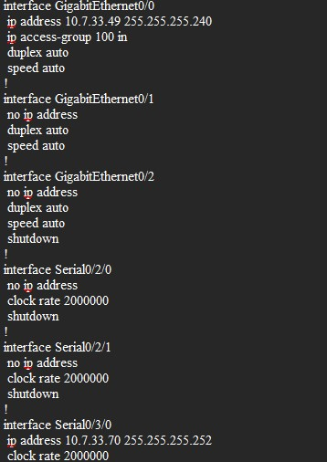

Sample Router Configuration File (Horsham)

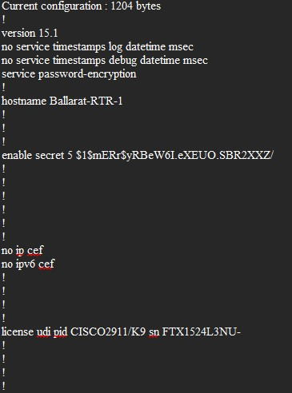

Sample Router Configuration File (Ballarat)

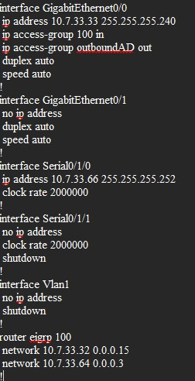
Sample Router Configuration File (Ararat)

4. Network Testing & Verification

4.1 Connectivity Testing Results
Test # | Source Device | Destination Device | Test  Method | Result | Evidence
1 | Ararat-PC1 | BallaratRadiologyServer | Ping | Success | 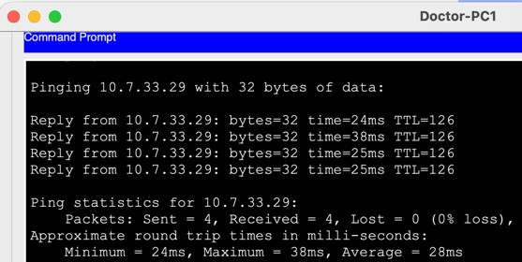
2 | Horsham-  Doctor-PC | Ballarat-  PACSSystem | Ping | Success | 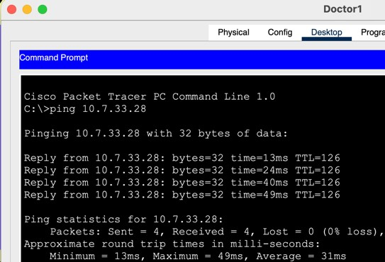
3 | Ararat-PC1 | Horsham-  Nurse-PC | Traceroute | Success | 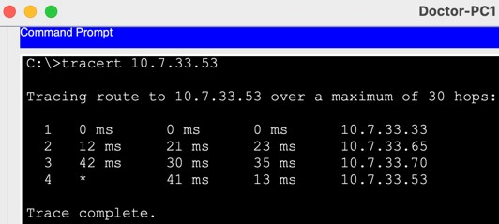
4 | Ararat -  Examination  Room  Laptop | Ballarat-FileServer | Traceroute | Success | 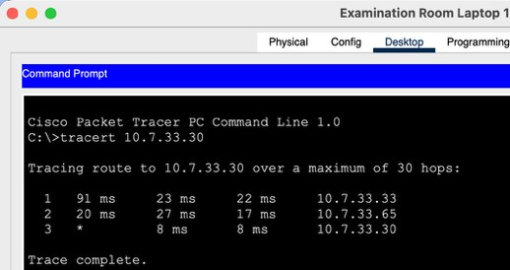
5 | Ararat -  Examination  Room  Laptop | Ballarat-  PACS-  Server | Ping | Success | 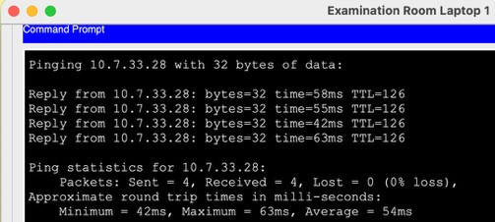

4.2 Routing Table Verification

4.2 Routing Table Verification
The routing tables were verified on all three routers using the show ip route command. The output confirmed that EIGRP had successfully established neighbour relationships between all sites and that each router had learned the correct routes to every subnet in the network.

Ballarat Router
Ballarat shows two directly connected LAN subnets (10.7.33.0/28 and 10.7.33.16/28) and two directly connected WAN links (10.7.33.64/30 and 10.7.33.68/30). It has also learned the Ararat LAN subnet (10.7.33.32/28) via Serial0/3/0 and the Horsham LAN subnet (10.7.33.48/28) via Serial0/3/1 through EIGRP, confirming full visibility of both branch sites from the hub.

Ararat Router
Ararat shows its own LAN subnet (10.7.33.32/28) and WAN link (10.7.33.64/30) as directly connected. It has learned both Ballarat LAN subnets and the Horsham LAN subnet via EIGRP through Serial0/1/0, meaning all traffic destined for Horsham routes through Ballarat as expected in a hub and branch topology.

Horsham Router
Horsham shows its own LAN subnet (10.7.33.48/28) and WAN link (10.7.33.68/30) as directly connected. Like Ararat, it has learned both Ballarat LAN subnets and the Ararat LAN subnet via EIGRP through Serial0/3/0, again routing through Ballarat as the central hub.
All three routing tables reflect the correct EIGRP learned routes with no missing or unexpected entries, confirming that the network is routing traffic correctly across all sites.
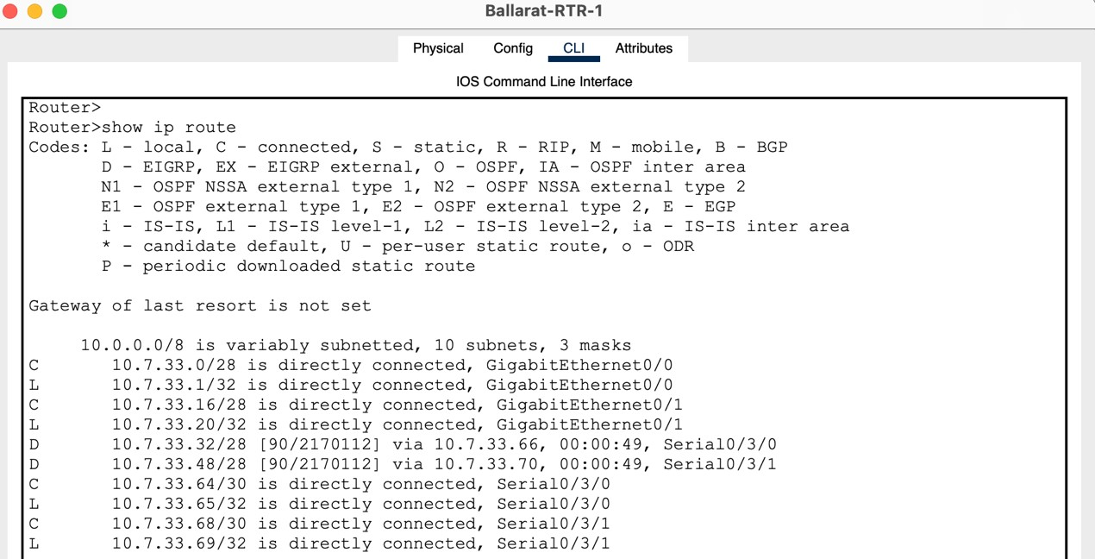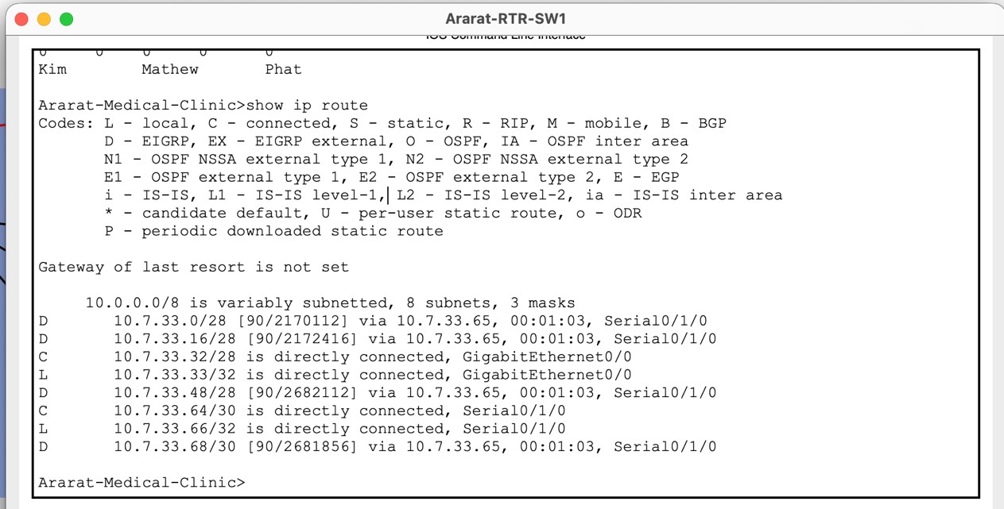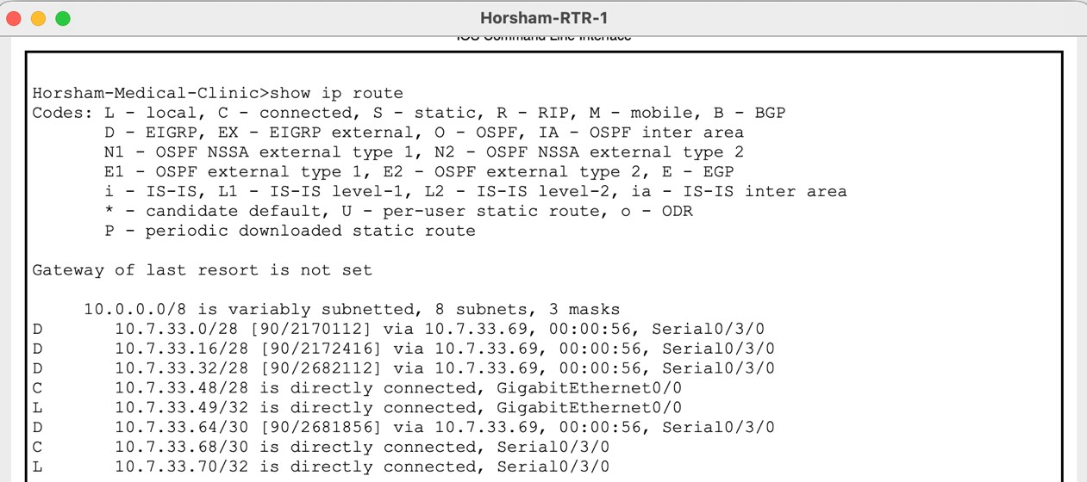

4.3 Troubleshooting Log
Issue # | Problem Description | Troubleshooting Steps | Resolution
1 | Laptops which connect to the local WAP were connecting to the other locations WAP in cisco packet tracer. | - – Investigate laptop wireless settings  - – Check WAP SSID  - – Rename WAP SSID from  “default” to respective locations “Ararat” or “Horsham” “Medical Clinic  WIFI”  - – Configure laptop wireless settings | Laptops stay connected to 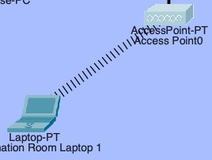respective locational WAP.  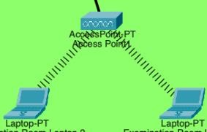
2 | IP address was misconfigured and the pinged address didn’t respond. | - – Investigate target device  IP settings  - – Fix assigned IP address  - – Ping again to test  - – Verify ping connection | IP address was fixed on the target device which resulted in a successful ping.
3 | A switch at Ballarat was not  forwarding traffic to connected devices | 1 - Checked physical cable connections 2 - Verified cables were plugged into the correct ports 3 - Checked port status using show ip interface brief | A cable was plugged into the wrong port on the switch. Moving it to the correct port restored connectivity to all affected devices.

5. Security & Best Practices

5.1 Network Security Measures
The network incorporates several security measures to protect device configurations and control access across all three sites. All three routers were secured with an enable secret password to restrict access to privileged mode, ensuring that only authorised personnel can make configuration changes. Console passwords were configured on each router to secure physical access via the console port, and VTY line passwords were set to control remote access connections over the network. Password encryption was enabled on all routers using the service password-encryption command, which ensures that passwords stored in the running configuration cannot be read as plain text by anyone who gains access to the configuration file. A login banner displaying an authorised access warning was also added to each router to notify anyone attempting to connect that access is restricted.

While the current implementation focuses on device-level access control, a healthcare network handling sensitive patient data would typically also require network-level security measures. In a production environment, this would include encrypted VPN tunnels over the WAN links to protect data in transit between sites and extend Access Control Lists (ACLs) on the routers to restrict which devices can communicate with sensitive systems such as the Ballarat PACS and imaging servers.

As mentioned above, the access control lists were added in both router place in Ararat and Horsham hospital building. Most noticeably, both devices from each side are unable to find the destination in administrative host. Extended access control list was configured to filter themself from send a request toward administrative inside Ballarat centre. However, administrative are allowed to request back to both side end devices when needed. End devices from outside Ballarat will be still function normally when sending request to another centre, this including PACS router in Ballarat. Furthermore, this will extend isolation in administrative from receiving malicious messages or potentially leaking sensitive information from the outsider request in their end device.

5.2 Bandwidth and Performance Considerations
The network was designed with the bandwidth demands of healthcare applications in mind. Medical imaging transfers, particularly DICOM images sent from the Ararat and Horsham clinics to the Ballarat PACS server, can be large and require reliable throughput to avoid delays in diagnosis. Telehealth video consultations also require consistent low-latency connections to remain usable in a clinical setting. The dedicated WAN serial links between Ballarat and each branch site provide stable point-to-point connections that are not shared with other traffic, which helps maintain predictable performance across the network.

The hub and branch topology also supports performance by centralising server resources at
Ballarat, meaning imaging and EHR data does not need to travel between branch sites directly.
All inter-site traffic routes through Ballarat, keeping the network path short and predictable. While Quality of Service (QoS) was not configured in this implementation, a production deployment would benefit from prioritising telehealth and imaging traffic over general administration traffic to ensure critical applications remain responsive during periods of high network load.

5.3 Redundancy and Fault Tolerance
The current network design uses single dedicated WAN serial links between Ballarat and each branch site, meaning that if either link went down the affected clinic would lose access to all centralised services including EHR access and specialist consultations until the link was restored. While EIGRP would detect the failure quickly, it cannot reroute traffic if there is no alternative physical path available.

To address this limitation, a recommended improvement would be to add a redundant serial link directly between Ararat and Horsham, creating a triangle topology across all three sites. This would mean that if the Ballarat to Ararat link went down, Ararat could still reach Ballarat by routing through Horsham, and vice versa. EIGRP would handle this rerouting automatically by detecting the failure and switching to the alternative path without any manual intervention. The additional link would be assigned the subnet 10.7.33.72/30, fitting cleanly into the remaining address space of the 10.7.33.0/24 base network. In a production healthcare environment, additional resilience could further be achieved through redundant routers or switches at the Ballarat hub given its critical role as the central point of the network.

5.4 Configuration Standards and Documentation
A consistent set of configuration standards was followed throughout the network implementation to ensure the design is easy to manage and hand over to other administrators. Device naming follows a location-based convention, with each device labelled to reflect its site and role. Routers are named after their site, for example Ballarat-Core-Router, Ararat-Medical-Clinic, and Horsham-Medical-Clinic. Switches are named to reflect both their site and department, for example Ballarat-NMS-SW1, Ballarat-Admin-SW1, Ararat-Clinic-SW1, and Horsham-ClinicSW1. This makes it straightforward to identify any device in the network at a glance without needing to refer to additional documentation.

Password policies were applied consistently across all three routers. An enable secret was configured on each router to restrict access to privileged mode, and separate passwords were set for both console and VTY line access. The service password-encryption command was applied network-wide to ensure all passwords stored in the running configuration are encrypted and cannot be read as plain text. A login banner was also added to each router to notify anyone attempting to connect that access is restricted to authorised personnel only. All configurations were saved using the write memory command to ensure settings persist after a restart

6. Individual Contribution Statements

[Le Kim Kha Nguyen] - Contribution Statement
I contributed mainly to the IP addressing and subnetting design for the project, including the implementation of VLSM to ensure efficient IP allocation across all sites. I was responsible for calculating subnet sizes, assigning network ranges, and verifying that the addressing scheme supported both current requirements and future growth. In addition, I assisted with designing the logical topology in Cisco Packet Tracer and participated in troubleshooting network connectivity issues during the testing phase. This included verifying communication between sites, identifying routing and configuration problems, and ensuring all devices operated correctly. I also contributed to improving the final report by revising several important sections and providing recommendations for the overall presentation structure and technical explanations used by the group.

[Hoang Gia Phat Nguyen] - Contribution Statement
I contributed significantly to the group project by taking a leading role in both the design and technical decision-making process. I was responsible for designing the physical layer of the network in Cisco Packet Tracer, ensuring that all devices were correctly connected and optimised for performance. I also identified an effective method to implement an extended access control list on one side only, which improved security while maintaining efficiency. In addition, I provided critical suggestions on the overall network model and routing approach, helping the group choose the most suitable design. I also contributed ideas for the structure and content of the upcoming presentation to ensure clarity and professionalism.

[Matthew Pomar] - Contribution Statement
My primary contribution to this project was developing and writing the technical design report, covering sections including the network design approach, VLSM justification, router and switch configuration summaries, routing protocol selection, security measures, and testing verification. I also configured and applied password security across all three routers in Packet Tracer, including enable secrets, console and VTY passwords, password encryption, and login banners to restrict unauthorised access. In addition to the report, I made edits to the network topology in Packet Tracer and assisted with verifying and testing connectivity between sites, including ping and traceroute tests across the three locations. I also contributed to preparing and delivering portions of the group presentation. Throughout the project I collaborated closely with my team members, sharing progress and coordinating tasks to ensure the overall design was consistent and complete.

Appendices

Appendix A: Router Configuration Files
[Include complete running-config exports from all routers as .txt files]
Router 1 – Ballarat-RTR-1
Ballarat_Router_Config.txt

Router 1 – Ararat-RTR-1
Ararat_Router_Config.txt

Router 1 - Horsham-Core-Router
Horsham_Router_Config.txt

Appendix B: Additional Network Diagrams
Diagrams are all within the document.

Appendix C: Presentation Slides
[Include final presentation slides used in Session 11 demonstration]

