**CS 362 Software Engineering II**

**Winter 2021**

**HW3**

**Kwanghyuk Kim**

Q1. S/W System A/B/C and Unit/Integration/System Testing

1. For System A

: Unit testing would be applied to the S/W system A. Unit testing tests individual components of the software and is usually performed by developers. This is not available for systems with many interdependencies between different modules, and it focuses on functional verification, so unit testing is suitable for the system A.

1. For System B

: System testing would be applied to the s/w system B. System testing refers to putting all product modules together and testing them as a whole at the final stage. This must meet customer and user requirements specifications and is usually performed by developers and testers. It focuses on system validation and consists of system and integration tests, not independent modules, so system testing is suitable for the system B.

1. For System C

: Integration testing would be applied to the s/w system C. Integration testing refers to testing the interface between two software units or modules. Integration testing is performed by the tester and after unit testing, it is built to simulate the interaction between the two modules to determine the accuracy of the interface, so integration testing is suitable for the system C.

Q2. 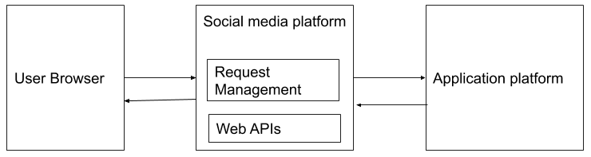

|  |  |
| --- | --- |
| Verification | Validation |
| * Does the social media platform meet the specifications of devices such as computers and mobiles used? What is the best system specification and does it meet the criteria for the lowest or highest specification? * Are there any legal terms such as copyright for images and videos, portrait rights, or the third party consent? Are they properly stated where they are easy to find? | * Has the login button to log in to user account located in the appropriate place? Does the platform have the option of logging in with an existing email such as Gmail or signing up when a user attempts to log in? Do each of the buttons work well when clicked without typos? * Are following or followers' accounts displayed appropriately? Do their updated feeds as photos and comments appear well in the proper position and size? |

|  |  |
| --- | --- |
| Functional tests | Non-functional tests |
| * Are the settings button and logout button designed to modify the user account after successful login? Are there buttons to edit information such as the user account image, ID, or password? Does the password characteristic include at least 8 digits long and includes uppercase letters, lowercase letters, numbers, or special characters? * Is it easy to access the following or followers’ accounts to see their feeds? Is there a search bar or sorting feature to search for followers' accounts? | * Are users notified within 2 seconds that they are done after modifying their user account? Is it possible within 3 seconds from the current page to the main screen after pressing the OK button? * Is the number of friends shown in your friend list 20? When the user scrolls down, are 20 additional people shown? Does the dynamic filter work within 2 seconds when scrolling? Are the feeds updated on the user's screen within 1 minute when followers' feeds are updated? |

Q3.

1. Write the program with error handled input.
2. Check in the following to Github:
   1. Leap year code without error handling
   2. Leap year code with error handling
   3. The flowchart in the readme.md file.

URL:

<https://github.com/kimkw88/hw3-cs362>

Q4.

|  |  |
| --- | --- |
| Testing in Agile | Testing in Waterfall |
| * Agile testing involves testing along with the development phase, so multiple testing levels overlap and all teams participate together. In agile testing, regression and acceptance testing are performed after every iteration.   For example, developers implement a restaurant system through the story of "As a restaurant customer, you can choose food from a menu to place an order," creating products at a constant rate in each sprint while improving products through customer feedback and testing. Agile testers constantly communicate with customers to build software and update functions according to customer requirements, such as changing menu formats, payment systems, and event creation. | * Waterfall testing is a task that is performed independently of development, and testing levels cannot overlap because it is only carried out one step at a time. In waterfall testing, regression and acceptance testing are performed only at the end.   For example, developers set a deadline for the restaurant system to be completed by the date the restaurant opens through consultation with customers in advance, and commit resources to develop the system. Testing is performed when the development phase is completed, until then, there should be no changes due to customer requests. This has the advantage of being less time consuming as the test is not performed at each iteration, but if a defect is found, it may take more time as multiple defects occur simultaneously. |