September 12, 2017

To Whom It May Concern,

Flight Risk Aerials is a delivery address only. I am the owner and president of both Flight Risk Aerials and Wellness On The Green, LLC. The legal business name is Wellness On The Green, not Flight Risk Aerials.

Sincerely,

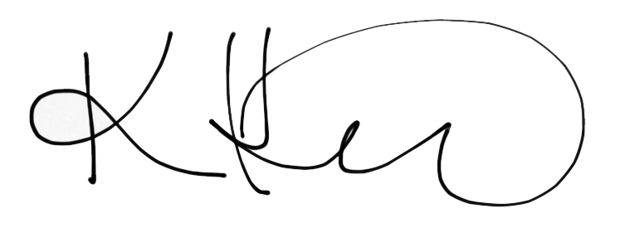

Kim Henry  
President