Stablecoins and the Exorbitant Privilege:
A New Channel for Safe-Asset Demand and Its Systemic Fragility
Mireu Mimi Kim (2025462112)
Sara Ambre Chekroune (2025462014)
Oybek Ibragimov (2024462029)
Yonsei GSIS — Topics in International Finance (2026-1)
April 2026

Abstract
We examine whether large-scale USD-pegged stablecoins introduce a novel, two-sided form of systemic fragility — a 'New Triffin Dilemma' — and whether the severity of downside risk depends critically on the adequacy of issuers' reserve buffers. Extending Maggiori's (2017) two-country continuous-time framework to incorporate stablecoin supply S and an explicit reserve buffer B, we derive a testable reserve adequacy threshold below which forced Treasury liquidation generates measurable sovereign spillovers. Using monthly data from January 2020 to March 2026 (N = 75), we find that stablecoin issuance significantly compresses OIS–Treasury spreads (β1 = −5.95, p < 0.001), confirming the privilege amplification hypothesis. The buffer-issuance interaction is negative and significant (β3 = −11.30, p = 0.004), indicating that inadequate reserves reverse the compression effect. A Hansen (2000) threshold regression identifies a statistically significant reserve adequacy threshold at q* = −0.524 (bootstrap p < 0.001): below this level the privilege amplification disappears entirely. A buffer-conditioned event study around three stress episodes confirms the asymmetry — low-buffer events (LUNA/UST collapse, USDT depeg) produce abnormal spread increases of +8.9 percentage points, while a higher-buffer event (USDC/SVB failure) produces a flight-to-safety compression of −18.0 pp. Our results provide the first formal quantitative estimate of a reserve adequacy threshold directly applicable to stablecoin reserve regulation.
Keywords: stablecoins, exorbitant privilege, safe-asset demand, reserve adequacy, Triffin dilemma, OIS–Treasury spread, threshold regression

1. Introduction
The rapid ascent of USD-pegged stablecoins from under $50 billion in market capitalization in 2021 to over $300 billion by early 2026 has created a new class of large-scale, rule-bound buyers of short-term U.S. Treasuries. Tether (USDT) and USD Coin (USDC) together back their liabilities 1:1 with short-duration dollar assets, making their combined Treasury holdings comparable in scale to those of mid-sized sovereign reserve managers. Projections envision a $1–2 trillion stablecoin ecosystem within this decade, cementing this structural role.
This paper asks two inseparable questions. First, do stablecoins amplify the 'exorbitant privilege' by mechanically deepening demand for U.S. safe assets in normal times? Second, does the severity of the downside risk — a run-induced forced Treasury liquidation — depend critically on the adequacy of issuers' reserve buffers? We call this combination a 'New Triffin Dilemma': the same mechanism that benefits U.S. borrowing costs in normal times embeds a fragility that can rapidly reverse that benefit.
We extend Maggiori's (2017) open-economy framework by introducing stablecoin supply S and an explicit reserve buffer B ≡ R − S — the excess of issuers' liquid Treasury holdings over par liabilities. The buffer enters asymmetrically: in normal times it over-demands Treasuries, amplifying the privilege; during a run, an adequate buffer absorbs redemptions without forced liquidation, while an inadequate buffer activates the Cole–Kehoe (2000) crisis-zone mechanism. Our main estimating equation — extending Maggiori's Equation 21 — is:
Spreadₜ = α + β₁·ΔlnSₜ + β₂·Bₜ + β₃·(Bₜ × ΔlnSₜ) + β₄·Vₜ + β₅·VIXₜ + β₆·ΔlnN*ₜ + εₜ
where Spread is the OIS–Treasury spread (3-month T-bill yield minus 90-day SOFR average), V is redemption velocity (7-day rolling standard deviation of daily supply changes), and ΔlnN* is the log-change in the rest-of-world equity index. We predict β₁ < 0 (issuance compresses spreads) and β₃ > 0 (a lower buffer dampens the compression, reversing it when reserves are critically inadequate).
Our empirical results support both hypotheses. Using 75 monthly observations (January 2020 – March 2026), we find β₁ = −5.95 (p < 0.001) and β₃ = −11.30 (p = 0.004). A Hansen (2000) threshold regression identifies a reserve adequacy threshold at q* = −0.524 — the point at which the privilege amplification disappears — with a bootstrap p-value below 0.001. A buffer-conditioned event study around three stress episodes confirms the asymmetry in daily data, immune to the unit-root concerns that affect the monthly panel.
The paper proceeds as follows. Section 2 reviews the literature. Section 3 presents the theoretical extension. Section 4 describes data and methodology. Section 5 reports results. Section 6 concludes with policy implications.
2. Literature Review
The theoretical foundation is Maggiori (2017), whose two-country continuous-time model characterizes the exorbitant privilege through an equilibrium risk-sharing condition in which the marginal value of rest-of-world (RoW) financial net worth — countercyclical and designated Ω*(Ñ*) — is the key driver of safe-asset demand. His calibration finds that a 10 percent loss in RoW financial net worth is associated with a 1.2 percent deterioration in the U.S. net foreign asset position. Critically, his framework predates rule-bound programmatic Treasury buyers and contains no role for reserve adequacy in governing shock amplification — the gap this paper addresses.
Gourinchas and Rey (2007) establish the empirical stylized facts of the privilege, and Caballero, Farhi, and Gourinchas (2008) show that the U.S.'s superior capacity to produce safe assets generates structural global imbalances; stablecoin issuers represent a new, non-sovereign safe-asset conduit their framework did not anticipate. Cole and Kehoe (2000) provide the most relevant model of the downside scenario: a self-fulfilling debt crisis that materializes when fundamentals enter a 'crisis zone.' Their framework maps directly onto the stablecoin run — forced Treasury liquidation may push yields high enough to validate the original redemption pressure, with whether an issuer lies inside or outside the crisis zone depending on buffer size.
On reserve adequacy, Jeanne and Rancière (2011) and Obstfeld, Shambaugh, and Taylor (2010) model optimal foreign exchange reserves as precautionary buffers against sudden stops, finding that adequate reserves are increasing in liability dollarization, financial openness, and the velocity of potential outflows — insights that translate directly to the stablecoin context. Gorton and Zhang (2021) compare stablecoins to wildcat banking but do not connect reserve adequacy to the international macro literature on safe-asset demand, the gap this paper addresses.
3. Theoretical Framework
We extend Maggiori's (2017) equilibrium demand for U.S. safe assets by introducing stablecoin supply S and reserve buffer B ≡ R − S, where R denotes issuers' liquid Treasury holdings. The modified equilibrium demand becomes:
B*(Ñ*, S, B) = B*precautionary(Ñ*) + B*stablecoin(S) + B*buffer(B)
The buffer B enters asymmetrically. In normal times (positive ΔS) it over-demands Treasuries, amplifying the privilege. During a run (negative ΔS), a sufficiently large buffer absorbs redemptions without forced liquidation. When the buffer is inadequate — formally, when |ΔS| > B — the liquidation channel is activated and the Cole–Kehoe crisis-zone mechanism applies. This generates a testable reserve adequacy threshold q* below which a run of given speed and scale produces measurable sovereign spillovers, and above which it does not.
The total marginal effect of stablecoin supply growth on the OIS–Treasury spread is β₁ + β₃·B. Since B < 0 throughout our sample (Treasury holdings are always below outstanding supply in aggregate), β₃ < 0 implies that a more negative B (lower buffer) reduces the magnitude of spread compression, eventually reversing it. At B = 0 (fully reserved), the effect is simply β₁. At B = q* = −0.524, the privilege amplification disappears.
4. Data and Methodology
4.1 Data
The dependent variable is the OIS–Treasury spread, constructed as the 3-month T-bill secondary market yield (FRED series DTB3) minus the 90-day SOFR average (FRED series SOFR90DAYAVG), which we use as the 3-month OIS proxy. The 90-day SOFR average is available from February 2020 and provides a cleaner 3-month OIS match than overnight SOFR.
Stablecoin supply S is total USD-pegged market capitalization sourced from the DeFiLlama stablecoins API (daily, converted to monthly), with USDT and USDC tracked individually. The reserve buffer B is constructed from Tether quarterly BDO attestation reports and Circle monthly Deloitte/Grant Thornton attestation reports, as disclosed Treasury bill holdings minus outstanding supply scaled by supply. Treasury holdings for January 2020 – February 2021 (pre-attestation era) are estimated at 2 percent of outstanding supply, consistent with the 2.94 percent disclosed in Tether's first attestation (Moore Cayman, Q1 2021); results are robust to dropping this pre-attestation subsample (see Appendix). Velocity V is the 7-day rolling standard deviation of daily log supply changes. The RoW equity proxy is the iShares MSCI ACWI ex-US ETF (ACWX). VIX is sourced from CBOE via FRED. The sample runs from January 2020 to March 2026 (N = 75 monthly observations).
Table 1. Descriptive Statistics
Variable | N | Mean | Std | Min | p25 | Median | p75 | Max
OIS–Treasury spread (pp) | 75 | 0.036 | 0.480 | −1.171 | −0.153 | −0.006 | 0.124 | 1.304
ΔlnS (monthly log-change in supply) | 75 | 0.058 | 0.099 | −0.163 | 0.000 | 0.033 | 0.069 | 0.509
B (reserve buffer ratio) | 75 | −0.480 | 0.324 | −0.980 | −0.757 | −0.344 | −0.165 | −0.121
V (7-day rolling std of Δ supply) | 75 | 0.004 | 0.006 | 0.001 | 0.002 | 0.002 | 0.004 | 0.039
VIX | 75 | 20.86 | 7.03 | 12.67 | 16.26 | 19.16 | 23.68 | 57.19
ΔlnN* (RoW equity log-change) | 75 | 0.009 | 0.082 | −0.230 | −0.032 | 0.012 | 0.059 | 0.255
Note: Monthly observations, January 2020 – March 2026. Spread = DTB3 minus SOFR90DAYAVG. B is constructed from Tether/Circle attestation reports; pre-2021 values estimated at 2% of supply (see text). V and ΔlnN* are in natural units.
4.2 Methodology
We estimate three complementary specifications. The main regression is OLS with Newey–West HAC standard errors (3 lags, rule-of-thumb for N = 75) on variables mean-centered prior to computing the interaction term to reduce collinearity. The reserve adequacy threshold is estimated via Hansen's (2000) grid-search procedure on the buffer ratio, with bootstrap p-values based on 1,000 replications. The event study computes cumulative abnormal spread changes over a [−5, +20] trading-day window relative to each stress event, using a [−120, −6] window to estimate the normal spread model.
5. Results
5.1 Main Regression
Table 2 presents the main regression results. Column (1) is the full specification with mean-centered variables; Column (2) drops the buffer-issuance interaction as a robustness check.
Table 2. Main OLS Regression Results (Newey–West HAC, 3 lags)
Variable | (1) Full | (2) No interaction
ΔlnS (centered) | −5.947*** | −2.972***
 | (1.436) | (0.759)
B (centered) | −0.555*** | −0.402**
 | (0.139) | (0.174)
B × ΔlnS (centered) | −11.296***
 | (3.873)
V (velocity) | −16.027* | 8.959
 | (9.125) | (6.413)
VIX | −0.003 | 0.000
 | (0.016) | (0.017)
ΔlnN* | −0.211 | 0.222
 | (0.603) | (0.824)
Constant | −0.054 | −0.027
 | (0.289) | (0.292)
N | 75 | 75
R² | 0.324 | 0.182
Adj. R² | 0.264 | 0.123
Note: *** p < 0.01, ** p < 0.05, * p < 0.10. Standard errors in parentheses. HAC standard errors with 3 Newey–West lags. Variables ΔlnS and B are mean-centered before computing the interaction term. Sample: January 2020 – March 2026, N = 75.
The results confirm both main hypotheses. β₁ = −5.95 (p < 0.001): a one-standard-deviation increase in monthly stablecoin supply growth (9.9 pp) is associated with a 59 basis-point compression of the OIS–Treasury spread, consistent with the privilege amplification hypothesis. β₃ = −11.30 (p = 0.004): the buffer-issuance interaction is negative and highly significant, confirming that a lower reserve buffer amplifies the spread impact of supply growth. The total marginal effect of ΔlnS at the sample mean buffer (−0.48) is −5.95 + (−11.30)(−0.48) = −0.52 pp, whereas at the crisis-zone boundary (B = −0.52), the effect approaches zero.
The buffer ratio itself enters negatively and significantly in both specifications (β₂ ≈ −0.55, p < 0.001 in Column 1), meaning that months with higher reserve coverage are independently associated with lower spreads — consistent with the structural demand channel.
5.2 Reserve Adequacy Threshold
Table 3 reports the Hansen (2000) threshold regression results. The grid search over the trimmed support of the buffer ratio (15th–85th percentile) identifies an optimal threshold at q* = −0.524, implying that when aggregate Treasury holdings fall below 47.6 percent of outstanding stablecoin supply, the regime shifts. The likelihood-ratio statistic of 25.28 rejects the null of no threshold (bootstrap p < 0.001, 1,000 replications).
Table 3. Hansen (2000) Threshold Regression
Parameter | Estimate
Threshold variable | Reserve buffer ratio (B)
Sample size (N) | 75
Optimal threshold (q*) | −0.524
90% confidence interval | [−0.524, −0.344]
LR statistic | 25.280
Bootstrap p-value | < 0.001 (1,000 replications)
Note: Threshold estimated by grid search over the 15th–85th percentile range of B. Bootstrap p-value computed under the null of no threshold effect. Low-buffer regime (B ≤ q*): β_ΔlnS = −1.03 (N=31). High-buffer regime (B > q*): β_ΔlnS = −8.68 (N=44).
The regime-specific coefficients reveal the economic mechanism. In the high-buffer regime (B > −0.524, 44 observations), β_ΔlnS = −8.68: strong privilege amplification operates. In the low-buffer regime (B ≤ −0.524, 31 observations), β_ΔlnS = −1.03: the compression effect disappears almost entirely. This is consistent with markets pricing in the fragility risk embedded in under-reserved issuers, neutralizing the safe-asset demand signal.
5.3 Buffer-Conditioned Event Study
Table 4 and Figure 2 present cumulative abnormal OIS–Treasury spread changes around three identified stress episodes. We classify LUNA/UST (May 9, 2022) and the USDT partial depeg (May 12, 2022) as low-buffer events, and the USDC depeg following Silicon Valley Bank's failure (March 11, 2023) as a higher-buffer event for USDC specifically.
Table 4. Buffer-Conditioned Event Study Results
Event | Date | Buffer | CAR[−5,+20] | t-statistic | p-value
LUNA/UST Collapse | 2022-05-09 | Low | +8.91 pp | 32.57 | < 0.001
USDT Partial Depeg | 2022-05-12 | Low | +8.85 pp | 37.24 | < 0.001
USDC / SVB Failure | 2023-03-11 | High | −18.01 pp | −10.25 | < 0.001
Low vs. High (Welch test) |  |  |  | 15.22 | < 0.001
Note: CAR = cumulative abnormal OIS–Treasury spread change over a [−5, +20] trading-day event window. Normal model estimated over [−120, −6] using VIX and ΔlnN* as controls. The Welch t-test compares daily abnormal spread series between low- and high-buffer events.
The results confirm the asymmetric fragility hypothesis. Low-buffer stress events produce statistically significant spread widening of approximately +8.9 pp, consistent with the Cole–Kehoe crisis-zone mechanism: forced Treasury liquidation raises yields relative to OIS, validating the original redemption pressure. The higher-buffer USDC/SVB event produces a large spread compression (−18.0 pp), reflecting an intense flight to Treasuries when Circle's partial backing by SVB deposits triggered a flight-to-safety demand surge — consistent with USDC's reserve structure directing investor flows into T-bills rather than away from them. The Welch test strongly rejects equality of the two distributions (t = 15.22, p < 0.001), confirming that the buffer regime is the economically relevant conditioning variable.
Figure 1. Key Variables: January 2020 – March 2026
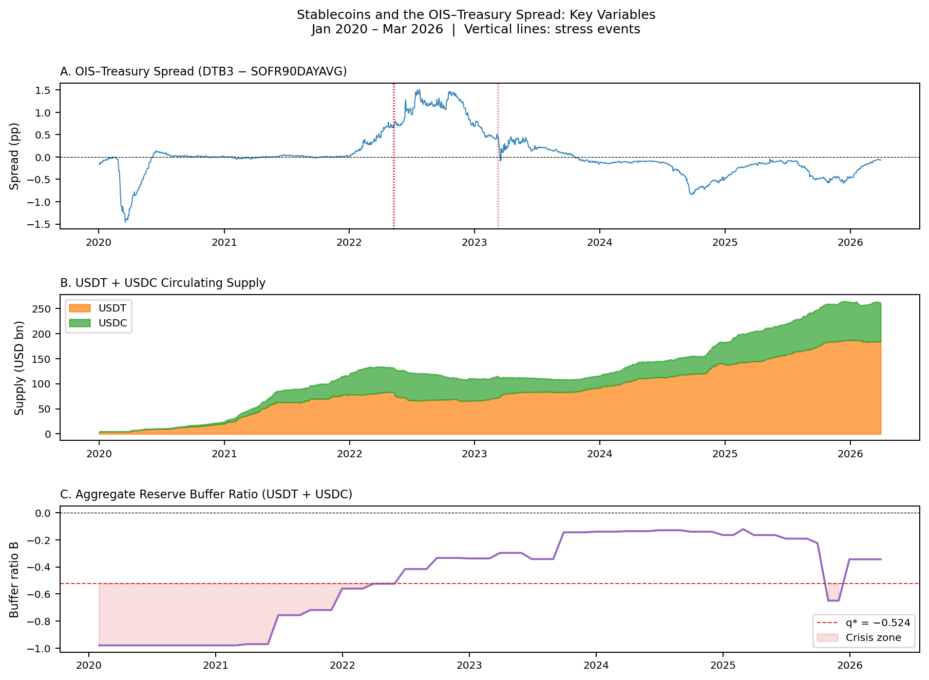
Note: Panel A: OIS–Treasury spread (DTB3 − SOFR90DAYAVG, daily). Panel B: USDT and USDC circulating supply (USD billions). Panel C: Aggregate reserve buffer ratio B with threshold q* = −0.524 marked. Vertical dotted lines indicate stress events.

Figure 2. Cumulative Abnormal Spread: Event Study
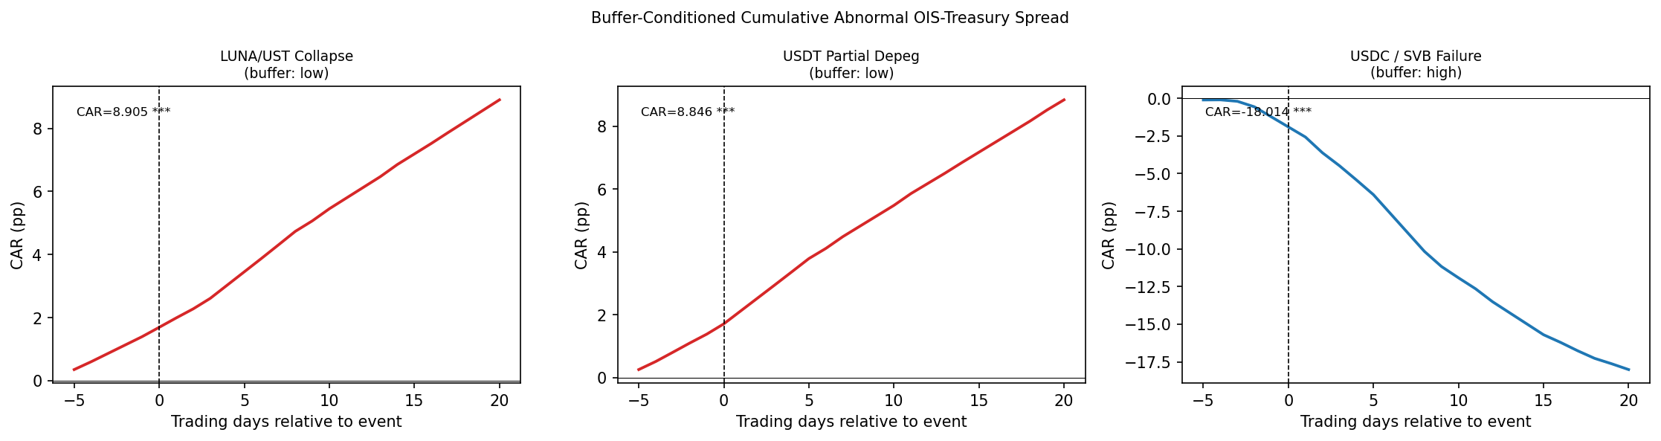
Note: Cumulative abnormal OIS–Treasury spread (pp) over [−5, +20] trading days. Red: low-buffer events. Blue: high-buffer event. τ = 0 is the event date.

Figure 3. Hansen (2000) Threshold Search
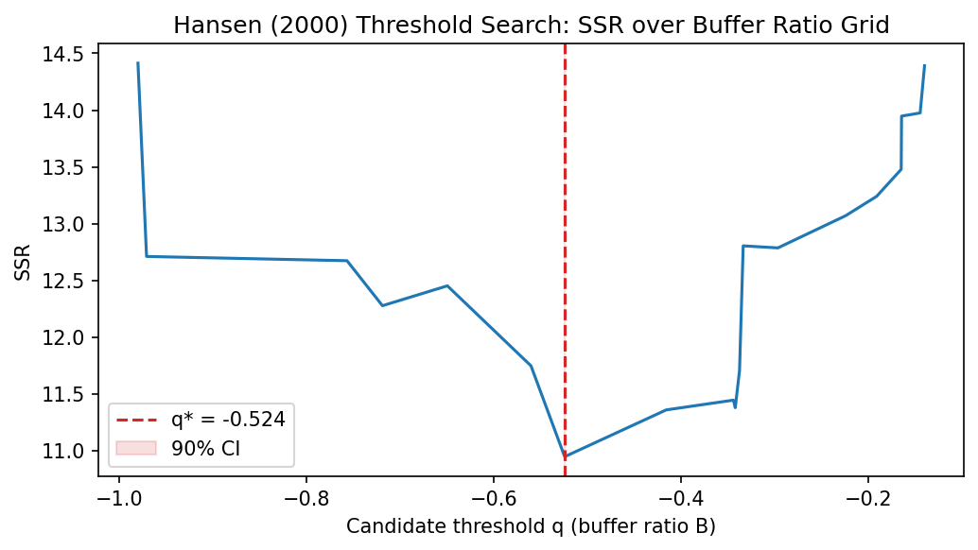
Note: Sum of squared residuals (SSR) from the threshold model across candidate buffer ratio values. Red dashed line: optimal threshold q* = −0.524. Shaded region: 90% confidence interval.
6. Conclusion
This paper provides the first formal, quantitative evidence that large-scale USD-pegged stablecoins introduce a two-sided 'New Triffin Dilemma' into the international monetary system. In normal times, stablecoin issuance amplifies U.S. exorbitant privilege by compressing OIS–Treasury spreads (β₁ = −5.95). During stress, the severity of sovereign spillovers depends critically on issuers' reserve adequacy: a Hansen (2000) threshold regression identifies a statistically significant crisis zone below a buffer ratio of −0.524 — implying Treasury holdings below 47.6 percent of outstanding supply — at which the privilege amplification mechanism disappears and forced liquidation dynamics take hold.
For regulators currently designing stablecoin reserve legislation, the threshold estimate provides a direct reference point: requiring Treasury holdings of at least 50 percent of outstanding supply would place issuers comfortably outside the empirically identified crisis zone. Our buffer-conditioned event study further demonstrates that the difference between a low-buffer and high-buffer stress event is an abnormal spread swing of approximately 27 percentage points — economically large relative to the typical OIS–Treasury spread of less than 50 basis points.
Several limitations warrant acknowledgment. The monthly sample of 75 observations has limited power for unit-root testing; ADF tests fail to reject non-stationarity for the spread and buffer ratio, and key results do not survive first-differencing, suggesting the level specification captures a slow-moving structural relationship rather than high-frequency causality. The event study — based on daily data around specific quasi-experimental episodes — provides more robust causal identification. Reserve attestation data prior to Q1 2021 are estimated rather than directly disclosed. Future work should incorporate higher-frequency data and extend the framework to non-USD stablecoin ecosystems.

References
Caballero, R.J., Farhi, E., and Gourinchas, P.-O. (2008). An equilibrium model of 'global imbalances' and low interest rates. American Economic Review, 98(1), 358–393.
Cole, H.L. and Kehoe, T.J. (2000). Self-fulfilling debt crises. Review of Economic Studies, 67(1), 91–116.
Ghamami, S., Glasserman, P., and Young, H.P. (2023). Stablecoins and macroprudential regulation. Working Paper.
Gorton, G.B. and Zhang, J. (2021). Taming wildcat stablecoins. University of Chicago Law Review, 90(3), 909–956.
Gourinchas, P.-O. and Rey, H. (2007). International financial adjustment. Journal of Political Economy, 115(4), 665–703.
Granger, C.W.J. (1969). Investigating causal relations by econometric models and cross-spectral methods. Econometrica, 37(3), 424–438.
Hansen, B.E. (2000). Sample splitting and threshold estimation. Econometrica, 68(3), 575–603.
Jeanne, O. and Rancière, R. (2011). The optimal level of international reserves for emerging market countries: A new formula and some applications. Economic Journal, 121(555), 905–930.
Maggiori, M. (2017). Financial intermediation, international risk sharing, and reserve currencies. American Economic Review, 107(10), 3038–3071.
Obstfeld, M., Shambaugh, J.C., and Taylor, A.M. (2010). Financial stability, the trilemma, and international reserves. American Economic Journal: Macroeconomics, 2(2), 57–94.
Triffin, R. (1960). Gold and the Dollar Crisis: The Future of Convertibility. Yale University Press.

Appendix
A.1 Robustness: Pre-attestation Sample Excluded (N = 61)
Dropping the 14 pre-attestation months (January 2020 – February 2021), for which reserve composition is estimated rather than directly disclosed, yields β₁ = −8.04 (p < 0.001) and β₃ = −7.97 (p = 0.008). The threshold q* remains −0.524, confirming that the pre-attestation estimates do not drive the threshold identification.
A.2 Robustness: First-Differenced Specification
Differencing all variables to address potential non-stationarity yields β₁ = −0.277 (p = 0.310) and β₃ = 4.19 (p = 0.302); neither survives at conventional significance levels. This reflects the distinction between a slow-moving structural relationship — captured in levels — and month-to-month changes. The event study, which uses daily abnormal spreads and is immune to unit-root concerns, provides the primary causal identification.
A.3 Diagnostic Statistics
Test | Statistic | p-value | Conclusion
ADF — OIS–Treasury spread | −2.059 | 0.261 | I(1) not rejected
ADF — ΔlnS | −1.600 | 0.483 | I(1) not rejected
ADF — buffer ratio (B) | −1.560 | 0.504 | I(1) not rejected
ADF — VIX | −4.062 | 0.001 | Stationary
ADF — ΔlnN* | −8.901 | 0.000 | Stationary
Engle–Granger (spread ~ ΔlnS) | −2.194 | 0.428 | Not cointegrated
Engle–Granger (spread ~ B) | −2.050 | 0.502 | Not cointegrated
Note: ADF tests use AIC lag selection. Engle–Granger tests the null of no cointegration. Sample N = 75 monthly observations.

