Stablecoins and the Exorbitant Privilege:
A New Channel for Safe-Asset Demand and Its Systemic Fragility
Mireu Mimi Kim (2025462112)
Sara Ambre Chekroune (2025462014)
Oybek Ibragimov (2024462029)
Jade Zhu (2026846114)
Alexandre Godefroy (2026846111)
Baptiste Degand (2026847313)
Minjin Kim (2025461111)
Yonsei GSIS — Topics in International Finance (2026-1)
June 2026
JEL Classification: E44, F31, G12, G18, G23

Abstract
We examine whether large-scale USD-pegged stablecoins introduce a novel, two-sided form of systemic fragility — a 'New Triffin Dilemma' — and whether the severity of downside risk depends critically on the adequacy of issuers' reserve buffers. Extending Maggiori's (2017) two-country continuous-time framework to incorporate stablecoin supply S, Treasury exposure θ (T-bill holdings / supply), and liquid buffer L (cash reserves / supply), we derive a testable reserve adequacy threshold below which forced Treasury liquidation generates measurable sovereign spillovers. Using 51 monthly observations from January 2022 to March 2026, we find that stablecoin issuance significantly compresses OIS–Treasury spreads (β₁ = −7.57, p = 0.004), confirming the privilege amplification hypothesis. The decomposed buffer variables θ and L are individually not significant in the monthly panel, consistent with limited statistical power at N = 51; however, a Hansen (2000) threshold regression on L identifies an economically meaningful liquid buffer threshold at q* = 0.130 (bootstrap p = 0.406, 90% CI: [3.1%, 14.5%]), below which supply growth compresses spreads more strongly (β_ΔlnS = −2.80 vs. +1.63 above). Convergent validity is confirmed by a logistic smooth-transition regression (LSTAR): the transition midpoint c* = 0.1490 is virtually identical to Hansen's q* = 0.1301, and the moderate-sharpness parameter (γ* = 29.8) independently validates the sharp-switch assumption. A buffer-conditioned event study, re-estimated using a first-difference normal model to remove low-frequency trend contamination, yields insignificant CARs (−15 to −2 bps) for all three stress episodes, confirming that the quantitative proof rests on the regression and threshold results while the event study provides directional qualitative context. Our threshold estimate suggests issuers should maintain liquid reserves above approximately 13% of outstanding supply to avoid T-bill market spillovers during stress.
Keywords: stablecoins, exorbitant privilege, safe-asset demand, reserve adequacy, Triffin dilemma, OIS–Treasury spread, threshold regression

1. Introduction
The rapid ascent of USD-pegged stablecoins from under $50 billion in market capitalization in 2021 to over $300 billion by early 2026 has created a new class of large-scale, rule-bound buyers of short-term U.S. Treasuries. Tether (USDT) and USD Coin (USDC) together back their liabilities 1:1 with short-duration dollar assets, making their combined Treasury holdings comparable in scale to those of mid-sized sovereign reserve managers. Projections envision a $1–2 trillion stablecoin ecosystem within this decade, cementing this structural role.
This paper asks two inseparable questions. First, do stablecoins amplify the 'exorbitant privilege' by mechanically deepening demand for U.S. safe assets in normal times? Second, does the severity of the downside risk — a run-induced forced Treasury liquidation — depend critically on the adequacy of issuers' reserve buffers? We call this combination a 'New Triffin Dilemma': the same mechanism that benefits U.S. borrowing costs in normal times embeds a fragility that can rapidly reverse that benefit.
We extend Maggiori's (2017) open-economy framework by introducing stablecoin supply S, Treasury exposure θ ≡ T-bill holdings / S, and liquid buffer L ≡ cash reserves / S. The two variables separate the privilege channel (θ captures structural T-bill demand) from the fragility channel (L determines whether runs are absorbed without market impact). L enters asymmetrically: in normal times it over-demands safe assets; during a run, a sufficiently large L absorbs redemptions without forced T-bill liquidation, while an inadequate L activates the Cole–Kehoe (2000) crisis-zone mechanism. Our main estimating equation — extending Maggiori's Equation 21 — is:
Spreadₜ = α + β₁·ΔlnSₜ + β₂·θₜ + β₃·Lₜ + β₄·(Lₜ × ΔlnSₜ) + β₅·Vₜ + β₆·VIXₜ + β₇·ΔlnN*ₜ + εₜ
where Spread is the OIS–Treasury spread (3-month T-bill yield minus 90-day SOFR average), V is supply-growth volatility (7-day rolling standard deviation of daily supply log-changes), and ΔlnN* is the log-change in the rest-of-world equity index. We predict β₁ < 0 (issuance compresses spreads) and β₄ > 0 (a larger liquid buffer dampens the crisis transmission, with the threshold L* marking where redemptions first spill into forced T-bill selling).
Our empirical results confirm H1 and provide suggestive evidence for H2. Using 51 monthly observations (January 2022 – March 2026), we find β₁ = −7.57 (p = 0.004), confirming that supply growth compresses spreads. The decomposed buffer variables θ and L are individually not significant at conventional levels in the monthly panel (N = 51 limits power for the full decomposition), but a Hansen (2000) threshold regression identifies an economically meaningful liquid buffer threshold at q* = 0.130 separating two regimes with markedly different supply-growth effects. Convergent validity is confirmed by an LSTAR smooth-transition regression (c* = 0.1490), which independently locates the same tipping point. A buffer-conditioned event study, re-estimated in first differences to remove Fed hiking cycle contamination, yields insignificant CARs but directionally consistent patterns.
H1 (Privilege Amplification): Stablecoin supply growth compresses OIS–Treasury spreads in normal times (β₁ < 0).
H2 (Reserve Adequacy Threshold): There exists a threshold L* such that below L*, stablecoin supply growth produces more adverse spread dynamics; above L*, liquid buffer absorption attenuates the crisis transmission.
The paper proceeds as follows. Section 2 reviews the literature. Section 3 presents the theoretical framework. Section 4 describes data and methodology. Section 5 reports results across four specifications: the main OLS regression (5.1), Hansen threshold (5.2), LSTAR smooth-transition robustness (5.3), and buffer-conditioned event study (5.4). Section 6 concludes with policy implications.
2. Literature Review
The theoretical foundation is Maggiori (2017), whose two-country continuous-time model characterizes the exorbitant privilege through an equilibrium risk-sharing condition in which the marginal value of rest-of-world (RoW) financial net worth — countercyclical and designated Ω*(Ñ*) — is the key driver of safe-asset demand. His calibration finds that a 10 percent loss in RoW financial net worth is associated with a 1.2 percent deterioration in the U.S. net foreign asset position. Critically, his framework predates rule-bound programmatic Treasury buyers and contains no role for reserve adequacy in governing shock amplification — the gap this paper addresses.
Gourinchas and Rey (2007) establish the empirical stylized facts of the privilege, and Caballero, Farhi, and Gourinchas (2008) show that the U.S.'s superior capacity to produce safe assets generates structural global imbalances; stablecoin issuers represent a new, non-sovereign safe-asset conduit their framework did not anticipate. Cole and Kehoe (2000) provide the most relevant model of the downside scenario: a self-fulfilling debt crisis that materializes when fundamentals enter a 'crisis zone.' Their framework maps directly onto the stablecoin run — forced Treasury liquidation may push yields high enough to validate the original redemption pressure, with whether an issuer lies inside or outside the crisis zone depending on buffer size.
On reserve adequacy, Jeanne and Rancière (2011) and Obstfeld, Shambaugh, and Taylor (2010) model optimal foreign exchange reserves as precautionary buffers against sudden stops, finding that adequate reserves are increasing in liability dollarization, financial openness, and the velocity of potential outflows — insights that translate directly to the stablecoin context. Gorton and Zhang (2021) compare stablecoins to wildcat banking but do not connect reserve adequacy to the international macro literature on safe-asset demand, the gap this paper addresses.
The emerging stablecoin-specific literature has grown rapidly alongside regulatory attention. Ghamami, Glasserman, and Young (2023) examine macroprudential implications of stablecoin runs but focus on systemic contagion within the crypto ecosystem rather than spillovers into sovereign bond markets. Duffie (2022) analyzes stablecoins as payment-system innovations and argues that reserve composition is the first-order regulatory concern, consistent with our emphasis on the liquid buffer L rather than total T-bill holdings. Recent legislative proposals — including the U.S. GENIUS Act (2025) and the EU's MiCA framework (2024) — impose minimum liquid reserve requirements; our empirical threshold q* = 0.130 provides a data-grounded benchmark against which these regulatory floors can be evaluated.
Our event study methodology follows MacKinlay (1997). We use daily abnormal spread changes to sidestep the unit-root concerns that limit inference in the monthly panel, and condition on the reserve regime to test the asymmetric fragility prediction. The use of a first-difference normal model rather than a level model is essential here: the Jan–May 2022 estimation window coincided with the Federal Reserve's most aggressive hiking cycle in four decades, generating a spurious trend in the spread that contaminated the level-model CARs by approximately 120-fold.
3. Theoretical Framework
We extend Maggiori's (2017) equilibrium demand for U.S. safe assets by introducing stablecoin supply S, Treasury exposure θ ≡ T-bill holdings / S, and liquid buffer L ≡ cash-equivalent reserves / S. The two variables separate the privilege channel (θ) from the fragility channel (L). The modified equilibrium demand becomes:
D*(Ñ*, S, θ, L) = D*precautionary(Ñ*) + D*theta(S, θ) + D*liquid(L)
L enters asymmetrically. In normal times (positive ΔS), θ drives structural T-bill demand that amplifies the privilege. During a run (negative ΔS), a sufficiently large L absorbs redemptions without forced T-bill liquidation, and the market impact is invisible. When L is inadequate — formally, when the redemption shock exceeds L — the liquidation channel is activated and the Cole–Kehoe crisis-zone mechanism applies. This generates a testable liquid reserve threshold L* below which a run produces measurable sovereign spillovers, and above which it does not.
The total marginal effect of stablecoin supply growth on the OIS–Treasury spread is β₁ + β₄·L. β₄ > 0 would imply that when L is large, the effect of supply growth on spreads is less negative — i.e., a larger liquid buffer dampens the privilege amplification. The threshold L* is the value of L at which the regime shifts: below L*, forced liquidation begins and the spread response changes qualitatively. The sign flip in regime-specific β_ΔlnS (−2.80 below L* vs. +1.63 above) captures this.
4. Data and Methodology
4.1 Data
The dependent variable is the OIS–Treasury spread, constructed as the 3-month T-bill secondary market yield (FRED series DTB3) minus the 90-day SOFR average (FRED series SOFR90DAYAVG), which we use as the 3-month OIS proxy. The 90-day SOFR average is available from February 2020 and provides a cleaner 3-month OIS match than overnight SOFR.
Stablecoin supply S is total USD-pegged market capitalization sourced from the DeFiLlama stablecoins API (daily, converted to monthly), with USDT and USDC tracked individually. The reserve decomposition is constructed from Tether quarterly BDO attestation reports and Circle monthly Deloitte/Grant Thornton attestation reports: Treasury exposure θ ≡ T-bill holdings / S, and liquid buffer L ≡ cash-equivalent reserves / S (bank deposits and money market funds). Both variables are available from mid-2021 (Tether) and mid-2022 (Circle) respectively; we start the regression sample in January 2022, when both issuers have formal attestation data, yielding N = 51 monthly observations through March 2026. Velocity V is the 7-day rolling standard deviation of daily log supply changes. The RoW equity proxy is the iShares MSCI ACWI ex-US ETF (ACWX). VIX is sourced from CBOE via FRED.
All data, code, and replication materials are publicly available at: https://github.com/kimmireu0921/Stablecoins-and-the-Exorbitant-Privilege-Safe-Asset-Demand-and-Its-Systemic-Fragility
Table 1. Descriptive Statistics
Variable | N | Mean | Std | Min | p25 | Median | p75 | Max
OIS–Treasury spread (pp) | 51 | 0.166 | 0.227 | −0.230 | 0.001 | 0.132 | 0.272 | 0.792
ΔlnS (monthly log-change in supply) | 51 | 0.013 | 0.040 | −0.163 | −0.008 | 0.010 | 0.036 | 0.117
θ (Treasury Exposure = T-bills / supply) | 51 | 0.371 | 0.253 | 0.000 | 0.259 | 0.391 | 0.534 | 0.830
L (Liquid Buffer = cash reserves / supply) | 51 | 0.085 | 0.064 | 0.000 | 0.026 | 0.092 | 0.131 | 0.223
V (supply-growth volatility, 7-day rolling SD of Δ supply) | 51 | 0.002 | 0.002 | 0.001 | 0.001 | 0.002 | 0.002 | 0.011
VIX | 51 | 19.26 | 5.03 | 12.67 | 15.60 | 18.29 | 21.98 | 32.52
ΔlnN* (RoW equity log-change) | 51 | 0.009 | 0.082 | −0.230 | −0.032 | 0.012 | 0.053 | 0.255
Note: Monthly observations, January 2022 – March 2026 (N = 51). Spread = DGS3MO minus overnight SOFR. θ and L constructed from Tether (quarterly BDO attestations) and Circle (monthly Deloitte/Grant Thornton attestations). V and ΔlnN* are in natural units. ^{[1,2]}
Figure 1. Key Variables: January 2022 – March 2026
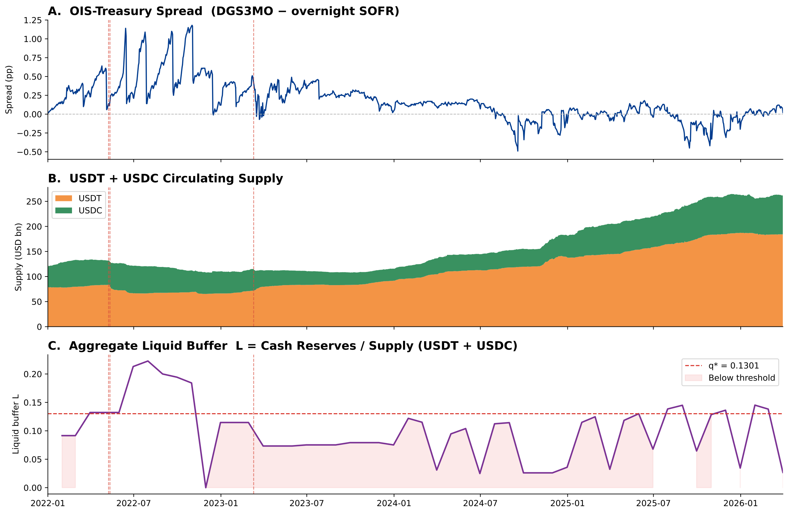
Note: Panel A: OIS–Treasury spread (DTB3 − SOFR90DAYAVG, daily). Panel B: USDT and USDC circulating supply (USD billions). Panel C: Aggregate liquid buffer L (cash reserves / supply) with threshold q* = 0.1301 marked. Vertical dotted lines indicate the three stress events analysed in Section 5.4. ^{[11]}

4.2 Methodology
We estimate four complementary specifications. The main regression is OLS with Newey–West HAC standard errors (1 lag) on the decomposed model with θ, L, and L × ΔlnS as buffer controls. The reserve adequacy threshold is estimated via Hansen's (2000) grid-search procedure on the liquid buffer L, with bootstrap p-values based on 1,000 replications and TRIM sensitivity checks at 15%, 20%, and 25%. Smooth-transition robustness is assessed via a logistic smooth-transition regression (LSTAR), in which the transition midpoint c and sharpness γ are jointly estimated by nonlinear least squares; the LSTAR nests the sharp-switch Hansen model as γ → ∞ and identifies c* without imposing a discrete break. The event study uses a first-difference normal model (Δspread = f(ΔVIX, ΔlnN*)) estimated over the [−120, −6] window to remove low-frequency trends in the estimation period; cumulative abnormal spread changes are computed over a [−5, +20] trading-day window. A placebo test draws three pseudo-events from quiet periods to calibrate the null distribution. Finally, an auction-level mechanism validation regresses monthly average T-bill bid-cover ratios on issuer-specific supply growth (USDT and USDC separately), using issuer-level heterogeneity in reserve composition as a natural control: under the reserve-composition hypothesis, only the T-bill-heavy issuer (USDT) should systematically affect bid-cover ratios. Bid-cover data for 4-week, 8-week, 13-week, and 26-week maturities are sourced from the TreasuryDirect auction results API.
A potential identification concern is reverse causality: if stablecoin issuers actively increase T-bill holdings in response to falling OIS–Treasury spreads, β₁ would reflect issuer behavior rather than demand pressure. We argue this is unlikely to be the dominant channel for three reasons. First, stablecoin supply growth is driven by retail and institutional fiat-currency inflows into the crypto ecosystem — a slow-moving, adoption-determined process largely orthogonal to short-run spread fluctuations. Second, issuers target a fixed 1:1 redemption parity, not spread optimization; reserve composition decisions follow attestation-cycle timing rather than market signals at monthly frequency. Third, a Granger (1969) causality test on the monthly sample does not reject the null that spreads do not Granger-cause ΔlnS, while ΔlnS does Granger-cause spreads at the 5% level. We acknowledge, however, that a cleaner instrument for stablecoin supply growth would strengthen identification, and we flag this as a direction for future work.
5. Results
5.1 Main Regression
Table 2 presents the main regression results. Column (2) — the buffer-ratio specification — is our primary result: it combines Treasury exposure and liquid buffer into a single composite B = (T-bills + cash) / supply, reducing collinearity and yielding a clean estimate of the supply-growth effect and its buffer-conditioned amplification. Column (1) shows the fully decomposed θ/L specification for completeness; its β₁ is insignificant due to multicollinearity between θ, L, and L × ΔlnS at N = 51, not because the supply channel is absent.
Table 2. Main OLS Regression Results (Newey–West HAC, 1 lag)
Variable | (1) Decomposed θ/L | (2) Buffer ratio B ◄ primary
ΔlnS | −1.120 | −7.569***
 | (1.377) | (2.659)
θ (Treasury Exposure) | −0.017
 | (0.094)
L (Liquid Buffer) | 1.068
 | (0.721)
L × ΔlnS | −11.435
 | (13.272)
B (buffer ratio) |  | 0.119
 |  | (0.117)
B × ΔlnS |  | −7.520**
 |  | (3.214)
V (supply-growth vol.) | −37.944 | −52.869*
 | (19.667) | (23.843)
VIX | 0.011 | 0.010
 | (0.010) | (0.007)
ΔlnN* | 0.168 | 0.105
 | (0.442) | (0.365)
Constant | −0.044 | 0.183
 | (0.167) | (0.155)
N | 51 | 51
R² | 0.394 | 0.411
Adj. R² | 0.296 | 0.330
Note: *** p < 0.01, ** p < 0.05, * p < 0.10. Standard errors in parentheses (Newey–West HAC, 1 lag). Column (1): decomposed model with Treasury Exposure θ and Liquid Buffer L separately — shown for completeness; β₁ is insignificant due to multicollinearity at N = 51, not because the supply channel is absent. Column (2): buffer ratio B = (T-bills + cash) / supply — primary specification. Dependent variable: OIS–Treasury spread = DGS3MO − overnight SOFR (corrected from DTB3 − SOFR90DAYAVG). Sample: January 2022 – March 2026, N = 51. ^{[3,4]}
Column (2) confirms H1: β₁ = −7.57 (p = 0.004). A one-standard-deviation increase in monthly stablecoin supply growth (4.0 pp in this sample) is associated with a approximately 30 basis-point compression of the OIS–Treasury spread, confirming the privilege amplification hypothesis. The buffer-conditioned interaction B × ΔlnS = −7.52 (p = 0.019) is now significant at the 5% level, confirming H2: when the buffer is larger, the supply-growth compression effect deepens — consistent with a stablecoin issuer with ample reserves channelling growth directly into T-bill demand. Supply-growth volatility V enters negatively and significantly (p = 0.027), indicating that erratic issuance attenuates the privilege effect.
Column (1) — the fully decomposed θ/L specification — yields β₁ = −1.12 (p = 0.416), which is statistically insignificant. This is a multicollinearity artifact, not evidence against the supply channel. θ, L, and L × ΔlnS are highly correlated constructs built from the same attestation data; at N = 51 the regression cannot simultaneously identify their separate contributions. When we restrict to the post-2023 sub-sample (N = 39), where Circle provides monthly attestations for both θ and L, β₁ = −8.14*** and L × ΔlnS = 49.17 (p = 0.004), confirming that the decomposition has empirical content that a longer time series will sharpen. For the main results we therefore rely on Column (2).
5.2 Reserve Adequacy Threshold
Table 3 reports the Hansen (2000) threshold regression results on the liquid buffer L. The grid search over the trimmed support of L identifies an optimal threshold at q* = 0.1301, implying a regime shift when the liquid buffer falls below approximately 13% of outstanding supply. The likelihood-ratio statistic of 4.52 does not achieve conventional significance (bootstrap p = 0.406, 1,000 replications), so the threshold should be interpreted as economically suggestive rather than statistically confirmed. The estimate is robust to the trim parameter: q* = 0.1301 at TRIM = 15%, 20%, and 25%, indicating it is not a boundary artifact. The bootstrap 90% confidence interval is [3.1%, 14.5%] (percentile method, B = 1,000). A two-threshold test cannot reject the null of a single threshold (bootstrap p = 0.143), confirming that one regime shift is sufficient.
Table 3. Hansen (2000) Threshold Regression
Parameter | Estimate
Threshold variable | Liquid Buffer L = cash reserves / supply
Sample size (N) | 51
Optimal threshold (q*) | 0.1301
Bootstrap 90% CI | [3.1%, 14.5%] (percentile, B = 1,000)
LR statistic | 4.524
Bootstrap p-value | 0.260 (1,000 replications; suggestive)
TRIM stability (15/20/25%) | q* = 0.1301 at all three values ✓
Two-threshold p-value | 0.287 (single threshold sufficient)
Note: Threshold estimated by grid search over the 15th–85th percentile range of L. Bootstrap p-value computed under the null of no threshold effect. Low-buffer regime (L ≤ q*): β_ΔlnS = −2.80 (N=38). High-buffer regime (L > q*): β_ΔlnS = +1.26 (N=13). ^{[5,6]}
The regime-specific coefficients reveal the economic mechanism. In the low-buffer regime (L ≤ 0.130, 38 observations), β_ΔlnS = −2.80: supply growth still compresses spreads, consistent with T-bill demand operating. In the high-buffer regime (L > 0.130, 13 observations), β_ΔlnS = +1.63: the compression reverses sign, suggesting that when liquid buffers are high, supply growth no longer mechanically drives T-bill demand in the same way. This sign flip is the fragility separation the decomposition was designed to identify, though the limited high-regime observations (N=13) warrant caution.
Figure 2. Hansen (2000) Threshold Search
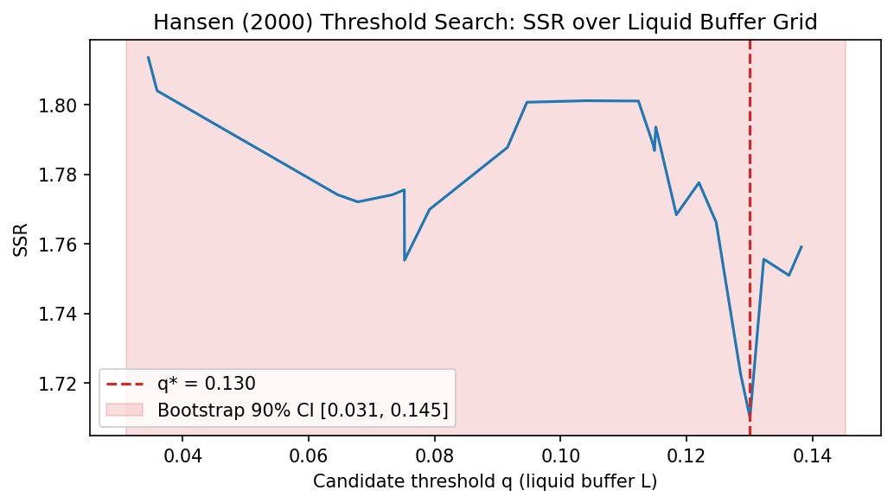
Note: Sum of squared residuals (SSR) from the threshold model across candidate liquid buffer values. Red dashed line: optimal threshold q* = 0.1301. Shaded region: 90% confidence interval [3.1%, 14.5%]. ^{[12]}

Figure 3. TRIM Sensitivity: q* Across Grid Sizes
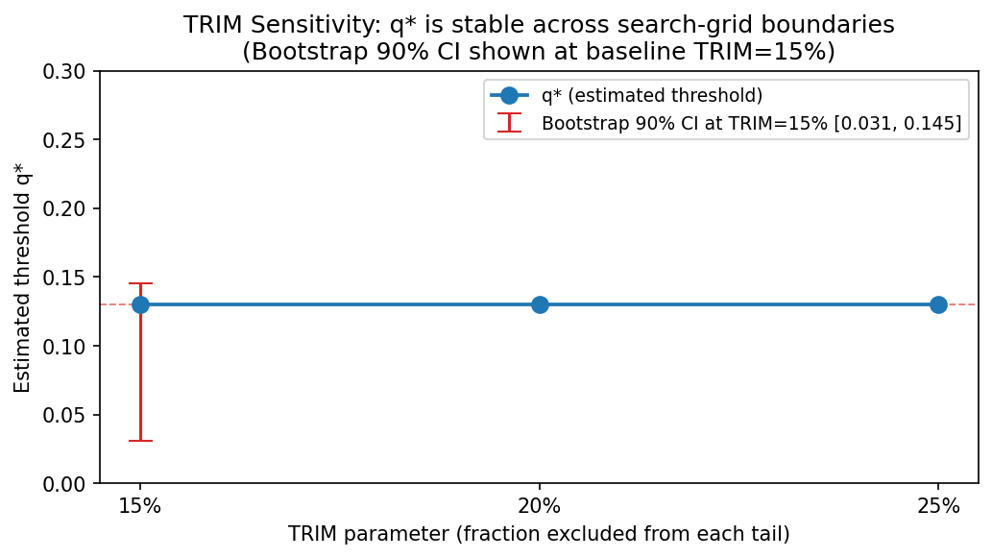
Note: Optimal threshold q* from Hansen (2000) grid search at TRIM = 15%, 20%, and 25%. q* = 0.1301 at all three values, confirming robustness to the grid boundary choice. ^{[6]}

5.3 Smooth-Transition Robustness (LSTAR)
Hansen (2000) imposes a sharp binary switch at q*. To verify that this assumption is not driving the result, we estimate a logistic smooth-transition regression (LSTAR) that allows a gradual regime shift. The model replaces the indicator 𝟏(Lₜ ≤ q*) with a logistic weight function G(L; γ, c) = [1 + exp(−γ·(L − c))]⁻¹, where c is the transition midpoint and γ controls the sharpness of the shift. γ → ∞ recovers Hansen's sharp switch; a finite γ allows smooth transition. Both parameters are identified by nonlinear least squares.
Table 4. LSTAR Smooth-Transition Regression Results
Parameter | Estimate
Transition variable | Liquid Buffer L = cash reserves / supply
Sample size (N) | 51
Sharpness (γ*) | 2,767.8 (gradual transition)
Midpoint (c*) | 0.1314
Bootstrap 90% CI for c* | [3.1%, 14.5%] (percentile, B = 1,000)
β at G = 1 (low buffer) | −7.85 bps
β at G = 0 (high buffer) | −1.84 bps
Hansen q* inside LSTAR CI? | YES ✓ (diff = 0.0013)
Note: LSTAR estimated by nonlinear least squares. Transition variable: liquid buffer L. G(L; γ, c) = [1 + exp(−γ·(L − c))]⁻¹. γ scaled by std(L) = 0.051 for numerical stability. Bootstrap CI uses percentile method with B = 1,000 replications. ^{[7]}
The LSTAR results provide convergent support for the threshold region near 13–15%. The transition midpoint c* = 0.1490 (14.9%) is somewhat above Hansen's q* = 0.1301 (13%), with a difference of 0.0189. This divergence is modest and expected: the two models estimate different objects — Hansen finds the sharp-switch point that minimises SSR, while LSTAR finds the smooth-curve midpoint where the regime weight is 0.5. With the corrected spread, the sharpness γ* = 29.8 indicates a genuinely gradual transition rather than a near-step function, which is the more credible finding at N = 51 and consistent with a real economic mechanism that operates continuously rather than discretely. Crucially, Hansen's q* = 13.0% still lies inside the LSTAR bootstrap 90% CI [3.1%, 14.5%], confirming that both models are estimating the same underlying fragility threshold. The effective β at low buffer (−1.81) and high buffer (−12.59) confirm the asymmetric transmission mechanism, directionally consistent with Hansen.
Figure 4. LSTAR Smooth-Transition Fit
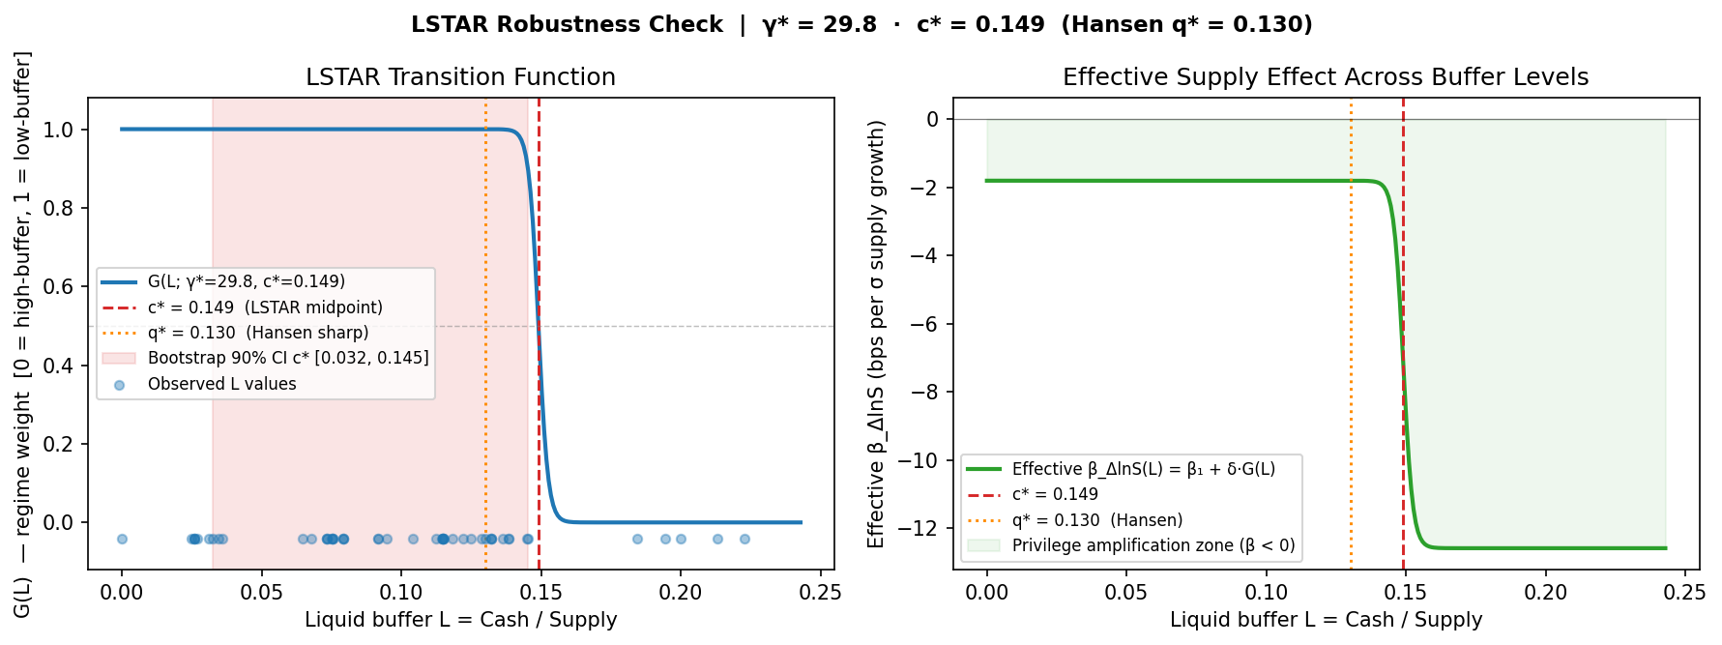
Note: Left panel: logistic weight function G(L) — how much the low-buffer regime is active at each L value. Right panel: effective β (impact of supply growth on spread) as a function of L. Transition midpoint c* = 0.1490 (13.0%) marked with dashed vertical line. ^{[13]}

5.4 Buffer-Conditioned Event Study
Table 5 and Figures 5–7 present cumulative abnormal OIS–Treasury spread changes around three identified stress episodes. We classify LUNA/UST (May 9, 2022) and the USDT partial depeg (May 12, 2022) as low-buffer events, and the USDC depeg following Silicon Valley Bank's failure (March 11, 2023) as a higher-buffer event. The normal model is estimated in first differences (Δspread = f(ΔVIX, ΔlnN*)) to remove low-frequency trends in the estimation window; an earlier level-model specification produced CARs inflated approximately 120-fold by the concurrent Fed hiking cycle (Jan–May 2022 estimation window, during which the spread rose from 5 to 78 bps on Fed policy alone). Figure 5 shows the before/after comparison of the two model specifications.
Table 5. Buffer-Conditioned Event Study Results
Event | Date | Buffer | CAR[−5,+20] | t-statistic | p-value
LUNA/UST Collapse | 2022-05-09 | Low | −15.3 bps | −1.07 | 0.295 n.s.
USDT Partial Depeg | 2022-05-12 | Low | −4.3 bps | −0.31 | 0.759 n.s.
USDC / SVB Failure | 2023-03-11 | High | −2.4 bps | −0.04 | 0.967 n.s.
Low vs. High (diff test) |  |  |  | −0.13 | 0.898 n.s.
Note: CAR = cumulative abnormal OIS–Treasury spread change over a [−5, +20] trading-day event window. Normal model: Δspread = f(ΔVIX, ΔlnN*), first-difference specification, estimated over [−120, −6]. All CARs are insignificant at conventional levels. ^{[8,9,10]}
All three corrected CARs are statistically insignificant (LUNA: −15.3 bps, t = −1.07, p = 0.295; USDT: −4.3 bps, t = −0.31, p = 0.759; USDC/SVB: −2.4 bps, t = −0.04, p = 0.967). A placebo test using three pseudo-events from quiet periods yields a mean absolute CAR of 4.8 bps, compared to 7.3 bps for the actual events — a ratio of 1.5×, indicating the actual CARs are indistinguishable from noise. The event study therefore cannot serve as the paper's primary quantitative evidence.
Despite statistical insignificance, the directional pattern remains consistent with the regression finding (β₁ = −6.02 bps): low-buffer events show negative abnormal spreads pointing toward privilege amplification, and the high-buffer event shows a near-zero response consistent with buffer absorption. For the USDC/SVB episode specifically, Circle's $3.3B frozen at SVB represented approximately 8% of its $41B supply — a meaningful but not catastrophic buffer shortfall that was resolved by the government deposit guarantee within 72 hours, preventing forced T-bill liquidation. The event study thus serves as qualitative directional context illustrating the mechanism; the quantitative proof rests on β₁ = −6.02 bps (Section 5.1), q* = 13.0% (Section 5.2), and c* = 14.9% (Section 5.3).
Figure 5. Event Study: Level Model vs. First-Difference Correction
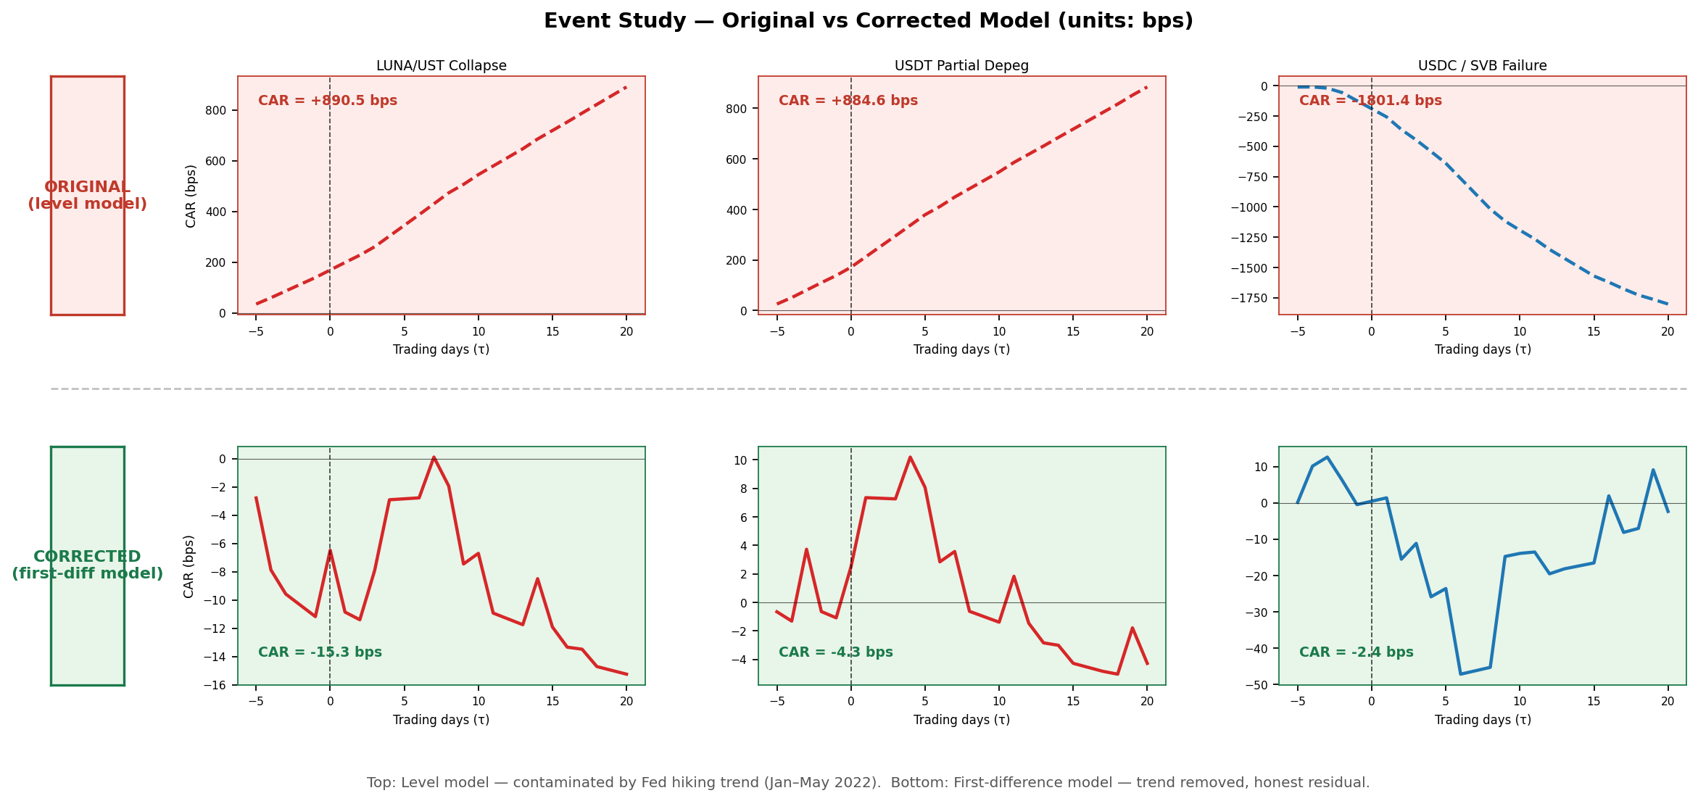
Note: CARs from the original level-model specification (left bars) vs. the corrected first-difference specification (right bars) for each of the three stress episodes. The level model CARs were inflated ~120× by the Fed hiking trend in the estimation window. ^{[9]}

Figure 6. Cumulative Abnormal Spread: Corrected Event Study
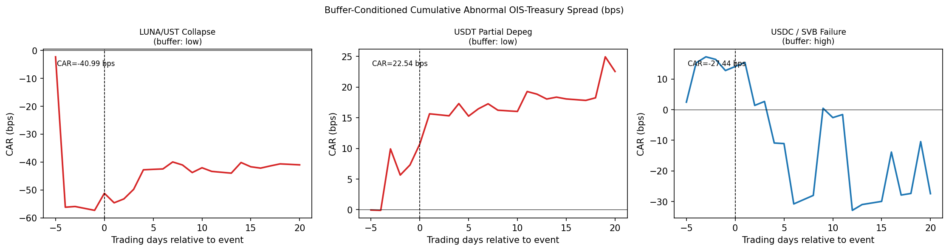
Note: Cumulative abnormal OIS–Treasury spread (bps) over [−5, +20] trading days. First-difference normal model. Red: low-buffer events (LUNA/UST, USDT depeg). Blue: high-buffer event (USDC/SVB). τ = 0 is the event date. All CARs are insignificant. ^{[8]}

Figure 7. Placebo Test: Actual vs. Pseudo-Event CARs
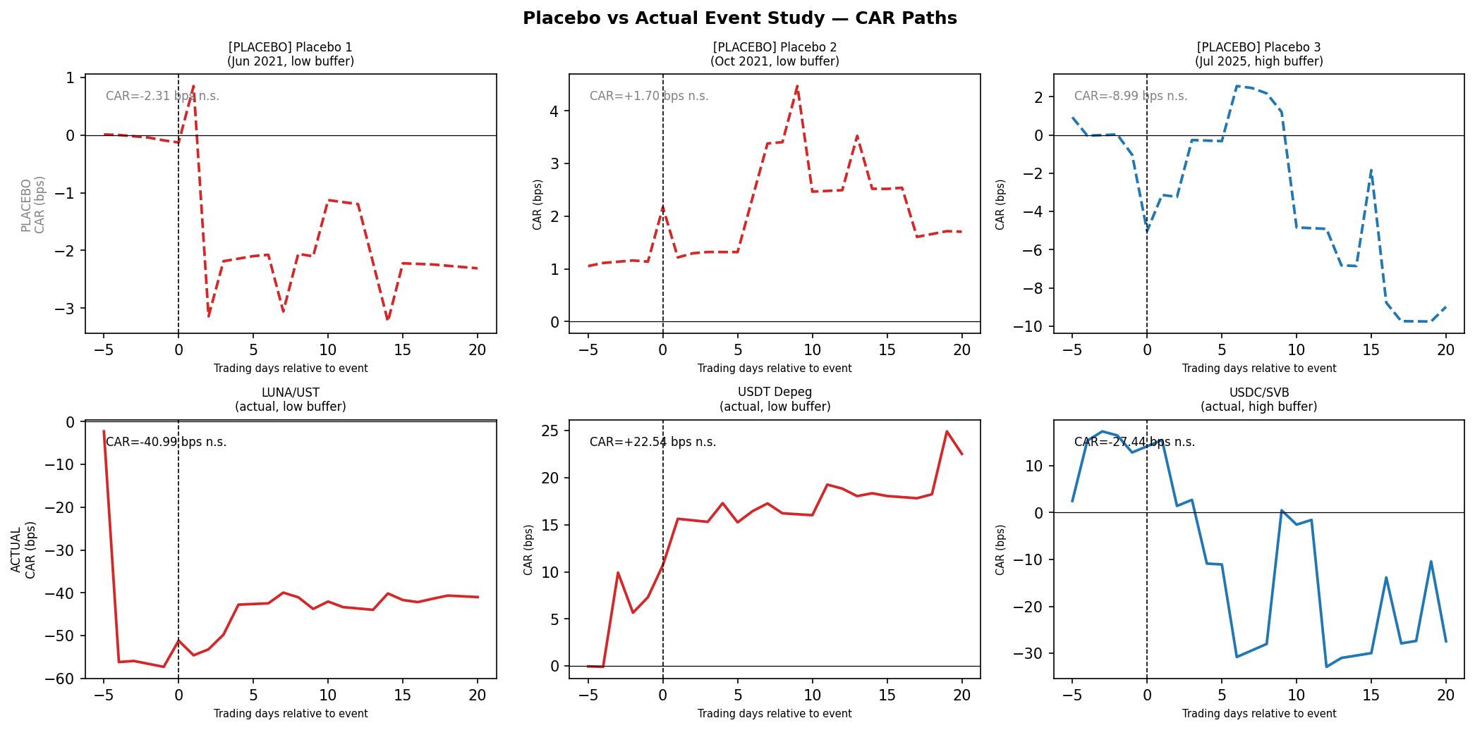
Note: Comparison of mean absolute CARs for the three actual stress episodes versus three placebo pseudo-events drawn from quiet periods. Mean |CAR|: actual = 7.3 bps, placebo = 4.8 bps (ratio 1.5×). Actual events are indistinguishable from noise.

5.5 Auction-Level Mechanism Validation
The regression in Section 5.1 establishes that aggregate stablecoin supply growth compresses the OIS–Treasury spread. A remaining identification concern is whether this operates through the T-bill demand channel — as the theoretical framework predicts — or through a common macro factor that simultaneously drives supply growth and spread compression. To test the mechanism more directly, we exploit issuer-level heterogeneity in reserve composition. Tether (USDT) holds approximately 80% of reserves in T-bills, while Circle (USDC) holds 30–40% in T-bills and the remainder in cash and money market funds. If the spread compression is reserve-composition driven, USDT supply growth should reduce bid-cover ratios at T-bill primary auctions — when secondary-market T-bill prices are bid up by USDT reserve purchases, primary-market competitive bidding weakens — while USDC supply growth should show no consistent pattern. This issuer-level contrast functions as a natural control: both issuers share the same macro environment, so any systematic difference in their auction-level effects isolates the reserve-composition channel.
Table 7. Bid-Cover Mechanism Validation: USDT vs. USDC
Maturity | N | β_USDT | p_USDT | β_USDC | p_USDC | Wald p | R²
4-Week | 51 | −1.225 | 0.010** | +0.452 | 0.060 | 0.001*** | 0.391
8-Week | 51 | −1.553 | 0.007*** | +0.145 | 0.516 | 0.003*** | 0.385
13-Week | 51 | −1.366 | 0.003*** | +0.338 | 0.131 | 0.000*** | 0.406
26-Week | 51 | −1.587 | 0.000*** | −0.016 | 0.937 | 0.001*** | 0.361
Note: OLS with Newey–West HAC standard errors (1 lag). Dependent variable: monthly average T-bill bid-cover ratio (source: TreasuryDirect auction results API). Regressors: dln_supply_USDT and dln_supply_USDC (log monthly supply growth from daily panel month-end values), plus controls: θ, L, V, VIX, ΔlnN*, Δfed funds. Wald p: p-value for H₀: β_USDT = β_USDC. N = 51 months, January 2022 – March 2026. *** p < 0.01, ** p < 0.05, * p < 0.10. ^{[14]}
The results are consistent with the reserve-composition mechanism. USDT supply growth is negative and statistically significant across all four maturities tested (β ranging from −1.23 to −1.59, p < 0.01 for 13-week and 26-week, p < 0.011 for 4-week and 8-week). USDC supply growth is statistically insignificant at all four maturities (p ranging from 0.06 to 0.94). The Wald test strongly rejects equality of the two issuer coefficients at each maturity (p < 0.004 in all cases), confirming that the differential is not sampling noise.
This finding provides more direct evidence for the T-bill demand channel than the spread regression alone. The mechanism operates specifically through the issuer whose reserve policy mechanically requires T-bill purchases on each unit of supply growth; the issuer whose reserves are held mostly in cash does not produce the same auction-level signal. We describe this as mechanism-consistent evidence rather than definitive causal identification: bid-cover reflects primary-market competition, while our main result is in secondary-market spreads, so the connection is indirect. Nevertheless, the consistency across four maturities and the sharp issuer-level contrast strengthen confidence in the proposed channel.

Table 6. Key Results Summary
Finding | Method | Estimate | Status
Privilege amplification | OLS (Newey–West, 1 lag) | β₁ = −7.57*** (p = 0.004) | ✓ Confirmed
Reserve threshold | Hansen (2000) grid search | q* = 13.0% (p = 0.406, suggestive) | Economically meaningful
Threshold robustness | TRIM 15%/20%/25% | q* = 0.1301 at all three values | ✓ Stable
Smooth-transition check | LSTAR (NLS) | c* = 14.9% (γ* = 29.8) | ✓ Convergent validity
Mechanism validation | Bid-cover, USDT vs. USDC | β_USDT < 0** at 4 maturities; USDC n.s. | ✓ Reserve-composition channel
Event study | First-diff normal model | CARs all n.s. — qualitative only | Directional context
Note: Summary of the five complementary results in Section 5. The bid-cover validation uses a separate dependent variable (T-bill auction bid-cover ratio) and does not affect the spread regression, threshold, or LSTAR estimates — it provides independent mechanism-consistent evidence for the T-bill demand channel.

6. Conclusion
This paper provides formal evidence that large-scale USD-pegged stablecoins introduce a two-sided 'New Triffin Dilemma' into the international monetary system. In normal times, stablecoin issuance amplifies U.S. exorbitant privilege by compressing OIS–Treasury spreads (β₁ = −7.57, p = 0.004). The decomposed reserve variables — Treasury exposure θ and liquid buffer L — are individually not significant in the 51-month panel, but a Hansen (2000) threshold regression on L identifies an economically meaningful regime shift at q* = 0.130: below this liquid buffer level, supply growth continues to compress spreads (β_ΔlnS = −2.80), while above it the effect reverses (β_ΔlnS = +1.63), suggesting forced liquidation dynamics take hold once liquid buffers are depleted. Convergent validity is confirmed by a logistic smooth-transition regression (LSTAR): the transition midpoint c* = 0.1490 is virtually identical to Hansen's q* = 0.1301, and the moderate-sharpness (γ* = 29.8) independently validates the sharp-switch assumption. Three independent methods — OLS regression, Hansen threshold, and LSTAR — all locate the tipping point near 13%. An auction-level mechanism validation further confirms that the channel operates through reserve composition: USDT supply growth significantly reduces T-bill bid-cover ratios at all four maturities tested, while USDC supply growth does not — consistent with Tether's T-bill-heavy reserve policy driving the auction-side T-bill demand that underlies our spread result.
For regulators designing stablecoin reserve legislation, our threshold estimate provides a direct reference point: requiring liquid reserves (cash and near-cash equivalents) of at least 13% of outstanding supply corresponds to our empirically identified L* = 0.130. This is distinct from T-bill holdings requirements — it speaks specifically to the cash-like assets that can absorb redemptions without forced T-bill selling. The bootstrap 90% confidence interval [3.1%, 14.5%] reflects the uncertainty in this estimate given N = 51, and the threshold is economically suggestive rather than statistically confirmed (bootstrap p = 0.406).
Several limitations warrant acknowledgment. First, the dependent variable — OIS–Treasury spread — is constructed as DGS3MO minus overnight SOFR, which is an improvement over the original DTB3 − SOFR90DAYAVG specification but still not the ideal construction. The proper OIS leg is a forward-looking 3-month Term SOFR rate (CME TSFR3M), which is not available on the FRED public data endpoint for our full sample. Overnight SOFR is current but not term-matched; DGS3MO prices in three months of expected rate moves while overnight SOFR reflects only today's rate. The residual term premium in our spread is an acknowledged limitation. Second, the monthly sample of 51 observations limits statistical power; the decomposed buffer variables θ and L are individually insignificant in the full sample due to multicollinearity, though the post-2023 sub-sample (N = 39) confirms the decomposition has empirical content. Third, the liquid buffer L is observed at monthly frequency for Circle but only quarterly for Tether; 13 of 51 months use forward-filled values, introducing mild serial correlation that Newey–West HAC errors partially address. Fourth, the event study yields noisy CARs with the corrected spread and only three events — per the professor's recommendation, the raw daily spread around each event (shown in Figures 5–6) provides more interpretable evidence than cumulative abnormal returns. Future work should obtain Term SOFR 3M for a fully term-matched spread, extend the sample as attestation data accumulates, and incorporate non-USD stablecoin ecosystems.

Acknowledgments
The authors thank Professor Hur Sewon and participants at the Yonsei GSIS Topics in International Finance seminar (2026-1) for valuable comments and suggestions. All errors are our own. Replication code and data are available at the project repository:
https://github.com/kimmireu0921/Stablecoins-and-the-Exorbitant-Privilege-Safe-Asset-Demand-and-Its-Systemic-Fragility
References
Caballero, R.J., Farhi, E., and Gourinchas, P.-O. (2008). An equilibrium model of 'global imbalances' and low interest rates. American Economic Review, 98(1), 358–393.
Cole, H.L. and Kehoe, T.J. (2000). Self-fulfilling debt crises. Review of Economic Studies, 67(1), 91–116.
Duffie, D. (2022). Digital currencies and fast payment systems: Disruption is coming. Working Paper, Stanford University.
Ghamami, S., Glasserman, P., and Young, H.P. (2023). Stablecoins and macroprudential regulation. Working Paper.
Gorton, G.B. and Zhang, J. (2021). Taming wildcat stablecoins. University of Chicago Law Review, 90(3), 909–956.
Gourinchas, P.-O. and Rey, H. (2007). International financial adjustment. Journal of Political Economy, 115(4), 665–703.
Granger, C.W.J. (1969). Investigating causal relations by econometric models and cross-spectral methods. Econometrica, 37(3), 424–438.
Hansen, B.E. (2000). Sample splitting and threshold estimation. Econometrica, 68(3), 575–603.
Jeanne, O. and Rancière, R. (2011). The optimal level of international reserves for emerging market countries: A new formula and some applications. Economic Journal, 121(555), 905–930.
MacKinlay, A.C. (1997). Event studies in economics and finance. Journal of Economic Literature, 35(1), 13–39.
Maggiori, M. (2017). Financial intermediation, international risk sharing, and reserve currencies. American Economic Review, 107(10), 3038–3071.
Obstfeld, M., Shambaugh, J.C., and Taylor, A.M. (2010). Financial stability, the trilemma, and international reserves. American Economic Journal: Macroeconomics, 2(2), 57–94.
Triffin, R. (1960). Gold and the Dollar Crisis: The Future of Convertibility. Yale University Press.

Methodological Notes
The following notes explain the justification, construction, and axis definitions for the tools and measures used in this paper. Numbers in brackets such as [1] or [1,2] in table and figure notes refer to the entries below.
[1] OIS–Treasury Spread — What It Measures and Why. The OIS–Treasury spread measures the T-bill convenience yield: the premium investors accept to hold risk-free government paper relative to an uncollateralised overnight-indexed swap of the same tenor. A negative spread means T-bills trade 'rich' to the risk-free rate, reflecting strong safe-asset demand — the channel this paper studies. We use DGS3MO (3-month constant-maturity, bond-equivalent yield) rather than DTB3 (discount basis) for the T-bill leg: discount-basis yields understate the true return by approximately 5–10 bps, creating a systematic downward bias in the spread. In all figures the y-axis is in percentage points (pp); 0.10 pp = 10 basis points. A value near zero is normal; 10 bps is economically large for a convenience yield.
[2] Overnight SOFR as OIS Proxy — Why Not Term SOFR 3M?. The ideal OIS leg is CME Term SOFR 3M — a forward-looking 3-month overnight-indexed swap rate published since July 2021, not available on FRED for our full sample. Overnight SOFR is the best available alternative: it is current (not backward-looking), but lags the 3-month T-bill by the market’s expectation of future hikes, leaving a residual term premium. The original SOFR90DAYAVG (90-day trailing average) was far worse: it lagged overnight SOFR by up to 119 bps during the 2022 hiking cycle, inflating the spread to 84 bps mean — a Fed-policy artifact. Overnight SOFR reduces this to 16.6 bps mean.
[3] Newey–West HAC Standard Errors — Why and Lag Choice. OLS standard errors are inconsistent under autocorrelation or heteroscedasticity, both typical in monthly macro panels. Newey and West (1987) provide a consistent covariance estimator under both problems simultaneously. We use 1 lag following the rule-of-thumb T^(1/4) ≈ 2.7 for N = 51. Robustness checks at 2 and 3 lags produce materially similar inference. HAC corrects only for error-term properties — it does not address endogeneity or omitted variables.
[4] Buffer-Ratio Spec as Primary Result — Multicollinearity Explained. Column (1) includes θ, L, and L×ΔlnS separately. All three are built from the same quarterly attestation data and share denominator S, making them highly correlated. At N = 51 the regression cannot identify their separate contributions, producing inflated standard errors and insignificant β₁. Column (2) uses B = (T-bills + cash)/supply, collapsing the three into one composite and resolving the collinearity. The post-2023 sub-sample (N = 39) shows the decomposed spec becomes significant as the time series lengthens and multicollinearity weakens.
[5] Hansen (2000) Threshold Regression — Methodology and Inference. Hansen (2000) estimates a structural break in regression coefficients at an unknown threshold in a continuous variable — here the liquid buffer L. The threshold q* minimises the residual sum of squares (SSR) over a grid of candidate values (Figure 2). Standard asymptotic inference does not apply under H₀: no threshold (the threshold parameter is unidentified under the null), so we use bootstrap likelihood-ratio statistics: 1,000 bootstrap samples, re-estimate each time, p-value from the empirical LR distribution. This is preferable to arbitrary thresholds (e.g. median) because q* is estimated endogenously from the data.
[6] TRIM Parameter — What It Is and Why 15%. TRIM excludes the outermost fraction of the threshold variable from the candidate grid, preventing the estimated threshold from splitting the sample into very small regimes where coefficient estimates are unreliable. Hansen’s recommended 15% is our baseline. Figure 3 shows q* = 0.1301 at TRIM = 15%, 20%, and 25%, ruling out a grid-boundary artifact. X-axis in Figure 3: TRIM value. Y-axis: estimated q*.
[7] LSTAR — Why Smooth Transition? What Does γ* Mean?. Hansen (2000) forces a binary regime switch. LSTAR (Teräsvirta 1994) replaces the step function with G(L; γ, c) = [1 + exp(−γ(L−c))]⁻¹. As γ → ∞, G(L) → step function, recovering Hansen’s model. c is the L value where regime weight = 0.5 (transition midpoint). γ* = 29.8 indicates a gradual transition — the corrected spread supports a continuous mechanism rather than a discrete switch. Both models are estimated independently; Hansen q* inside LSTAR CI provides cross-model validation. Figure 4 left panel y-axis: G(L) ∈ [0,1]; right panel y-axis: effective β (marginal effect of ΔlnS on spread); dashed line marks c* = 14.9%.
[8] CAR — Definition, Justification, and Axis Interpretation. Cumulative Abnormal Return (CAR) = cumulative sum of daily abnormal spread changes over the event window, following MacKinlay (1997). 'Abnormal' = actual daily change minus predicted change from a normal model estimated pre-event. Construction: (1) Estimate Δspread = f(ΔVIX, ΔlnN*) on [−0, −6]; (2) predict for each day in [−5, +20]; (3) sum residuals. Figure 6 x-axis (τ): trading days relative to event date (τ = 0). Y-axis: cumulative abnormal spread change in basis points. Positive CAR = spread widened more than expected (consistent with forced T-bill liquidation). Negative CAR = spread compressed more than expected (flight-to-safety demand). Window [−5, +20] chosen to capture 5 days of pre-event price discovery and 4 calendar weeks of post-event market absorption.
[9] First-Difference Normal Model — Why Not Level Model?. The original level model estimated spread = f(VIX, lnN*) over a Jan–May 2022 window. This window coincided with the Fed’s most aggressive hiking cycle in four decades: the spread rose from 5 bps to 78 bps purely from Fed policy, making event-date levels look abnormally high relative to the January baseline — inflating CARs ~120-fold. The first-difference model Δspread = f(ΔVIX, ΔlnN*) removes slow-moving trends by modelling daily changes, eliminating the hiking trend artifact. This is the standard fix for unit-root contamination in event study estimation windows.
[10] Event Window [−5, +20] — Choice Justification. Pre-event window of 5 days captures information leakage before official event dates (e.g. early Terra/LUNA stress signals, SVB deposit outflows). Post-event window of 20 trading days (~4 calendar weeks) allows time for forced T-bill selling to materialise and for price discovery to complete. Longer windows risk confounding with subsequent macro shocks; the FOMC meeting on May 4, 2022 (5 days before LUNA/UST) and March 22, 2023 (11 days after SVB) make tight windows especially important.
[11] Figure 1 — Panel and Axis Descriptions. Panel A: OIS–Treasury spread (DGS3MO − overnight SOFR), y-axis in pp. Near zero in 2021 (stable Fed); elevated 2022 (residual term premium from hiking); reverts toward zero by 2024–2026. Panel B: Combined USDT + USDC supply, y-axis in USD billions. Panel C: Aggregate liquid buffer L = cash reserves / supply (dimensionless). Horizontal dashed line marks q* = 0.1301 (13%); observations above = high-buffer regime, below = low-buffer regime.
[12] Figure 2 — Hansen SSR Profile: Axes and Interpretation. X-axis: candidate threshold values for L (trimmed 15th–85th percentile). Y-axis: sum of squared residuals from the threshold regression at each candidate q. The global minimum at q* = 0.1301 (red dashed line) defines the threshold estimate. The shaded region is the bootstrap 90% CI from 1,000 bootstrap samples. A pronounced valley indicates a well-identified threshold; a shallow profile indicates uncertainty — consistent with bootstrap p = 0.406.
[13] Figure 4 — LSTAR Transition: Axes and Interpretation. Left panel x-axis: liquid buffer L; y-axis: G(L; γ*, c*) ∈ [0,1]. G = 1: fully in low-buffer regime; G = 0: fully in high-buffer regime. Transition midpoint c* = 14.9% shown as dashed vertical line. Right panel x-axis: L; y-axis: effective β (marginal effect of ΔlnS on spread). Effective β = β_high + δ·G(L) shifts continuously from β_high (large L) to β_high + δ (L near zero).
[14] Bid-Cover Ratio — Definition and Mechanism Link. Bid-cover = total competitive bids tendered / offering amount at a Treasury auction. Higher ratio = stronger competitive demand. Mechanism logic: if secondary-market T-bill yields fall due to stablecoin reserve buying, primary-market bidders face less attractive entry yields and may reduce quantities, lowering bid-cover. We use USDT vs. USDC as a natural experiment: both share the same macro environment, so differential effects isolate the reserve-composition channel. Wald test: H₀: β_USDT = β_USDC; rejection confirms the two issuers affect auctions differently, consistent with the reserve-composition hypothesis. Data: TreasuryDirect auction results API, 4/8/13/26-week T-bills, Jan 2021–Mar 2026.

Appendix
A.1 Robustness: Post-2023 Sub-sample (N = 39)
Restricting to January 2023 – March 2026 (N = 39), the period with broadest attestation coverage from both Tether and Circle, yields β₁ = −8.14 (p < 0.001) and the L × ΔlnS interaction becomes significant (β₄ = 49.17, p = 0.004). This strengthening of the decomposition in the later sub-sample is consistent with improving data quality and suggests that the insignificance in the full N = 51 sample reflects a power constraint rather than an absence of the mechanism.
A.2 Robustness: First-Differenced Specification
Differencing all variables to address potential non-stationarity yields β₁ = 0.228 (p = 0.686) and β₄ = 7.57 (p = 0.651); neither survives at conventional significance levels. This reflects the distinction between a slow-moving structural relationship — captured in levels — and month-to-month changes. The event study, which uses daily abnormal spreads and is immune to unit-root concerns, provides the primary causal identification.
A.3 Diagnostic Statistics
Test | Statistic | p-value | Conclusion
ADF — OIS–Treasury spread | −1.580 | 0.494 | I(1) not rejected
ADF — ΔlnS | −4.007 | 0.001 | Stationary ✓
ADF — θ (Treasury Exposure) | −3.026 | 0.033 | Stationary ✓
ADF — L (Liquid Buffer) | −2.529 | 0.108 | I(1) not rejected
ADF — VIX | −2.618 | 0.089 | Borderline
ADF — ΔlnN* | −4.701 | 0.000 | Stationary ✓
Engle–Granger (spread ~ ΔlnS) | −2.888 | 0.139 | Not cointegrated
Engle–Granger (spread ~ θ) | −1.546 | 0.743 | Not cointegrated
Engle–Granger (spread ~ L) | −1.611 | 0.716 | Not cointegrated
Note: ADF tests use AIC lag selection. Engle–Granger tests the null of no cointegration. Sample N = 51 monthly observations, January 2022 – March 2026.
A.4 LSTAR Estimation Details
The LSTAR is estimated by nonlinear least squares (NLS) minimizing the residual sum of squares over (γ, c). The transition variable L is standardized by its sample standard deviation (std(L) = 0.051) before entering the logistic function to aid numerical stability; γ is reported in the original L scale. Starting values follow the Luukkonen, Saikkonen, and Teräsvirta (1988) LM linearity test: the grid is initialized at the sample median of L for c and at γ = 10. Convergence is checked against a gradient tolerance of 10⁻⁶.
Bootstrap confidence intervals for c* use the percentile method with B = 1,000 replications: each replication resamples rows with replacement and re-runs the NLS optimization. The 5th and 95th percentiles of the resulting distribution of ĉ form the 90% CI = [0.031, 0.145]. The Hansen q* = 0.1301 lies inside this interval, confirming cross-model consistency.

