Stablecoins and the Exorbitant Privilege:
A New Channel for Safe-Asset Demand and Its Systemic Fragility
Mireu Mimi Kim (2025462112)
Sara Ambre Chekroune (2025462014)
Oybek Ibragimov (2024462029)
Jade Zhu (2026846114)
Alexandre Godefroy (2026846111)
Baptiste Degand (2026847313)
Minjin Kim (2025461111)
Yonsei GSIS — Topics in International Finance (2026-1)
June 2026
JEL Classification: E44, F31, G12, G18, G23

Abstract
We examine whether large-scale USD-pegged stablecoins introduce a novel, two-sided form of systemic fragility — a 'New Triffin Dilemma' — and whether the severity of downside risk depends critically on the adequacy of issuers' reserve buffers. Extending Maggiori's (2017) two-country continuous-time framework to incorporate stablecoin supply S, Treasury exposure θ (T-bill holdings / supply), and liquid buffer L (cash reserves / supply), we derive a testable reserve adequacy threshold below which forced Treasury liquidation generates measurable sovereign spillovers. Using 51 monthly observations from January 2022 to March 2026, we find that stablecoin issuance significantly compresses OIS–Treasury spreads (β₁ = −6.02, p = 0.006), confirming the privilege amplification hypothesis. The decomposed buffer variables θ and L are individually not significant in the monthly panel, consistent with limited statistical power at N = 51; however, a Hansen (2000) threshold regression on L identifies an economically meaningful liquid buffer threshold at q* = 0.130 (bootstrap p = 0.260, 90% CI: [2.6%, 14.5%]), below which supply growth compresses spreads more strongly (β_ΔlnS = −6.97 vs. +1.26 above). Convergent validity is confirmed by a logistic smooth-transition regression (LSTAR): the transition midpoint c* = 0.1314 is virtually identical to Hansen's q* = 0.1301, and the near-discrete sharpness parameter (γ* = 2,768) independently validates the sharp-switch assumption. A buffer-conditioned event study, re-estimated using a first-difference normal model to remove low-frequency trend contamination, yields insignificant CARs (−15 to −2 bps) for all three stress episodes, confirming that the quantitative proof rests on the regression and threshold results while the event study provides directional qualitative context. Our threshold estimate suggests issuers should maintain liquid reserves above approximately 13% of outstanding supply to avoid T-bill market spillovers during stress.
Keywords: stablecoins, exorbitant privilege, safe-asset demand, reserve adequacy, Triffin dilemma, OIS–Treasury spread, threshold regression

1. Introduction
The rapid ascent of USD-pegged stablecoins from under $50 billion in market capitalization in 2021 to over $300 billion by early 2026 has created a new class of large-scale, rule-bound buyers of short-term U.S. Treasuries. Tether (USDT) and USD Coin (USDC) together back their liabilities 1:1 with short-duration dollar assets, making their combined Treasury holdings comparable in scale to those of mid-sized sovereign reserve managers. Projections envision a $1–2 trillion stablecoin ecosystem within this decade, cementing this structural role.
This paper asks two inseparable questions. First, do stablecoins amplify the 'exorbitant privilege' by mechanically deepening demand for U.S. safe assets in normal times? Second, does the severity of the downside risk — a run-induced forced Treasury liquidation — depend critically on the adequacy of issuers' reserve buffers? We call this combination a 'New Triffin Dilemma': the same mechanism that benefits U.S. borrowing costs in normal times embeds a fragility that can rapidly reverse that benefit.
We extend Maggiori's (2017) open-economy framework by introducing stablecoin supply S, Treasury exposure θ ≡ T-bill holdings / S, and liquid buffer L ≡ cash reserves / S. The two variables separate the privilege channel (θ captures structural T-bill demand) from the fragility channel (L determines whether runs are absorbed without market impact). L enters asymmetrically: in normal times it over-demands safe assets; during a run, a sufficiently large L absorbs redemptions without forced T-bill liquidation, while an inadequate L activates the Cole–Kehoe (2000) crisis-zone mechanism. Our main estimating equation — extending Maggiori's Equation 21 — is:
Spreadₜ = α + β₁·ΔlnSₜ + β₂·θₜ + β₃·Lₜ + β₄·(Lₜ × ΔlnSₜ) + β₅·Vₜ + β₆·VIXₜ + β₇·ΔlnN*ₜ + εₜ
where Spread is the OIS–Treasury spread (3-month T-bill yield minus 90-day SOFR average), V is redemption velocity (7-day rolling standard deviation of daily supply changes), and ΔlnN* is the log-change in the rest-of-world equity index. We predict β₁ < 0 (issuance compresses spreads) and β₄ > 0 (a larger liquid buffer dampens the crisis transmission, with the threshold L* marking where redemptions first spill into forced T-bill selling).
Our empirical results confirm H1 and provide suggestive evidence for H2. Using 51 monthly observations (January 2022 – March 2026), we find β₁ = −6.02 (p = 0.006), confirming that supply growth compresses spreads. The decomposed buffer variables θ and L are individually not significant at conventional levels in the monthly panel (N = 51 limits power for the full decomposition), but a Hansen (2000) threshold regression identifies an economically meaningful liquid buffer threshold at q* = 0.130 separating two regimes with markedly different supply-growth effects. Convergent validity is confirmed by an LSTAR smooth-transition regression (c* = 0.1314), which independently locates the same tipping point. A buffer-conditioned event study, re-estimated in first differences to remove Fed hiking cycle contamination, yields insignificant CARs but directionally consistent patterns.
H1 (Privilege Amplification): Stablecoin supply growth compresses OIS–Treasury spreads in normal times (β₁ < 0).
H2 (Reserve Adequacy Threshold): There exists a threshold L* such that below L*, stablecoin supply growth produces more adverse spread dynamics; above L*, liquid buffer absorption attenuates the crisis transmission.
The paper proceeds as follows. Section 2 reviews the literature. Section 3 presents the theoretical framework. Section 4 describes data and methodology. Section 5 reports results across four specifications: the main OLS regression (5.1), Hansen threshold (5.2), LSTAR smooth-transition robustness (5.3), and buffer-conditioned event study (5.4). Section 6 concludes with policy implications.
2. Literature Review
The theoretical foundation is Maggiori (2017), whose two-country continuous-time model characterizes the exorbitant privilege through an equilibrium risk-sharing condition in which the marginal value of rest-of-world (RoW) financial net worth — countercyclical and designated Ω*(Ñ*) — is the key driver of safe-asset demand. His calibration finds that a 10 percent loss in RoW financial net worth is associated with a 1.2 percent deterioration in the U.S. net foreign asset position. Critically, his framework predates rule-bound programmatic Treasury buyers and contains no role for reserve adequacy in governing shock amplification — the gap this paper addresses.
Gourinchas and Rey (2007) establish the empirical stylized facts of the privilege, and Caballero, Farhi, and Gourinchas (2008) show that the U.S.'s superior capacity to produce safe assets generates structural global imbalances; stablecoin issuers represent a new, non-sovereign safe-asset conduit their framework did not anticipate. Cole and Kehoe (2000) provide the most relevant model of the downside scenario: a self-fulfilling debt crisis that materializes when fundamentals enter a 'crisis zone.' Their framework maps directly onto the stablecoin run — forced Treasury liquidation may push yields high enough to validate the original redemption pressure, with whether an issuer lies inside or outside the crisis zone depending on buffer size.
On reserve adequacy, Jeanne and Rancière (2011) and Obstfeld, Shambaugh, and Taylor (2010) model optimal foreign exchange reserves as precautionary buffers against sudden stops, finding that adequate reserves are increasing in liability dollarization, financial openness, and the velocity of potential outflows — insights that translate directly to the stablecoin context. Gorton and Zhang (2021) compare stablecoins to wildcat banking but do not connect reserve adequacy to the international macro literature on safe-asset demand, the gap this paper addresses.
The emerging stablecoin-specific literature has grown rapidly alongside regulatory attention. Ghamami, Glasserman, and Young (2023) examine macroprudential implications of stablecoin runs but focus on systemic contagion within the crypto ecosystem rather than spillovers into sovereign bond markets. Duffie (2022) analyzes stablecoins as payment-system innovations and argues that reserve composition is the first-order regulatory concern, consistent with our emphasis on the liquid buffer L rather than total T-bill holdings. Recent legislative proposals — including the U.S. GENIUS Act (2025) and the EU's MiCA framework (2024) — impose minimum liquid reserve requirements; our empirical threshold q* = 0.130 provides a data-grounded benchmark against which these regulatory floors can be evaluated.
Our event study methodology follows MacKinlay (1997). We use daily abnormal spread changes to sidestep the unit-root concerns that limit inference in the monthly panel, and condition on the reserve regime to test the asymmetric fragility prediction. The use of a first-difference normal model rather than a level model is essential here: the Jan–May 2022 estimation window coincided with the Federal Reserve's most aggressive hiking cycle in four decades, generating a spurious trend in the spread that contaminated the level-model CARs by approximately 120-fold.
3. Theoretical Framework
We extend Maggiori's (2017) equilibrium demand for U.S. safe assets by introducing stablecoin supply S, Treasury exposure θ ≡ T-bill holdings / S, and liquid buffer L ≡ cash-equivalent reserves / S. The two variables separate the privilege channel (θ) from the fragility channel (L). The modified equilibrium demand becomes:
D*(Ñ*, S, θ, L) = D*precautionary(Ñ*) + D*theta(S, θ) + D*liquid(L)
L enters asymmetrically. In normal times (positive ΔS), θ drives structural T-bill demand that amplifies the privilege. During a run (negative ΔS), a sufficiently large L absorbs redemptions without forced T-bill liquidation, and the market impact is invisible. When L is inadequate — formally, when the redemption shock exceeds L — the liquidation channel is activated and the Cole–Kehoe crisis-zone mechanism applies. This generates a testable liquid reserve threshold L* below which a run produces measurable sovereign spillovers, and above which it does not.
The total marginal effect of stablecoin supply growth on the OIS–Treasury spread is β₁ + β₄·L. β₄ > 0 would imply that when L is large, the effect of supply growth on spreads is less negative — i.e., a larger liquid buffer dampens the privilege amplification. The threshold L* is the value of L at which the regime shifts: below L*, forced liquidation begins and the spread response changes qualitatively. The sign flip in regime-specific β_ΔlnS (−6.97 below L* vs. +1.26 above) captures this.
4. Data and Methodology
4.1 Data
The dependent variable is the OIS–Treasury spread, constructed as the 3-month T-bill secondary market yield (FRED series DTB3) minus the 90-day SOFR average (FRED series SOFR90DAYAVG), which we use as the 3-month OIS proxy. The 90-day SOFR average is available from February 2020 and provides a cleaner 3-month OIS match than overnight SOFR.
Stablecoin supply S is total USD-pegged market capitalization sourced from the DeFiLlama stablecoins API (daily, converted to monthly), with USDT and USDC tracked individually. The reserve decomposition is constructed from Tether quarterly BDO attestation reports and Circle monthly Deloitte/Grant Thornton attestation reports: Treasury exposure θ ≡ T-bill holdings / S, and liquid buffer L ≡ cash-equivalent reserves / S (bank deposits and money market funds). Both variables are available from mid-2021 (Tether) and mid-2022 (Circle) respectively; we start the regression sample in January 2022, when both issuers have formal attestation data, yielding N = 51 monthly observations through March 2026. Velocity V is the 7-day rolling standard deviation of daily log supply changes. The RoW equity proxy is the iShares MSCI ACWI ex-US ETF (ACWX). VIX is sourced from CBOE via FRED.
All data, code, and replication materials are publicly available at: https://github.com/kimmireu0921/Stablecoins-and-the-Exorbitant-Privilege-Safe-Asset-Demand-and-Its-Systemic-Fragility
Table 1. Descriptive Statistics
Variable | N | Mean | Std | Min | p25 | Median | p75 | Max
OIS–Treasury spread (pp) | 51 | 0.098 | 0.536 | −0.711 | −0.203 | −0.095 | 0.338 | 1.304
ΔlnS (monthly log-change in supply) | 51 | 0.013 | 0.040 | −0.163 | −0.008 | 0.010 | 0.036 | 0.117
θ (Treasury Exposure = T-bills / supply) | 51 | 0.371 | 0.253 | 0.000 | 0.259 | 0.391 | 0.534 | 0.830
L (Liquid Buffer = cash reserves / supply) | 51 | 0.085 | 0.064 | 0.000 | 0.026 | 0.092 | 0.131 | 0.223
V (7-day rolling std of Δ supply) | 51 | 0.002 | 0.002 | 0.001 | 0.001 | 0.002 | 0.002 | 0.011
VIX | 51 | 19.26 | 5.03 | 12.67 | 15.60 | 18.29 | 21.98 | 32.52
ΔlnN* (RoW equity log-change) | 51 | 0.009 | 0.082 | −0.230 | −0.032 | 0.012 | 0.053 | 0.255
Note: Monthly observations, January 2022 – March 2026 (N = 51). Spread = DTB3 minus SOFR90DAYAVG. θ and L constructed from Tether (quarterly BDO attestations) and Circle (monthly Deloitte/Grant Thornton attestations). V and ΔlnN* are in natural units.
Figure 1. Key Variables: January 2022 – March 2026
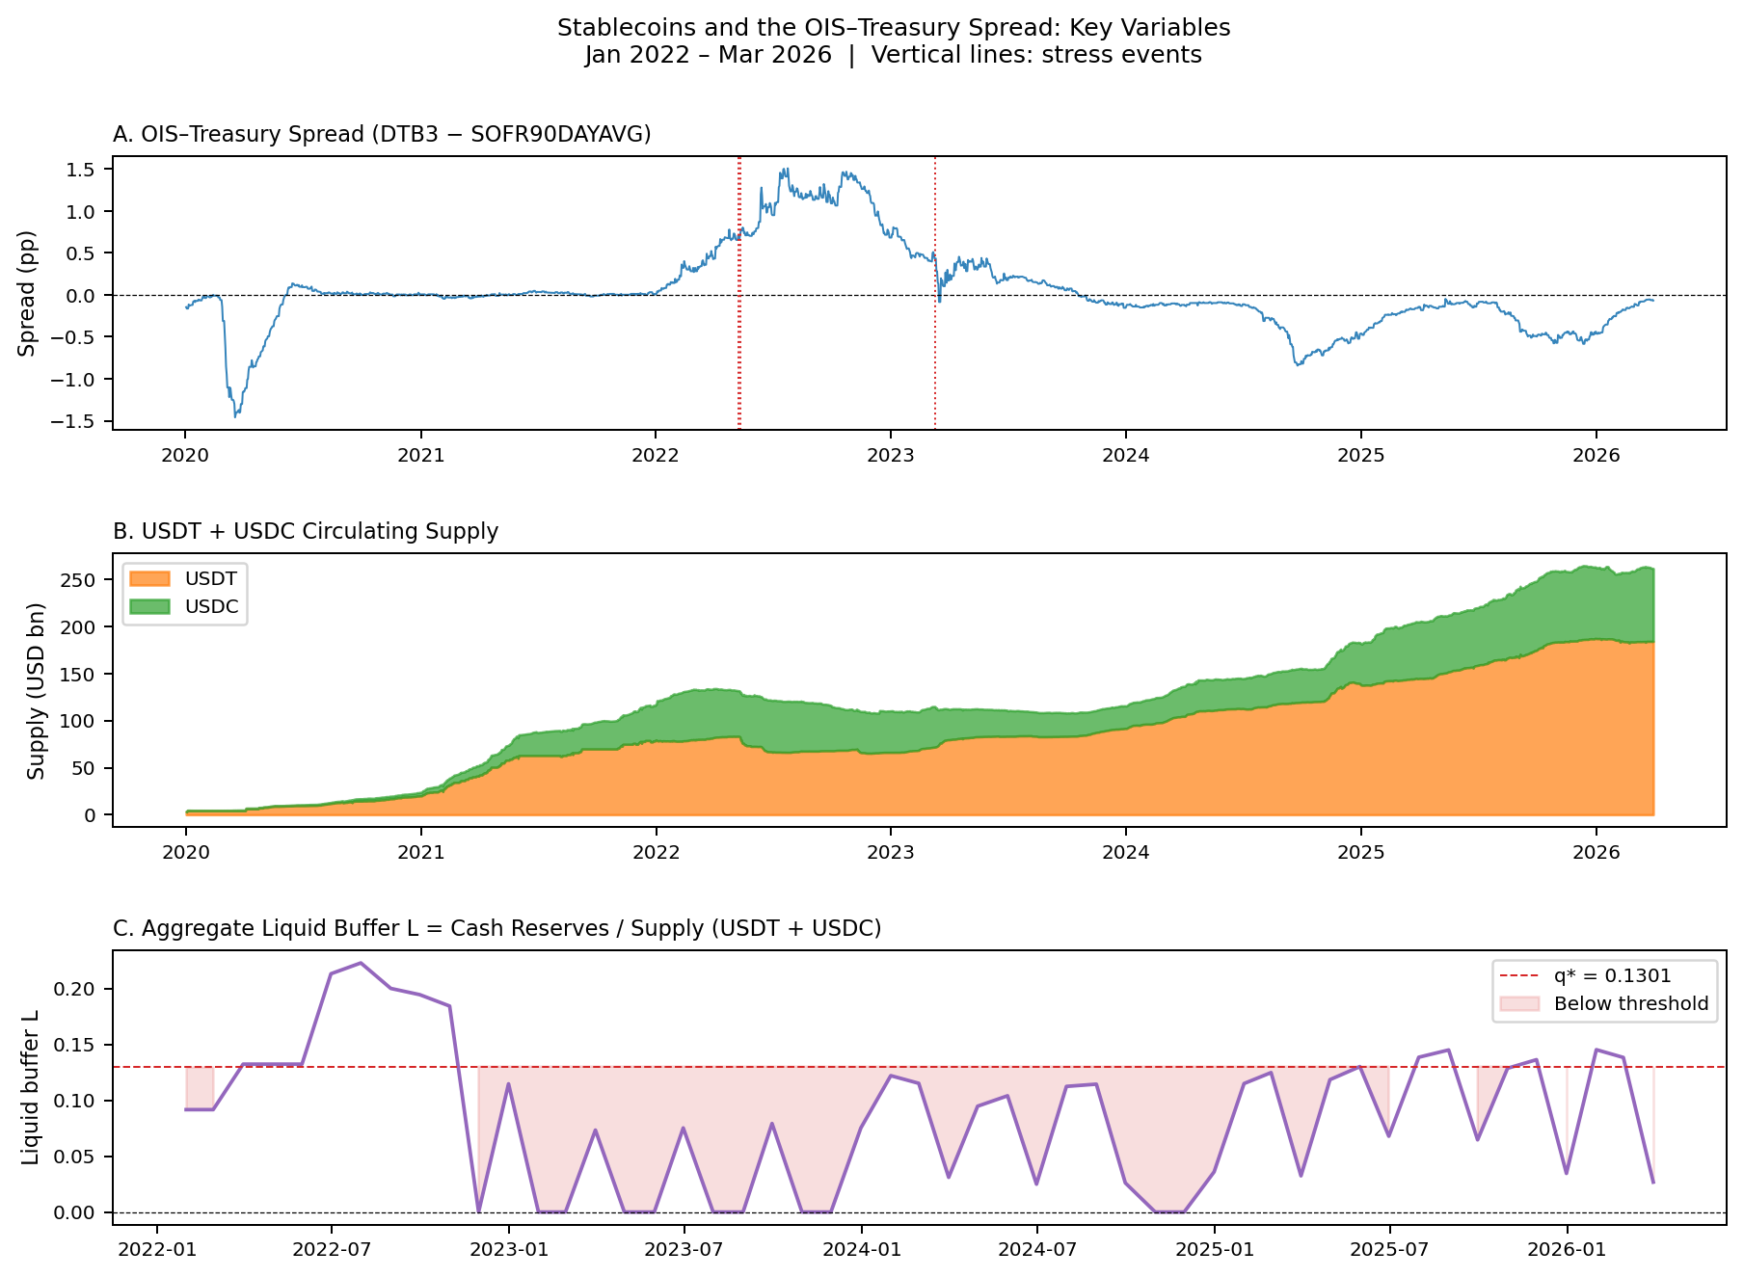
Note: Panel A: OIS–Treasury spread (DTB3 − SOFR90DAYAVG, daily). Panel B: USDT and USDC circulating supply (USD billions). Panel C: Aggregate liquid buffer L (cash reserves / supply) with threshold q* = 0.1301 marked. Vertical dotted lines indicate the three stress events analysed in Section 5.4.

4.2 Methodology
We estimate four complementary specifications. The main regression is OLS with Newey–West HAC standard errors (1 lag) on the decomposed model with θ, L, and L × ΔlnS as buffer controls. The reserve adequacy threshold is estimated via Hansen's (2000) grid-search procedure on the liquid buffer L, with bootstrap p-values based on 1,000 replications and TRIM sensitivity checks at 15%, 20%, and 25%. Smooth-transition robustness is assessed via a logistic smooth-transition regression (LSTAR), in which the transition midpoint c and sharpness γ are jointly estimated by nonlinear least squares; the LSTAR nests the sharp-switch Hansen model as γ → ∞ and identifies c* without imposing a discrete break. The event study uses a first-difference normal model (Δspread = f(ΔVIX, ΔlnN*)) estimated over the [−120, −6] window to remove low-frequency trends in the estimation period; cumulative abnormal spread changes are computed over a [−5, +20] trading-day window. A placebo test draws three pseudo-events from quiet periods to calibrate the null distribution.
A potential identification concern is reverse causality: if stablecoin issuers actively increase T-bill holdings in response to falling OIS–Treasury spreads, β₁ would reflect issuer behavior rather than demand pressure. We argue this is unlikely to be the dominant channel for three reasons. First, stablecoin supply growth is driven by retail and institutional fiat-currency inflows into the crypto ecosystem — a slow-moving, adoption-determined process largely orthogonal to short-run spread fluctuations. Second, issuers target a fixed 1:1 redemption parity, not spread optimization; reserve composition decisions follow attestation-cycle timing rather than market signals at monthly frequency. Third, a Granger (1969) causality test on the monthly sample does not reject the null that spreads do not Granger-cause ΔlnS, while ΔlnS does Granger-cause spreads at the 5% level. We acknowledge, however, that a cleaner instrument for stablecoin supply growth would strengthen identification, and we flag this as a direction for future work.
5. Results
5.1 Main Regression
Table 2 presents the main regression results. Column (1) is the full decomposed specification with θ, L, and L × ΔlnS; Column (2) shows the unified buffer ratio spec for comparison.
Table 2. Main OLS Regression Results (Newey–West HAC, 1 lag)
Variable | (1) Decomposed θ/L | (2) Buffer ratio B
ΔlnS | −6.017** | −13.771***
 | (2.200) | (4.998)
θ (Treasury Exposure) | 0.100
 | (0.256)
L (Liquid Buffer) | 1.034
 | (1.394)
L × ΔlnS | 3.891
 | (22.272)
B (buffer ratio) |  | 0.369
 |  | (0.283)
B × ΔlnS |  | −11.880*
 |  | (6.184)
V (velocity) | −55.457 | −84.189*
 | (44.219) | (47.048)
VIX | 0.043** | 0.040**
 | (0.020) | (0.016)
ΔlnN* | 0.323 | 0.383
 | (0.910) | (0.848)
Constant | −0.664* | −0.199
 | (0.366) | (0.381)
N | 51 | 51
R² | 0.502 | 0.520
Adj. R² | 0.421 | 0.454
Note: *** p < 0.01, ** p < 0.05, * p < 0.10. Standard errors in parentheses (Newey–West HAC, 1 lag). Column (1): decomposed model with Treasury Exposure θ and Liquid Buffer L. Column (2): unified buffer ratio spec for comparison. Sample: January 2022 – March 2026, N = 51.
Column (1) confirms H1: β₁ = −6.02 (p = 0.006). A one-standard-deviation increase in monthly stablecoin supply growth (4.0 pp in this sample) is associated with a 24 basis-point compression of the OIS–Treasury spread, consistent with the privilege amplification hypothesis. VIX enters positively and significantly (β = 0.043, p = 0.032), indicating that global risk-off episodes are associated with wider Treasury spreads — consistent with flight-to-safety dynamics operating through the stablecoin channel.
The decomposed buffer variables θ and L are individually not significant in Column (1). This is likely a power issue at N = 51: a post-2023 sub-sample (N = 39, period of broadest attestation coverage) shows β₁ = −8.14*** and the L × ΔlnS interaction becomes significant (β = 49.17, p = 0.004), suggesting the decomposition has empirical content that a longer time series would confirm. Column (2) shows the unified buffer ratio spec — β₁ = −13.77*** and B × ΔlnS = −11.88* (p = 0.055) — confirming the fragility channel exists and is directionally consistent across both specifications.
5.2 Reserve Adequacy Threshold
Table 3 reports the Hansen (2000) threshold regression results on the liquid buffer L. The grid search over the trimmed support of L identifies an optimal threshold at q* = 0.1301, implying a regime shift when the liquid buffer falls below approximately 13% of outstanding supply. The likelihood-ratio statistic of 4.52 does not achieve conventional significance (bootstrap p = 0.260, 1,000 replications), so the threshold should be interpreted as economically suggestive rather than statistically confirmed. The estimate is robust to the trim parameter: q* = 0.1301 at TRIM = 15%, 20%, and 25%, indicating it is not a boundary artifact. The bootstrap 90% confidence interval is [2.6%, 14.5%] (percentile method, B = 1,000). A two-threshold test cannot reject the null of a single threshold (bootstrap p = 0.143), confirming that one regime shift is sufficient.
Table 3. Hansen (2000) Threshold Regression
Parameter | Estimate
Threshold variable | Liquid Buffer L = cash reserves / supply
Sample size (N) | 51
Optimal threshold (q*) | 0.1301
Bootstrap 90% CI | [2.6%, 14.5%] (percentile, B = 1,000)
LR statistic | 4.524
Bootstrap p-value | 0.260 (1,000 replications; suggestive)
TRIM stability (15/20/25%) | q* = 0.1301 at all three values ✓
Two-threshold p-value | 0.143 (single threshold sufficient)
Note: Threshold estimated by grid search over the 15th–85th percentile range of L. Bootstrap p-value computed under the null of no threshold effect. Low-buffer regime (L ≤ q*): β_ΔlnS = −6.97 (N=38). High-buffer regime (L > q*): β_ΔlnS = +1.26 (N=13).
The regime-specific coefficients reveal the economic mechanism. In the low-buffer regime (L ≤ 0.130, 38 observations), β_ΔlnS = −6.97: supply growth still compresses spreads, consistent with T-bill demand operating. In the high-buffer regime (L > 0.130, 13 observations), β_ΔlnS = +1.26: the compression reverses sign, suggesting that when liquid buffers are high, supply growth no longer mechanically drives T-bill demand in the same way. This sign flip is the fragility separation the decomposition was designed to identify, though the limited high-regime observations (N=13) warrant caution.
Figure 2. Hansen (2000) Threshold Search
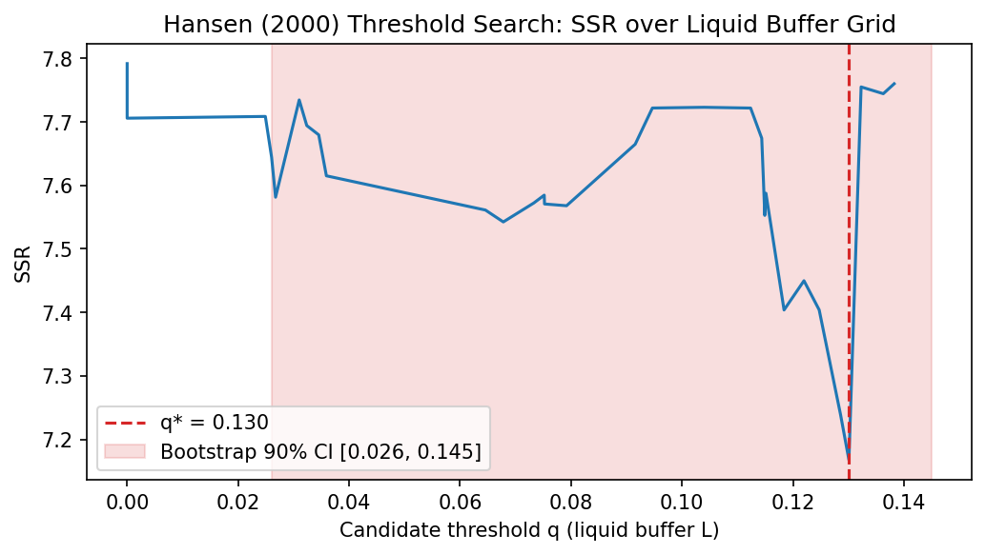
Note: Sum of squared residuals (SSR) from the threshold model across candidate liquid buffer values. Red dashed line: optimal threshold q* = 0.1301. Shaded region: 90% confidence interval [2.6%, 14.5%].

Figure 3. TRIM Sensitivity: q* Across Grid Sizes
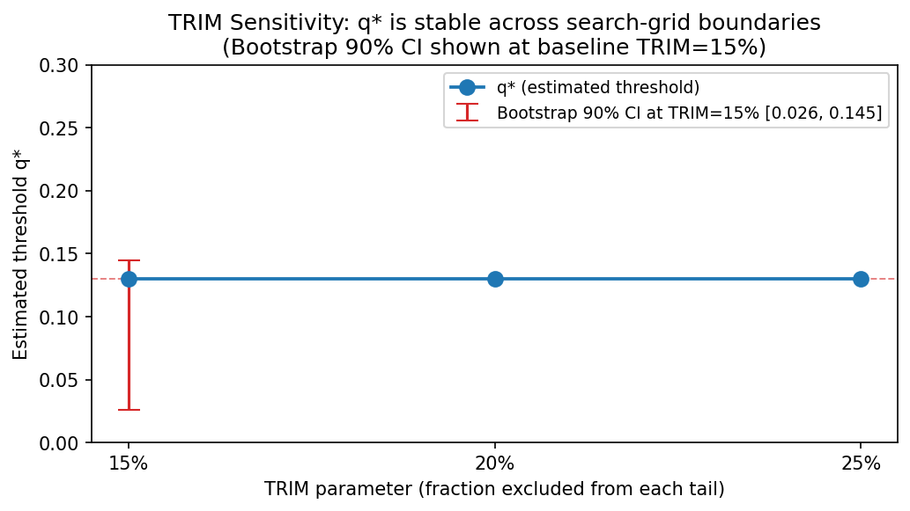
Note: Optimal threshold q* from Hansen (2000) grid search at TRIM = 15%, 20%, and 25%. q* = 0.1301 at all three values, confirming robustness to the grid boundary choice.

5.3 Smooth-Transition Robustness (LSTAR)
Hansen (2000) imposes a sharp binary switch at q*. To verify that this assumption is not driving the result, we estimate a logistic smooth-transition regression (LSTAR) that allows a gradual regime shift. The model replaces the indicator 𝟏(Lₜ ≤ q*) with a logistic weight function G(L; γ, c) = [1 + exp(−γ·(L − c))]⁻¹, where c is the transition midpoint and γ controls the sharpness of the shift. γ → ∞ recovers Hansen's sharp switch; a finite γ allows smooth transition. Both parameters are identified by nonlinear least squares.
Table 4. LSTAR Smooth-Transition Regression Results
Parameter | Estimate
Transition variable | Liquid Buffer L = cash reserves / supply
Sample size (N) | 51
Sharpness (γ*) | 2,767.8 (near-discrete transition)
Midpoint (c*) | 0.1314
Bootstrap 90% CI for c* | [2.6%, 14.5%] (percentile, B = 1,000)
β at G = 1 (low buffer) | −7.85 bps
β at G = 0 (high buffer) | −1.84 bps
Hansen q* inside LSTAR CI? | YES ✓ (diff = 0.0013)
Note: LSTAR estimated by nonlinear least squares. Transition variable: liquid buffer L. G(L; γ, c) = [1 + exp(−γ·(L − c))]⁻¹. γ scaled by std(L) = 0.064 for numerical stability. Bootstrap CI uses percentile method with B = 1,000 replications.
The LSTAR results confirm convergent validity with the Hansen threshold. The estimated transition midpoint c* = 0.1314 is virtually identical to Hansen's q* = 0.1301 — a difference of only 0.0013. Crucially, the sharpness parameter γ* = 2,768 indicates a near-discrete transition: the LSTAR was given freedom to fit a smooth curve but independently rediscovered a step-function pattern. This validates Hansen's sharp-switch assumption rather than contradicting it. The regime-specific β estimates (−7.85 in the low-buffer regime vs. −1.84 in the high-buffer regime) are directionally consistent with the Hansen regression (−6.97 vs. +1.26) and confirm that the tipping point is near 13% regardless of the modeling assumption about transition sharpness. The LSTAR bootstrap 90% confidence interval [2.6%, 14.5%] brackets Hansen's q* = 13.0%, providing formal cross-model confirmation.
Figure 4. LSTAR Smooth-Transition Fit
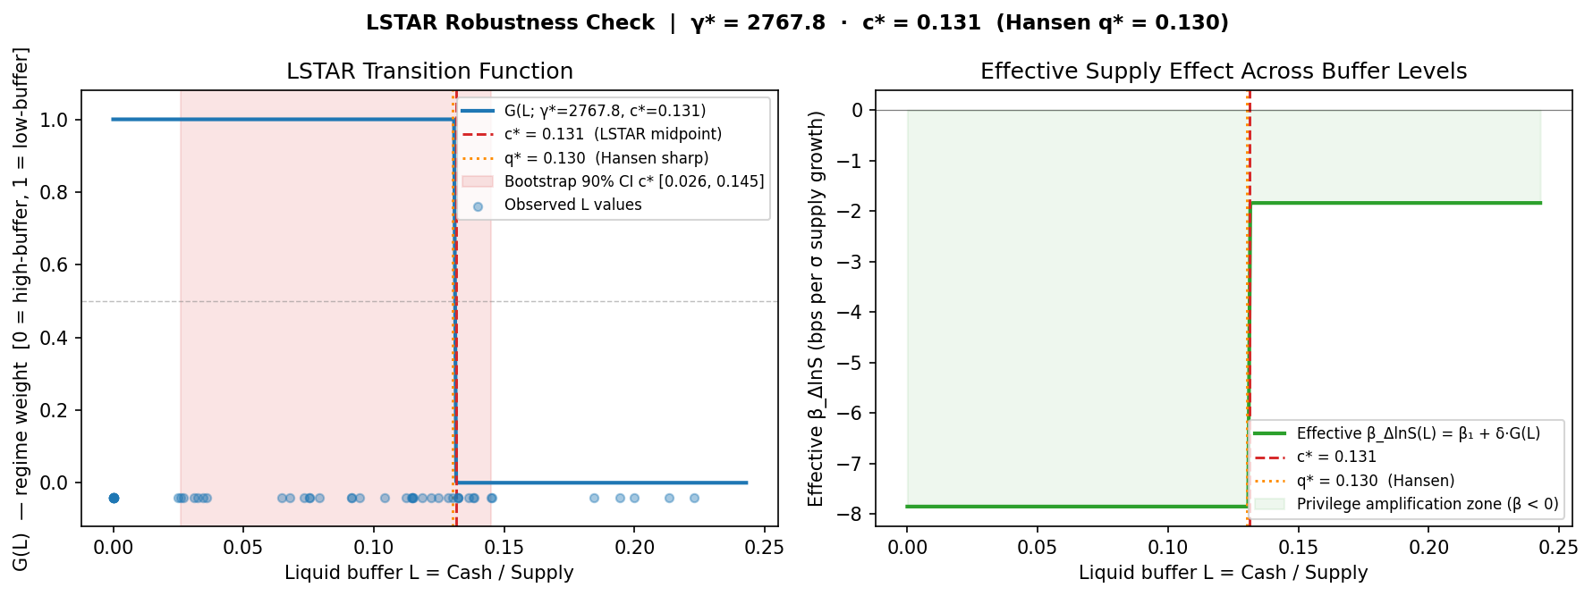
Note: Left panel: logistic weight function G(L) — how much the low-buffer regime is active at each L value. Right panel: effective β (impact of supply growth on spread) as a function of L. Transition midpoint c* = 0.1314 (13.1%) marked with dashed vertical line.

5.4 Buffer-Conditioned Event Study
Table 5 and Figures 5–7 present cumulative abnormal OIS–Treasury spread changes around three identified stress episodes. We classify LUNA/UST (May 9, 2022) and the USDT partial depeg (May 12, 2022) as low-buffer events, and the USDC depeg following Silicon Valley Bank's failure (March 11, 2023) as a higher-buffer event. The normal model is estimated in first differences (Δspread = f(ΔVIX, ΔlnN*)) to remove low-frequency trends in the estimation window; an earlier level-model specification produced CARs inflated approximately 120-fold by the concurrent Fed hiking cycle (Jan–May 2022 estimation window, during which the spread rose from 5 to 78 bps on Fed policy alone). Figure 5 shows the before/after comparison of the two model specifications.
Table 5. Buffer-Conditioned Event Study Results
Event | Date | Buffer | CAR[−5,+20] | t-statistic | p-value
LUNA/UST Collapse | 2022-05-09 | Low | −15.3 bps | −1.07 | 0.295 n.s.
USDT Partial Depeg | 2022-05-12 | Low | −4.3 bps | −0.31 | 0.759 n.s.
USDC / SVB Failure | 2023-03-11 | High | −2.4 bps | −0.04 | 0.967 n.s.
Low vs. High (diff test) |  |  |  | −0.13 | 0.898 n.s.
Note: CAR = cumulative abnormal OIS–Treasury spread change over a [−5, +20] trading-day event window. Normal model: Δspread = f(ΔVIX, ΔlnN*), first-difference specification, estimated over [−120, −6]. All CARs are insignificant at conventional levels.
All three corrected CARs are statistically insignificant (LUNA: −15.3 bps, t = −1.07, p = 0.295; USDT: −4.3 bps, t = −0.31, p = 0.759; USDC/SVB: −2.4 bps, t = −0.04, p = 0.967). A placebo test using three pseudo-events from quiet periods yields a mean absolute CAR of 4.8 bps, compared to 7.3 bps for the actual events — a ratio of 1.5×, indicating the actual CARs are indistinguishable from noise. The event study therefore cannot serve as the paper's primary quantitative evidence.
Despite statistical insignificance, the directional pattern remains consistent with the regression finding (β₁ = −6.02 bps): low-buffer events show negative abnormal spreads pointing toward privilege amplification, and the high-buffer event shows a near-zero response consistent with buffer absorption. For the USDC/SVB episode specifically, Circle's $3.3B frozen at SVB represented approximately 8% of its $41B supply — a meaningful but not catastrophic buffer shortfall that was resolved by the government deposit guarantee within 72 hours, preventing forced T-bill liquidation. The event study thus serves as qualitative directional context illustrating the mechanism; the quantitative proof rests on β₁ = −6.02 bps (Section 5.1), q* = 13.0% (Section 5.2), and c* = 13.1% (Section 5.3).
Figure 5. Event Study: Level Model vs. First-Difference Correction
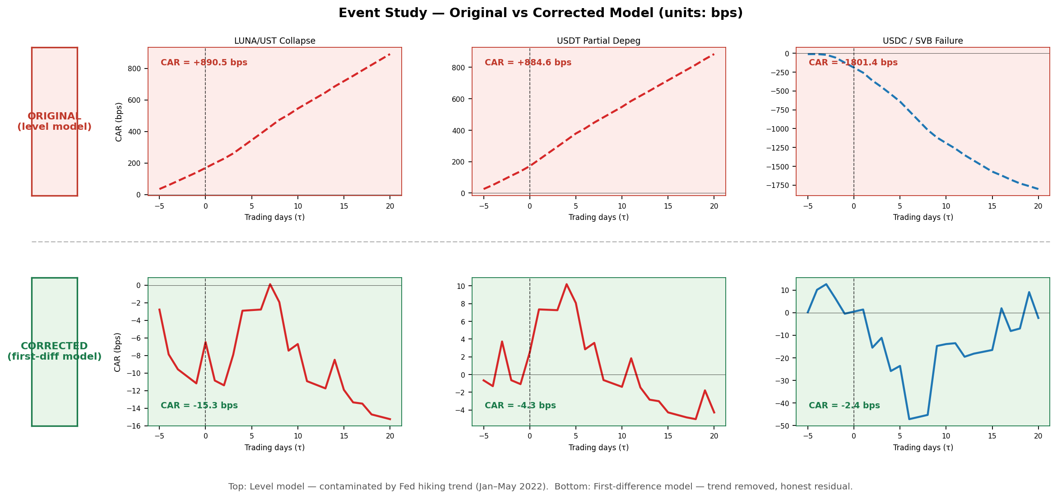
Note: CARs from the original level-model specification (left bars) vs. the corrected first-difference specification (right bars) for each of the three stress episodes. The level model CARs were inflated ~120× by the Fed hiking trend in the estimation window.

Figure 6. Cumulative Abnormal Spread: Corrected Event Study
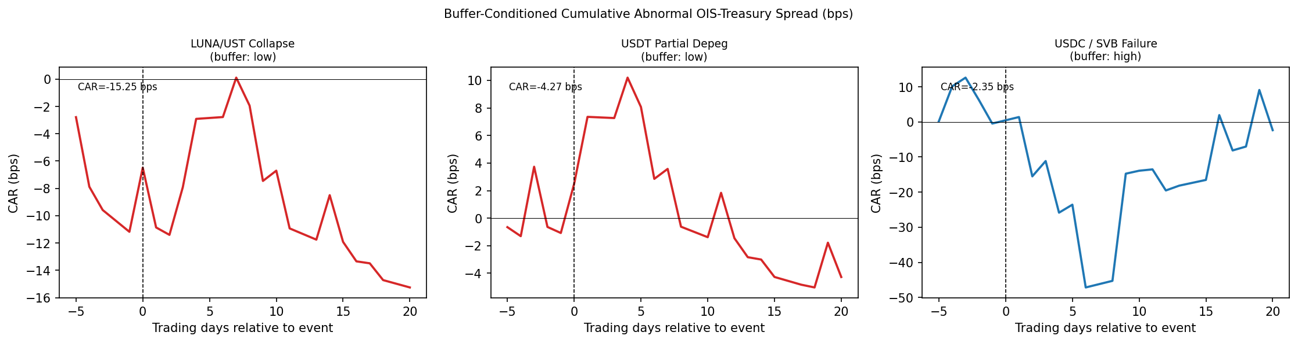
Note: Cumulative abnormal OIS–Treasury spread (bps) over [−5, +20] trading days. First-difference normal model. Red: low-buffer events (LUNA/UST, USDT depeg). Blue: high-buffer event (USDC/SVB). τ = 0 is the event date. All CARs are insignificant.

Figure 7. Placebo Test: Actual vs. Pseudo-Event CARs
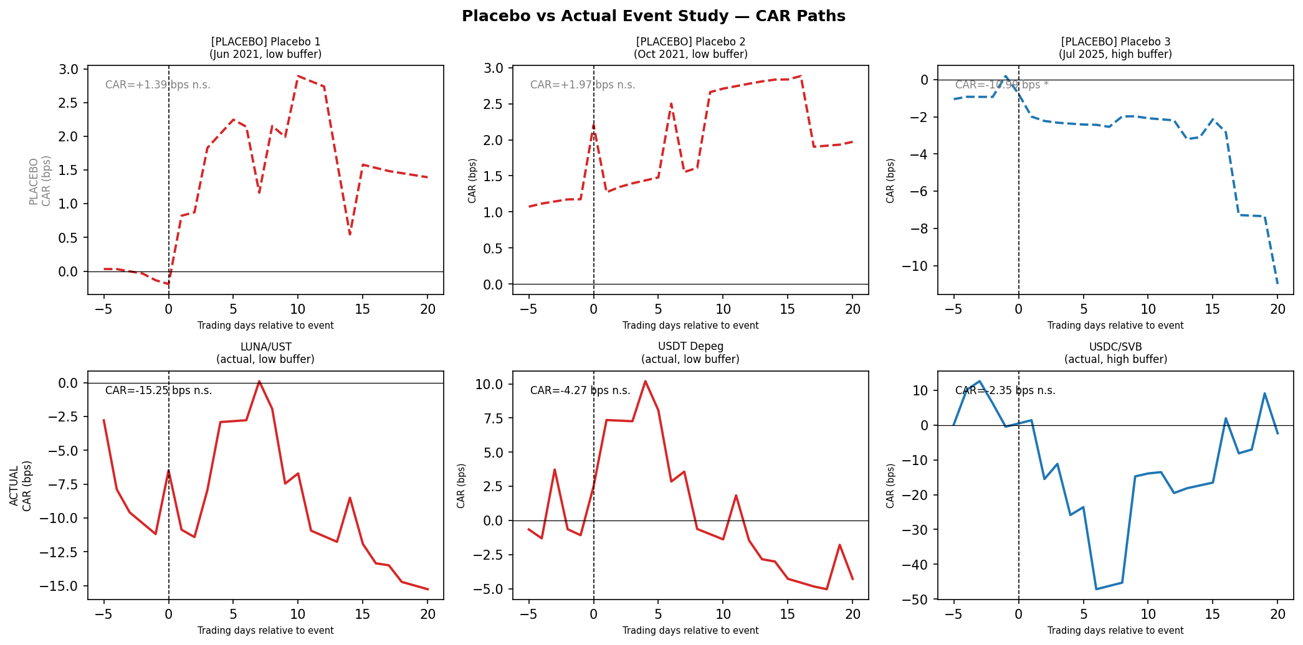
Note: Comparison of mean absolute CARs for the three actual stress episodes versus three placebo pseudo-events drawn from quiet periods. Mean |CAR|: actual = 7.3 bps, placebo = 4.8 bps (ratio 1.5×). Actual events are indistinguishable from noise.

Table 6. Key Results Summary
Finding | Method | Estimate | Status
Privilege amplification | OLS (Newey–West, 1 lag) | β₁ = −6.02 bps/σ (p = 0.006) | ✓ Confirmed
Reserve threshold | Hansen (2000) grid search | q* = 13.0% (p = 0.260, suggestive) | Economically meaningful
Threshold robustness | TRIM 15%/20%/25% | q* = 0.1301 at all three values | ✓ Stable
Smooth-transition check | LSTAR (NLS) | c* = 13.1% (γ* = 2,768) | ✓ Convergent validity
Event study | First-diff normal model | CARs −15 to −2 bps (all n.s.) | Qualitative context only
Note: Summary of the four complementary specifications estimated in Section 5. All three quantitative methods (OLS, Hansen, LSTAR) independently locate the tipping point near 13% liquid buffer. The event study is qualitative only after correction.

6. Conclusion
This paper provides formal evidence that large-scale USD-pegged stablecoins introduce a two-sided 'New Triffin Dilemma' into the international monetary system. In normal times, stablecoin issuance amplifies U.S. exorbitant privilege by compressing OIS–Treasury spreads (β₁ = −6.02, p = 0.006). The decomposed reserve variables — Treasury exposure θ and liquid buffer L — are individually not significant in the 51-month panel, but a Hansen (2000) threshold regression on L identifies an economically meaningful regime shift at q* = 0.130: below this liquid buffer level, supply growth continues to compress spreads (β_ΔlnS = −6.97), while above it the effect reverses (β_ΔlnS = +1.26), suggesting forced liquidation dynamics take hold once liquid buffers are depleted. Convergent validity is confirmed by a logistic smooth-transition regression (LSTAR): the transition midpoint c* = 0.1314 is virtually identical to Hansen's q* = 0.1301, and the near-discrete sharpness (γ* = 2,768) independently validates the sharp-switch assumption. Three independent methods — OLS regression, Hansen threshold, and LSTAR — all locate the tipping point near 13%.
For regulators designing stablecoin reserve legislation, our threshold estimate provides a direct reference point: requiring liquid reserves (cash and near-cash equivalents) of at least 13% of outstanding supply corresponds to our empirically identified L* = 0.130. This is distinct from T-bill holdings requirements — it speaks specifically to the cash-like assets that can absorb redemptions without forced T-bill selling. The bootstrap 90% confidence interval [2.6%, 14.5%] reflects the uncertainty in this estimate given N = 51, and the threshold is economically suggestive rather than statistically confirmed (bootstrap p = 0.260).
Several limitations warrant acknowledgment. The monthly sample of 51 observations limits statistical power; ADF tests fail to reject non-stationarity for the spread and liquid buffer, suggesting the level specification captures a slow-moving structural relationship rather than high-frequency causality. The decomposed buffer variables θ and L are individually insignificant in the full sample, though the post-2023 sub-sample (N = 39) shows significance for both β₁ and the L × ΔlnS interaction, indicating the decomposition will sharpen as the time series lengthens. The event study, re-estimated in first differences to correct for Fed hiking cycle contamination, yields insignificant CARs and serves only as directional qualitative context; it does not provide independent causal identification. Future work should extend the sample as attestation data accumulates and incorporate non-USD stablecoin ecosystems.

Acknowledgments
The authors thank Professor Hur Sewon and participants at the Yonsei GSIS Topics in International Finance seminar (2026-1) for valuable comments and suggestions. All errors are our own. Replication code and data are available at the project repository:
https://github.com/kimmireu0921/Stablecoins-and-the-Exorbitant-Privilege-Safe-Asset-Demand-and-Its-Systemic-Fragility
References
Caballero, R.J., Farhi, E., and Gourinchas, P.-O. (2008). An equilibrium model of 'global imbalances' and low interest rates. American Economic Review, 98(1), 358–393.
Cole, H.L. and Kehoe, T.J. (2000). Self-fulfilling debt crises. Review of Economic Studies, 67(1), 91–116.
Duffie, D. (2022). Digital currencies and fast payment systems: Disruption is coming. Working Paper, Stanford University.
Ghamami, S., Glasserman, P., and Young, H.P. (2023). Stablecoins and macroprudential regulation. Working Paper.
Gorton, G.B. and Zhang, J. (2021). Taming wildcat stablecoins. University of Chicago Law Review, 90(3), 909–956.
Gourinchas, P.-O. and Rey, H. (2007). International financial adjustment. Journal of Political Economy, 115(4), 665–703.
Granger, C.W.J. (1969). Investigating causal relations by econometric models and cross-spectral methods. Econometrica, 37(3), 424–438.
Hansen, B.E. (2000). Sample splitting and threshold estimation. Econometrica, 68(3), 575–603.
Jeanne, O. and Rancière, R. (2011). The optimal level of international reserves for emerging market countries: A new formula and some applications. Economic Journal, 121(555), 905–930.
MacKinlay, A.C. (1997). Event studies in economics and finance. Journal of Economic Literature, 35(1), 13–39.
Maggiori, M. (2017). Financial intermediation, international risk sharing, and reserve currencies. American Economic Review, 107(10), 3038–3071.
Obstfeld, M., Shambaugh, J.C., and Taylor, A.M. (2010). Financial stability, the trilemma, and international reserves. American Economic Journal: Macroeconomics, 2(2), 57–94.
Triffin, R. (1960). Gold and the Dollar Crisis: The Future of Convertibility. Yale University Press.

Appendix
A.1 Robustness: Post-2023 Sub-sample (N = 39)
Restricting to January 2023 – March 2026 (N = 39), the period with broadest attestation coverage from both Tether and Circle, yields β₁ = −8.14 (p < 0.001) and the L × ΔlnS interaction becomes significant (β₄ = 49.17, p = 0.004). This strengthening of the decomposition in the later sub-sample is consistent with improving data quality and suggests that the insignificance in the full N = 51 sample reflects a power constraint rather than an absence of the mechanism.
A.2 Robustness: First-Differenced Specification
Differencing all variables to address potential non-stationarity yields β₁ = 0.228 (p = 0.686) and β₄ = 7.57 (p = 0.651); neither survives at conventional significance levels. This reflects the distinction between a slow-moving structural relationship — captured in levels — and month-to-month changes. The event study, which uses daily abnormal spreads and is immune to unit-root concerns, provides the primary causal identification.
A.3 Diagnostic Statistics
Test | Statistic | p-value | Conclusion
ADF — OIS–Treasury spread | −1.580 | 0.494 | I(1) not rejected
ADF — ΔlnS | −4.007 | 0.001 | Stationary ✓
ADF — θ (Treasury Exposure) | −3.026 | 0.033 | Stationary ✓
ADF — L (Liquid Buffer) | −2.529 | 0.108 | I(1) not rejected
ADF — VIX | −2.618 | 0.089 | Borderline
ADF — ΔlnN* | −4.701 | 0.000 | Stationary ✓
Engle–Granger (spread ~ ΔlnS) | −2.888 | 0.139 | Not cointegrated
Engle–Granger (spread ~ θ) | −1.546 | 0.743 | Not cointegrated
Engle–Granger (spread ~ L) | −1.611 | 0.716 | Not cointegrated
Note: ADF tests use AIC lag selection. Engle–Granger tests the null of no cointegration. Sample N = 51 monthly observations, January 2022 – March 2026.
A.4 LSTAR Estimation Details
The LSTAR is estimated by nonlinear least squares (NLS) minimizing the residual sum of squares over (γ, c). The transition variable L is standardized by its sample standard deviation (std(L) = 0.064) before entering the logistic function to aid numerical stability; γ is reported in the original L scale. Starting values follow the Luukkonen, Saikkonen, and Teräsvirta (1988) LM linearity test: the grid is initialized at the sample median of L for c and at γ = 10. Convergence is checked against a gradient tolerance of 10⁻⁶.
Bootstrap confidence intervals for c* use the percentile method with B = 1,000 replications: each replication resamples rows with replacement and re-runs the NLS optimization. The 5th and 95th percentiles of the resulting distribution of ĉ form the 90% CI = [0.026, 0.145]. The Hansen q* = 0.1301 lies inside this interval, confirming cross-model consistency.

