Data Requirements Specification

for
Movie Analytics
Prepared by:
Montana, Kim
Data Engineer Intern
Stratpoint Technologies
2025

Table of Contents
1. Project Overview 3
1.1. Objective 3
1.2. Scope 3
2. Data Source and Ingestion 3
3. Data Mapping 3
4. Data Modeling 3
5. ETL Pipeline Design 3
6. Reporting and Dashboarding 3

Revision History
Name | Date | Reason For Changes | Version
 | 03-19-2025 | Initial Draft | 1.0

Project Overview

Objective

Scope

Data Source Profiling and Data Quality
Movies_main.csv
Column Name | Data Type | Completeness (NULL check) | Uniqueness (duplicates) | Accuracy/Validity/Integrity | Business Rule | Transformation Rule
id | String | 0 | 49 | - 1-10 range char format  - There are 3 ids that is in YYYY-MM-DD format | 1-6 character format is accepted | - Remove the duplicates  - Drop those 3 ids that is not integer format
title | String/Text | 6 | 49 | - 125 rows, who doesn’t have characters | numbers is allowed, foreign characters is allowed. | - No transformation required.
release_date | date | 90 | 49 | - MM/DD/YYYY : 15067 rows  - DD-MM-YYYY: 15135 rows  - YYYY-MM-DD: 15194 rows | YYYY-MM-DD is the chosen date format | - Transform to YYYY-MM-DD format.
budget | Integer | 4435 | 49 | - 0 budget: 33887 rows  - Non-integer, + Null: 4437 rows  - Min_budget: 0  - Max_budget: 380,000,000 | The budget should be in integer format.  Still looking for 0 budget consideration | - ?
revenue | Integer | 6 | 49 | - 0 revenue: 38068 rows  - Null: 6  - Min_revenue: 0  - Max Revenue: 2,787,965,087 | The Revenue must be in integer format  Still looking for 0 revenue budget consideration | - ?

Movie_extended.csv
Column Name | Data Type | Completeness (NULL check) | Uniqueness (duplicates) | Accuracy/Validity/Integrity | Business Rule | Transformation Rule
id | String | 0 | 29 | - 1-10 range char format  - There are 3 ids that is in YYYY-MM-DD format | 1-6 character format is accepted | - Remove the duplicates  - Drop those 3 ids that is not integer format
genres | String/Text |  | 29
production_companies | String/Text |  | 29
production_countries | String/Text |  | 29
Spoken_language | String/Text |  | 29

Movie_extended.csv
Column Name | Data Type | Error Analysis
id | Integer
genres | String/Text
production_companies | String/Text
production_countries | String/Text
Spoken_language | String/Text

Ratings.json
Column Name | Data Type | Error Analysis
movie_id | Integer
avg_rating | float
total_ratings | integer
std_dev | float
last_rated | integer

Data Modeling

OLAP Star Schema Design
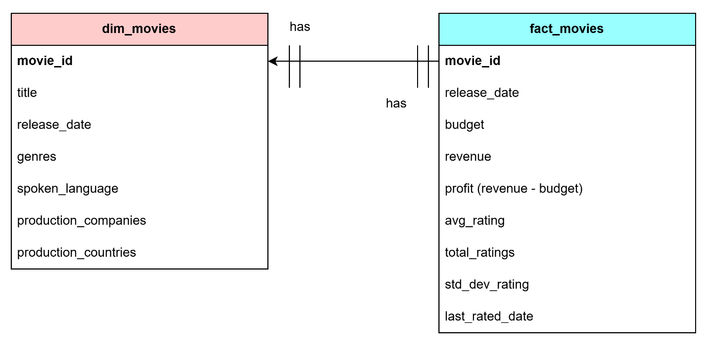

Data Mapping
Movies_main.csv
Column Name | Target Table | Transformation Rule
id | dim_movies, fact_movies
title | dim_movies
release_date | dim_movies, fact_movies
budget | fact_movies
revenue | fact_movies

Movie_extended.csv
Column Name | Target Table | Transformation Rule
id | dim_movies, fact_movies
genres | dim_movies
production_companies | dim_movies
production_countries | dim_movies
Spoken_language | dim_movies

Movie_extended.csv
Column Name | Target Table | Transformation Rule
movie_id | dim_movies, fact_movies
avg_rating | fact_movies
total_ratings | fact_movies
std_dev | fact_movies
last_rated | fact_movies

ETL Pipeline Design

Reporting and Dashboarding

