Section Analysis Tool User Guide

|  |  |  |
| --- | --- | --- |
| Version | Update Notes | Date |
| 0.0.1 | Updated to allow for inhomogeneous sections | 11/21/2016 |
|  |  |  |
|  |  |  |
|  |  |  |
|  |  |  |
|  |  |  |
|  |  |  |

# Overview:

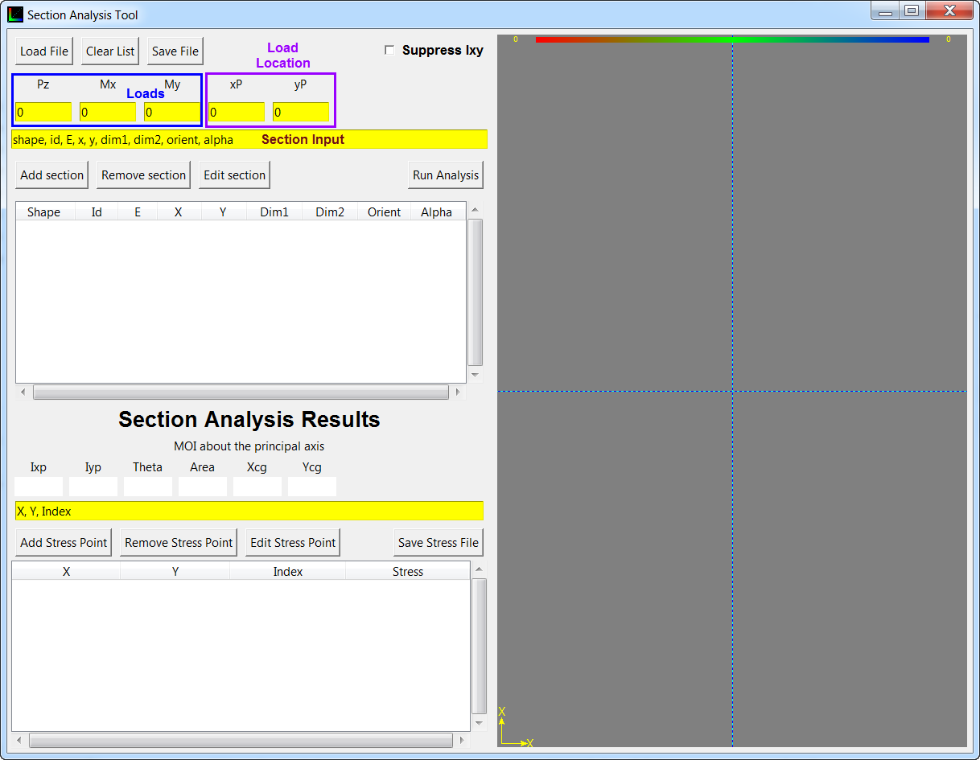

# Run Analysis:

To run an analysis, simply create your section and input some loads in Pz, Mx and My. See the results of a run below. The color stream at the top indicates the stress field. The Blue is the minimum (compression if negative) and Red is the maximum (Tension if positive). After running an analysis, the section will have dots colored in representing the stress at that particular location. To see the location and stress, simply hover over the pixel. The numbers in the parenthesis is the coordinate of the pixel (x, y) and the number followed by the colon is the stress. Additionally, there are two special pixels. These are indicated by a yellow inside and black outside. They represent the min and max stresses.

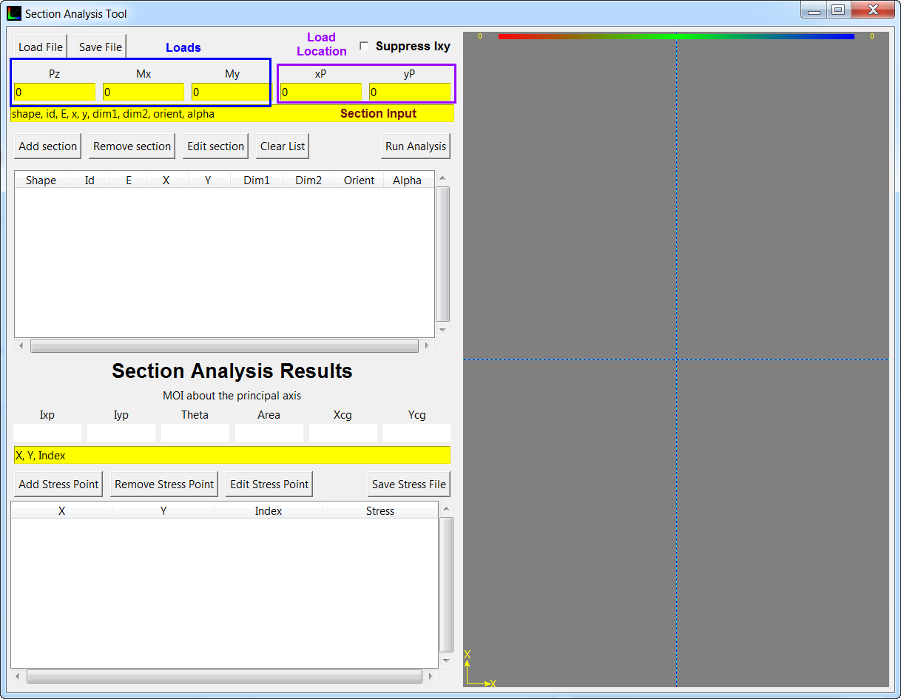

# Inputs

## Pz:

The load in Z-direction. Positive Z comes out of the page per the right-hand rule. The load is applied at the origin indicated by the intersection of the two solid blue lines.

## Mx:

The moment in the X-direction. Positive moment points to the right. The load is applied at the origin.

## My:

The moment in the Y-direction. Positive moment points to up. The load is applied at the origin.

## X Coord:

The X-coordinate to calculate the stress at.

## Y Coord:

The Y-coordinate to calculate the stress at.

## Xp:

The X-coordinate to place the load at

## Yp:

The Y-coordinate to place the load at.

## Section input:

Add or edit section information (double click a section to bring up its info). There are three kinds of shapes which you can add. As of version 0.0.1, inhomogeneous sections can now be analyzed. A modulus must now be included after the Section Id.

### Rectangle

A Rectangle section can be created by inputting Shape information which starts with the letter “R” or “r”. Valid shape strings include but are not limited to: R, r, Rec, rectangle, Roar, r*. All shapes must have an id. The id will label the shapes in the drawing area. The id can be anything, but it cannot be left out.

The list table shows Shape, Id, E, X, Y, Dim1, Dim2, Orient, and alpha.

For a rectangle the Shape, Id, E, X, Y, Dim1, Dim2 and Orient must be included in the section input. The X and Y are the coordinates of the bottom left corner relative to the origin. Dim1 represents the base and Dim2 represents the height. The orientation is the angle in degrees between the rectangles’ base to the x axis. Positive angle goes CCW from the +x axis.

Example: R,R1, 5000, 0, 0, 2, 2, 30

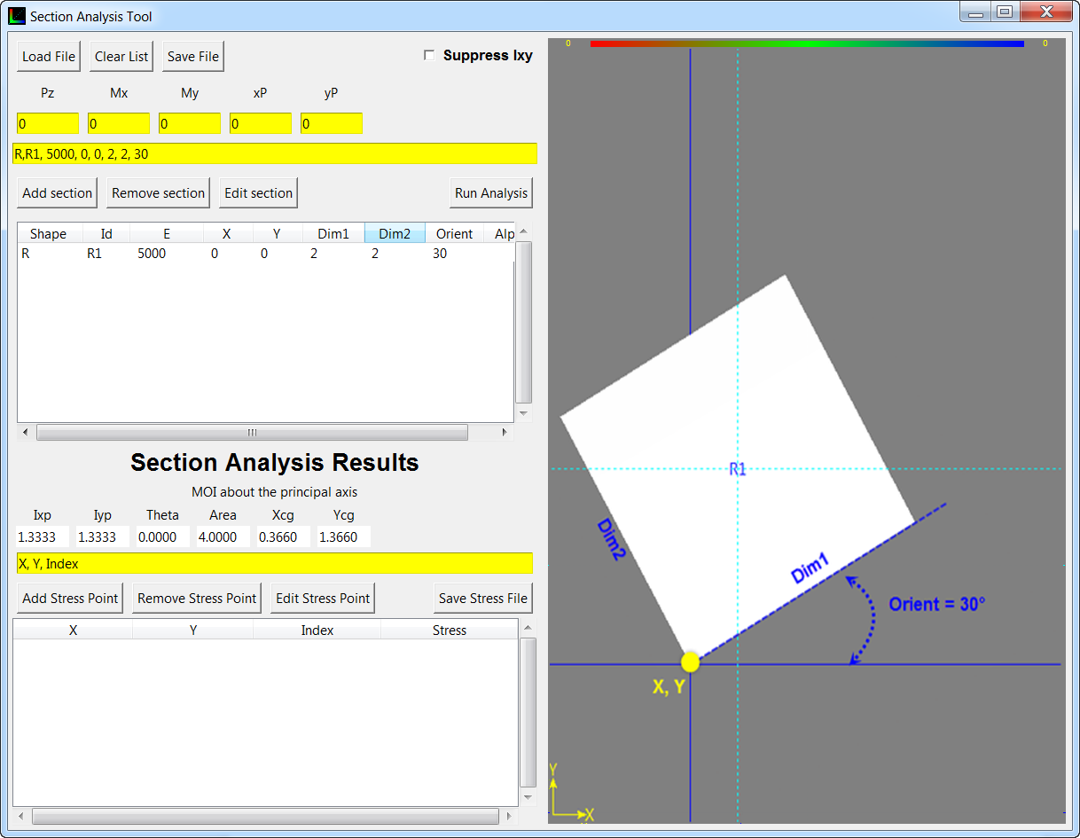

### Circle Segment

A Circle section can be created by inputting Shape information which starts with the letter “C” or “c”. Valid shape strings include but are not limited to: C, c, circ, Circle, c*. All shapes must have an id. The id will label the shapes in the drawing area. The id can be anything, but it cannot be left out.

The list table shows Shape, Id, E, X, Y, Dim1, Dim2, Orient, and alpha.

For a circle the Shape, Id, E, X, Y, Dim1, Dim2, Orient and alpha must be included in the section input. The X and Y are the coordinates of the center relative to the origin. Dim1 represents the outer radius and Dim2 represents the inner radius. The orientation is the angle in degrees between the mid angle of the circle and the x axis. The alpha is the angle in degrees of the circle arc. Please see example for clarification.

Example: C, c1, 5000, 1, 1, 1, .5, -135, 90

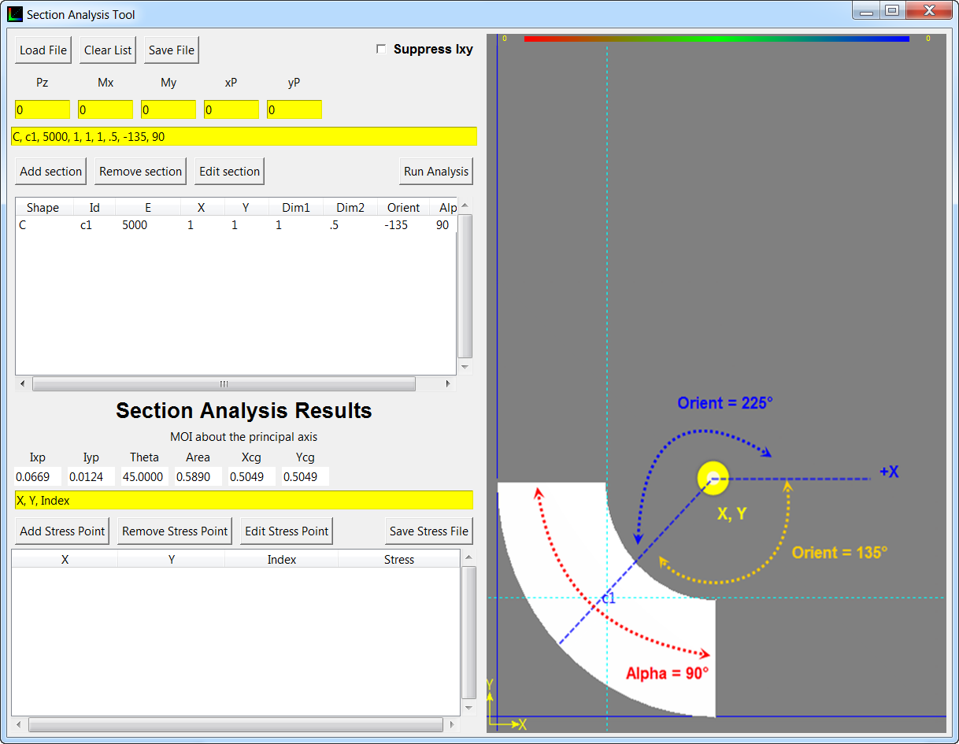

### Polygon:

A Polygon section can be created by inputting Shape information which starts with the letter “P” or “p”. Valid shape strings include but are not limited to: P, p, Poly, pol, poor, p*. All shapes must have an id. The id will label the shapes in the drawing area. The id can be anything, but it cannot be left out.

The list table shows Shape, Id, E, X, Y, Dim1, Dim2, Orient, and alpha.

For a polygon the Shape, Id, and a minimum of 3 points must be inputted. The polygon is very flexible. You may add as many points as you like, to a minimum of three points. A polygon is defined by the Shape, ID, E, and x0, y0, x1, y1, x2, y2, x3, y3. Although the program allows you to create intersecting polygon it will not give you a correct analysis. This is due to the polygon section information being calculated based on formulas for a simple non-intersecting polygon.

Example: P, P1, 5000, 0, 1, 0, 0, 1, 0, 1, .077, .077, .077, .077, 1

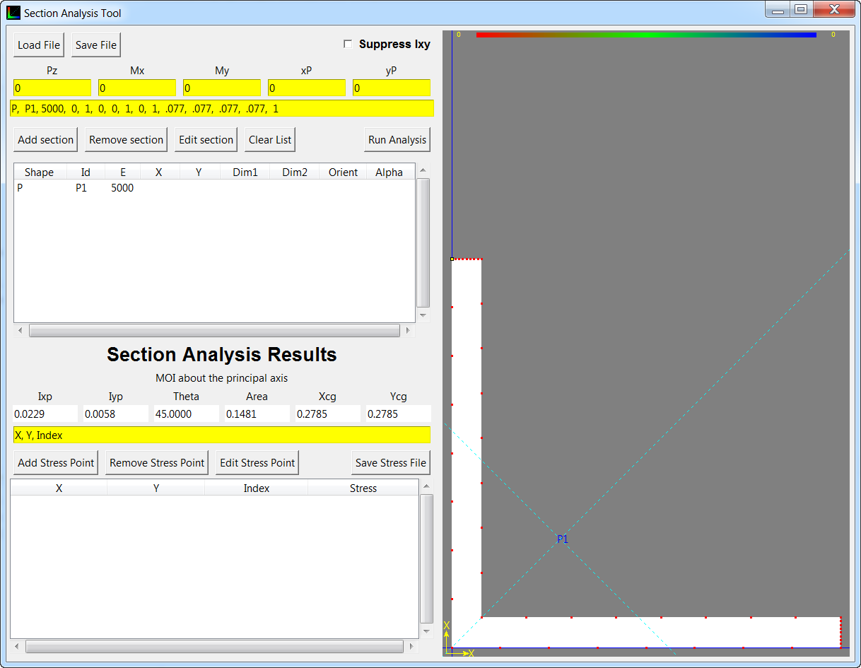

# Buttons

## Load File:

User selects a section file to load. The file loads in the sections. Sections are defined by a shape, id, and dimensions.

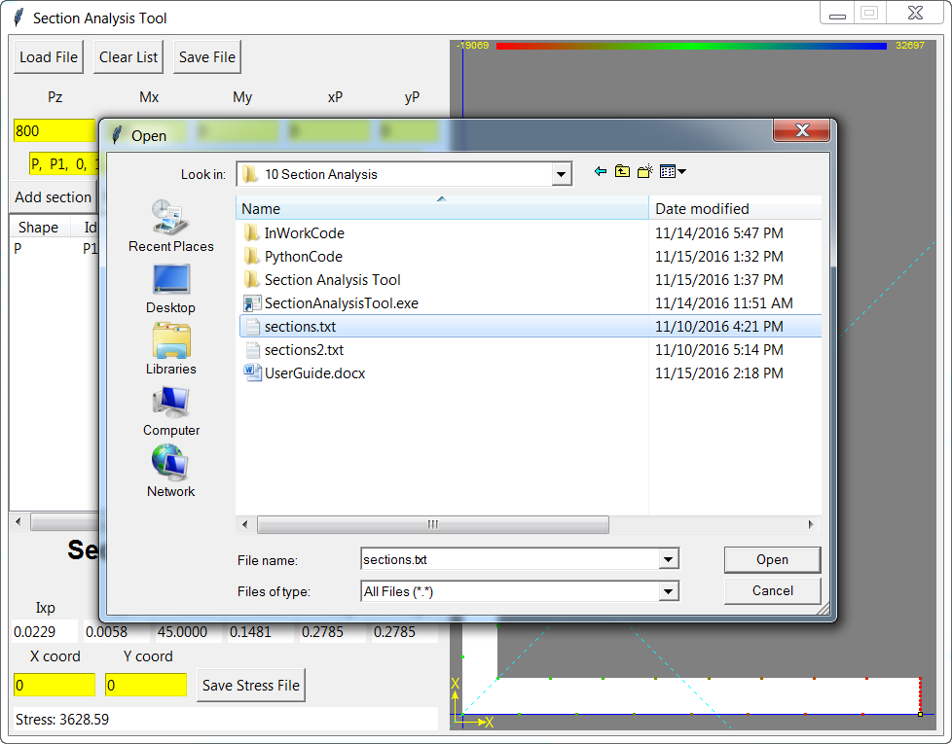

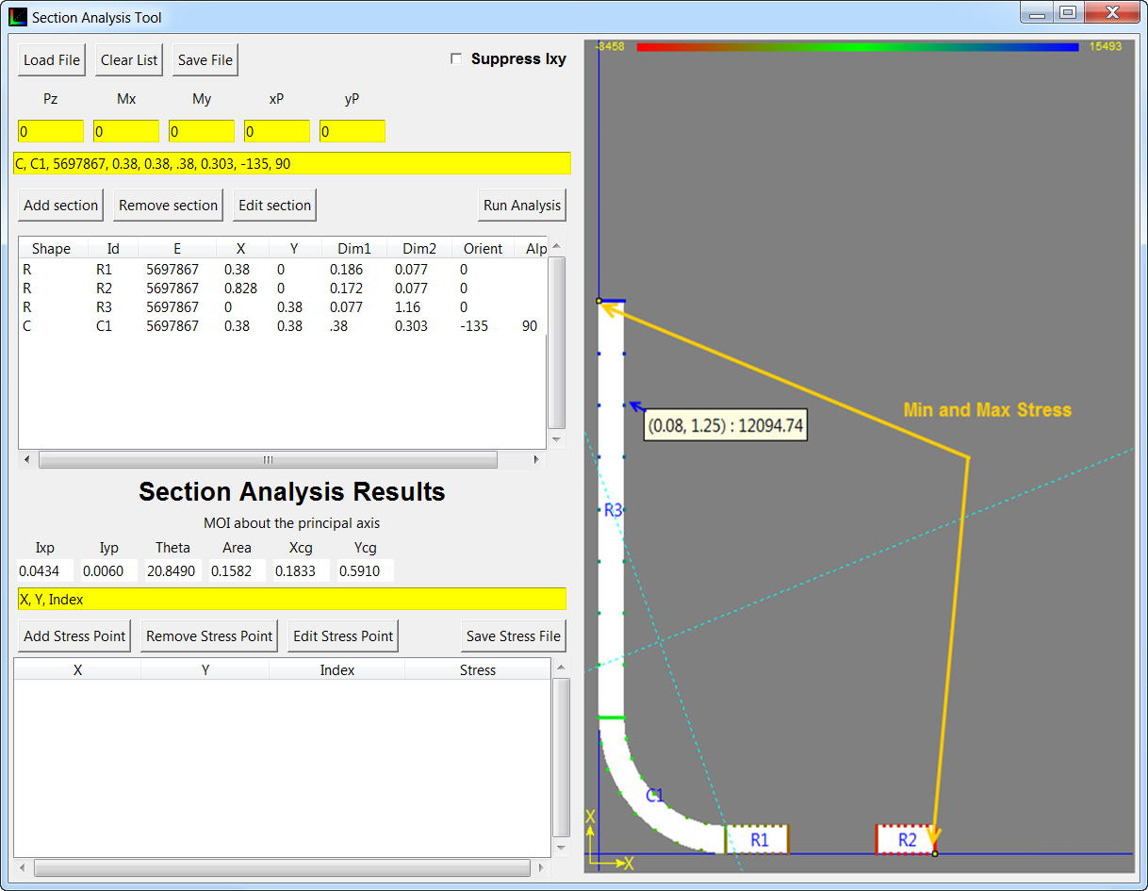

## Clear List:

Clears the list of sections

## Save File:

Saves the sections into a file

## Add Section:

Adds a section to the list of sections

## Remove Section:

Removes the selected section from the list of sections

## Edit Section:

Replaces the selected section with the information in the section info box (circled in orange in the overview).

## Run Analysis:

Runs a stress analysis on the part.

## Save Stress File:

Saves the stress analysis to a file. The stress file is a list formatted as x, y, stress. x and y are coordinates of a stress point and the stress is the stress at that location.

# Calculations:

This section discuss the math behind the program.

## Single Section Property:

### Rectangle

A rectangle’s section analysis can be calculated by the following equations:

$area=dim1*dim2$

$x_{cg}=x+\frac{dim1}{2}*\cos\left(orient\right)-\frac{dim2}{2}*\sin\left(orient\right)$

$y_{cg}= y+\frac{dim1}{2}*\sin\left(orient\right)+\frac{dim2}{2}*\cos{(orient)}$

$I_{x_{not-inclined}}=\frac{1}{12}*dim1*dim2^{3}$ $I_{y_{not-inclined}}=\frac{1}{12}*dim1^{3}*dim2$

### Circle

A circle’s section analysis can be calculated by the following equations:

$alpha=alpha*\frac{π}{180}$ (alpha is converted to radians)

$area=\frac{alpha}{2}(dim1^{2}-dim2^{2})$

$x_{cg_{pie-section}}=x+2*r*\sin\left(\frac{alpha}{2}\right)*\frac{2cos\left(orient\right)}{3alpha}$ (plug in dim1 and dim2 for r for Xcgdim1 and Xcgdim2)

(plug in dim1 and dim2 for r for Ycgdim1 and Ycgdim2)

MOI about not-inclined axis

$I_{x_{not-inclined}}= \frac{dim1^{4}-dim2^{4}}{4}\left(\frac{alpha}{2}-\sin\left(\frac{alpha}{2}\right)\cos\left(\frac{alpha}{2}\right)\right)$

$I_{y_{not-inclined}}=\frac{dim1^{4}-dim2^{4}}{4}(\frac{alpha}{2}+\sin\left(\frac{alpha}{2}\right)\cos\left(\frac{alpha}{2}\right)-area*{\left[\frac{\left(\frac{2}{3}\sin\left(\frac{alpha}{2}\right)\left(dim1^{3}-dim2^{3}\right)\right)}{\frac{alpha}{2}\left(dim1^{2}-dim2^{2}\right)}\right]}^{2}$

### Circle and Rectangle

MOI about inclined axis:

$I_{x_{inclined}}=I_{x_{not-inclined}}*\cos^{2}\left(orient\right)+I_{y_{not-inclined}}*\sin^{2}\left(orient\right)$

$I_{y_{inclined}}=I_{x_{not-inclined}}*\sin^{2}\left(orient\right)+I_{y_{not-inclined}}*\cos^{2}\left(orient\right)$

$I_{xy_{inclined}}=\frac{-\left(I_{x_{not-inclined}}-I_{y_{not-inclined}}\right)\sin\left(2orient\right)}{2}$

MOI about origin: $I_{x_{o}}=I_{x_{inclined}}*area*y_{cg}^{2}$ $I_{y_{o}}=I_{y_{inclined}}*area*x_{cg}^{2}$ $I_{xy_{o}}=I_{xy_{inclined}}+area*x_{cy}*y_{cg}$

### Polygon

The centroid of a non-self-intersecting closed polygon defined by *n* vertices (*x*0,*y*0), (*x*1,*y*1), ..., (*xn*−1,*yn*−1) is the point (*C*x, *C*y), where

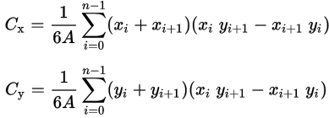

and where *A* is the polygon's signed area,

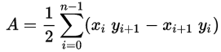

In these formulas, the vertices are assumed to be numbered in order of their occurrence along the polygon's perimeter. Furthermore, the vertex ( *xn*, *yn* ) is assumed to be the same as ( *x*0, *y*0 ), meaning *i + 1*on the last case must loop around to *i = 0*. Note that if the points are numbered in clockwise order the area *A*, computed as above, will have a negative sign; but the centroid coordinates will be correct even in this case.

Information is taken from:

<https://en.wikipedia.org/wiki/Centroid>

Similarly, the moment of inertia calculations are based on: <https://en.wikipedia.org/wiki/Second_moment_of_area>

The second moment of area for any simple polygon on the XY-plane can be computed in general by summing contributions from each segment of the polygon. A polygon is assumed to have n vertices, numbered in counter-clockwise fashion. If polygon vertices are numbered clockwise, returned values will be negative, but absolute values will be correct.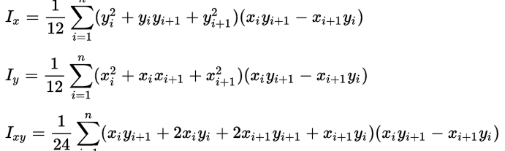

Where x{\displaystyle x_{i},y_{i}}xxxxxxi, yi are the coordinates of the {\displaystyle i}i-th polygon vertex, for 1≤ I ≤ n{\displaystyle 1\leq i\leq n}. Also, {\displaystyle x_{n+1},y_{n+1}}xn+1, yn+1 are assumed to be equal to the coordinates of the first vertex, i.e., {\displaystyle x_{n+1}=x_{1}}xn+1 = x1 and yn+1 = y1

The polygon’s moment of inertia are calculated about the origin.

## Total Section Property

The centroid of the total section is the sum of each single section xcg, ycg times the single section area over the sum of each section area. Below, n represents the n-th section. The moment of inertia for the total section is the sum of each single section.

$$E=\frac{\sum_{1}^{n}{E_{n}}}{\sum_{1}^{n}{area_{n}}} \\ x_{cg}=\frac{\left[\sum_{1}^{n}{area_{n}*x_{cg_{n}}}*E_{n}\right]}{\left[\sum_{1}^{n}{area_{n}}\right]E}$$

$y_{cg}=\frac{\left[\sum_{1}^{n}{area_{n}*y_{cg_{n}}*E_{n}}\right]}{\left[\sum_{1}^{n}{area_{n}}\right]E}$ $area= \sum_{1}^{n}{area_{n}}$

$I_{xo}=\sum_{1}^{n}{I_{xo_{n}}}E_{n}/E$

$I_{yo}=\sum_{1}^{n}{I_{yo_{n}}}E_{n}/E$

$I_{xyo}=\sum_{1}^{n}{I_{xyo_{n}}}E_{n}/E$

The MOI about the CG can then be calculated as:

$I_{x_{cg}}=I_{xo}-area*y_{cg}^{2}$

$I_{y_{cg}}=I_{yo}-area*x_{cg}^{2}$

$I_{xy_{cg}}=I_{xyo}-area*x_{cg}*y_{cg}$

The principal axis angle and MOI about the principal axis can be calculated as follows:

$theta=\frac{\operatorname{atan}\left(2*\frac{I_{{xy}_{cg}}}{I_{y_{cg}}-I_{x_{cg}}}\right)}{2}$

$I_{xp}=I_{x_{cg}}*\cos^{2}\left(theta\right)+I_{y_{cg}}*\sin^{2}\left(theta\right)-2I_{xy_{cg}}\sin\left(theta\right)\cos\left(theta\right)$

$I_{yp}=I_{x_{cg}}*\sin^{2}\left(theta\right)+I_{y_{cg}}*\cos^{2}\left(theta\right)+2I_{xy_{cg}}\sin\left(theta\right)\cos\left(theta\right)$

The stress at a point X,Y can be calculated with the following equations:

Resolved moment about the cg:

$M_{x_{cg}}=M_{x_{o}}-P_{z}*{(y}_{cg}-y_{f})$

$M_{y_{cg}}=M_{y_{o}}+P_{z}*(x_{cg}-x_{f})$

$M_{xp}=M_{x_{cg}}\cos\left(theta\right)-M_{y_{cg}}\sin\left(theta\right)$

$M_{yp}=M_{x_{cg}}\sin\left(theta\right)+M_{y_{cg}}cos⁡(theta)$

$σ=\left(\frac{P_{z}}{area}-\frac{M_{xp}y_{p}}{I_{xp}}-\frac{M_{yp}x_{p}}{I_{yp}}\right)*\frac{E_{n}}{E}$

Where yp and xp are points rotated about the principal axis and relative to the centroid and yf and xf are the location of the load relative to the origin. En is the E of the section of the stress analysis and E is the overall modulus of the section.

MOI about principal axis are taken from Bruhn Analysis and Design of Flight Vehicle Structures, A13.

# Coding:

This app uses python. All currently working code is provided in the PythonCode folder (what the exe is made from). All code that is current in work and being updated is in the InWork folder. After creating updates, simply run build under the gui folder

For single section Analysis refer to Partial* Rectangle*, Circle* and Polygon* where * is Analysis.

For total section Analysis refer to SectionAnalysis.

For drawing of shapes, refer to Shape, Rect, Circ, Poly.

For GUI refer to SectionAnalysisTool. MultiColumnListbox is used to create the list.