- Test Scenario : Submit email to request your query

These high spec multi-domain hosting accounts are for the more demanding entrepreneurial developer or designer. You can host up to 800 domains in one account, each domain with its own cgi-bin directory, its own stats, its own mailboxes, etc.

- Steps to follow :

- The User visit on http://thedemosite.co.uk/index.php site.
- The portal displays the home page.

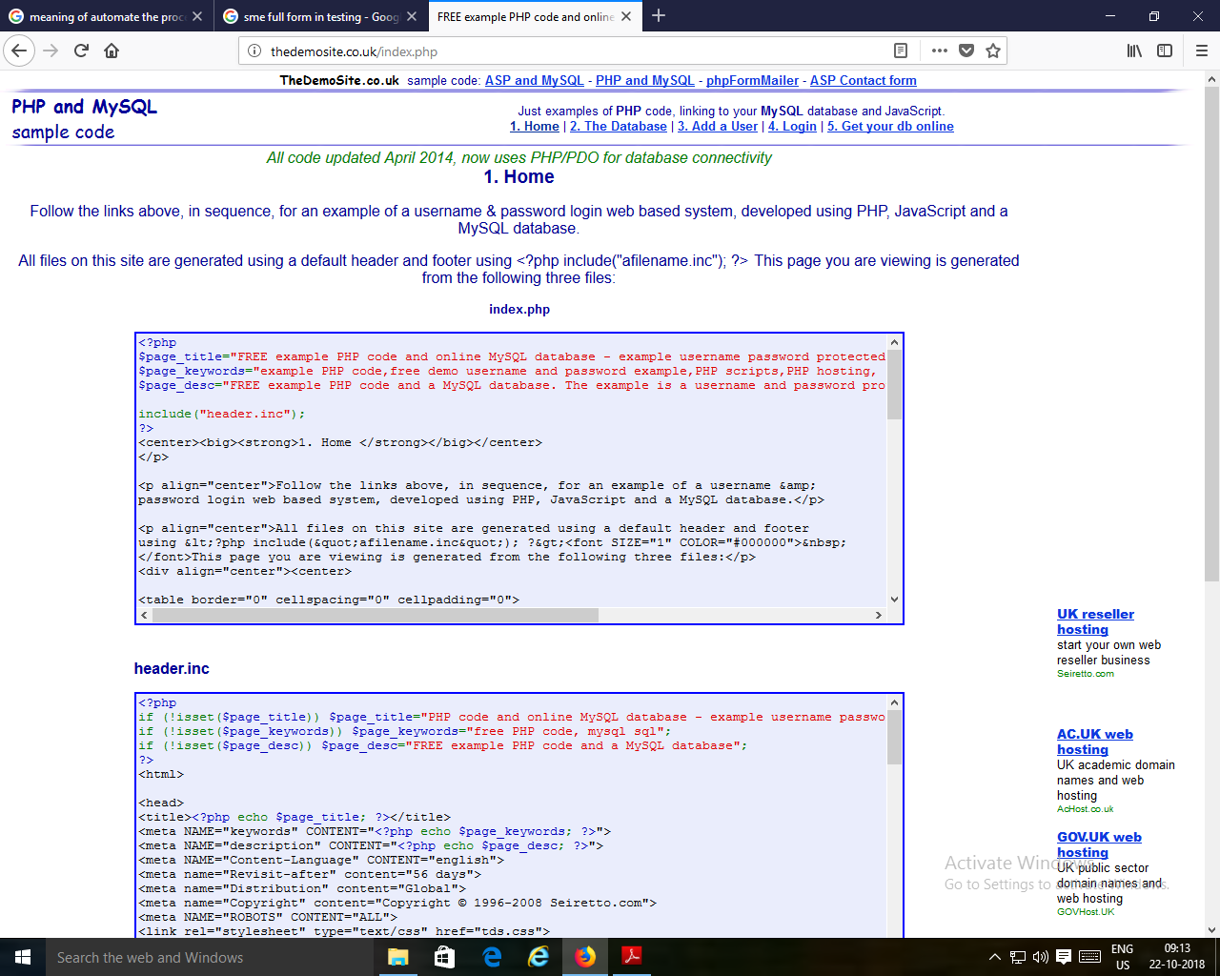

- The user click on the UK reseller hosting link. The portal displays Seiretto web hosting page.

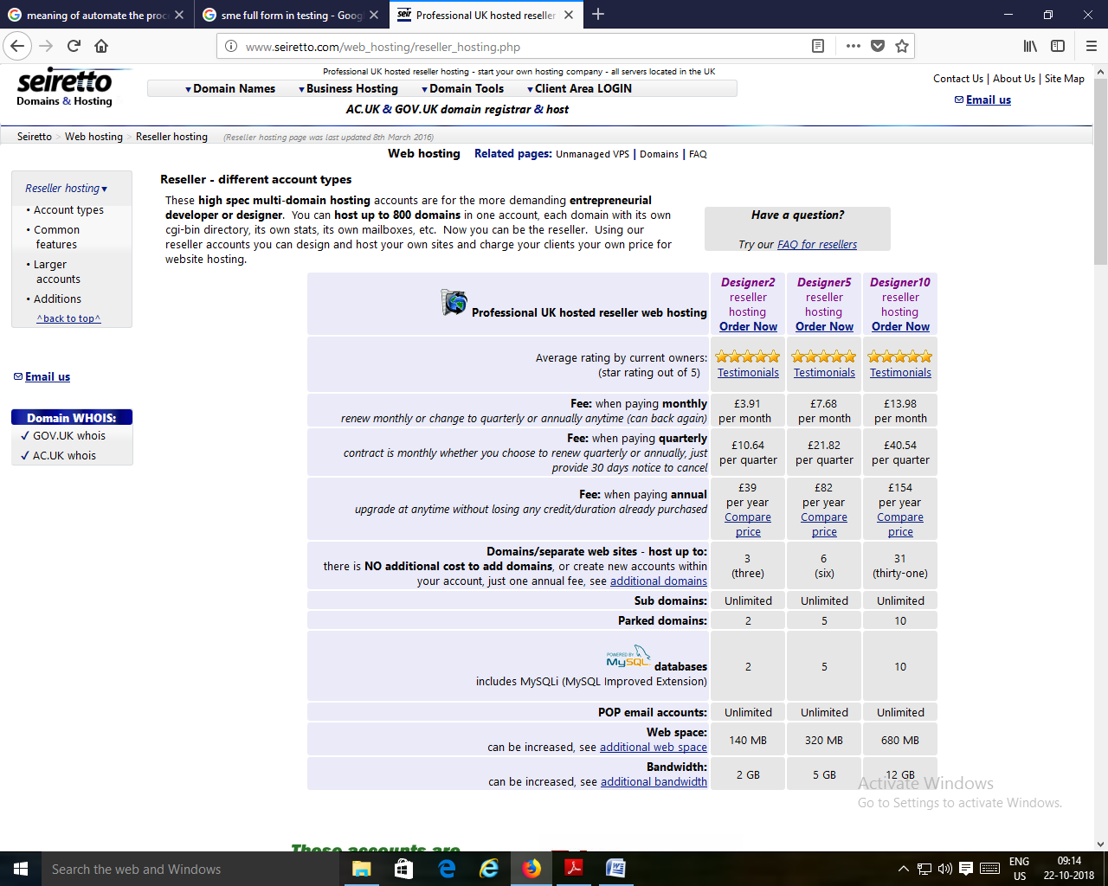

- The user Click on the Email us link. The link prompts the email form.

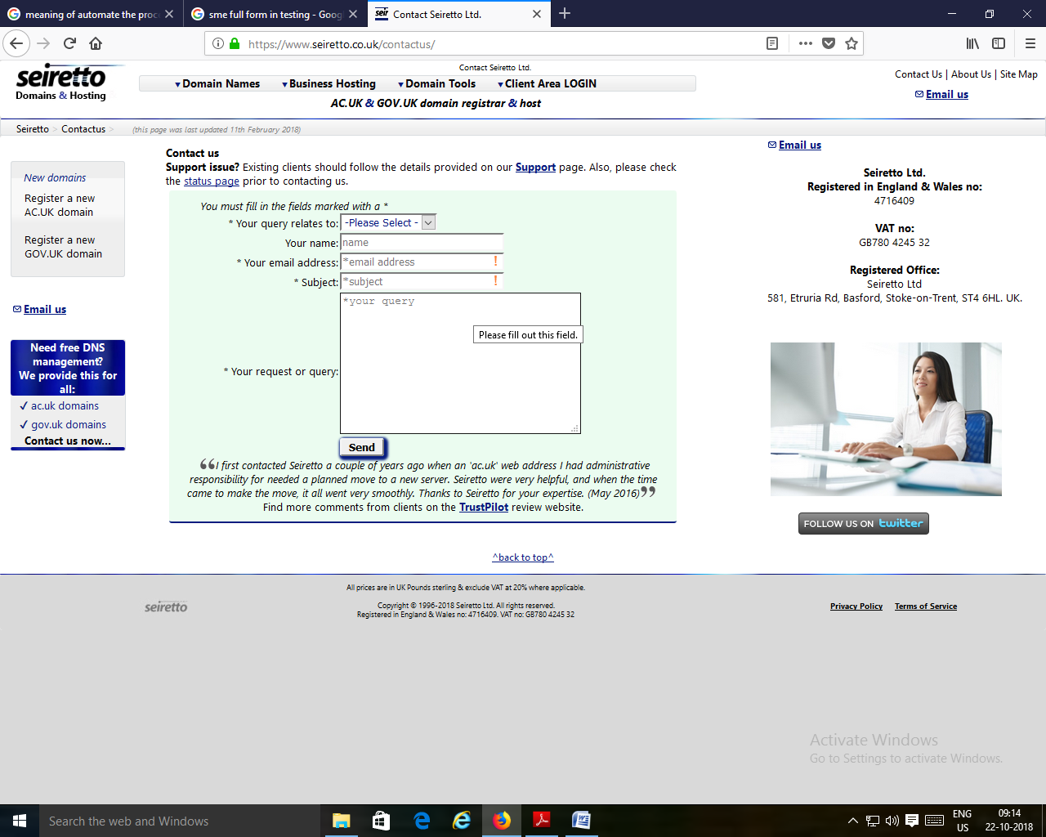
- The fill all the details in the form and click on the Send button.
- The portal displays ‘Success, your query has been sent’ message on the screen.

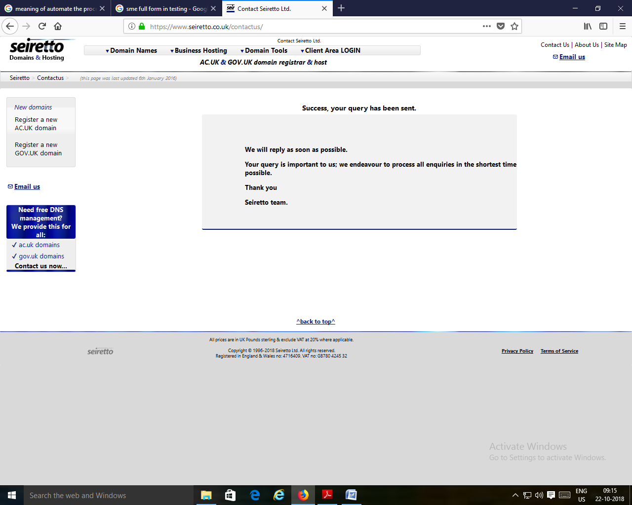

- Rules :

- The fields marked as * are mandatory fields.
- Follow the given rules :

Fields | Description
Your query relates to: | Select the Option from the following :  - Sales  - Support  - Marketing  - Vacancies  - Other
Your name: | - The name should accept only alphabets.  - The length should be 3 to 30 characters.
 | Should accept only valid and existing email.
  Your email address:
Subject: | The length should be 15 to 50 characters.
Your request or query: | The length should be 20 to 100 characters.

