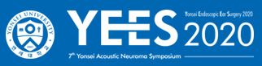
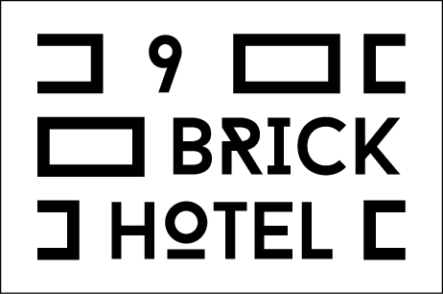
Corperate (Room only)
Prices may change due to hotel conditions. ( 10% government tax is included )
Room Category | Published Rates (KRW) | Special Rates _RM Only (KRW)
Room Category | Published Rates (KRW) | WeekDay | WeekEnd
Standard Double | 200,000 | 80,000 | 110,000
Standard Twin | 200,000 | 80,000 | 110,000
Deluxe Double | 250,000 | 10,000 | 130,000

Corperate (B/F PKG)
Prices may change due to hotel conditions . ( 10% government tax is included )
Room Category | Published Rates (KRW) | Special Rate _ B/F PKG ( KRW)
Room Category | Published Rates (KRW) | WeekDay | WeekEnd
Standard Double | 200,000 | 90,000 | 120,000
Standard Twin | 200,000 | 90,000 | 120,000
Deluxe Double | 250,000 | 110,000 | 140,000
One person standard
* The rate for Superior double&twin and Deluxe Double will be increased by 5,000 won for weekdays during high demand; ( 4,7,8,9,10,12 )
Additional Charge
-Extra person Superior & Deluxe ₩10,000
-Add Bedding ₩ 25,000
-Breakfast Restaurant (07:00~09:30) >>> 2F Encemoment Brunch
: adult ₩15,000 ₩ 5,000 (age 4~7) : Semi-Buffet
Internet
- Available in all rooms: Free Wireless Internet access, Free Wired high-speed Internet access

Cancellation Policy
- If you wish to cancel, please do so 2 day prior to arrival to avoid cancellation penalties.
- Free Wifi
- D’Live plus (OTT set top box) – VOD service, Wireless Display (Screen Mirroring)
- LED 50” SMART LED TV
- Laptop computer rental service
- Air-conditioning and individual heating system
- Complimentary water, coffee, tea
- YAMAHA Bluetooth speaker
- Designer Furniture and lighting
- The best premium SIMMONS bed and PRAUDEN duck down bedding
- Eco-friendly fabrics, and comfortable interior
- Laundry service
- Meeting room rental service

Reservation. Tel: +82 02-3141-8800, E-mail : 9brickhotel@naver.com
Last Name (Mr./Ms.) : | First Name :
Company Name : YEES2020
Address :
Phone No. : | Fax No. :
Email: | Sharing Room with :
Check-in Date : | Arrival Flight No./ Time :
Check-out Date : | Departure Flight No./ Time :

♦ A credit card number is required to guarantee your reservation.
Card: □ Amex □ Diners □ Master □ Visa □ JCB | 4 digit # for AMEX: _ _ _ _
Card Number: | Expiry Date:

Hotel9Brick Hongik-ro 5-gil, Mapo-Ku, Seoul, Korea. Tel : 82-2-3141-8800 Fax : 82-2-3141-8802

