

**RMIT International University Vietnam**

**Assignment Cover Page (Group)**

|  |  |
| --- | --- |
| **Subject Code:** | COSC2083 |
| **Subject Name:** | Introduction to Information Technology |
| **Location & Campus:** | Saigon South |
| **Title of Assignment:** | Project Proposal |
| **Teachers Name:** | Long Nguyen Minh |
| **Group Name:** | F-APP |
| **Group Members:** | Kim Nguyen Ngoc_s3970589  Jimin Cho_s3940575  Huy Luong Anh_s3979199  Minh Phan Nhat_s3978598 |
| **Assignment due date:** | 20/11/2022 |
| **Date of Submission:** | 20/11/2022 |
| **Declaration of Authorship:** | We declare that in submitting all work for this assessment we have read, understood and agree to the content and expectations of the Assessment Declaration |
| **Consent to use:** | We do NOT give RMIT University permission to use our work |

**Table of content**

|  |  |
| --- | --- |
| Project background | 3 |
| People | 4 |
| Project scope | 6 |
| Timetable | 9 |
| Communication | 12 |
| Risks | 13 |

**Project background**

Numerous people are concerned about nutritional imbalance and the rise in obesity rates. *According to Shattuck (2017), obesity rates did not exceed 15% in any U.S. state in 1985, and by 2016 no state had a rate under 20%. Currently, the average obesity rate is over 33%[1]*. It is obvious that correcting dietary imbalances will benefit society.

*As rates of physical activity have decreased, there is an increasing epidemic of obesity (Skinner et al., 2018, cited in Armstrong, 2019)[2]*.. IT professionals are not exempt from this rule. In particular, persons who spend several hours sitting in chairs and avoid outdoor activities are more likely to be exposed to obesity or underweight risks.

As a result, our group developed an interest in the topic of nutritional imbalance. BMI is one of the well-known and practical measurements of obesity. By dividing one's weight by the square of height, individuals can quickly determine their present physical state. Our group identified shortcomings in other BMI calculators. This was the issue with only giving out the basic necessities of data, such as the present situation and statistics. Our group believed that it would be more practical if it offered suggestions as to what types of management are required beyond just calculating BMI. Therefore, we made the decision to develop a calculator that does not require users to check their BMI, search for exercises online, or find another calculator to see how many calories they consumed today. Users can calculate their daily caloric intake and receive suggestions depending on their BMI using our project. This allows users to know roughly whether they should reduce their diet, exercise, or increase their diet.

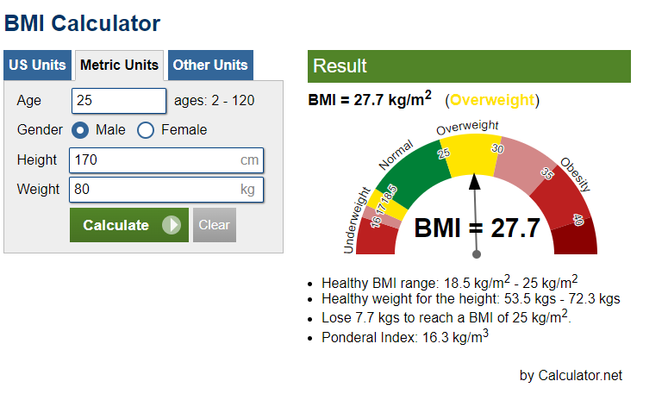

*Other calculator example*

*Source: Calculator.net*

*[1]Shattuck, M. 2017, Control diet, weight in diabetes fight: As rates of obesity increase, so too do rates of Type 2 diabetes, Appleton, Wis.*

*[2]Armstrong, S. & Wong, C. (2019) Physical Activity Interventions Improve Quality of Life of Children With Obesity: Should We Expect Them to Also Decrease Body Mass Index? Journal of adolescent health. [Online] 65 (3), 309–310.*

*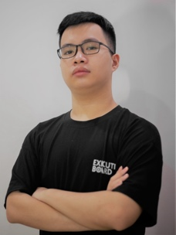***People**

**Phan Nhat Minh (s3978598)**

[*s3978598@rmit.edu.vn*](mailto:s3978598@rmit.edu.vn)

*0907459988*

**Role:** Project leader, designer

**Interest in the topic:** This topic not only help other people but also my health as well.

**Skills:** Project managing, making media, writing reports.

*“I am a dedicated person for whatever that I’m working for. And I also like Bun bo as well so that is why I’m interested in this topic so that I can eat Bun bo without worrying.”*

**Jimin Cho (s3940575)**

*s3940575@rmit.edu.vn*

*0765047285*

**Role:** Making slides and website.

**Interest in the topic:** Interested in diet, and want to experience in website producing through this project.

**Skills:** Making slides, HTML.

*“I am currently on a diet and I am very interested in it. My goal is to experience website creating and I hope this project will help me lose weight.”*

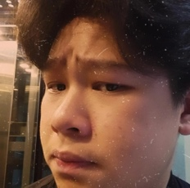

**Nguyen Ngoc Kim (s3970589)**

*s3970589@rmit.edu.vn*

*0392803666*

**Role:** Presentator

**Interest in the topic:** To learn more programming languages

**Skills:** Presenting

*“I am interested in IT and want to work in a big 4 technology companies in the future. Also, my hobby is playing music and if I have a chance I will become a singer as well.”*

****Luong Anh Huy (s3979199)**

[*s3979199@rmit.edu.vn*](mailto:s3979199@rmit.edu.vn)

*0399390377*

**Role:** Adviser, supporter

**Skills:** Presenting, proof-reading, critical thinking, attention to details

*“I'm fascinated in coding and problem solving, A.I and brain teasers, which is why I chose IT as my major. I’m looking forward to learning new stuff and making new friends during my years in university.”*

**Project Scope**

|  |  |  |  |  |
| --- | --- | --- | --- | --- |
|  | **Priority** | **Feature** | **Description** | **Note** |
| **In scope** | **For trainee** | | | |
| **High** | **Diagnose body status** | Caculate base on data input:   * Height * Weight * Age * Gender * Other sickness * … |  |
| **Give conclusion about body status** | Get input from user about their exercises, meals,... in order to give more accurate suggestion |  |
| **Daily data input** | Get input from user about their exercises, meals,... in order to give more accurate suggestion |  |
| **Recommendations**  **/Advices/Solutions for your status** |  |  |
| **Medium** | **Home page** | "Log in options:  Create a account or sign up with Google/Facebook/...  Forget password  Sign up a [app name] account" |  |
| **Meals, food, exercises library and how to make/do it at home** | Provid a wide selection of meals and exercises beside the one that already provided in the advices. |  |
| **Feedback** | User can give feedback on our free program and user experience in general |  |
| **Search engine** | Searching for specific exercise, meals or trainer |  |
| **PT filter (location)** | If trainee would like to meet the trainer face-to-face, this will help |  |
| **Progress summary** | Give weekly progress summary for users (maybe create a level, challenge or something like that) to encourage user keep trying to be fit |  |
| **Low** | **Identity verification** | Both trainees and trainers are required to verify the identity (only for paid plans) |  |
| **Advertisement** | Resource for developing |  |
| **Payment** | Payment options for premium version and donation |  |
| **For trainers** | | | |
| **Medium** | **Profile tools** | Give trainers chance to introduce themselves on our app |  |
| **Trainees management** | * Track trainee progress * Communicate with trainees * Plan meals and exercises for trainees * Trainees feedback |  |
| **Income** | Trainers will receive a portion (20% - 40%) of trainee’s subscription |  |
| **Out of scope** | | **Data input from smart watches and fitness devices** | Automatically input exercises data from smart watches Ex: Apple watch can show the burned calories after doing exercises, we can get input from this so that the user do not have to manually input to the app |  |
| **Premium version (Paid plans)** | There are a option (premium plan) for hiring a PT for better experience |  |
| **PT feedback and rating** |  |  |

**Timetable** *\*Timetable could be changed*

|  |  |  |
| --- | --- | --- |
| *Done* | *In progress* | *Have not started* |

|  |  |  |  |  |  |  |
| --- | --- | --- | --- | --- | --- | --- |
| Phase | Task | Duration | Start | Finish | In-charge | Note |
| PROPOSAL  [EARLY FEEDBACK] | Self research and idea brainstorm | 4 days | Nov 4 2022 | Nov 7 2022 | All |  |
| Finalize the projects’ idea | 1 day | Nov 8 2022 | Nov 8 2022 | Minh | Meeting at 1.1.018 for 2 hours |
| Proposal structure | 1 day | Nov 9 2022 | Nov 10 2022 | Minh | Meeting at 2.4.005 for 1 hour |
| Proposal first draft | 2 days | Nov 9 2022 | Nov 11 2022 | Minh | Meeting |
| First draft adjusting | 1.5 days | Nov 11 2022 | Nov 12 2022 | Minh | Meeting at 1.2.26 for 1.5 hours |
| First draft finalising for early feedback | 1.5 days | Nov 12 2022 | Nov 13 2022 | Minh | Meeting at 1.1.018 for 2 hours |
| PROPOSAL  [FINAL] | Adjustment base on feedback |  | After feedback release | Nov 18 2022 | Minh | Meeting ater receiving feedback |
| Final adjustment (content & visual) | 1 day | Nov 18 2022 | Nov 19 2022 | Minh | Meeting |
|  |  |  |  |  |  |  |
|  |  |  |  |  |  |  |
| PREPARATION | JavaScript (optional) | 2 weeks | Nov 22 2022 | Dec 6 2022 | Jimin |  |
| Getting familiar with HTML and Github | Jimin & Kim |  |
| Medical research about BMI calculation | Jimin |  |
| Market research | Huy |  |
| DEVELOPING | UI/UX first brainstorm | 5 days | Dec 6 2022 | Dec 11 2022 |  |  |
| UI desgin | 2 weeks | Dec 11 2022 | Dec 25 2022 | Minh |  |
| Complete UX | 1 week | Dec 11 2022 | Dec 18 2022 | Huy |  |
| UX testing/operating | 1 week | Dec 18 2022 | Dec 25 2022 | Huy |  |
| PLAN A:  Protoype using JavaScript (if possible) | 2 weeks | Dec 25 2022 | Jan 8 2023 | Jimin |  |
| PLAN B:  Prototype using UI demos | 2 weeks | Dec 25 2022 | Jan 8 2023 | Minh & Jimin |  |
| PRESENTATION | Presentation plan | 2 days | Dec 19 2022 | Dec 21 2022 | Kim |  |
| Presentation slides | 5 days | Dec 21 2022 | Dec 26 2022 | Jimin |  |
| Presentation script | 2 days | Dec 26 2022 | Dec 28 2022 | Huy |  |
| Presenting practice | 2 days | Dec 28 2022 | Dec 30 2022 | All | A demo presentation will occur |
| Presentation final adjustments | 1 day | Dec 29 2022 | Dec 30 2022 | Minh |  |
| Presenation day | 1 day | Jan 13 2023 | Jan 13 2023 | All |  |
| FINAL REPORT | Remaining sections’ outlines | 2 days | Dec 26 2022 | Dec 28 2022 | Minh |  |
| Outlines finalising | 5 days | Dec 28 2022 | Jan 2 2023 | Minh |  |
| Adjustments & reflections | 1 week | Jan 2 2023 | Jan 9 2023 | All |  |
| Final review before submitting | 1 day | Jan 14 2023 | Jan 14 2023 | Minh |  |

**Communication**

**Face-to-face communication:** meetings at school or outside

**Online communication:** Facebook

Documents, references, pictures,… storage: Google Drive (current), GitHub, Web (pending)

**Urgent situations:** Phone

**Formal communication:** RMIT email

**Group commitment:**

* **Reply group message within 2 hours max** (if not please provide suitable reason)
* Keep updating your progress on the main group so that we all know what we are doing.
* Be on time for face-to-face meetings (10-15 minutes late is acceptable).
* In some cases, if we can not gather for a meeting then an online meeting will occur.
* Important discussions should be face-to-face if possible

**Before any tasks, a meeting is required.**

While doing a task, try to **update the progress to the team group on Facebook** so that other teammates can send help if needed.

Email will be used for formal situations.

**All documents, meeting minutes, notes,... will be saved in a shared folder on Google Drive.**

**If a person in the group does not respond to group activities within a day**, we will give a warning for the first time. From the second time, we will consider having a face-to-face conversation or report to the lecturer for a final decision.

**Risks**

***Time management***

**Problem:** Each member is working on multiple projects, taking multiple courses at the same time, so time will be the our biggest

**Solution:** We will split the workload equally to make sure that we have the same workload on this project.

***Lack of knowledge***

**Problem:** This project is about building and developing a mobile app/website, so we, newbies in IT may have some difficulties in building the prototype for the project.

**Solution:** If learning other programming languages is not possible, we will use 2D graphics demo instead.

***Cost***

**Problem:** Although, many early phases in app development are cost-free. But we think in the future when the developing work becomes more serious, it won’t be cost-free anymore.

**Solution:** Using free resources on the Internet and free services provided by the school.

***Communication***

**Problem:** In some special cases like technological problems, or health-related problems,… a member can not give information to the team as soon as possible, and there would be miscommunications internally. This may lead to inefficient operation in general.

**Solution:** We committed to communication in the group so that we when do the backups and have enough spare time to finish the missing part of the disappearing friend.

***Scope creep***

**Problem:** We still don’t have much experience in making and operating a complete project before so there are some aspects that we could not expect and have prepared for it.

**Solution:** We will try to stick to the scope as much as we can and make it perfect than come up with unexpected and unneccessary features.

***Performance***

**Problem:** The project outcomes or project prototype might not meet our expectations and also users' expectation. This could lead to the failure of the project.

**Solution:** Feedback from users is an important part in our development. We will consider to change and fix the problem base on users’ feedback.

***Market***

**Problem:** The project idea and background are not so distinctive so joining the market will be a tough challenge for a new project like us.

**Soultion:** Our biggest aim of the project is the user experience so we think that will make us stand out from other opponents that already joined the market.