PoolAdapt Improvement 1 Evaluation Report
Frozen TEST evaluation, paired analysis, Pareto trade-offs, and failure review
Analysis of the completed SciFact TEST handoff | 12 November 2026

Abstract
This report evaluates PoolAdapt against fixed-prefix and other candidate-selection methods using the frozen 300-query SciFact TEST set. The handoff contains 11,100 execution rows across 37 method/operating-point/seed strata. The primary paired comparisons use B10, B20, and B50, where actual pair-count means fall within the prespecified ±5% matching threshold. PoolAdapt averages 0.6748 nDCG@10 at B10 and 0.6816 at B50. Across all nine primary paired tests, Holm-adjusted permutation p-values are not below 0.05; intervals and effects are reported below. Pair consumption is substantially below the 100-pair Full Rerank reference, but observed reranking latency has long tails at several operating points. The provenance audit retains two FAIL and three NOT VERIFIED items, and TEST controller features and query-group labels are unavailable. The evidence supports a quality-efficiency trade-off description, not a claim of causal superiority or complete historical reproducibility.

Research objective and questions
The evaluation asks whether PoolAdapt can preserve retrieval quality while reducing the number of candidates sent to the cross-encoder, how it compares with Fixed Prefix at matched actual pair budgets, whether the observed operating points are Pareto efficient, and whether reranking latency tails align with actual pair counts. All analyses use frozen TEST outputs; no retrieval, reranking, training, or model inference was rerun.

Experimental context and frozen TEST setup
The source evaluation records a Tesla T4 on cuda:0, CUDA 13.0, and Python 3.11.15. The recorded latency measures pair preparation, cross-encoder inference, and sorting. It excludes retrieval, selection, model loading, and warm-up, so it is reranking-stage latency rather than end-to-end latency. Methods include PoolAdapt, Fixed Prefix, SAGE-SLO, PACE-EF, Random, and Full Rerank. Operating points are B10, B20, B30, B50, and Full Rerank B100.

Dataset and method overview
The TEST handoff covers 300 unique SciFact queries and 339 positive qrels judgments. Each method/operating-point/seed stratum covers the same 300 query IDs. Random has five genuine execution seeds (0–4) per query and operating point. For cross-query summaries, the five seed measurements are averaged within each query; the resulting independent population remains 300 queries. Non-Random methods have one execution per query and operating point.

Random seed sensitivity
Seed SD describes variation among five seed-level 300-query means. It is reported separately from paired query-level uncertainty and is not used as an independent-query sample size.
Point | Seeds | nDCG mean ± SD | Recall mean ± SD | MRR mean ± SD | Pairs/q
B10 | 5 | 0.0901 ± 0.0098 | 0.0970 ± 0.0106 | 0.0943 ± 0.0117 | 10.00
B20 | 5 | 0.1660 ± 0.0136 | 0.1861 ± 0.0129 | 0.1695 ± 0.0137 | 20.00
B30 | 5 | 0.2357 ± 0.0227 | 0.2719 ± 0.0219 | 0.2358 ± 0.0245 | 30.00
B50 | 5 | 0.3780 ± 0.0206 | 0.4412 ± 0.0154 | 0.3706 ± 0.0223 | 50.00

Random latency percentile standardization
The primary Random latency estimand first averages the five seed observations within each query and operating point, then calculates P50 and P95 across the 300 query means. This preserves the frozen query as the independent population. The sensitivity table also shows the median and range of the five per-seed percentiles, the pooled 1,500 query-seed percentile distribution, and the historical source-summary values, which are means of per-seed percentiles. The pooled distribution combines query and seed variation and is not treated as 1,500 independent queries.
Point | Primary P50 / P95 | Per-seed P50 median [range] | Per-seed P95 median [range] | Pooled P50 / P95 | Historical P50 / P95
B10 | 56.75 / 59.65 | 57.72 [57.63, 58.17] | 60.66 [60.29, 60.74] | 57.84 / 60.54 | 57.82 / 60.55
B20 | 116.20 / 118.93 | 116.70 [115.89, 116.96] | 119.45 [119.42, 119.98] | 116.62 / 119.58 | 116.58 / 119.57
B30 | 177.39 / 181.56 | 178.17 [175.66, 178.37] | 182.87 [181.65, 186.44] | 177.92 / 183.82 | 177.65 / 183.69
B50 | 252.30 / 284.98 | 252.58 [250.59, 253.28] | 285.19 [283.75, 289.13] | 252.15 / 285.45 | 252.26 / 285.65

Data validation and provenance audit
Downstream checks passed for 11,100 rows, 11,100 unique composite keys, 37 strata, complete 300-query coverage in each stratum, valid [0,1] retrieval metrics, finite nonnegative latency, selected_k equal to actual reranked pairs, execution-manifest linkage, and positive-qrels coverage. Blank controller_features, query_group, and execution_id values remain unavailable; they are not interpreted as zeros. The downstream input manifest records current observed hashes and explicitly does not present them as historical output hashes.
The upstream provenance audit reports 12 PASS, two FAIL, and three NOT VERIFIED. The FAIL items concern a historical hash mismatch for experiments/run_phase2_evaluation.py and mismatches for provenance amendment/reviewed source manifest hashes relative to historical execution-manifest values. The three NOT VERIFIED items concern missing TEST controller feature/query-group data, absent explicit execution ID/timestamp, and the lack of frozen output hashes for predictions/metrics. Current reviewed source files match the current source manifest, but this does not repair the historical mismatch. Therefore, this report does not claim complete historical reproducibility.
The downstream reproduction check matches source summary values under their documented aggregation rules. The eight historical Random P50/P95 fields use means of per-seed percentiles; standardized primary values instead compute percentiles over 300 within-query seed means. Both estimates are retained and labeled in latency_cost/random_latency_percentile_sensitivity.csv. The primary values in this report follow the query-level estimand; historical fields are not validation targets for that different estimand.

Metric definitions
Quality is measured with nDCG@10, Recall@10, and MRR@10. Average K is the selector's average candidate count. Average actual reranked pairs is the recorded workload per query. Compression ratio is method mean actual pairs divided by the Full Rerank mean actual pairs; pair-consumption reduction is one minus that ratio. These are pair-count comparisons, not monetary savings, billed GPU cost, or latency reduction. For Random, each query's latency is the arithmetic mean across seeds 0-4; cross-query latency percentiles are then calculated across the 300 query means. Non-Random methods have one recorded observation per query and operating point. Each aggregate uses the same frozen TEST population; no per-query compression ratios are averaged.

Matched-budget methodology
The primary PoolAdapt versus Fixed Prefix budget comparison uses actual average pair counts and a ±5% tolerance. B10, B20, and B50 satisfy that criterion; B30 differs by more than 5% and is supplementary only. Paired statistics align each method by query_id. Full Rerank B100 supplies the 100-pair normalization reference.

Matched-budget results
Method | Point | n | Pairs/q | nDCG | Recall | MRR | Ratio | Pair reduction | Status
PoolAdapt | B10 | 300 | 10.27 | 0.6748 | 0.8082 | 0.6379 | 0.103 | 89.7% | primary matched
Fixed Prefix | B10 | 300 | 10.00 | 0.6740 | 0.8059 | 0.6379 | 0.100 | 90.0% | primary matched
PoolAdapt | B20 | 300 | 20.83 | 0.6704 | 0.8027 | 0.6340 | 0.208 | 79.2% | primary matched
Fixed Prefix | B20 | 300 | 20.00 | 0.6716 | 0.8129 | 0.6348 | 0.200 | 80.0% | primary matched
PoolAdapt | B30 | 300 | 32.87 | 0.6756 | 0.8256 | 0.6344 | 0.329 | 67.1% | supplementary; fails ±5% matching criterion
Fixed Prefix | B30 | 300 | 30.00 | 0.6680 | 0.8136 | 0.6298 | 0.300 | 70.0% | supplementary; fails ±5% matching criterion
PoolAdapt | B50 | 300 | 49.33 | 0.6816 | 0.8289 | 0.6419 | 0.493 | 50.7% | primary matched
Fixed Prefix | B50 | 300 | 50.00 | 0.6795 | 0.8289 | 0.6391 | 0.500 | 50.0% | primary matched
PoolAdapt and Fixed Prefix show similar aggregate quality at the primary matched budgets. PoolAdapt's actual pair count is 2.67% above Fixed Prefix at B10, 4.17% above at B20, and 1.33% below at B50. B30 is explicitly labeled supplementary because its pair means differ by 9.56%. The figure uses the same query-level aggregation and makes no significance claim.
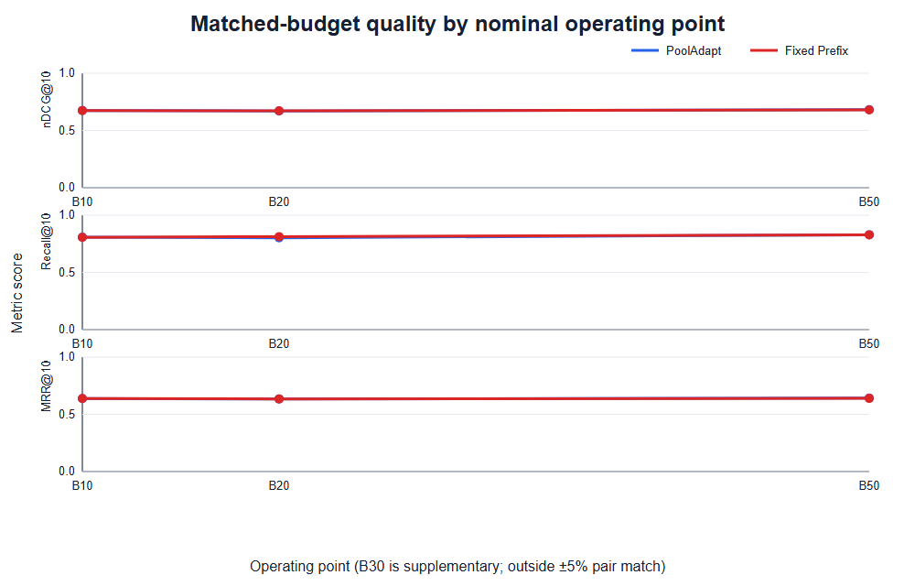
Figure 1. Matched-budget quality scores for PoolAdapt and Fixed Prefix.

Paired statistical analysis
For each metric at B10, B20, and B50, paired differences are PoolAdapt minus Fixed Prefix on the same 300 queries. Confidence intervals use 10,000 paired query-level bootstrap resamples with seed 20261112. Two-sided permutation p-values use 100,000 Monte Carlo sign flips and a plus-one correction. Holm adjustment is applied across the three operating-point comparisons separately for each metric. Supplementary Wilcoxon signed-rank tests exclude zero differences. Cohen's dz divides the mean paired difference by its sample standard deviation; undefined statistics remain blank. A nonsignificant result is not evidence of equivalence.
Point | Metric | n | Mean Δ | Bootstrap 95% CI | Raw p | Holm p | Cohen dz
B10 | nDCG@10 | 300 | 0.00085 | [-0.00090, 0.00337] | 0.7504 | 1.0000 | 0.0460
B10 | Recall@10 | 300 | 0.00233 | [0.00000, 0.00667] | 0.5001 | 1.0000 | 0.0751
B10 | MRR@10 | 300 | -0.00000 | [-0.00167, 0.00167] | 1.0000 | 1.0000 | -0.0000
B20 | nDCG@10 | 300 | -0.00117 | [-0.01518, 0.01371] | 0.8786 | 1.0000 | -0.0091
B20 | Recall@10 | 300 | -0.01028 | [-0.03683, 0.01483] | 0.4316 | 1.0000 | -0.0458
B20 | MRR@10 | 300 | -0.00083 | [-0.01413, 0.01266] | 0.9103 | 1.0000 | -0.0069
B50 | nDCG@10 | 300 | 0.00205 | [-0.00317, 0.00741] | 0.4411 | 1.0000 | 0.0445
B50 | Recall@10 | 300 | 0.00000 | [-0.01333, 0.01333] | 1.0000 | 1.0000 | 0.0000
B50 | MRR@10 | 300 | 0.00276 | [-0.00101, 0.00735] | 0.2229 | 0.6687 | 0.0742
No Holm-adjusted primary permutation test reaches 0.05. The B10 mean differences are small (nDCG +0.00085, Recall +0.00233, MRR approximately 0); B20 differences favor Fixed Prefix slightly on average; B50 differences favor PoolAdapt slightly. Confidence intervals include zero for all nine metric-budget comparisons. These results do not establish equivalence or superiority.

Pareto analysis
Pair consumption and measured reranking latency are treated as separate objectives. For each, nDCG@10 is maximized while the corresponding resource is minimized. Pareto status is calculated across all method/operating points, including Full Rerank. A point is dominated only if another has no greater resource use and no lower nDCG@10, with at least one strict improvement; exact ties remain non-dominated. The output marks both efficient and dominated points and includes the comparison subset.
Non-dominated points for Quality versus actual pair consumption: Fixed Prefix B10 (nDCG 0.6740); SAGE-SLO B10 (nDCG 0.6757); SAGE-SLO B20 (nDCG 0.6823)
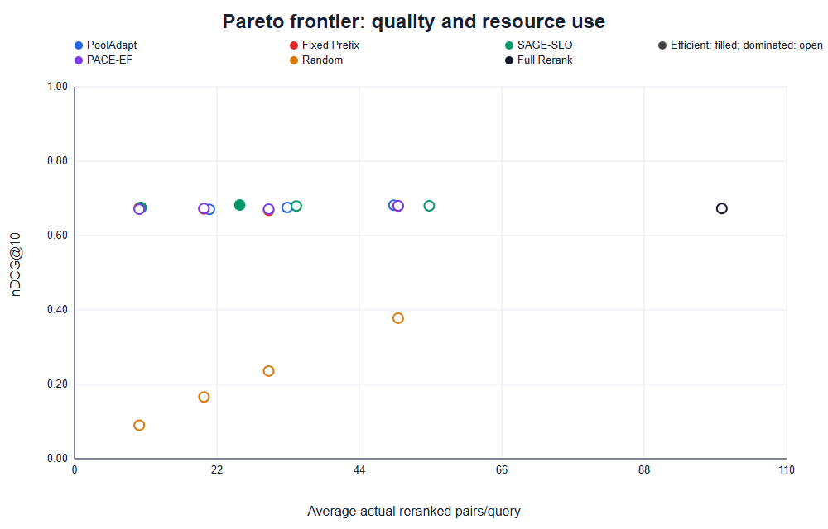
Pareto frontier for Quality versus actual pair consumption.
Non-dominated points for Quality versus measured reranking latency: Fixed Prefix B10 (nDCG 0.6740); SAGE-SLO B10 (nDCG 0.6757); SAGE-SLO B20 (nDCG 0.6823)
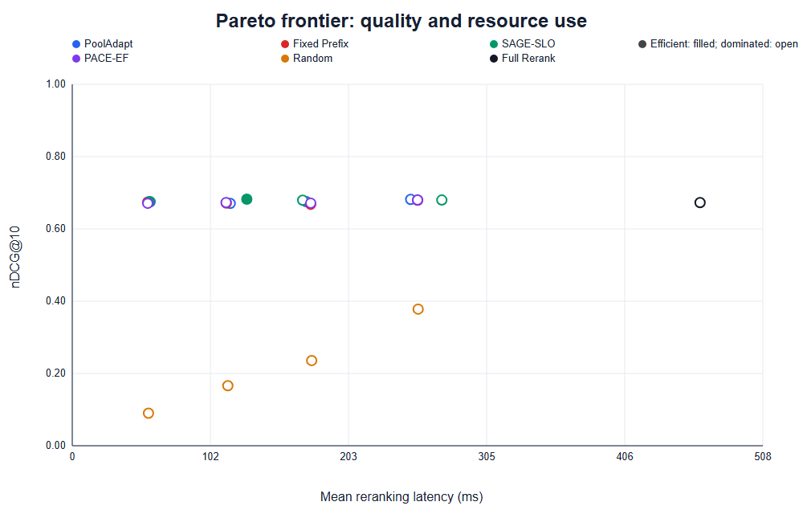
Pareto frontier for Quality versus measured reranking latency.
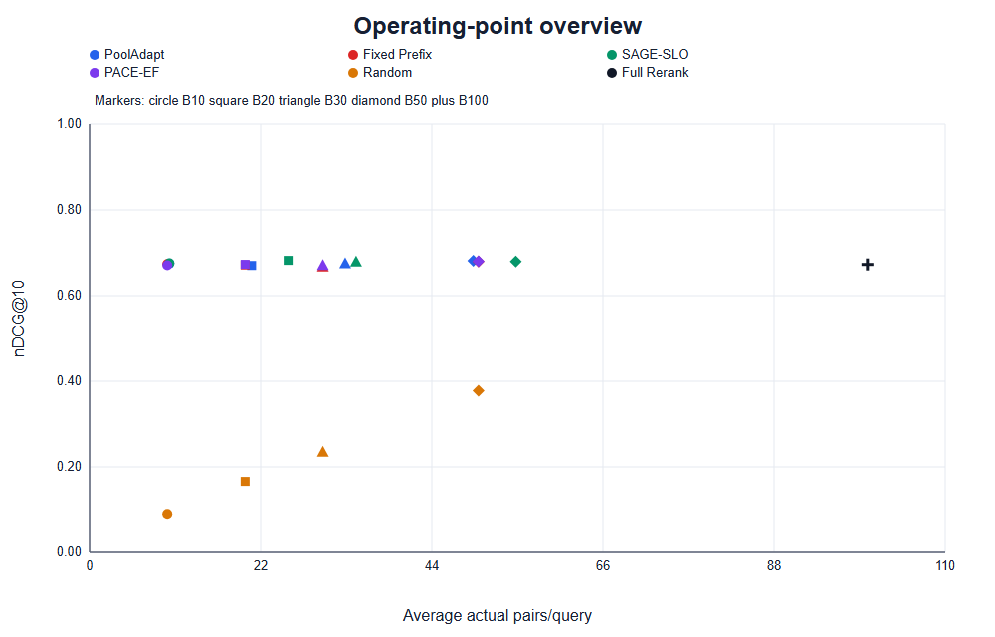
Operating-point overview across methods.

Query-group analysis
Status: UNAVAILABLE for retrieval-ambiguity groups. The authoritative handoff contains exactly 300 frozen TEST query IDs and query text, but its controller_features and query_group fields are blank. The frozen TEST predictions contain ranking IDs and execution outputs without per-query BM25 or dense scores/ranks, RRF scores, or saved retrieval feature vectors. Existing Phase 2 query_features.csv, pool_features.csv, and candidate_features.csv cover 809 train/validation IDs with zero overlap against the 300 TEST IDs; the Phase 2 Easy/Hard labels are based on qrels-derived M* outcomes and cannot be transferred. Query length could be tokenized from frozen query text before reranking, but it measures text length rather than agreement or decisiveness of retrieval evidence, so a median split would not support the requested ambiguity interpretation. No feature or group label is inferred from evaluation outcomes, and no group comparison figure is generated. See audit/phase2_easy_hard_reuse_assessment.md and audit/data_handoff_specification.md.

Failure analysis
Failure categories were declared before case selection and are evaluated only at primary matched budgets B10, B20, and B50. Under-allocation candidates require fewer actual pairs than same-point Fixed Prefix and an nDCG@10 decrease of at least 0.20. Over-allocation candidates require at least 10% and at least two more actual pairs than Fixed Prefix, with no nDCG@10 gain. The CSV preserves every qualifying query/point; the allocation figure shows the highest-magnitude qualifying cases in both categories. Counts are 11 under-allocation candidates, 132 over-allocation candidates, and 8 representative high-latency cases. The latter are the top three Tukey outliers in each of PoolAdapt B20, B30, and B50. Full Rerank per-query metrics are included as context.
These are descriptive screening categories, not confirmed root causes. TEST controller features, sparse/dense disagreement, ambiguity, and ranking-instability signals are unavailable. No causal mechanism is inferred. Proposed selector follow-up should be evaluated only after these signals can be recovered or through a new, separately authorized evaluation.
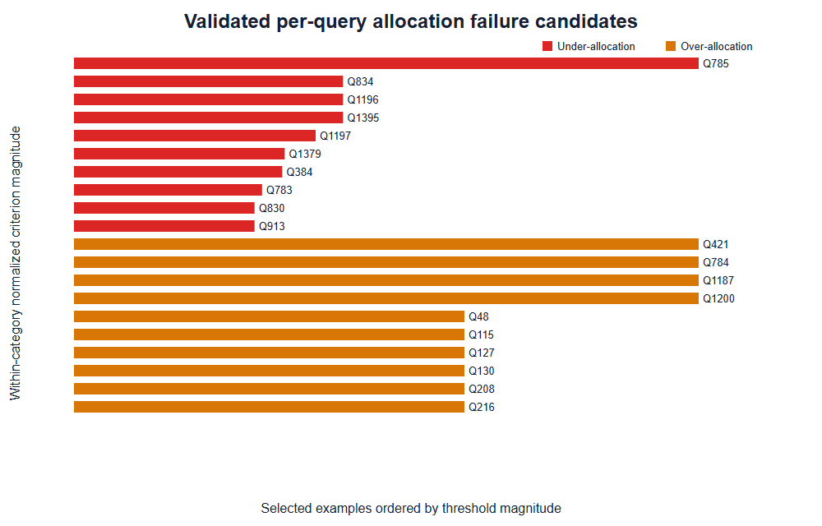
Per-query cases ordered by predeclared threshold magnitude.

Latency-tail investigation
Latency distributions are summarized per query after averaging Random seeds within query. The Random P50/P95 values in the main results table use the standardized query-level mean convention; per-seed and pooled query-seed sensitivity estimates are reported above. High latency is defined consistently within each method/operating point as latency above Q3 + 1.5×IQR; no observation is removed. The table reports mean, P50, P75, P90, P95, P99, standard deviation, IQR, the P95–P50 gap, high-latency count, and Spearman associations with actual pairs and quality metrics. Linear pair-count model R² and residual SD are included to show remaining variation after a simple count adjustment; this descriptive model does not establish causality.
Method | Point | Mean | P50 | P75 | P90 | P95 | P99 | SD | IQR | P95−P50 | High/n (ms)
PoolAdapt | B20 | 116.2 | 73.7 | 175.3 | 238.0 | 261.5 | 408.3 | 78.6 | 115.2 | 187.8 | 5/300
PoolAdapt | B30 | 172.0 | 176.1 | 246.8 | 272.1 | 405.3 | 515.2 | 108.2 | 187.3 | 229.2 | 2/300
PoolAdapt | B50 | 248.9 | 247.3 | 267.1 | 429.0 | 474.9 | 526.9 | 109.4 | 88.2 | 227.6 | 45/300
SAGE-SLO | B20 | 128.4 | 59.1 | 174.9 | 413.3 | 458.5 | 521.2 | 136.2 | 119.6 | 399.5 | 35/300
SAGE-SLO | B30 | 169.5 | 60.2 | 258.4 | 440.4 | 475.6 | 521.7 | 151.6 | 200.9 | 415.4 | 1/300
Pair-count and residual checks: PoolAdapt B20: Spearman latency-vs-pairs ρ=0.93; linear pair-count R²=0.96; residual SD=15.1 ms; PoolAdapt B30: Spearman latency-vs-pairs ρ=0.97; linear pair-count R²=0.97; residual SD=19.9 ms; PoolAdapt B50: Spearman latency-vs-pairs ρ=0.92; linear pair-count R²=0.95; residual SD=24.4 ms; SAGE-SLO B20: Spearman latency-vs-pairs ρ=0.80; linear pair-count R²=0.98; residual SD=19.8 ms; SAGE-SLO B30: Spearman latency-vs-pairs ρ=0.91; linear pair-count R²=0.98; residual SD=22.5 ms. Representative high-latency query IDs and measured values: Q1104 B50 (572.5 ms); Q343 B50 (570.1 ms); Q343 B30 (567.9 ms); Q852 B30 (542.4 ms); Q852 B50 (542.1 ms); Q690 B20 (527.7 ms); Q1200 B20 (491.5 ms); Q1187 B20 (432.9 ms).
PoolAdapt B20 shows a large P95–P50 gap, as do PoolAdapt B30/B50 and SAGE-SLO B20/B30. High-latency cases occur in a small subset under the Tukey rule, though PoolAdapt B50 has a broader upper tail. Pair counts are strongly rank-associated with latency for adaptive methods where K varies, but Fixed Prefix has no pair-count variation within a point, so its pair-count correlation is undefined. Residual variation remains after linear pair adjustment. Available logs do not support attribution to GPU contention, thermal throttling, or background load.
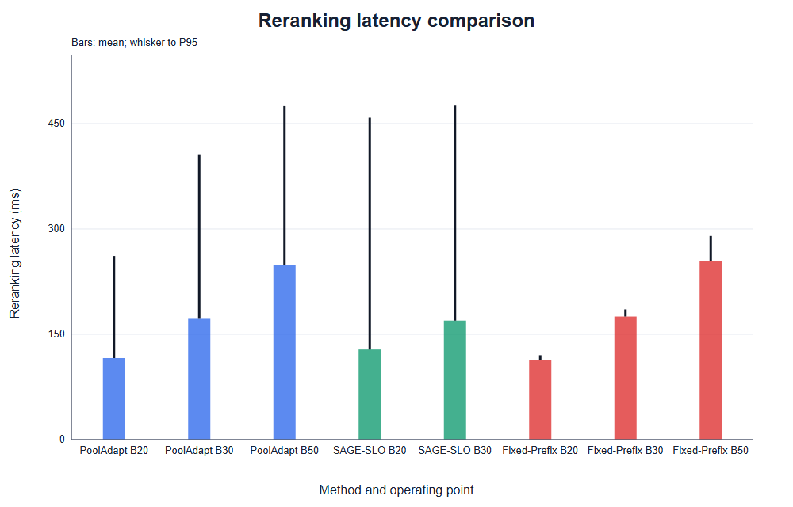
Mean reranking latency bars with whiskers to P95.
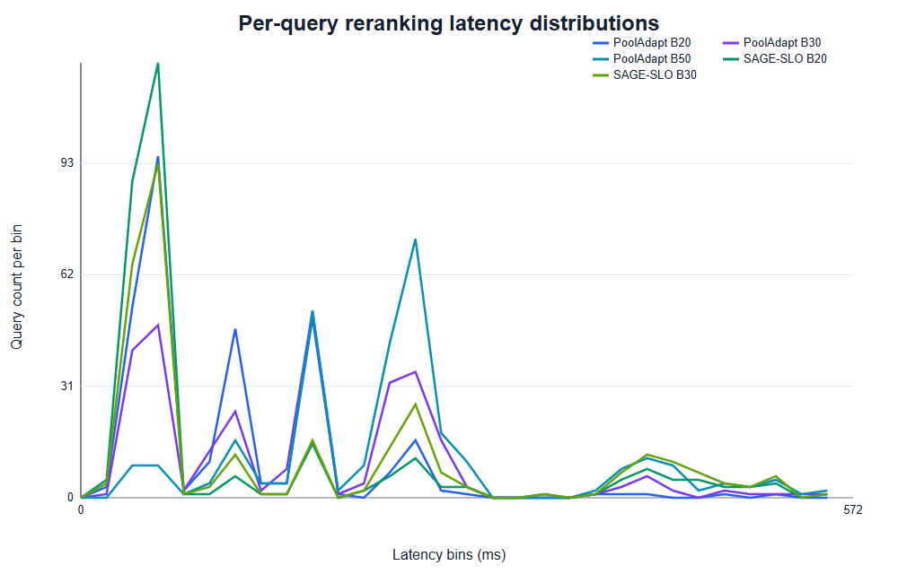
Per-query latency distributions for the five required strata.

Cost and efficiency
Average K and actual reranked pairs coincide in this handoff because every record passed selected_k = actual_reranked_pairs. Compression and pair-consumption reduction are relative to Full Rerank's observed 100 pairs/query. At B10, PoolAdapt averages 10.27 pairs/query (ratio 0.103); at B20 it averages 20.83 (ratio 0.208); at B50 it averages 49.33 (ratio 0.493). This corresponds to pair-count reductions of 89.73%, 79.17%, and 50.67%. These figures do not represent billed compute cost or measured latency reduction. Mean latency can exhibit long tails and does not scale exactly with average pair count.
Method | Point | Avg K | Pairs/q | Ratio | Pair reduction | Mean ms | P50 ms | P95 ms
PoolAdapt | B10 | 10.27 | 10.27 | 0.103 | 89.7% | 57.2 | 56.4 | 68.2
PoolAdapt | B20 | 20.83 | 20.83 | 0.208 | 79.2% | 116.2 | 73.7 | 261.5
PoolAdapt | B30 | 32.87 | 32.87 | 0.329 | 67.1% | 172.0 | 176.1 | 405.3
PoolAdapt | B50 | 49.33 | 49.33 | 0.493 | 50.7% | 248.9 | 247.3 | 474.9
Fixed Prefix | B10 | 10.00 | 10.00 | 0.100 | 90.0% | 55.5 | 57.9 | 60.5
Fixed Prefix | B20 | 20.00 | 20.00 | 0.200 | 80.0% | 113.3 | 115.8 | 120.2
Fixed Prefix | B30 | 30.00 | 30.00 | 0.300 | 70.0% | 175.3 | 177.0 | 185.5
Fixed Prefix | B50 | 50.00 | 50.00 | 0.500 | 50.0% | 254.0 | 250.6 | 290.0
SAGE-SLO | B10 | 10.27 | 10.27 | 0.103 | 89.7% | 56.8 | 57.8 | 60.9
SAGE-SLO | B20 | 25.53 | 25.53 | 0.255 | 74.5% | 128.4 | 59.1 | 458.5
SAGE-SLO | B30 | 34.27 | 34.27 | 0.343 | 65.7% | 169.5 | 60.2 | 475.6
SAGE-SLO | B50 | 54.80 | 54.80 | 0.548 | 45.2% | 271.8 | 252.6 | 479.7
PACE-EF | B10 | 10.00 | 10.00 | 0.100 | 90.0% | 55.5 | 57.9 | 60.8
PACE-EF | B20 | 20.00 | 20.00 | 0.200 | 80.0% | 113.2 | 115.8 | 120.0
PACE-EF | B30 | 30.00 | 30.00 | 0.300 | 70.0% | 175.4 | 177.0 | 184.4
PACE-EF | B50 | 50.00 | 50.00 | 0.500 | 50.0% | 254.0 | 252.1 | 287.3
Random | B10 | 10.00 | 10.00 | 0.100 | 90.0% | 56.1 | 56.7 | 59.6
Random | B20 | 20.00 | 20.00 | 0.200 | 80.0% | 114.4 | 116.2 | 118.9
Random | B30 | 30.00 | 30.00 | 0.300 | 70.0% | 176.1 | 177.4 | 181.6
Random | B50 | 50.00 | 50.00 | 0.500 | 50.0% | 254.4 | 252.3 | 285.0
Full Rerank | B100 | 100.00 | 100.00 | 1.000 | 0.0% | 461.8 | 452.1 | 542.0
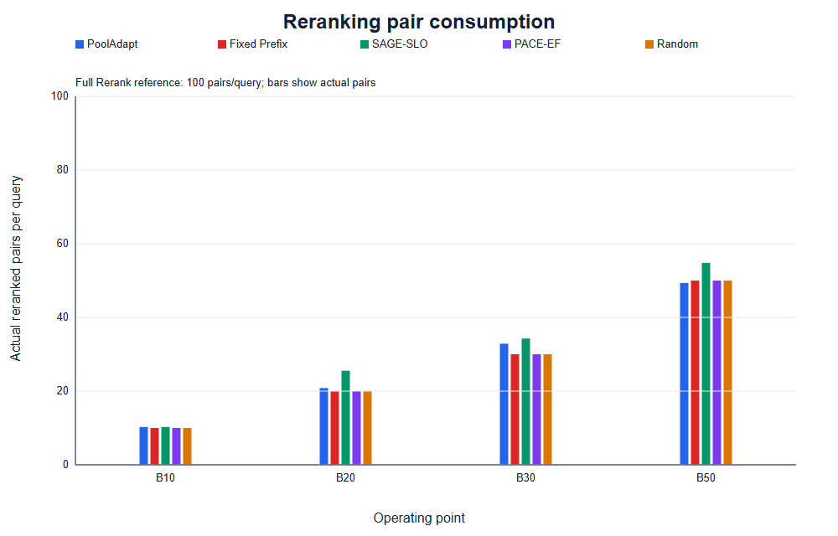
Mean actual pair consumption by method and operating point.
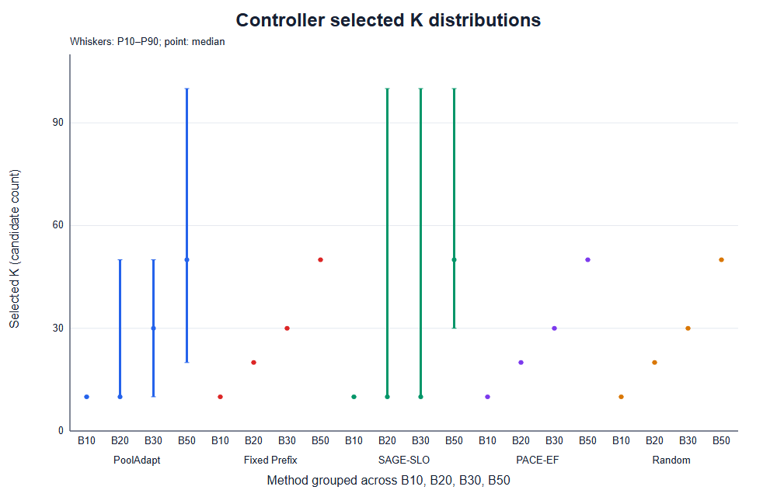
Per-query selected-K median and P10–P90 distributions.

Discussion
Across the three matched budgets, the aggregate quality differences are small and the paired inferential results do not show Holm-adjusted evidence of a difference at the 0.05 level. PoolAdapt spends slightly more pairs than Fixed Prefix at B10/B20 and slightly fewer at B50. The descriptive B30 result has a higher actual PoolAdapt budget and cannot support a matched-budget claim. Long latency tails matter for deployment decisions even where mean pair consumption is lower; a cost policy based only on average K would miss this operational variation.

Threats to validity and limitations
The available evidence inherits two provenance hash failures and three unverified provenance items. TEST retrieval features and retrieval-ambiguity groups remain unavailable; query length alone is not treated as a substitute. Explicit execution identifiers and timestamps are also unavailable. The recorded latency excludes retrieval, selection, model loading, and warm-up. Random seed aggregation is standardized by averaging within query; the reported sensitivity analyses describe seed variability but do not treat seeds as independent queries. The simple bootstrap and sign-flip procedures quantify paired query-level uncertainty under the specified resampling/null procedure; they do not establish equivalence. The failure criteria are screening thresholds. The pair-count linear latency fit and correlations are descriptive and cannot identify a causal latency mechanism. No monetary pricing or GPU billing data are available.

Conclusion
The frozen handoff supports a reproducible downstream comparison on 300 SciFact TEST queries. PoolAdapt and Fixed Prefix have similar observed quality at B10, B20, and B50 actual pair budgets, with no Holm-adjusted paired test below 0.05. PoolAdapt reduces pair consumption relative to Full Rerank, while latency tails and provenance limitations remain material. The results support describing an efficiency-quality trade-off; they do not demonstrate equivalence, causal mechanism, complete historical reproducibility, or monetary savings.

Reproducibility and artifact references
The frozen downstream analysis can be reproduced from the repository root with Python 3.11, NumPy, and SciPy using python improvement/improvement_1/scripts/run_all.py; this reruns analysis only, not retrieval or model inference. The targeted Random latency percentile standardization can be reproduced with the standard-library script improvement/improvement_1/scripts/standardize_random_latency.py. Generate this report with python improvement/improvement_1/scripts/generate_report.py. These procedures do not modify the frozen Phase 2 predictions, qrels, checkpoints, model configurations, manifests, or experiment outputs. Query-group analysis remains unavailable and no query_group_comparison.png is fabricated. Primary artifact paths: matched_budget/query_level_evaluation.csv (authoritative source, preserved); matched_budget/query_level_analysis.csv; statistics/paired_statistical_analysis.csv; pareto/pareto_analysis.csv; latency_cost/latency_cost_summary.csv; latency_cost/random_latency_percentile_sensitivity.csv; latency_cost/random_latency_seed_percentiles.csv; failure_analysis/failure_case_analysis.csv; audit/downstream_validation_report.md; audit/downstream_consistency_audit.md.

