CST3130 Advanced Web Development with Big Data

Data Visualization Website – Project Proposal

M00898110 – Kim Ngoc Thien Nguyen

Computer Science Department

Faculty of Science & Technology

Middlesex University

***Table of contents***

1 Description 3

2 Mock-ups of front end 3

3 List of sources of numerical data 4

4 List of sources of data for sentiment analysis 5

5 Screenshot or URL of the static website hosted on the cloud 5

# Description

The project is a data visualisation website that focuses on the cryptocurrency market. The website will display historical and real-time numerical data on crypto prices, predictions about future prices, sentiment analysis of social media, and news articles related to crypto. The website will be built using front-end web development technologies and back-end cloud services.

The project's technology includes TypeScript, AWS Lambda functions, AWS SageMaker, AWS Comprehend, and WebSockets. TypeScript will be used as the primary programming language for the project, providing optional type annotations and other features to improve code maintainability. AWS Lambda functions will perform tasks such as data processing and machine learning inference on the data. AWS SageMaker will train machine learning models on the numerical data and make predictions. AWS Comprehend will be used to perform sentiment analysis on text data. WebSockets will be used to push updates to the website in real time.

The features of the website will include the following:

* Historical and real-time data visualization of crypto prices using charts and graphs.
* Predictions of future crypto prices using machine learning models.
* Sentiment analysis of social media and news articles related to crypto.
* A user-friendly interface lets users view numerical data, predictions, and sentiment analysis on one page.
* Real-time updates using WebSockets ensure that the website's data is always up-to-date.
* Secure and scalable back-end services using AWS Lambda functions and AWS API Gateway.

# Mock-ups of front end

This is my idea for my website. When users choose a cryptocurrency (dropdown button) they would like to watch, I will show them everything on one page: information about that currency, historical data, predictions, and sentiment analysis.

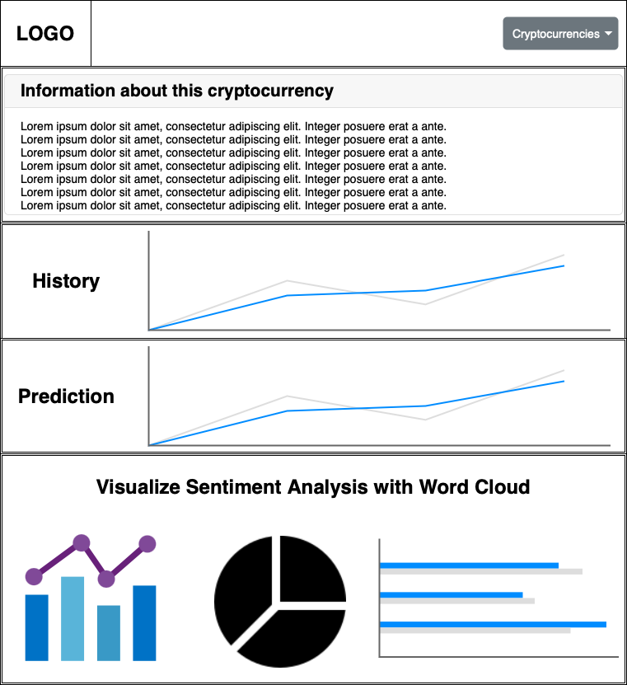

# List of sources of numerical data

This is the list of sources of numerical data for my project.

* CryptoCompare API: https://min-api.cryptocompare.com/
* CoinMarketCap: <https://coinmarketcap.com/>
* CryptoCompare: <https://www.cryptocompare.com/>
* CoinGecko: <https://coingecko.com/>
* CryptoDataDownload: <https://www.cryptodatadownload.com/>
* Yahoo Finance: <https://finance.yahoo.com/>
* Cryptocurrency Market Capitalizations: <https://coinmarketcap.com/>

# List of sources of data for sentiment analysis

This is the list of sources of data for sentiment analysis for my project

* Twitter: <https://twitter.com/>
* NewsAPI: <https://newsapi.org/>
* NewsRiver: <https://newsriver.io/>
* GDELT: <https://www.gdeltproject.org/>
* LexisNexis: <https://www.lexisnexis.com/en-us/home.page>
* Kaggle: <https://www.kaggle.com/>
* UCI Machine Learning Repository: <https://archive.ics.uci.edu/ml/index.php>
* Reddit: <https://www.reddit.com/>

# Screenshot or URL of the static website hosted on the cloud

This is URL of the website: <https://cst3130-2022-23-kimnguyen-test.s3.amazonaws.com/index.html>

