CST3130 Advanced Web Development with Big Data

Data Visualization Website – Final Report

M00898110 – Kim Ngoc Thien Nguyen

Computer Science Department

Faculty of Science & Technology

Middlesex University

***Table of contents***

1 Screenshot of all front-end website pages 3

1.1 Bitcoin 4

1.2 Ethereum 5

1.3 XRP 6

1.4 Polkadot 7

1.5 DogeCoin 8

2 System Architecture Diagram 9

# Screenshot of all front-end website pages

My website provides historical data, results of sentiment analysis, and predictions for the top 5 cryptocurrencies - Bitcoin, Ethereum, XRP, Polkadot, and Dogecoin. Our website presents line charts displaying each cryptocurrency's historical prices and pie charts showcasing the sentiment analysis related to each cryptocurrency. I used machine learning to generate predictions for numerical and synthetic data in plot charts.

This is a link for my website: https://cst3130-2022-23-crypto.s3.amazonaws.com/index.html

## Bitcoin

## Ethereum

## XRP

## Polkadot

## DogeCoin

# System Architecture Diagram

This architecture diagram includes the main features of AWS services.

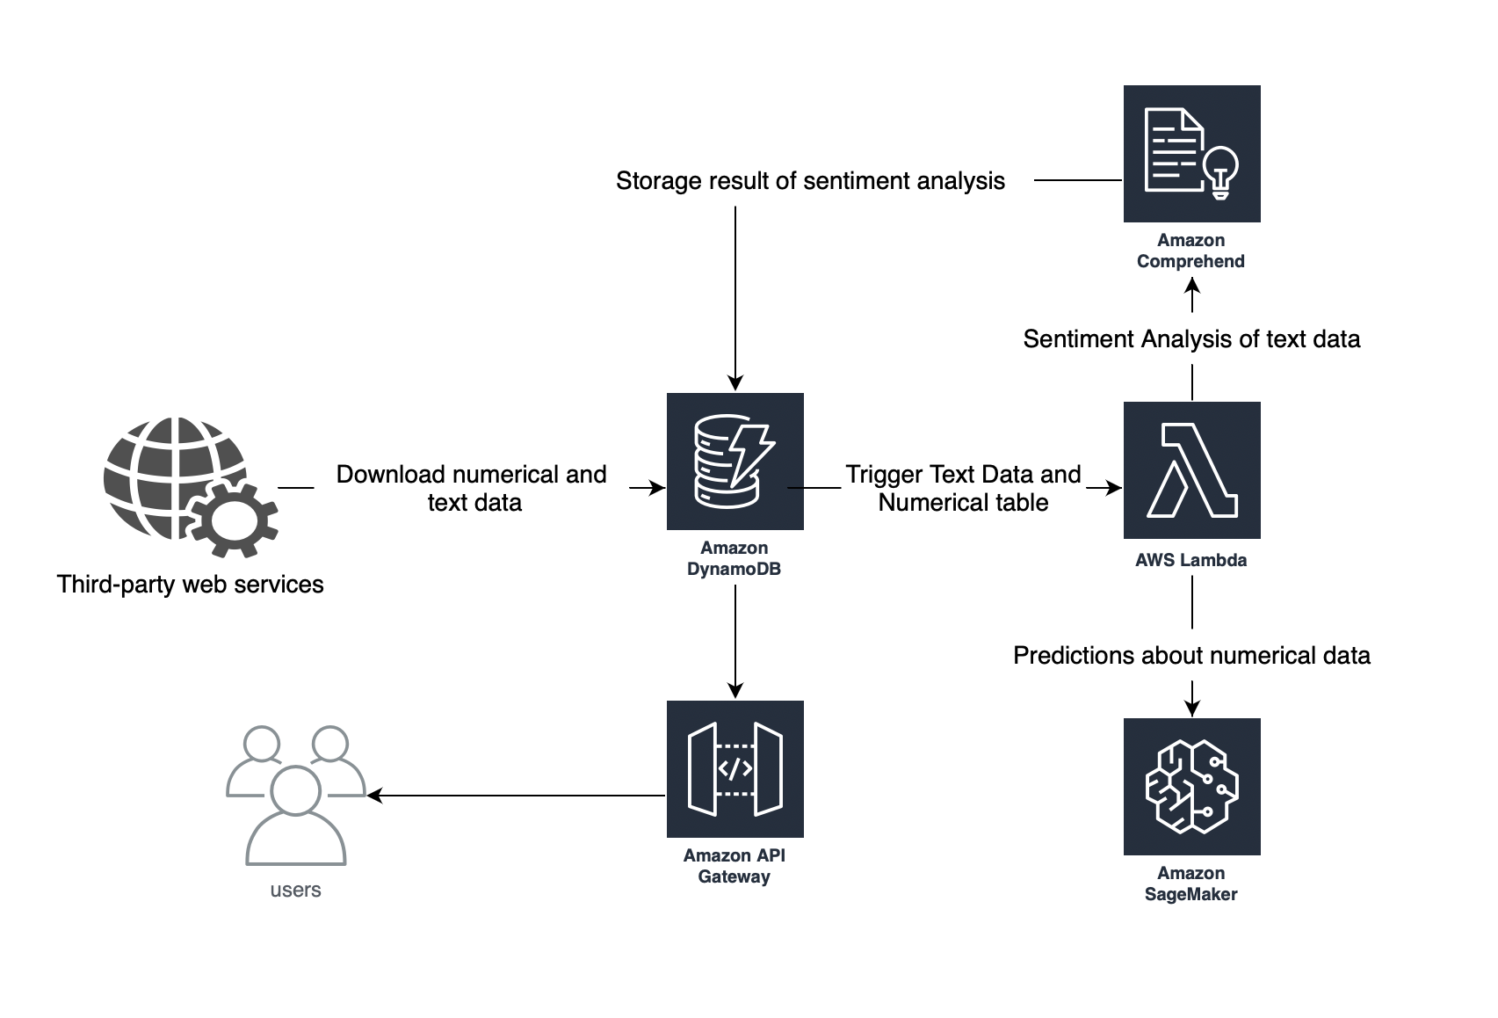

Explanation:

1. Third-Party Web Service: Data, including numerical and text data, is downloaded from third-party web services and stored in DynamoDB.
2. AWS Lambda Function: The back-end of the website runs on a serverless architecture using AWS Lambda functions. Lambda functions are triggered by events in DynamoDB, such as the sentiment analysis or numerical prediction.
3. AWS SageMaker: Machine learning is performed using AWS SageMaker to generate correct predictions about synthetic data and to generate predictions about numerical data.
4. AWS Comprehend: Sentiment analysis is performed using AWS Comprehend on text data stored in the cloud.
5. DynamoDB: Cloud database used to store data from the third-party web service and the sentiment data resulting from the sentiment analysis.
6. AWS API Gateway: The WebSocket back-end runs on AWS API Gateway, which enables real-time communication between the client and server using WebSockets.
7. S3 Bucket: All of the front-end files are publicly available on an S3 bucket.