The 3 parts of use strict
(출처 : https://perlmaven.com/strict )
use strict 'vars'; generates a compile-time error if you access a variable without declaration.
use strict 'refs'; generates a runtime error if you use symbolic references.
use strict 'subs'; compile-time error if you try to use a bareword identifier in an improper way.

use VERSION

VERSION may be either a v-string such as v5.24.1, which will be compared to $^V (aka $PERL_VERSION), or a numeric argument of the form 5.024001, which will be compared to $].
In the current implementation, any explicit use of use strict or no strict overrides use VERSION, even if it comes before it. However, this may be subject to change in a future release of Perl, so new code should not rely on this fact. It is recommended that a use VERSION declaration be the first significant statement within a file (possibly after a package statement or any amount of whitespace or comment), so that its effects happen first, and other pragmata are applied after it.

ASCII Table
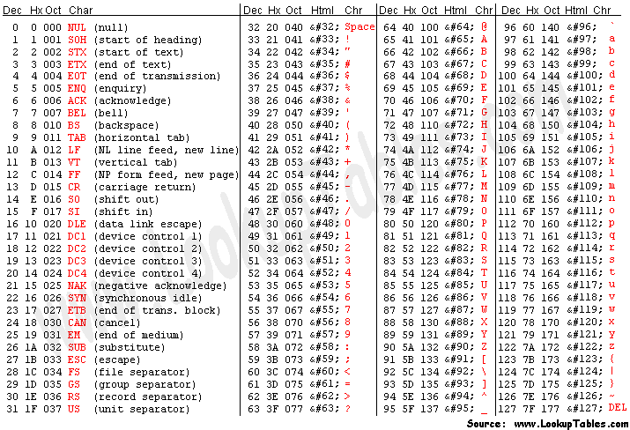

Extended ASCII Codes

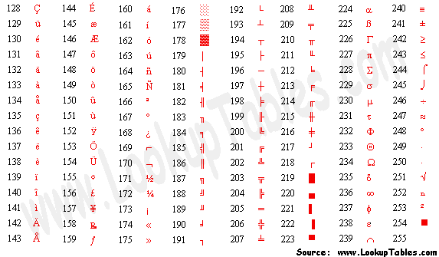

How do I create a switch or case statement? Switch::Plain:
출처 : https://perldoc.perl.org/perlfaq7#How-do-I-create-a-switch-or-case-statement
설치 : Open a terminal(Ctrl-Alt-t).
- Enter the command cpan.
- At the prompt cpan[1]>, type install Switch.
- Once completed, Type exit.

There is a given/when statement in Perl, but it is experimental and likely to change in future. See perlsyn for more details.
The general answer is to use a CPAN module such as Switch::Plain:
use Switch::Plain;
sswitch($variable_holding_a_string) {
case 'first': { }
case 'second': { }
default: { }
}
or for more complicated comparisons, if-elsif-else:
for ($variable_to_test) {
if (/pat1/) { } # do something
elsif (/pat2/) { } # do something else
elsif (/pat3/) { } # do something else
else { } # default
}
Here's a simple example of a switch based on pattern matching, lined up in a way to make it look more like a switch statement. We'll do a multiway conditional based on the type of reference stored in $whatchamacallit:
SWITCH: for (ref $whatchamacallit) {

/^$/ && die "not a reference";

/SCALAR/ && do {
print_scalar($$ref);
last SWITCH;
};

/ARRAY/ && do {
print_array(@$ref);
last SWITCH;
};

/HASH/ && do {
print_hash(%$ref);
last SWITCH;
};

/CODE/ && do {
warn "can't print function ref";
last SWITCH;
};

# DEFAULT

warn "User defined type skipped";

}
See perlsyn for other examples in this style.
Sometimes you should change the positions of the constant and the variable. For example, let's say you wanted to test which of many answers you were given, but in a case-insensitive way that also allows abbreviations. You can use the following technique if the strings all start with different characters or if you want to arrange the matches so that one takes precedence over another, as "SEND" has precedence over "STOP" here:
chomp($answer = <>);
if ("SEND" =~ /^\Q$answer/i) { print "Action is send\n" }
elsif ("STOP" =~ /^\Q$answer/i) { print "Action is stop\n" }
elsif ("ABORT" =~ /^\Q$answer/i) { print "Action is abort\n" }
elsif ("LIST" =~ /^\Q$answer/i) { print "Action is list\n" }
elsif ("EDIT" =~ /^\Q$answer/i) { print "Action is edit\n" }
A totally different approach is to create a hash of function references.
my %commands = (
"happy" => \&joy,
"sad", => \&sullen,
"done" => sub { die "See ya!" },
"mad" => \&angry,
);

print "How are you? ";
chomp($string = <STDIN>);
if ($commands{$string}) {
$commands{$string}->();
} else {
print "No such command: $string\n";
}
Starting from Perl 5.8, a source filter module, Switch, can also be used to get switch and case. Its use is now discouraged, because it's not fully compatible with the native switch of Perl 5.10, and because, as it's implemented as a source filter, it doesn't always work as intended when complex syntax is involved.

Switch::Plain - a simple switch statement for Perl
출처 : https://metacpan.org/pod/Switch::Plain

SYNOPSIS
use Switch::Plain;
# string version
sswitch (get_me_a_string()) {
# return value of get_me_a_string() is bound to $_ in this block
case 'foo': {
# runs if $_ equals 'foo'
}
case 'bar': {
# runs if $_ equals 'bar'
}
case 'melonlord' if $DEBUG: {
# runs if $_ equals 'melonlord' and $DEBUG is true
}
default if $VERBOSE > 1: {
# runs if nothing else matched so far and $VERBOSE is greater than 1
}
default: {
# runs if nothing else matched so far
}
}
# number version
nswitch (get_me_a_number()) {
# return value of get_me_a_number() is bound to $_ in this block
case 1: {
# runs if $_ equals 1
}
case 2: {
# runs if $_ equals 2
}
case 99 if $DEBUG: {
# runs if $_ equals 99 and $DEBUG is true
}
default if $VERBOSE > 1: {
# runs if nothing else matched so far and $VERBOSE is greater than 1
}
default: {
# runs if nothing else matched so far
}
}

DESCRIPTION
This module provides (yet another) switch statement for Perl. Differences between this module and Switch include:
- It's not a source filter. (It uses perl's pluggable keywords instead.)
- It generates non-horrible code. If you want to see this for yourself, run some sample code through perl -MO=Deparse.
- It doesn't try to be smart about matching fancy data structures; it only does simple string or numeric equality tests. This also sets it apart from perl's built in given statement and smartmatch operator ~~.

Syntax
This module understands the following grammar:
switch_statement := switch_keyword switch_scrutinee switch_body
switch_keyword := 'sswitch' | 'nswitch'
switch_scrutinee := '(' EXPR ')'
switch_body := '{' case_clause* '}'
case_clause := case_pattern+ BLOCK
case_pattern := case_keyword case_modifier? ':'
case_keyword := 'default' | 'case' EXPR
case_modifier := 'if' EXPR | 'unless' EXPR

*, +, and ? have their usual regex meaning; BLOCK and EXPR represent standard Perl blocks and expressions, respectively.

Semantics
The meaning of a switch statement is given by the following translation rules:
- sswitch (FOO) { ... } and nswitch (FOO) { ... } turn into
do {
local *_ = \FOO;
...
};

That is, they alias $_ to FOO within the body of the switch statement.
- A series of case clauses in the switch body turns into a single if/elsif chain. That is, the first clause becomes an if; every subsequent clause becomes an elsif.
- case FOO: becomes if ($_ eq FOO) for sswitch and if ($_ == FOO) for nswitch.
default: becomes if (1).
case FOO if BAR: becomes if ($_ eq FOO && BAR) for sswitch and if ($_ == FOO && BAR) for nswitch.
default if BAR: becomes if (BAR).
... unless BAR works similarly, but with the condition inverted (!BAR).
If there are multiple case/defaults before a single block, their conditions are combined with ||.
Here's an example demonstrating all combinations:
sswitch (SCRUTINEE) {
case FOO0: {
BODY0
}
case FOO1:
case FOO2 if BAR1:
case FOO3 unless BAR2:
default if BAR3:
default unless BAR4: {
BODY1
}
default: {
BODY2
}
}

This is equivalent to:
do {
# temporarily alias $_ to SCRUTINEE within this block:
local *_ = \SCRUTINEE;
if ($_ eq FOO0) {
BODY0
}
elsif (
$_ eq FOO1 ||
($_ eq FOO2 && BAR1) ||
($_ eq FOO3 && !BAR2) ||
BAR3 ||
!BAR4
) {
BODY1
}
elsif (1) {
BODY2
}
};

Differences between Switch::Plain and C's switch
- C's switch is limited to integer scrutinees. Switch::Plain supports any number or string.
- C's case labels must be compile-time constants. Switch::Plain allows any expression and even additional arbitrary conditions via the if/unless case modifiers.
- C's case labels are actual labels in that they can appear anywhere within the switch statement's body (even nested). With Switch::Plain all cases must be at the top level.
- In C the order of the cases does not matter since they're all known at compile time and guaranteed to be distinct. Switch::Plain evaluates them in the order they're written: If you put default: { ... } in the middle of a switch, it will intercept all values, and any following cases will be ignored (this is like writing ... elsif (1) { ... } else { ... }).
- Since C's case labels are actual labels and C's switch is effectively a dynamic goto, C actually has no concept of a "case clause" or a "case block". switch simply transfers control to one of the cases and that's it. This has the side effect of "fallthrough" behavior if you want to use C's switch to check for multiple distinct cases; that is, you must insert an explicit break; to leave the switch statement when you're done with your case.
Switch::Plain has nothing of the kind. Because it turns into a single if/elsif chain and every case block is clearly delimited, execution of sswitch/nswitch stops as soon one case pattern matches. However, it is possible to attach multiple case patterns to a single block:
case 2:
case 3:
case 5: {
...
}

This trivial case works the same way as fallthrough would in C (any value of 2, 3, or 5 is accepted).
- Since C's break refers to the innermost enclosing switch or loop, you can't use it in switch to leave a surrounding loop (you have to use goto instead). This particular problem would be avoidable in Perl thanks to loop labels; however, this isn't even necessary because sswitch/nswitch work like if: They don't count as loops and last/next/redo ignore them.

Scoping
This module is a lexical pragma, i.e. the effects of use Switch::Plain (turning sswitch and nswitch into keywords) are scoped to the innermost enclosing block (or the whole file if there is no enclosing block).
If you are a module author who wants to wrap Switch::Plain from another module, simply call Switch::Plain->import from your own import method. It will affect whatever scope is currently being compiled (i.e. your caller).

Use of Perl Data::Dumper
출처 : https://linuxhint.com/use-perl-data-dumper/
3 months ago
by Fahmida Yesmin
The Dumper is a function of the Perl data module that is used to convert any type of the Perl data variable and print the content in the Perl format. Any Perl scalar variable or array variable or hash variable can be passed as the argument of the Dumper function and stores the output in the $VARn variable where the value of the “n” depends on the number of reference variables. The output of the Dumper function can be used as the argument of the eval() function. The Data:Dumper module is required to be included in the script to use the Dumper function.

Different Uses of the Perl Data::Dumper
The uses of the Dumper function to print the scalar variables, array variables, hash variables, and file content are shown in this part of the tutorial.

Example 1: Using the Data::Dumper for Scalar Variables
Create a Perl file with the following script that prints the values of the “string” variable and the “number” variable using the Dumper function:
#!/usr/bin/perl
use strict;
use warnings;
use 5.34.0;
use Data::Dumper;
#Declare a string variable
my $name = "Md. Ali";
#Declare a number variable
my $age = 35;
#Print the scalar variables
print Dumper $name."\n";
print Dumper $age."\n";
Output:
The following output appears after executing the script. The string value of “Md. Ali” and the number of “35” are printed by the $VAR1 variable of the Dumper function. The number value is printed as a string value in the output:
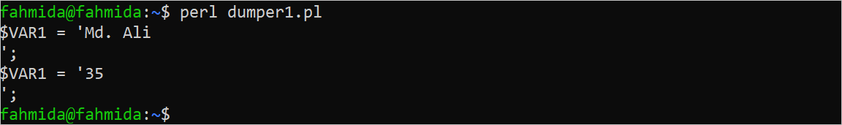

Example 2: Using the Data::Dumper for the Array Variable
Create a Perl file with the following script that prints the values of an array of numbers and an array of strings using the Dumper function. An array of five numbers and an array of four string values have been define in the script. The values of these arrays have been printed later.
#!/usr/bin/perl
use strict;
use warnings;
use 5.34.0;
use Data::Dumper;
#Declare an array of numbers
my @arrnum = (67, 23, 90, 12, 87);
#Declare an array of string
my @arrstr = ('Learn', 'Perl', 'Programming', 'Basic');
#Print the array variables
print "The output for an array of numbers:\n".Dumper \@arrnum;
print "The output for an array of strings:\n".Dumper \@arrstr;
Output:
The following output appears after executing the script. According to the output, the values of the array of numbers are printed as number values, and the values of the array of strings are printed as string values:
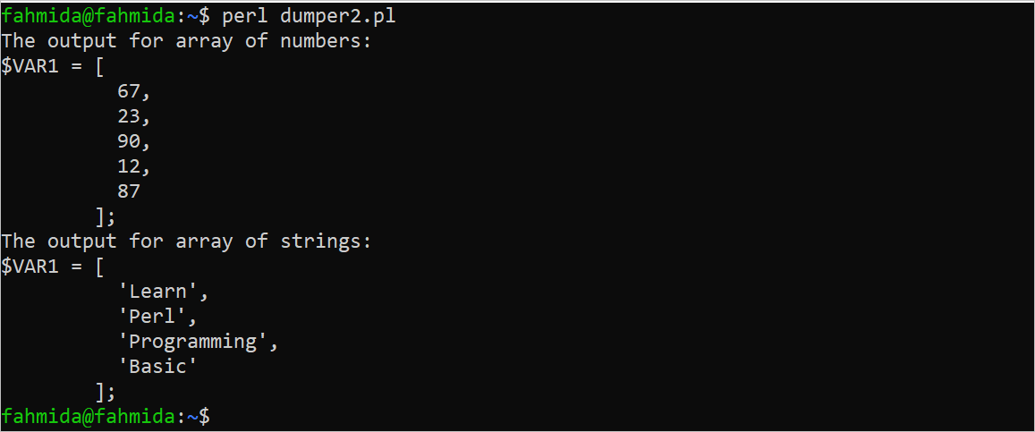

Example 3: Using the Data::Dumper for the Hash Variable
Create a Perl file with the following script that prints the values of a hash variable using the Dumper function. A hash variable of four key-value pairs is declared in the script. The keys and values of this hash variable are printed later:
#!/usr/bin/perl
use strict;
use warnings;
use 5.34.0;
use Data::Dumper;
#Declare a hash variable
my %hashvar = ('HDD' => 6000, 'Monitor' => 7000, 'Mouse' => 1000, 'Printer' => 4000);
#Print the hash variable
print Dumper \%hashvar;
Output:
The following output appears after executing the script. According to the output, four key-value pairs of the hash variable are printed by the $VAR1 Dumper variable:
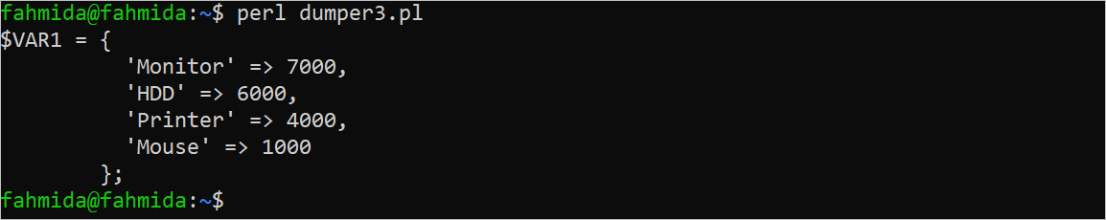

Example 4: Using the Data::Dumper to Read the File
Create a text file named “test.txt” with some content to check the script of this example. Here, the following content is added to the “test.txt” file:
test.txt
This file is created for testing purposes.
Create a Perl file with the following script that opens the “test.txt” file for reading, read the first line of the file into a variable, and print the variable using the Dumper function. Here, the “<” operator is used to open the file for reading. The first line of the file is read using the file handler named “f_handler” and stored into the $data variable. The content of this variable is printed by the Dumper function.
#!/usr/bin/perl
use strict;
use warnings;
use 5.34.0;
use Data::Dumper;
#Open a file for reading
open(f_handler, "< test.txt") or die "Unable to open the file.\n";
#Read the first line of the file
my $data = <f_handler>;
#Print the first line using Dumper
print Dumper $data;
#Close the file handler
close f_handler;
Output:
The following output appears after executing the script. According to the output, the first line of the “test.txt” file is printed as a string value using the $VAR1 variable:

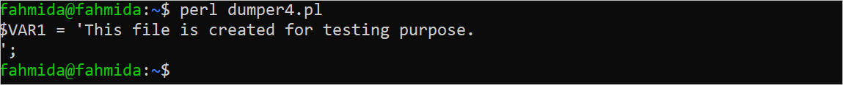

Conclusion
Some basic uses of the Dumper function are shown in the examples of this tutorial. The Perl Data::Dumper has many functionalities that can be used for various purposes which are not explained in this short tutorial. The Perl users will be able to print all the values of different types of Perl variables and it is helpful for debugging purposes

Use of Perl Modules
출처 : https://linuxhint.com/use-perl-modules/
2 months ago
by Fahmida Yesmin
The module in Perl is an important feature of Perl programming. Perl has many built-in modules to perform different types of operations and the Perl users can also create their module with the “.pm” extension. The “package” keyword is used to create a user-defined module in Perl. Any module can be imported in any Perl file using the “use” function. The uses of the built-in and user-defined modules in Perl are shown in this tutorial.

Different Examples of Perl Modules
The methods of using the built-in Perl modules and user-defined modules are shown in this part of the tutorial.

Example 1: Using the Built-In Module
In this example, the uses of three built-in modules of Perl are shown. These are “strict”, “warnings”, and “5.34.0”. The “strict” module is used to enable the different types of restrictions to write the Perl scripts. For example, no variable can be declared without the “my” keyword if this module is used in the script. The “warnings” module is used to display the different types of warning messages after executing the script that helps the coder understand the error. The “5.34.0” module is used to use the different features of this module in the script. The “say” function that is used to print the messages with newline is the feature of this module.
#!/usr/bin/perl
#Enable restriction for coding
use strict;
#Display warning message for error
use warnings;
#Enable different services
use 5.34.0;
#Use of 'my' keyword is mandatory for 'strict' module
my $language = 'Perl';
#Enable the use of the 'say' feature
say "Learn $language programming.";
Output:
The following output appears after executing the script:

Example 2: Using the User-Defined Module
The Perl users can create their module for a particular purpose by creating a file with the “.pm” extension. In this example, a user-defined module is created and it is used in another Perl script using the “use” keyword.

Create a User-Defined Module:
Create a file named “Bonus.pm” with the following script. Here, the “package” keyword is used to define that it is a module. This module contains a subroutine that calculates the bonus of an employee based on the salary and the sales amount. Two argument values are passed from the Perl script in which this module is used. The first argument contains the salary and the second argument contains the sales amount. The bonus is 15% of the sales amount if the salary is more than 10000. The bonus is 10% of the sales amount if the salary is more than 7000. The bonus is 5% of the sales amount if the salary is less than 10000. The “1;” is used at the end of the module to return true. Otherwise, an error is printed.
Bonus.pm
#!/usr/bin/perl # .pm에도 반드시 쉬뱅을 써줘야한다.
use strict;
use warnings;
use 5.34.0;
package Bonus;
#Declare subroutine to calculate bonus
sub calculate_bonus
{
# Initialize the variables
my $salary = $_[0];
my $sales_amount = $_[1];
my $bonus = 0.0;
#Calculate bonus
if ($salary > 10000)
{
$bonus = $sales_amount*0.15;
}
elsif ($salary >7000)
{
$bonus = $sales_amount*0.10;
}
else
{
$bonus = $sales_amount*0.05;
}
#Return the calculated bonus
return $bonus;
}
1;

Import a Module in a Perl Script:
Create a Perl file with the following script that imports the “Bonus” module that is created earlier to calculate the bonus amount of an employee based on the salary and sales amount that are assigned in the script.
#!/usr/bin/perl
use v5.38.1;
use strict;
use warnings;

use File::Basename qw(dirname);  use Cwd qw(abs_path);  use lib dirname(abs_path $0) . /perl';  use Bonus; | 그냥  use lib “.”;  한줄 쓰면 같은 디렉토리에서 .pm찾는다. 만약 ./lib  에 .pm을 넣는다면  use lib “./lib”;  use rlib는 ../lib아니면 안되는듯.

# File::Basename모듈의 dirname()은 마지막 부분을 제외하고 디렉토리부분을 반환한다.
# Cwd모듈의 abs_path()함수는 /home/kimnux/Exercise/perl/bonus.pl을 반환한다.
# dirname abs_path $0은 /home/kimnux/Exercise/perl을 반환
# dirname(dirname abs_path $0)은 /home/kimnux/Exercise를 반환.
# 여기가 루트 디렉토리가 된다.
# https://ko.perlmaven.com/how-to-create-a-perl-module-for-code-reuse
# 위의 예에서는 루트디렉토리가 .pl의 두단계 위이기 때문에 dirname을 두번 썼지만,
# 나는 그냥 .pl과 .pm이 한 디렉토리이기 때문에 굳이 두번을 쓸 필요가 없다.
# use lib (https://www.oreilly.com/library/view/programming-perl-3rd/0596000278/ch31s13.html)
# use lib "$ENV{HOME}/libperl"; # 컴파일시에 ~/libperl을 @INC에 더한다.
no lib "."; # remove cwd

#Initialize variables
my $name = "Mir Sabbir";
my $salary = 6000;
my $sal_amount = 9700;

#Call subroutine from the module
my $bonus = Bonus::calculate_bonus($salary, $sal_amount);
my $salary_with_bonus = $salary + $bonus;

#Print the employee information based on sales
say "Employee Details:\n";
say "Name: $name";
say "Salary: $salary";
say "Salaary(with bonus): $salary_with_bonus";
Output:
The following output appears after executing the script. Here, the “-I.” option has to be used at the time of executing the script to find out the user-defined imported module:
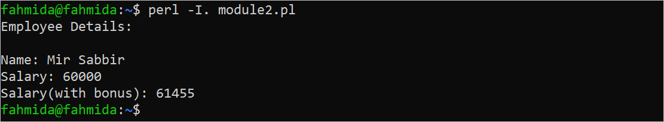

Example 3: Using the User-Defined Module Using “Require”
The “require” function is another way of importing the modules in the Perl script and it is shown in this example. The previously created “Bonus” module is imported into the script using the “require” function. The salary and sales amount values are taken from the user in this script. The other part of the script is similar to the previous example.
#!/usr/bin/perl
use strict;
use warnings;
use 5.34.0;
require Bonus;
#Take input from the user
say "Enter the employee name:";
chomp(my $name =<>);
say "Enter the salary:";
chomp(my $salary = <>);
say "Enter the sales amount:";
chomp(my $sal_amount = <>);
#Call subroutine from the module
my $bonus = Bonus::calculate_bonus($salary, $sal_amount);
my $salary_with_bonus = $salary + $bonus;
#Print the employee information based on sales
say "Employee Details:\n";
say "Name: $name";
say "Salary: $salary";
say "Salary(with bonus): $salary_with_bonus";
Output:
The following output appears after executing the script:
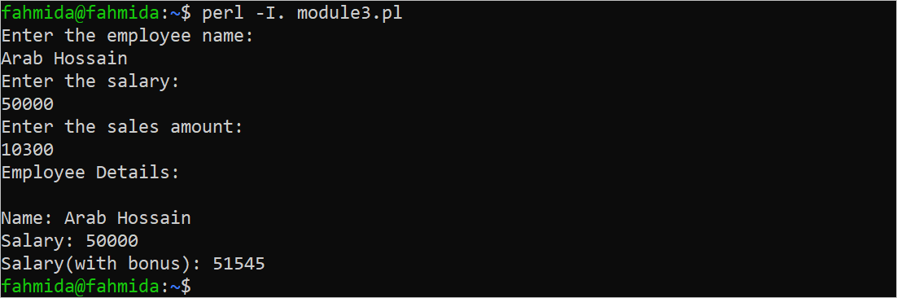

Conclusion
The uses of both built-in and user-defined modules in Perl are shown in this tutorial using simple examples.

Using Perl Module
Perl provides three ways to use modules: do, require, and use.
- do looks for the module file by searching the @INC path. If Perl finds the file, it places the code inside the calling program and executes it. Otherwise, Perl will skip the do statement silently.
- require loads the module file once. If you put the require with the same file twice, Perl will ignore it. In addition, Perl will issue an error message if it cannot find the file.
- use is similar to require except that Perl applies it before the program starts. This is the reason why you cannot use the use statement with condition statements like if-else. You often use the use statement to include a module in your program.

Print, printf, sprintf, say 차이점.
출처 : https://stackoverflow.com/questions/36882022/difference-between-printf-print-and-sprintf-in-perl

Short:
See the manuals:
- http://perldoc.perl.org/functions/print.html
- http://perldoc.perl.org/functions/printf.html
- http://perldoc.perl.org/functions/sprintf.html
Long:
print is the default output function. It does no formatting but may append a line break if Perl is called with -l:
print $foo;
print "Hello $world";
print $filehandle $something;
sprintf is a formatter and doesn't do any printing at all:
$result = sprintf('The %s is %d', 'answer', 42);
printf is the same as sprintf, but actually prints the result:
printf 'This is question %d on %s', 36882022, 'StackOverflow';
See the sprintf documentation for more details on valid placeholders/format strings.
Since 5.10, Perl also supports say which is basically a print plus an additional \n.
출처 : https://perldoc.perl.org/functions/sprintf

%% a percent sign
%c a character with the given number
%s a string
%d a signed integer, in decimal
%u an unsigned integer, in decimal
%o an unsigned integer, in octal
%x an unsigned integer, in hexadecimal
%e a floating-point number, in scientific notation
%f a floating-point number, in fixed decimal notation
%g a floating-point number, in %e or %f notation
In addition, Perl permits the following widely-supported conversions:
%X like %x, but using upper-case letters
%E like %e, but using an upper-case "E"
%G like %g, but with an upper-case "E" (if applicable)
%b an unsigned integer, in binary
%B like %b, but using an upper-case "B" with the # flag
%p a pointer (outputs the Perl value's address in hexadecimal)
%n special: *stores* the number of characters output so far
into the next argument in the parameter list
%a hexadecimal floating point
%A like %a, but using upper-case letters
Finally, for backward (and we do mean "backward") compatibility, Perl permits these unnecessary but widely-supported conversions:
%i a synonym for %d
%D a synonym for %ld
%U a synonym for %lu
%O a synonym for %lo
%F a synonym for %f

how to add a relative directory to @INC
출처 : https://perlmaven.com/how-to-add-a-relative-directory-to-inc
When writing an application, or even "just" a module with a command line script, it is very useful to make sure every use statement will load the modules from a directory relative to where the main Perl program can be found.
This will make sure that when you are developing the code, it won't, by accident, load the old installed versions of the modules.
If you check out several copies of the whole project from your version control system. In each copy the scripts will use the module in the same copy. So you can work on several changes at the same time without them interfering with each other.

Directory layout and use-case
A common directory layout of a project would look like this:
.../
project/
script/
app.pl
code.pl
lib/
App/
Module.pm
Other/
Class.pm
Though there might be some other files and directories, this is what currently interests us.
There are several executable scripts like the app.pl and the code.pl in our case. They are all placed in the directory called script inside the project directory. (Though some people would use the name bin instead of script, this does not matter for us.)
Each one of these scripts start like this:
use strict;
use warnings;
use 5.010;

use App::Module;
use App::Other::Class;

...
If we run this script it will try to load the file implementing App::Module, and later the file implementing App::Other::Class.
In order to find App::Module perl will go over the content of the @INC array that has a list of file-system directory paths in it. It will look for a subdirectory called App and within that subdirectory a file called Module.pm.
The content of @INC was set when Perl was installed and while in another article we can see how to change @INC in several ways, but in all those cases we assumed we know the absolute location of the module within the file-system.
In our case we would like to make sure that the app.pl script will find the module in the lib directory next to it, regardless of where we put the whole project directory.
We would even like to be able to have 2 or more copies of the whole tree, and each copy of the app.pl script should find and load the module from the directory next to it.
This is especially important during development. We might make some changes to the code in one copy of the tree, and we might be working on a totally different change in the other copy. Maybe even on a totally different version of the application.
So we would like to make sure each script will find the module relative to the location of the script.
In other words we would like to add a directory relative to the location of the script to @INC.
Let me stress that. We are not trying to add a directory relative to the current working directory, but relative to the directory where the script can be found.

Solution 1 - FindBin
use FindBin;
use File::Spec;
use lib File::Spec->catdir($FindBin::Bin, '..', 'lib');
The FindBin module has a global variable called $Bin that we can access as $FindBin::Bin. It contains the path to the directory where the current script can be found. (In our case that would .../project/script.) The catdir method of the File::Spec module/class can concatenate parts of a file-system path in a platform specific way. It is almost like join except that the string it uses to join the parameters depends on the Operating System. On Unix/Linux that will be a slash (/). On Windows that will be back-slash (\). On some other operating systems it might be something else.
So File::Spec->catdir($FindBin::Bin, '..', 'lib') means take the path, go one directory up and then descend into the lib directory.
Passing that path as a parameter to use lib will add the path to the beginning of @INC. So our scripts will look like this:
use strict;
use warnings;
use 5.010;

use FindBin;
use File::Spec;
use lib File::Spec->catdir($FindBin::Bin, '..', 'lib');

use App::Module;
use App::Other::Class;

...
One of the advantages of this example is that both modules are standard.

Solution 2 - $0
In the second solution we rely on $0 that always contains the name of the current executable script.
use File::Basename;
use File::Spec;
use lib File::Spec->catdir(
File::Basename::dirname(File::Spec->rel2abs($0)),
'..',
'lib');
Because $0 might contain just the name of the script we first need to ask the currently running Perl to calculate the absolute path. We do that using the rel2abs method of the File::Spec module. Once we have the absolute path, we get rid of the last part of the path which is the name of the file We do that by calling the dirname function of File::Basename Then, as before, we use catdir to go one directory up (..) and then descend to the lib directory.
This solution too uses only standard modules.

Solution 3 - Cwd
In the above example we could replace the call File::Spec->rel2abs($0) by a call to Cwd::abs_path($0). That would still work the same way.

Solution 4 - Dir::Self
Another solution I saw recently uses Dir::Self. When loading, this module will add a symbol __DIR__ to the name-space of the current code. This symbol contains the absolute path to the directory where the file is located. So we only need to compute the relative directory using catdir:
use Dir::Self;
use lib File::Spec->catdir(
__DIR__,
'..',
'lib');
This solution already looks better, but it has the drawback of needing an external module. There is also this thing with the strange-looking _DIR__ symbol.
Under the hood, the __DIR__ function uses the following code-snippet to to calculate the current directory:
my $file = (caller 0)[1];
File::Spec->rel2abs(join '', (File::Spec->splitpath($file))[0, 1])

Solution 5 - Path::Tiny
The solution that I currently like the best, involves the use of the Path::Tiny module
use Path::Tiny qw(path);
use lib path($0)->absolute->parent(2)->child('lib')->stringify;
Path::Tiny by default exports the path function, but I like to be explicit - for the sake of the maintenance programmer who will need to figure out where does the path function come from -, so I load the module by writing use Path::Tiny qw(path);.
Given an absolute or relative path, the path function returns an object representing that thing in the file-system. We passed the $0 variable that contains the name of the script being executed.
The absolute method turns it into an absolute path even if it was a relative path originally.
That's important, because if we run the script from the same directory where the script is: perl programming.pl, then $0 will only contain programming.pl and it will be hard to find out what is the parent directory. With absolute paths, we don't have the problem.
The parent method will point to the parent directory. While it is longer than writing '..' but our intentions are clearer with parent, than if we wrote '..' or even if we called dirname.
In addition, though we don't need it for our purposes, you can pass a number to it (e.g. parent(2)) and go several levels up in one call.
Then we are calling the child method with the name of the specific child-directory.
This returns a Path::Tiny object so we still need to call the stringify method to turn it into a real string.
I think our intentions are much clearer with this code, and besides, the Path::Tiny module is very useful for other tasks as well. We used it in the article fetching whois records, for locating a file and reading the content into memory.

Solution 6 - Path::Tiny
As suggested by Yary H in the comments, we can even make it shorter and nicer by using the sibling method:
use Path::Tiny qw(path);
use lib path($0)->absolute->parent->sibling('lib')->stringify;

Solution 7 – rlib
I've never seen this before but Tony Edwardson has suggested rlib which looks great. It has not seen any release since 1998, but it very simple and it seems to "just work". (I've tried on Linux and OSX.)
use rlib '../lib'; ‘ ‘가 비어있으면 디폴트로 “../lib”를 지정한다. 그냥 use lib “.”하면 같은
디렉토리를 찾는다.

Solution 8 - FindBin::libs
FindBin::libs is a bit magical. By default it looks around the location of the currently running script, finds the lib directory and adds it to @INC. You only need to load the module:
use FindBin::libs;
It will work with seeral directory layouts. I have tried the following two cases:
/bin/script.pl
/lib/Module.pm
or if the script is in the root directory of the project:
script.pl
/lib/Module.pm
Unlike the other solutions, if there is no lib directory, this won't add the path to a not-existing directory to @INC.

Conclusion
If you can install CPAN modules, and I really hope for your that you can, I'd recommend Path::Tiny, rlib, or FindBin::libs.

next 와 redo의 차이
redo, next and last are used inside loop blocks in Perl. Most often you will see them in for or while blocks, but you can use them in a bare block if you need to
The essential difference is
- redo jumps to the beginning of the loop block -- the opening brace {
- next jumps to the end of the loop block -- the closing brace }
- last jumps out of the loop block altogether
next and last are only different for the blocks of while and for loops (and for blocks that have a continue section)
So you could write a loop like this
my $n;
{
++$n;
print $n, "\n";
redo if $n < 10;
}
which would print the numbers from 1 to 10

strftime - format date and time

LIBRARY top
Standard C library (libc, -lc)

SYNOPSIS top
#include <time.h>

size_t strftime(char s[restrict .max], size_t max,
const char *restrict format,
const struct tm *restrict tm);

size_t strftime_l(char s[restrict .max], size_t max,
const char *restrict format,
const struct tm *restrict tm,
locale_t locale);

DESCRIPTION top
The strftime() function formats the broken-down time tm according
to the format specification format and places the result in the
character array s of size max. The broken-down time structure tm
is defined in <time.h>. See also ctime(3).

The format specification is a null-terminated string and may
contain special character sequences called conversion
specifications, each of which is introduced by a '%' character
and terminated by some other character known as a conversion
specifier character. All other character sequences are ordinary
character sequences.

The characters of ordinary character sequences (including the
null byte) are copied verbatim from format to s. However, the
characters of conversion specifications are replaced as shown in
the list below. In this list, the field(s) employed from the tm
structure are also shown.

%a The abbreviated name of the day of the week according to
the current locale. (Calculated from tm_wday.) (The
specific names used in the current locale can be obtained
by calling nl_langinfo(3) with ABDAY_{1–7} as an
argument.)

%A The full name of the day of the week according to the
current locale. (Calculated from tm_wday.) (The specific
names used in the current locale can be obtained by
calling nl_langinfo(3) with DAY_{1–7} as an argument.)

%b The abbreviated month name according to the current
locale. (Calculated from tm_mon.) (The specific names
used in the current locale can be obtained by calling
nl_langinfo(3) with ABMON_{1–12} as an argument.)

%B The full month name according to the current locale.
(Calculated from tm_mon.) (The specific names used in the
current locale can be obtained by calling nl_langinfo(3)
with MON_{1–12} as an argument.)

%c The preferred date and time representation for the current
locale. (The specific format used in the current locale
can be obtained by calling nl_langinfo(3) with D_T_FMT as
an argument for the %c conversion specification, and with
ERA_D_T_FMT for the %Ec conversion specification.) (In
the POSIX locale this is equivalent to %a %b %e %H:%M:%S
%Y.)

%C The century number (year/100) as a 2-digit integer. (SU)
(The %EC conversion specification corresponds to the name
of the era.) (Calculated from tm_year.)

%d The day of the month as a decimal number (range 01 to 31).
(Calculated from tm_mday.)

%D Equivalent to %m/%d/%y. (Yecch—for Americans only.
Americans should note that in other countries %d/%m/%y is
rather common. This means that in international context
this format is ambiguous and should not be used.) (SU)

%e Like %d, the day of the month as a decimal number, but a
leading zero is replaced by a space. (SU) (Calculated from
tm_mday.)

%E Modifier: use alternative ("era-based") format, see below.
(SU)

%F Equivalent to %Y-%m-%d (the ISO 8601 date format). (C99)

%G The ISO 8601 week-based year (see NOTES) with century as a
decimal number. The 4-digit year corresponding to the ISO
week number (see %V). This has the same format and value
as %Y, except that if the ISO week number belongs to the
previous or next year, that year is used instead. (TZ)
(Calculated from tm_year, tm_yday, and tm_wday.)

%g Like %G, but without century, that is, with a 2-digit year
(00–99). (TZ) (Calculated from tm_year, tm_yday, and
tm_wday.)

%h Equivalent to %b. (SU)

%H The hour as a decimal number using a 24-hour clock (range
00 to 23). (Calculated from tm_hour.)

%I The hour as a decimal number using a 12-hour clock (range
01 to 12). (Calculated from tm_hour.)

%j The day of the year as a decimal number (range 001 to
366). (Calculated from tm_yday.)

%k The hour (24-hour clock) as a decimal number (range 0 to
23); single digits are preceded by a blank. (See also
%H.) (Calculated from tm_hour.) (TZ)

%l The hour (12-hour clock) as a decimal number (range 1 to
12); single digits are preceded by a blank. (See also
%I.) (Calculated from tm_hour.) (TZ)

%m The month as a decimal number (range 01 to 12).
(Calculated from tm_mon.)

%M The minute as a decimal number (range 00 to 59).
(Calculated from tm_min.)

%n A newline character. (SU)

%O Modifier: use alternative numeric symbols, see below. (SU)

%p Either "AM" or "PM" according to the given time value, or
the corresponding strings for the current locale. Noon is
treated as "PM" and midnight as "AM". (Calculated from
tm_hour.) (The specific string representations used for
"AM" and "PM" in the current locale can be obtained by
calling nl_langinfo(3) with AM_STR and PM_STR,
respectively.)

%P Like %p but in lowercase: "am" or "pm" or a corresponding
string for the current locale. (Calculated from tm_hour.)
(GNU)

%r The time in a.m. or p.m. notation. (SU) (The specific
format used in the current locale can be obtained by
calling nl_langinfo(3) with T_FMT_AMPM as an argument.)
(In the POSIX locale this is equivalent to %I:%M:%S %p.)

%R The time in 24-hour notation (%H:%M). (SU) For a version
including the seconds, see %T below.

%s The number of seconds since the Epoch, 1970-01-01 00:00:00
+0000 (UTC). (TZ) (Calculated from mktime(tm).)

%S The second as a decimal number (range 00 to 60). (The
range is up to 60 to allow for occasional leap seconds.)
(Calculated from tm_sec.)

%t A tab character. (SU)

%T The time in 24-hour notation (%H:%M:%S). (SU)

%u The day of the week as a decimal, range 1 to 7, Monday
being 1. See also %w. (Calculated from tm_wday.) (SU)

%U The week number of the current year as a decimal number,
range 00 to 53, starting with the first Sunday as the
first day of week 01. See also %V and %W. (Calculated
from tm_yday and tm_wday.)

%V The ISO 8601 week number (see NOTES) of the current year
as a decimal number, range 01 to 53, where week 1 is the
first week that has at least 4 days in the new year. See
also %U and %W. (Calculated from tm_year, tm_yday, and
tm_wday.) (SU)

%w The day of the week as a decimal, range 0 to 6, Sunday
being 0. See also %u. (Calculated from tm_wday.)

%W The week number of the current year as a decimal number,
range 00 to 53, starting with the first Monday as the
first day of week 01. (Calculated from tm_yday and
tm_wday.)

%x The preferred date representation for the current locale
without the time. (The specific format used in the
current locale can be obtained by calling nl_langinfo(3)
with D_FMT as an argument for the %x conversion
specification, and with ERA_D_FMT for the %Ex conversion
specification.) (In the POSIX locale this is equivalent
to %m/%d/%y.)

%X The preferred time representation for the current locale
without the date. (The specific format used in the
current locale can be obtained by calling nl_langinfo(3)
with T_FMT as an argument for the %X conversion
specification, and with ERA_T_FMT for the %EX conversion
specification.) (In the POSIX locale this is equivalent
to %H:%M:%S.)

%y The year as a decimal number without a century (range 00
to 99). (The %Ey conversion specification corresponds to
the year since the beginning of the era denoted by the %EC
conversion specification.) (Calculated from tm_year)

%Y The year as a decimal number including the century. (The
%EY conversion specification corresponds to the full
alternative year representation.) (Calculated from
tm_year)

%z The +hhmm or -hhmm numeric timezone (that is, the hour and
minute offset from UTC). (SU)

%Z The timezone name or abbreviation.

%+ The date and time in date(1) format. (TZ) (Not supported
in glibc2.)

%% A literal '%' character.

Some conversion specifications can be modified by preceding the
conversion specifier character by the E or O modifier to indicate
that an alternative format should be used. If the alternative
format or specification does not exist for the current locale,
the behavior will be as if the unmodified conversion
specification were used. (SU) The Single UNIX Specification
mentions %Ec, %EC, %Ex, %EX, %Ey, %EY, %Od, %Oe, %OH, %OI, %Om,
%OM, %OS, %Ou, %OU, %OV, %Ow, %OW, %Oy, where the effect of the O
modifier is to use alternative numeric symbols (say, roman
numerals), and that of the E modifier is to use a locale-
dependent alternative representation. The rules governing date
representation with the E modifier can be obtained by supplying
ERA as an argument to a nl_langinfo(3). One example of such
alternative forms is the Japanese era calendar scheme in the
ja_JP glibc locale.

strftime_l() is equivalent to strftime(), except it uses the
specified locale instead of the current locale. The behaviour is
undefined if locale is invalid or LC_GLOBAL_LOCALE.

RETURN VALUE top
Provided that the result string, including the terminating null
byte, does not exceed max bytes, strftime() returns the number of
bytes (excluding the terminating null byte) placed in the array
s. If the length of the result string (including the terminating
null byte) would exceed max bytes, then strftime() returns 0, and
the contents of the array are undefined.

Note that the return value 0 does not necessarily indicate an
error. For example, in many locales %p yields an empty string.
An empty format string will likewise yield an empty string.

Passing Complex Parameters to a Subroutine
출처: https://www.geeksforgeeks.org/perl-passing-complex-parameters-to-a-subroutine/
Prerequisite: Perl | Subroutines or Functions A Perl function or subroutine is a group of statements that together perform a specific task. In every programming language, the user wants to reuse the code. So the user puts the section of code in a function or subroutine so that there will be no need to rewrite the same code again and again. For this reason, function or subroutine is used in every programming language. These functions or subroutines can take various different types of data structures as parameters. Some of these are explained below:
- Passing Lists or Arrays to a Subroutine
- Passing References to a Subroutine
- Passing Hashes to a Subroutine
- Passing File Handles to a Subroutine
Passing Lists or Arrays to a Subroutine: An array or list can be passed to the subroutine as a parameter and an array variable @_ is used to accept the list value inside of the subroutine or function. Example 1: Here a single list is passed to the subroutine and their elements are displayed.
#!/usr/bin/perl

# Defining Subroutine
sub Display_List
{

# array variable to store
# the passed arguments
my @List1 = @_;

# Printing the passed list elements
print "Given list is @List1\n";
}

# Driver Code

# passing list
@list = (1, 2, 3, 4);

# Calling Subroutine with
# list parameter
Display_List(@list);

Output:
Given list is 1 2 3 4
Example 2: Here two lists are passed to the subroutine and their elements are displayed.

#!/usr/bin/perl

# Defining Subroutine
sub Display_List
{

# array variable to store
# the passed arguments
my @List3 = @_;

# Printing the passed lists' elements
print "Given lists' elements are @List3\n";
}

# Driver Code

# passing lists
@List1 = (1, 2, 3, 4);
@List2 = (10, 20, 30, 40);

# Calling Subroutine with
# list parameters
Display_List(@List1, @List2);

Output:
Given lists' elements are 1 2 3 4 10 20 30 40
Example 3: Here a scalar argument and list is passed to the subroutine and their elements are displayed.
#!/usr/bin/perl

# Defining Subroutine
sub Display_List
{

# array variable to store
# the passed arguments
my @List2 = @_;

# Printing the passed list and scalar elements
print "List and scalar elements are @List2\n";
}

# Driver Code

# passing lists
@List = (1, 2, 3, 4);

# passing scalar argument
$scalar = 100;

# Calling Subroutine with
# list parameters
Display_List(@List, $scalar);

Output:
List and scalar elements are 1 2 3 4 100
Passing References to a Subroutine: References can also be passed to the subroutines as a parameter. Here the reference of the given array is passed to the subroutine and the maximum value of array elements is returned. Example:
#!/usr/bin/perl
use warnings;
use strict;

# Creating an array of some elements
my @Array = (10, 20, 30, 40, 50);

# Making reference of the above array
# and calling the subroutine with
# reference of the array as the parameter
my $m = max(\@Array);

# Defining subroutine
sub max
{

# Getting the array elements
my $Array_ref = $_[0];
my $k = $Array_ref->[0];

# Iterating over each element of the
# array and finding maximum value
for(@$Array_ref)
{
$k = $_ if($k < $_);
}
print "The max of @Array is $k\n";
}

Output:
The max of 10 20 30 40 50 is 50
Passing Hash to a Subroutine: A Hash can also be passed to a subroutine as a parameter and its key-value pair is displayed. Example:

#!/usr/bin/perl

# Subroutine definition
sub Display_Hash
{

# Hash variable to store
# the passed arguments
my (%Hash_var) = @_;

# Displaying the passed list elements
foreach my $key (keys %Hash_var)
{
my $value = $Hash_var{$key};
print "$key : $value\n";
}
}

# Driver Code

# defining hash
%Hash = ('Company' => 'GeeksforGeeks',
'Location' => 'Noida');

# calling Subroutine with hash parameter
Display_Hash(%Hash);

Output:
Company : GeeksforGeeks
Location : Noida
Passing File Handles to a Subroutine: For creating a file or accessing the file contents one needs a filehandle which is nothing but a structure which is used along with the operators to access the file in a certain mode like reading, writing, appending, etc. FileHandles can also be passed to a subroutine as a parameter to perform various operations on Files. In the below example, a filehandle is passed to a subroutine:- Example:
#!/usr/bin/perl

sub printer
{
my $file = shift;

while (<$file>) {
print;
}
}

open(fh, "Hello.txt") or die "File '$filename' can't be opened";

printer *fh;

Output:
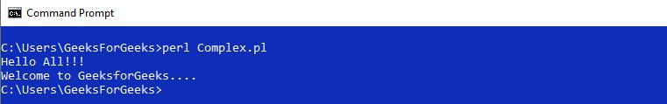
Whether you're preparing for your first job interview or aiming to upskill in this ever-evolving tech landscape, GeeksforGeeks Courses are your key to success. We provide top-quality content at affordable prices, all geared towards accelerating your growth in a time-bound manner. Join the millions we've already empowered, and we're here to do the same for you. Don't miss out - check it out now!
Commit to GfG's Three-90 Challenge! Purchase a course, complete 90% in 90 days, and save 90% cost click here to explore.
Last Updated : 23 Feb, 2023

10 Perl Global Variable Best Practices
출처 : https://climbtheladder.com/10-perl-global-variable-best-practices/
Global variables are a necessary part of Perl programming, but there are some best practices to follow to ensure that they are used correctly.

Harrison Lash
Published Dec 18, 2022
Perl is a popular programming language used for scripting and automation. It is a versatile language and can be used to create a wide variety of applications. One of the most important features of Perl is its ability to use global variables. Global variables are variables that are accessible from anywhere in the code. This makes them very useful for sharing data between different parts of the code.
However, using global variables can also lead to problems if they are not used correctly. In this article, we will discuss 10 best practices for using global variables in Perl. We will look at how to declare them, how to use them, and how to avoid common pitfalls.

1. Use strict and warnings to ensure that global variables are declared
Strict and warnings are two pragmas that can be used to help catch errors in a Perl program. Strict enforces the use of declared variables, which means that all variables must be declared with “my” or “our” before they can be used. This helps prevent accidental use of global variables, as well as typos(오자) in variable names. Warnings will alert you when an undeclared variable is used, so it’s important to enable this feature as well. To enable strict and warnings, simply add the following lines at the top of your script:
use strict;
use warnings;

2. Always use the my keyword when declaring new global variables
The my keyword is used to declare a lexical variable, which has a limited scope and visibility. This means that the variable will only be visible within the current block or file, depending on where it was declared. By using the my keyword when declaring global variables, you can ensure that they are not inadvertently modified by other parts of your code. Additionally, this helps to prevent namespace collisions, as each variable will have its own unique name. Furthermore, using the my keyword makes it easier to debug your code, since you can easily identify which variables are local and which are global.

3. Avoid using global variables in modules
Global variables are accessible from anywhere in the code, which can lead to unexpected behavior and difficult-to-debug errors. By avoiding global variables in modules, you ensure that any changes made to a variable within the module will not affect other parts of the program. Additionally, using global variables in modules makes it more difficult to test the code since the tests must be aware of the state of the global variables.
To avoid using global variables in modules, use lexical (my) variables instead. Lexical variables are only visible within the scope they were declared in, so they cannot be accessed outside of the module. This helps keep the module’s internal logic separate from the rest of the program, making it easier to maintain and debug. Additionally, lexical variables make it easier to write unit tests for the module since their values can be set explicitly without affecting the rest of the program.

4. Use a naming convention for global variables
Using a naming convention for global variables helps to make code more readable and maintainable. It also makes it easier to identify which variables are global, as opposed to local or package-level variables. This is especially important when working with large projects that involve multiple developers.
A common naming convention for Perl global variables is to prefix them with an underscore (_). For example, if you have a variable called “myVar”, you would name the corresponding global variable “_myVar”. This makes it easy to distinguish between global and non-global variables at a glance.
It’s also important to use descriptive names for your global variables. This will help other developers understand what the variable is used for without having to look up its definition in the code. Additionally, using descriptive names can help prevent accidental overwriting of existing variables.

5. Prefix all global variables with an underscore (_)
The underscore prefix is a visual cue that the variable is global, and it helps to avoid name collisions with other variables. This is especially important when using modules or libraries from outside sources, as they may contain variables with the same names as those used in your own code.
Using an underscore also makes it easier to identify which variables are being used globally within a program. It’s much simpler to search for all instances of “_” than to try to remember what each variable represents.
Perl provides two special variables, @_ and %_, which can be used to store global data. These variables should always be prefixed with an underscore so that they don’t conflict with any user-defined variables.
When declaring global variables, use the “our” keyword instead of “my”. This will ensure that the variable is visible throughout the entire scope of the program. Additionally, you should declare all global variables at the top of the script, before any subroutines or functions. This will make them easier to find and maintain.

6. Do not rely on Perl’s built-in type system for data validation
Perl’s built-in type system is not designed to be used for data validation. It does not provide any guarantees that the data stored in a variable is valid or safe, and it can lead to unexpected results if used incorrectly.
Instead of relying on Perl’s built-in type system, developers should use explicit checks to validate data before using it. This includes checking for expected values, ranges, formats, etc. For example, when dealing with user input, developers should check for malicious code, SQL injection attempts, and other potential security risks.
Using explicit checks also helps ensure that the data being used is consistent across different parts of the application. By explicitly defining what types of data are allowed, developers can avoid introducing bugs due to unexpected data types.
Additionally, explicit checks make it easier to debug issues since they clearly define what types of data are expected. If an issue arises, developers can quickly identify which part of the code is causing the problem and take appropriate action.

7. Make sure your code is thread safe
Thread safety is important because it ensures that multiple threads of execution can access the same global variables without interfering with each other. To make sure your code is thread safe, you should use locking mechanisms such as flock(), semaphores, and mutexes to ensure that only one thread at a time has access to the global variable. Additionally, you should also avoid using Perl’s built-in global variables (e.g., $!, @ARGV, etc.) in threaded applications, since they are not thread safe. Instead, create your own global variables and use them instead. Lastly, if you need to share data between threads, consider using shared memory or message queues.

8. Use lexical scoping instead of global variables
Lexical scoping is a way of limiting the scope of variables to the block in which they are declared. This means that any variable declared within a given block will not be accessible outside of it, and vice versa. This helps to avoid name collisions between different blocks, as well as making code more readable by clearly defining where each variable can be used. Additionally, lexically scoped variables are only visible within their own scope, so there’s no need to worry about them being accidentally modified or overwritten elsewhere in the program. To use lexical scoping instead of global variables in Perl, simply declare your variables with my instead of our. For example:
my $variable = “value”;

9. Consider using packages to create namespaces for global variables
Packages are a way to group related code and data together, which makes it easier to organize and maintain. By using packages to create namespaces for global variables, you can avoid name collisions between different parts of your program that use the same variable name. This is especially important when writing large programs with multiple modules or libraries.
Creating namespaces also helps make your code more readable by making it clear where each variable comes from. For example, if you have two variables called $name in different parts of your program, you can prefix them with their package name (e.g., $MyPackage::name) so that it’s easy to tell them apart.
Using packages also allows you to control access to global variables. You can set up private variables within a package that cannot be accessed outside of it, as well as public variables that can be used anywhere. This gives you greater flexibility and control over how your variables are used.

10. Ensure proper security protocols are in place for accessing global variables
Perl global variables are accessible from anywhere in the program, which makes them vulnerable to malicious code. If an attacker can gain access to a Perl script that uses global variables, they could potentially modify or delete data stored in those variables. To prevent this, it is important to ensure proper security protocols are in place for accessing global variables.
One way to do this is by using strict and warnings pragmas. These two modules help enforce secure coding practices by preventing accidental use of global variables and alerting developers when potential security issues arise. Additionally, developers should avoid using global variables whenever possible and instead opt for lexical variables, which are only visible within their scope. This helps reduce the risk of attackers gaining access to sensitive information stored in global variables.
It is also important to consider the environment in which the Perl script will be running. For example, if the script is going to be run on a shared server, additional measures may need to be taken to protect against unauthorized access. This could include setting up user authentication and restricting file permissions.

Perl's 'printf' function for formatting output
Author: Lea Tate Date: 2023-04-08
출처 : https://copyprogramming.com/howto/formatting-output-with-printf-in-perl
The printf function created reports using string formats and operators, which included numbers that could be retrieved through conversions. The function utilized a variety of format specifiers, including both numbers and string characters, as well as comparison operators that were referenced by the same names.
Table of contents
- Formatting output with 'printf' in Perl
- Perl print formatting
- Perl printf
- How do you use printf in Perl?
- How to write formatted data in Perl?
- What is sprintf function in Perl?
- How to limit the size of a text field in Perl?

Formatting output with 'printf' in Perl
Question:
I'm attempting to structure my output to resemble columns by utilizing the printf function function.
Here's what I have:
printf("%s %10s %12s %10s\n", "Qty", "Desc.", "Unit \$", "Total");
for ($he = 0; $he <= 6; $he++) {
if (@quantity[$he] != 0) {
printf("%d %10s %12.2f %10.2f\n", @quantity[$he], @selections[$he], @prices[$he], @prices[$he] * @quantity[$he])
}
}
My goal is to align the second printf in the if of the for loop with the headers "Qty", "Desc.", "Unit \$" and "Total.

Solution 1:
It is necessary to ensure that the numbers used in both formats are identical.
printf("%3s %10s %15s %13s\n", "Qty", "Desc.", "Unit \$", "Total");
and
printf("%3d %10s %12.2f %10.2f\n", @quantity[$he], @selections[$he], @prices[$he], @prices[$he]*@quantity[$he])
Please be aware that the first format, which I wrote as 15, represents 12.2, where 12 refers to 12 digits and 2 refers to 2 decimal points. This same principle applies to the number 13 as well.

It is worth mentioning that the way you're accessing the elements in the array is incorrect.
Substitute @quantity[$he] with $quantity[$he] by exchanging @ for $ .
Solution 2:
Perl was primarily utilized for file formatting in the past, and despite its continued possession of such abilities, I haven't witnessed its application in a program since the advent of Perl 4.x.
Take a look at the perlform documentation along with the format and write functions.
Although it has been years since I last wrote the code, I could have provided you with an example. Alternatively, you can make use of the printf statement and format it using %-10.10s to left justify the string and pad it to a maximum of 10 characters without exceeding the limit.
I recommend purchasing a modern Perl book that covers the topic of references.
Your program has been modified to use references. It is worth noting that all the information is currently consolidated in one array, as opposed to being distributed across four individual arrays, which you had hoped would help maintain the index.
To discuss the $item[1] dish's main course, I can convey $item[1]->{ENTREE} as it enhances readability and maintenance.
Please be aware that the loop for for has been modified to eliminate the need for knowing the number of items. In the previous version, adding a new item would require modifying the loop. In the new version, I employ $#menu to obtain the last index of the menu and (0..$#menu) to perform an automatic loop from the first item to the last item in the @menu array.
And, while you're at it:
- Pay attention to the formats of the statement that contains printf .
- Observe the incorporation of use strict; and use warnings; in the code, which can detect numerous errors.
- I prefer to use parentheses and curly braces to indicate distinct sections of code, and this method is favored.
And, now the program:
use strict;
use warnings;
my @menu = (
{ ENTREE => "Hamburger", PRICE => 3.49, QUANTITY => 3 },
{ ENTREE => "Frankfurter", PRICE => 2.19, QUANTITY => 0 },
{ ENTREE => "French Fries", PRICE => 1.69, QUANTITY => 0 },
{ ENTREE => "Large Coke", PRICE => 1.79, QUANTITY => 4 },
{ ENTREE => "Medium Coke", PRICE => 1.59, QUANTITY => 0 },
{ ENTREE => "Small Coke", PRICE => 1.39, QUANTITY => 0 },
{ ENTREE => "Onion Rings", PRICE => 1.19, QUANTITY => 8 },
);
printf "%-3.3s %-10.10s %-6.6s %s\n\n", 'Qty', 'Desc.', 'Unit $', 'Total';
# Use $#menu to get the number of items in the array instead of knowing it's 6
foreach my $item (0..$#menu) {
# Dereference $menu[$item] to make $menu_item a hash
# This makes the syntax easier to read.
my %menu_item = %{ $menu[$item] };
if ( $menu_item{QUANTITY} ) {
printf "%3d %-10.10s %9.2f %7.2f\n",
$menu_item{QUANTITY}, $menu_item{ENTREE}, $menu_item{PRICE},
$menu_item{QUANTITY} * $menu_item{PRICE};
}
}
OUTPUT:
Qty Desc. Unit $ Total
3 Hamburger 3.49 10.47
4 Large Coke 1.79 7.16
8 Onion Ring 1.19 9.52
Output formatting - How to print data in column form in, printf is of course easier to use than a print sprintf combination. I'm getting syntactic "errors", after correcting, there are again errors: "Use of …
Tags:
formatting output with printf in perl

Perl print formatting
Question:
When printing in Perl, how can I limit the length of a string by either truncating or appending characters to a specified length?
For example
$string='my_string';
printf("%04s",$string);
should print
my_s
also if
$string='my';
I should get
00my
Is it possible to obtain a printout of the last four characters?
ring
and if string is
$string='my';
it should print
00my

Solution 1:
Instead of your own format string, you are interested in using this particular one.
printf ("%04.4s", $string);
The reason for requiring the .4 is to indicate the maximum length, whereas the 4 at the start denotes only the minimum length.
here are the output of some tests:
$ perl -e "my \$string = \"my_string\";print sprintf(\"%04.4s\", 22);"
0022
$ perl -e "my \$string = \"my_string\";print sprintf(\"%04.4s\", \$string);"
my_s
$ perl -e "my \$string = \"my\";print sprintf(\"%04s\", \$string);"
00my
The resulting output displays strings that are not truncated due to the use of an incorrect format string.
$ perl -e "my \$string = \"my_string\";print sprintf(\"%04s\", 22);"
0022
$ perl -e "my \$string = \"my_string\";print sprintf(\"%04s\", \$string);"
my_string
Solution 2:
printf('%04s', substr($_, 0, 4));
String - Perl print formatting, I would like to format(truncate/append with chars) a string to a specified length while printing in Perl. For example $string='my_string'; …

Perl printf

Introduction to Perl printf
The Perl printf function is used to display a list of values with specified output formats. It can be applied to file handling or user input data in string format. Similar to sprint function , the printf Function function also uses printf formatters, but the resulting output is not necessarily the same. Additionally, the printf function does not automatically add new lines to the output screen.
Syntax:
By default, the Perl script data type includes pre-set keywords, functions, and scalar variables that only allow for a single value. The value can be any combination of numbers, letters, characters, and digits with operators. However, the variable must always begin with a letter or symbol, unlike underscore operator which cannot start with a digit.
$ variable name = value;
printf(“ “, $variable name);
---some Perl script logics---
The code mentioned above represents basic syntax that enables the utilization of printf() function within Perl scripts. When the script employs the printf function, it can employ certain advanced features of the function on the field specifiers as well.

How does the printf Function Work in Perl?
- The printf() method in Perl is used to print user data on the screen by utilizing format specifiers. The function interprets and prints the values from a list using these specifiers as output. The printf() function also incorporates the filehandle concept to handle errors and exceptions via exception classes and modules. Properties related to fields and attributes are commonly used in conjunction with the printf function.
- The function is designed to have similar properties as the print function in the script, resulting in a better output format that is related to user inputs. This is comparable to field specifiers and text string format specifiers, which may include delimiters like comma, semi-colon, or underscore. Regular Expressions concepts are applied to validate and evaluate user inputs in the backend codes, and the output is displayed on the user's screen.

Examples of Perl printf
Here are some instances of perl printf provided below:

Example #1
Code:
$var = 1562.45;
$strn = ("Welcome To My Domain");
printf("Hi user your input is \$%6.3f and converted output is %s ", $var, $strn);
Output:
Explanation:
- The example above utilizes two variables, namely $var and $strn. These variables are associated with specific formats. $var is assigned values that only comprise float type numbers, hence when the variable is executed in the script, the results will have a decimal point, and these results will be printed on the user screen.
- The variable $strn is designed to only accept string values such as "Welcome to My domain". This string format specifies the user information for the printf function. The function then passes calls to the string and inserts fields into separate memory locations.

Example #2
Code:
printf("Welcome To My Domain: ");
printf("'%7d' ", 7);
printf("'%7d' ", 596903);
printf("'%7d' ", -94758);
printf("'%7d' ", -904685);
printf(" ");
printf("Have a Nice Day: ");
printf("'%-8d' ", 785);
printf("'%-8d' ", 1023894785);
printf("'%-8d' ", -923487568);
printf("'%-8d' ", -1293475);
printf(" ");
printf(" ");
printf("Thanks for your interest in our application: ");
printf("'%09d' ", 3);
printf("'%09d' ", 223);
printf("'%09d' ", 9234687);
printf("'%09d' ", -9238747);
printf("'%09d' ", -2390478);
printf("'%04d' ", 23);
printf("'%04d' ", 'Welcome');
printf("'%04d' ", 'Welcome34');
printf("'%04d' ", -9243747);
printf("'%04d' ", -4590478);
printf("'%02d' ", 'Tyujk');
printf("'%02d' ", 'udg 4857 sdhfg');
printf("'%02d' ", 9238747);
printf("'%03d' ", -93476538747);
printf("'%02d' ", -239754478);
Output:
Explanation:
- The second example demonstrates the various ways in which the printf function can be utilized. Inputs of different types such as integer, float, decimal, short, long and double can be passed into the function, which will be converted into the required output format.
- Certain formats adhere to specific guidelines governing field dimensions, including height and width. Additionally, other fields may be present, such as those responsible for printing left- or right-justified, zero-filled numbers stored in variables used for calculating functions and storing memory location data. The format accommodates both positive and negative numbers, along with their respective signatures, to suit various use cases.

Example #3
Code:
\ \ \ \ printf\("'%4s'\n",\ "Welcome"\);\ \ \ \
\ \ \ \ printf\("'%76s'\n",\ "Welcome"\);\ \ \ \
\ \ \ \ printf\("'%\-76s'\n",\ "Welcome"\);\ \ \ \
\ \ \ \ printf\("Welcome\ To\ My\ Domain\n"\);\ \ \ \
\ \ \ \ printf\("Have\ a\ Nice\ Day\n"\);\ \ \ \
\ \ \ \ printf\("kjadgvds\ hasjkgdf\ ashdjfh\ jsdhfhj\ ajsg\n"\);\ \ \ \
\ \ \ \ printf\("Welcome\tTo\ My\ Domain\n"\);\ \ \ \
\ \ \ \ printf\("jasg\ hsagdfj\ skjdfhk\ skdh\ shfj\ sj\n"\);\ \ \ \
\ \ \ \ printf\("Welcome\n\ To\ My\ Domain\n"\);\ \ \ \
\ \ \ \ printf\("kjshdfj\ kjahksj\ nkjh\ 2734\ shj2983\ 3974y\ k\n"\);\ \ \ \
\ \ \ \ printf\("C:\Users\Kripya\-PC\Documents\articles\\\n"\);\ \ \ \
\ \ \ \ printf\("hsdfjg\ jhajs\ kjaskdj\ kjaksd\ jask\n"\);\ \ \ \
\ \ \ \ printf\("/Downloads\n"\);\ \ \ \
\ \ \ \ printf\("weh\ jkhj\ kawj\ kwejk\ jwlkl\ lkwqejkwlkqjlk\n"\);\ \ \ \
\ \ \ \ printf\("'%\.3f'\n\n",\ 873\.974\);\ \ \ \
\ \ \ \ printf\("87v\ hk\ jskj\ oi3y\ khk38\ i347\ bi3748\n"\);\ \ \ \
\ \ \ \ printf\("'%\.5f'\n",\ 873\.975\);\ \ \ \
\ \ \ \ printf\("jdshj38\ 3784\ 3748687j\ he83sk\ 94\n"\);\ \ \ \
\ \ \ \ printf\("'%6\.4f'\n",\ 748\.28374\);\ \ \ \
\ \ \ \ printf\("u3928\ oiwu498y\ bu4589\ io349\ b3974\n"\);\ \ \ \
\ \ \ \ printf\("'%7\.14f'\n",\ 734\.837495\);\ \ \ \
\ \ \ \ printf\("3749\ yiwe\ b843\ sekk48905\ je48\n"\);\ \ \ \
\ \ \ \ printf\("'%06\.4f'\n",\ 83\.8346\);\ \ \ \
\ \ \ \ printf\("2638\ hy3w8\ j8939475\ jbi34y8b\ wu4985b\ 3u984y\ bu498\n"\);\ \ \ \
\ \ \ \ printf\("'%\-6\.3f'\n\n",\ 857\.98374\);\ \ \ \
\ \ \ \ printf\("26837\ hjkwehr234yv\ hj\ gu4\ s\ h\ \ jkh\ jkjkh\ 3987\n"\);\ \ \ \
\ \ \ \ printf\("'%\-5\.25f'\n",\ 8347958\.892365\);\ \ \
Output:
Explanation:
- The printf() function employs a combination of numerical and string characters in its format specifiers, as well as comparison operators under the same reference names. This function utilizes string format-compatible operators to produce reports, which may also contain numerical values that can be accessed through conversions.
- Operators such as the % sign will be utilized during conversions, even if the same number of characters are assigned. The printf function necessitates the use of exponential notations.

Conclusion
To sum up, programming languages are equipped with internal mechanisms to exhibit results on the screen. These methods have individual features and characteristics that cater to the user's requirements. For instance, Perl utilizes the printf function, which utilizes format specifiers to showcase outputs on the user screen.

Final thoughts
In this guide, we will explore Perl's printf function. We will cover its introduction, how it works in Perl, and provide some examples. Additionally, if you would like to learn more, please refer to the following articles.
Perl printf of colored text, 1. I have this issue, that when I use colored text, the printf formatting (aligning) is not correct. In this example, notice how the last column is 1 space to …
Read other technology post: Java overwrite data txt file java code example

for()와 foreach()의 차이점
출처 : https://stackoverflow.com/questions/38666306/perl-why-does-for-and-foreach-give-me-different-results
---------------------------------------------------------------------------
# Foreach loop \
foreach my $item (@array) > same \
for my $item (@array) / \
> different
# Augmented while loop \ /
for (my $i=0; $i < scalar @array; $i++) > same /
foreach (my $i=0; $i < scalar @array; $i++) /
----------------------------------------------------------------------------
When people say they are used interchangably, they mean that the foreach keyword is just a synonym for the for keyword. That means the following two lines mean exactly the same thing:
foreach my $item (@array) {...}
for my $item (@array) {...}
For the avoidance of doubt I will ignore the foreach keyword and use only for below.
The following two lines, as you have seen, do not behave identically:
for my $item (@array) {...}
for (my $i = 0; $i < scalar @array; $i++) {...}
The manual advises against adding or removing elements in @array in the loop body of the first line, and doesn't say what would be the result.
If the loop body of the second line removes an element in @array at or before $i, the result will be that the element at new position $i will be skipped over. If it adds an element at or before $i, the result will be that the element at old position $i will be seen by the loop a second time.

Loop Control
출처: https://perldoc.perl.org/perlsyn#Foreach-Loops
The next command starts the next iteration of the loop:
LINE: while (<STDIN>) {
next LINE if /^#/; # discard comments
...
}
The last command immediately exits the loop in question. The continue block, if any, is not executed:
LINE: while (<STDIN>) {
last LINE if /^$/; # exit when done with header
...
}
The redo command restarts the loop block without evaluating the conditional again. The continue block, if any, is not executed. This command is normally used by programs that want to lie to themselves about what was just input.
For example, when processing a file like /etc/termcap. If your input lines might end in backslashes to indicate continuation, you want to skip ahead and get the next record.
while (<>) {
chomp;
if (s/\\$//) {
$_ .= <>;
redo unless eof();
}
# now process $_
}
which is Perl shorthand for the more explicitly written version:
LINE: while (defined($line = <ARGV>)) {
chomp($line);
if ($line =~ s/\\$//) {
$line .= <ARGV>;
redo LINE unless eof(); # not eof(ARGV)!
}
# now process $line
}
Note that if there were a continue block on the above code, it would get executed only on lines discarded by the regex (since redo skips the continue block). A continue block is often used to reset line counters or m?pat? one-time matches:
# inspired by :1,$g/fred/s//WILMA/
while (<>) {
m?(fred)? && s//WILMA $1 WILMA/;
m?(barney)? && s//BETTY $1 BETTY/;
m?(homer)? && s//MARGE $1 MARGE/;
} continue {
print "$ARGV $.: $_";
close ARGV if eof; # reset $.
reset if eof; # reset ?pat?
}
If the word while is replaced by the word until, the sense of the test is reversed, but the conditional is still tested before the first iteration.
Loop control statements don't work in an if or unless, since they aren't loops. You can double the braces to make them such, though.
if (/pattern/) {{
last if /fred/;
next if /barney/; # same effect as "last",
# but doesn't document as well
# do something here
}}
This is caused by the fact that a block by itself acts as a loop that executes once, see "Basic BLOCKs".
The form while/if BLOCK BLOCK, available in Perl 4, is no longer available. Replace any occurrence of if BLOCK by if (do BLOCK).

For Loops
Perl's C-style for loop works like the corresponding while loop; that means that this:
for ($i = 1; $i < 10; $i++) {
...
}
is the same as this:
$i = 1;
while ($i < 10) {
...
} continue {
$i++;
}
There is one minor difference: if variables are declared with my in the initialization section of the for, the lexical scope of those variables is exactly the for loop (the body of the loop and the control sections). To illustrate:
my $i = 'samba';
for (my $i = 1; $i <= 4; $i++) {
print "$i\n";
}
print "$i\n";
when executed, gives:
1
2
3
4
samba
As a special case, if the test in the for loop (or the corresponding while loop) is empty, it is treated as true. That is, both
for (;;) {
...
}
and
while () {
...
}
are treated as infinite loops.
Besides the normal array index looping, for can lend itself to many other interesting applications. Here's one that avoids the problem you get into if you explicitly test for end-of-file on an interactive file descriptor causing your program to appear to hang.
$on_a_tty = -t STDIN && -t STDOUT;
sub prompt { print "yes? " if $on_a_tty }
for ( prompt(); <STDIN>; prompt() ) {
# do something
}
The condition expression of a for loop gets the same magic treatment of readline et al that the condition expression of a while loop gets.

Foreach Loops
The foreach loop iterates over a normal list value and sets the scalar variable VAR to be each element of the list in turn. If the variable is preceded with the keyword my, then it is lexically scoped, and is therefore visible only within the loop. Otherwise, the variable is implicitly local to the loop and regains its former value upon exiting the loop. If the variable was previously declared with my, it uses that variable instead of the global one, but it's still localized to the loop. This implicit localization occurs only for non C-style loops.
The foreach keyword is actually a synonym for the for keyword, so you can use either. If VAR is omitted, $_ is set to each value.
If any element of LIST is an lvalue, you can modify it by modifying VAR inside the loop. Conversely, if any element of LIST is NOT an lvalue, any attempt to modify that element will fail. In other words, the foreach loop index variable is an implicit alias for each item in the list that you're looping over.
If any part of LIST is an array, foreach will get very confused if you add or remove elements within the loop body, for example with splice. So don't do that.
foreach probably won't do what you expect if VAR is a tied or other special variable. Don't do that either.
As of Perl 5.22, there is an experimental variant of this loop that accepts a variable preceded by a backslash for VAR, in which case the items in the LIST must be references. The backslashed variable will become an alias to each referenced item in the LIST, which must be of the correct type. The variable needn't be a scalar in this case, and the backslash may be followed by my. To use this form, you must enable the refaliasing feature via use feature. (See feature. See also "Assigning to References" in perlref.)
As of Perl 5.36, you can iterate over multiple values at a time. You can only iterate with lexical scalars as the iterator variables - unlike list assignment, it's not possible to use undef to signify a value that isn't wanted. This is a limitation of the current implementation, and might be changed in the future.
If the size of the LIST is not an exact multiple of the number of iterator variables, then on the last iteration the "excess" iterator variables are aliases to undef, as if the LIST had , undef appended as many times as needed for its length to become an exact multiple. This happens whether LIST is a literal LIST or an array - ie arrays are not extended if their size is not a multiple of the iteration size, consistent with iterating an array one-at-a-time. As these padding elements are not lvalues, attempting to modify them will fail, consistent with the behaviour when iterating a list with literal undefs. If this is not the behaviour you desire, then before the loop starts either explicitly extend your array to be an exact multiple, or explicitly throw an exception.
Examples:
for (@ary) { s/foo/bar/ }

for my $elem (@elements) {
$elem *= 2;
}

for $count (reverse(1..10), "BOOM") {
print $count, "\n";
sleep(1);
}

for (1..15) { print "Merry Christmas\n"; }

foreach $item (split(/:[\\\n:]*/, $ENV{TERMCAP})) {
print "Item: $item\n";
}

use feature "refaliasing";
no warnings "experimental::refaliasing";
foreach \my %hash (@array_of_hash_references) {
# do something with each %hash
}

foreach my ($foo, $bar, $baz) (@list) {
# do something three-at-a-time
}

foreach my ($key, $value) (%hash) {
# iterate over the hash
# The hash is immediately copied to a flat list before the loop
# starts. The list contains copies of keys but aliases of values.
# This is the same behaviour as for $var (%hash) {...}
}
Here's how a C programmer might code up a particular algorithm in Perl:
for (my $i = 0; $i < @ary1; $i++) {
for (my $j = 0; $j < @ary2; $j++) {
if ($ary1[$i] > $ary2[$j]) {
last; # can't go to outer :-(
}
$ary1[$i] += $ary2[$j];
}
# this is where that last takes me
}
Whereas here's how a Perl programmer more comfortable with the idiom might do it:
OUTER: for my $wid (@ary1) {
INNER: for my $jet (@ary2) {
next OUTER if $wid > $jet;
$wid += $jet;
}
}
See how much easier this is? It's cleaner, safer, and faster. It's cleaner because it's less noisy. It's safer because if code gets added between the inner and outer loops later on, the new code won't be accidentally executed. The next explicitly iterates the other loop rather than merely terminating the inner one. And it's faster because Perl executes a foreach statement more rapidly than it would the equivalent C-style for loop.
Perceptive Perl hackers may have noticed that a for loop has a return value, and that this value can be captured by wrapping the loop in a do block. The reward for this discovery is this cautionary advice: The return value of a for loop is unspecified and may change without notice. Do not rely on it.

Input Operators
출처 : https://docstore.mik.ua/orelly/perl2/prog/ch02_11.htm
There are several input operators we'll discuss here because they parse as terms. Sometimes we call them pseudoliterals because they act like quoted strings in many ways. (Output operators like print parse as list operators and are discussed in Chapter 29, "Functions".)

2.11.1. Command Input (Backtick) Operator
First of all, we have the command input operator, also known as the backtick operator, because it looks like this:
$info = `finger $user`;
A string enclosed by backticks (grave accents, technically) first undergoes variable interpolation just like a double-quoted string. The result is then interpreted as a command line by the system, and the output of that command becomes the value of the pseudoliteral. (This is modeled after a similar operator in Unix shells.) In scalar context, a single string consisting of all the output is returned. In list context, a list of values is returned, one for each line of output. (You can set $/ to use a different line terminator.)
The command is executed each time the pseudoliteral is evaluated. The numeric status value of the command is saved in $? (see Chapter 28, "Special Names" for the interpretation of $?, also known as $CHILD_ERROR). Unlike the csh version of this command, no translation is done on the return data--newlines remain newlines. Unlike in any of the shells, single quotes in Perl do not hide variable names in the command from interpretation. To pass a $ through to the shell you need to hide it with a backslash. The $user in our finger example above is interpolated by Perl, not by the shell. (Because the command undergoes shell processing, see Chapter 23, "Security", for security concerns.)
The generalized form of backticks is qx// (for "quoted execution"), but the operator works exactly the same way as ordinary backticks. You just get to pick your quote characters. As with similar quoting pseudofunctions, if you happen to choose a single quote as your delimiter, the command string doesn't undergo double-quote interpolation;
$perl_info = qx(ps $$); # that's Perl's $$
$shell_info = qx'ps $$'; # that's the shell's $$

2.11.2. Line Input (Angle) Operator
The most heavily used input operator is the line input operator, also known as the angle operator or the readline function (since that's what it calls internally). Evaluating a filehandle in angle brackets (STDIN, for example) yields the next line from the associated filehandle. (The newline is included, so according to Perl's criteria for truth, a freshly input line is always true, up until end-of-file, at which point an undefined value is returned, which is conveniently false.) Ordinarily, you would assign the input value to a variable, but there is one situation where an automatic assignment happens. If and only if the line input operator is the only thing inside the conditional of a while loop, the value is automatically assigned to the special variable $_. The assigned value is then tested to see whether it is defined. (This may seem like an odd thing to you, but you'll use the construct frequently, so it's worth learning.) Anyway, the following lines are equivalent:
while (defined($_ = <STDIN>)) { print $_; } # the longest way
while ($_ = <STDIN>) { print; } # explicitly to $_
while (<STDIN>) { print; } # the short way
for (;<STDIN>;) { print; } # while loop in disguise
print $_ while defined($_ = <STDIN>); # long statement modifier
print while $_ = <STDIN>; # explicitly to $_
print while <STDIN>; # short statement modifier
Remember that this special magic requires a while loop. If you use the input operator anywhere else, you must assign the result explicitly if you want to keep the value:
while (<FH1> && <FH2>) { ... } # WRONG: discards both inputs
if (<STDIN>) { print; } # WRONG: prints old value of $_
if ($_ = <STDIN>) { print; } # suboptimal: doesn't test defined
if (defined($_ = <STDIN>)) { print; } # best
When you're implicitly assigning to $_ in a $_ loop, this is the global variable by that name, not one localized to the while loop. You can protect an existing value of $_ this way:
while (local $_ = <STDIN>) { print; } # use local $_
Any previous value is restored when the loop is done. $_ is still a global variable, though, so functions called from inside that loop could still access it, intentionally or otherwise. You can avoid this, too, by declaring a lexical variable:
while (my $line = <STDIN>) { print $line; } # now private
(Both of these while loops still implicitly test for whether the result of the assignment is defined, because my and local don't change how assignment is seen by the parser.) The filehandles STDIN, STDOUT, and STDERR are predefined and pre-opened. Additional filehandles may be created with the open or sysopen functions. See those functions' documentation in Chapter 29, "Functions" for details on this.
In the while loops above, we were evaluating the line input operator in a scalar context, so the operator returns each line separately. However, if you use the operator in a list context, a list consisting of all remaining input lines is returned, one line per list element. It's easy to make a large data space this way, so use this feature with care:
$one_line = <MYFILE>; # Get first line.
@all_lines = <MYFILE>; # Get the rest of the lines.
There is no while magic associated with the list form of the input operator, because the condition of a while loop always provides a scalar context (as does any conditional).
Using the null filehandle within the angle operator is special; it emulates the command-line behavior of typical Unix filter programs such as sed and awk. When you read lines from <>, it magically gives you all the lines from all the files mentioned on the command line. If no files were mentioned, it gives you standard input instead, so your program is easy to insert into the middle of a pipeline of processes.
Here's how it works: the first time <> is evaluated, the @ARGV array is checked, and if it is null, $ARGV[0] is set to "-", which when opened gives you standard input. The @ARGV array is then processed as a list of filenames. More explicitly, the loop:
while (<>) {
... # code for each line
}
is equivalent to the following Perl-like pseudocode:
@ARGV = ('-') unless @ARGV; # assume STDIN iff empty
while (@ARGV) {
$ARGV = shift @ARGV; # shorten @ARGV each time
if (!open(ARGV, $ARGV)) {
warn "Can't open $ARGV: $!\n";
next;
}
while (<ARGV>) {
... # code for each line
}
}
except that it isn't so cumbersome to say, and will actually work. It really does shift array @ARGV and put the current filename into the global variable $ARGV. It also uses the special filehandle ARGV internally--<> is just a synonym for the more explicitly written <ARGV>, which is a magical filehandle. (The pseudocode above doesn't work because it treats <ARGV> as nonmagical.)
You can modify @ARGV before the first <> as long as the array ends up containing the list of filenames you really want. Because Perl uses its normal open function here, a filename of "-" counts as standard input wherever it is encountered, and the more esoteric features of open are automatically available to you (such as opening a "file" named "gzip -dc < file.gz|"). Line numbers ($.) continue as if the input were one big happy file. (But see the example under eof in Chapter 29, "Functions" for how to reset line numbers on each file.)
If you want to set @ARGV to your own list of files, go right ahead:
# default to README file if no args given
@ARGV = ("README") unless @ARGV;
If you want to pass switches into your script, you can use one of the Getopt::* modules or put a loop on the front like this:
while (@ARGV and $ARGV[0] =~ /^-/) {
$_ = shift;
last if /^--$/;
if (/^-D(.*)/) { $debug = $1 }
if (/^-v/) { $verbose++ }
... # other switches
}
while (<>) {
... # code for each line
}
The <> symbol will return false only once. If you call it again after this, it will assume you are processing another @ARGV list, and if you haven't set @ARGV, it will input from STDIN.
If the string inside the angle brackets is a scalar variable (for example, <$foo>), that variable contains an indirect filehandle, either the name of the filehandle to input from or a reference to such a filehandle. For example:
$fh = \*STDIN;
$line = <$fh>;
or:
open($fh, "<data.txt");
$line = <$fh>;

2.11.3. Filename Globbing Operator
You might wonder what happens to a line input operator if you put something fancier inside the angle brackets. What happens is that it mutates into a different operator. If the string inside the angle brackets is anything other than a filehandle name or a scalar variable (even if there are just extra spaces), it is interpreted as a filename pattern to be "globbed".[19] The pattern is matched against the files in the current directory (or the directory specified as part of the fileglob pattern), and the filenames so matched are returned by the operator. As with line input, names are returned one at a time in scalar context, or all at once in list context. The latter usage is more common; you often see things like:
@files = <*.xml>;
As with other kinds of pseudoliterals, one level of variable interpolation is done first, but you can't say <$foo> because that's an indirect filehandle as explained earlier. In older versions of Perl, programmers would insert braces to force interpretation as a fileglob: <${foo}>. These days, it's considered cleaner to call the internal function directly as glob($foo), which is probably the right way to have invented it in the first place. So instead you'd write
@files = glob("*.xml");
if you despise overloading the angle operator for this. Which you're allowed to do.
[19]Fileglobs have nothing to do with the previously mentioned typeglobs, other than that they both use the * character in a wildcard fashion. The * character has the nickname "glob" when used like this. With typeglobs, you're globbing symbols with the same name from the symbol table. With a fileglob, you're doing wildcard matching on the filenames in a directory, just as the various shells do.
Whether you use the glob function or the old angle-bracket form, the fileglob operator also does while magic like the line input operator, assigning the result to $_. (That was the rationale for overloading the angle operator in the first place.) For example, if you wanted to change the permissions on all your C code files, you might say:
while (glob "*.c") {
chmod 0644, $_;
}
which is equivalent to:
while (<*.c>) {
chmod 0644, $_;
}
The glob function was originally implemented as a shell command in older versions of Perl (and in even older versions of Unix), which meant it was comparatively expensive to execute and, worse still, wouldn't work exactly the same everywhere. Nowadays it's a built-in, so it's more reliable and a lot faster. See the description of the File::Glob module in Chapter 32, "Standard Modules" for how to alter the default behavior of this operator, such as whether to treat spaces in its operand (argument) as pathname separators, whether to expand tildes or braces, whether to be case insensitive, and whether to sort the return values--amongst other things.
Of course, the shortest and arguably the most readable way to do the chmod command above is to use the fileglob as a list operator:
chmod 0644, <*.c>;
A fileglob evaluates its (embedded) operand only when starting a new list. All values must be read before the operator will start over. In a list context, this isn't important because you automatically get them all anyway. In a scalar context, however, the operator returns the next value each time it is called, or a false value if you've just run out. Again, false is returned only once. So if you're expecting a single value from a fileglob, it is much better to say:
($file) = <blurch*>; # list context
than to say:
$file = <blurch*>; # scalar context
because the former returns all matched filenames and resets the operator, whereas the latter alternates between returning filenames and returning false.
If you're trying to do variable interpolation, it's definitely better to use the glob operator because the older notation can cause confusion with the indirect filehandle notation. This is where it becomes apparent that the borderline between terms and operators is a bit mushy:
@files = <$dir/*.[ch]>; # Works, but avoid.
@files = glob("$dir/*.[ch]"); # Call glob as function.
@files = glob $some_pattern; # Call glob as operator.
We left the parentheses off of the last example to illustrate that glob can be used either as a function (a term) or as a unary operator; that is, a prefix operator that takes a single argument. The glob operator is an example of a named unary operator, which is just one kind of operator we'll talk about in the next chapter. Later, we'll talk about pattern-matching operators, which also parse like terms but behave like operators.

Perl: Understanding the Distinction between open and sysopen
출처: https://copyprogramming.com/howto/what-s-the-difference-between-open-and-sysopen-in-perl
Author: Walter Andersen Date: 2023-05-26
At work, we frequently need to parse enormous data files, usually between 30GB to 50GB, as I perform numerous file-to-file reconciliations. During my reading of the APUE (3rd edition) book, I found out about the open system call's functionality, which allows users to open files for atomic operations with a mode that enables multiple processes to write to a file descriptor. The kernel ensures that the data written to the single file by multiple processes does not overlap, and all lines remain intact.
Table of contents
- What's the difference between open and sysopen in Perl?
- Perl seems to require an external module to use the builtin sysopen
- Perl: sysopen() hangs while opening named pipe
- Can perl sysopen open file for atomic writes?
- What is the sysopen function in Perl?
- How to open and close a file in Perl?
- What is sysopen function in Linux?
- What are the basic file handles in Perl?

What's the difference between open and sysopen in Perl?
Question:
They appear to have identical functions, don't they?
Could someone provide me with an instance where they perform a diverse range of tasks?

Solution 1:
The sysopen wrapper is a direct mapping of the open(2) kernel system call. On the other hand, open is a more advanced wrapper that allows for redirections, piping, and other features.
For regular files on disk, open should suffice unless you are dealing with a particular device that necessitates special flags to be passed at open(2) time.
Solution 2:
According to the perlopentut guide, the following is stated:
Perl's open can provide the convenience of the shell. However, for those seeking greater precision than C's basic fopen(3S), Perl's sysopen provides a direct connection to the open(2) system call. This option does require more effort, but it offers a higher level of precision.
Due to Perl being written in C, both methods likely involve the same system call, as seen in open(2) . However, Perl's open() offers conveniences for opening, piping, and redirection, making them effortless. Nevertheless, it lacks the flexibility of sysopen() , including its masking functionality and other features that are not available in open() .
Sometimes, all that is required is the implementation of open() to address various scenarios.
Atomic open of non-existing file in Perl, Next, they try to open the file with open, and if that fails, they then try sysopen. They continue on to say: Now even if the file somehow springs into existence between when open fails and when sysopen tries to open a new file for writing, no harm is done, because with the flags provided, sysopen will refuse to …
Tags:
require an external module to use the builtin sysopen perl sysopen hangs while opening named pipe difference between open and sysopen in perl

Perl seems to require an external module to use the builtin sysopen
Question:
$ perl -e 'use strict subs; print sysopen(my $temp, "./myfile.txt", O_RDONLY);'
Bareword "O_RDONLY" not allowed while "strict subs" in use at -e line 1
When attempting to run the command on the command line, an error is prompted. Although I comprehend the reason behind the error, the solution requires the installation of use Fnctl on the system. I am striving to create a tool that showcases Perl's convenience and usefulness, without bringing attention to it. However, this error does not contribute towards that goal.
As I work on a Perl tool, I want it to function as a single file without the need to set up external libraries . I am curious why a built-in requires an external module. While O_RDONLY may differ across various operating systems, the same can be true for STDIN , STDERR , and STDOUT . However, use strict subs can be used with all of them.

Solution 1:
What is the reason for needing an additional module when using a built-in?
The Fcntl module is not an external one, but rather a standard module that comes with Perl. If it fails to load, it indicates that Perl has not been installed correctly. However, you can opt to use an alternative by utilizing numeric values check and substituting it with perl -MFcntl -E 'say O_RDONLY' .
Solution 2:
By utilizing perl , you can make use of corelist to verify the condition of the modules.
$ corelist Fcntl
Data for 2020-06-20
Fcntl was first released with perl 5
$ corelist Module::CoreList
Data for 2020-06-20
Module::CoreList was first released with perl v5.8.9
Module Module::Build was once included in the core, but it was later deprecated and eventually eliminated.
$ corelist Module::Build
Data for 2022-03-13
Module::Build was first released with perl v5.9.4, deprecated (will be CPAN-only) in v5.19.0 and removed from v5.21.0
The Special variables in Perl, namely STDOUT , STDERR , and STDIN , are aware of their intended use as long as Perl does not generate an error message regarding the variables that are automatically provided (perlvar).
Opening and Closing Files in Perl, Sysopen Function The sysopen function in Perl is similar to the main open function, except that it uses the system open () function, using the parameters supplied to it as the parameters for the system function − For example, to open a file for updating, emulating the +<filename format from open − sysopen (DATA, …

Perl: sysopen() hangs while opening named pipe
Question:
The code I am using is meant to open a named pipe situated at '/tmp/xyz' but only for the purpose of reading.
#!/usr/bin/perl
use strict;
use Fcntl;
...
sysopen(FIFO, "/tmp/xyz", O_RDONLY) or die ("opening named pipe failed: $!\n");
...
The issue lies in the fact that when called, sysopen neither terminates nor allows any subsequent code to execute.
output of ls -la /tmp/xyz:
prw-r--r-- 1 user group 0 Jun 20 11:45 /tmp/xyz
Does anyone have any insight into the current situation? Thank you in advance!

Solution:
The program will remain blocked until the FIFO receives input as it was opened in blocking mode.
It is advisable to open it in a non-blocking manner.
O_RDONLY | O_NONBLOCK
Perl - File locking with Fcntl: Baffling bug involving 'use', By foregoing use, you deprive the Perl parser of the knowledge that O_RDONLY et al. are parameterless subroutines. You have to be a bit more verbose in that situation: You have to be a bit more verbose in that situation:

Can perl sysopen open file for atomic writes?
Question:
As I was going through the APUE (3rd edition) book, I learned about the open system call. It enables users to open a file in an atomic operation using the write and O_APPEND mode. This means that multiple processes can write to a file descriptor while the kernel ensures that data written multiple processes accessing the same file do not overlap and that all lines remain intact.
After successfully testing the open system call using a C/C++ program, I confirmed that it functions as described in the book. I managed to execute launch multiple processes that wrote to a solitary file, and all the lines were attributable to their respective process PIDs.
I wanted to witness a similar action using Perl sysopen for some job-related tasks. However, my attempt to do so failed. After examining the output file, I noticed several occurrences where interleaved lines appeared, indicating a possible race condition.
Is it feasible to accomplish an atomic write operation by several processes on a single file using Perl's sysopen function, and is it distinct from the open system call in Linux?
Supplementing the post with both C and Perl code used for testing purposes.
C/C++ code
int main(void)
{
if ((fd = open("outfile.txt",O_WRONLY|O_CREAT|O_APPEND)) == -1) {
printf ("failed to create outfile! exiting!\n");
return -1;
}
for (int counter{1};counter<=MAXLINES;counter++)
{ /* write string 'line' for MAXLINES no. of times */
std::string line = std::to_string(ACE_OS::getpid())
+ " This is a sample data line ";
line += std::to_string(counter) + " \n";
if ((n = write(fd,line.c_str(),strlen(line.c_str()))) == -1) {
printf("Failed to write to outfile!\n";
}
}
return 0;
}
Perl code
#!/usr/bin/perl
use Fcntl;
use strict;
use warnings;
my $maxlines = 100000;
sysopen (FH, "testfile", O_CREAT|O_WRONLY|O_APPEND) or die "failed sysopen\n";
while ($maxlines != 0) {
print FH "($$) This is sample data line no. $maxlines\n";
$maxlines--;
}
close (FH);
__END__
Modified information (following the preliminary examination):
With the assistance provided in the given response, I managed to resolve the issue. However, I faced a problem with some absent lines that arose due to my practice of using O_TRUNC to open the file with every process, which was not the correct approach, but I failed to notice it initially. After analyzing it thoroughly, I identified the problem and rectified it. As usual, the reliability of Linux was maintained.
Below is the bash script I utilized to initiate the procedures:
#!/bin/bash
# basically we spawn "$1" instances of the same
# executable which should append to the same output file.
max=$1
[[ -z $max ]] && max=6
echo "creating $max processes for appending into same file"
# this is our output file collecting all
# the lines from all the processes.
# we truncate it before we start
>testfile
for i in $(seq 1 $max)
do
echo $i && ./perl_read_write_with_syscalls.pl 2>>_err &
done
# end.
Confirmation through the file's output:
[compuser@lenovoe470:07-multiple-processes-append-to-a-single-file]$ ls -lrth testfile
-rw-rw-r--. 1 compuser compuser 252M Jan 31 22:52 testfile
[compuser@lenovoe470:07-multiple-processes-append-to-a-single-file]$ wc -l testfile
6000000 testfile
[compuser@lenovoe470:07-multiple-processes-append-to-a-single-file]$ cat testfile |cut -f1 -d" "|sort|uniq -c
1000000 (PID: 21118)
1000000 (PID: 21123)
1000000 (PID: 21124)
1000000 (PID: 21125)
1000000 (PID: 21126)
1000000 (PID: 21127)
[compuser@lenovoe470:07-multiple-processes-append-to-a-single-file]$
Observations:
It was unexpected for me to find out that the system did not have any wait average load. I speculate that the kernel may have managed it, but I am unaware of the details. I am curious to learn more about this.
What are the potential uses of this?
At work, I frequently perform file-to-file reconciliations that require parsing massive data files (ranging from 30gb to 50gb). Previously, I would hash file1, hash file2, and then compare key-value pairs between the two files. However, with my current approach, I can perform these operations in parallel, which significantly reduces the time it takes to complete the task.
Thanks

Reference / dereference
출처 : https://gist.github.com/aero/1542213
Solution:
Regardless of whether you employ open or sysopen , the crucial aspect is utilizing syswrite and sysread in place of print / printf / say / etc, along with readline / read / eof / etc.
The combination of syswrite and Maps to a single followed by a write(2) call, along with print , printf , say , or other similar codes, can lead to multiple calls to write(2) even if the autoflush feature is enabled, as stated in [1].
A solitary call to read(2) corresponds to sysread . However, readline , read , eof , and others may lead to numerous calls to read(2) .
When working on a POSIX system, utilizing syswrite and sysread guarantees that you will receive all of the assurances that POSIX offers for these calls, although the specifics of these assurances are not specified.

www.perlmania.or.kr에서 본인이 답변한 내용정리

차례대로 정리를 해보면 perl에서 reference를 dereference 할때는 [sigil]{}연산자를
사용합니다. 여기서 sigil은 결과로 어떤 데이터 타입을 가질것인가를 결정하는거죠.

@array = ( "one", "two", "three", "four", [10, 20, 30, 40, 50] );
$arrayref = \@array;
인 상태에서 $arrayref 안의 one을 가져오려면 해당값은 scalar이므로 sigil은 $가 되고
${$arrayref}[0] 이 됩니다.( @array의 첫번째 요소를 나타낼때 $array[0] 이렇게 하는걸 상기 )

여기서 [sigil]{} 에서 {}는 생략가능합니다. 그래서
$$arrayref[0] 가 되고
그리고 [sigil]{}은 ->로 대체가능합니다. 따라서
$arrayref->[0] 이 됩니다.

이제 더 복잡한 익명배열,혹은 레퍼런스를 포함한 자료구조로 가서 위에서
@array안의 익명배열 [10,20,30,40,50]에서 10 을 가져오려면 어떻게 해야 할까요?
일단 @array안의 5번째 요소(여기서는 익명배열레퍼런스)를 가져와야 합니다.
레퍼런스 자체는 scalar이므로 sigil로는 $을 사용해야 하겠죠? 따라서
${$arrayref}[4] 가 익명배열의 레퍼런스가 될겁니다. 이제 이것을 또 dereference해야하고
dereference후 최종적으로 가져올 10이 scalar이니깐 sigil은 $가 사용됩니다.

따라서 ${${$arrayref}[4]}[0]; 이렇게 하면 10을 가져옵니다. 이것을 처음에 말씀드린 규칙을 통해
여러형태로 변경해보면 다음것들이 모두 다 동일한 결과를 가져옵니다.

$$arrayref[4]->[0]
$$arrayref[4][0]

${$$arrayref[4]}[0]
${$arrayref->[4]}[0]
$arrayref->[4]->[0] 여기서 [],{}들사이의 ->는 편의상 생략이 가능합니다. 따라서
$arrayref->[4][0]

이렇게 여러 형태로 사용가능하지만 마지막 형태를 제일 많이쓰죠 제일 깔끔하기도 하고.

여기서 {}를 생략한 형태인 $$$arrayref[4][0] 혹은 $$arrayref->[4][0] 은 왜 안되느냐?
하는 의문이 있을 수 있습니다.

그 이유는 []가 연산자 우선순위가 가장 낮기 때문에 derefernce 대상인 $$arrayref[4] 와
$arrayref->[4] 를 dereference 하지못하고 앞의 sigil들끼리 먼저 결합해버리기 때문입니다.
앞에서 예를든 ${$arrayref}[0] 가 $$arrayref[0] 가 될 수 있는건 [0]이 제일 마지막에
해석되는건 이러나 저러나 변함이 없기 때문이죠 두가지 경우를 꼼꼼히 비교해 보시면
안되는 이유를 더 명확히 아실 수 있을겁니다.

그러면 @array의 5번째 요소인 익명배열을 @b 라는 배열에 넣을려면 어떻게 해야할까요?
지금까지 배운 규칙을 사용해서 하나하나 차근차근 해보면 일단 익명배열의 레퍼런스(scalar값)는
${$arrayref}[4] 가 됩니다. 이제 이 익명배열 레퍼런스를 dereference해서 배열로 하려면
@{}을 사용해서 @{${$arrayref}[4]} 로 하면 최종적으로 배열을 뽑아내게 됩니다. 따라서
@b = @{${$arrayref}[4]}; 이렇게 하면 되겠죠. 그리고 앞에서 배운 규칙에 따라
@b = @{$$arrayref[4]}; 혹은
@b = @{$arrayref->[4]};
이렇게도 됩니다.

여기서 {}을 생략하는 형태인 이것들은 왜 안될까? 하는건
@b = @$$arrayref[4];
@b = @$arrayref->[4];
이미 위에서 예를 들어 얘기했기 때문에 알 수 있을겁니다.

제가 말씀드린 규칙
1. reference를 dereference 할때는 [sigil]{}연산자를 사용
( sigil은 최종적으로 만들어질 타입, reference는 scalar값이다. )

2. [sigil]{} 에서 {}는 생략가능
( 단 생략할때는 연산자 우선순위에 따른 해석 순서에 문제가 없어야 함 )

3. [sigil]{}은 ->로 대체가능
( 여러개일때 [],{}들사이의 ->는 편의상 생략이 가능 )

이것만 잘 기억하고 이해하시면 reference/derefrence는 헷갈릴 일이 전혀 없습니다.

추가 답변

@array = ( "one", "two", "three", "four", [10, 20, 30, 40, 50] );

$array[4][4]는 실제로 다음과 같은 절차를 거친 형태입니다.
1. ${$array[4]}[4]
2. $array[4]->[4]
3. $array[4][4]

$arrayref->[4][4] 는 다음과 같은 절차를 거친 형태이고요.
1. ${${$arrayref}[4]}[4]
2. ${$arrayref->[4]}[4]
3. $arrayref->[4]->[4]
4. $arrayref->[4][4]

다음은 Perl Cookbook에 있는 내용을 발췌 한것입니다.
이 내용에 입각해서 원초적 형태로 돌려 놓고 보면 혼돈의 여지가 없을겁니다.
--------------------------------------------------------------
<원문>
Confusion About Precedence
The expressions involving key lookups might cause some confusion. Do you read $$rarray[1] as ${$rarray[1]} or {$$rarray}[1] or ${$rarray}[1]?

(Pause here to give your eyes time to refocus!)

As it happens, the last one is the correct answer. Perl follows these two simple rules while parsing such expressions: (1) Key or index lookups are done at the end, and (2) the prefix closest to a variable name binds most closely. When Perl sees something like $$rarray[1] or $$rhash{"browns"}, it leaves index lookups ([1] and {"browns"}) to the very end. That leaves $$rarray and $$rhash. It gives preference to the `$' closest to the variable name. So the precedence works out like this: ${$rarray} and ${$rhash}. Another way of visualizing the second rule is that the preference is given to the symbols from right to left (the variable is always to the right of a series of symbols).

<해석>
우선순위에 대한 혼돈
key를 찾는것을 포함하는 표현은 약간의 혼돈을 줄 수 있다. $$rarray[1]을
${$rarray[1]} 또는 {$$rarray}[1] 또는 ${$rarray}[1] 어떤것으로 읽겠는가?

마지막이 맞는답이다. Perl은 그러한 표현을 파싱하는데 있어 다음의 간단한 두 법칙을 따른다:
(1) Key또는 index 찾는건 맨 마지막에 일어난다.
(2) 변수명에 가장 가까운 prefix는 가장 가까이서 결합된다.
Perl이 $$rarray[1] 또는 $$rhash{"browns"}를 볼때 [1]과 {"browns"}같은 index는 맨 마지막으로 제껴두면 $$rarray와 $$rhash가 남는다.
이것은 변수명에 가장가까운 $에 우선순위를 둔다.
그래서 우선순위는 ${$rarray}와 ${$rhash} 와 같이 동작한다.
두번째 법칙을 가시화하는 또 다른 방법은 우선순위는 symbol들에서 오른쪽에서 왼쪽으로 주어진다는것이다.
(변수는 항상 심볼들의 집합에서 항상 오른쪽에 위치한다.)
--------------------------------------------------------

Perl References: Unlocking The Power Of Data Structures
by Adrian Petruk • 8 min read
출처 : https://marketsplash.com/tutorials/perl/perl-references/
Navigating Perl references can be tricky, but it's a key skill to enhance your coding prowess. Our article untangles the topic, exploring everything from the basics to more complex data structures and handling circular references.
Perl references are integral to managing complex data structures, boosting efficiency, and streamlining your code. As we navigate the nuances of this potent feature, you'll gain insights that can redefine your scripting prowess. With a bit of practice and understanding, the realm of references will no longer seem as intimidating as it may initially appear.
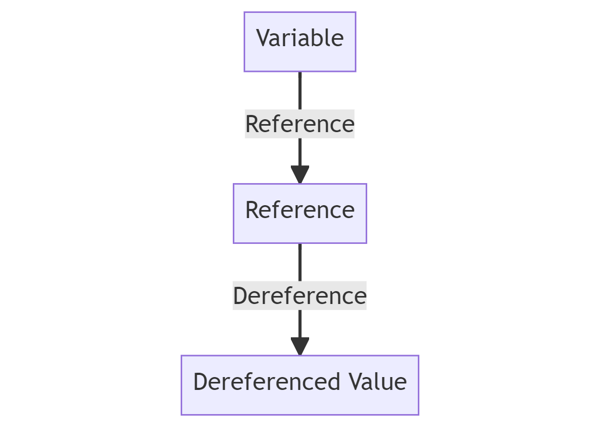
- Creating And Using Scalar References
- Array And Hash References
- Reference To Subroutines
- Manipulating Complex Data Structures
- Circular References And Memory Leaks
- Frequently Asked Questions

Creating And Using Scalar References
🎓
In Perl, a scalar reference is a scalar variable that contains the memory address of another scalar.

- Accessing Data Through Scalar References
- Modifying Data Through Scalar References
- Use Cases For Scalar References

The act of creating a scalar reference involves the use of the backslash (\) operator on an existing scalar.
Consider the following code example:
my $value = 42;
my $ref_to_value = \$value;
👆
Here, $value is a scalar variable containing the number 42, while $ref_to_value is a scalar reference that contains the address of $value.

Accessing Data Through Scalar References
The process of retrieving the original data from a scalar reference is known as dereferencing. Perl uses the $$ operator for this purpose. The $$ operator followed by the reference variable fetches the original data.
my $value = 42;
my $ref_to_value = \$value;
print $$ref_to_value; # prints 42
👆
In this case, $$ref_to_value dereferences the scalar reference and retrieves the original data, which is the number 42.

Modifying Data Through Scalar References
Scalar references can also be used to modify the original data they point to. When the data retrieved from the reference is changed, the original data is altered as well.
my $value = 42;
my $ref_to_value = \$value;
$$ref_to_value = 100;
print $value; # prints 100
👆
After assigning a new value to $$ref_to_value, the value of $value changes to 100. This illustrates how scalar references can be used to modify data.

Use Cases For Scalar References
Scalar references are useful when you want to pass large amounts of data to subroutines without incurring the cost of data copying. By passing a reference, you allow the subroutine to manipulate the original data, which can be more efficient than passing copies of data.
Furthermore, scalar references allow the creation of complex data structures, such as arrays of arrays or hashes of hashes. These structures are crucial when dealing with multi-dimensional data.
🧐
Scalar references provide a flexible tool for manipulating and managing data in Perl, enabling efficient use of memory and creating opportunities for more sophisticated data structures. Through practice and application, the potential of scalar references can be fully exploited to optimize your Perl programming tasks.

Array And Hash References
🎓
Just as you can create references to scalar variables in Perl, you can also generate references to arrays and hashes. This powerful feature allows you to create more complex and dynamic data structures, such as arrays of arrays or hashes of arrays, and so forth.
Creating a reference to an array or a hash is similar to creating a scalar reference. You use the backslash operator (\).
Consider the following example:
my @array = (1, 2, 3);
my $ref_to_array = \@array;
👆
In this code, $ref_to_array is a reference to @array.

Accessing Array And Hash Data Through References
To dereference an array reference and access the array data, Perl provides two primary methods. The first method is to use the @{} operator. The second method is to use the arrow (->) operator for accessing individual elements.
my @array = (1, 2, 3);
my $ref_to_array = \@array;

# Dereferencing the entire array
my @dereferenced_array = @{$ref_to_array};
print "@dereferenced_array\n"; # prints "1 2 3"

# Accessing individual elements
print $ref_to_array->[1]; # prints "2"
For hashes, the process is similar, but uses %{} for dereferencing the entire hash and -> for accessing individual elements.
my %hash = ( apple => 'red', banana => 'yellow' );
my $ref_to_hash = \%hash;

# Dereferencing the entire hash
my %dereferenced_hash = %{$ref_to_hash};
while ( my ($key, $value) = each %dereferenced_hash ) {
print "$key => $value\n";
}

# Accessing individual elements
print $ref_to_hash->{apple}; # prints "red"

Modifying Data Through Array And Hash References
Just like with scalar references, modifying the data retrieved from an array or hash reference also alters the original array or hash.
my @array = (1, 2, 3);
my $ref_to_array = \@array;
$ref_to_array->[1] = 200;
print "@array\n"; # prints "1 200 3"
👆
In this example, modifying the second element of the array through the reference changes the original array.

Benefits Of Array And Hash References
Array and hash references are particularly useful for creating multi-dimensional data structures. For example, an array of arrays or an array of hashes can be easily managed using references.
Moreover, like scalar references, array and hash references allow for efficient passing of large data structures to subroutines. This eliminates the need for data copying, making your programs more memory efficient.
🧐
By understanding and effectively using array and hash references in Perl, you can take full advantage of the language's flexible and dynamic data handling capabilities. This in turn can contribute to writing more efficient and versatile Perl scripts.

Reference To Subroutines
🎓
In Perl, you can create references to subroutines in a manner similar to creating references to scalars, arrays, and hashes. A subroutine reference lets you store and manipulate code in data structures, leading to more dynamic and flexible programs.
- Calling A Subroutine Using Its Reference
- Passing Arguments To A Subroutine Via Its Reference
- Storing Subroutine References In Data Structures
How To Use Perl Subroutine: A Step-By-Step Approach
Get ready to refine your coding skills as we explore the practical application of Perl subroutines. From understanding syntax and structure, creating, and calling, to passing arguments and returning values, this guide will equip you with essential knowledge.
MarketSplashAdrian Petruk

The creation of a subroutine reference involves using the backslash operator (\) on a named subroutine, as shown below:
sub greet {
print "Hello, Perl!\n";
}
my $ref_to_greet = \&greet;
👆
In this code, $ref_to_greet is a reference to the greet subroutine.

Calling A Subroutine Using Its Reference
To call a subroutine via its reference, you can use the -> operator followed by parentheses. Alternatively, you can use the &{$subref} syntax.
$ref_to_greet->(); # calls the subroutine
&{$ref_to_greet}(); # also calls the subroutine
👆
In both cases, the greet subroutine is called, printing "Hello, Perl!" to the console.

Passing Arguments To A Subroutine Via Its Reference
Subroutine references can also be used to pass arguments to the subroutine. The arguments are provided in the parentheses following the -> operator.
sub greet {
my ($name) = @_;
print "Hello, $name!\n";
}
my $ref_to_greet = \&greet;
$ref_to_greet->('OpenAI'); # prints "Hello, OpenAI!"
👆
Here, the string 'OpenAI' is passed as an argument to the greet subroutine via its reference.

Storing Subroutine References In Data Structures
One of the powerful uses of subroutine references is to store them in data structures, such as arrays or hashes.
This allows for dynamic function calls, as shown in the following example:
sub greet {
print "Hello, Perl!\n";
}

sub farewell {
print "Goodbye, Perl!\n";
}

my %actions = ( hello => \&greet, goodbye => \&farewell );
$actions{hello}->(); # prints "Hello, Perl!"
$actions{goodbye}->(); # prints "Goodbye, Perl!"
👆
In this code, references to two different subroutines are stored in a hash. The appropriate subroutine is then called dynamically based on the hash key.
References to subroutines enable a greater degree of flexibility and dynamism in your Perl programs, allowing for advanced coding patterns like dispatch tables, callbacks, and higher-order functions. By understanding this aspect of Perl, you can craft more adaptable and efficient scripts, opening up new possibilities for your code.

Manipulating Complex Data Structures
🎓
Perl's references enable the creation and manipulation of complex data structures like multidimensional arrays and hashes, or a mix of both. Such structures are invaluable when dealing with elaborate datasets or representing intricate relationships.
Let's start with multidimensional arrays, which are essentially arrays of arrays.
Here's a simple example:
my $array_ref = [
[1, 2, 3],
[4, 5, 6],
[7, 8, 9]
];
This code defines a reference to a 3x3 two-dimensional array. To access an element, use the arrow (->) operator:
print $array_ref->[1][2]; # prints "6"

Multidimensional Hashes
Next, multidimensional hashes are hashes whose values are also hashes.
Here's an example:
my $hash_ref = {
'John' => { 'age' => 30, 'city' => 'New York' },
'Jane' => { 'age' => 28, 'city' => 'Chicago' }
};
To access nested hash values, use the -> operator:
print $hash_ref->{'John'}{'age'}; # prints "30"

Complex Structures
References also allow creation of more complex structures, such as arrays of hashes or hashes of arrays. For instance, an array of hashes can represent a list of people with various attributes:
my $people_ref = [
{ 'name' => 'John', 'age' => 30 },
{ 'name' => 'Jane', 'age' => 28 }
];
To access a hash element within the array, you can use the arrow operator:
print $people_ref->[1]{'name'}; # prints "Jane"

Manipulating Complex Data Structures
You can also modify complex data structures through their references. For example, to change Jane's age in the previous array of hashes:
$people_ref->[1]{'age'} = 29;
🧐
Complex data structures powered by Perl's references allow for efficient handling of complicated datasets, significantly enhancing Perl's data manipulation capabilities. The ability to create and manipulate these structures paves the way for better organization and utilization of data in your programs.

Circular References And Memory Leaks
🎓
While references offer powerful capabilities in Perl, one area to be cautious of is circular references, as they can cause memory leaks.
- Understanding Memory Leaks
- Breaking Circular References
A circular reference occurs when two or more references indirectly or directly reference each other, creating a loop.
An example of a circular reference is as follows:
my $foo = {};
my $bar = { 'foo' => $foo };
$foo->{'bar'} = $bar;
👆
In this code, $foo references $bar, and $bar references $foo, creating a circular reference.

Understanding Memory Leaks
Memory leaks happen when a program doesn't release memory that it no longer needs. Despite Perl's garbage collector (which frees up memory from data no longer in use), it may fail to reclaim memory tied up in circular references, as they always appear in use.
For instance, in our previous example, even if you delete $foo and $bar:
undef $foo;
undef $bar;
The memory allocated for $foo and $bar will not be reclaimed, as they still reference each other.

Breaking Circular References
To avoid memory leaks, you need to break the circular references when they are no longer needed. You can do this by setting one of the references in the loop to undef, which will break the loop and allow the garbage collector to reclaim the memory.
$foo->{'bar'} = undef;
Once the circular reference is broken, you can safely undef $foo and $bar, and Perl will reclaim the memory they used:
undef $foo;
undef $bar;
🧐
Managing circular references is crucial in large and complex Perl applications. By properly handling these references, you can maintain optimal memory utilization and prevent memory leaks, ensuring the efficiency and stability of your Perl programs.

Frequently Asked Questions

How do I create a reference in Perl?
You can create a reference by using the backslash operator. For example, to create a scalar reference, you can write: $ref = \$scalar;

How do I dereference in Perl?
To dereference a reference in Perl, you use the appropriate dereferencing operator: ${} for scalar references, @{} for array references, and %{} for hash references.

Can I create references to subroutines in Perl?
Yes, Perl allows creating references to subroutines. It's done by using a backslash before the subroutine name without parentheses.

How do I avoid memory leaks due to circular references?
To avoid memory leaks due to circular references, you should break the circular references when they are no longer needed. This can be done by setting one of the references in the loop to undef.

What are complex data structures in Perl?
Complex data structures in Perl involve using references to create multi-dimensional arrays and hashes. They allow you to store and manipulate data in more complex ways than simple arrays or hashes.
Let’s test your knowledge!
Which Perl Data Type Cannot Be Directly Referenced?
Scalar
array
hash
none

How To Work With Perl Function Parameters
by Adrian Petruk • 10 min read
출처 : https://marketsplash.com/tutorials/perl/perl-function-parameters/
Perl function parameters are the building blocks of modular and reusable code. In this article, we'll delve into the intricacies of how to effectively use and manage these parameters. From basic usage to advanced techniques, get ready to enhance your Perl coding skills.
Function parameters in Perl can sometimes be a source of confusion, especially if you're transitioning from other programming languages. Understanding how to properly use them can make your code more efficient and readable. Let's get right into the details and clarify some common misconceptions.
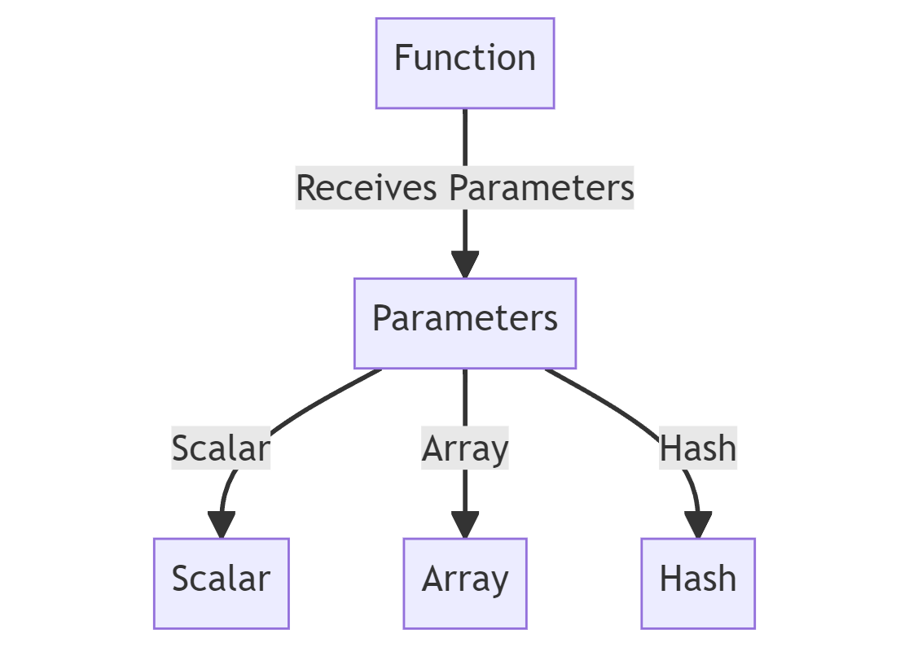
- Understanding Perl Function Parameters
- Defining Functions With Multiple Parameters
- Passing Arrays And Hashes As Parameters
- Using Default Values For Parameters
- Best Practices For Parameter Handling
- Frequently Asked Questions

Understanding Perl Function Parameters
When you're writing functions in Perl, function parameters are a fundamental concept you'll need to grasp. These are the variables or values you pass into a function to influence its behavior.
- The Basics Of @_ Array
- Positional Parameters
- Variable Number Of Arguments
- Named Parameters
- Type And Value Checks

The Basics Of @_ Array
In Perl, all function parameters are stored in a special array called @_. This array holds the values passed to the function.
# Function that prints the first parameter
sub print_first {
print $_[0];
}
📌
In this example, $_[0] refers to the first parameter passed to the function print_first.
The array @_ is zero-indexed, like all arrays in Perl.

Positional Parameters
The most straightforward way to handle parameters is positional parameters. You define them in the order they are passed.
# Function that adds two numbers
sub add {
my ($first, $second) = @_;
return $first + $second;
}
📌
Here, $first and $second are positional parameters.
They capture the first and second values from the @_ array, respectively.

Variable Number Of Arguments
Perl allows functions to accept a variable number of arguments. This is particularly useful for operations like summing an array.
# Function to sum an array
sub sum {
my $total = 0;
$total += $_ for @_;
return $total;
}
📌
In this function, sum calculates the sum of all elements passed to it.
It iterates through each element in @_ to compute the total.

Named Parameters
For more complex functions, named parameters can make your code easier to read and maintain. You can pass a hash or hash reference to achieve this.
# Function with named parameters
sub display_info {
my %args = @_;
print "Name: $args{name}, Age: $args{age}\n";
}
📌
In this example, display_info uses a hash %args to capture named parameters.
This makes the function call more descriptive and self-explanatory.

Type And Value Checks
It's good practice to validate parameter types and values to ensure your function behaves as expected.
# Function with type and value checks
sub divide {
my ($numerator, $denominator) = @_;
die "Denominator cannot be zero" if $denominator == 0;
return $numerator / $denominator;
}
📌
Here, the function divide checks if the denominator is zero before proceeding with the division, thus avoiding a potential error.

Defining Functions With Multiple Parameters
- Defining Functions With Multiple Parameters
- Using Shift To Extract Parameters
- Named Parameters With Hashes

Defining Functions With Multiple Parameters
When working with Perl, you'll often need to define functions that accept multiple parameters. The most straightforward way to do this is by using the special array @_, which holds all the passed arguments.
# Define a function that takes three parameters
sub add_numbers {
my ($a, $b, $c) = @_;
return $a + $b + $c;
}
📌
In this example, the function add_numbers takes three parameters: $a, $b, and $c.
These are extracted from the @_ array using the my keyword.

Using Shift To Extract Parameters
Another approach to extract parameters is by using the shift function. This method is particularly useful when you have a variable number of arguments.
# Define a function using shift to extract parameters
sub add_numbers_shift {
my $a = shift;
my $b = shift;
my $c = shift;
return $a + $b + $c;
}
📌
Here, the shift function removes and returns the first element from @_ for each call.
This allows you to extract parameters one by one.

Named Parameters With Hashes
Sometimes, you may want to use named parameters for better code readability. In Perl, you can achieve this by passing a hash or a hash reference.
# Define a function using named parameters
sub print_info {
my %params = @_;
print "Name: $params{name}, Age: $params{age}\n";
}
📌
In this example, the function print_info takes a hash as its parameter. The keys name and age are used to access the respective values.
This makes the function call more self-explanatory.

Passing Arrays And Hashes As Parameters
In Perl, arrays and hashes can be passed as parameters to functions. This is useful for manipulating multiple data points or key-value pairs within a function. Let's start with arrays.
- Passing Arrays
- Passing Hashes
- Using References For Efficiency

Passing Arrays
To pass an array to a function, you can directly use the array variable. However, inside the function, it's crucial to capture the array properly.
# Function to calculate the sum of an array
sub sum_array {
my @arr = @_;
my $sum = 0;
$sum += $_ for @arr;
return $sum;
}
📌
In this example, the function sum_array takes an array as a parameter.
The array is captured using @_ and stored in @arr.
Perl Array Manipulation: From Basics To Advanced Operations
Perl arrays are central to effective scripting and data management. This article simplifies Perl array manipulation, with concise explanations and practical examples. It’s the right place to boost your Perl array skills.
MarketSplashAdrian Petruk

Passing Hashes
Passing hashes is similar to arrays. You can pass a hash to a function and capture it using the % symbol.
# Function to print key-value pairs of a hash
sub print_hash {
my %hash = @_;
while (my ($key, $value) = each %hash) {
print "$key => $value\n";
}
}
📌
Here, the function print_hash takes a hash as its parameter.
The hash is captured using %hash, and its key-value pairs are printed.
How To Perform Perl Hash Manipulation For Data Handling
Hash manipulation in Perl provides developers with a versatile toolset for managing data. This article breaks down the essentials, from creation to best practices, ensuring a comprehensive grasp of Perl hashes for efficient coding.
MarketSplashAdrian Petruk

Using References For Efficiency
For large arrays and hashes, passing references is more memory-efficient. This avoids copying the entire data structure.
# Function using references
sub sum_array_ref {
my $arr_ref = shift;
my $sum = 0;
$sum += $_ for @$arr_ref;
return $sum;
}
📌
In this example, sum_array_ref takes an array reference ($arr_ref).
We use the @$arr_ref syntax to dereference it within the function.
Perl References: Unlocking The Power Of Data Structures
Navigating Perl references can be tricky, but it’s a key skill to enhance your coding prowess. Our article untangles the topic, exploring everything from the basics to more complex data structures and handling circular references.
MarketSplashAdrian Petruk

Using Default Values For Parameters
Setting default values for function parameters can make your Perl code more flexible and user-friendly. It allows functions to operate even when some arguments are missing.
- Basic Default Values
- Conditional Defaults
- Using Hashes For Named Parameters With Defaults
- Optional And Mandatory Parameters

Basic Default Values
You can set default values for parameters using the // operator. This sets a value only if the parameter is undefined.
# Function with default values for parameters
sub greet {
my ($name, $age) = @_;
$name //= 'Guest';
$age //= 25;
print "Hello, $name. You are $age years old.\n";
}
📌
In this example, the function greet has default values for both $name and $age.
If these parameters are not provided, the defaults are used.

Conditional Defaults
Sometimes, you may want to set conditional defaults based on other parameters. You can do this using simple if statements.
# Function with conditional default values
sub calculate {
my ($a, $b, $operation) = @_;
$operation //= 'add';
return $a + $b if $operation eq 'add';
return $a - $b if $operation eq 'subtract';
}
📌
Here, the function calculate performs an operation based on the $operation parameter.
If $operation is not provided, it defaults to 'add'.

Using Hashes For Named Parameters With Defaults
For more complex functions, using named parameters with default values can improve readability and flexibility.
# Function using named parameters with default values
sub display_info {
my %params = @_;
$params{name} //= 'John';
$params{age} //= 30;
print "Name: $params{name}, Age: $params{age}\n";
}
📌
In this function, display_info takes a hash of named parameters.
Default values for name and age are set using the // operator.

Optional And Mandatory Parameters
When you have both optional and mandatory parameters, it's crucial to validate the inputs to ensure the function behaves as expected.
# Function with both optional and mandatory parameters
sub process {
my ($mandatory, %optional) = @_;
die "Mandatory parameter missing" unless defined $mandatory;
$optional{setting} //= 'default';
# Function body here
}
📌
In this example, the function process has one mandatory parameter ($mandatory) and an optional hash (%optional).
The function checks for the presence of the mandatory parameter and sets a default for an optional one.
💡
Case Study: Implementing a Simple Calculator Using Perl Function Parameters
We needed to create a simple calculator in Perl that could perform basic operations like addition, subtraction, multiplication, and division. The calculator should be flexible enough to handle different numbers of arguments for addition and multiplication.
🚩
The Solution
To tackle this, we used Perl's ability to handle multiple function parameters and set default values.
We defined four functions: add, subtract, multiply, and divide.
# Function for addition
sub add {
my $sum = 0;
$sum += $_ for @_;
return $sum;
}

# Function for subtraction
sub subtract {
my ($a, $b) = @_;
return $a - $b;
}

# Function for multiplication
sub multiply {
my $product = 1;
$product *= $_ for @_;
return $product;
}

# Function for division
sub divide {
my ($a, $b) = @_;
die "Cannot divide by zero" if $b == 0;
return $a / $b;
}
📌
For the add and multiply functions, we used Perl's special array @_ to capture all arguments passed to the function.
This allowed us to add or multiply more than two numbers.
😎
The Outcome
The calculator functions were flexible and robust. They could handle multiple arguments for addition and multiplication, and they included checks for division by zero.
By effectively using Perl function parameters, we were able to create a simple yet powerful calculator with minimal code.

Best Practices For Parameter Handling
When it comes to parameter handling in Perl, a few best practices can make your code more maintainable and less error-prone. Let's go through some of these.
- Validate Parameter Types
- Limit Number Of Parameters
- Use Named Parameters For Clarity
- Avoid Global Variables
- Check For Undefined Values

Validate Parameter Types
It's crucial to validate the types of parameters passed to a function. This ensures that the function behaves as expected.
# Function to validate parameter types
sub multiply {
my ($a, $b) = @_;
die "Both parameters should be numbers" unless looks_like_number($a) && looks_like_number($b);
return $a * $b;
}
📌
In this example, the function multiply uses the looks_like_number function from the Scalar::Util module to validate that both $a and $b are numbers.

Limit Number Of Parameters
Keeping the number of parameters to a minimum makes a function easier to understand and use. If a function requires many parameters, consider passing a hash or an object.
# Function using a hash to limit the number of parameters
sub create_user {
my %params = @_;
# Function body here
}
📌
Here, the function create_user takes a hash of parameters, making it easier to manage multiple inputs.

Use Named Parameters For Clarity
Using named parameters can make your code more readable and self-explanatory, especially for functions with multiple optional parameters.
# Function using named parameters for clarity
sub draw_shape {
my %params = @_;
my $shape = $params{shape} // 'circle';
my $color = $params{color} // 'red';
# Function body here
}
📌
In this example, the function draw_shape uses named parameters with default values, making the function call more understandable.

Avoid Global Variables
It's a good practice to avoid global variables as parameters. Always pass what the function needs as parameters.
# Avoiding global variables
my $global_var = 10;

sub bad_example {
print $global_var; # Avoid this
}

sub good_example {
my ($param) = @_;
print $param; # Better
}
📌
In the bad_example, the function relies on a global variable, which is not a good practice.
The good_example function takes what it needs as a parameter.

Check For Undefined Values
Always check for undefined values to avoid unexpected behavior or errors in your code.
# Function to check for undefined values
sub safe_divide {
my ($a, $b) = @_;
return "Cannot divide by zero" if $b == 0;
return $a / $b;
}
📌
In this function, safe_divide checks if the divisor $b is zero before performing the division, thus avoiding a runtime error.

Frequently Asked Questions

How Do I Pass Multiple Parameters to a Perl Function?
You can pass multiple parameters to a Perl function simply by separating them with commas when calling the function. Inside the function, these parameters will be stored in the @_ array, and you can access them using array indexing or by assigning them to variables.

Can I Pass Arrays and Hashes as Parameters?
Yes, you can pass arrays and hashes to Perl functions. However, they will be flattened into the @_ array, so you'll need to carefully capture them inside the function. Alternatively, you can pass references to arrays or hashes for more efficient memory usage.

Is There a Limit to the Number of Parameters a Function Can Have?
Perl doesn't impose a strict limit on the number of parameters a function can have. However, for readability and maintainability, it's generally a good idea to keep the number of parameters reasonable.

Can I Mix Positional and Named Parameters?
Yes, you can mix positional and named parameters, but you'll need to be careful when capturing them inside the function. Typically, positional parameters are captured first, followed by a hash or hash reference for the named parameters.

How Do I Validate Parameter Types?
You can use various methods to validate parameter types, such as using the ref function to check for references or using modules like Scalar::Util for more advanced type checks.
Let’s test your knowledge!

Which array in Perl holds all the parameters passed to a function?
А: %_
B: $_
C: @_
D: @

Use of Perl Data::Dumper
출처 : https://linuxhint.com/use-perl-data-dumper/
3 months ago
by Fahmida Yesmin
The Dumper is a function of the Perl data module that is used to convert any type of the Perl data variable and print the content in the Perl format. Any Perl scalar variable or array variable or hash variable can be passed as the argument of the Dumper function and stores the output in the $VARn variable where the value of the “n” depends on the number of reference variables. The output of the Dumper function can be used as the argument of the eval() function. The Data:Dumper module is required to be included in the script to use the Dumper function.

Different Uses of the Perl Data::Dumper
The uses of the Dumper function to print the scalar variables, array variables, hash variables, and file content are shown in this part of the tutorial.

Example 1: Using the Data::Dumper for Scalar Variables
Create a Perl file with the following script that prints the values of the “string” variable and the “number” variable using the Dumper function:
#!/usr/bin/perl
use strict;
use warnings;
use 5.34.0;
use Data::Dumper;
#Declare a string variable
my $name = "Md. Ali";
#Declare a number variable
my $age = 35;
#Print the scalar variables
print Dumper $name."\n";
print Dumper $age."\n";
Output:
The following output appears after executing the script. The string value of “Md. Ali” and the number of “35” are printed by the $VAR1 variable of the Dumper function. The number value is printed as a string value in the output:

Example 2: Using the Data::Dumper for the Array Variable
Create a Perl file with the following script that prints the values of an array of numbers and an array of strings using the Dumper function. An array of five numbers and an array of four string values have been define in the script. The values of these arrays have been printed later.
#!/usr/bin/perl
use strict;
use warnings;
use 5.34.0;
use Data::Dumper;
#Declare an array of numbers
my @arrnum = (67, 23, 90, 12, 87);
#Declare an array of string
my @arrstr = ('Learn', 'Perl', 'Programming', 'Basic');
#Print the array variables
print "The output for an array of numbers:\n".Dumper \@arrnum;
print "The output for an array of strings:\n".Dumper \@arrstr;
Output:
The following output appears after executing the script. According to the output, the values of the array of numbers are printed as number values, and the values of the array of strings are printed as string values:

Example 3: Using the Data::Dumper for the Hash Variable
Create a Perl file with the following script that prints the values of a hash variable using the Dumper function. A hash variable of four key-value pairs is declared in the script. The keys and values of this hash variable are printed later:
#!/usr/bin/perl
use strict;
use warnings;
use 5.34.0;
use Data::Dumper;
#Declare a hash variable
my %hashvar = ('HDD' => 6000, 'Monitor' => 7000, 'Mouse' => 1000, 'Printer' => 4000);
#Print the hash variable
print Dumper \%hashvar;
Output:
The following output appears after executing the script. According to the output, four key-value pairs of the hash variable are printed by the $VAR1 Dumper variable:

Example 4: Using the Data::Dumper to Read the File
Create a text file named “test.txt” with some content to check the script of this example. Here, the following content is added to the “test.txt” file:
test.txt
This file is created for testing purposes.
Create a Perl file with the following script that opens the “test.txt” file for reading, read the first line of the file into a variable, and print the variable using the Dumper function. Here, the “<” operator is used to open the file for reading. The first line of the file is read using the file handler named “f_handler” and stored into the $data variable. The content of this variable is printed by the Dumper function.
#!/usr/bin/perl
use strict;
use warnings;
use 5.34.0;
use Data::Dumper;
#Open a file for reading
open(f_handler, "< test.txt") or die "Unable to open the file.\n";
#Read the first line of the file
my $data = <f_handler>;
#Print the first line using Dumper
print Dumper $data;
#Close the file handler
close f_handler;
Output:
The following output appears after executing the script. According to the output, the first line of the “test.txt” file is printed as a string value using the $VAR1 variable:

Conclusion
Some basic uses of the Dumper function are shown in the examples of this tutorial. The Perl Data::Dumper has many functionalities that can be used for various purposes which are not explained in this short tutorial. The Perl users will be able to print all the values of different types of Perl variables and it is helpful for debugging purposes.

inode에 대해
출처 : https://velog.io/@redgem92/%EC%9A%B4%EC%98%81%EC%B2%B4%EC%A0%9C-%ED%8C%8C%EC%9D%BC-%EC%8B%9C%EC%8A%A4%ED%85%9C-inode-%EB%B0%A9%EC%8B%9D%EC%97%90-%EB%8C%80%ED%95%98%EC%97%AC
운영체제에서 사용하는 파일 시스템 중 하나에요. Inode의 기본 구조는 파일 시스템을 대표하는 수퍼 블록, 그 파일의 상세 정보, 일종의 PCB인 아이노드 블록 그리고 실제 데이터를 담은 데이터 블록이 있어요(파일 시스템에서의 블록은 하나의 단위에요. 이 블록의 크기는 1~4KB정도에요. 따라서 하나의 파일엔 다수의 데이터 블록이 있어요).

inode와 파일의 관계
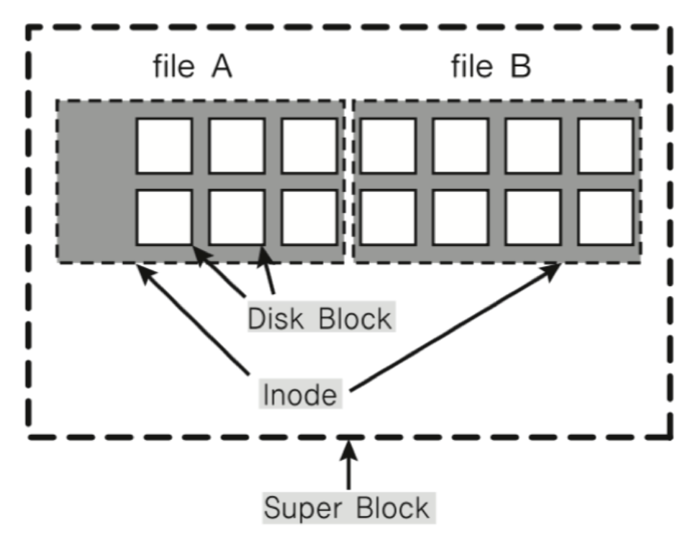
위 그림은 언급한 블록의 관계도에요.
파일은 inode 고유 값과 자료구조에 의해 주요 정보를 관리해요. 컴퓨터를 사용하는 사람은 파일 이름으로만 인식하지만, 실제 컴퓨터는 파일이름:inode로 파일과 inode 번호를 매칭시켜 인식해요.
파일 처리
1. 파일이 생성되자마자 inode 번호가 부여되요.
2. inode 블록이 생성되어 상세 정보Meta-data가 기입되요.
3. 이를 기반으로 파일을 접근해요.

inode 구조
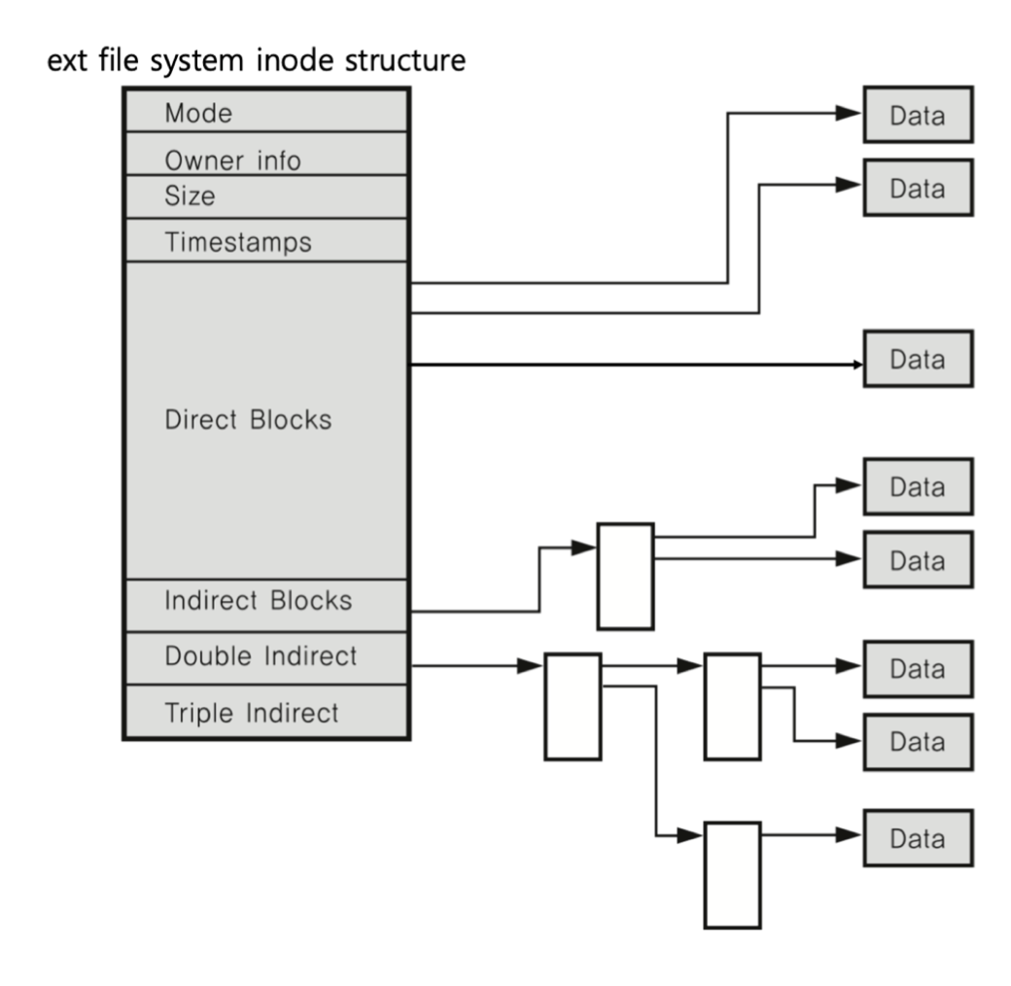
가져온 그림은 리눅스에서 사용하는 파일 시스템인 ext에 대한 구조에요. inode 메타 데이터에는 파일 권한, 소유자 정보, 파일 사이즈, 생성 시간 등 시간 정보 및 데이터 저장 위치 등을 담고 있어요.
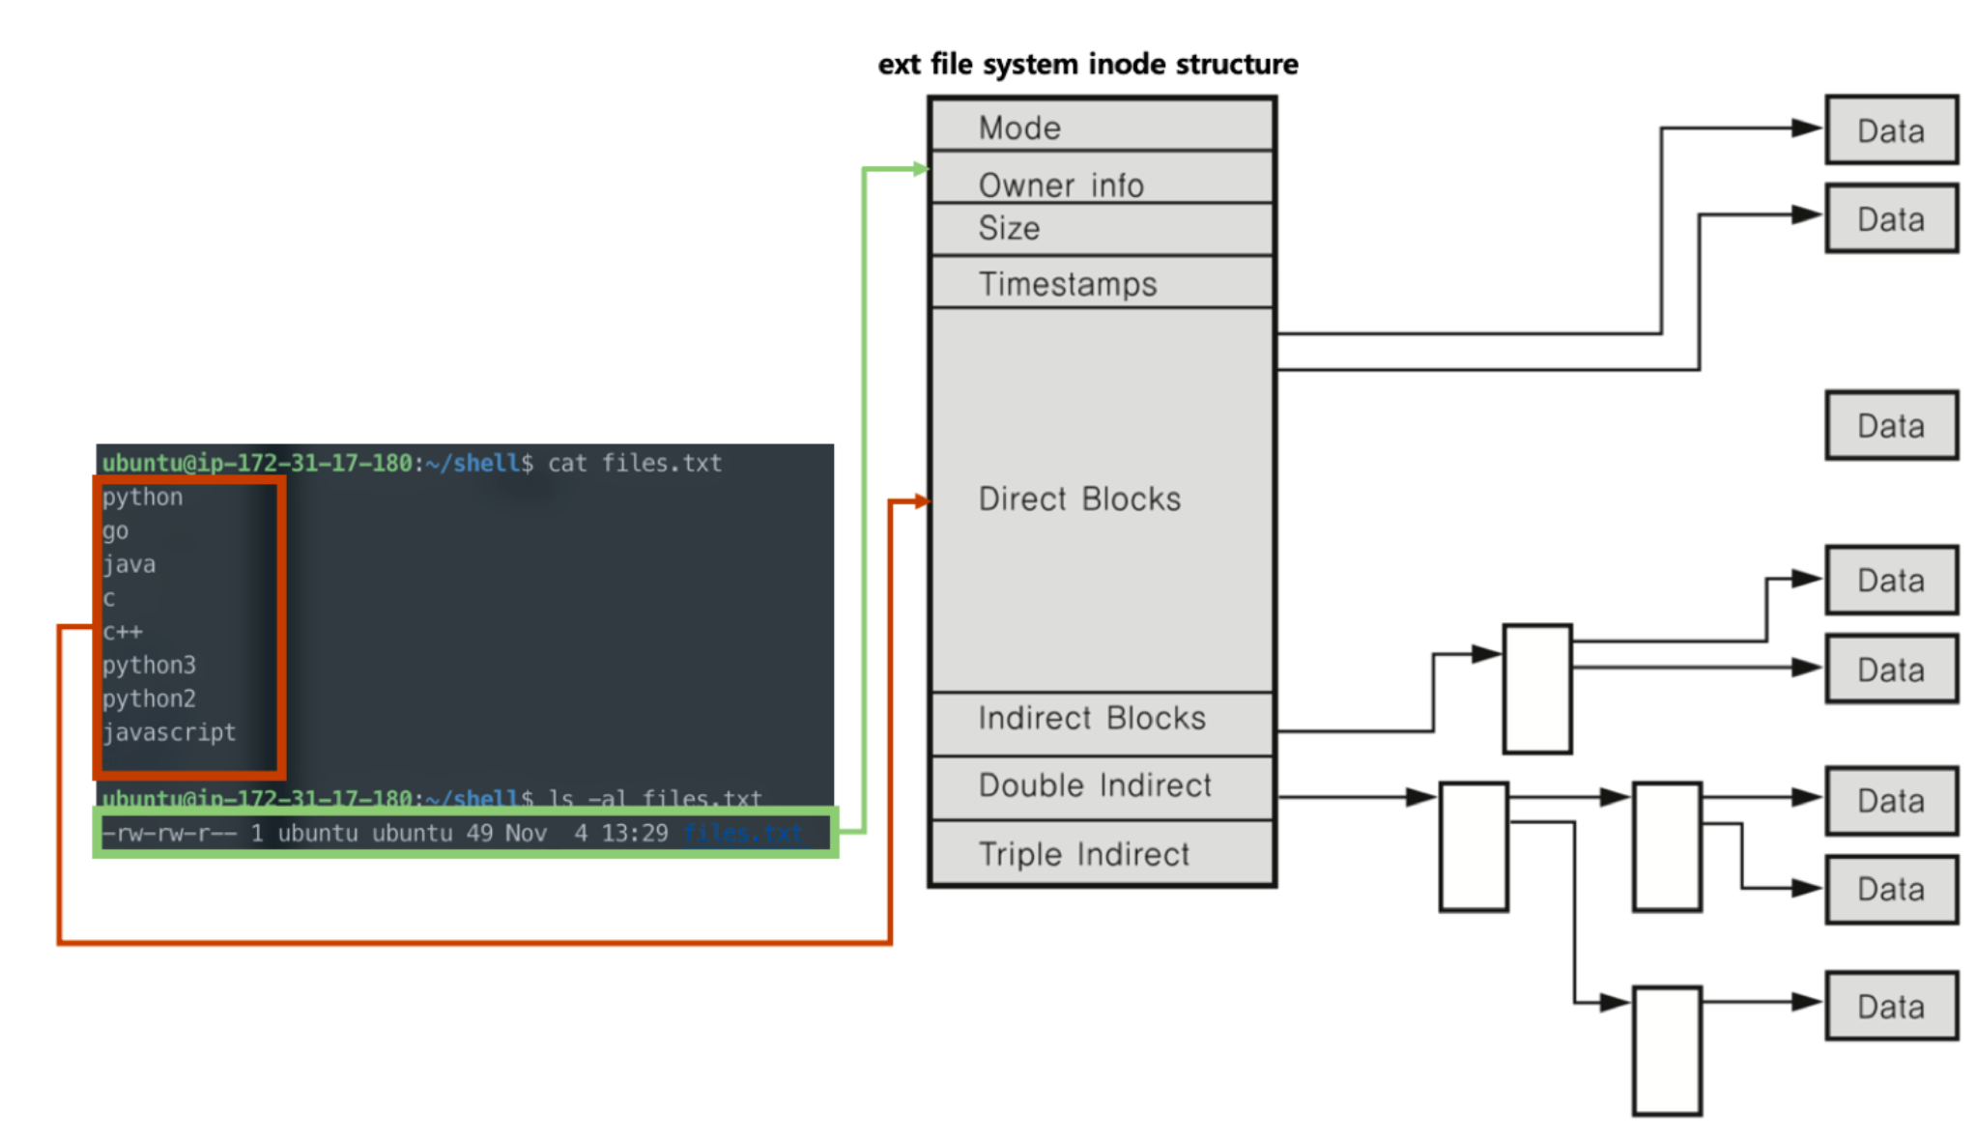
예시로 설명드리자면, cat 명령어는 대상 파일의 내용을 출력해요. 이에 대한 메커니즘은,
- inode 블록에 접근해서 파일의 정보를 읽어요.
- 이후 Direct Block에 접근해서 내부 데이터를 읽어와요.
이 Direct Block은 12개의 주소만 저장해요. 블록의 크기는 최대 4KB니까 파일의 공간은 48KB 밖에 되지 않아요. 하지만 우리가 사용하는 모든 프로그램이나 파일은 이 크기를 아득히 뛰어넘죠. 이 구조에서 어떻게 파일을 관리하면 될까요?

inode 구조와 파일 데이터
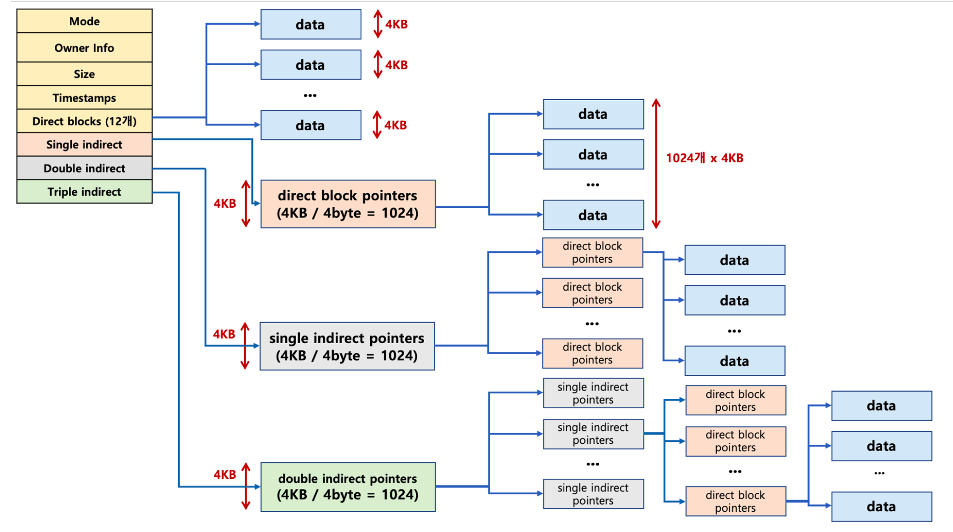
파일의 용량이 클수록 데이터 정보를 담는 Direct Block의 크기를 늘리면 비효율적이에요. 그래서 이를 Single Indirect, Double Indirect, Triple Indirect로 처리해요.
각 Indirect는 4KB의 블록인데, 여기 안에 데이터를 직접 처리하는게 아니라 특정 블록을 접근할 수 있게 주소를 담고 있어요.
Single Indirect의 경우 4KB / 4byte = 1024개의 데이터 주소를 담아요. 그리고 Double Indirect는 Single Indirect의 주소를 1024개를 담고 있어요. 계산하면 1024 x 1024 x 4KB = 4GB정도의 데이터를 접근할 수 있어요. 마지막으로 Triple Indirect는 Double Indirect의 주소를 1024개 담고 있어요. 이러한 구조를 통해 파일은 비교적 적은 블록을 가지고 있어도 대량의 데이터를 관리할 수 있게 되는거에요.
inode에 대한 내용은 여기까지에요.

[Linux] ext 파일 시스템과 inode - Linux File System Hierarchy
출처 : https://heeya-stupidbutstudying.tistory.com/entry/Linux-ext-%ED%8C%8C%EC%9D%BC-%EC%8B%9C%EC%8A%A4%ED%85%9C%EA%B3%BC-inode-Linux-File-System-Hierarchy
heeee__ya 2022. 8. 2.

리눅스든 윈도우든 저장 장치 안의 데이터에 접근할 때 일반적으로 직접 저장 장치에 접근하지 않고 파일 시스템을 통해 접근한다. 이게 무슨 뜻일까? 파일 시스템이 없다고 가정하면, 메모리에 있는 데이터를 저장 장치에 저장할 때 데이터를 보관한 주소와 사이즈를 스스로 기억하지 않으면 안된다. 이렇게 되면 사용자에게 매우 성가신 일이 아닐 수 없다.
파일 시스템은 사용자에게 의미가 있는 하나의 데이터를 이름, 위치, 사이즈 등의 보조 정보를 추가하여 파일(file)이라는 단위로 관리한다. 그리고 어느 장소에 어떤 파일을 배치할지 등의 데이터 구조는 사양으로 미리 정해, 커널 안에서 이 파일 시스템을 다룬다. 이러한 프로세스 덕분에 사용자는 파일의 위치나 사이즈 등 복잡한 정보를 기억하지 않고 파일의 이름만으로도 저장 장치에 읽거나 쓸 수 있다.
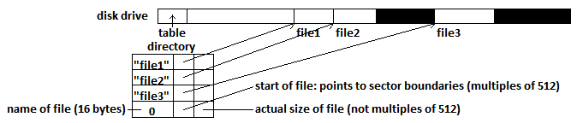
가령 사용자가 파일을 읽고 싶다면, 파일 읽기 시스템 콜을 날려 파일 이름과 파일 상의 오프셋 및 사이즈를 지정해 파일 시스템을 다루는 처리가 해당 데이터를 찾아 사용자에게 전달해줄 수 있다.
- 데이터(data): 사용자가 작성한 문서나 사진, 프로그램 등의 내용
- 메타 데이터(meta data): 파일의 이름이나 저장 장치 내의 위치, 사이즈 등의 보조 정보

1. Linux Directory Structure
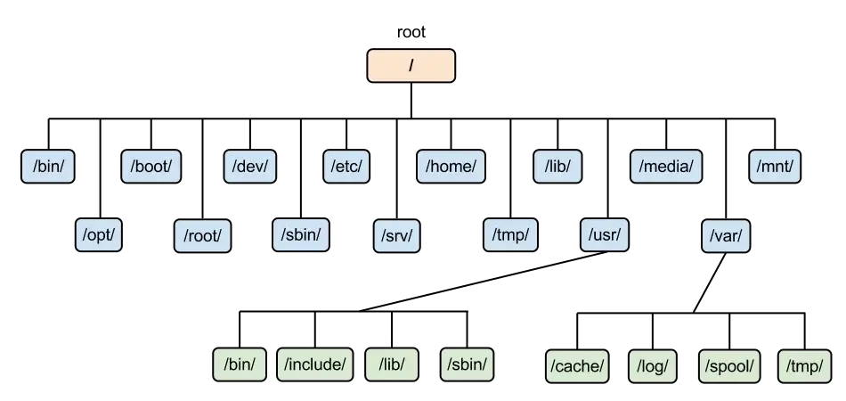
파일을 카테고리별로 정리할 수 있도록 리눅스의 파일 시스템(윈도우도 마찬가지)에는 파일을 보관하는 특수한 파일인 디렉터리(directory)가 존재한다. 디렉터리 트리(directory tree)란 루트 디렉터리 아래에 파일 및 하위 디렉터리가 존재하는 계층 구조를 이른다. 반면, 차이점으로는 물리 디스크가 몇 개든 리눅스에서는 언제나 시스템 전체에 단 하나의 트리만 가지게 된다는 점이다(윈도우에서는 디스크가 2개면 디렉터리 트리도 2개이다. 그래서 C:\, D:\ 처럼 저장 장치별로 별도의 트리 구조를 갖게 됨).

1-1. FHS (Filesystem Hierarchy Standard)
FHS는 리눅스의 파일 시스템 계층을 정의하는 표준 사양이다. /usr 및 /bin과 같은 최상위 하위 디렉터리에 대한 최소 요구 사항과, 해당 디렉터리에 위치해야 하는 파일과 symbolic link를 지정한다. FHS 호환 운영 체제에서 모든 파일과 디렉터리는 루트(단일 슬래시 '/')라는 최상위 디렉터리에 라우팅된다. 참고로 대부분의 리눅스 배포판은 FHS를 따르지만 현재 대부분의 배포판은 제안한 표준을 완전히 따르지는 않는다고 한다(가령 NixOS는 고유한 계층 구조를 사용해 Nix 패키지 관리자의 파일 시스템에 리눅스를 설치한다고 한다)
2015년에 업데이트된 가장 최신 버전인 FHS 3.0은 여기를 참고:
https://refspecs.linuxfoundation.org/FHS_3.0/fhs/index.html

1. 주요 디렉터리

/bin | 일반 사용자 및 관리자가 사용하는 주 명령어의 실행 파일이 배치되어 있음 (e.g. cat, ls, cp)
/dev | 디바이스 파일이 배치되어 있음  (디바이스 파일 - 디스크나 키보드 등 하드웨어를 다루기 위한 특수 파일)
/etc | 리눅스와 애플리케이션 설정 파일이 배치되어 있음
/home | 사용자별로 할당되는 홈 디렉터리  사용자의 이름이 hee라면 해당 사용자의 홈 디렉터리는 /home/hee가 된다.
/sbin | /bin과 비슷하게 실행 파일을 포함 + 관리자용 명령어 (e.g. init, shutdown)
/tmp | 임시 파일용 디렉터리.  참고로 이 디렉터리 안의 파일을 삭제하도록 설정된 배포판도 있으므로 중요한 파일을 /tmp에 보관하면 안된다.
/usr | 읽기 전용 사용자 데이터 및 설치한 애플리케이션의 실행 파일, 문서, 라이브러리 등이 위치.  루트와 비슷한 보조 계층 구조를 갖고 있다.  - /usr/bin : 모든 사용자의 비 필수 명령어 실행 파일  - /usr/sbin : 비 필수 시스템 실행 파일  - /usr/etc : 비 필수 유틸리티와 파일
/var | 변화하는 데이터를 저장하기 위한 디렉터리.  애플리케이션 실행 중에 만들어진 데이터나 로그 등이 이곳에 저장된다.

2. 기타

/boot | 부팅 과정에서 필요한 실행 파일들을 포함.
/lib | 부팅과 시스템 운영에 필요한 공유 라이브러리(shared library)와 커널 모듈(kernel module) 위치.
/media | 이동식 미디어의 마운트 지점.
/mnt | (루트 파일 시스템에 연결된) 임시 마운트 포인트 디렉터리.
/opt | Add-on(선택 가능한) 애플리케이션 소프트웨어 패키지가 설치됨.
/proc | 시스템에서 운영되고 있는 다양한 프로세서와 프로그램 정보를 포함.  /proc은 커널이 메모리 상에 만들어 놓은 것으로, 디스크에는 존재하지 않는다.
/root | 루트 사용자 홈 디렉터리.
/srv | 시스템에서 제공하는 사이트별 데이터 위치.

2. Linux File System

2-1. inode
리눅스의 디폴트 파일 시스템인 ext 계열 파일 시스템에 대해 알아보기 전에 inode 구조를 설명할 필요가 있다. inode는 Unix 스타일의 파일 시스템에서 파일이나 디렉터리와 같은 파일 시스템 개체를 표현하는 자료구조이다. disk block들에 대한 위치 정보들을 기록한 index block을 따로 사용하는 인덱스 블록 기법(indexed allocation)과 유사하다. inode 구조에서는 inode block이라는 것을 생성해 파일들에 대한 inode를 관리한다.
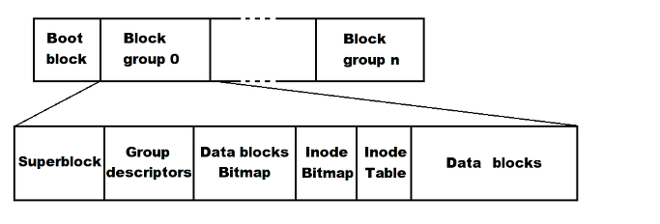
모든 파일이나 디렉터리는 반드시 inode를 하나씩 가지게 된다. inode에는 파일의 정보(접근 권한, 소유주, 크기, inode 번호 등)가 저장되는데, 간단히 말하면 해당 파일의 메타 데이터를 가지고 있다고 볼 수 있다. 사용자는 외부적으로 파일 이름만 아는 상태로 파일을 읽고 쓰지만, 내부적으로는 inode 정보를 참조해서 처리된다. 위의 ext2 inode 구조 그림을 바탕으로 포함되는 속성은 다음과 같다:
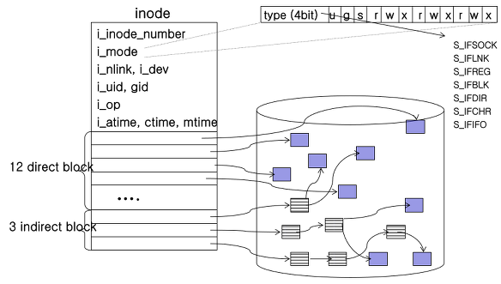

- i_inode_number : 파일이 생성되자마자 부여되는 inode 번호
- i_mode : 해당 inode가 관리하는 파일의 속성 및 접근 제어 정보
- i_nlink : 해당 inode를 가리키고 있는 파일 수(혹은 링크 수)
- i_uid : 파일을 생성한 소유자의 user ID
- i_gid : 파일을 생성한 소유자의 group ID
- i_op: 해당 inode의 함수 오퍼레이션 주소
- i_atime, i_ctime, i_mtime : 파일의 접근시간, 생성시간, 수정시간

i_mode - File mode
16bit로 구성된 i_mode 변수는 리눅스의 file permission management와도 연관이 깊다.
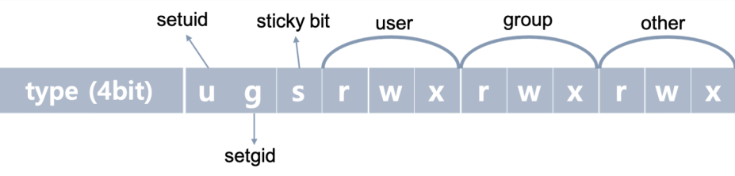
- 상위 4bit : 파일의 유형 (S_IFREG(-)-정규파일, S_IFDIR(d)-디렉터리, S_IFLNK(l)-링크파일 등)
- u : setuid(set user id) bit; 파일이 수행될 때 (일시적으로) 파일을 생성한 사용자의 권한으로 동작할 수 있게 함
- g : setgid(set group id) bit; 파일이 수행될 때 (일시적으로) 파일 소유 그룹의 멤버로의 권한으로 동작할 수 있게 함
- s : sticky bit; 해당 bit가 설정된 디렉터리에는 누구든 파일을 저장할 수 있으나, 파일 삭제는 해당 파일 소유자만 가능하도록 함
- 하위 9bit : 파일의 접근 제어에 사용(순서대로 읽기(r)-쓰기(w)-실행(x))

i_block[15] field
inode 하단부에는 i_block[15] 필드가 존재하는데, 이것은 파일에 속한 disk block들의 위치를 관리하기 위해 사용된다. i_block[15]은 총 15개의 엔트리가 존재하며, 12개는 직접 블록(direct block)이고 3개는 간접 블록(indirect block)이다.
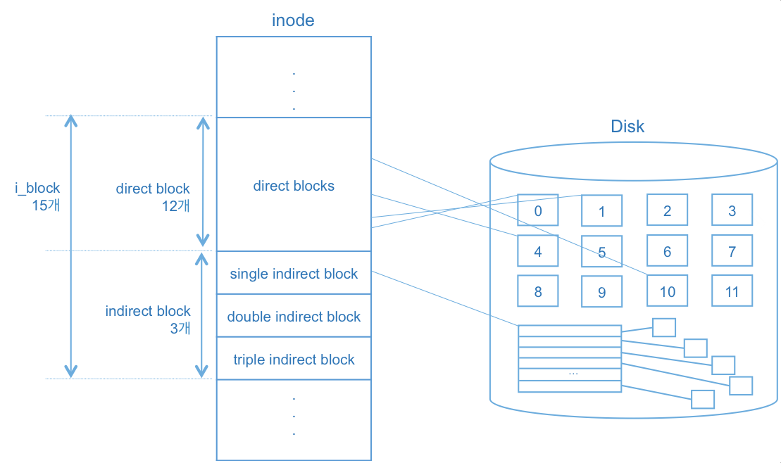
- 직접 블록(direct block): 실제 파일의 내용을 담고 있는 디스크의 data block을 가리키는 포인터 변수
- 간접 블록(indirect block): disk block을 가리키는 포인터들을 갖는 블록인 index block을 가리키는 포인터 변수
  - single indirect block - 하나의 index block을 가짐
  - double indirect block은 2중의, triple indirect block은 삼중의 index block을 가짐
위의 그림에서 각 data block의 크기가 4KB라고 가정하면, direct block으로 지원할 수 있는 파일의 크기는 4KB x 12 = 48KB이다. 반면 single indirect block의 경우 하나의 index block을 갖는데, 이 index block도 결국 disk block에 존재하므로 4KB의 크기를 가진다. 그리고 각각의 포인터를 위해 4byte를 할당하게 되면 4KB % 4byte = 1024개의 포인터가 존재하게 된다. 즉, single indirect block으로 지원할 수 있는 파일의 크기는 48KB + 4MB + 4GB + 4TB가 된다. 같은 방식으로 계산하면 triple indirect block은 4TB만큼을 지원할 수 있다.
이와 같이 계산하면 이론상 리눅스의 inode 구조가 지원할 수 있는 파일의 최대 크기는 48KB + 4MB + 4GB + 4TB가 된다. 반대로 파일의 크기가 48KB 미만인 경우 별도의 index block을 디스크에서 읽어올 필요가 없기도 하다. inode가 매우 깔끔하고 효율적으로 설계되어 있는 자료구조임을 알 수 있다.

※ 참고
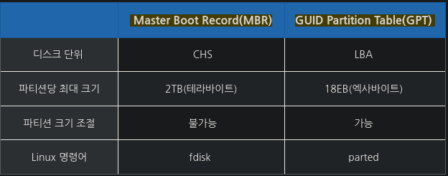
당연하지만 실제 리눅스가 저 정도의 파일 사이즈를 지원해주지는 않는다(...) 리눅스 커널 내부의 파일 관련 함수들이 사용하는 변수나 인자들이 32bit로 구현되어 있기 때문에 4GB의 제한을 갖는다고 한다.
GPT 방식으로 설치하면 4TB 이상도 사용가능하다.

2-2. ext 계열 파일 시스템 (extended file system)

ext2
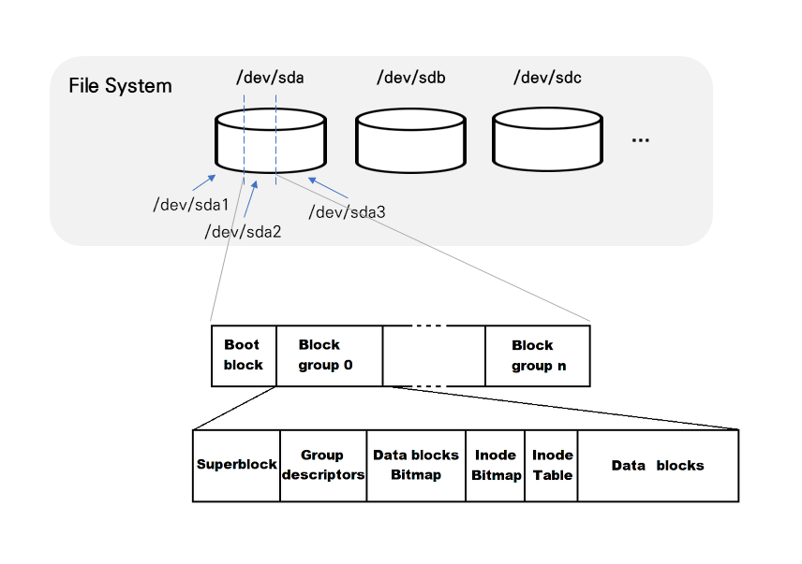
ext2 파일 시스템을 기반으로 향상된 버전이 ext3, ext4이기 때문에 ext2의 세부 구조에 대해 알아두면 나머지도 이해하기 쉽다(여기에 덧붙여서 저널링만 이해하면 됨). 위 그림은 CSI방식의 디스크가 장착된 시스템 구조를 나타낸 것이다. 이는 /dev 디렉터리에 들어가보면 확인할 수 있다.
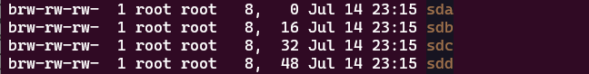
SCSI방식의 디스크는 "sd"라는 이름으로 접근이 되고, 첫번째 디스크부터 순서대로 sda, sdb, sdc, … 식으로 이름이 붙는다.
디스크가 시스템에 장착되면, 하나의 물리 저장장치인 디스크를 여러 디스크 공간인 파티션(partition)으로 분할할 수 있다. 공간을 물리적으로 나누게 되면 프라이머리(primary)라고 부르고, 논리적으로 나누게 되면 익스텐디드(extended)라고 부른다. 그림은 하나의 sd 디스크를 3개의 파티션인 sda1, sda2, sda3로 나눈 것이다.
파일 시스템은 각각의 파티션 마다 하나씩 만들어진다. 하나의 파티션에 ext2 파일 시스템을 만들면, 해당 파티션은 여러 개의 block group으로 나뉜다. 부팅에 필요한 정보를 담고 있는 부트스트랩 코드가 존재하는 부트 블록(boot block)은 부팅 시 필요한 부분이기 때문에, 어떤 파일 시스템에서라도 가장 먼저 등장하는 block이다. 기타 block group들은 다시 6가지 부분으로 구분된다:

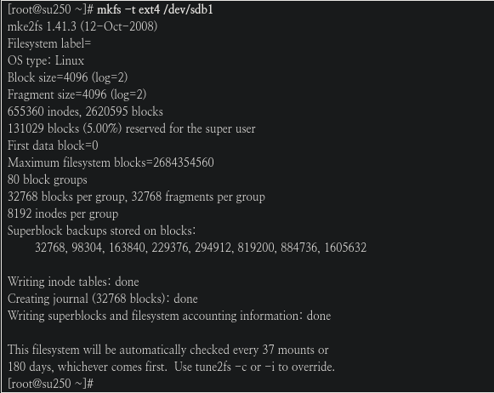
실제로 mkfs 사용시에 inode와 기타 data들이 생성된다.
(출처: https://www.linux.co.kr/bbs/board.php?bo_table=lecture&wr_id=3737 )
2024.1.05. 10:33 현재 내 PC의 filesystem block sizes. 단위 : byte
모든 파일 시스템들은 파일을 저장하기 위해 파티션들을 block들로 쪼개어 사용한다.
따라서 6byte 크기의 파일이라도 4096-byte-block으로 저장된다.
또한 mkfs -t ext4 -b 1024 /dev/sdb1 식의 명령으로 blocksize를 조정할 수 있다.
mkfs -t ext -i 4096 : -i 옵션을 사용하면 inode가 사용하는 byte 크기를 지정할 수도 있다.
inode byte 크기를 줄일 수록 inode 갯수를 2배,4배로 만들 수 있지만, 갯수를 늘릴수록 가용 disk
공간이 줄어들기 때문에 적당히 조절해야 한다.
➜ stat -f .
파일: "."
ID: 80300000000 이름 길이: 255 형식: f2fs
블록 크기: 4096 기본 블록 크기: 4096
블록: 전체: 87293440 여유: 73388718 가용: 73388718
아이노드: 전체: 12346877 여유: 11681988

➜ stat -f /
파일: "/"
ID: 80200000000 이름 길이: 255 형식: f2fs
블록 크기: 4096 기본 블록 크기: 4096
블록: 전체: 26213888 여유: 19710468 가용: 19710468
아이노드: 전체: 13511677 여유: 13137511

- 슈퍼 블록(super block) : 전체 공간의 5%
- 파일 시스템의 전체 크기나 마운트 정보, data block의 개수 등 파일 시스템과 관련된 중요한 정보들을 담고 있음
- 리눅스는 super block의 정보를 사용해 파일 시스템을 관리함
- 다른 block group에 있는 super block도 똑같은 내용을 갖고 있음(사본)
- 그룹 디스크립터(group descriptor; GDT)
- 해당 파일 시스템 내의 모든 block group들의 정보를 기록
- super block과 마찬가지로, 다른 block group에 있는 GDT도 똑같은 내용을 갖고 있는 사본임
- group 내의 free block 개수, inode 개수 및 디렉토리 개수 등이 저장되어 있음
- 데이터 블록 비트맵(data block bitmap)
- data block 내에서의 빈 공간을 관리하기 위해 비트맵을 사용한 것
- block의 할당 상태를 나타내며, block을 할당하거나 해제할 때 사용됨
- inode 비트맵(inode bitmap)
- inode 테이블 내에서의 빈 공간을 관리하기 위해 비트맵을 사용한 것
- (data block bitmap과 비슷하게) inode를 할당하거나 해제할 때 사용됨
- inode 테이블 : 전체 공간(파티션)의 1%
- 접근권한, 소유주, inode 번호 등 파일에 대한 정보를 저장하고 있는 부분
-파일 하나 당 하나의 inode가 사용되는데, 이렇게 생성된 모든 inode 번호들이 inode 테이블에 포함되어 있음(파일 시스템이 생성될 때 함께 생성됨)
- 데이터 블록(data block)
- 실제 데이터의 내용이 저장되는 디스크 영역
참고로 df -ih 명령어를 사용해 파일 시스템에서 할당 가능한 inode 개수와 할당되지 않은 inode 개수를 확인할 수 있다.
df -i
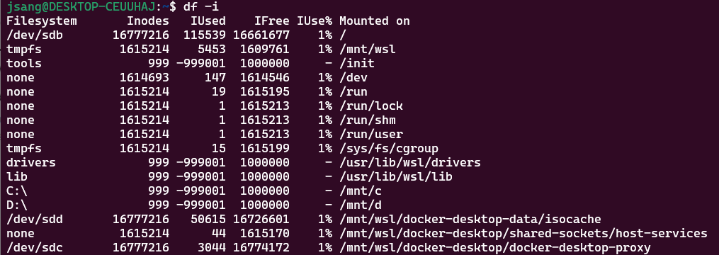

ext2 vs ext3 vs ext4
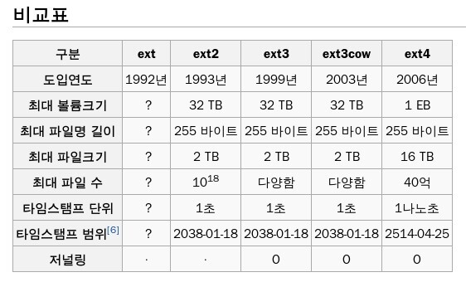

저널링(journaling)은 단연코 ext2와 ext3, ext4를 구분짓는 강력한 기능이라고 할 수 있다. ext3부터는 디스크 안에 별도의 공간인 journal을 통해 파일 시스템의 주요 부분에 아직 commit 되지 않은 변경 사항을 추적할 수 있게 했다. 시스템 충돌 또는 전원 오류(불시에 전원이 나간다거나 하는 오류)가 발생할 경우, 이러한 파일 시스템은 손상될 가능성이 낮아지고 보다 신속하게 온라인 상태로 되돌아올 수 있다(fault tolerant).
ext3에서 지원하는 저널링 모드는 다음 세 가지가 있다.
- Journal - 모든 데이터는 파일 시스템에 쓰여지기 전에 journal에 commit 되고, 나중에 실제 파일 시스템에 복사된다. 속도 측면의 성능은 떨어지지만 가장 높은 안정성을 보장한다.
- Ordered - (ext4 default mode) 데이터는 저널링 없이 기록하고, 메타 데이터만 journal에 기록한다. 비정상 종료시에는 메타 데이터가 journal에 기록되지 않았다면 데이터를 손실할 수 있다.
- Writeback - 데이터를 먼저 저널링하여 기록 후 메타 데이터를 journal에 기록한다. 속도 면에서의 성능은 좋아질 수 있지만, 안정성은 떨어진다.

Perl | Accessing a Directory using File Globbing
출처 : https://www.geeksforgeeks.org/perl-accessing-a-directory-using-file-globbing/
In Perl, a directory is used to store values in the form of lists. A directory is quite similar to a file. Just like a file, the directory also allows performing several operations on it. These operations are used for the modification of an existing directory or creation of a new one. A directory can be very easily opened and processed using the built-in function glob.
Glob:
It returns a list of files that match the expression passed in the argument. This function can print all or the specific files whose extension has been passed to it.
Syntax:
@list = <*>; // Prints all files in current directory
@list = glob(“*.pl”); // Prints all files in current directory with extension .pl
@list = glob(‘//GeeksforGeeks//Files//*); // Prints all files in the given path
Here are some examples that illustrate accessing a directory using File Globbing.
Examples:
- Accessing the current directory of the script:
#!/usr/bin/perl -w

# Accessing files using glob function
@files = glob('*'); # Returns list of all files
foreach $file (@files) # Loop to run through all files
{
print $file . "\n"; # Print all files
}

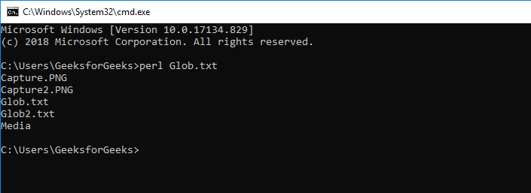
Output:
- Opening a specified directory:
#!/usr/bin/perl -w

# Prints only the filename excluding the path
use File::Basename;

# Returns list of all files
@files = glob('C:/Users/GeeksForGeeks/Folder/*');
foreach $file (@files) # Loop to run through all files
{
print basename($file), "\n"; # Print all files
}
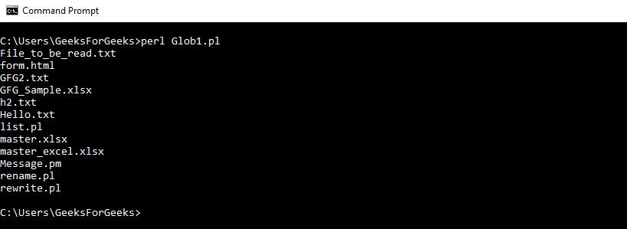
Output:
Whether you're preparing for your first job interview or aiming to upskill in this ever-evolving tech landscape, GeeksforGeeks Courses are your key to success. We provide top-quality content at affordable prices, all geared towards accelerating your growth in a time-bound manner. Join the millions we've already empowered, and we're here to do the same for you. Don't miss out - check it out now!

Special varible

Scoping Rules of Regex Variables
출처 : https://perldoc.perl.org/perlvar#Scoping-Rules-of-Regex-Variables
Regular expression variables allow the programmer to access the state of the most recent successful regex match in the current dynamic scope.
The variables themselves are global and unscoped, but the data they access is scoped similarly to dynamically scoped variables, in that every successful match behaves as though(=마치) it localizes(local 변수처럼 동작한다는 뜻) a global state object to the current block or file scope. (See "Compound Statements" in perlsyn for more details on dynamic scoping and the local keyword.)(참고 : https://ko.perlmaven.com/scope-of-variables-in-perl ) local 변수는 값이 일시적으로
저장되었다가 블럭을 벗어나면 다른 값을 가지게 되므로 temporary, dynamically-scoped value를 갓는 dynamic variable이라고 부른다.
-------------------------------------------------------------------------------
What is dynamic scoping in perl?
출처: https://www.reddit.com/r/perl/comments/gdsplw/what_is_dynamic_scoping_in_perl/
A misnomer, if you ask me. It's not really about scope as much as it's about time. It applies to package-scoped variables, and values inside of aggregates, and it means that a variable gets a new value (which is called a "local" value even though it's not really local, it's more like "temporal"!), and that value is visible even from other scopes, but the previous value is saved on a stack and restored when execution leaves the scope where the "local" happened.
Historically, this existed before lexical scoping, and it was a way to implement safe(ish) function-local variables, even for recursion(반복,순환), without lexical scoping. Today, it's mostly used for oddball(괴짜) tricks, or for temporarily overriding the values of "special global" variables like $/ or %ENV.
Some examples:
my $answer = 42;

sub foo {
say "The answer is $answer.";
}

sub bar {
my $answer = 23;
foo();
}

bar();
foo();
prints The answer is 42. twice because foo isn't lexically inside bar, so bar doesn't see foo's $answer (in fact, nothing does.)
our $answer = 42;

sub foo {
say "The answer is $answer.";
}

sub bar {
local $answer = 23;
foo();
}

bar();
foo();
prints The answer is 23. then The answer is 42. because the execution of foo is temporally between the local statement and the end of bar, so it sees the "localized" value of the package-global $answer; but once bar returns, the 23 goes away and the 42 is restored.
It's also useful in patterns like
{
local $SIG{__WARN__} = sub { push @warnings, $_[0] };
do_something_noisy();
}
which captures all warnings emitted by do_something_noisy (or anything it calls) onto an array instead of letting them warn, but resets the usual warning behavior immediately after, or
{
local $ENV{GITHUB_TOKEN} = $credential_manager->get_token;
system("do_upload");
}
which runs the external process do_upload with GITHUB_TOKEN in its environment, but doesn't expose it anywhere else.
I don't think it's a big thing fundamental concept to harp on, but it gets that treatment sometimes because materials written around the dawn of Perl 5 (in 1994) spent a lot of time explaining the difference between lexical scoping and what people were using before, because Perl 4 didn't have lexical scoping. And a lot of that material is still influencing people in one way or another today.

-------------------------------------------------------------------------------

Simple Statements
The only kind of simple statement is an expression evaluated for its side-effects. Every simple statement must be terminated with a semicolon, unless it is the final statement in a block, in which case the semicolon is optional. But put the semicolon in anyway if the block takes up more than one line, because you may eventually add another line. Note that there are operators like eval {}, sub {}, and do {} that look like compound statements, but aren't--they're just TERMs in an expression--and thus need an explicit termination when used as the last item in a statement.

Statement Modifiers
Any simple statement may optionally be followed by a SINGLE modifier, just before the terminating semicolon (or block ending). The possible modifiers are:
if EXPR
unless EXPR
while EXPR
until EXPR
for LIST
foreach LIST
when EXPR
The EXPR following the modifier is referred to as the "condition". Its truth or falsehood determines how the modifier will behave.
if executes the statement once if and only if the condition is true. unless is the opposite, it executes the statement unless the condition is true (that is, if the condition is false). See "Scalar values" in perldata for definitions of true and false.
print "Basset hounds got long ears" if length $ear >= 10;
go_outside() and play() unless $is_raining;
The for(each) modifier is an iterator: it executes the statement once for each item in the LIST (with $_ aliased to each item in turn). There is no syntax to specify a C-style for loop or a lexically scoped iteration variable in this form.
print "Hello $_!\n" for qw(world Dolly nurse);
while repeats the statement while the condition is true. Postfix while has the same magic treatment of some kinds of condition that prefix while has. until does the opposite, it repeats the statement until the condition is true (or while the condition is false):
# Both of these count from 0 to 10.
print $i++ while $i <= 10;
print $j++ until $j > 10;
The while and until modifiers have the usual "while loop" semantics (conditional evaluated first), except when applied to a do-BLOCK (or to the Perl4 do-SUBROUTINE statement), in which case the block executes once before the conditional is evaluated.
This is so that you can write loops like:
do {
$line = <STDIN>;
...
} until !defined($line) || $line eq ".\n"
See "do" in perlfunc. Note also that the loop control statements described later will NOT work in this construct, because modifiers don't take loop labels. Sorry. You can always put another block inside of it (for next/redo) or around it (for last) to do that sort of thing.
For next or redo, just double the braces:
do {{
next if $x == $y;
# do something here
}} until $x++ > $z;
For last, you have to be more elaborate and put braces around it:
{
do {
last if $x == $y**2;
# do something here
} while $x++ <= $z;
}
If you need both next and last, you have to do both and also use a loop label:
LOOP: {
do {{
next if $x == $y;
last LOOP if $x == $y**2;
# do something here
}} until $x++ > $z;
}
NOTE: The behaviour of a my, state, or our modified with a statement modifier conditional or loop construct (for example, my $x if ...) is undefined. The value of the my variable may be undef, any previously assigned value, or possibly anything else. Don't rely on it. Future versions of perl might do something different from the version of perl you try it out on. Here be dragons.
The when modifier is an experimental feature that first appeared in Perl 5.14. To use it, you should include a use v5.14 declaration. (Technically, it requires only the switch feature, but that aspect of it was not available before 5.14.) Operative only from within a foreach loop or a given block, it executes the statement only if the smartmatch $_ ~~ EXPR is true. If the statement executes, it is followed by a next from inside a foreach and break from inside a given.
Under the current implementation, the foreach loop can be anywhere within the when modifier's dynamic scope, but must be within the given block's lexical scope. This restriction may be relaxed in a future release. See "Switch Statements" below.

Compound Statements
In Perl, a sequence of statements that defines a scope is called a block. Sometimes a block is delimited by the file containing it (in the case of a required file, or the program as a whole), and sometimes a block is delimited by the extent of a string (in the case of an eval).
But generally, a block is delimited by curly brackets, also known as braces. We will call this syntactic construct a BLOCK. Because enclosing braces are also the syntax for hash reference constructor expressions (see perlref), you may occasionally need to disambiguate by placing a ; immediately after an opening brace so that Perl realises the brace is the start of a block. You will more frequently need to disambiguate the other way, by placing a + immediately before an opening brace to force it to be interpreted as a hash reference constructor expression. It is considered good style to use these disambiguating mechanisms liberally, not only when Perl would otherwise guess incorrectly.
The following compound statements may be used to control flow:
if (EXPR) BLOCK
if (EXPR) BLOCK else BLOCK
if (EXPR) BLOCK elsif (EXPR) BLOCK ...
if (EXPR) BLOCK elsif (EXPR) BLOCK ... else BLOCK

unless (EXPR) BLOCK
unless (EXPR) BLOCK else BLOCK
unless (EXPR) BLOCK elsif (EXPR) BLOCK ...
unless (EXPR) BLOCK elsif (EXPR) BLOCK ... else BLOCK

given (EXPR) BLOCK

LABEL while (EXPR) BLOCK
LABEL while (EXPR) BLOCK continue BLOCK

LABEL until (EXPR) BLOCK
LABEL until (EXPR) BLOCK continue BLOCK

LABEL for (EXPR; EXPR; EXPR) BLOCK
LABEL for VAR (LIST) BLOCK
LABEL for VAR (LIST) BLOCK continue BLOCK

LABEL foreach (EXPR; EXPR; EXPR) BLOCK
LABEL foreach VAR (LIST) BLOCK
LABEL foreach VAR (LIST) BLOCK continue BLOCK

LABEL BLOCK
LABEL BLOCK continue BLOCK

PHASE BLOCK
As of Perl 5.36, you can iterate over multiple values at a time by specifying a list of lexicals within parentheses:
no warnings "experimental::for_list";
LABEL for my (VAR, VAR) (LIST) BLOCK
LABEL for my (VAR, VAR) (LIST) BLOCK continue BLOCK
LABEL foreach my (VAR, VAR) (LIST) BLOCK
LABEL foreach my (VAR, VAR) (LIST) BLOCK continue BLOCK
If enabled by the experimental try feature, the following may also be used
try BLOCK catch (VAR) BLOCK
try BLOCK catch (VAR) BLOCK finally BLOCK
The experimental given statement is not automatically enabled; see "Switch Statements" below for how to do so, and the attendant caveats.
Unlike in C and Pascal, in Perl these are all defined in terms of BLOCKs, not statements(문장). This means that the curly brackets are required--no dangling statements allowed. If you want to write conditionals without curly brackets, there are several other ways to do it. The following all do the same thing:
if (!open(FOO)) { die "Can't open $FOO: $!" }
die "Can't open $FOO: $!" unless open(FOO);
open(FOO) || die "Can't open $FOO: $!";
open(FOO) ? () : die "Can't open $FOO: $!";
# a bit exotic, that last one
The if statement is straightforward. Because BLOCKs are always bounded by curly brackets, there is never any ambiguity about which if an else goes with. If you use unless in place of if, the sense of the test is reversed. Like if, unless can be followed by else. unless can even be followed by one or more elsif statements, though you may want to think twice before using that particular language construct, as everyone reading your code will have to think at least twice before they can understand what's going on.
The while statement executes the block as long as the expression is true. The until statement executes the block as long as the expression is false. The LABEL is optional, and if present, consists of an identifier followed by a colon. The LABEL identifies the loop for the loop control statements next, last, and redo. If the LABEL is omitted, the loop control statement refers to the innermost enclosing loop. This may include dynamically searching through your call-stack at run time to find the LABEL. Such desperate behavior triggers a warning if you use the use warnings pragma or the -w flag.
If the condition expression of a while statement is based on any of a group of iterative expression types then it gets some magic treatment. The affected iterative expression types are readline, the <FILEHANDLE> input operator, readdir, glob, the <PATTERN> globbing operator, and each. If the condition expression is one of these expression types, then the value yielded by the iterative operator will be implicitly assigned to $_. If the condition expression is one of these expression types or an explicit assignment of one of them to a scalar, then the condition actually tests for definedness of the expression's value, not for its regular truth value.
If there is a continue BLOCK, it is always executed just before the conditional is about to be evaluated again. Thus it can be used to increment a loop variable, even when the loop has been continued via the next statement.
When a block is preceded by a compilation phase keyword such as BEGIN, END, INIT, CHECK, or UNITCHECK, then the block will run only during the corresponding phase of execution. See perlmod for more details.
Extension modules can also hook into the Perl parser to define new kinds of compound statements. These are introduced by a keyword which the extension recognizes, and the syntax following the keyword is defined entirely by the extension. If you are an implementor, see "PL_keyword_plugin" in perlapi for the mechanism. If you are using such a module, see the module's documentation for details of the syntax that it defines.
--------------------------------------------------------------------------------

A successful match includes any successful match performed by the search and replace operator s/// as well as those performed by the m// operator.
Consider the following code:
my @state; # @stats는 scope의 영향이 없다.
sub matchit {
push @state, $1; # pushes "baz" # 아래에서 함수를 콜하기전 매칭된 문자열이
baz이므로 $1 eq baz 이다.
@state = (foo,foo,bar,baz)

my $str = shift; # 아래에서 matchit($str); 즉 매개변수로 $str을 넘겼으므로,
#scope가 다르기때문에, # 이를 system variable인 @_가 넘겨받고, 이를 사용하려면,
#아래와 동일한 변수명을 써도 # 변수를 선언하고 할당해야 한다. 그런데 parameter가
#상관이 없다. 아래랑 같다고 # 한개의 문자열이었으므로 shift를 하면 한개의 문자열이
# my 빼면 에러난다. # 그냥 스칼라 변수에 할당되게 된다.

$str =~ /(zat)/; # matches "zat" ← successful match
push @state, $1; # pushes "zat" @state = (foo,foo,bar,baz,zat) 이게 함수호출
# 했던 이후로 리턴된다.(zat)도 localized된것이지만 블록을 바로
# 벗어나버리므로 아래 matchit($str);의 밑에 있는 $1은 baz가 된다.
}

{
my $str = "foo bar baz blorp zat";
$str =~ /(foo)/; # matches "foo" ← successfule match
push @state, $1; # pushes "foo" @state = (foo)
{
$str =~ /(pizza)/; # does NOT match
push @state, $1; # pushes "foo" # regex 변수인 $1은 global and unscopped이다.
@state = (foo, foo)
$str =~ /(bar)/; # matches "bar" ← 매칭되었으므로 $1=(bar)가된다.
push @state, $1; # pushes "bar" @state = (foo, foo, bar)
$str =~ /(baz)/; # matches "baz"($1이 localized되어서 위의 matchit 함수에 전달됨)
# ← successful match @state=(foo,foo,bar)
matchit($str); # see above
push @state, $1; # pushes "baz" @state = (foo,foo,bar,baz,zat,baz)
# 이 $1도 localized됐지만, block을 바로 벗어나버리므로 밑에 있는
# $1은 foo가 된다.
}
$str =~ s/noodles/rice/; # does NOT match, 여기의 $str은 자신이 속한 블럭의 $str이다.
push @state, $1; # pushes "foo" #위 블럭을 지났으므로 자신이 속해있는 block에서
# $1을 찾게 된다. @state = (foo,foo,bar,baz,zat,baz,foo)
$str =~ s/(blorp)/zwoop/; # matches "blorp" ← successful match
push @state, $1; # pushes "blorp" @state = (foo,foo,bar,baz,zat,baz,foo,blorp)
}
# the following prints "foo, foo, bar, baz, zat, baz, foo, blorp"
print join ",", @state; #
Notice that each successful match in the exact same scope overrides the match context of the previous successful match, but that unsuccessful matches do not. Also note that in an inner nested scope /the previous state from an outer dynamic scope persists until it has been overriden by another successful match,/ but that when the inner nested scope exits /whatever match context was in effect(사실상) before the inner successful match is restored /when the scope concludes(끝나다).
It is a known issue that goto LABEL may interact poorly with the dynamically scoped match context. This may not be fixable, and is considered to be one of many good reasons to avoid goto LABEL.

Performance issues
Traditionally in Perl, any use of any of the three variables $`, $& or $' (or their use English equivalents) anywhere in the code, caused all subsequent successful pattern matches to make a copy of the matched string, in case the code might subsequently access one of those variables. This imposed a considerable performance penalty across the whole program, so generally the use of these variables has been discouraged.
In Perl 5.6.0 the @- and @+ dynamic arrays were introduced that supply the indices of successful matches. So you could for example do this:
$str =~ /pattern/;

print $`, $&, $'; # bad: performance hit

print # good: no performance hit
substr($str, 0, $-[0]),
substr($str, $-[0], $+[0]-$-[0]),
substr($str, $+[0]);
three ways parameters to a subroutine:
출처 : https://stackoverflow.com/questions/21451924/whats-the-benefit-of-shifting-for-argument-passing-in-perl
Since I do shifting, I'll explain why I do it.

Method 1: List Assignment
sub foo {
my ( $user, $date, $system ) = @_; # No shifting, and @_ preserved

Method 2: Individual Assignment from @_
sub foo {
my $user = $_[1];
my $date = $_[2]; # Must be YYYY-MM-DD
my $system = $_[3]; # Optional

Method 3: Using "shift"
sub foo {
my $user = shift;
my $date = shift; # Must be YYYY-MM-DD
my $system = shift; # Optional
Method 1 is popular. Ikegami uses it, and so do many other advanced Perl developers. It gives you a parameter list and gives you a way of saying these are my parameters and no others.
However, Method 2 and Method 3 give you a nice, easy to read parameter list, and you can add comments to the end of the line. However, Method 2 also has the advantage of maintaining the value of @_, so why use shift?
Take a look at Method 2 again. See a problem? I started with @_[1] and not with @_[0] -- a common error. Plus, as you're developing your subroutine, you might decide to reorder your parameters. Using Method 2 means renumbering them. Method 3 doesn't require renumbering, so you don't end up with this:
sub foo {
my $date = $_[1]; # Must be YYYY-MM-DD
my $user = $_[0];
my $system = $_[2]; # Optional
Um, what's the order of the parameters again?
So, what about preserving the value of @_? If you write a program where you change the value of a parameter, you're probably aren't going to be restoring it from @_. And, if you do, you are likely to produce some error prone code. If you need to munge a parameter, put it in another variable and munge that. This isn't 1975 where computers had only 4 kilobytes of memory.
And, talking about the 1970s, computers are fast enough that the amount of time of a few (dozen, hundred, thousands) shift operations isn't going to make that much difference in your total runtime. If your program is inefficient, optimize it where it is inefficient, and not by possibly shaving a few milliseconds eliminating a shift. More time will be spent maintaining your program than actually running it.

Damian Conway (The author of Perl Best Practices) recommends both Method #1 and Method #3. He states that Method #1 is "...is more concise, and it keeps the parameters together in a horizontal list, which enhances readability, provided that the number of parameters is small." (the emphasis is mine).

Damian states about Method #3: "The shift-based version is preferable, though, whenever one or more arguments has to be sanity-checked or needs to be documented with a trailing comment."
I simply use Method #3 all of the time. This way, I don't have to worry about reformatting if my parameter list grows, and I simply think it looks better.

What does '@_' do in Perl?
출처 : https://stackoverflow.com/questions/452775/what-does-do-in-perl

I was glancing through some code I had written in my Perl class and I noticed this.
my ($string) = @_;
my @stringarray = split(//, $string);
I am wondering two things: The first line where the variable is in parenthesis, this is something you do when declaring more than one variable and if I removed them it would still work right?
The second question would be what does the @_ do?
대답 1)
The @_ variable is an array that contains all the parameters passed into a subroutine. (서브루틴으로 전달되는 모든 파라미터들을 포함하는 배열을 나타내는 변수)
The parentheses around the $string variable are absolutely necessary. They designate that you are assigning variables from an array. Without them, the @_ array is assigned to $string in a scalar context, which means that $string would be equal to the number of parameters passed into the subroutine. For example:
sub foo {
my $bar = @_; @_을 쓸거면 앞의 $bar에 괄호를 반드시 치던가,
print $bar; @_을 안 쓸거면 @_없이 shift를 써줘야 한다.
}

foo('bar');
The output here is 1--definitely not what you are expecting in this case.
Alternatively, you could assign the $string variable without using the @_ array and using the shift function instead:
sub foo {
my $bar = shift;
print $bar;
}
Using one method over the other is quite a matter of taste. I asked this very question which you can check out if you are interested.
대답 2)
Perl has two different contexts, scalar context, and list context. An array '@_', if used in scalar context returns the size of the array.
So given these two examples, the first one gives you the size of the @_ array, and the other gives you the first element.
my $string = @_ ; 배열 @_의 크기(number)를 대입시킨다.
my ($string) = @_ ; 배열 @_의 첫번째 인자를 대입시킨다.
Perl has three 'Default' variables $_, @_, and depending on who you ask %_. Many operations will use these variables, if you don't give them a variable to work on. The only exception is there is no operation that currently will by default use %_.
For example we have push, pop, shift, and unshift, that all will accept an array as the first parameter. If you don't give them a parameter, they will use the 'default' variable instead. So 'shift;' is the same as 'shift @_;'
The way that subroutines were designed, you couldn't formally tell the compiler which values you wanted in which variables. Well it made sense to just use the 'default' array variable '@_' to hold the arguments.
So these three subroutines are (nearly) identical.
sub myjoin{
my ( $stringl, $stringr ) = @_;
return "$stringl$stringr";
}

sub myjoin{
my $stringl = shift;
my $stringr = shift;
return "$stringl$stringr";
}

sub myjoin{
my $stringl = shift @_;
my $stringr = shift @_;
return "$stringl$stringr";
}
I think the first one is slightly faster than the other two, because you aren't modifying the @_ variable.

@LAST_MATCH_START
@-
출처: https://perldoc.perl.org/perlvar
This array holds the offsets of the beginnings of the last successful match and any capture buffers it contains. (See "Scoping Rules of Regex Variables").
The number of elements it contains will be one more than the number of the highest capture buffers (also called a subgroup) that actually matched something. (As opposed to @+ which may have fewer elements.)
$-[0] is the offset of the start of the last successful match. $-[n] is the offset of the start of the substring matched by n-th subpattern, or undef if the subpattern did not match.
Thus, after a match against $_, $& coincides with(일치하다) substr $_, $-[0], $+[0] - $-[0]. Similarly, $n coincides with substr $_, $-[n], $+[n] - $-[n] if $-[n] is defined, and $+ coincides with substr $_, $-[$#-], $+[$#-] - $-[$#-]. One can use $#- to find the last matched subgroup in the last successful match. Contrast with $#+, the number of subgroups in the regular expression.
$-[0] is the offset into the string of the beginning of the entire match. The nth element of this array holds the offset of the nth submatch, so $-[1] is the offset where $1 begins, $-[2] the offset where $2 begins, and so on.
After a match against some variable $var:
$` is the same as substr($var, 0, $-[0])
$& is the same as substr($var, $-[0], $+[0] - $-[0])
$' is the same as substr($var, $+[0])
$1 is the same as substr($var, $-[1], $+[1] - $-[1])
$2 is the same as substr($var, $-[2], $+[2] - $-[2])
$3 is the same as substr($var, $-[3], $+[3] - $-[3])
This variable is read-only, and its value is dynamically scoped.
This variable was added in Perl v5.6.0.
--------------------------------------------------------------------------------
펄 언어에서 $-[0] is the offset of the start of the last successful match. 여기서 opsition 이라는게 무슨 의미야?
펄(Perl)에서 $-[0]은 정규 표현식을 사용할 때, 마지막으로 성공한 매치의 시작 오프셋을 나타냅니다. 이 값은 정규 표현식 엔진이 문자열에서 매치를 찾은 후, 해당 매치의 시작 위치를 가리키는 인덱스입니다. 인덱스는 0부터 시작한다.
여기서 "position"이라는 용어는 문자열에서의 위치를 의미합니다. $-[0]는 배열의 첫 번째 요소로, 즉 [0] 인덱스의 값을 가리키기 때문에 이를 "position"으로 이해할 수 있습니다. 이 값은 정규 표현식 매치가 성공했을 때, 매치의 시작 위치를 나타냅니다.
예를 들어:
perl
my $string = "Hello, World!";
if ($string =~ /World/) {
print "Match found at position: $-[0]\n";
}
위의 코드에서는 "World"라는 문자열이 $string에 포함되어 있으므로, 매치가 성공하게 됩니다. 그리고 $-[0]는 매치된 문자열 "World"의 시작 위치를 나타냅니다.

그럼 그 오프셋이 매치하는 문자열의 앞을 가리키는 거야? 아니면 match 된 문자열의 첫글자를 가리키는 거야?
$-[0]는 정확한 매치된 문자열의 시작 위치를 나타냅니다. 따라서 이 값은 매치된 문자열의 첫 글자를 가리키는 것이 아니라, 매치된 문자열 전체의 시작 위치를 나타냅니다. 그래서 이 오프셋은 매치된 문자열의 앞을 가리키는 것이 아니라, 매치된 문자열 자체의 시작 위치입니다.
간단한 예시를 통해 설명해보겠습니다:
perl
my $string = "Hello, World!";
if ($string =~ /World/) {
print "Match found at position: $-[0]\n";
print "Matched substring: $&\n";
}
위의 코드에서 $-[0]는 "World" 문자열의 시작 위치를 나타냅니다. 그리고 $&는 실제 매치된 문자열 자체를 나타냅니다. 이 두 값을 출력하면:
yaml
Match found at position: 7
Matched substring: World
위와 같이 "World" 문자열이 전체 문자열에서 7번 인덱스부터 시작함을 알 수 있습니다.
$+[0]이 실제보다 1크게 나오는 이유.
출처 : https://stackoverflow.com/questions/77635469/why-is-perl-special-variable-1-index-based-when-is-0-index-based
Both arrays are 0-based. I don't know what problem you are seeing or where you read that information, but it's not right.
- $-[0], the first item in the array @-, is the index for the starting position for the entire match. Think of this as the position of the start of $&.
- $+[0], the first item in the array @+, is the index for the ending position for the entire match. Think of this as the position of the end of $&. I remember this that "+" has more than "-", so @+ has the ending positions.
- After that, the indices(인덱스들) in those array are the number of the capture buffer they represent.
- The ending positions are the regex cursor position, so after you have matched a character, that cursor advances one. This is the position where the next part of the match starts. From the docs:
This is the same value as what the pos function returns when called on the variable that was matched against.
Maybe you saw something like this:
#!/usr/bin/perl
use v5.26;

"1234567890" =~ m/(456)\d/;

say <<~"HERE";
\$1 is $1
starts: $-[1]
end: $+[1]
\$&: $&
starts: $-[0]
ends: $+[0]
HERE
The output:
$1 is 456
starts: 3
end: 6
$&: 4567
starts: 3
ends: 7
The start of the capture buffer $1 is at position 3, and that's the same as the start over the portion of the string matched. However, the capture ends at position 6 (which is the seventh position because we are zero-based), but the overall match kept going to match one more digit. It's ending position is one past the end of the first capture buffer, so it's ending offset is also one greater.
Now the trick is to figure out why having the ending position one past the position of the last character is helpful. Remember that substr takes a starting position and a length. I find that very annoying because I usually know the ending position and not the length, but that's life. However, substracting(빼다) the corresponding values in @+ and @- gives the right length:
#!/usr/bin/perl
use v5.26;

my $string = '1234567890';
$string =~ m/(\d\d)(\d\d)(\d\d)(\d\d)(\d\d)/;

my $n = int(rand 5);
printf "capture <%s> was <%s>\n", $n, substr $string, $-[$n], $+[$n] - $-[$n];
And some runs (remember capture 0 is the part of the string that matched the entire pattern):
$ perl test.pl
capture <1> was <12>
$ perl test.pl
capture <3> was <56>
$ perl test.pl
capture <0> was <1234567890>
$ perl test.pl
capture <4> was <78>
$ perl test.pl
capture <3> was <56>
$ perl test.pl
capture <1> was <12>
$ perl test.pl
capture <0> was <1234567890>
$ perl test.pl
capture <1> was <12>

--------------------------------------------------------------------------------
$-[0]는 매치의 전체에 대한 시작 위치를 나타내는데, $+[1]은 첫 번째 캡처 그룹의 끝 위치를 나타냅니다. 여기서는 전체 매치에 대한 시작과 끝 위치를 출력하겠습니다.
perl
use strict;
use warnings;

my $text = "Hello, World!";

sub process_text {
if ($_[0] =~ /(\w+), (\w+)/) {
print "\$0 starts at $-[0], ends at $+[0]\n";
print "\$1 starts at $-[1], ends at $+[1]\n";
print "\$2 starts at $-[2], ends at $+[2]\n";
}
}

process_text($text);
위 코드를 실행하면 다음과 같은 결과가 출력됩니다:
bash
$0 starts at 0, ends at 7
$1 starts at 0, ends at 5
$2 starts at 7, ends at 12
여기서 $0은 전체 매치에 대한 정보를 나타내며, $1과 $2는 각각 첫 번째와 두 번째 캡처 그룹에 대한 정보를 나타냅니다. 시작 위치와 끝 위치가 각각 출력됩니다.

================================================================================
Adding example for better understanding of $-[0],$+[0]
Also adding info on variable $+
use strict;
use warnings;

my $str="This is a Hello World program";
$str=~/Hello/;

local $\="\n"; # Used to separate output

print $-[0]; # $-[0] is the offset of the start of the last successful match.

print $+[0]; # $+[0] is the offset into the string of the end of the entire match.

$str=~/(This)(.*?)Hello(.*?)program/;

print $str;

print $+; # This returns the last bracket result match
Output:
D:\perlex>perl perlvar.pl
10 # position of 'H' in str
15 # position where match ends in str
This is a Hello World program
World
--------------------------------------------------------------------------------
@LAST_MATCH_END
@+
This array holds the offsets of the ends of the last successful match and any matching capture buffers that the pattern contains. (See "Scoping Rules of Regex Variables")
The number of elements it contains will be one more than the number of capture buffers in the pattern, regardless of which capture buffers actually matched. You can use this to determine how many capture buffers there are in the pattern. (As opposed to @- which may have fewer elements.)
$+[0] is the offset into the string of the end of the entire match. This is the same value as what the pos function returns when called on the variable that was matched against. The nth element of this array holds the offset of the nth submatch, so $+[1] is the offset past where $1 ends, $+[2] the offset past where $2 ends, and so on. You can use $#+ to determine how many subgroups were in the last successful match. See the examples given for the @- variable.
This variable is read-only, and its value is dynamically scoped.
This variable was added in Perl v5.6.0.
%{^CAPTURE_ALL}
%-
Similar to %+, this variable allows access to the named capture groups in the last successful match in the currently active dynamic scope. (See "Scoping Rules of Regex Variables"). To each capture group name found in the regular expression, it associates a reference to an array containing the list of values captured by all buffers with that name (should there be several of them), in the order where they appear.
Here's an example:
if ('1234' =~ /(?<A>1)(?<B>2)(?<A>3)(?<B>4)/) {
foreach my $bufname (sort keys %-) {
my $ary = $-{$bufname};
foreach my $idx (0..$#$ary) {
print "\$-{$bufname}[$idx] : ",
(defined($ary->[$idx])
? "'$ary->[$idx]'"
: "undef"),
"\n";
}
}
}
would print out:
$-{A}[0] : '1'
$-{A}[1] : '3'
$-{B}[0] : '2'
$-{B}[1] : '4'
The keys of the %- hash correspond to all buffer names found in the regular expression.
The behaviour of %- is implemented via the Tie::Hash::NamedCapture module.
Note: %- and %+ are tied views into a common internal hash associated with the last successful regular expression. Therefore mixing iterative access to them via each may have unpredictable results. Likewise, if the last successful match changes, then the results may be surprising. See "Scoping Rules of Regex Variables".
This variable was added in Perl v5.10.0. The %{^CAPTURE_ALL} alias was added in 5.25.7.
This variable is read-only, and its value is dynamically scoped.
${^LAST_SUCCESSFUL_PATTERN}
The last successful pattern that matched in the current scope. The empty pattern defaults to matching to this. For instance:
if (m/foo/ || m/bar/) {
s//BLAH/;
}
and
if (m/foo/ || m/bar/) {
s/${^LAST_SUCCESSFUL_PATTERN}/BLAH/;
}
are equivalent.
You can use this to debug which pattern matched last, or to match with it again.
Added in Perl 5.37.10.
%{^CAPTURE}
%LAST_PAREN_MATCH
%+
Similar to @+, the %+ hash allows access to the named capture buffers, should they exist, in the last successful match in the currently active dynamic scope. (See "Scoping Rules of Regex Variables").
For example, $+{foo} is equivalent to $1 after the following match:
'foo' =~ /(?<foo>foo)/;
The keys of the %+ hash list only the names of buffers that have captured (and that are thus associated to defined values).
If multiple distinct capture groups have the same name, then $+{NAME} will refer to the leftmost defined group in the match.
The underlying behaviour of %+ is provided by the Tie::Hash::NamedCapture module.
Note: %- and %+ are tied views into a common internal hash associated with the last successful regular expression. Therefore mixing iterative access to them via each may have unpredictable results. Likewise, if the last successful match changes, then the results may be surprising.
This variable was added in Perl v5.10.0. The %{^CAPTURE} alias was added in 5.25.7.
This variable is read-only, and its value is dynamically scoped.

local and my
Almost everyone already knows that there's a local function that has something to do with local variables. What is it, and how does it related to my? The answer is simple, but bizarre:
my creates a local variable. local doesn't.
First, here's what local $x really does: It saves the current value of the package variable $x in a safe place, and replaces it with a new value, or with undef if no new value was specified. It also arranges for the old value to be restored when control leaves the current block. The variables that it affects are package variables, which get local values. But package variables are always global, and a local package variable is no exception. To see the difference, try this:
$lo = 'global';
$m = 'global'; # my, our, state등을 붙이지 않고 선언하면 기본값은 global.
A();

sub A {
local $lo = 'AAA';
my $m = 'AAA';
B();
}

sub B {
print "B ", ($lo eq 'AAA' ? 'can' : 'cannot') ,
" see the value of lo set by A.\n";

print "B ", ($m eq 'AAA' ? 'can' : 'cannot') ,
" see the value of m set by A.\n";
}
This prints
B can see the value of lo set by A.
B cannot see the value of m set by A.
What happened here? The local declaration in A saved a new temporary value, AAA, in the package variable $lo. The old value, global, will be restored when A returns, but before that happens, A calls B. B has no problem accessing the contents of $lo, because $lo is a package variable and package variables are always available everywhere, and so it sees the value AAA set by A.
In contrast, the my declaration created a new, lexically scoped variable named $m, which is only visible inside of function A. Outside of A, $m retains its old meaning: It refers the the package variable $m; which is still set to global. This is the variable that B sees. It doesn't see the AAA because the variable with that value is a lexical variable, and only exists inside of A.

What Good is local?
Because local does not actually create local variables, it is not very much use. If, in the example above, B happened to modify the value of $lo, then the value set by A would be overwritten. That is exactly what we don't want to happen. We want each function to have its own variables that are untouchable by the others. This is what my does.
Why have local at all? The answer is 90% history. Early versions of Perl only had global variables. local was very easy to implement, and was added to Perl 4 as a partial solution to the local variable problem. Later, in Perl 5, more work was done, and real local variables were put into the language. But the name local was already taken, so the new feature was invoked with the word my. my was chosen because it suggests privacy, and also because it's very short; the shortness is supposed to encourage you to use it instead of local. my is also faster than local.

When to Use my and When to Use local
Always use my; never use local.
Wasn't that easy?

Other Properties of my Variables
Every time control reaches a my declaration, Perl creates a new, fresh variable. For example, this code prints x=1 fifty times:
for (1 .. 50) {
my $x;
$x++;
print "x=$x\n";
}
You get a new $x, initialized to undef, every time through the loop.
If the declaration were outside the loop, control would only pass by it once, so there would only be one variable:
{ my $x;
for (1 .. 50) {
$x++;
print "x=$x\n";
}
}

This prints x=1, x=2, x=3, ... x=50.
You can use this to play a useful trick. Suppose you have a function that needs to remember a value from one call to the next. For example, consider a random number generator. A typical random number generator (like Perl's rand function) has a seed in it. The seed is just a number. When you ask the random number generator for a random number, the function performs some arithmetic operation that scrambles the seed, and it returns the result. It also saves the result and uses it as the seed for the next time it is called.
Here's typical code: (I stole it from the ANSI C standard, but it behaves poorly, so don't use it for anything important.)
$seed = 1;
sub my_rand {
$seed = int(($seed * 1103515245 + 12345) / 65536) % 32768;
return $seed;
}
And typical output:
16838
14666
10953
11665
7451
26316
27974
27550
There's a problem here, which is that $seed is a global variable, and that means we have to worry that someone might inadvertently tamper with it. Or they might tamper with it on purpose, which could affect the rest of the program. What if the function were used in a gambling program, and someone tampered with the random number generator?
But we can't declare $seed as a my variable in the function:
sub my_rand {
my $seed;
$seed = int(($seed * 1103515245 + 12345) / 65536) % 32768;
return $seed;
}
If we did, it would be initialized to undef every time we called my_rand. We need it to retain its value between calls to my_rand.
Here's the solution:
{ my $seed = 1;
sub my_rand {
$seed = int(($seed * 1103515245 + 12345) / 65536) % 32768;
return $seed;
}
}
The declaration is outside the function, so it only happens once, at the time the program is compiled, not every time the function is called. But it's a my variable, and it's in a block, so it's only accessible to code inside the block. my_rand is the only other thing in the block, so the $seed variable is only accessible to the my_rand function.
$seed here is sometimes called a `static' variable, because it stays the same in between calls to the function. (And because there's a similar feature in the C language that is activated by the static keyword.)

my Variable Trivia
- You can't declare a variable my if its name is a punctuation character, like $_, @_, or $$. You can't declare the backreference variables $1, $2, ... as my. The authors of my thought that that would be too confusing.
- Obviously, you can't say my $DBI::errstr, because that's contradictory---it says that the package variable $DBI::errstr is now a lexical variable. But you can say local $DBI::errstr; it saves the current value of $DBI::errstr and arranges for it to be restored at the end of the block.
- New in Perl 5.004, you can write
foreach my $i (@list) {
instead, to confine the $i to the scope of the loop instead. Similarly,
for (my $i=0; $i<100; $i++) {
confines the scope of $i to the for loop.

Declarations
If you're writing a function, and you want it to have private variables, you need to declare the variables with my. What happens if you forget?
sub function {
$x = 42; # Oops, should have been my $x = 42.
}
In this case, your function modifies the global package variable $x. If you were using that variable for something else, it could be a disaster for your program.
Recent versions of Perl have an optional protection against this that you can enable if you want. If you put
use strict 'vars';
at the top of your program, Perl will require that package variables have an explicit package qualifier. The $x in $x=42 has no such qualifier, so the program won't even compile; instead, the compiler will abort and deliver this error message:
Global symbol "$x" requires explicit package name at ...
If you wanted $x to be a private my variable, you can go back and add the my. If you really wanted to use the global package variable, you could go back and change it to
$main::x = 42;
or whatever would be appropriate.
Just saying use strict turns on strict vars, and several other checks besides. See perldoc strict for more details.
Now suppose you're writing the Algorithms::KnuthBendix modules, and you want the protections of strict vars But you're afraid that you won't be able to finish the module because your fingers are starting to fall off from typing $Algorithms::KnuthBendix::Error all the time.
You can save your fingers and tell strict vars to make an exception:
package Algorithms::KnuthBendix;
use vars '$Error';
This exempts the package variable $Algorithms::KnuthBendix::Error from causing a strict vars failure if you refer to it by its short name, $Error.
You can also turn strict vars off for the scope of one block by writing
{ no strict 'vars';

# strict vars is off for the rest of the block.

}

Summary
Package variables are always global. They have a name and a package qualifier. You can omit the package qualifier, in which case Perl uses a default, which you can set with the package declaration. For private variables, use my. Don't use local; it's obsolete.
You should avoid using global variables because it can be hard to be sure that no two parts of the program are using one another's variables by mistake.
To avoid using global variables by accident, add use strict 'vars' to your program. It checks to make sure that all variables are either declared private, are explicitly qualified with package qualifiers, or are explicitly declared with use vars.

perl 펄 정규표현식 패턴매칭 및 특수변수 by 해커남
출처 : https://blog.naver.com/ifkiller/70054083868

오늘은 패턴 매칭에 대해 배워보겠습니다.
이놈 아주 중요한 놈입니다.. 빡씨게 배워서 자기껄로 만드세요...
패턴 매칭 (Pattern Matching) 이란??
문자열의 형식이 일치하는 것을 조사하는것을 패턴매칭이라 합니다.
패턴은 //사이에 문자로 비교하고자 하는 문자열(정규표현식)을 넣어서 표현합니다.
본격적으로 들어가기 전에 두가지를 알고 넘어가야 합니다..
바로 =~, !~ 이 두가진데요..
=~ 는 문자열의 패턴이 일치할때 참(1)을 반환하고 거짓일땐 undef를 반환 합니다.
!~ 는 위와 반대로 일치하지 않을때 참을 반환합니다...
이게 뭔가 하실텐데 예로 바로 알아보겠습니다.
정규표현식을 만들땐 어제 배운 메타기호들을 써서 패턴을 만들어 쓰는 것들입니다..
=~와 !~ 는 연산자이기 때문에 좌항과 우항이 필요합니다.
패턴매칭의 기본 표현은 문자열이 있는 변수 or 문자열 / 연산자(=~ or !~) / 정규표현식
이렇게 됩니다..
/는 실제 사용되는게 아니고 보기 쉽게 하려고 서로 구분짓기 위해 제가 그냥 넣어 놓은 것입니다.
사용 예)
$result1 = "pattern matching Example" =~ /Example/;
이건 정말 기본적인 사용예인데요...
결과를 말하자면 $result1에는 1이 들어가게 되죠..
궂이 설명하자면 Example 이 문자열에 있는지 없는지 확인후 있으면 참 이라는 소리..
자 이번 예제는 좀 다릅니다.
$_ = "pattern matching Example";
$word = "Example";
if(/$word/){print "Example is Matching \n";}
$_는 전에 설명드렸지만 특수변수 입니다...
이걸 사용하는 이유는 생략이 가능하기 때문입니다..
어디서 어떻게 생략이 되는지 궁금하시죠??
if문의 조건식을 보면 원래는 if($_=~/$word/) 이것입니다.
아무튼 이 예제는 $_에 있는 문자열중 $word 안의 문자열이 있는지 찾는 예제 입니다.
이와같이 정규표현식 안에는 변수가 들어갈 수도 있습니다.

이제 패턴 매칭의 결과를 따로 나타내주는 특수변수를 알아보겠습니다.
--------------------------------------------------------------------------------
$& : 매치하는 문자열 전체
$`(Grave Accent) : 매치하는 부분보다 앞에 있는 문자열
$'(Single Quotation) : 매치한는 부분보다 뒤에 있는 문자열
$1, $2, $3.... : 첫번째, 두번째, 세번째....그룹에 매치하는 문자열
$+ : 마지막 그룹에 매치하는 문자열
--------------------------------------------------------------------------------
이것들은 다 특수변수 입니다..
이런것들이 있는건 알았는데 막상 어떻게 쓰는지 모르겠죠??
예를 들어 바로 머릿속에 넣어드리겠습니다.
$String = "Don't be afraid, when things go wrong, Just be strong!";
$String =~ /Just/;
간단한 예제지만 $&, $`, $' 이 세가지를 알수 있는 예제 입니다..
$&는 매치하는 문자열 전체라고 했으니 Just가 들어가겠네요..
그럼 나머지 $`, $' 는 바로 아시겠죠??
$` 여기엔 Don't be afraid, when things go wrong, 이게 들어가고
$' 이곳은 be strong! 이것이 들어가죠...이해 되시죠??
아참!! 실제로 프린트 해서 자세히 보면 $'의 be strong! 은 한칸 뒤로 밀려있습니다.

그 이유는 공백도 문자로 간주하기 때문에 Just 뒤에 띄어쓰기가 적용되서 그런거예요.
참고하세요...공백도 문자로 간주한다는거!!
그럼 그룹 어쩌고 하는건 뭔가..?? 예제로 한방에 알아보죠..
$String = "Don't be afraid, when things go wrong, Just be strong!";
$String =~ /,(.+),(.+)!/;
같은 문자열에 정규표현식만 바꿨습니다..
일단 저 정규표현식의 뜻은
, : , 로 시작해서
(.+) : 한개 이상 어떠한 문자가 있고
, : , 가 있고
(.+) : 또다시 한개 이상 어떠한 문자가 있고
! : !로 끝나는 문자열
을 뜻합니다..
다음부턴 일일히 정규표현식 설명 안하겠습니다.. 줄이 길어지네요...ㅠㅠ
처음으로 좀 복잡한 정규표현식이 나와서 설명한건데 사실 저건 정말 간단한 표현식이고요
실제로 쓰는 정규표현식은 정말 길고 복잡합니다.. 메타기호 외우세요...ㅡㅡ;
아무튼 매칭되는게 있죠?? --> ,when things go wrong, Just be strong!
콤마로 시작해 하나이상 문자가 있고 다시 콤마가 있고 또 하나 문자가 있고 느낌표로 끝나자나요..
자!! 문자들은 () 로 쌓여있고 ()는 그룹을 뜻합니다.
눈치가 빠르시면 이제 바로 아실꺼 같습니다..
$& : ,when things go wrong, Just be strong!
$1 : when things go wrong
$2 : Just be strong
$+ : Just be strong
아시겠죠??
/ / 사이에 있는 ,나 !는 문자입니다. 다른 메타기호와 혼동하시면 안되요..
메타기호를 문자로 쓸땐 \ 를 사용하면 되는데 그건 나중에 다시 알려드리겠습니다.
특수변수에 대해 어느정도 아시겠죠??
좀 복잡해 보이지만 이게 정규표현식의 시작입니다..
벌써 어려워 하시면 뒤에껀...ㄷㄷㄷ
아직은 안어려우시죠?? 다음엔 문자열 검색을 배워볼께요...

Perl 펄 정규표현식 문자열 검색 및 해당 옵션 by 해커남

사실 제가 블로그를 만든 이유는 그냥 제 공부 하고 복습겸 나중에 참고겸 하려고 만든건데
어쩌다보니 양이 많아지네요...
여담이었고요...^^
이제 문자열 검색을 배워보겠습니다..
일단 매치연산자를 이용해서 검색하고 복수의 옵션을 붙히는것도 가능합니다..
무슨말이냐고요??
이글 끝까지 쭈~~욱 보고 다시 보세요...그럼 이해되요..^^
--------------------------------------------------
/g : 전역 매치 문자열의 마지막까지 검색 수행
/i : 대소문자 구별하지 않음
/x : 공백을 무시하며 주석을 허용함
/m : ^와 $이 \n 다음에 매치되도록 함
/s : 개행문자도 포함
-------------------------------------------------
이런 특수문자들이 있어요..
사용법을 알려드릴께요...
이놈들은 /정규표현식/O <-- 요기!! 즉 // 바로 뒤에 쓰는 놈들입니다..옵션이죠..^^
그리고 복수로 옵션을 달수 있다는 말은 /정규표현식/OOO 이렇게 옵션을 달수 있다는 말입니다..^^
이제 친절하게 하나하나 설명하겠습니다..

먼저 /g 이놈!!
간단하게
$string = "aaa bbb aaa";
foreach($string=~/aaa/){ $cnt++; }
print $cnt;
이렇게 하면 결과는 1 이 나옵니다..
이유는 aaa가 매치가 되는 순간 매치가 끝나기 때문입니다.
하지만 /aaa/g 이렇게 /aaa/ 뒤에 g옵션을 붙히면 결과는 2가 되죠..
위의 설명대로 /g옵션은 매치가 되도 문자열의 마지막까지 검색을 수행하기 때문이죠..

다음 /i 이놈은 설명 그대로 입니다..검사를 할때 영문자 대소를 구별을 안할때 사용하는 옵션입니다.
/x 이녀석은 예로 쉽게 설명하겠습니다.
$string = "apple";
$string =~ /a pp l e/;
print "$&";
이건 좀 어이없는 예제인데 어쨋던 어떤 개념인지 알수는 있겠네요...^^;
아무튼 결과는 없겠죠??매치가 안되니까...
이럴때 x옵션을 쓰면 매치가 됩니다..
그럼 결과는 apple 이 나오죠...
그럼 주석은 무슨소리냐....
실제로 정규표현식을 쓰면 짧고 간결하게 하려해도 복잡하고 길어지고 나중엔 자기가 만든 표현식도
무슨뜻인지 보기 어려울때가 있습니다..
그럴때 쓰는게 주석이자나요...주석을 가능하게 해주는 옵션이 x 입니다.
$string =~/abc #주석
(.+)\.$(.+) #주석
! ,/
뭐 대략 이런식으로...x옵션에 대해 하셨죠?? 공백과 주석...
/s 옵션을 보겠습니다.
설명은 개행문자 포함이라고 하는데 어떻게 쓰는지 처음보신분은 막막할텐데요..
역시 예제가 좋겠네요..
$string = "perl\nperl\n";
$string =~ /l.p/;
print "$&";
또 극단적인 예 나왔네요...ㅋㅋ;;
이렇게 하면 결과는 안나옵니다..매치가 안되죠...
하지만 /l.p/ 뒤에 s 옵션을 붙히면 결과는
l
p
이렇게 나옵니다..
이유인 즉, .은 개행문자를 못받습니다.. 하지만 s 옵션을 붙혀서 받게 할수 있죠..
perl\nperl 에서 저 빨간부분이 매치되어 출력되는거지요...개행과 함께...

/m 옵션을 보죠...
이 옵션을 설명하려면 다시 세부 옵션을 알아야 합니다...
아...옵션의 옵션....옵션이 왜이리 많은지...ㅡㅡ; 머리가 아프네요...ㅎㅎ
-----------------------------------------------
^ or \A : 문자열의 시작에서만 일치시킨다.
$ or \Z : 스트링의 끝에서만 일치시킨다.
\b : 단어 단위로만 일치시킨다.
\B : 단어 안에서 일치시킨다.
-----------------------------------------------
휴~~ 일단 이 세부옵션부터 설명하고 m옵션을 설명해야겠네요..ㅠㅠ
$string = "All for you, \nnothing can change my heart";
$string =~/^nothing/;
print "$&";
결과부터 말하면 결과는 매치 안됩니다..
^는 문자열의 시작에서만 일치해야 일치하는것이기 때문에 매치가 안되죠..
다시말해 All 이 아닌 이상 매치가 안되는 것입니다..
이건 어떤경우에 사용되냐면 문자열의 시작만 검사하고 싶을때 사용합니다.
하지만 실제 문자열은 여러줄로 되있으니까 여러개의 시작점이 있자나요...
첫번재 줄의 시작점 말고 그 이후의 시작점에서 매치를 시키고 싶을때
바로 /m 옵션을 사용하면 매치가 됩니다.
저 예제에서 m옵션을 붙히면 결과는 매치가 되니까 nothing 이 나오죠..
이제 나머지 세부옵션을 설명해드리겠습니다..
$는 ^과 사용법이 같습니다.. 단지 스트링의 맨 뒤에서 매치가되는거죠..
참고할건...아니 알아야 할껀 ^는 ^뒤의 문자를 보고 $는 $의 앞의 문자를 봅니다..
$string =~/nothing^/;
이건 하나 마나라는거죠...^뒤엔 문자가 없으니까...
그럼 \b 와 \B 는 무슨 뜻인가??
$_ = "the they the theater";
뭐 이런식의 문자열이 있을때
foreach (/the/g){$cnt++;}
print $cnt;
결과는 4가 나옵니다...they의 the도 매치를 하니까요
이렇게 원하는건 the만 찾고 싶을때 \b를 사용합니다..
(/the\b/g) 이렇게요...그럼 결과는 원하는 2가 나오게 되지요...
근데 만약 $_ 안에 athe 라는 문자가 추가되 있다면??
결과는 3이 나옵니다. 이유는 \b 옵션이 the 뒤에 있기때문에 앞은 안보는거죠..
그래서 정확하게 the만 찾고 싶으면 (/\bthe\b/g) 이렇게 써야 합니다.
한마디로 양옆을 본다는거예요...
그러타면 \B는 뭔가...
\b의 반대개념입니다..
(/\bthe\b/g) 이렇게 하면 the 양옆에 다른 문자가 있는걸 매치 안시키자나요??
(/\Bthe\B/g) 이렇게 하면 the 얖엪에 다른 문자가 있어야 매치를 시킵니다.
단어 안에서 일치시킨다는 설명대로죠?? 이제 이해하셨을꺼라 생각드네요..
즉 other 이건 매치 othe 이건 매치가 안되죠... 왜냐면 e옆에 문자가 없으니까..
보다시피 \b와 마찬가지로 the 양엪에서 옵션을 붙히느냐 마느냐에 따라 결과값이 틀려집니다...
이해 안되시면 스크롤을 위로.....
자세히 알려드리려다보니 내용이 길어지네요...자꾸....ㅠㅠ
오늘은 여기까지 하고요...다음엔 결과값을 배열에 넣는 방법을 알려드릴께요..
그럼 이만 꾸벅!

perl 펄 정규표현식 매치 문자열 배열에 저장 하기 by 해커남
https://blog.naver.com/ifkiller/70054090416
내용은 제목그대로 입니다.
바로 예제 들어갑니다.
$string = "10(ten), 20(twenty), 30(thirty), 40(forty)";
이러한 문자열이 있습니다.
@Array = $string =~ /\d+/;
print 'array= '."@Array\n";
결과는 1입니다..
@Array = $string =~ /\d+/g;
print 'array= '."@Array\n";
결과는 10 20 30 40 입니다..
첫번째 결과의 이유는 매치되는 순간 매치를 끝내기 때문이죠..
두번째는 g옵션을 달아서 끝까지 매치를 시키죠...
근데 첫번째 1이 10의 1인걸로 착각할 수 있지만 저건 참을 뜻하는 1입니다..
만약 10을 20으로 바꿔도 결과는 1입니다..
근데 두번째는 참 거짓이 아닌 숫자로 들어갔을까요??
$string =~ /\d+/; 이렇게만 보면 전의 강의내용처럼 $string엔 참인 1이 들어갑니다.
$& 안에 1이 들어가는건 10의 1이죠..
근데 g옵션을 붙히면 리스트형을 반환해줍니다.
그래서 각 배열의 요소에 10 20 30 40이 들어가는것이죠...
그럼 참의 1이 아닌 10을 찾을 수는 없을까요??
이렇게 하면 됩니다. \
@Array = $string =~ /\b(\d+)/;
print 'array= '."@Array\n";
예상대로 결과는 10 입니다.
()이렇게 그룹으로 묶으면 단어단위이기 때문에 참이 아닌 10을 반환해주는거죠..
@Array = $string =~ /\([a-z]+\)/g;
print 'array= '."@Array\n";
결과는 (ten) (twenty) (thirty) (forty) 입니다..
여기서 \( \)이것은 그룹을 묶기 위함이 아니고 각각 "(" 와 ")" 의 문자를 나타내기 위함이죠
전에 설명했듯 메타기호를 문자로 쓸땐 \를 써야 합니다.
만약 저 예제에서 g를 빼면? 결과는 1 이죠..
이제 이해가 좀 되시죠??
이밖에 더 배울게 있지만 나중에 하다보면 자연스레 알게되는 부분들입니다..
오늘은 귀차니즘에 빠져서 여기까지 하겠습니다...ㅠㅠ

