Cairo University Faculty of Computers and Artificial Intelligence



**Software design specification document**

**2022**

**Project Team**

|  |  |  |
| --- | --- | --- |
| **ID** | **Name** | **Email** |
| 20210475 | Yousef Abdalla Attia | Yabdalla463@gmail.com |
| 20210412 | Mohand Magdy Ahmed | mohandmagdii45@gmail.com |
| 20210350 | Mohamed Kamal Abdelgid | mk5391130@gmail.com |
| 20210416 | Momen Mostafa Mabrouk | momenmostafa585@gmail.com |

Contents

Instructions[To be removed] 2

Class diagram design 2

Class diagram Explanation 3

Sequence diagram design 3

Github repository link 4

# Instructions[To be removed]

* **IMPORTANT. Rename this document to** Assignment1_SE_StudentID1_StudentID2_StudentID3_StudentID4**_SDS Document.docx**
* **Remove the following notes and any red notes**

# Class diagram design

* **You should provide clean version for your class diagram design.**
* **Class diagram is a static diagram and should not represent any dynamic flow of events.**
* **Put Relationships between classes and the types of the relationships.**
* **Put multiplicity.**
* **Put relationship name (e.g. faculty "offer" course).**
* **Put attributes in the classes.**
* **Put functions &Put parameters.**
* **Put data types of each attributes and the parameters.**
* **Highly perfered: Each class has a corresponding interface**
  + **Let all objects parameters and returns be of interface type.**
* **See Shopping Cart Case Study**

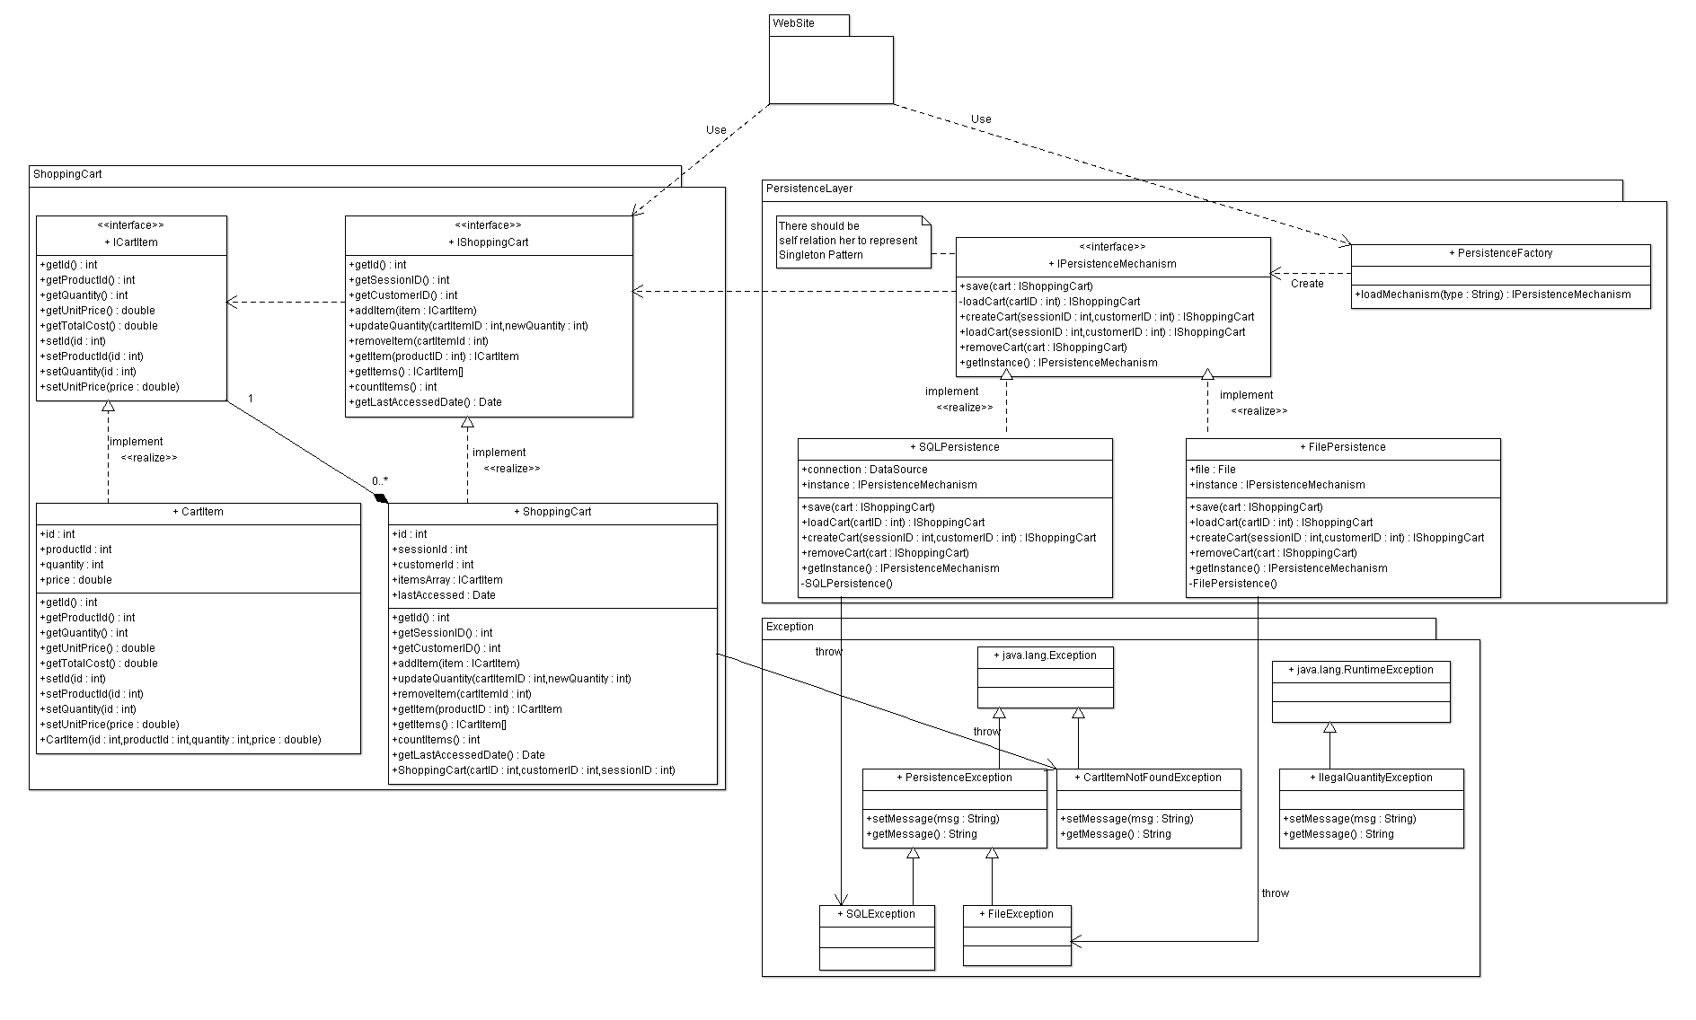

# Class diagram Explanation

* **Explain here the design pattern(s) that you used and your justification for using them, and the participating classes for each pattern.**

# Requirements Exposure as Web Service API

**Part 1: Exposed Postman Collection**

**Part 2:**

**Explain here the exact mapping between every single requirement and its corresponding web service API operation. A sample example is provided to better explain the concept.**

|  |  |  |
| --- | --- | --- |
| Requirement |  | Exposed API |
| The system should check if the username or the email is registered before. |  | 1- GET /user/check  A service to check if the user exists or not. This service returns all user info if exists  Input: email and password. |
|  |  | A list of all the products currently available for purchase should be displayed |
|  |  |  |
|  |  |  |