CHAPTER 1
INTRODUCTION
1.1 Introduction

Diseases should be treated well and on time. If they are not treated on time, they can lead to many health problems and these problems may become the cause of death. These problems are becoming worse due to the scarcity of specialists, practitioners and health facilities. In an effort to address such problems, studies made attempts to design and develop expert systems which can provide advice for physicians and patients to facilitate the diagnosis and recommend treatment of Swine flu’s patients. This Expert System is also able to find comorbidities related to swine flu. This system will able to predict a comprehensive study of medical expert systems for diagnosis of swine flu.

Expert System is one of the most common applications of artificial intelligence. It is a computer program that simulates the decision and actions of a person or an association that has specialist facts and experience in a particular field. Normally, such a system contains a knowledge base containing accumulated experience and a set of rules for applying the knowledge base to each particular situation. The major features of expert system are user interface, data representation, inference, explanations etc. Advantages of expert system are increased reliability, reduced errors, reduced cost, multiple expertise, intelligent database, reduced danger etc. Disadvantages of expert system are absence of common sense and no change with changing environment. Medical diagnosis system for swine flu prediction and detection this expert system able to find information about safe health.it will able to find comorbidities related to swine flu. It will also provide information about how we can prevent from swine flu? Treatment related to swine treatment related to swine flu. This system will able to predict a comprehensive study of medical expert systems for diagnosis of swine flu.

  - Scope

- This system will be designed for comorbidities related to swine flu which can be extended for comorbidities related to all other diseases.
- This feature will allow displaying the information of diseases in multiple languages. Potentially allow users to view the information of diseases in their own native languages.
1.3 Objective
- To find comorbidities related to swine flu.
- To give proper information about treatment of swine flu and its comorbidities diseases.
- To prevent the spread of swine flu virus.

CHAPTER 2
REQUIREMENT SPECIFICATION

2.1 Hardware requirements
MOBILE DEVICE: ANDROID

2.2 Software requirements
OPERATING SYSTEM : ANDROID
LANGUAGE: JAVA
ANDROID API: 21 Above

CHAPTER 3
Breakdown Structure

Medical Diagnosis System (MyDr)

Safe Health Information
Swine Flu Comorbidities
Health Information

Home

Asthma
Swine Flu
TB
Diabetes

CHAPTER 4
SAMPLE SCREENSHOTS
4.1


4.2
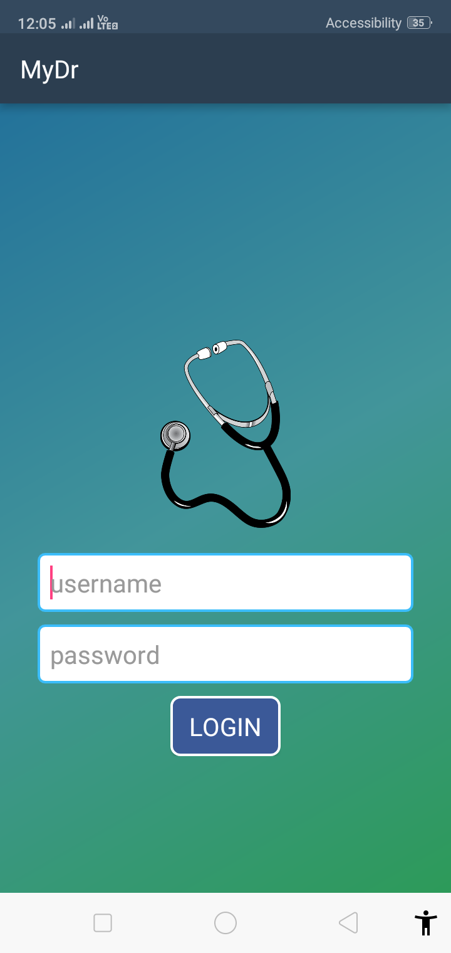

4.3

4.4
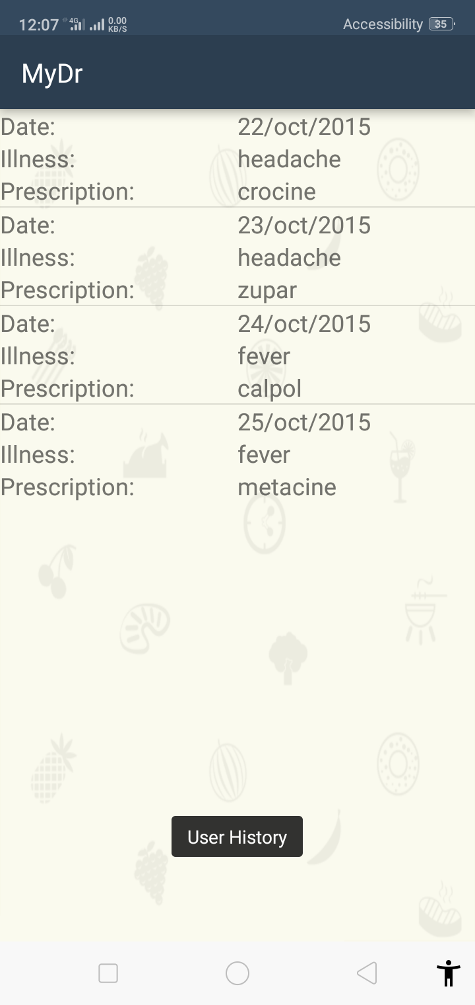
4.5
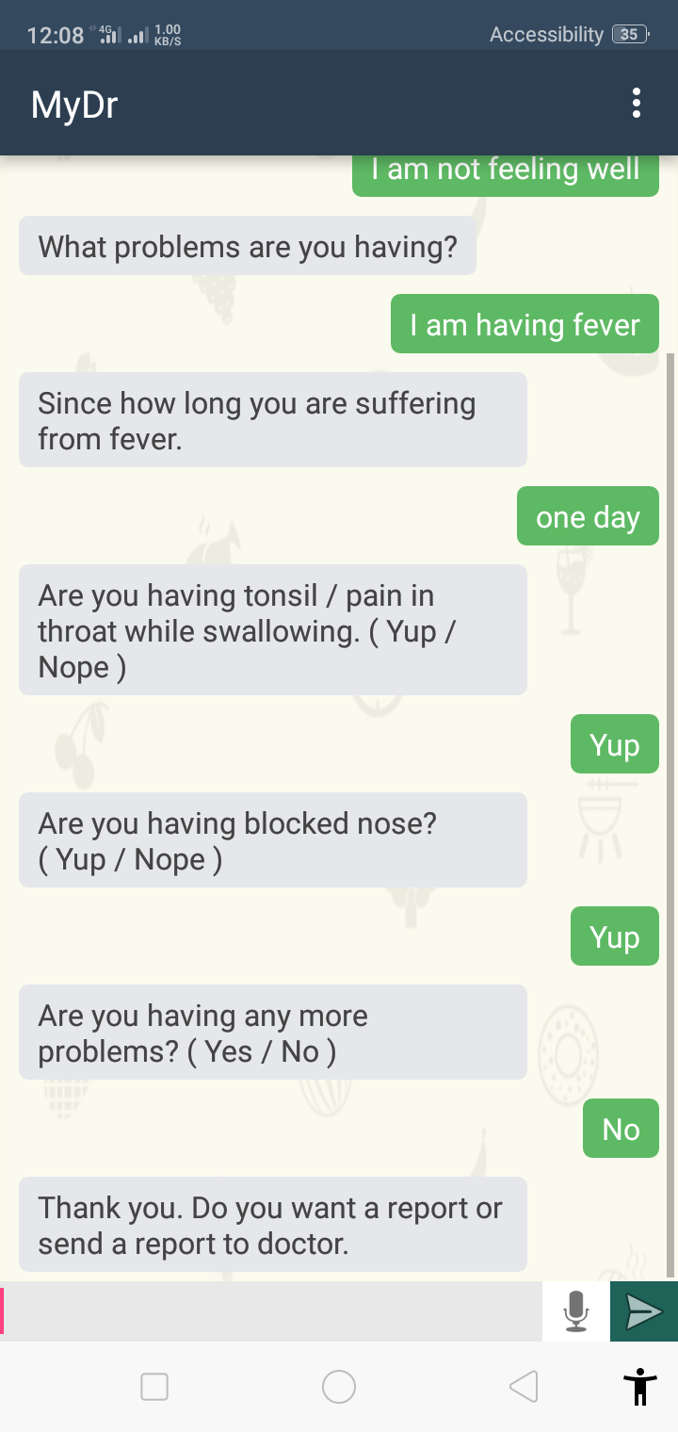

4.6
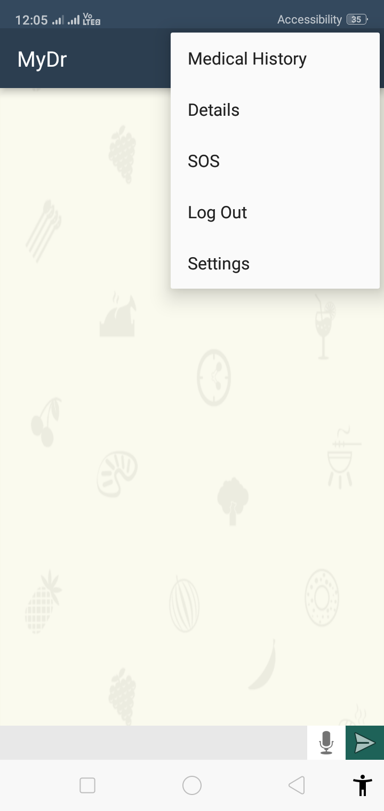
4.7
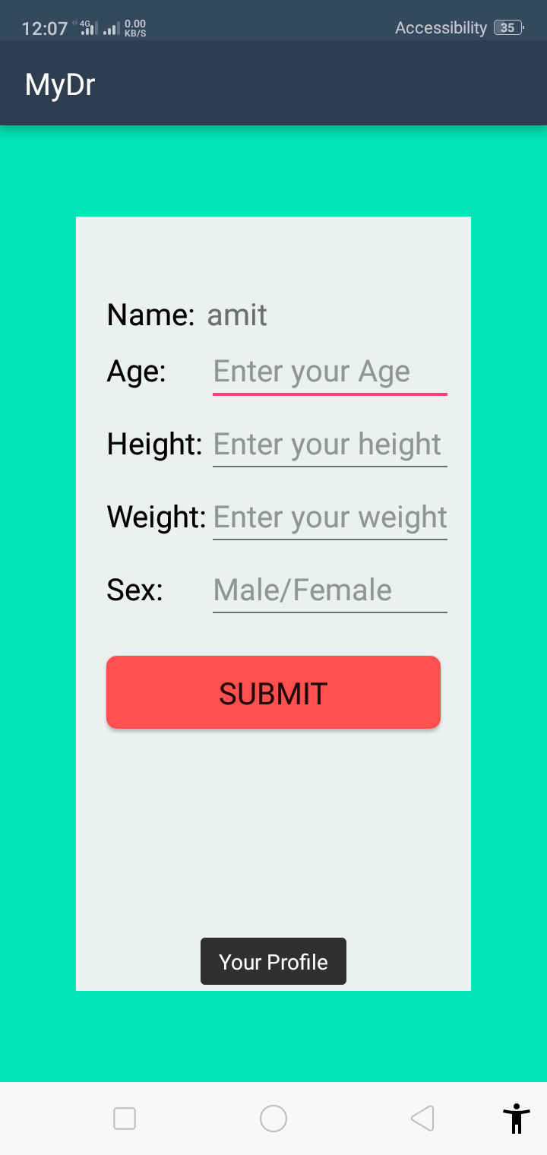

CHAPTER 6

CONCLUSION

The Android based medical diagnosis system is a system that helps user to get the appropriate information needed regarding swine flu, diabetes, TB, Asthma. Medical Diagnosis System for prediction and detection of swine flu. In order to address health problems, made attempts to design and develop expert systems which can provide advice for physicians and patients to facilitate the diagnosis and recommend treatment of Swine flu’s patients. This Expert System is also able to find comorbidities related to swine flu. This system will able to predict a comprehensive study of medical expert systems for diagnosis of swine flu.

REFERENCES

- “Medical Expert Systems for Diagnosis of Various Diseases”, Jimmy Singla ,Abhinav Bhandari, at International Journal of Computer Applications (0975 – 8887) Volume 93 – No.7, May 2014
- “Disease Diagnosis System”, Dipanwita Biswas, Sagar Bairagi , Neelam Panse & Nirmala Shinde,at Computer Department, Saraswati College of Engineering, Kharghar, Navi Mumbai Maharashtra, India, Mumbai University.
- www.pewresearch.org
- www.pandemicflu.gov

