British Tech Network - Mac

Chris Kimpton

* **Revision History**

|  |  |  |  |
| --- | --- | --- | --- |
| **Version** | **Date** | **Description** | **Author** |
| *1.0* | *2012.6.10* | * *Initial version* | *Chris Kimpton* |
|  |  |  |  |

Contents

**1** **Description of BTN-Mac App** 4

1.1 Objectives 4

1.2 Functions of BTN-Mac App 4

1.3 Brief Information 4

**2** **Description of UI Structure and detailed screen configurations** 4

2.1 Whole UI structure 4

2.2 Description of detailed screen configuration 5

**3** **Detailed UI Function Description** 5

3.1 Each functional UI description 5

3.2 Describe Input value 5

3.3 How to check multi languages(required) 6

**4** **Detailed Usage Scenario** 6

4.1 Usage Scenario 6

*Please be sure to follow this template as much as possible****, if ‘required’ items haven’t been written, a test request would be rejected***

1. **Description of BTN-Mac App**
   1. Objectives

*The app provides a front end into the British Tech Network Mac podcast on Samsung Smart TVs*

* 1. Functions of BTN-Mac App

*choice of episodes to watch.*

* 1. Brief Information

|  |  |
| --- | --- |
| **Items** | **Contents** |
| **Sound(required)** | ***Check whether Sound system is supported or not.***  □ **Yes** □ ~~No~~ |
| DRM | *None* |
| Programming Language | *Javascript* |
| External Devices | *None* |
| Single Sign-On(SSO) | □ ~~Yes~~ □ **No** |
| GeoFiltering | None |
| Other Features/  Information for testing | *None* |

1. **Description of UI Structure and detailed screen configurations** 
   1. Whole UI structure

There are *2 levels to the user interface*

* *an episode list for the channel, detailing all shows available to watch*
* *and a full screen option to watch episode*

* 1. Description of detailed screen configuration

The first screen details the episodes available to watch, as per below

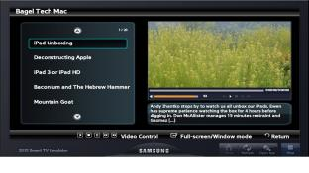

If the play button is selected for a given episode, then show is shown on the right, as per below.

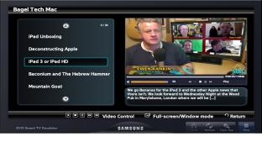

If the full screen <enter> button is pressed, the episode is played in full screen mode.



1. **Detailed UI Function Description**
   1. Each functional UI description

*Basic episode selection facility*

* 1. Describe Input value
     1. Usual movement (up/down/left/right) and play/pause/stop buttons. Enter to select and return to come out.
  2. How to check multi languages(required)
     1. Check whether multi languages are supported or not.

□ ~~Yes~~ □ **No**

*If 3.3.1 is yes, 3.3.2 & 3.3.3 should be written. If it’s no, ignore them.*

* + 1. Supported languages

*<Write all supported languages.>*

* + 1. Describe how to check it

*<If multi languages are supported, describe how to check multi languages on the App. >*

*(e.g.) change country setting to Spain on SMART HUB*

*(e.g.) change OSD Language setting to German etc..*

1. **Detailed Usage Scenario**
   1. Usage Scenario

*User selects/starts app when want to watch British Tech TV - Mac*

*User gets list of episodes available to watch*

*User selects episode and press play to watch selected episode.*