Republic of the Philippines

Department of Environment and Natural Resources

**COMMUNITY ENVIRONMENT & NATURAL RESOURCES OFFICE**

(CENRO Sara) Brgy. San Nicolas, San Dionisio, Iloilo

Email Add: [denrcenrosara@yahoo.com](mailto:denrcenrosara@yahoo.com).ph

August 3, 2022

**MEMORANDUM**

FOR : The OIC, CENR Officer

DENR-CENRO, Sara

THRU : The Chief, Conservation and Development Section

FROM : Project Support Staff

SUBJECT : **ACCOMPLISHMENT REPORT TRAVEL ORDER DATED AS OF JULY 28-29, 2022.**

In line with the above subject and in compliance to the directives per approved Travel Order (T.O), herewith are the activities conducted by the undersigned to wit:

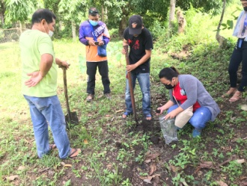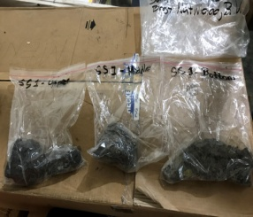

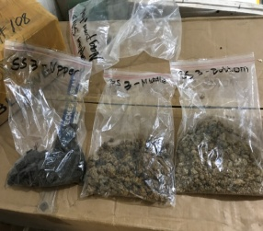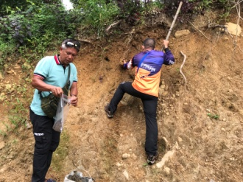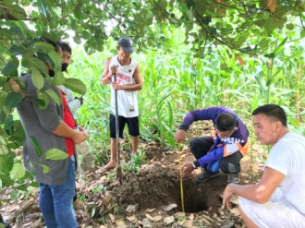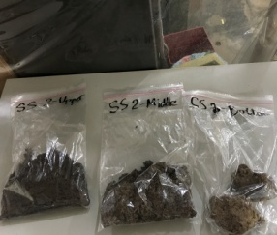On July 28-29, 2022, the undersigned together with Forester I/IWMP Asst. Team Leader Samuel G. Calaguio and representatives from MENRO and MAO of Barotac Viejo and Banate, Iloilo conducted soil sample collection at the sampling sites within Barotac Viejo Watershed, namely: Brgys. Natividad, Dela Peña and Lipata, Barotac Viejo and Brgy. Libertad, Banate, Iloilo subject for Soil Analysis as needed data for the crafting and finalization of Integrated Watershed Management Plan. Soil analysis test is one of major requirement in planning the watershed management to determine the major soil type condition and characteristics, erosion susceptibility based on soil map, influence of soil characteristics, infiltration capacity of watersheds, subsequent surface runoff, groundwater recharge and related processes and assess soil characteristics relative to the suitability of an area for crop production.

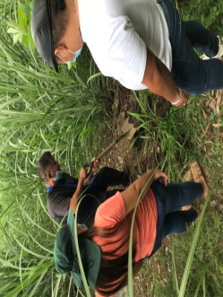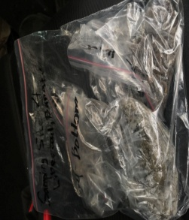Collection of soil samples from the low, middle and high elevation should follow the soil collection procedure being employed by BSWM. Considered that soil samples be taken from the topsoil (0-20cm) and subsoil (21-50cm) portion of the soil horizon. Lastly, the geographic coordinates, where the soil samples have been taken, should be recorded for the mapping and documentation process.

For information and record.

**SALVE B. SEVILLENO**

Noted by:

**EDROZA E. DOYOLA**

Senior EMS/Chief, CDS