Republic of the Philippines

Department of Environment and Natural Resources

**COMMUNITY ENVIRONMENT & NATURAL RESOURCES OFFICE**

(CENRO Sara) Brgy. San Nicolas, San Dionisio, Iloilo

Email Add: [denrcenrosara@yahoo.com](mailto:denrcenrosara@yahoo.com).ph

August 9, 2022

**MEMORANDUM**

FOR : The OIC, CENR Officer

DENR-CENRO, Sara

THRU : The Chief, Conservation and Development Section

FROM : Project Support Staff

SUBJECT : **ACCOMPLISHMENT REPORT TRAVEL ORDER DATED AS OF AUGUST 4-5, 2022.**

In line with the above subject and in compliance to the directives per approved Travel Order (T.O), herewith are the activities conducted by the undersigned to wit:

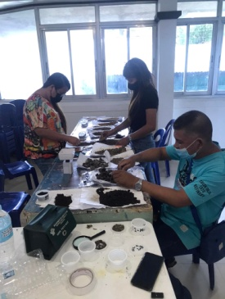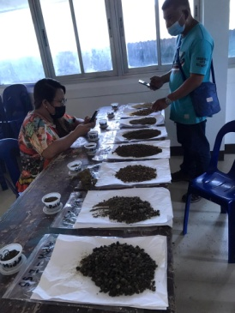

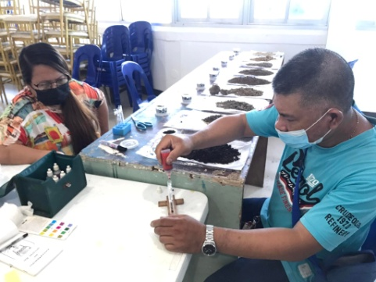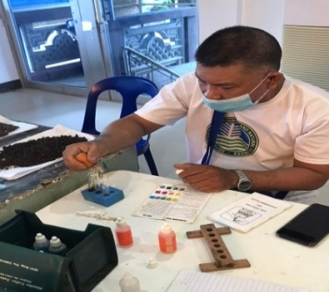On August 4-5, 2022, the undersigned together with Forester I/IWMP Asst. Team Leader Samuel G. Calaguio and representatives from MENRO and MAO of Barotac Viejo, Iloilo conducted soil analysis of the collected samples from the lower, middle and upper elevation within Barotac Viejo Watershed. Soil analysis test is one of major requirement in planning the watershed management to determine the major soil type condition and characteristics, erosion susceptibility based on soil map, influence of soil characteristics, infiltration capacity of watersheds, subsequent surface runoff, groundwater recharge and related processes and assess soil characteristics relative to the suitability of an area for crop production. Soil collected were air dried and powdered in preparation for soil sampling analysis using soil test kit. Essential features such as soil color, structure and texture were also conducted prior to the NPK and pH test. Soil color indicates the presence of minerals and the organic matter in the soil. The Team used the Munsell color chart in determining the soil color. Soil texture or relative proportions of various size groups was determined using the feel or roll method. Soil structure is defined by the way individual particles of sand, silt, and clay are assembled. Single particles when assembled appear as larger particles (aggregates). The circulation of water in the soil varies greatly according to structure, therefore, it is important for us to know about the structure of the soil. Together, soil texture and soil structure have the greatest influence on pore space in a soil, and how easily air, water, and roots can move through a soil. NPK and pH test were done using a soil test kit. Soil pH or soil reaction is an indication of the acidity or alkalinity of soil and is measured in pH units. NPK (Nitrogen, Phosphorus and Potassium) stands for the three major nutrients that plants need to live and grow. The Team also followed up the request for water analysis as well as the provision of water sampling containers. The Team will be updated for the approval and instructions from EMB regarding the schedule of the water sample collection.

For information and record.

**SALVE B. SEVILLENO**

Noted by:

**EDROZA E. DOYOLA**

Senior EMS/Chief, CDS