Republic of the Philippines

Department of Environment and Natural Resources

**COMMUNITY ENVIRONMENT & NATURAL RESOURCES OFFICE**

(CENRO Sara) Brgy. San Nicolas, San Dionisio, Iloilo

Email Add: [denrcenrosara@yahoo.com](mailto:denrcenrosara@yahoo.com).ph

August 22, 2022

**MEMORANDUM**

FOR : The OIC, CENR Officer

DENR-CENRO, Sara

THRU : The Chief, Conservation and Development Section

FROM : Project Support Staff

SUBJECT : **ACCOMPLISHMENT REPORT TRAVEL ORDER DATED AS OF AUGUST 10-12, 2022.**

In line with the above subject and in compliance to the directives per approved Travel Order (T.O), herewith are the activities conducted by the undersigned to wit:

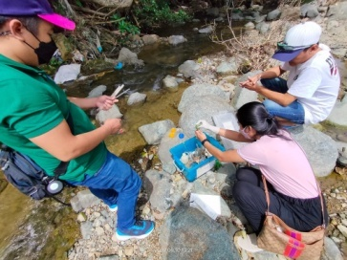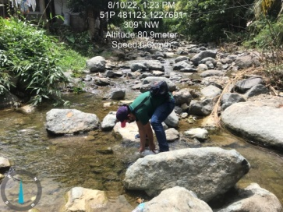

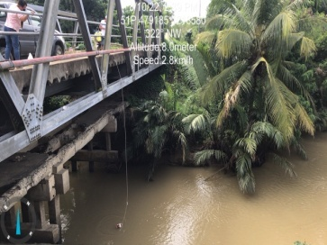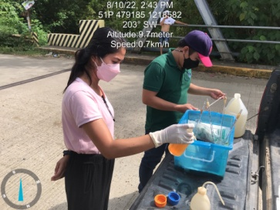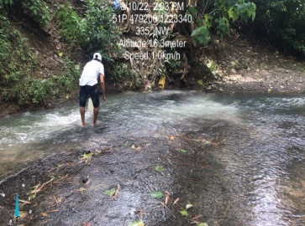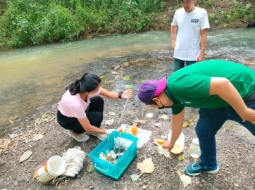On August 10, 2022, the undersigned together with Jose Redentor Francisco of Environmental Management Bureau (EMB)-Region VI and MENRO-designate Baby Joy Baldelovar of Barotac Viejo, Iloilo conducted water sample collection from upstream (Sitio Nagpana, Brgy. Lipata, Barotac Viejo), midstream (Brgy. California, Barotac Viejo) and downstream (Brgy. Libertad) within the Barotac Viejo Watershed subject for quality analysis (laboratory). On-site analysis including dissolve oxygen (DO), temperature and pH were performed and recorded. Other parameters/observations such as weather condition, time of sampling and visual color of water were also noted.

On August 11-12, 2022, the undersigned gathered pertinent information for the data gaps needed in the crafting and finalization of Integrated Watershed Management Plan.

For information and record.

**SALVE B. SEVILLENO**

Noted by:

**EDROZA E. DOYOLA**

Senior EMS/Chief, CDS