How to control the effect?
-You can adjust the Rotation at the Z-axis to change the direction of the effect.
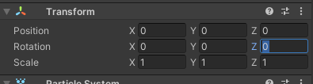
-The BeamEffect has 2 main elements: Beam and Power_Accumulation.
You can change the length of beam at the element of the Beam (has text (Control)).
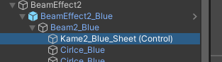
You can change the number of the Length Scale to change the length of the Beam.
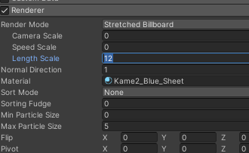
-If you have any questions, you can send me mail. I will support you.
My mail: letuananh0401@gmail.com
Thank you so much.
Sincerely,

