

All Sports Blockchain Open Platform

**NOTICE**

NOTHING IN THIS WHITEPAPER CONSTITUTES LEGAL, FINANCIAL, BUSINESS OR TAX ADVICE AND YOU SHOULD CONSULT YOUR OWN LEGAL, FINANCIAL, TAX OR OTHER PROFESSIONAL ADVISER BEFORE ENGAGING IN ANY ACTIVITY IN CONNECTION HEREWITH. NEITHER ALL SPORTS FOUNDATION LTD. (THE **FOUNDATION**), ANY OF THE PROJECT TEAM MEMBERS WHO HAVE WORKED ON THE ALL SPORTS PLATFORM (AS DEFINED HEREIN) OR PROJECT TO DEVELOP THE ALL SPORTS PLATFORM IN ANY WAY WHATSOEVER (THE **ALL SPORTS TEAM**) NOR ANY SERVICE PROVIDER SHALL BE LIABLE FOR ANY KIND OF DIRECT OR INDIRECT DAMAGE OR LOSS WHATSOEVER WHICH YOU MAY SUFFER IN CONNECTION WITH ACCESSING THIS WHITEPAPER, THE WEBSITE AT [HTTP://ALLSPORTSCHAIN.COM](http://ALLSPORTSCHAIN.COM/) OR ANY OTHER MATERIALS PUBLISHED BY THE FOUNDATION.

All contributions will be applied towards the Foundation's objects, including without limitation promoting the research, design and development of, and advocacy for a decentralised, globalised sports blockchain platform which is deeply rooted in the sports industry ecosystem, enabling free-­‐flow of sharing and transmission of values by all users and participants in the industry and a variety of blockchain-­‐based applications in the sports industry, and promoting the safe and harmonious development of the open source blockchain community ecosystem.

This Whitepaper is intended for general informational purposes only and does not constitute a prospectus, an offer document, an offer of securities, a solicitation for investment, or any offer to sell any product, item or asset (whether digital or otherwise). The information herein below may not be exhaustive and does not imply any elements of a contractual relationship. There is no assurance as to the accuracy or completeness of such information and no representation, warranty or undertaking is or purported to be provided as to the accuracy or completeness of such information. Where this Whitepaper includes information that has been obtained from third party sources, the Foundation and/or the All Sports team have not independently verified the accuracy or completion of such information.

This Whitepaper does not constitute any offer by the Foundation or the All Sports team to sell any SOC (as defined herein) nor shall it or any part of it nor the fact of its presentation form the basis of, or be relied upon in connection with, any contract or investment decision. Nothing contained in this Whitepaper is or may be relied upon as a promise, representation or undertaking as to the future performance of the All Sports Platform. The agreement between the Foundation (or its affiliate) and you, in relation to any sale and purchase of SOC is to be governed by only the separate terms and conditions of such agreement.

By accessing this Whitepaper or any part thereof, you represent and warrant to the Foundation, its affiliates and the All Sports team as follows:

1. you acknowledge, understand and agree that SOC may have no value, there is no guarantee or representation of value or liquidity for SOC, and SOC is not for speculative investment;
2. none of the Foundation, its affiliates, and/or the All Sports team members shall be responsible for or liable for the value of SOC, the transferability and/or liquidity of SOC and/or the availability of any market for SOC through third parties or otherwise;
3. in any decision to purchase any SOC, you have not relied on any statement set out in this Whitepaper;
4. you will and shall at your own expense ensure compliance with all laws, regulatory requirements and restrictions applicable to you (as the case may be); and
5. you acknowledge, understand and agree that you are not eligible to purchase any SOC if you are a citizen, national, resident (tax or otherwise), domiciliary and/or green card holder of a geographic area or country (i) where it is likely that the sale of SOC would be construed as the sale of a security (howsoever named) or investment product and/or (ii) in which access to or participation in the SOC token sale or the All Sports Platform is prohibited by applicable law, decree, regulation, treaty, or administrative act, and/or (including without limitation the United States of America, New Zealand, People's Republic of China and the Republic of Korea).

The Foundation and the All Sports team do not and do not purport to make, and hereby disclaims, all representations, warranties or undertaking to any entity or person. Prospective purchasers of SOC should carefully consider and evaluate all risks and uncertainties (including financial and legal risks and uncertainties) associated with the SOC token sale, the Foundation and the All Sports team.

The information set out in this Whitepaper is for community discussion only and is not legally binding. The agreement for sale and purchase of SOC shall be governed by a separate set of Terms and Conditions or Token Purchase Agreement (as the case may be) setting out the terms of such purchase (the **Token Purchase Agreement**), which shall be separately provided to you or made available at [http://allsportschain.com.](http://allsportschain.com/) In the event of any inconsistencies between the Token Purchase Agreement and this Whitepaper, the Token Purchase Agreement shall prevail.

All statements contained in this Whitepaper, statements made in press releases or in any place accessible by the public and oral statements that may be made by the Foundation and/or the All Sports team may constitute forward-­‐looking statements (including statements regarding intent, belief or current expectations with respect to market conditions, business strategy and plans, financial condition, specific provisions and risk management practices). You are cautioned not to place undue reliance on these forward-­‐looking statements given that these statements involve known and unknown risks, uncertainties and other factors that may cause the actual future results

to be materially different from that described by such forward-­‐looking statements. These forward-­‐looking statements are applicable only as of the date of this Whitepaper and the Foundation and the All Sports team expressly disclaims any responsibility (whether express or implied) to release any revisions to these forward-­‐ looking statements to reflect events after such date.

This Whitepaper may be translated into a language other than English and in the event of conflict or ambiguity between the English language version and translated versions of this Whitepaper, the English language version shall prevail. You acknowledge that you have read and understood the English language version of this Whitepaper.

No part of this Whitepaper is to be copied, reproduced, distributed or disseminated in any way without the prior written consent of the Foundation.

# Section 1: Abstract

With the increasing popularity of blockchain technology, All Sports public blockchain hopes to fill the space for blockchain-­‐based applications in the sports industry through blockchain technology, which is a sun-­‐rise industry all over the world.

All Sports public blockchain makes use of blockchain technology, which combines application and business situations of sports industry and sports ecosystem chain, and will issue its native cryptographic token All Sports Coin (**SOC**) for use on the All Sports public blockchain. With the help of smart contracts and token systems, it offers both convenient payment and settlement and application development agreement for developers, and it is planned that the ecosystem will support sports information and community open platforms, sports IP asset trading and promoting platforms, prediction entertainment platforms, application open platforms etc.

Developers and ecosystem partners would be able to develop and access their own applications and resources in All Sports public blockchain, and realise customer acquisition quickly through information and community open platforms. Further, these ecosystem partners may achieve their aim of value transfer and token consumption through sports IP asset trading and promoting platforms, prediction entertainment platforms and application open platforms. The role of All Sports public blockchain is to assist developers to finish application development and resources monetising through the usage of SOC with APIs of key applications.

The Foundation's aim is to create a decentralised, globalised sports blockchain platform which is deeply rooted in the sports industry ecosystem, enabling free-­‐flow of sharing and transmission of values by all users and participants in the industry, and a variety of blockchain-­‐based applications in the sports industry.

The Foundation has strong technical capability and offline resources integration capability. It has also reached consensus with the world's largest mobile football media and community, the world's top sports betting suppliers and service providers, and the world's top sports stars on blockchain cooperation, allowing it to build All Sports public blockchain with strong industry support.

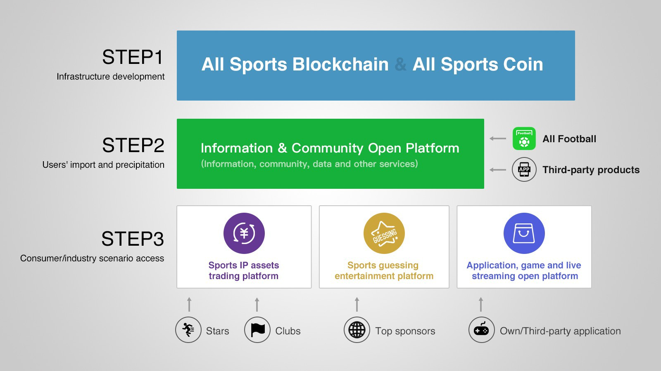

# Section 2: Background Introduction and Market Opportunity

## Background

In 2017 the annual output value of global sports industry is nearly 2 trillion U.S. dollars, including various categories such as competitive sports, recreational sports and emerging e-­‐sports. The market size is very huge and it covers a wide range of areas. Athletes, clubs, teams, events, brokerage firms, venues, equipments, training institutions and media form the perfect and evolving ecosystem chain of sports industry.

With the development and growth of Internet, especially of mobile Internet, sports industry has been massively migrating from traditional channels to mobile Internet and expanded continuously through the mobile Internet. Information, data, live streams, videos and other contents have spread rapidly with mobile Internet. With the help of mobile Internet's capability, social communities and networks of sports users in the world are built to further expand influence and user stickiness of sports industry at the same time.

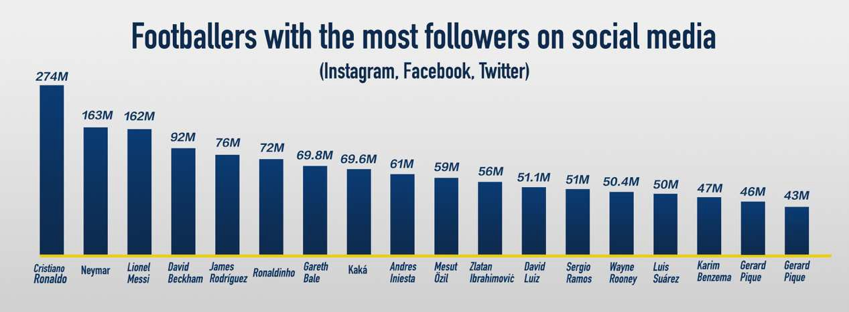

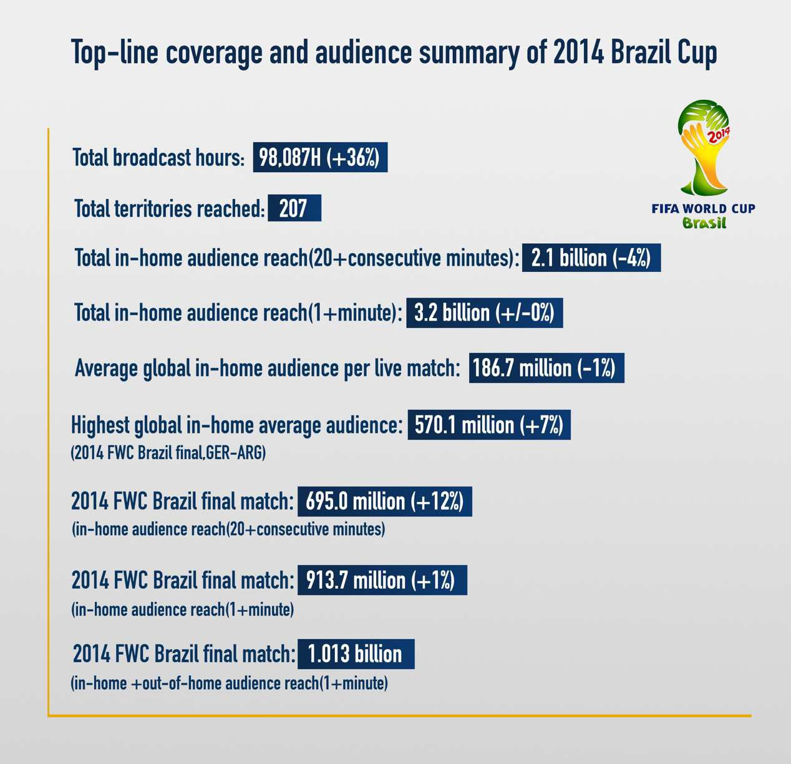

Sponsored derivatives (based on IP licensing) as well as sports betting have become the two largest sources of commercial revenue for sports industry.

Neymar’s transfer to Paris Saint-­‐Germain for an astronomical 220 million euros, Floyd Mayweather and Connor McGregor’s cross-­‐border game made more than 600 million US dollars, and Dota2 TI7 grabbed over 10 million US dollars for the champion.

These cases all reflect that in sports industry, top IPs and top stars contain huge commercial values. Every single IP (individual or organisation) in this industrial chain has its commercial value, which does not exist independently, but is determined by demand in the industrial chain. The higher the degree of demand is, the higher the value of IP assets; the faster and wider the value delivers, the higher the commercial efficiency of IP assets.

IP licensing includes portrait rights, advertising photography, offline activities, authorised derivatives, social media and so forth. Traditional IP licensing negotiations relies on peer-­‐to-­‐peer communications between advertising agencies and IP brokers.

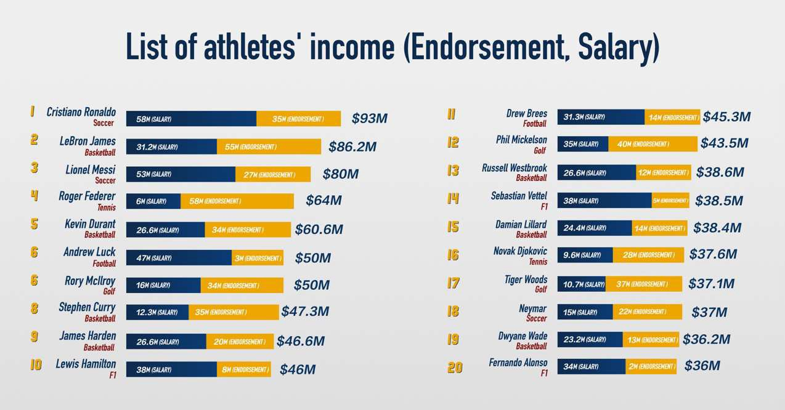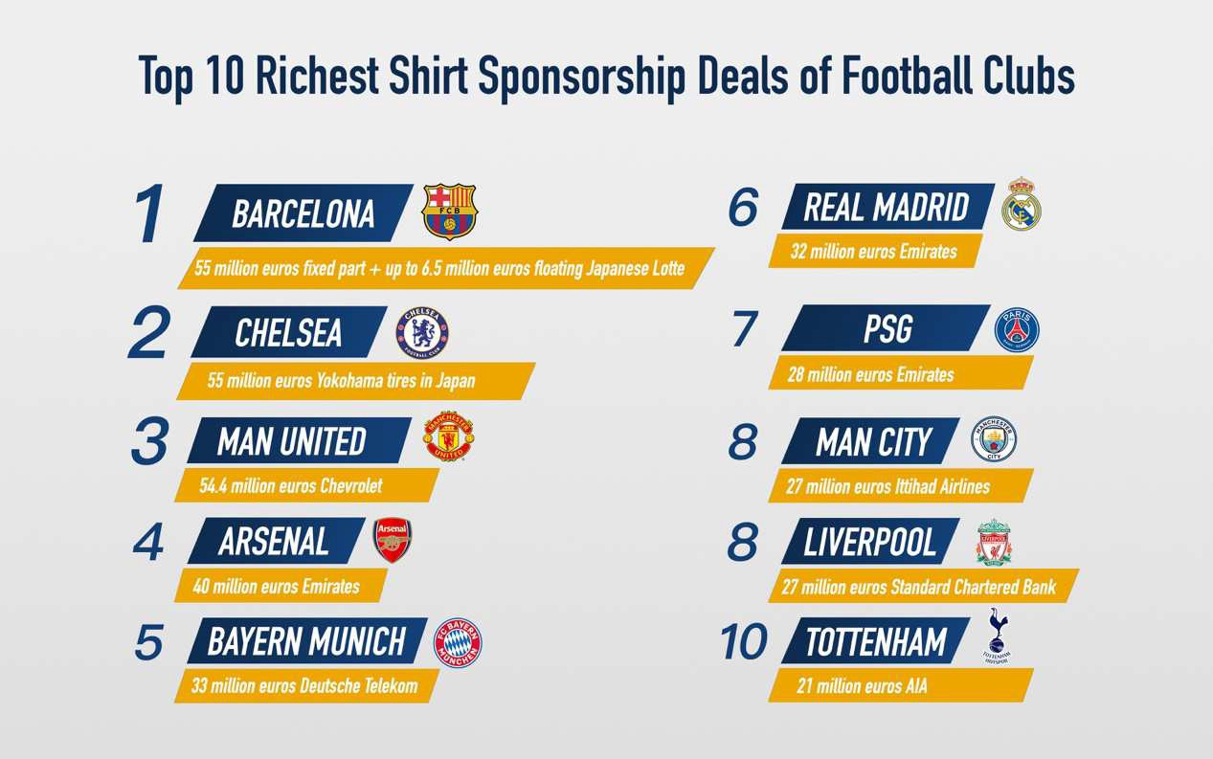

Nowadays more than 100 countries and regions in the world have declared that betting industry is legal. According to data from British betting companies, the global betting market is estimated to reach as high as 536 billion dollars in 2017.

With the addition of various underground betting markets, it is estimated that the market size has reached over one trillion dollars. The U.S. betting market is 166.2 billion dollars, accounting for 30% of the global market, which ranks the first. The related department has said that by 2020, the global online betting market is expected to grow rapidly at an annual rate of 11% after investigation and analysis.

## The global betting market total value and share are as follows:

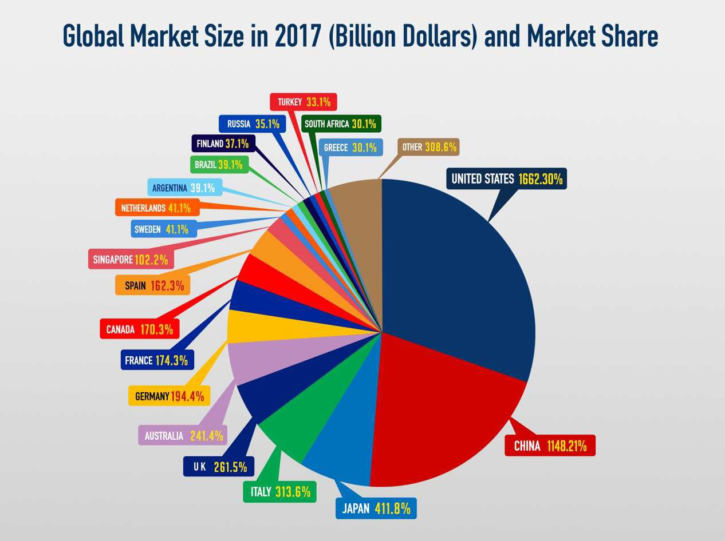

* 1. **Pain point of Market**

Sports industry market is very huge, online sports information & community is now the largest application scenarios for users while sports IP and betting are the best ways for realisation and income in sports industry.

*Sports information & community*

The spread of sports industry, the exertion of its influence, and the interaction between IPs and fans have all transferred to mobile Internet in large numbers. However, there are still many problems in modes and systems of sports information and community on the mobile Internet, which are specifically as follows:

* The authentication mechanism of content value lags behind and now the content of media is generated by a centralised platform-­‐generated content model. The definition of value is based on output cost and profit return, which results in a "factory-­‐type" centralised processing mode. However, there are many subjects involved in the spatiotemporal distribution of sports information. Users' demands for information contents and forms are rich and varied, which makes the cost of meeting needs is very high.
* With a lack of user identity mechanism, online sports communities are closed.

Except for the real iconic characters, users need to create their own image from 0 to 1 in each community, which will lead to the slow integration of new people into the community and community growth.

* The system of incentive mechanism is poor. The largest community members are a large number of non-­‐KOL users who simply speak and quietly praise. These users are handling information, reading posts, giving likes, commenting and sharing to help the entire community. However, these activities which build the ecosystem are not fairly rewarded under the current system.
* It is difficult for commercial communities to commercialise the value which they have created. Due to the poor structure of incentive mechanism and the fragile relationship between sports communities and their large number of users, it is difficult to integrate two into one single subject, which makes it even more difficult to realise during the business process of intervention into users.

*Asset trading of sports IPs*

Although the commercial value of sports IP assets has been recognised by the society, there are still many problems in the overall development. The concrete manifestation is as follows:

* The lack of a centralised platform for sports IP assets to display their information and the low level of transparency of information lead to the decrease of the value of many assets, which increases the cost and the threshold for investors and content providers (i.e. of games, application, media) (**CP**) to obtain information for IP transaction and business value at the same time as well.
* Sports IP builds a primary market by its own owners or brokers, but Sports IP lacks sufficient resources to build a secondary market. This is the main reason why the commercial value has not been effectively determined and released.
* Sports IP lacks sufficient market-­‐oriented pricing mechanism and means of estimating. Under the existing centralised system, the IP business value strongly depends on the point-­‐to-­‐point information transfer separated by the broker or the marketing team and the CP, and mastery of asymmetric information becomes a key factor in price negotiations. As a whole, Both IP and CP do not maximise their revenues or profits.
* The value of sporting IP assets is largely determined by fans and consumers, but there is a chasm between assets and fans which is that there is no link between the actions of fans and the value of the sporting IP asset. Fans do not share in the rise in the asset value of IP assets, while IP assets do not drive fans to create value quickly.
* Moreover, the demand side of asset operations also need to spend a large amount of money to reach fans and consumers through numerous means after obtaining the authorisation to use assets. Therefore, the utilisation efficiency of commercial value of assets needs to be improved urgently.
* The difficulty of ownership belonging judgement and default risk in IP asset trading process is high. The operation and commercial realisation of sports IP assets often have a large number of cross-­‐border transactions, and the settlement is complicated.

*Betting*

Presently, there exists centralised betting service providers consisting of large-­‐scale betting establishments that hold licenses in countries which are friendly to betting activities, and many underground betting companies. However, there are still many problems in operation and trading:

* First of all, there are regional restrictions. The regulation of currencies by various countries has resulted in the inability to support global betting payments.
* Second place, there are trust issues with payments. Users’ trust in claim payments depends only on the trustworthiness of the banker and the platform, especially when there is a risk at the complex and long-­‐term payment and delivery.
* Odds and changes in handicap are not transparent. Betting rules, betting, information concerning betting outcomes are not open and transparent. For dealers there is room for fraud and misconduct.
* In the third place, inability to pay immediately. With the development of time and the change of odds, bettors can choose to cash in advance, but the existing centralised mechanism can only rely on dealers’ limited repurchase.
* Last but not the least, there are also privacy and security protection. There is risk in users’ privacy and financial security.

*Games & Applications*

Now most sports games and applications are on mobile terminals, but the current mobile ecosystem is a typical closed ecosystem, which brings some problems to sports games and applications:

* Pricing and value of users’ acquisition process are not transparent, the mainstream of CPT, CPA access to acquire users need to be paid in advance for

exposure and start-­‐up, of whom it takes a certain period of time to clear the actual value of users, however. So, there is a risk of loss of investment in game / application production. In CPS mode, the final effect of realisation is mastered in the traffic or CP side with a risk of deduction, which makes it hard to promote the cooperation.

* More and more games become similar or same with each other. As games can issue in-­‐game currency freely, a large number of games are inflating the in-­‐game currency supply to deprive users of value, rather than creating value for users to get rewarded through quality and rich gameplays.
* It is difficult to get IP resources. In order to obtain users and enhance the experience, applications always need the authorisation of IP. However, in reality there is a big difficulty in acquiring IPs, which is a consequence of the opacity in IP asset transactions.

# Section 3: All Sports Public Blockchain and SOC

## Abstract

All Sports Public Blockchain uses SOC as the medium to combine sports industry and the application and business environment of sports ecosystem chain by blockchain technology.

The All Sports platform is based on the use of smart contract and token system to provide developers with a convenient and complete set of interface protocols for payment and settlement as well as application development (the **All Sports Platform**)

-­‐ including sporting contents, online community, IP asset trading and its promoting platform, sports prediction platform, sports apps and gaming platforms, etc.

The All Sports Platform aims to use blockchain technology to provide open platform services for decentralised sports ecosystem chain, giving all business participants transparent application development services and business realisations through operation of blockchain ecosystem chain and tokenisation of assets in order to achieve business goals.

All Sports offers an open-­‐source blockchain ecosystem platform to record all participants' interactions in the community as well as participants' transactions in different scenarios, such as IP asset trading promotion, gaming and entertainment by the use of decentralised account.

SOC is a major component of the ecosystem on the All Sports Platform. SOC is a digitally-­‐encrypted virtual currency based on blockchain and smart contract technology that is tailored to sporting contents, community-­‐based incentives and spendings on different scenarios. SOC is a non-­‐refundable functional utility token which will be used as the unit of exchange (e.g. for smart contracts and trade of digital assets) between participants on the All Sports Platform on the All Sports Platform.

SOC does not in any way represent any shareholding, participation, right, title, or interest in the Foundation, its affiliates, or any other company, enterprise or undertaking, nor will SOC entitle token holders to any promise of fees, revenue, profits or investment returns, and are not intended to constitute securities in Singapore or any relevant jurisdiction. SOC may only be utilised on the All Sports Platform, and ownership of SOC carries no rights, express or implied, other than the right to use SOC as a means to enable usage of and interaction with the All Sports Platform. SOC is an integral and indispensable part of the All Sports Platform, because in the absence of SOC, there would be no common unit of exchange for services provided on the All Sports Platform, thus rendering the ecosystem on the All Sports Platform unsustainable.

In particular, you understand and accept that SOC:

1. is non-­‐refundable cannot be exchanged for cash (or its equivalent value in any other virtual currency) or any payment obligation by the Foundation or any affiliate;
2. does not represent or confer on the token holder any right of any form with respect to the Foundation (or any of its affiliates) or its revenues or assets, including without limitation any right to receive future revenue, shares, ownership right or stake, share or security, any voting, distribution, redemption, liquidation, proprietary (including all forms of intellectual property), or other financial or legal rights or equivalent rights, or intellectual property rights or any other form of participation in or relating to the All Sports Platform, the Foundation and/or its service providers;
3. is not intended to be a representation of money (including electronic money), security, commodity, bond, debt instrument or any other kind of financial instrument or investment;
4. is not a loan to the Foundation or any of its affiliates, is not intended to represent a debt owed by the Foundation or any of its affiliates, and there is no expectation of profit; and
5. does not provide the token holder with any ownership or other interest in the Foundation or any of its affiliates.

The contributions in the token sale will be held by the Foundation (or its affiliate) after the token sale, and contributors will have no economic or legal right over or beneficial interest in these contributions or the assets of that entity after the token sale.

To the extent a secondary market or exchange for trading SOC does develop, it would be run and operated wholly independently of the Foundation, the sale of SOC and the All Sports Platform. The Foundation will not create such secondary markets nor will it act as an exchange for SOC.

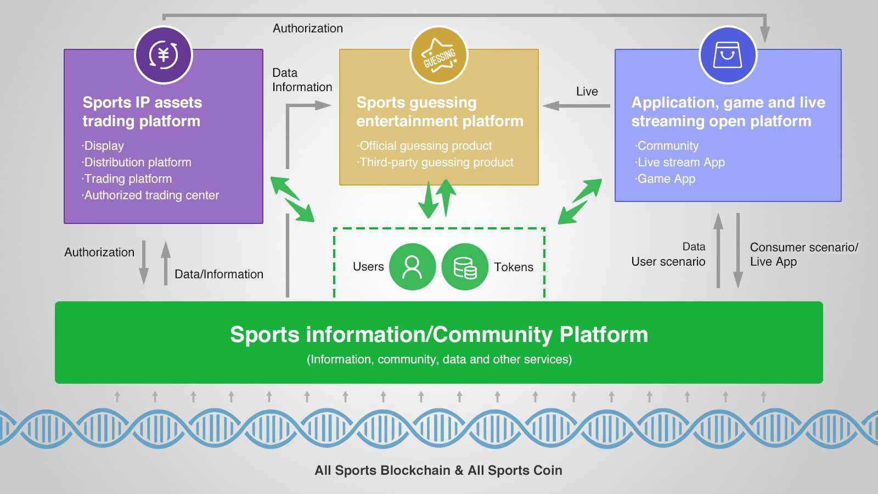

## Open Platform for Contents and Community

The open All Sports Platform for contents and community will comprise the All Sports public blockchain which allows third parties to build their decentralised applications, with SOC used as the medium of exchange as well as the incentive to incentivise ecosystem community building.

The All Sports Platform will combine platform-­‐generated content, user-­‐generated, and developers to provide contents / information, community features, live play, data and other services to attract and retain users as well as provide service for consumption scene.

These processes would require an open and transparent pricing system designed for various aspects such as content supplement, interactive supplement and service consumption. All incentives to be paid by All Sports Platform will be settled by SOC.

* Users: Online activities which promote the development of the ecosystem on the All Sports Platform (e.g. reading, evaluating, sharing, and reporting spams on various content / topics) will be tagged. Tags will classify the behavior of users in an open and transparent manner, and users will obtain SOC as incentives for positive behaviour. SOC is required to pay for community items when using community apps, and SOC will be deducted when users post spam information and violate community rules.
* Platform-­‐generated content: Flexible dynamic registration and fragmented production are reflected. Higher quality content is rewarded by more SOC, thus promoting the generation of higher quality content on the All Sports Platform.

Platform-­‐generated content would have to provide an assurance payment in SOC before being given access to the initial distribution. Contents will be examined through objecting criteria such as clicks received, number of times shared or reported by users, as well as other interactive feedback means. Higher quality content will be rewarded with extra SOC, while poorer quality content will lead to a deduction of assurance payment.

* Developer: Developers are able to develop third party applications and services on the All Sports Platform, and offer them for use by users (e.g. a variety of community services, such as emojis, live score push notifications). Payment for these applications and services will be made in SOC (based on usage of service), and developers distributing and promoting their own services would need to pay SOC to the All Sports Platform for service fee.
* All Sports Platform: For each transaction in the ecosystem on All Sports Platform, the platform will charge a certain service fee, which will be applied towards the objects of the Foundation (including development of ecosystem, expansion, as well as construction, maintenance and development of All Sports Platform).

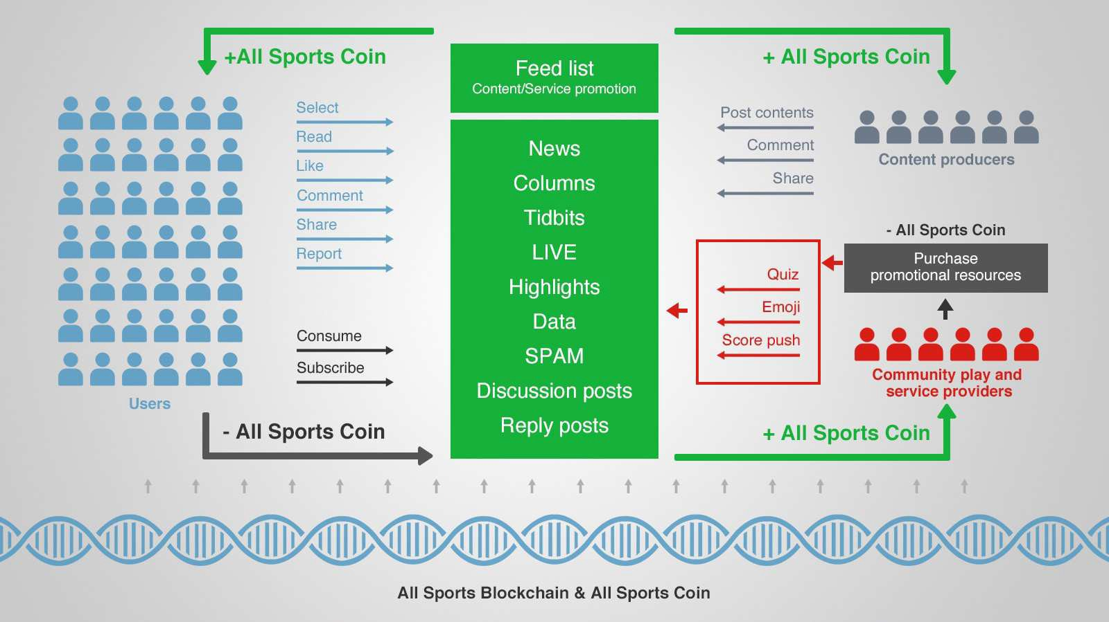

## Sports IP asset trading platform

Sports IP asset trading platform connects the sports IP asset owners, supporters, fans, content providers to fulfil the integration of industry resources, the delivering of values and the promotion of the sports industry development as well as evolution.

The platform is based on the All Sports public blockchain and SOC. It consists of an IP asset display platform, an IP asset distribution platform (primary market), IP asset transactions (secondary market), and an IP authorised transaction centre.

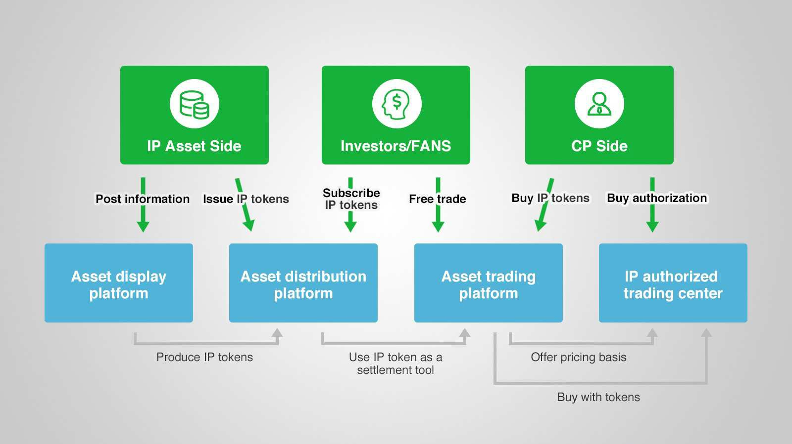

*Platform Features*

* IP asset display platform: Portal entrance with content information service, search and inquiry service, making the information of IP assets fully transparent and facilitating the value transmission and diffusion.
* IP asset distribution platform (primary market): A platform to first release the IP assets and distribute them through the form of additional IP token. The total number of each IP token is fixed, while the proportion of the initial distribution of shares cannot be too much nor too little. Payment through SOC is the only way supported on the platform.
* IP asset trading platform (secondary market): Circulating IP tokens are introduced. Supporters and fans are able to trade IP tokens on the trading platform with SOC, to bring the price of IP assets in line with the market.
* IP authorised transaction centre: IP asset owners set the reserve price settled in IP tokens in minutes so as to derive the total amount of time. What’s more, owners should execute that to their authorised materials with a time share, so that CP can redeem them after purchase . CPs who have gained IP authorisation can purchase IP tokens through the secondary market and also be able to purchase the licenses.

*Economic system*

* Party with IP assets

-­‐ Enroll in an asset distribution platform and then issue IP tokens which are named

after the respective IP, in exchange for SOC from supporters and fans. Thereafter, the issued IP tokens would enter the secondary market.

-­‐ Set the reserve price settled by IP tokens and also the total amount of time; Execute that to their authorised materials with a time share, so that CP can redeem them after purchase.

-­‐ Publish IP information on a regular basis according to the size of transactions of IP authorisation so as to regularly release all rights of proceeding.

-­‐ Attract fans and supporters onto the platform with IP’s own influence to encourage more asset trading activities.

* Supporters and fans

-­‐ Buy and sell IP tokens on asset trading platforms through SOC held, and potentially share in the value of the underlying IP.

* CPs

-­‐ Buy IP tokens on the asset trading platform and then bid for the IP authorisations on IP authorised transaction centre, in order to be entitled to use that IP in their own products and services in order to achieve commercial realisation.

-­‐ Attract IP supporters and fans to their own products and services so that precise promotion and the empowerment of IP can be achieved.

* All Sports Platform

-­‐ Charge each transaction a transaction fee, which will go to the Foundation for follow-­‐up platform construction and maintenance, expansion of platform ecosystem partners and more IP cooperation inclusion in order to enhance the overall ecosystem value.

## Prediction and entertainment platform

All Sports Prediction and Entertainment Platform is a set of ecosystem services built on the All Sports Platform, public blockchain and SOC. It provides the world with underlying and basic technical services for sports prediction and entertainment.

The market volume or user base for sports prediction is very large, which provides a strong economic base and broad application prospects for this service.

*Ecosystem composition*

* Global prediction and entertainment providers can implement various online entertainment scenarios and applications through API (Application Programming Interface) and SDK (Software Development Kit) provided by the All Sports Platform.
* Users can participate in prediction markets or organise their own prediction games through the usage of SOC.

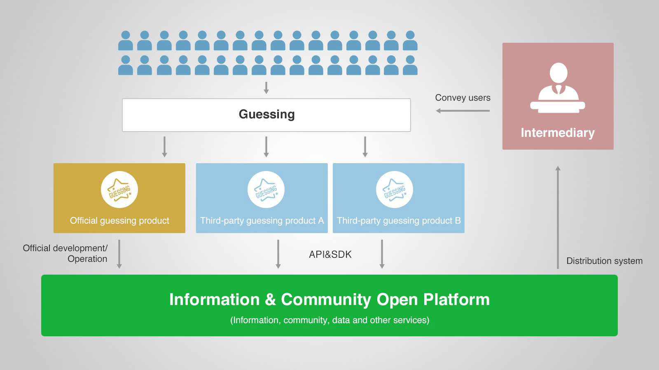

*Service system*

* Network platform: The prediction platform on the All Sports Platform focuses on the global online market, and intends to build a full-­‐dimensional and matrix network of prediction service system. In addition to building the underlying SDK based on the All Sports public blockchain, it also provides customised user-­‐end application, including but not limited to PC end, H5 webpage, App(iOS & Android), mini programme, etc. It also supports various consumer-­‐to-­‐consumer OTC activities with underlying technology.
* Third-­‐party vendor access: For all sports prediction providers worldwide, game makers and other non-­‐blockchain online prediction platforms around the world, All Sports public blockchain provides smart contract templates and frameworks, application components, customised APIs and SDKs to reduce the threshold of online prediction game development.
* Network distribution: For worldwide intermediaries, it provides a smart distribution system, including user overview, offline management, commission settings, financial sub-­‐accounts and other functions.

*Advantages of blockchain technology*

* Open, transparent and without tampering: Blockchain technology can guarantee prediction participants (wallet address), prediction rules, betting, results and other information will be set out in an open, transparent and tamper-­‐proof manner.

It is envisaged that all Sports public blockchain would completely erase obsolete bad habits such as cheating, fraud, etc., as well as allegations faced by innocent online prediction platforms and the dealers.

Also, as it is based on a completely open and transparent environment that is supervised by the public, All Sports Platform aims to rebuild the reputation of the sports prediction industry, enhancing participants' contractual spirit and maintaining a good platform order.

* Smart contract delivery: Through a customised smart contract to achieve a variety of gaming scenarios and different levels of complexity of the code delivery and the usage of the All Sports public blockchain, the All Sports Platform can prevent the risk of default among participants, ensuring the interests of all parties can be deducted or delivered in a safe, timely and smooth platform.

The default smart contract can also be used to implement the forward code delivery. Once the trigger condition is reached, the smart contract will be executed or will provide evidence right away.

* Encryption protection: Wallet address (representing participants), digital tokens and other blockchain data are the encryption features that can effectively protect the information security of all participants, enhancing the reputation of the platform and improving the service level of the platform.
* No more traditional geographical restrictions: Users can either play through any client ends on All Sports public prediction entertainment platform (collectively referred to as OTC) anytime, anywhere, or play through the blockchain wallet using token to self-­‐organise consumer-­‐to-­‐consumer's OTC game.

This allows people around the world to overcome the geographical barriers and use their fragmented time anytime, anywhere to participate.

## Applications and games’ open platform

Third party developers will be able to use SDK and API interfaces provided by the All Sports public blockchain to develop applications and games. These applications and games may be promoted to users on the All Sports Platform and/or charge users a

usage fee through the payment of SOC.

All games and apps provided by CPs -­‐ and also the props and functions in these games

-­‐ use SOC for open and transparent pricing. All users' consumer behaviors are decentralised through the All Sports Platform. The non-­‐privacy information and attributes of all users in the platform are all publicly available by the CP. Therefore, CP can directly acquire target users and thus do their promotion.

## Exclusive wallet

The All Sports Platform will offer a digital wallet to assist members of the community (including users and third party developers) to manage their SOC.

Basic features such as viewing of amount, transfer, etc. of SOC can be realised. It also helps participants manage their own accounts, as well as use of payment for a wide range of apps and consumer scenarios across the platform.

As a result, it becomes a unified wallet system for the entire platform, recording the users' income and expenditures and the flow of SOC.

## Technical realisation

Blockchain technology is used to record all trading information and user information on the open All Sports Platform in a native decentralised ledger.

By submitting a smart contract, it specifies basic open-­‐economy rules for the entire platform, addressing the trading and incentive issues in various communities and consumer scenarios on the platform, and ensuring that the ecosystem of the entire platform is open and transparent.

Distributed database will store media information of large capacity. These include basic information about community and contextual user profiles, contents published by platform-­‐generated content and user-­‐generated content, live streaming, IP asset trading, prediction entertainment, gaming and the needs of third party application.

Based on blockchain technology and distributed repositories, the All Sports Platform is a set of basic clearing systems and open platform interface protocols supported by smart contracts and token systems, and the earliest developers will set the rules and start off the development.

Application layer bases itself on the All Sports public blockchain to implement various applications. Start-­‐up members will work as a team to first develop applications such as information (contents) and community applications, IP asset trading, business applications such as prediction entertainment, live broadcast applications and wallet

applications, etc. Anyone and any third party software can contribute their own applications to the platform of All Sports public blockchain.

# Section 4: Partners on the ecosystem platform

Concurrently with the launch of the All Sports Platform, the Foundation has struck a strategic partnership with All Football, the world's largest football media and community. All Football will be the first to gain access to the information and community open platform and the games/apps open platform.

As of the date of writing, All Football has nearly 60 million loyal fans worldwide, mainly in England, Argentina, Nigeria, Ghana, Spain and other English and Spanish speaking countries, with approximately 1 million daily active users.

Manchester City, West Bromwich Albion, Schalke 04, RCD Espanyol, Crystal Palace, Birmingham City, Cardiff City, Leeds United clubs have all settled on All Football.

Top IPs such as Cristiano Ronaldo, Roberto Baggio and Inter Milan have signed and gained access into the IP asset trading platform. On the one hand, the Foundation will work hard to exert influence to attract fans to the All Sports Platform; On the other hand it will strive to recruit more well-­‐known IP assets to enhance the ecosystem on the All Sports Platform.

The world's top providers of sports prediction information and services will be able to gain access to All Sports prediction entertainment platform. In the prediction entertainment platform, third-­‐party entertainment service providers may grant access to their products and enrich the types of games to make the ecosystem more vibrant and ful-­‐filled. At the same time, third-­‐party service providers can support SOC through their SDKs or APIs on their own web-­‐based platforms.

# Section 5: All Sports Public Blockchain Foundation

## The establishment of All Sports Foundation

Considering the internationalisation of the All Sports Platform and native public chain, the Foundation had been established in Singapore.

The foundation devotes itself to the research, design and development of, and advocacy for a decentralised, globalised sports blockchain platform which is deeply rooted in the sports industry ecosystem, enabling free-­‐flow of sharing and transmission of values by all users and participants in the industry and a variety of blockchain-­‐based applications in the sports industry, and promoting the safe and harmonious development of the open source blockchain community ecosystem

## Foundation structure

The foundation structure of All Sports Public Blockchain Foundation includes operational processes and protocols for everyday work and special situations.

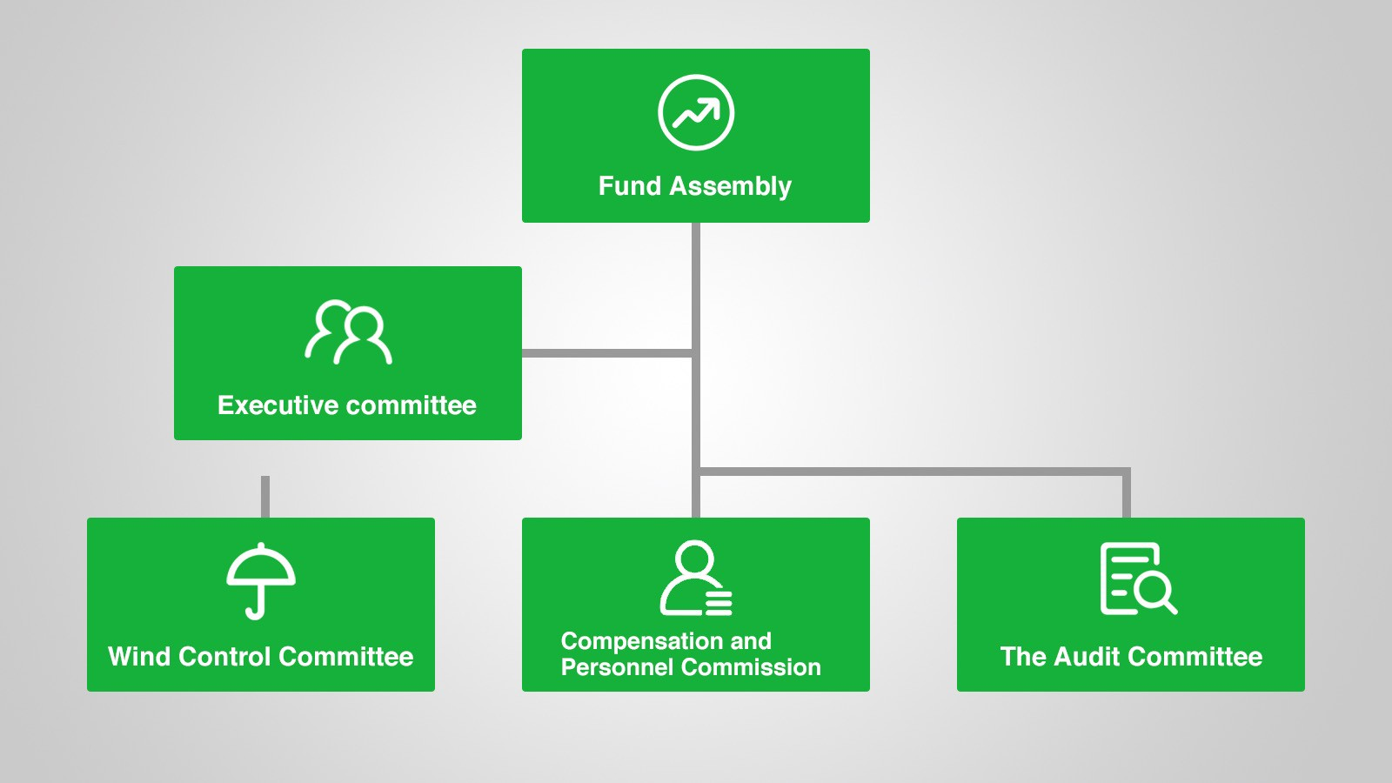

## Functions of various committees

* Board of Directors:

Study and formulate long-­‐term plans, manage the use of resources for the development of the All Sports Platform, constitute regulations and management systems, analyse and approve the feasibility of new projects, and manage daily operations of All Sports Public Blockchain.

* Risk Control Committee:

Research and formulate risk control strategies, develop risk control standards, review overall operational risks, convene risk review meetings for projects and reveal the outcomes of reviews.

* Compensation and Personnel Committee:

Formulate and modify remuneration, incentive programs, audit institutions and post settings, take charge of staff recruitment.

* Audit Committee:

Responsible for operational audit, financial audit, and code audit.

# Section 6: Team Introduction and Advisory Group

**Early Contributors and Advisory Team:**







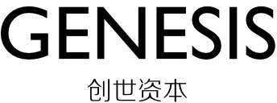



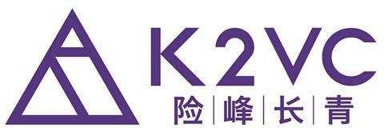

# Section 7: Development Plan and Timetable

Development plan for All Sports Platform and public blockchain.

**Update the plan and timetable in 2018/2/7**

|  |  |
| --- | --- |
| **Time** | **Event** |
| **2018 Q1** | Completion of underlying structure design. Secure more than one partners for SOC for using and consumption. Develop and improve the platform and relative application for sports betting and entertainment platforms. Increase incentives for the support of the underlying system. |
| **2018 Q2** | Complete the SOC’s opening and thus increase relative incentives in society, etc.. Start the development of sports entertainment application in order to promote a wider scale of sports betting and entertainment. Secure business partners. |
| **2018 Q3** | Beta version of the sports entertainment platform goes online and starts testing. |
| **2018 Q4** | Completion of public blockchain development and beginning of testing. |
| **2019 Q1** | Completion of relocation of public blockchain. |
| **2019 Q2** | Completion of development of sports prediction entertainment platform. |

# Section 8: Token Release Plan

1.5 billion SOC will be issued in total, and distributed as follows:

1. 40% of SOC issued (600 million) will be sold in the private sale, to a maximum of 149 purchasers.
2. 40% of SOC issued (600 million) will be held by the Foundation for ecosystem incubation, incubation, marketing, commercial development, legal compliance, etc. to maintain the rapid prototyping and subsequent healthy and sustained development of communities and the entire ecosystem on the All Sports Platform.
3. 20% of SOC issued (300 million) will be issued to incentivise and motivate the founding and development team. The All Sports team has done much work in terms of project design, resource organisation, incubation of the pre-­‐commercial environment and various other aspects, and continuously input manpower resources, intelligence and material inputs in shaping the ecosystem. This incentive will be released over four years – one quarter will be released in the first year, and one quarter will be released each year thereafter.

# Section 9: Risks

You acknowledge and agree that there are numerous risks associated with purchasing SOC, holding SOC, and using SOC for participation in the All Sports Platform.

## Uncertain Regulations and Enforcement Actions

The regulatory status of SOC and distributed ledger technology is unclear or unsettled in many jurisdictions. It is impossible to predict how, when or whether regulatory agencies may apply existing regulations or create new regulations with respect to such technology and its applications, including SOC and/or the All Sports Platform. Regulatory actions could negatively impact SOC and/or the All Sports Platform in various ways. The Foundation (or its affiliates) may cease operations in a jurisdiction in the event that regulatory actions, or changes to law or regulation, make it illegal to operate in such jurisdiction, or commercially undesirable to obtain the necessary regulatory approval(s) to operate in such jurisdiction.

After consulting with a wide range of legal advisors and continuous analysis of the development and legal structure of virtual currencies, the Foundation will apply a cautious approach towards the sale of SOC. Therefore, for the crowdsale, the Foundation may constantly adjust the sale strategy in order to avoid relevant legal risks as much as possible.

## Competitors

It is possible that alternative networks could be established that utilise the same or similar code and protocol underlying SOC and/or the All Sports Platform and attempt to re-­‐create similar facilities. The All Sports Platform may be required to compete with these alternative networks, which could negatively impact SOC and/or the All Sports Platform.

## Loss of Talent

The development of the All Sports Platform depends on the continued co-­‐operation of the existing technical team and expert consultants, who are highly knowledgeable and experienced in their respective sectors. The loss of any member may adversely affect the All Sports Platform or its future development.

## Failure to develop

There is the risk that the development of the All Sports Platform will not be executed or implemented as planned, for a variety of reasons, including without limitation the event of a decline in the prices of any digital asset, virtual currency or SOC, unforeseen

technical difficulties, and shortage of development funds for activities.

## Security weaknesses

Hackers or other malicious groups or organisations may attempt to interfere with SOC and/or the All Sports Platform in a variety of ways, including, but not limited to, malware attacks, denial of service attacks, consensus-­‐based attacks, Sybil attacks, smurfing and spoofing. Furthermore, there is a risk that a third party or a member of the Foundation or its affiliates may intentionally or unintentionally introduce weaknesses into the core infrastructure of SOC and/or the All Sports Platform, which could negatively affect SOC and/or the All Sports Platform.

## Other risks

In addition to the aforementioned risks, there are other risks (as more particularly set out in the Token Purchase Agreement) associated with your purchase, holding and use of SOC, including those that the Foundation cannot anticipate. Such risks may further materialise as unanticipated variations or combinations of the aforementioned risks. You should conduct full due diligence on the Foundation (and its affiliates), the All Sports team, understand the overall framework and vision for the All Sports Platform prior to purchasing SOC.