Practical DBMS
Name : Kimsan
Roll No: 2338138
Submitted to: Dr. Geethanjali Kher
Course: Bsc (P) Physical Science with Computer Science
SQL Code:

create database company;
use company;

# create table of department and employee
create table dept (
deptno integer,
dname varchar(200),
loc varchar(200),
primary key(deptno)
);
create table emp(
empno integer,
ename varchar(200),
job varchar(200),
mgr varchar(200),
hiredate date,
sal decimal,
comm decimal,
deptno integer,
primary key(empno),
foreign key(deptno) references dept(deptno)
);

# department table
insert into dept(deptno, dname, loc) values
(10, 'ACCOUNTING', 'NEW YORK'),
(20, 'RESEARCH', 'DALLAS'),
(30, 'SALES', 'CHICAGO'),
(40, 'OPERATIONS', 'BOSTON');

# employee table
insert into emp(empno, ename, job, mgr, hiredate, sal, comm, deptno) values
(7369, 'SMITH', 'CLERK', 7902, '1980-12-17', 800, NULL, 20),
(7499, 'ALLEN', 'SALESMAN', 7698, '1981-02-20', 1600, 300, 30),
(7521, 'WARD', 'SALESMAN', 7698, '1981-02-22', 1250, 500, 30),
(7566, 'JONES', 'MANAGER', 7839, '1981-04-02', 2975, NULL, 20),
(7654, 'MARTIN', 'SALESMAN', 7698, '1981-09-28', 1250, 1400, 30),
(7698, 'BLAKE', 'MANAGER', 7839, '1981-05-01', 2850, NULL, 30),
(7782, 'CLARK', 'MANAGER', 7839, '1981-06-09', 2450, NULL, 10),
(7788, 'SCOTT', 'ANALYST', 7566, '1982-12-09', 3000, NULL, 20),
(7839, 'KING', 'PRESIDENT', NULL, '1981-11-17', 5000, NULL, 10),
(7844, 'TURNER', 'SALESMAN', 7698, '1981-09-08', 1500, 0, 30),
(7876, 'ADAMS', 'CLERK', 7788, '1983-01-12', 1100, NULL, 20),
(7900, 'JAMES', 'CLERK', 7698, '1981-12-03', 950, NULL, 30),
(7902, 'FORD', 'ANALYST', 7566, '1981-12-04', 3000, NULL, 20),
(7934, 'MILLER', 'CLERK', 7782, '1982-01-23', 1300, NULL, 10);

select*from dept;


select*from emp;
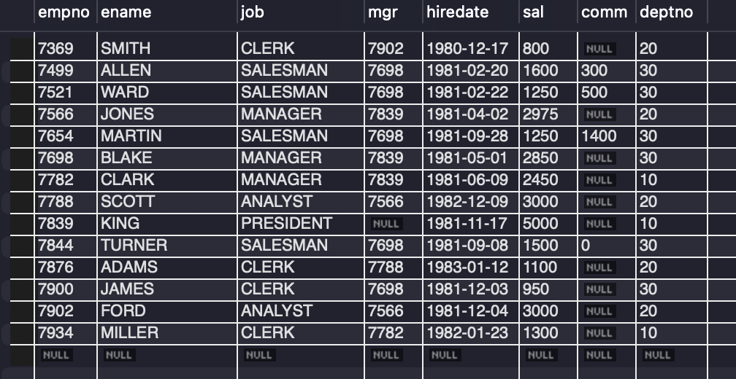

select * from emp, dept where emp.deptno = dept.deptno;
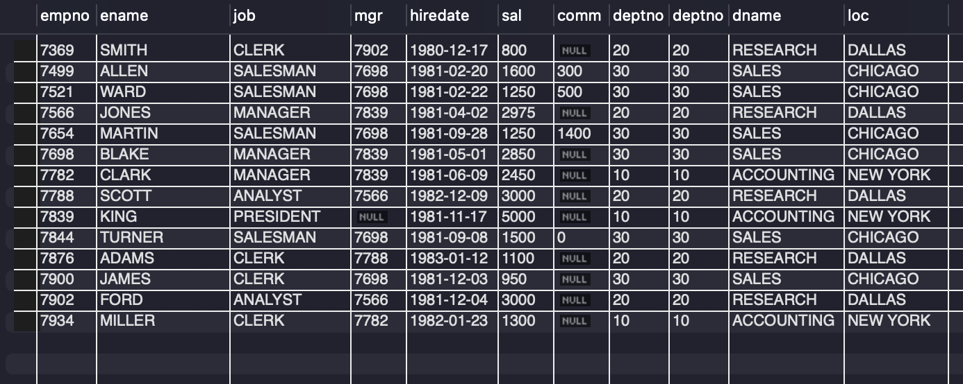

select ename from emp;


select deptno, empno, mgr from emp;
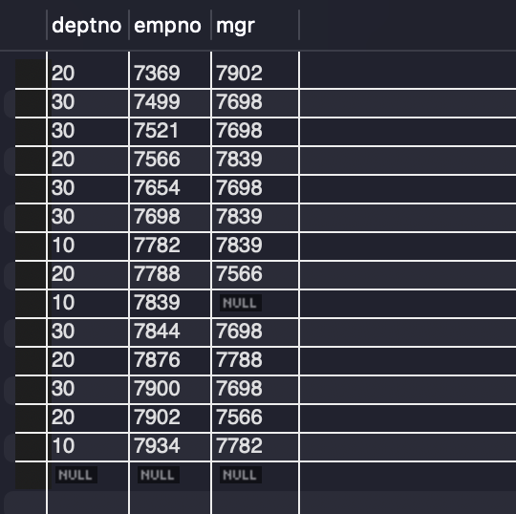

select dname, loc from dept;
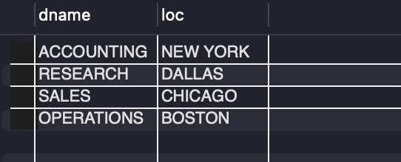

select ename, sal from emp;
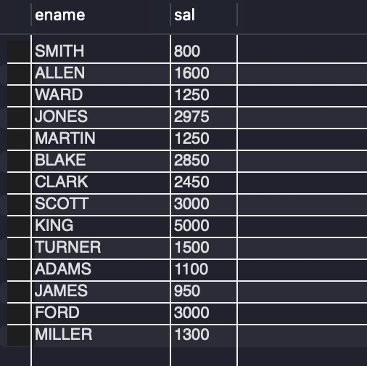

select ename, sal, sal*0.1 from emp;
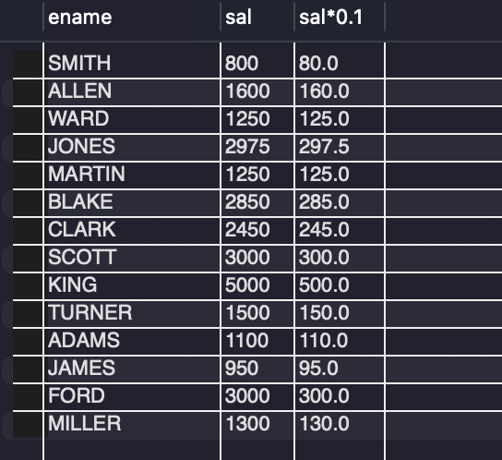

select ename, sal, sal*0.1 as "PF" from emp;
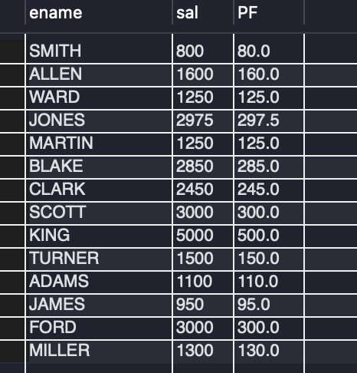

select empno, sal, comm, sal+comm "Total Salary" from emp;
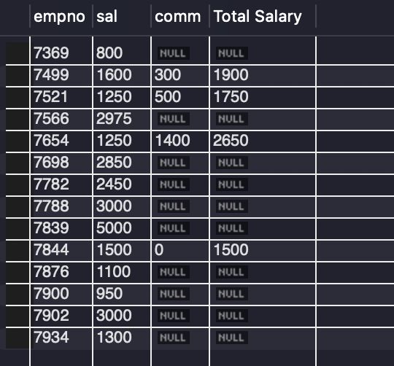

select empno, sal, comm, ifnull(comm,0)+sal as "Total Salary" from emp;
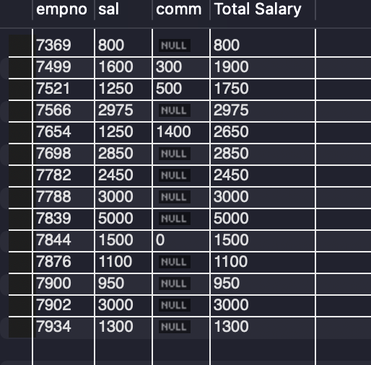

-- operator used
select * from emp where deptno=20;
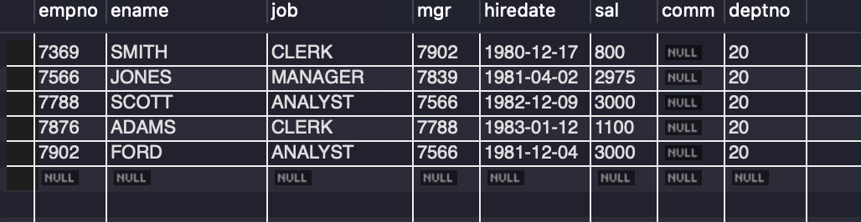

select ename, sal from emp where sal>1000;
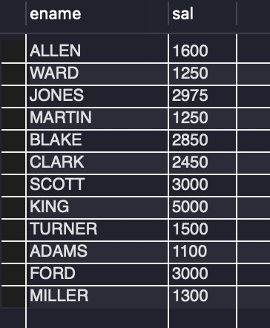

select ename, job from emp where job='clerk' and deptno=30;


select ename, job from emp where job='salesman' or job='analyst';
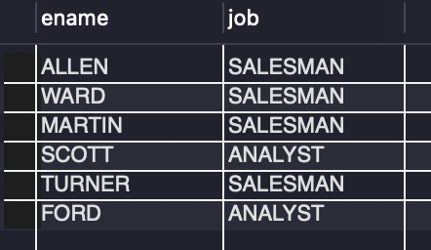

select empno, ename from emp where job!='manager';
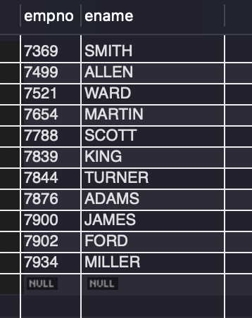

select ename, empno from emp where empno=7369 or empno=7521 or empno=7839 or empno=7934;
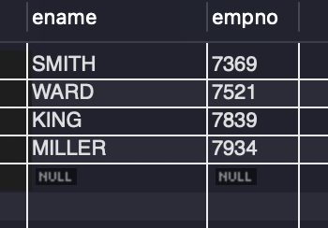

select ename, empno from emp where empno in(7369,7521,7839,7934);
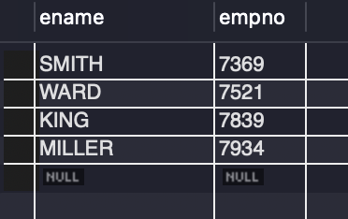

select * from emp where deptno not in (10,30,40);
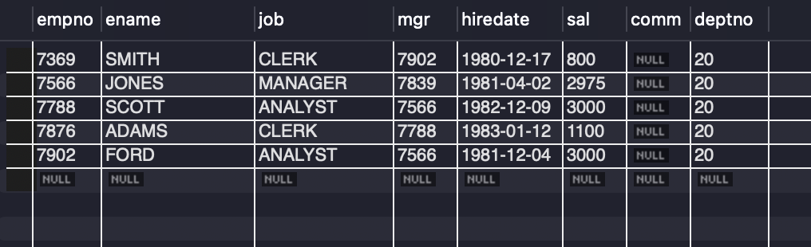

select * from emp where sal>=1000 and sal<=2000;
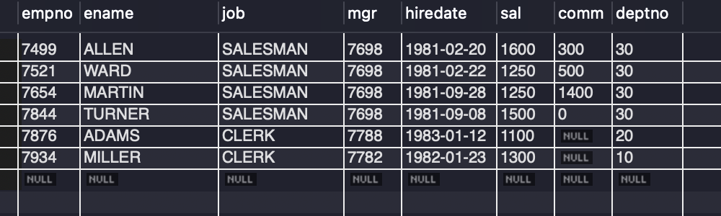

select * from emp where sal between 1000 and 2000;
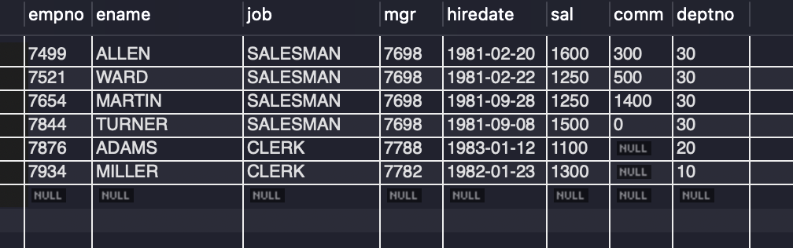

select ename from emp where ename like 's%';
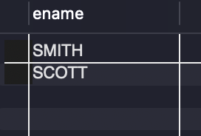

select ename from emp where ename like '_i%';
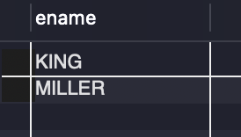

select * from emp where ename like '____';
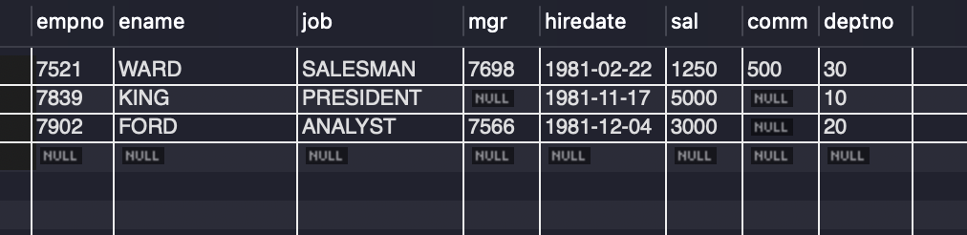

select job from emp;
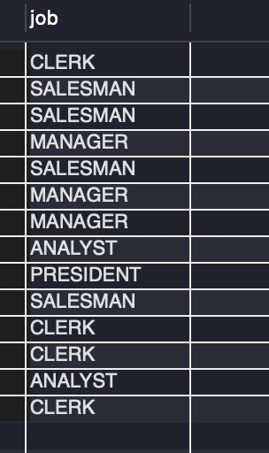

select distinct job from emp;


select * from emp where mgr is NULL;
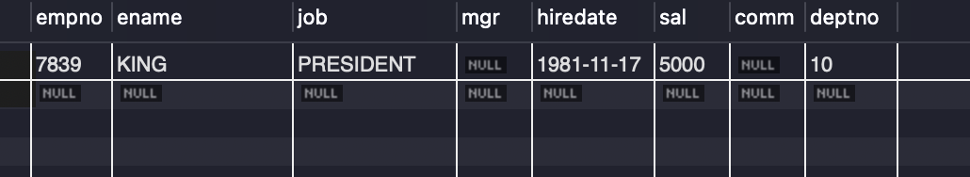
select * from emp order by ename;
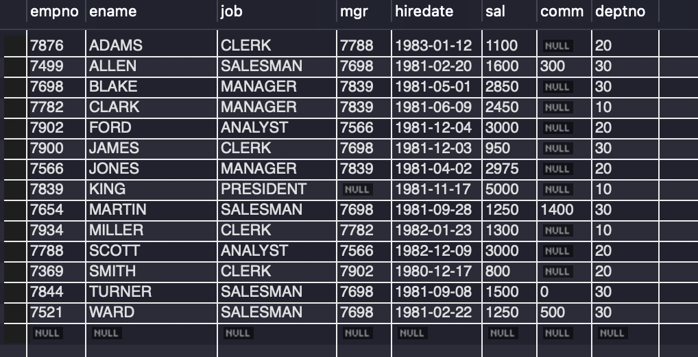

select * from emp where sal>2000 order by job, ename;
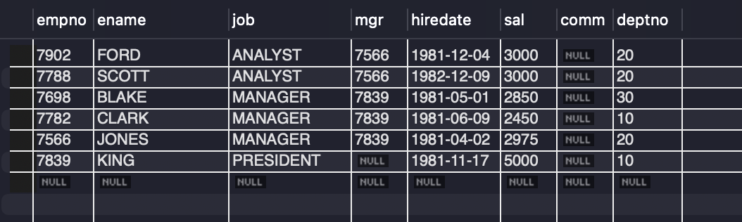

select * from emp where sal>2000 order by job, sal desc, ename;
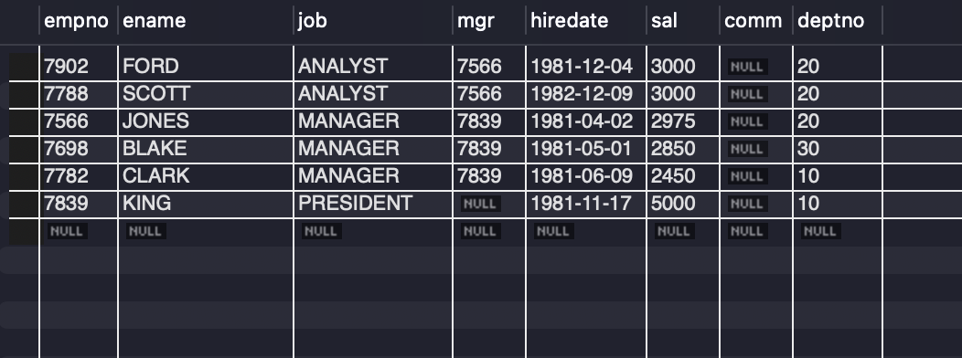

-- aggregate function

select count(*) from emp;


select count(comm) from emp;
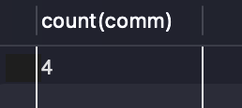

select sum(sal) from emp where job='manager';


select min(sal) from emp where job="salesman";


select ename, sal from emp where sal=(select min(sal) from emp where job="salesman");
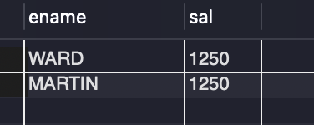

select deptno, count(*) from emp group by deptno;


select job, avg(sal) from emp where job!= 'clerk' group by job order by job desc;
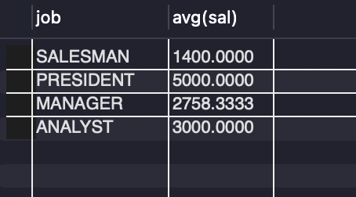

select deptno, avg(sal) from emp group by deptno having count(*)>5;
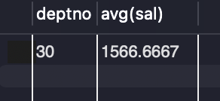

select job, sum(sal), max(sal) from emp where deptno=20 group by job having sum(sal)>5000 order by sum(sal);
