Practical Data Mining I

Name : Kimsan
Roll No: 2338138
Submitted to: Dr. Gagan Soni Sir
Course: Bsc (P) Physical Science with Computer Science

Practical I: Apply data cleaning techniques on any dataset (e.g., Paper Reviews dataset in UCI repository).
Techniques may include handling missing values, outliers and inconsistent values. A set of validation rules can be prepared based on the dataset and validations can be performed.

'''
Aim:
Apply data cleaning techniques on any dataset (e.g., Paper Reviews dataset in UCI repository).
Techniques may include:
1. handling missing values.
2. outliers and inconsistent values.
3. A set of validation rules can be prepared based on the dataset and validations can be performed.
'''

# import necessary library for our practical
import pandas as pd
import numpy as np
import matplotlib.pyplot as plt
import seaborn as sns
from sklearn.impute import SimpleImputer
from sklearn.ensemble import IsolationForest

# load the dataset
df = sns.load_dataset("titanic")

# overview of the dataset
print(df.head())
print(df.shape)
print(df.dtypes)
print(df.isnull().sum()) # isna() can also be used
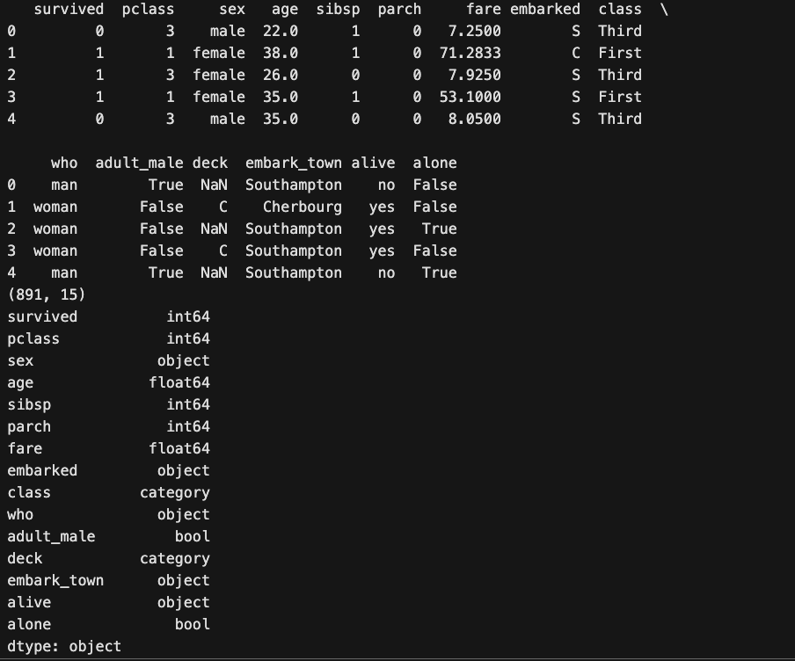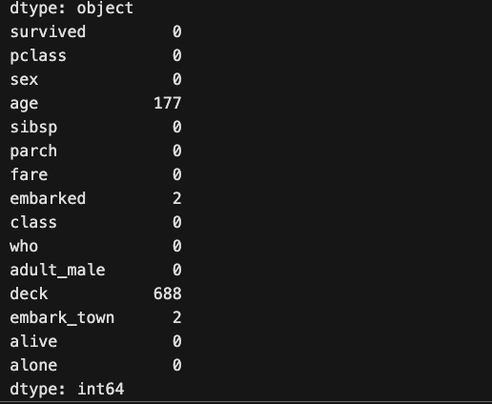

# Step 1: Handling missing value using SimpleImputer
print("\nMissing values before cleaning:\n", df.isnull().sum())

# Fill numeric missing values with mean
num_cols = df.select_dtypes(include=['float64', 'int64']).columns
imputer = SimpleImputer(strategy='mean')
df[num_cols] = imputer.fit_transform(df[num_cols])

# Categorical columns → Fill missing with mode
cat_cols = df.select_dtypes(include=['object', 'category']).columns
for col in cat_cols:
df[col].fillna(df[col].mode()[0], inplace=True)

print("\nMissing values after cleaning:\n", df.isnull().sum())

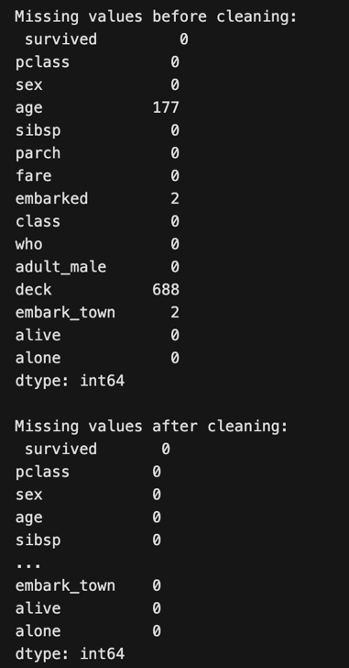
# Step 2: Detecting outliers and Removing using Isolation Forest
# Visualize before removal
numeric_cols = df.select_dtypes(include=['float64', 'int64']).columns
for col in numeric_cols:
plt.figure(figsize=(5,3))
sns.boxplot(df[col])
plt.title("Before Outlier Removal: " + col)
plt.show()

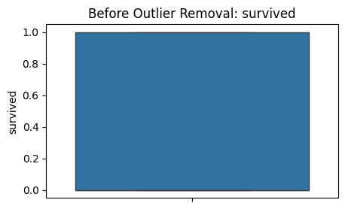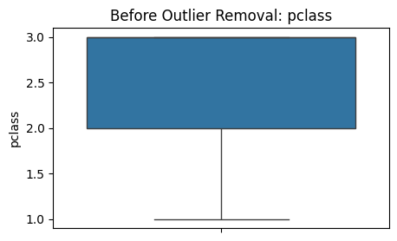

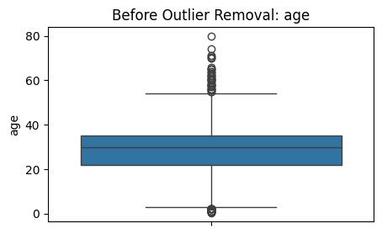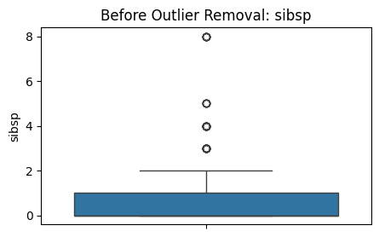

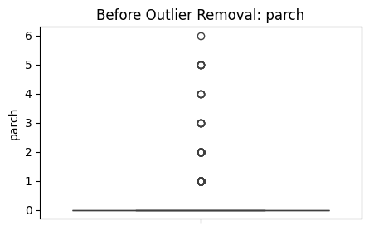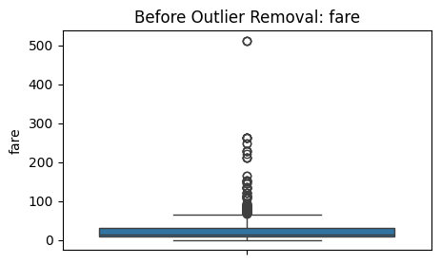

# Isolation Forest for outlier detection
iso = IsolationForest(contamination=0.05, random_state=42)
outlier_labels = iso.fit_predict(df[numeric_cols])
df['outlier'] = outlier_labels
print("\nOutlier summary (-1 = outlier, 1 = normal):\n", df['outlier'].value_counts())

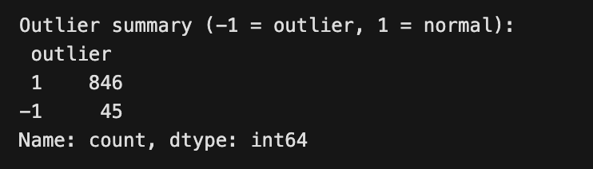

# Remove outliers
df = df[df['outlier'] == 1].drop(columns=['outlier'])
print("\n Outliers removed. Remaining records: ", len(df))

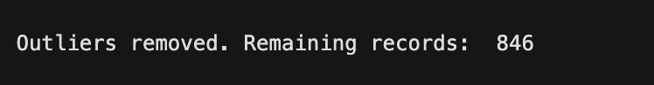

# Visualize after removal
for col in numeric_cols:
plt.figure(figsize=(5,3))
sns.boxplot(df[col])
plt.title("After Outlier Removal: "+ col)
plt.show()

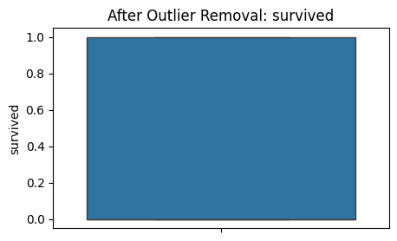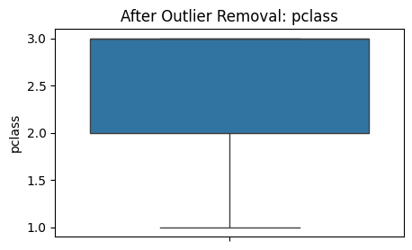
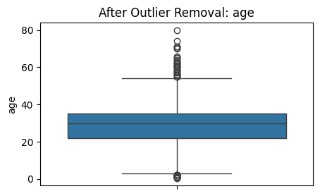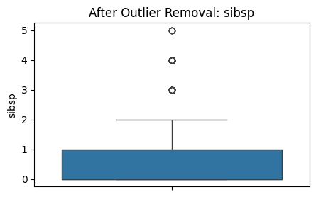
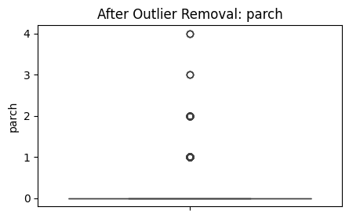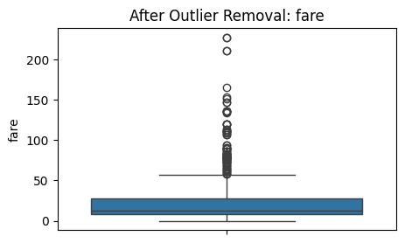
# Step 3: Fix Inconsistent Value
# Normalize categorical text (strip spaces, lowercase)
for col in df.select_dtypes(include=['object', 'category']).columns:
df[col] = df[col].astype(str).str.strip().str.lower()

print("\nUnique values in 'sex' and 'embarked' after normalization:")
print("sex:", df['sex'].unique())
print("embarked:", df['embarked'].unique())

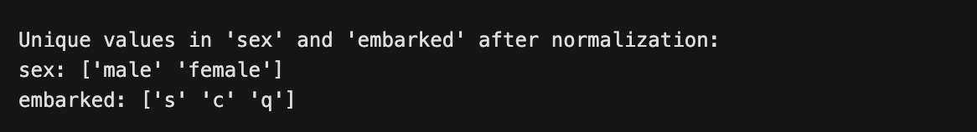

# Step 4: Apply Validation Rules
def validate_rules(df):
invalid_rows = pd.DataFrame()

# Rule 1: Age should be between 0 and 100
invalid_age = df[(df['age'] < 0) | (df['age'] > 100)]

# Rule 2: Fare should be positive
invalid_fare = df[df['fare'] < 0]

# Rule 3: Pclass should be in [1, 2, 3]
invalid_pclass = df[~df['pclass'].isin([1, 2, 3])]

invalid_rows = pd.concat([invalid_age, invalid_fare, invalid_pclass])
return invalid_rows

invalid_data = validate_rules(df)

if invalid_data.empty:
print("\n All rows passed validation rules.")
else:
print("\n Invalid rows detected:\n", invalid_data)

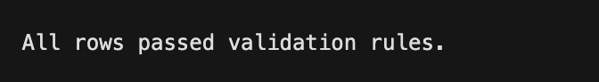

# Step 5: Saved the cleaned dataset
df.to_csv("../dataset/cleaned_titanic_dataset.csv", index=False)
print("\n Cleaned dataset saved as '../dataset/cleaned_titanic_dataset.csv'")

