Brewer’s Sparrow – 1059 total, Active = 881

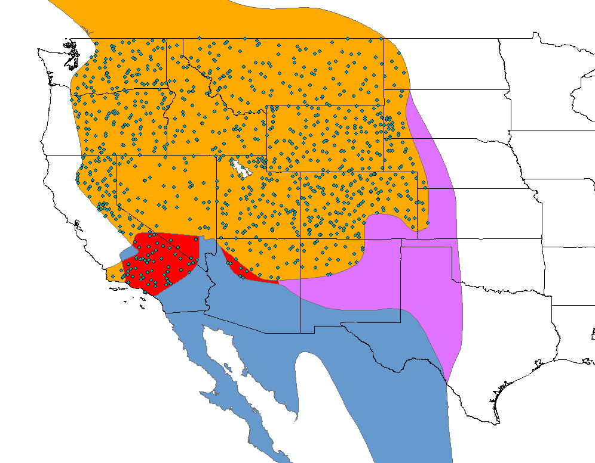

Sage Thrasher – 816 total, Active = 678

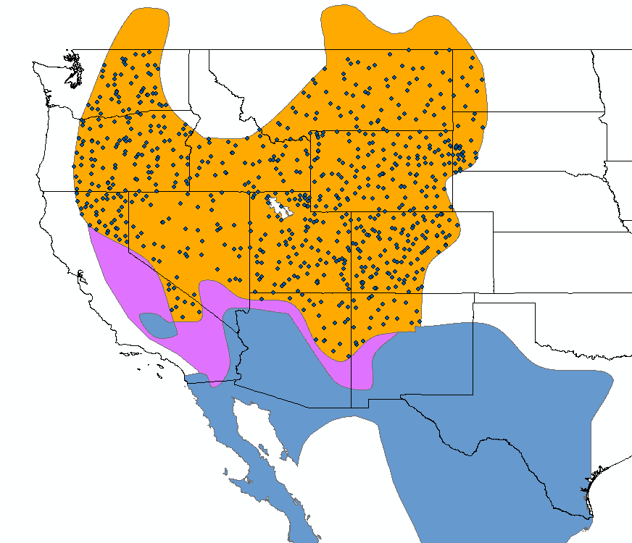

Sagebrush Sparrow – 376 total, Active = 303

