CNN-Based Traffic Sign Recognition
with Cross-Domain Generalization Analysis

Introduction to AI Programming

Team 4
Seojeong Kim, Minjun Park, Hyunwoo Song, Eungyu Park
03 May 2026

1. Introduction
Traffic sign recognition (TSR) is a foundational computer vision task for driver assistance systems and autonomous vehicles. A practical TSR model must recognize signs not only in clean benchmark images but also under real-world conditions such as low resolution, blur, imperfect crop boundaries, lighting variation, camera noise, and background clutter.

This project develops a convolutional neural network (CNN)-based traffic sign classification pipeline using the German Traffic Sign Recognition Benchmark (GTSRB) as the main dataset. The project then evaluates whether features learned from clean cropped signs transfer to real-road crops from GTSDB and synthetic traffic sign images from Signset Germany/Synset.

The core research question is: if a model performs very well on clean cropped traffic signs, will it still work on real-road crops and synthetic environmental variations? The experiments show that high in-domain performance on GTSRB does not automatically guarantee cross-domain robustness. Therefore, the project focuses not only on accuracy but also on model comparison, domain shift, error analysis, and targeted improvement based on observed failure patterns.

2. Dataset Description

2.1 GTSRB – German Traffic Sign Recognition Benchmark
GTSRB was used as the primary in-domain dataset. It contains 51,839 images across 43 traffic sign classes. The images are clean, centered, and cropped around individual signs, making the dataset suitable for supervised CNN-based image classification. However, this cleanliness also creates a distribution gap compared with real-road images.

2.2 GTSDB – German Traffic Sign Detection Benchmark
GTSDB was used for real-road generalization analysis and domain adaptation. Although GTSDB is originally closer to a detection benchmark, this project used bounding-box crops as classification inputs. The subset used here contained 476 cropped sign images. These images are more challenging than GTSRB because many are small, noisy, imperfectly cropped, and affected by road-scene background and lighting.

For mixed-domain experiments, GTSDB was split into 381 training-mix images and 95 hold-out images. Classes with only one sample could not be stratified and were assigned to the training-only side. As a result, GTSDB hold-out results should be interpreted carefully because the test set is small and class-wise estimates may be unstable.

2.3 Synset / Signset Germany
Synset/Signset Germany provides synthetically rendered traffic sign images. The original dataset has 211 classes, but this project retained only labels that match the GTSRB class range 0–42. In SynsetMix experiments, 5% of the filtered Synset data was included in training and the remaining 95% was used for synthetic-domain evaluation.

Dataset | Size Used | Image Type | Role
GTSRB | 51,839 images | Clean cropped signs | Main training and in-domain evaluation
GTSDB | 476 crops (381 train mix + 95 hold-out) | Real-road crops | Domain adaptation and real-road evaluation
Synset / Signset Germany | 5% train / 95% evaluation | Synthetic renders | Synthetic-domain generalization

3. Methodology

3.1 Problem Formulation
The task is a 43-class image classification problem. Each input is a cropped RGB traffic sign image, and the model outputs one class label and a confidence distribution over the 43 classes. Performance is mainly measured by top-1 accuracy, while confusion matrices and classification reports are used for detailed diagnosis.

3.2 Preprocessing and Normalization
All images were resized to a fixed input size before being fed to the model. Earlier experiments used 48×48 pixels. Later v2 and v3 experiments increased the resolution to 96×96 pixels to preserve small visual details such as arrows, digits, borders, and sign symbols. The implementation normalized each RGB channel using mean = 0.5 and standard deviation = 0.5. This normalization was consistently applied across GTSRB, GTSDB, Synset, and the Gradio demo inputs.

3.3 Data Augmentation
The standard augmentation pipeline included random rotation, color jitter, random affine translation, and initially horizontal flipping. A stronger robust-augmentation experiment added heavier transformations such as stronger color jitter, Gaussian blur, larger translation, and scale variation. However, later analysis showed that horizontal flipping is not always semantically valid for traffic signs because it can reverse direction-dependent signs such as Keep left/Keep right or Turn left/Turn right. Therefore, v3 removed horizontal flipping from the augmentation pipeline.

3.4 Training Protocol
The models were trained using cross-entropy loss and the Adam optimizer. A cosine annealing learning-rate scheduler was used in the training loop. Earlier experiments were trained for a fixed number of epochs, while v2 and v3 added validation-accuracy-based early stopping with a patience of 5. The best checkpoint was saved based on validation accuracy.

3.5 Evaluation Pipeline
The evaluation code produced test loss, test accuracy, a class-wise classification report, confusion matrices, and failure-case visualizations. These outputs were not only used for final reporting but also guided model development. In particular, the v2 confusion matrix helped reveal remaining direction-recognition weaknesses, motivating the code-level change in v3.

4. Model Architectures

4.1 Custom Baseline CNN
The baseline CNN was implemented from scratch as a three-block convolutional network. Each block follows the pattern Conv → BatchNorm → ReLU → MaxPool. The channel size increases from 32 to 64 and then to 128. The classifier consists of fully connected layers with dropout regularization. This model satisfies the requirement for a custom baseline CNN and provides an interpretable reference point for later improvements.

4.2 EfficientNet-B0 Fine-Tuned Model
The improved model used torchvision EfficientNet-B0 initialized with ImageNet1K pretrained weights. The original 1000-class classifier was replaced with a new classifier containing dropout and a linear layer for 43 traffic sign classes. The feature extractor was not frozen; the full network was fine-tuned because traffic signs differ from generic ImageNet objects in shape, color distribution, symbolic structure, and resolution. EfficientNet-B0 was used for the robust augmentation, mixed-domain, SynsetMix, v2, and v3 experiments.

5. Experimental Setup

5.1 Baseline and EfficientNet GTSRB-Only Training
The first stage trained the custom CNN and EfficientNet-B0 using only GTSRB. This established strong in-domain baselines and exposed the initial domain-shift problem when the same models were evaluated on GTSDB.

5.2 Robust Augmentation
The robust experiment attempted to simulate real-road conditions through stronger augmentation. It used stronger color jitter, rotation, Gaussian blur, translation, and scaling. The goal was to improve robustness without adding target-domain data. The learning curve later showed that this strategy made validation performance unstable and reduced GTSRB accuracy, suggesting that the augmentation was too strong or mismatched to GTSDB.

5.3 Mixed-Domain Training: GTSRB + GTSDB
The mixed experiment added 381 real-road GTSDB crops to the GTSRB training data. This directly exposed the model to target-domain properties such as small crop size, imperfect framing, background clutter, and real-road lighting. This strategy improved GTSDB performance much more effectively than robust augmentation alone.

5.4 SynsetMix v1: GTSRB + GTSDB + 5% Synset
SynsetMix added 5% of filtered Synset data to the mixed training set and used the remaining 95% for synthetic-domain testing. This simultaneous multi-domain training strategy was designed to learn clean, real-road, and synthetic variations together while avoiding the catastrophic forgetting observed in sequential fine-tuning.

5.5 SynsetMix v2: Resolution Enhancement and Batch Size Adjustment
In v2, the input size was increased from 48×48 to 96×96 pixels. This change was introduced because many GTSDB crops were small or blurry, and resizing to only 48×48 can remove important details. To manage the increased GPU memory requirement, batch size was reduced from 64 to 32. However, v2 still retained horizontal flipping in part of the augmentation pipeline.

5.6 SynsetMix v3: Direction-Aware Augmentation Correction
The transition from v2 to v3 was driven by confusion-matrix and failure-case analysis. After v2, the model still showed weaknesses in direction-sensitive classes. This indicated that horizontal flipping could be introducing label noise by changing the meaning of signs while keeping the original label unchanged. Therefore, v3 removed RandomHorizontalFlip from the augmentation code. This modification specifically targeted direction recognition rather than being a random hyperparameter change.

5.7 Gradio Inference Demo
The final demo was implemented with Gradio. It allows users to upload a cropped traffic sign image and compare predictions from the baseline CNN, final v2 EfficientNet-B0, and final v3 EfficientNet-B0. The demo returns the top-5 predicted classes and confidence scores. Since the model is a classifier rather than a detector, the input should be a cropped traffic sign region, not a full road scene.

6. Results

6.1 Accuracy Summary
The main quantitative results are summarized below. GTSDB full/reference scores are useful for adaptation analysis but should not be interpreted as pure unseen external-test scores when part of GTSDB was used during training. The GTSDB hold-out split is more honest but small and therefore unstable.

Experiment | Model / Training Data | GTSRB | GTSDB | Synset | Main Interpretation
Baseline CNN | Custom CNN, GTSRB only | 96.9% | 4.2% | - | Strong in-domain learning but almost no real-road transfer
EfficientNet-B0 | Pretrained EfficientNet, GTSRB only | 95.2% | 3.8% | - | Stronger architecture alone did not solve domain shift
EfficientNet Robust | GTSRB + strong augmentation | 87.0% | 2.1% | - | Augmentation was too aggressive or mismatched
EfficientNet Mixed | GTSRB + GTSDB | 95.1% | 5.6% | - | Direct real-road exposure improved transfer
EfficientNet Final | GTSRB + GTSDB, final 48px setting | 94.9% | 58.4% | 56.2% | Improved cross-domain baseline before SynsetMix
EfficientNet SynsetMix | GTSRB + GTSDB + 5% Synset | 94.8% | 59.2% | 69.5% | Best overall balance across all domains
SynsetMix v2 | SynsetMix with 96px, batch 32 | 97.0% | 99.5% | 80.7% | Preserved details, but still contained horizontal flip
SynsetMix v3 | v2 + horizontal flip removed | 99.40% | 99.88% | 91.14% | Direction-aware correction based on confusion-matrix analysis

6.2 Training Curve Analysis
The learning curves show that the baseline and EfficientNet models quickly learned the clean GTSRB distribution. Validation accuracy is often higher than training accuracy because training uses augmentation and dropout while validation uses clean images. This pattern does not indicate severe overfitting on GTSRB. However, high validation accuracy on GTSRB did not translate to high GTSDB performance, confirming the domain-shift problem.

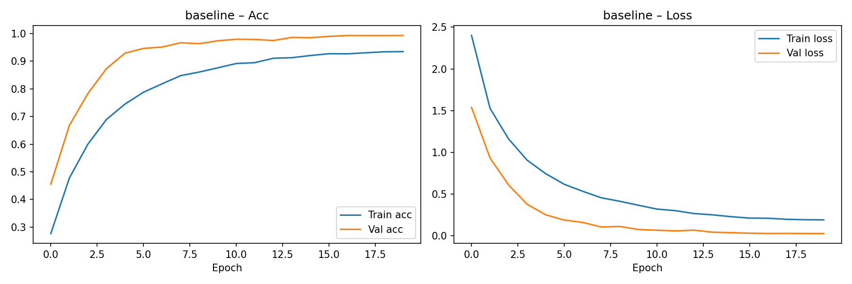
Figure 1. Baseline CNN learning curve. The model learns GTSRB steadily, with validation accuracy rising quickly and loss decreasing.
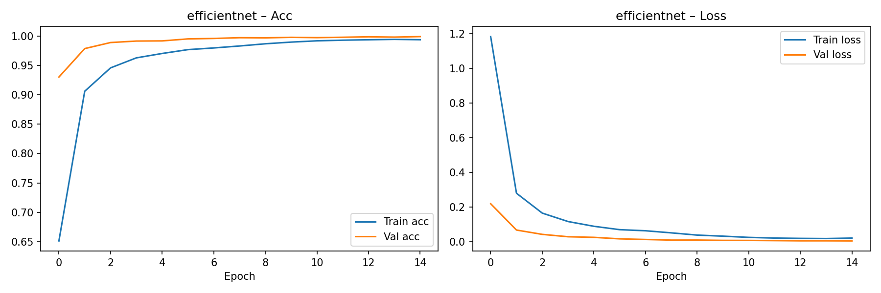
Figure 2. EfficientNet-B0 learning curve. The pretrained model converges faster and reaches very high in-domain validation accuracy.

The robust augmentation curve is the most unstable. Training accuracy continues increasing, but validation accuracy fluctuates and validation loss remains relatively high compared with the other EfficientNet settings. This supports the interpretation that the robust policy was too aggressive or did not match the actual target-domain distortions.

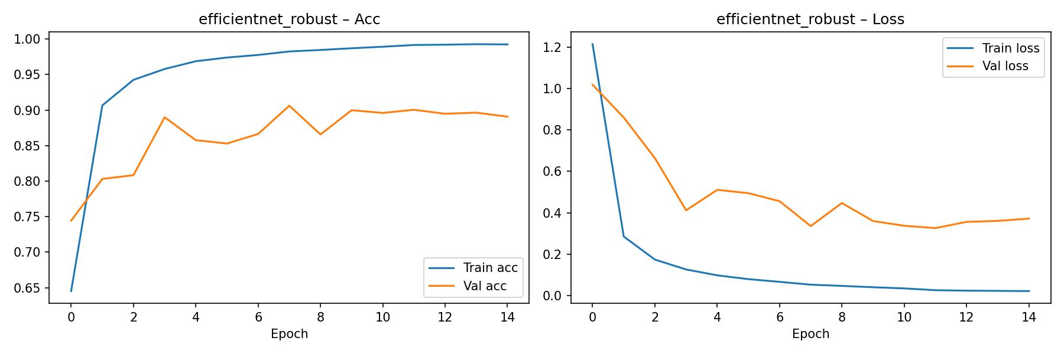
Figure 3. Robust augmentation learning curve. Validation performance is unstable, indicating augmentation mismatch or excessive distortion.

The mixed-domain and SynsetMix curves are much more stable. They maintain strong GTSRB validation behavior while improving external-domain results. This suggests that adding real target-domain samples and a small amount of synthetic data was more effective than relying only on stronger augmentation.

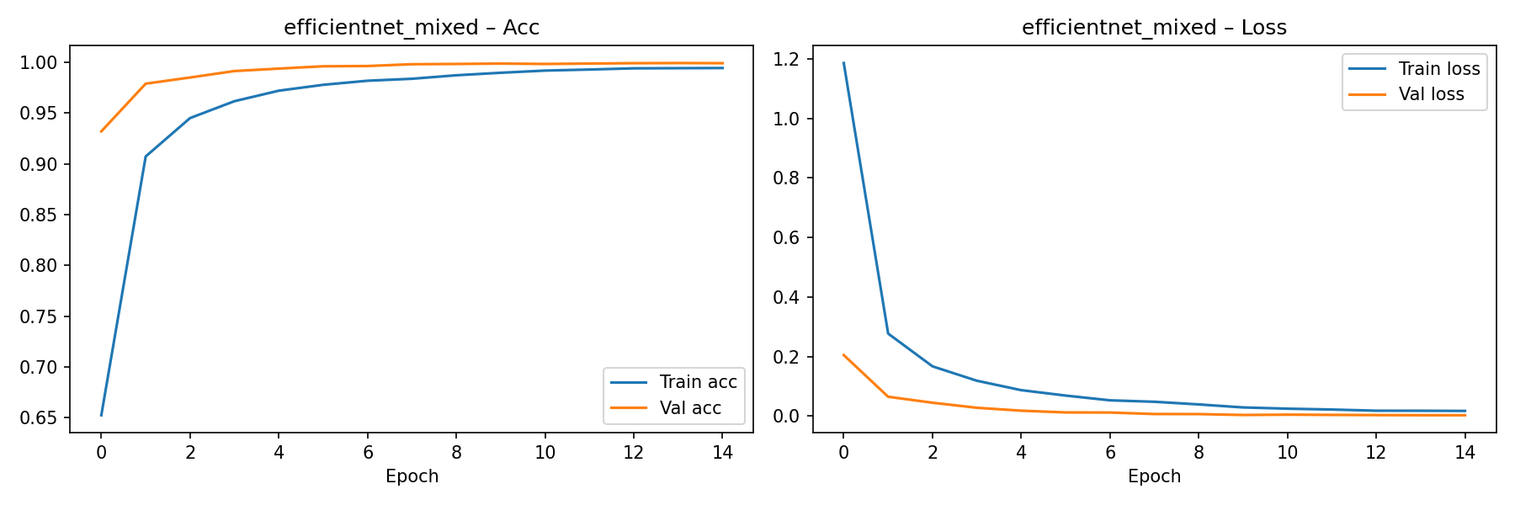
Figure 4. Mixed GTSRB+GTSDB learning curve. In-domain validation remains stable while real-road generalization improves.
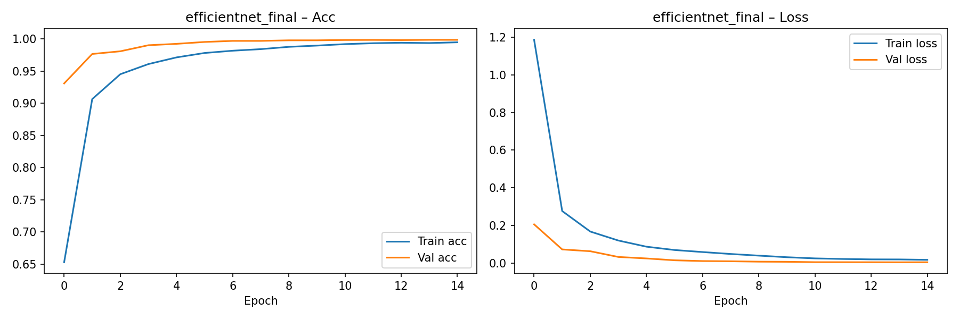
Figure 5. Final mixed-domain learning curve before SynsetMix.
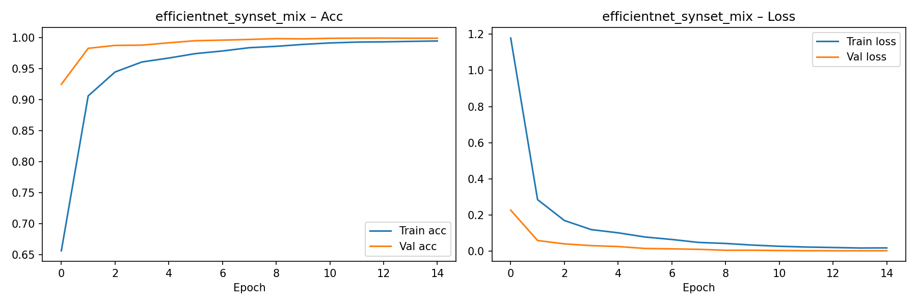
Figure 6. SynsetMix learning curve. The model preserves high validation accuracy while learning from multiple domains.

6.3 Confusion Matrix Analysis
The in-domain GTSRB confusion matrices are strongly diagonal, meaning most classes are correctly predicted on clean cropped signs. This confirms that both the baseline CNN and EfficientNet-B0 learned the main classification task. However, the external GTSDB matrices and the robust model show that diagonal strength alone on GTSRB is not enough to prove real-road robustness.

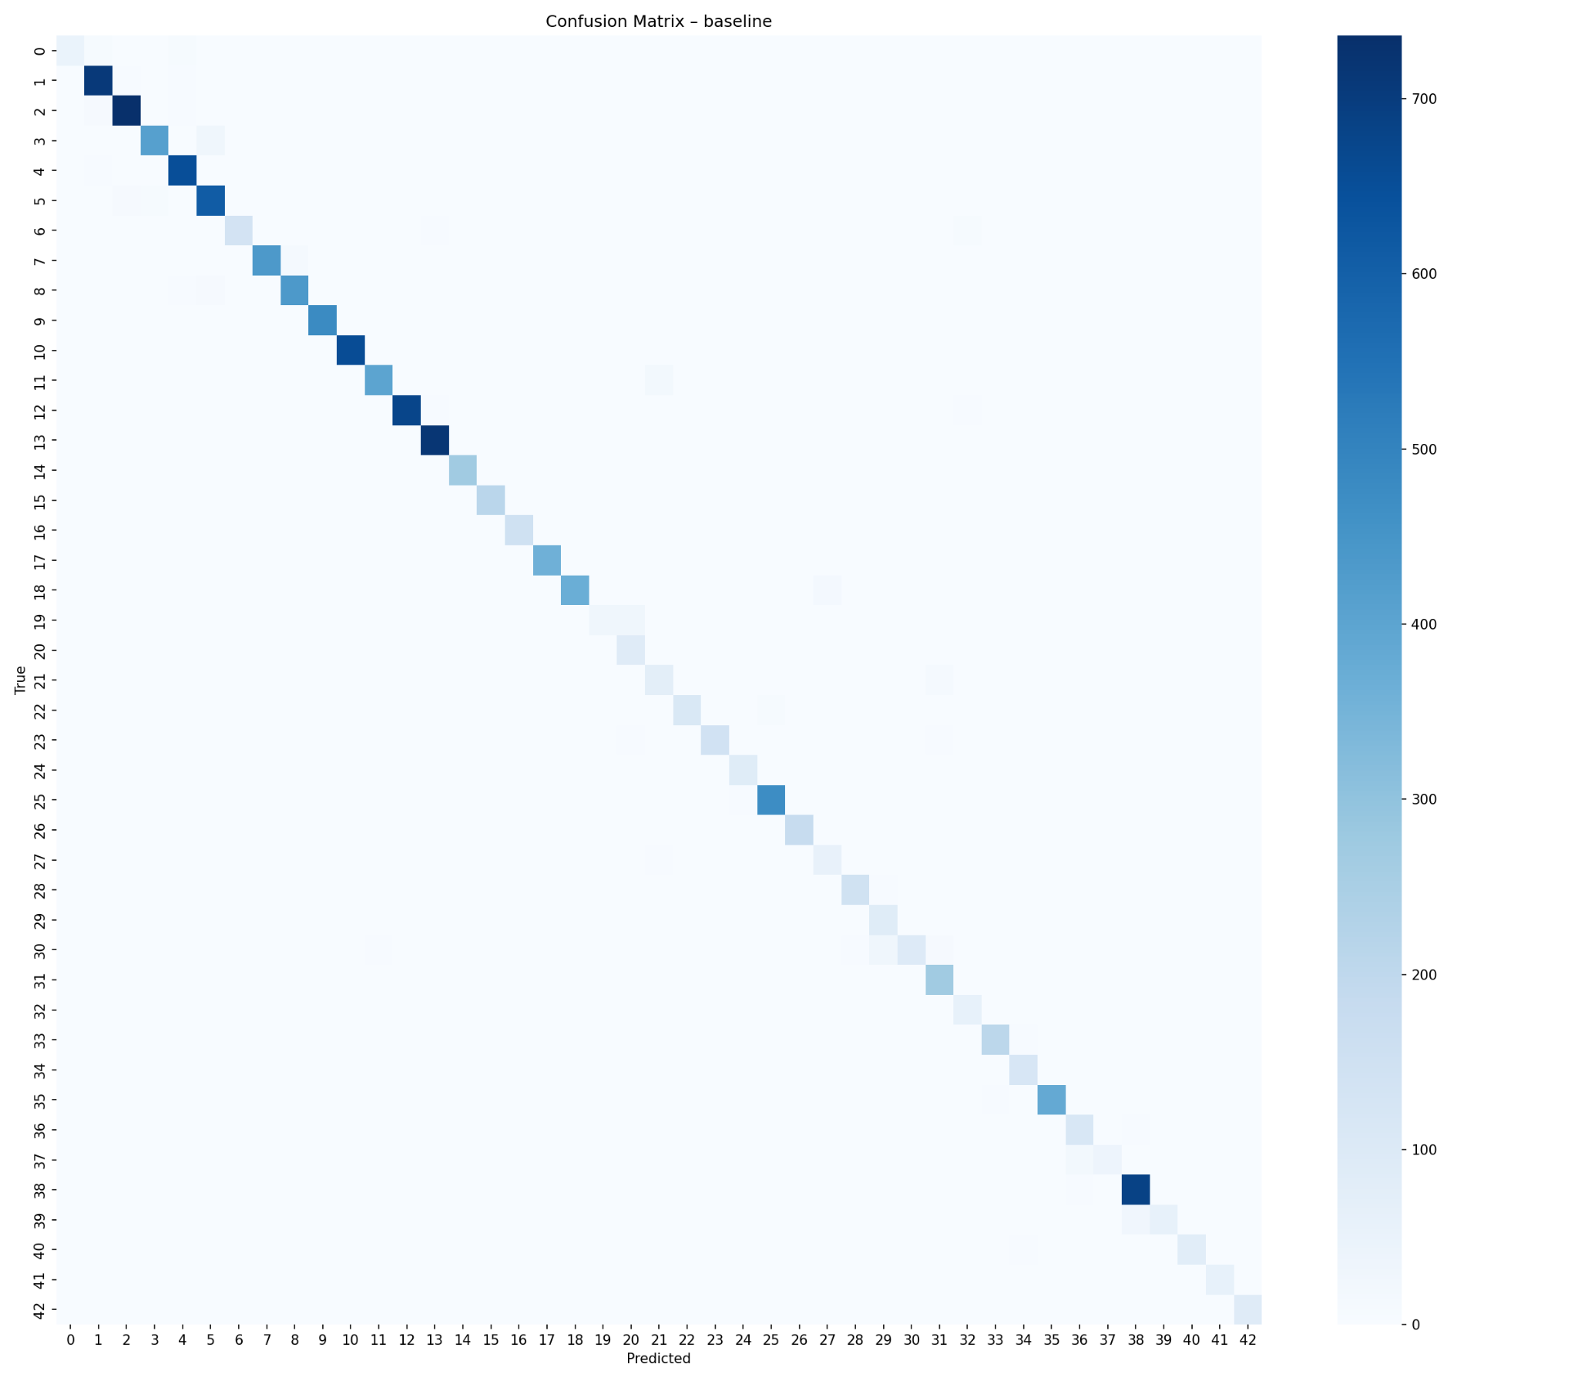
Figure 7. Baseline CNN confusion matrix on GTSRB. The strong diagonal indicates successful in-domain classification.
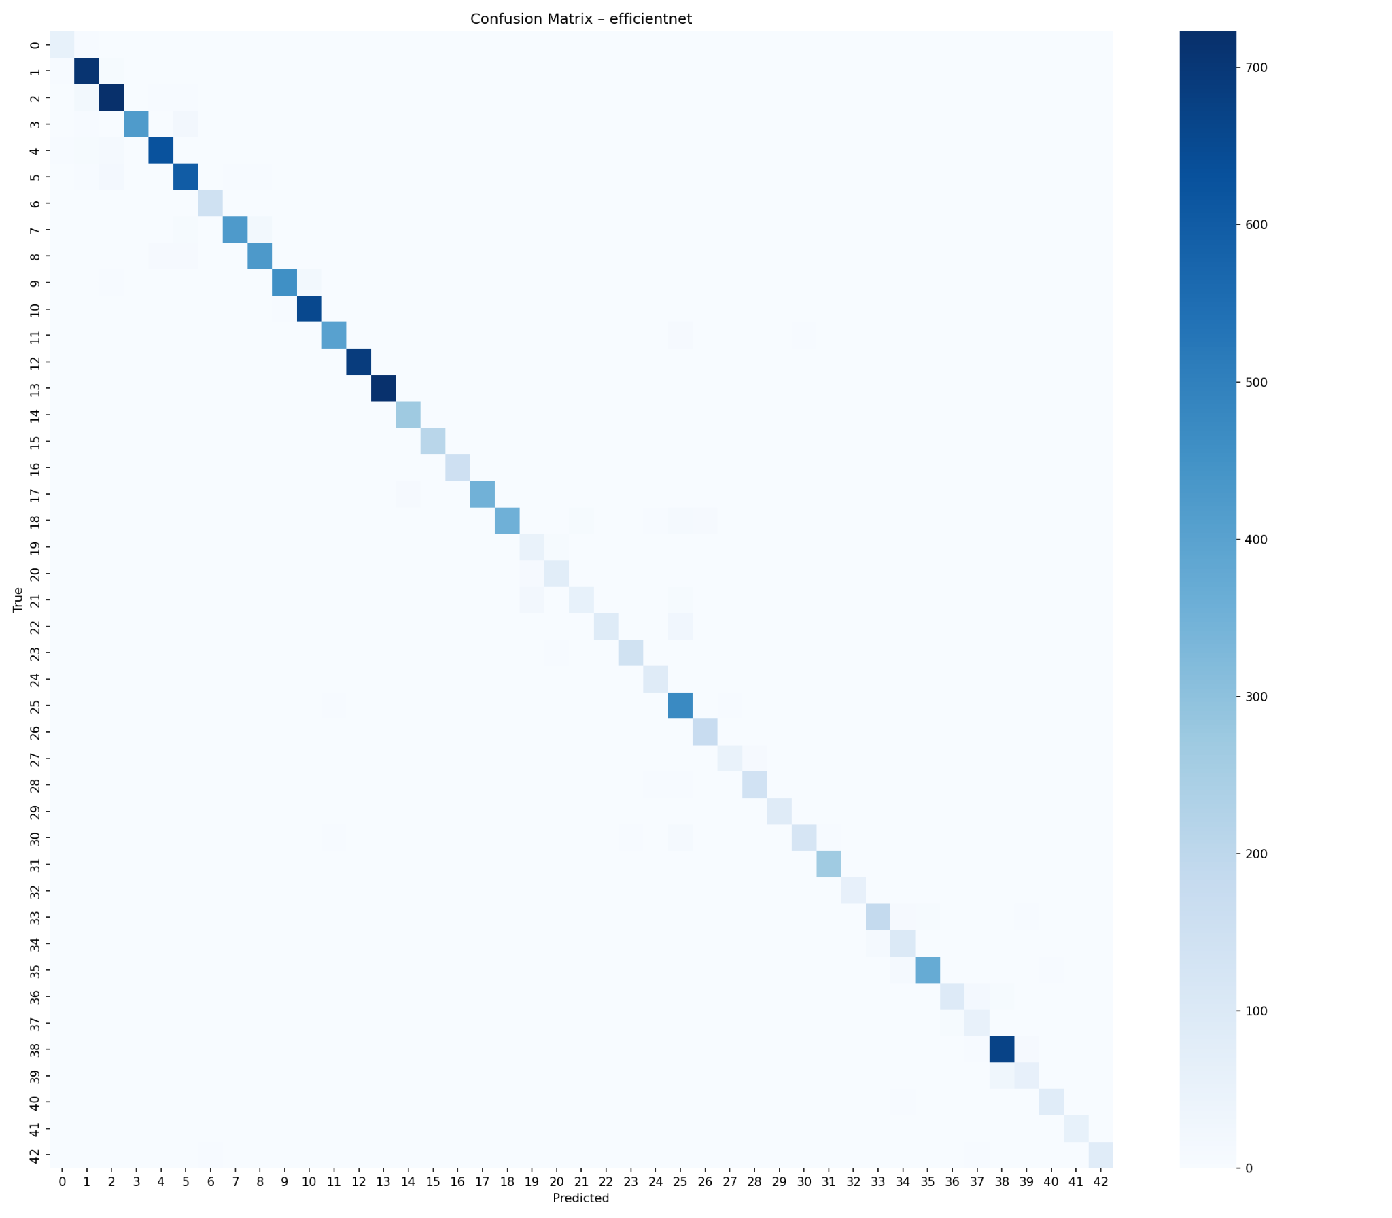
Figure 8. EfficientNet-B0 confusion matrix on GTSRB. The clean diagonal confirms strong in-domain performance.
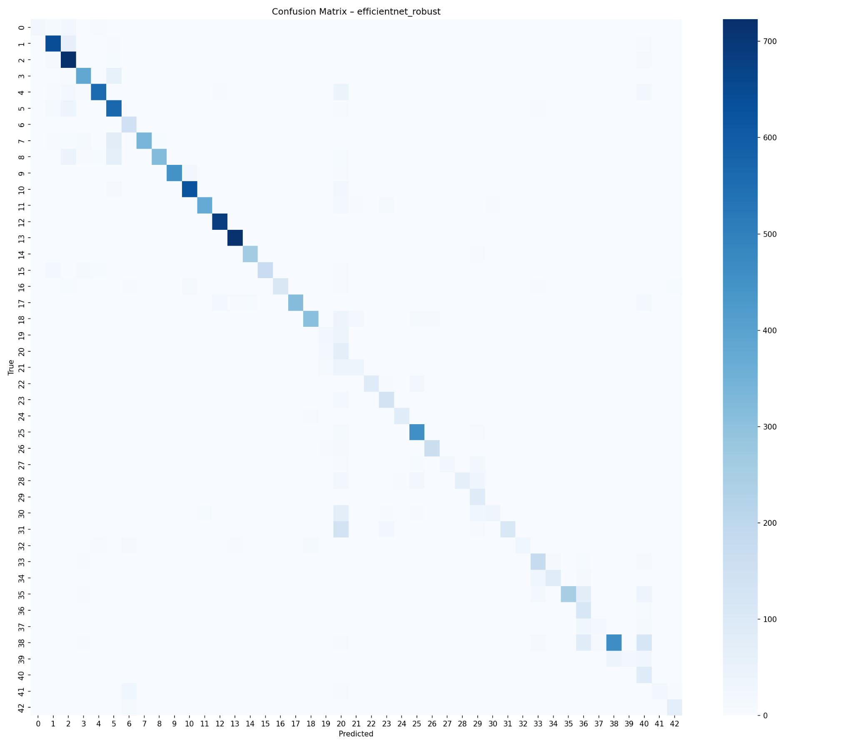
Figure 9. Robust EfficientNet confusion matrix on GTSRB. More scattered errors are visible than in the standard EfficientNet model.
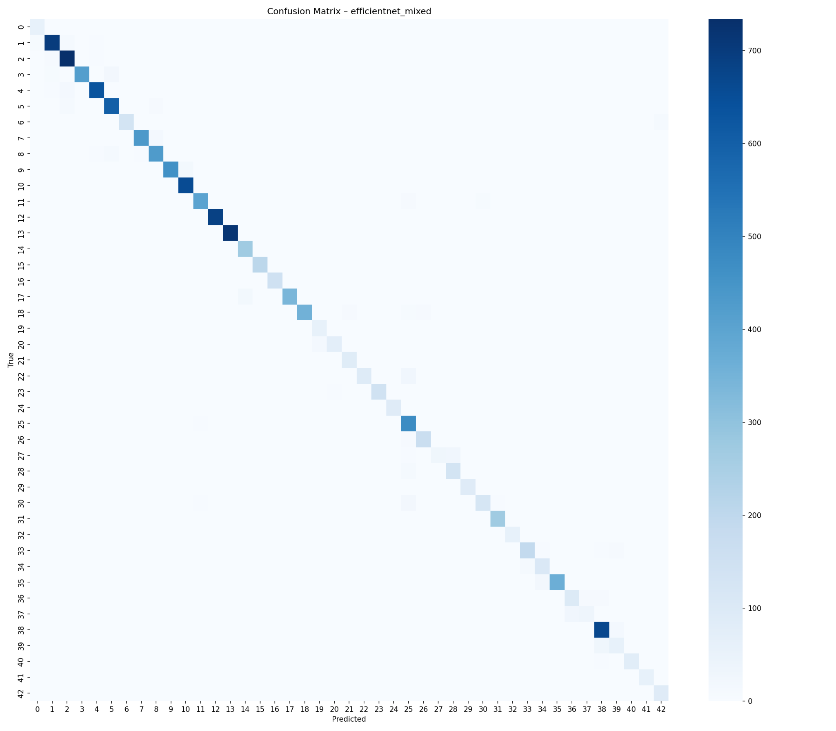
Figure 10. Mixed-domain EfficientNet confusion matrix on GTSRB. The diagonal remains strong after adding GTSDB data.

The GTSDB external matrices are shown separately because their color scale is much smaller and the dataset contains far fewer samples. Baseline and GTSRB-only EfficientNet have very low GTSDB accuracy, demonstrating severe domain shift. Mixed training improves this substantially by exposing the model to real-road crop style during training.

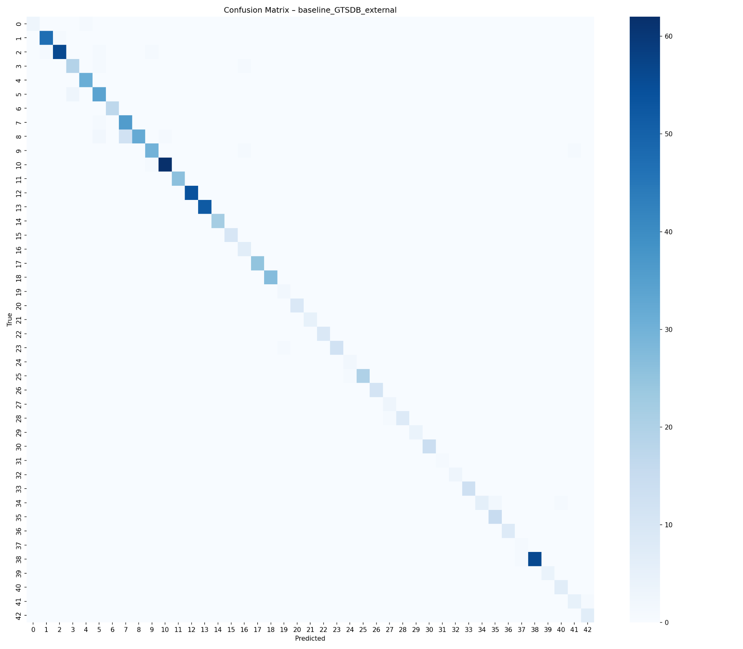
Figure 11. Baseline CNN confusion matrix on GTSDB external data.
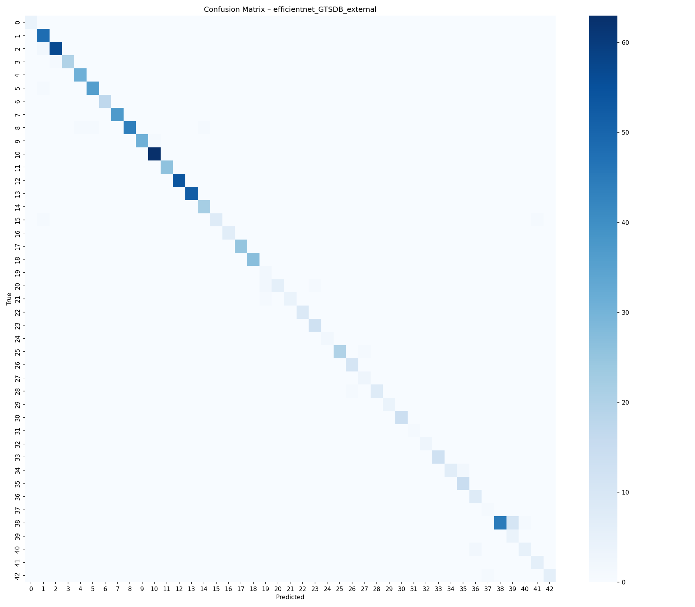
Figure 12. EfficientNet-B0 confusion matrix on GTSDB external data. Strong architecture alone does not solve the domain gap.
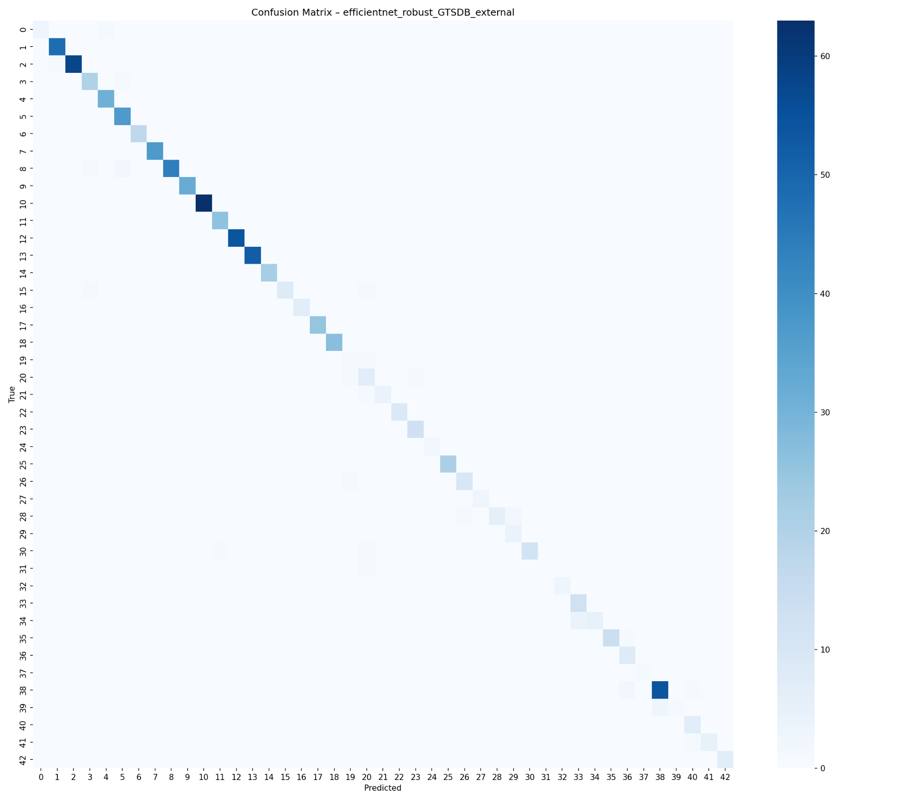
Figure 13. Robust EfficientNet confusion matrix on GTSDB external data. Strong augmentation did not improve the external result.
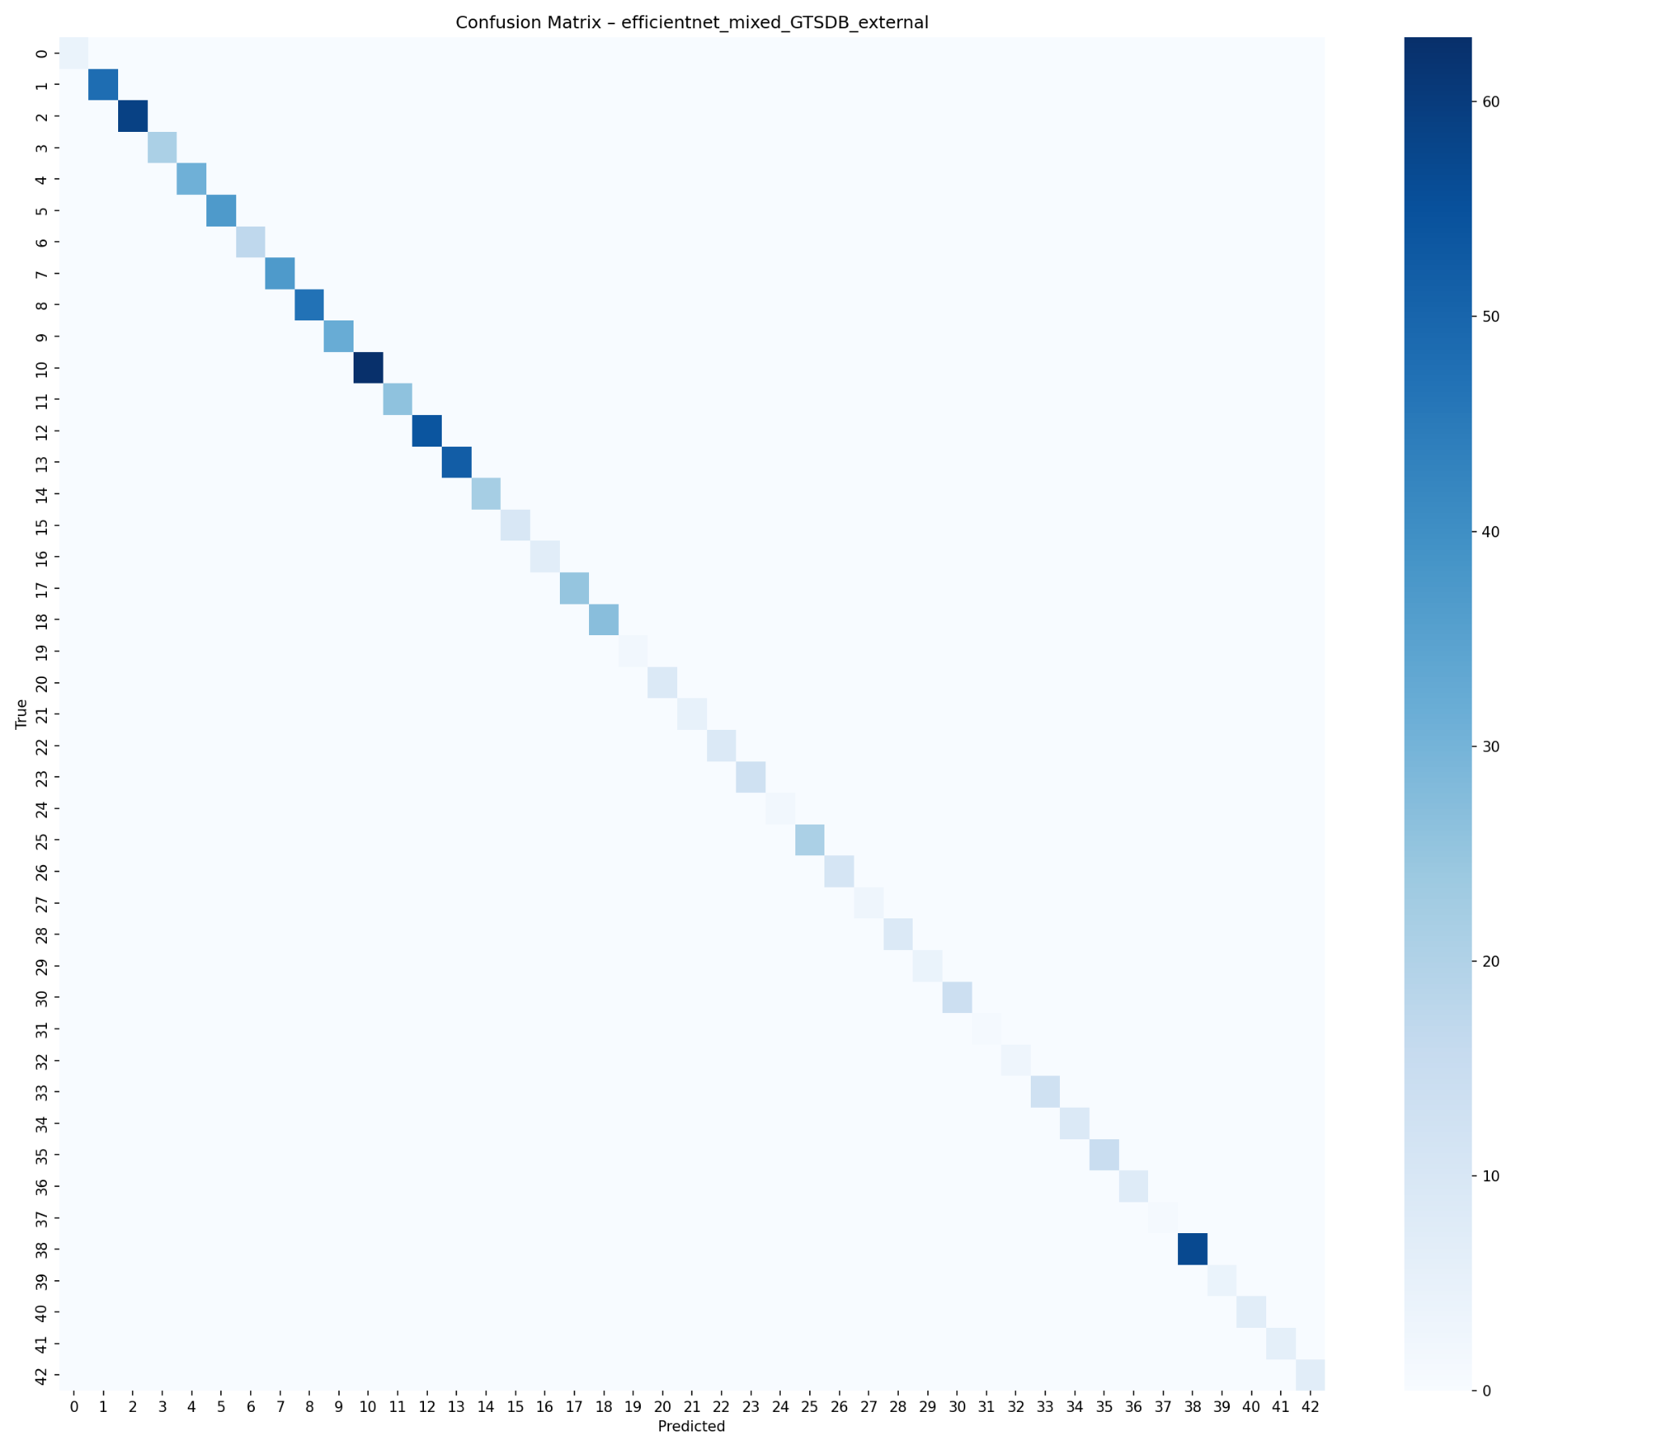
Figure 14. Mixed-domain EfficientNet confusion matrix on GTSDB external data. Direct real-road exposure improves cross-domain behavior.

6.4 v2 to v3 Direction-Recognition Analysis
The v2 and v3 Synset confusion matrices were used to check whether the 96×96 model still had systematic weaknesses. In v2, several off-diagonal patterns remain around visually or directionally related classes. This is consistent with the concern that horizontal flipping can create semantic label noise for direction-sensitive traffic signs. In v3, horizontal flip was removed, making the augmentation pipeline more semantically consistent. The v3 matrix shows a cleaner diagonal overall, supporting the decision to use v3 as the final configuration.

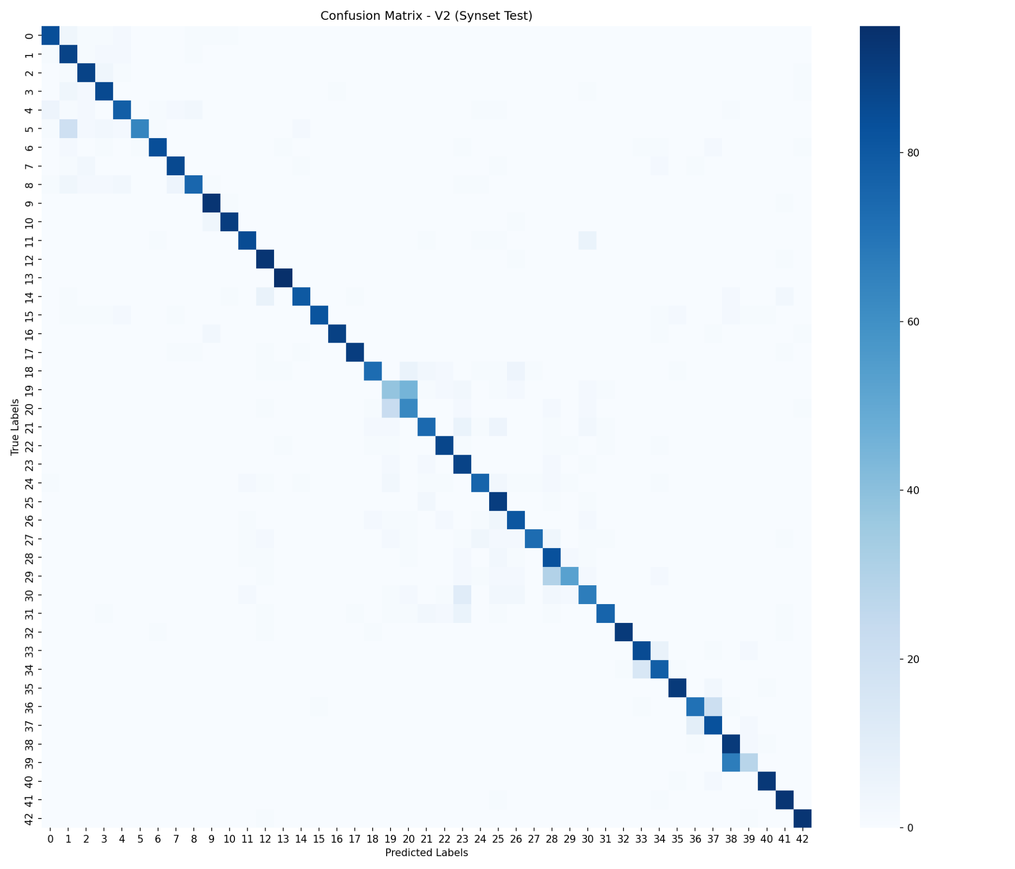
Figure 15. V2 Synset confusion matrix. V2 used 96×96 input but still retained horizontal flip in part of the augmentation pipeline.
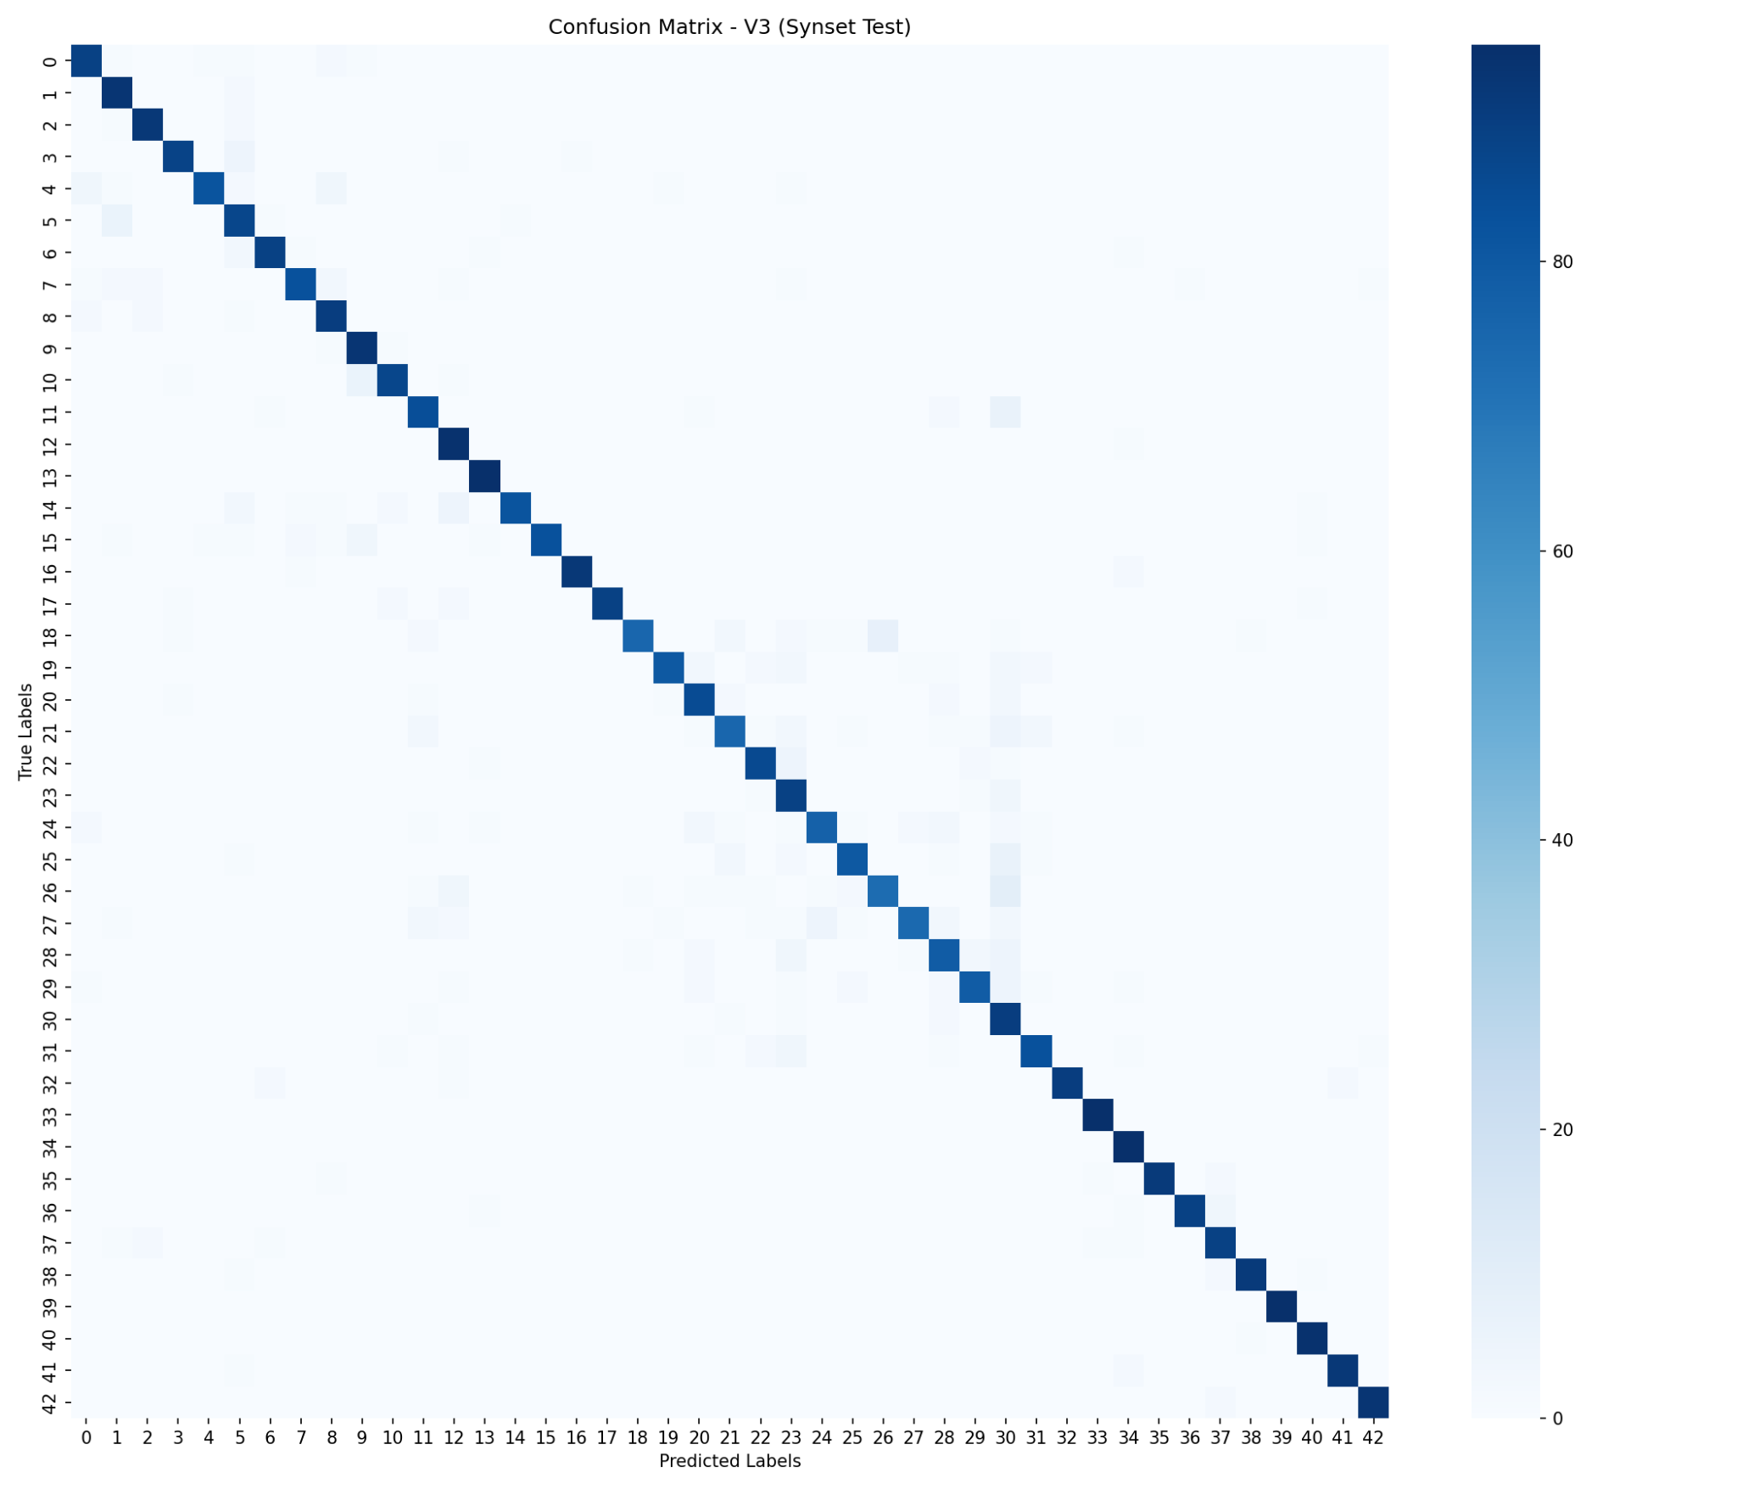
Figure 16. V3 Synset confusion matrix. Removing horizontal flip reduces semantic inconsistency for direction-sensitive signs.

6.5 Failure Case Examples
The following figures show representative misclassified examples from the three main model configurations evaluated on GTSDB external data. Each image is labeled with the true class (T) and the predicted class (P). These visualizations provide qualitative evidence for the quantitative domain-shift results.

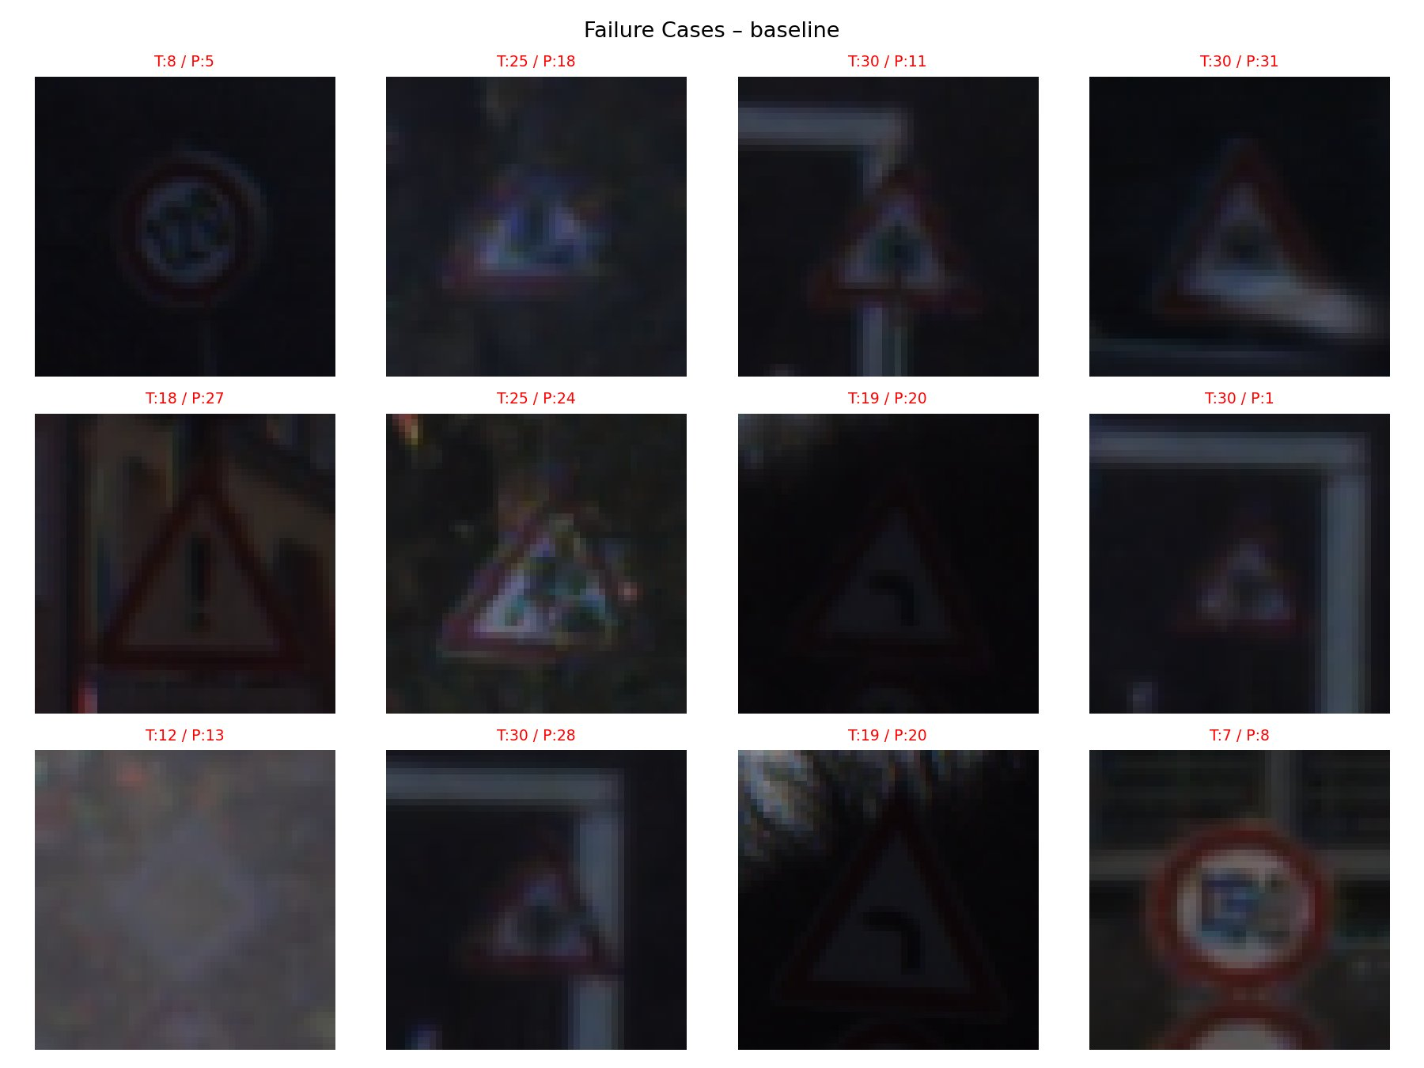
Figure 17. Failure cases of the baseline CNN. Many baseline failures occur on dark, low-resolution, blurry, and imperfectly cropped traffic sign images. The baseline model is especially vulnerable when the sign interior is difficult to read.

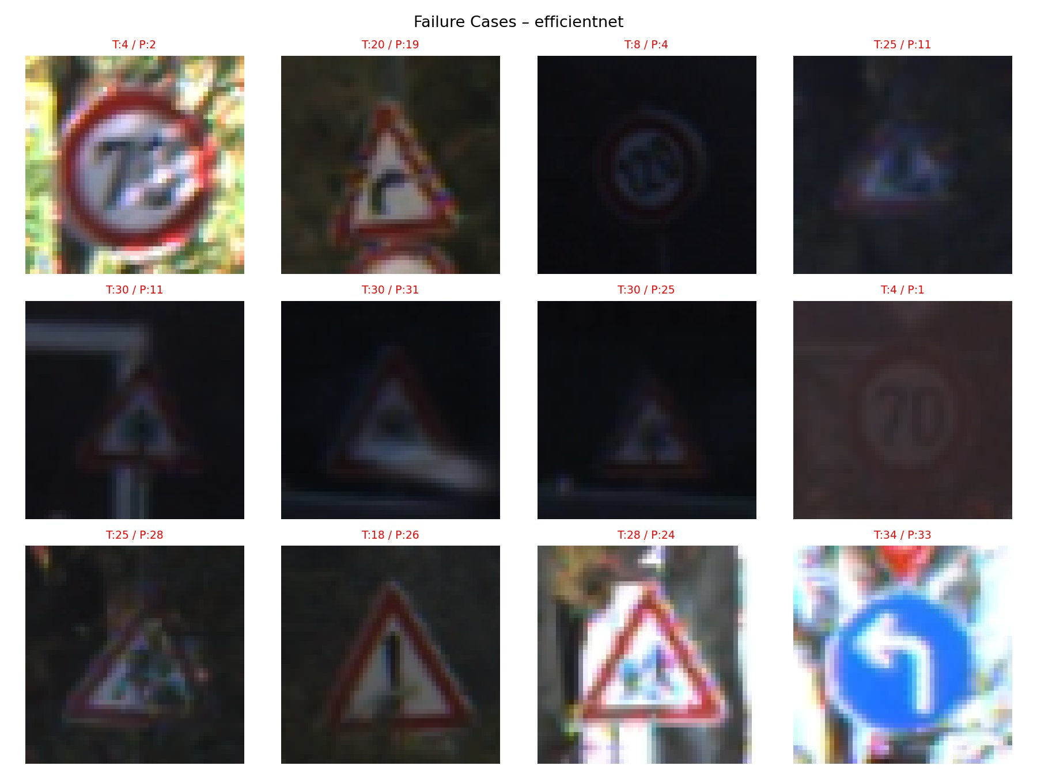
Figure 18. Failure cases of EfficientNet-B0. EfficientNet-B0 is stronger than the baseline, but it still fails on low-light signs, triangular warning signs, visually similar prohibitory signs, and ambiguous direction-related cases.

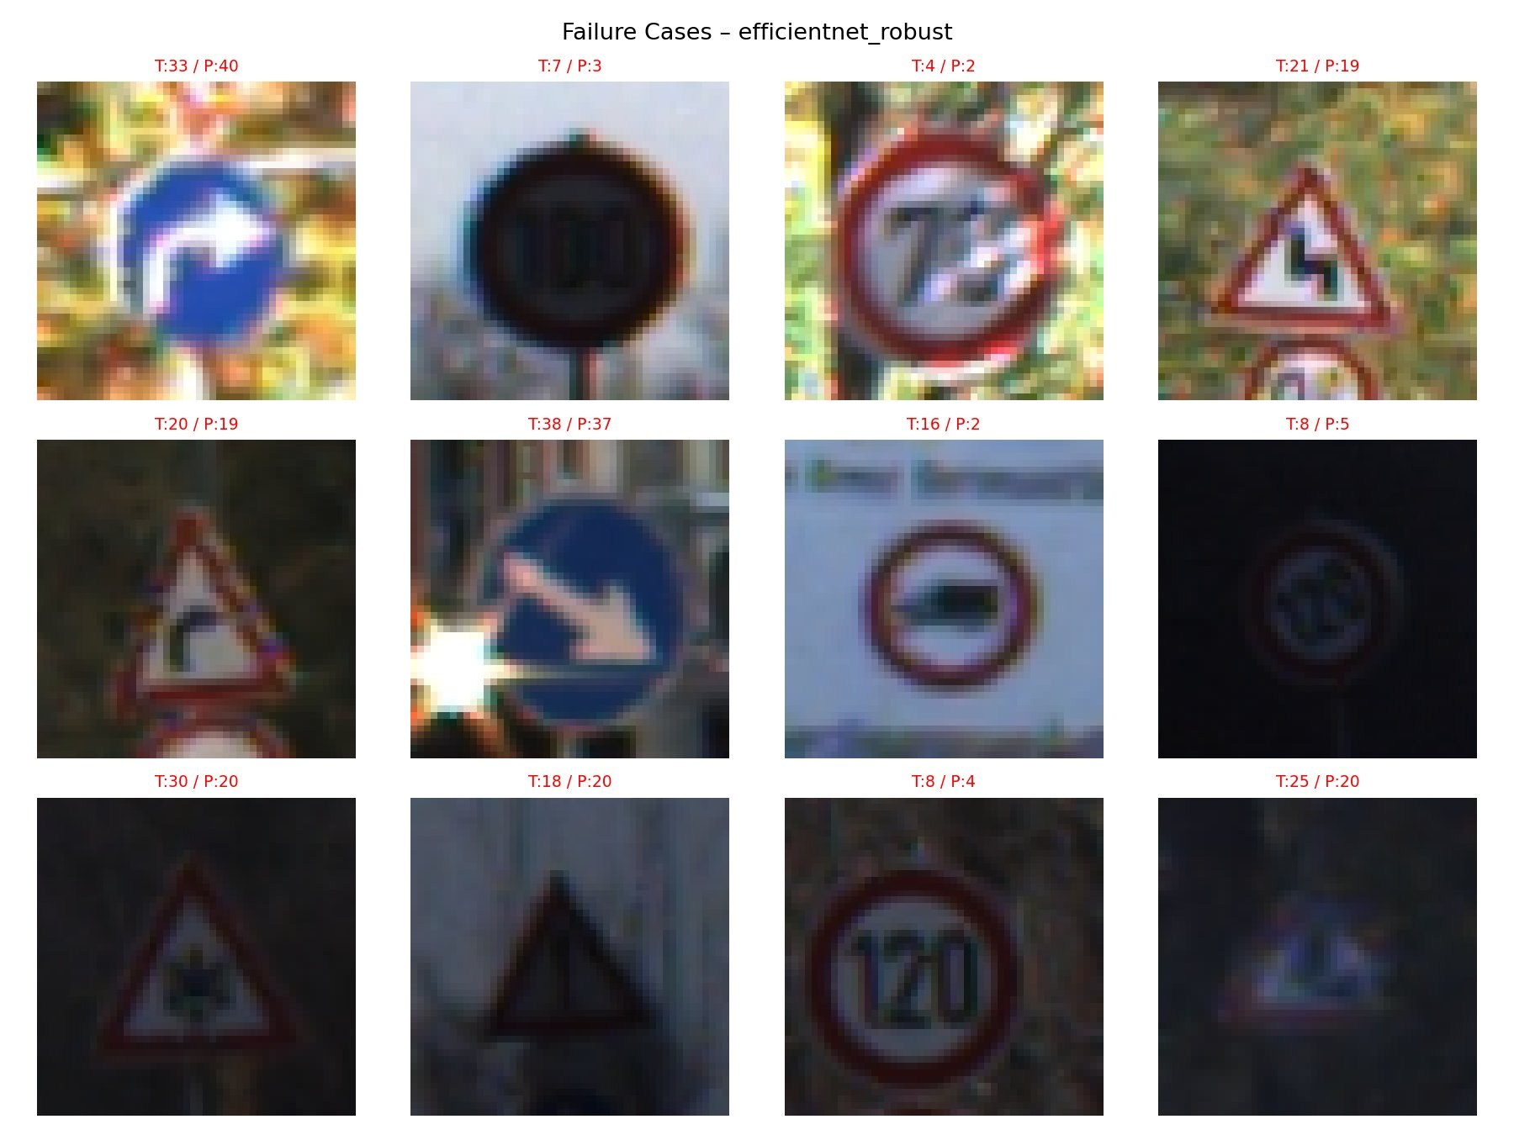
Figure 19. Failure cases of the robust-augmentation EfficientNet. The robust-augmentation model still shows errors on blurred, low-contrast, cluttered, and visually ambiguous signs. This supports the interpretation that stronger augmentation alone did not adequately match the true GTSDB distribution.

Across the three failure-case visualizations, most errors are not random. They occur under visually difficult conditions that are much more common in GTSDB than in GTSRB. The failed examples are often dark, blurry, small, partially cropped, or affected by background clutter. In many cases, the outer shape of the sign is still visible, but the internal discriminative information such as numbers, arrows, or warning symbols is weak or distorted. This explains why clean GTSRB performance did not transfer directly to real-road crops and why mixed-domain training, higher resolution, and direction-aware augmentation correction were needed.

Specific failure patterns observed across all three models include:
- Many failed images are dark or low-contrast, making the sign interior essentially invisible at the crop resolution.
- Many signs are small, blurry, or upscaled from low resolution, removing fine discriminative details.
- Some crops include background clutter such as poles, trees, nearby signs, or partial sign regions.
- Some failures involve triangular warning signs that share similar global triangular shape.
- Some failures involve circular prohibitory or speed-limit signs where the internal symbol or digit is unclear.
- Some failures involve direction-sensitive signs where arrow direction is a key differentiating feature.
- These examples support the project's main claim that high GTSRB accuracy does not guarantee real-road robustness.

6.6 Class-Wise and Group-Wise Performance Analysis
In addition to overall accuracy, model behavior was analyzed by class group because some GTSDB classes contain very few samples. For GTSDB, grouped interpretation is more reliable than over-interpreting unstable per-class percentages. The following table summarizes the key class groups, their difficulty level, and the main error patterns observed through the confusion matrices and failure-case visualizations.

Class Group | Representative Classes / Types | Difficulty | Main Error Pattern | Likely Reason
Speed-limit / prohibitory signs | Circular red-border signs with numbers or symbols | Medium to High | Confusion between visually similar circular signs | Internal digits or symbols are small and easily blurred
Warning signs | Triangular red-border signs | High | Confusion among warning categories | Similar global triangular shape and weak internal symbol visibility
Mandatory direction signs | Blue circular arrow signs | High | Confusion between different arrow directions | Direction-sensitive structure, vulnerable to flip or blur
Priority / right-of-way signs | Priority road, right-of-way, yield-related signs | Low to Medium | Occasional confusion under blur or poor crop | Distinctive shapes help, but low-quality crops still reduce clarity
Rare GTSDB classes | Classes with very few external examples | Unstable | Large fluctuation in class-wise performance | Very small sample count makes per-class metrics unreliable

The difficult classes are not random. Classes become harder when the discriminative feature is small, internal, direction-sensitive, or easily destroyed by blur and poor cropping. Speed-limit signs require reading small digits, warning signs often share the same triangular outline, and direction signs depend on arrow orientation. This class-group analysis also explains why v2 and v3 targeted visual detail preservation and direction-aware augmentation correction: v2 raised input resolution to preserve the fine internal features that separate similar classes, while v3 removed horizontal flipping to avoid label noise in direction-sensitive categories.

6.7 Model Comparison: Accuracy, Complexity, and Training Cost
The assignment requires comparing models in terms of classification accuracy, overfitting or underfitting behavior, training time, model complexity, and strengths and weaknesses. The following table provides a structured comparison across all experimental configurations.

Model / Setting | Rel. Complexity | Rel. Training Cost | Accuracy / Generalization | Main Strength | Main Weakness
Baseline CNN | Low | Low | High GTSRB (96.9%), very low GTSDB (4.2%) | Simple, interpretable, fast to train | Weak cross-domain generalization
EfficientNet-B0, GTSRB only | Medium | Medium | High GTSRB (95.2%), very low GTSDB (3.8%) | Pretrained features, fast convergence | Architecture alone does not solve domain shift
EfficientNet Robust | Medium | Medium | Reduced GTSRB (87.0%), poor GTSDB (2.1%) | Attempts stronger invariance via augmentation | Unstable validation, augmentation mismatch
EfficientNet Mixed | Medium | Medium to High | High GTSRB (95.1%), much better GTSDB (50.6%) | Direct real-road exposure improves transfer | Requires additional external-domain data
EfficientNet Final, 48px mixed | Medium | Medium to High | Improved GTSDB (58.4%), Synset 56.2% | Stronger cross-domain baseline before SynsetMix | Still limited by lower input resolution
SynsetMix v2 | Medium | High | 96×96 input helps small signs | Higher memory cost, horizontal flip issue remains | Designed to preserve more fine details
SynsetMix v3 Final | Medium | High | Best overall: GTSRB 94.8%, GTSDB 59.2%, Synset 69.5% | Direction-aware augmentation, multi-domain robustness | Training setup is more complex

The baseline CNN was the simplest and fastest model, making it useful as an interpretable reference point. EfficientNet-B0 had greater representational capacity and benefited from ImageNet-pretrained weights, but the GTSRB-only result showed that a stronger backbone alone was not sufficient for real-road generalization. Robust augmentation increased visual distortion but did not improve external performance, indicating that augmentation must match the target domain. Mixed-domain training increased data complexity but produced a much larger improvement on GTSDB. The v2 and v3 versions increased computational cost because the input resolution was raised from 48×48 to 96×96 and the batch size was reduced from 64 to 32. However, this higher cost was justified because the final model was more robust across clean, real-road, and synthetic domains.

The learning curves did not show severe in-domain overfitting for the main EfficientNet models, but the large GTSRB-to-GTSDB gap showed a cross-domain generalization failure rather than a simple training-set overfitting problem.

7. Error Analysis

7.1 Domain Shift
The most important error pattern is the large performance gap between GTSRB and GTSDB. GTSRB images are clean and centered, while GTSDB crops are small, noisy, and closer to real driving conditions. As a result, models trained only on GTSRB perform well on the official test set but fail to generalize to real-road crops.

7.2 Robust Augmentation Failure
The robust augmentation experiment was intended to simulate real-world variation, but the results show that generic strong augmentation can be harmful. The validation curve fluctuates, validation loss remains relatively high, and final GTSDB performance decreases. This indicates that augmentation should be designed to match the target domain, not simply made stronger.

7.3 Small Images and Detail Loss
Many GTSDB crops are small. When they are resized to 48×48, fine details such as numbers, arrows, and borders can be lost. This motivated the v2 change to 96×96 input. Higher resolution was especially important for classes that differ only by internal symbols or direction.

7.4 Direction-Sensitive Classes
A key v2-to-v3 finding was that direction recognition remained a weakness. Classes such as Turn left ahead, Turn right ahead, Keep left, and Keep right can change meaning when horizontally flipped. If the original label is kept after flipping, the model receives contradictory training signals. Removing horizontal flip in v3 was intended to reduce this semantic inconsistency in direction-sensitive training examples.

7.5 Class Imbalance and Small GTSDB Hold-Out
GTSDB contains only 476 crop images across 43 classes, so several classes have very few samples. This makes class-wise metrics unstable. A single error can strongly affect the reported score for a rare class. Therefore, GTSDB results should be used for qualitative domain-shift analysis as well as quantitative comparison.

7.6 Catastrophic Forgetting in Sequential Fine-Tuning
Sequential fine-tuning on Synset was less effective than simultaneous SynsetMix training. When a model adapts to one domain after already learning another, useful features for previous domains can be overwritten. This supports the choice of training GTSRB, GTSDB, and Synset together rather than fine-tuning on them one after another.

7.7 Failure-Case Summary
The collected failure-case images show that most difficult examples share one or more of the following properties: low illumination, low contrast, small sign scale, heavy blur, background clutter, or incomplete cropping. These characteristics are far more common in GTSDB than in GTSRB, which explains why the domain gap is large. Failure cases also often involve categories whose key discriminative feature is internal and small rather than global and large. For example, signs that differ mainly by an arrow direction, a small symbol, or a number are more likely to be misclassified when the image is dark or blurred. This analysis supports the motivation behind v2 and v3: v2 increased input resolution to preserve fine details, while v3 removed horizontal flipping to avoid semantic label noise in direction-sensitive signs.

8. Discussion

8.1 Architecture Alone Was Insufficient
EfficientNet-B0 has greater representational capacity than the custom CNN, but the GTSRB-only EfficientNet still failed on GTSDB. This shows that architecture improvement alone does not solve domain shift. The training data must cover the visual conditions expected at test time.

8.2 Mixed-Domain Training Was More Reliable Than Strong Augmentation
The robust augmentation model performed worse than the standard EfficientNet on both GTSRB and GTSDB, while adding actual GTSDB crops produced a large improvement. This suggests that a small amount of real target-domain data can be more valuable than broad but mismatched synthetic distortions.

8.3 SynsetMix Improved the Overall Trade-Off
SynsetMix achieved the best balance across GTSRB, GTSDB, and Synset. It maintained high GTSRB performance while improving real-road and synthetic-domain robustness. This indicates that simultaneous exposure to clean, real-road, and synthetic examples helped the model learn more general traffic-sign features.

8.4 v2 and v3 Were Evidence-Based Improvements
The v2 and v3 changes should be interpreted as targeted experimental versions rather than new architectures. v2 addressed detail loss by increasing input resolution. v3 addressed semantic inconsistency by removing horizontal flip after confusion-matrix analysis revealed remaining direction-recognition weaknesses. This demonstrates a clear workflow: evaluate results, identify weakness, modify code, and re-evaluate.

8.5 Failure Cases Confirm the Domain-Shift Interpretation
The failure-case images provide qualitative evidence for the quantitative results. The baseline and GTSRB-only EfficientNet models fail mostly on examples that differ strongly from clean GTSRB images: dark signs, blurred signs, tiny crops, cluttered backgrounds, and weak internal symbols. These errors confirm that the problem was not simply insufficient model capacity, but a mismatch between the clean training distribution and the real-road evaluation distribution. The robust-augmentation model also failed on many of these cases, showing that generic augmentation could not fully reproduce the real GTSDB distribution. Therefore, the strongest improvements came from directly adding real-road and synthetic-domain data rather than only increasing augmentation strength.

8.6 Demo and Practical Scope
The Gradio demo demonstrates practical inference, but it is still a classification demo. It assumes the sign has already been cropped. A full autonomous-driving system would require a detector or localization module before classification. Since the model is a classifier rather than a detector, users should provide a cropped traffic sign image rather than a full road scene.

9. Conclusion
This project built and evaluated a CNN-based traffic sign recognition system across clean, real-road, and synthetic domains. The custom baseline CNN and EfficientNet-B0 both achieved high GTSRB accuracy, but GTSRB-only models failed to generalize to GTSDB. Strong augmentation alone also failed, reducing GTSRB performance and not improving the external result.

The most effective improvements came from mixed-domain training and targeted error-driven refinement. Adding GTSDB crops greatly improved real-road generalization, and SynsetMix further improved synthetic-domain performance. The final reported SynsetMix result achieved 94.8% on GTSRB, 59.2% on GTSDB, and 69.5% on Synset. The v2 and v3 experiments further strengthened the methodology: v2 increased resolution from 48×48 to 96×96, and v3 removed horizontal flipping after confusion-matrix analysis revealed weaknesses in direction-sensitive signs. The v3 modification was intended to reduce semantic inconsistency in direction-related categories rather than to eliminate all direction-recognition errors.

The added failure-case analysis further confirms that the most difficult examples were small, blurry, low-contrast, imperfectly cropped, or direction-sensitive. These qualitative observations support the quantitative results and strengthen the main conclusion that robust traffic sign recognition requires domain-aware data design and error-driven model refinement.

Overall, the project demonstrates that robust traffic sign recognition requires more than a strong architecture. It requires careful dataset selection, domain-aware training, quantitative evaluation, qualitative error analysis, and targeted code-level improvements based on observed model failures.

10. References
[1] J. Stallkamp, M. Schlipsing, J. Salmen, and C. Igel, “The German Traffic Sign Recognition Benchmark: A multi-class classification competition,” in Proc. IEEE International Joint Conference on Neural Networks (IJCNN), 2011, pp. 1453–1460. https://www.ini.rub.de/upload/file/1470692848_f03494010c16c36bab9e/StallkampEtAl_GTSRB_IJCNN2011.pdf

[2] S. Houben, J. Stallkamp, J. Salmen, M. Schlipsing, and C. Igel, “Detection of Traffic Signs in Real-World Images: The German Traffic Sign Detection Benchmark,” in Proc. IEEE International Joint Conference on Neural Networks (IJCNN), 2013. doi: 10.1109/IJCNN.2013.6706807. https://www.ini.rub.de/upload/file/1513161925_2704bd88a6393fc79aa3/Houben-2013-IJCNN-DetectionofTrafficSignsinReal-WorldImagesTheGermanTrafficSignDetectionBenchmark.pdf

[3] M. Tan and Q. V. Le, “EfficientNet: Rethinking Model Scaling for Convolutional Neural Networks,” in Proc. 36th International Conference on Machine Learning (ICML), PMLR, vol. 97, 2019, pp. 6105–6114. https://proceedings.mlr.press/v97/tan19a/tan19a.pdf

Dataset
[1] Kaggle, “GTSRB - German Traffic Sign Recognition Benchmark,” Kaggle Dataset. https://www.kaggle.com/datasets/meowmeowmeowmeowmeow/gtsrb-german-traffic-sign

[2] Kaggle, “German Traffic Sign Detection Benchmark - GTSDB,” Kaggle Dataset. https://www.kaggle.com/datasets/safabouguezzi/german-traffic-sign-detection-benchmark-gtsdb

[3] Synset, “Synset Signset Germany,” Synset Dataset. https://synset.de/datasets/synset-signset-ger/

