ICD10_groups_scorecard

## R Markdown

## R J L E B Z N D K F M person_id target I G S H Q T A Y O P C V W X  
## 1 1 1 1 1 1 1 1 1 1 1 1 1 1 0 0 0 0 0 0 0 0 0 0 0 0 0 0  
## 2 1 1 0 0 0 0 0 0 0 0 0 2 1 0 0 0 0 0 0 0 0 0 0 0 0 0 0  
## 3 1 0 0 1 0 0 0 0 1 0 1 3 1 1 1 0 0 0 0 0 0 0 0 0 0 0 0  
## 4 1 1 0 1 1 0 1 1 0 0 1 4 1 1 0 1 1 0 0 0 0 0 0 0 0 0 0  
## 5 1 1 1 1 0 1 1 1 1 1 1 5 1 1 1 1 1 1 1 0 0 0 0 0 0 0 0  
## 6 1 1 1 1 1 1 1 1 1 1 1 6 1 1 1 0 0 0 0 0 0 0 0 0 0 0 0

## [INFO] filtering variables ...

## Warning in split_df(all_data_f, y = "target", ratio = 0.8, seed = 30): The  
## ratio is set to c(0.8, 0.2)

## [INFO] creating woe binning ...

## [INFO] converting into woe values ...   
## [INFO] converting into woe values ...

## [INFO] The threshold of confusion matrix is 0.3093.

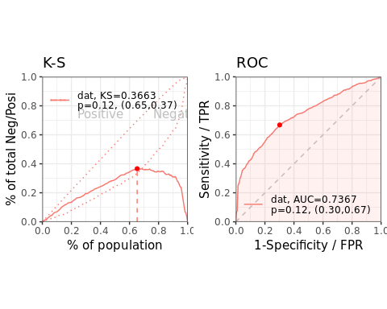

## [INFO] The threshold of confusion matrix is 0.2054.

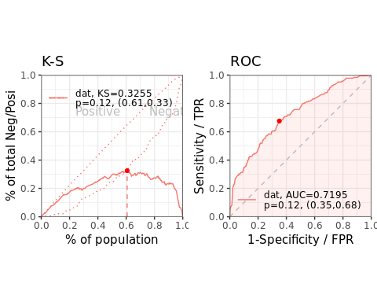

## $pic  
## $pic$score

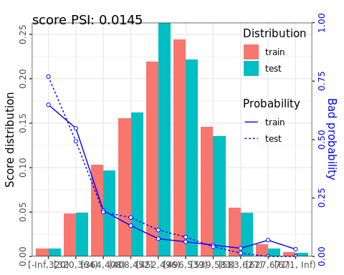

##   
##   
## $psi  
## variable dataset psi  
## 1: score train_test 0.01452308