

Schools must use the funding to make **additional and sustainable** improvements to the quality of PE and sport they offer. This means that you should use the Primary PE and Sport Premium to:

* develop or add to the PE and sport activities that your school already offers
* 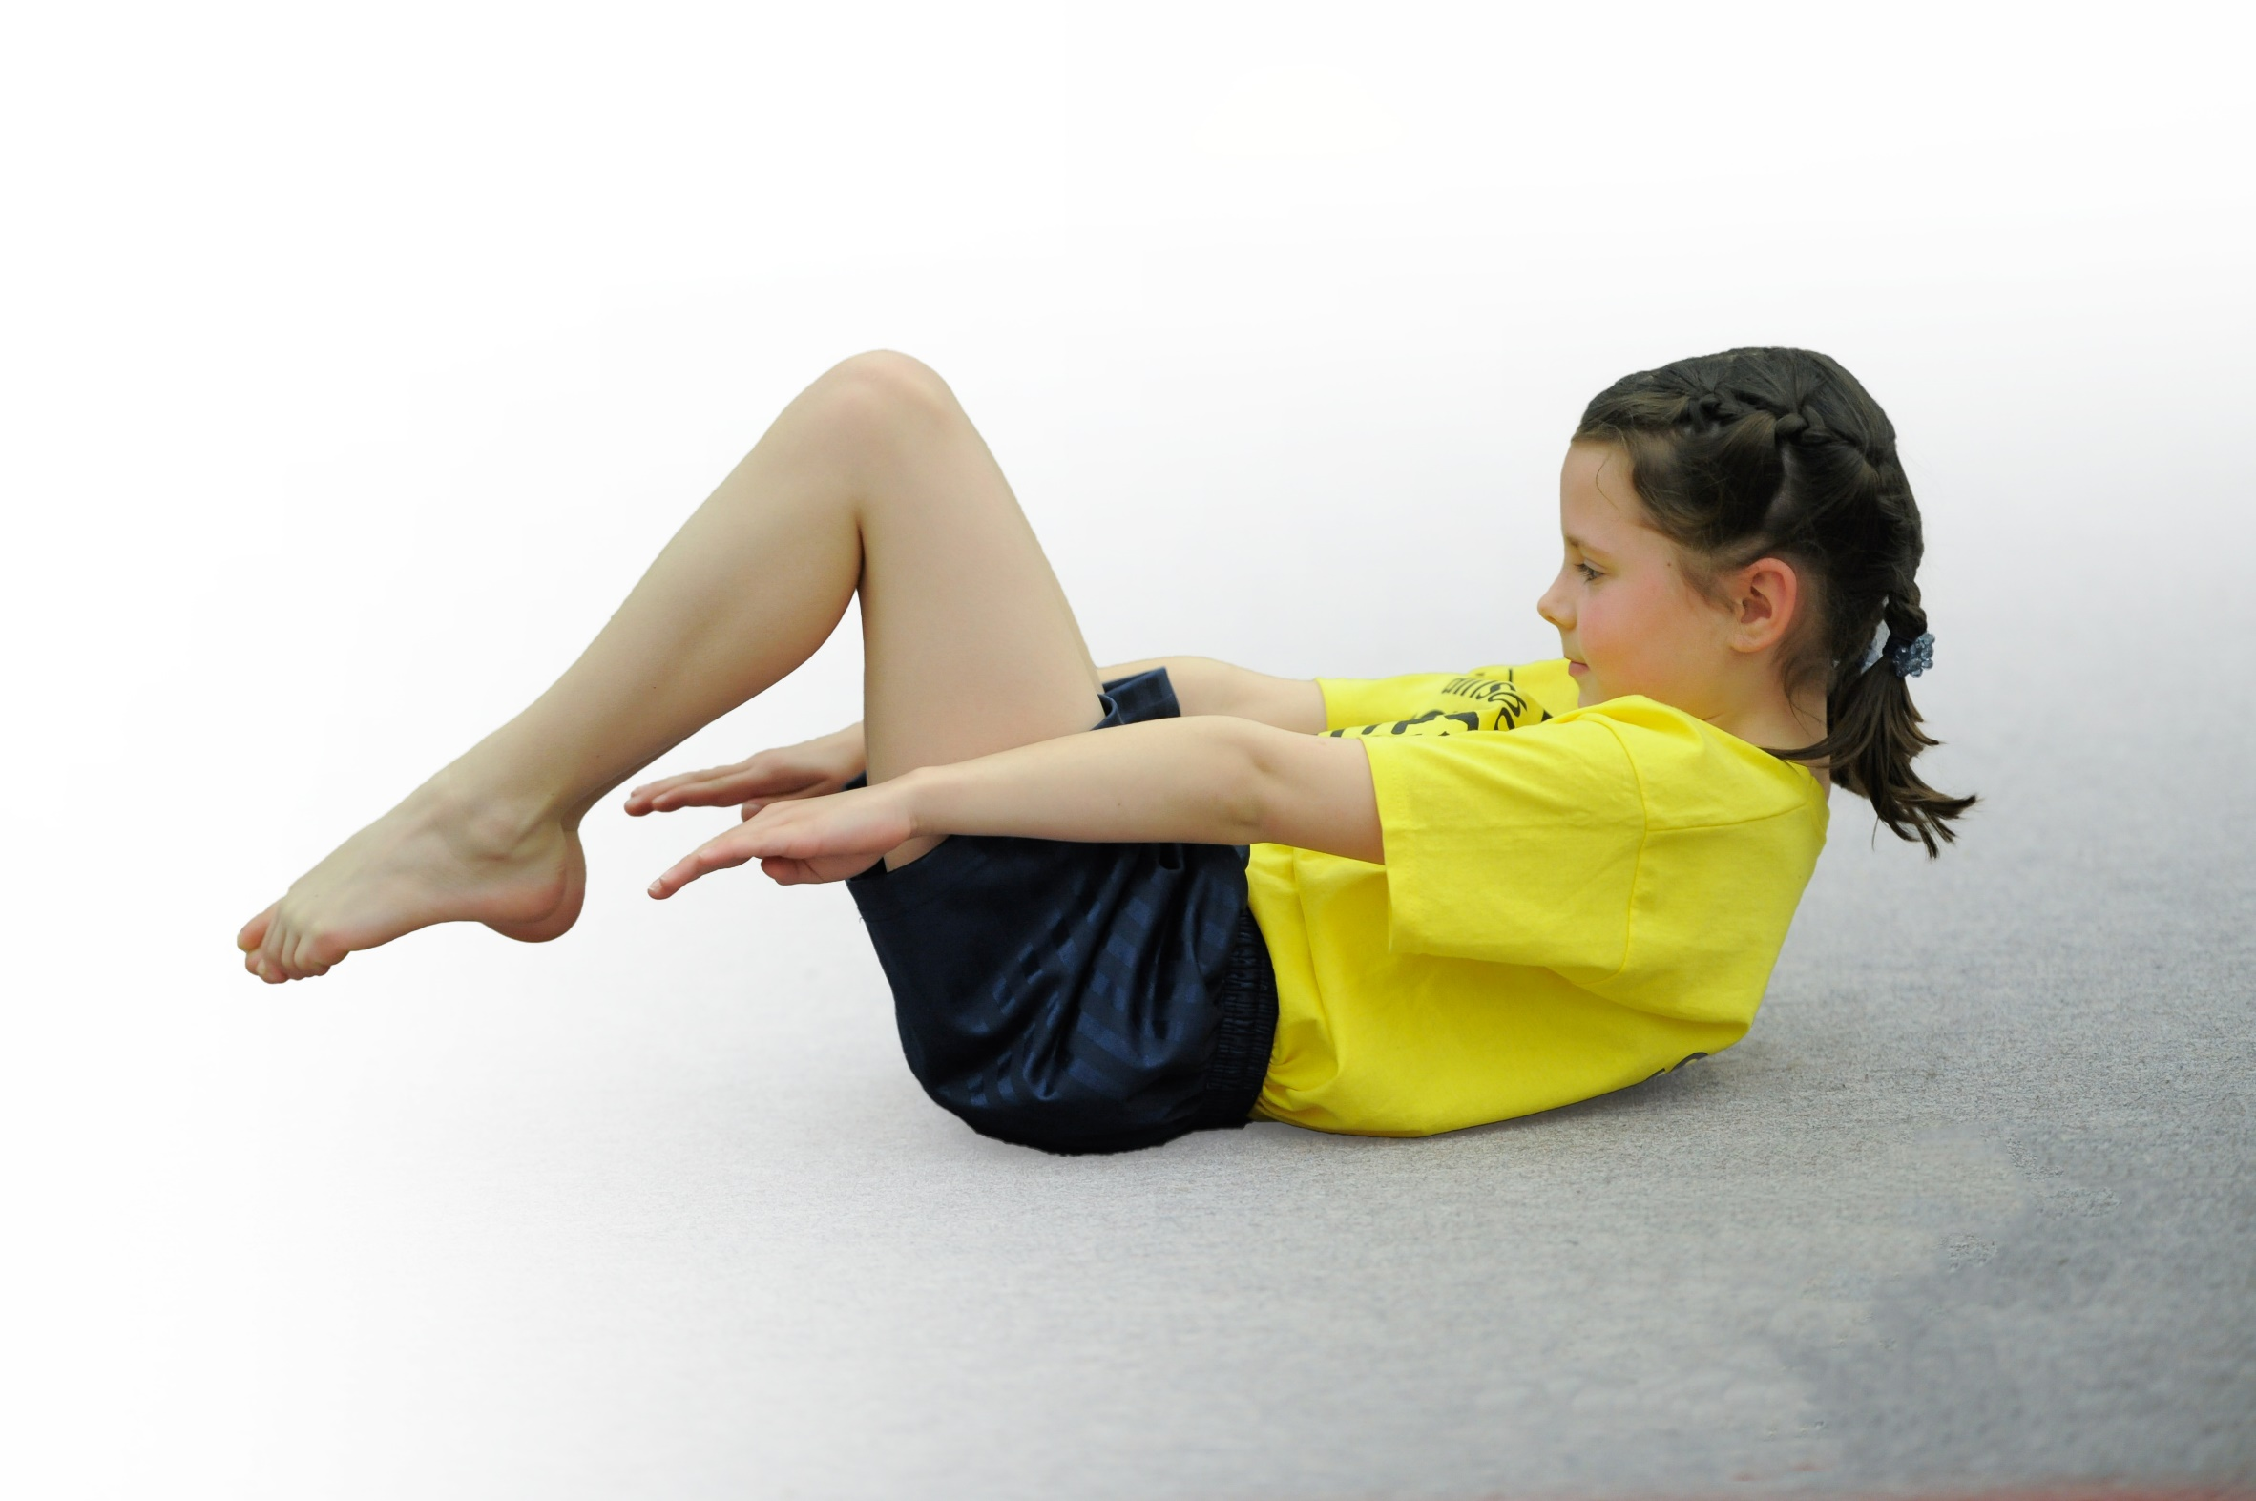build capacity and capability within the school to ensure that improvements made now will benefit pupils joining the school in future years

Please visit [gov.uk](https://www.gov.uk/guidance/pe-and-sport-premium-for-primary-schools) for the revised DfE guidance including the 5 key indicators across which schools should demonstrate an improvement. This document will help you to review your provision and to report your spend. DfE encourages schools to use this template as an effective way of meeting the reporting requirements of the Primary PE and Sport Premium.

We recommend you start by reflecting on the impact of current provision and reviewing the previous spend.

Under the [Ofsted Schools Inspection Framework](https://www.gov.uk/government/publications/school-inspection-handbook-from-september-2015), inspectors will assess how effectively leaders use

the Primary PE and Sport Premium and measure its impact on outcomes for pupils, and how effectively [governors](https://www.gov.uk/government/publications/governance-handbook) hold them to account

for this.

Schools are required to [publish details](https://www.gov.uk/guidance/what-maintained-schools-must-publish-online#pe-and-sport-premium-for-primary-schools) of how they spend this funding as well as on the impact it has on pupils’ PE

and sport participation and attainment.

We recommend regularly updating the table and

publishing it on your website as evidence

of your ongoing review into how you are using the money

to secure maximum, sustainable impact. To see an example of how to complete the table please click [HERE](http://www.afpe.org.uk/physical-education/wp-content/uploads/Template-Exemplification.pdf).

Support for review and reflection - considering the 5 key indicators from DfE, what development needs are a priority for your setting and your students now and why? Use the space below to reflect on previous spend, identify current need and priorities for the future.

|  |  |
| --- | --- |
| **Springvale Primary School** | |
| Key achievements to date: | Areas for further improvement and baseline evidence of need: |
| -Increasing the number of clubs and extra-curricular engagement of all age groups  -Increasing the quality of curriculum PE through high quality support and CPD for class teachers  -Excellent coverage of the whole PE curriculum with specialists in gymnastics, games and dance  -Inclusive sports like fencing, archery and goalball developing  -Improving playground games and young leader programmes | -To continue to increase family participation in sports  -To continue to develop clubs and ensure that all groups of pupils engage with sport at some level  -To continue to increase the amount of competitions  -To increase opportunities for more able pupils to be stretched and challenged  -Increase the link between healthy eating and sports as part of a balanced diet |

|  |  |
| --- | --- |
| Meeting national curriculum requirements for swimming and water safety | Please complete all of the below*: |
| What percentage of your current Year 6 cohort swim competently, confidently and proficiently over a distance of at least 25 metres? | 100% |
| What percentage of your current Year 6 cohort use a range of strokes effectively [for example, front crawl, backstroke and breaststroke]? | 100% |
| What percentage of your current Year 6 cohort perform safe self-rescue in different water-based situations? | 73% |
| Schools can choose to use the Primary PE and Sport Premium to provide additional provision for swimming but this must be for activity **over and above** the national curriculum requirements. Have you used it in this way? | No- we were very pleased with the standards reached by this cohort. |
|  | |

*Schools may wish to provide this information in April, just before the publication deadline.

**Action Plan and Budget Tracking**

Capture your intended annual spend against the 5 key indicators. Clarify the success criteria and evidence of impact that you intend to measure to evaluate for students today and for the future.

|  |  |  |  |  |
| --- | --- | --- | --- | --- |
| **Academic Year:** 2017/18 | **Total fund allocated:** £18,050 | **Date Updated: April 2018** | |  |
| **Key indicator 1:** The engagement of all pupils in regular physical activity – Chief Medical Officer guidelines recommend that primary school children undertake at least 30 minutes of physical activity a day in school | | | | Percentage of total allocation: |
| 27% |
| School focus with clarity on intended **impact on pupils**: | Actions to achieve: | Funding allocated: | Evidence and impact: | Sustainability and suggested next steps: |
| -Trained playground leaders in Y6 and selected a group to have further training.  -Develop new and safe playground systems to ensure that all children can be active throughout break and lunchtime. | -equipment purchased and stored appropriately.  -Training in place for all pupils.  -Further trained for selected key leaders.  -Training for SMSAs to develop and oversee the project.  -MUGA/trim trail upkeep.  -Extra SMSA to oversee the project. | £1000  £500  £200  £300  £1000  £2000  Total- £5000 | Approximately 75% of pupils are now active at breaks- games, skills or climbing, etc.  Young leadership engagement is high and effective and impacting classroom progress.  Health and safety figures show that injuries and incidents have decreased. Behaviour has improved rapidly. Pupils now have access to an extra 1 hour of exercise and/or games each day. | Embed and develop so that Y5/6 are trained next year.  Link to H/S figures and behavior patterns more frequently.  Develop further sports and games across the school grounds.  Consider options on wet weather days.  Implement the Active Schools Planner as a whole school tool to ensure as a school that pupils are regularly active throughout the day and all pupils are achieving at least 30 active minutes. |
| **Key indicator 2:** The profile of PE and sport being raised across the school as a tool for whole school improvement | | | | Percentage of total allocation: |
| 6% |
| School focus with clarity on intended **impact on pupils**: | Actions to achieve: | Funding allocated: | Evidence and impact: | Sustainability and suggested next steps: |
| Link sports and clubs to the behavior system and the new ethos of ‘play together, learn together, achieve together.’  Raise profile of PE in school to impact on whole school issues and maintain Gold School Games Mark for 2017-18 | Ensure that effort and achievement are linked and that reward and competition are linked explicitly to behavior systems and expectations.  Use of the School Games & School Games values to promote and build a school ethos around PE & Sport across school | £1050  £0 | Behaviour is outstanding. Any issues are addressed through reward and sanction using sport and games as a tool to ensure that child show high standards of organization and self-control. | Embed the new steps to success and the school ethos.  Maintain current level of engagement to ensure that we retain Gold School Games Mark for 2018-19 |

|  |  |  |  |  |
| --- | --- | --- | --- | --- |
| **Key indicator 3:** Increased confidence, knowledge and skills of all staff in teaching PE and sport | | | | Percentage of total allocation: |
| 33% |
| School focus with clarity on intended  **impact on pupils**: | Actions to achieve: | Funding  allocated: | Evidence and impact: | Sustainability and suggested  next steps: |
| Specialist teachers in various areas of PE deployed to work alongside teachers. | Continue to link teachers weaknesses (based on a skills audit) to specialist practitioners to ensure that CPD is delivered appropriately. | £6k | Pupils receive quality first teaching.  Staff increase their competence and confidence to teach PE. | Ensure that PE is assessed appropriately and securely and that teachers feed this information into specialist coaches, club leaders and new teachers/parents. |
| **Key indicator 4:** Broader experience of a range of sports and activities offered to all pupils | | | | Percentage of total allocation: |
| 11% |
| School focus with clarity on intended  **impact on pupils:** | Actions to achieve: | Funding  allocated: | Evidence and impact: | Sustainability and suggested  next steps: |
| Additional achievements:  Inclusive sports trailed and coached (archery, fencing, table tennis, goal-ball) by specialists.  21 different clubs offered this year to a range of age groups. | Offer various inclusive sports that supplement our broad sports and dance curriculum.  Develop clubs for all pupils and subsidise these opportunities where required. | £2000 | Children can access a wide range of sports. Children with SEND take part in PE lessons and competitions.  Children have several opportunities to try new sports. | Embed the inclusive sports programme and build links in this area with Team Activ and 4all Sport.  Continue to develop the range and quality of clubs. Build links to external clubs for home learning. |
| **Key indicator 5:** Increased participation in competitive sport | | | | Percentage of total allocation: |
| 22% |
| School focus with clarity on intended  **impact on pupils**: | Actions to achieve: | Funding  allocated: | Evidence and impact: | Sustainability and suggested  next steps: |
| Sign up to Team Activ competitions. Target 50% of opportunities to compete.  Engagement in the School Games Programme to promote participation in competitive school sport in and out of school. | Sign up to the Team Activ service and select competitions (including inclusive events) to attend and compete at.  Ensure safe and appropriate transport is arranged.  Participation in Level 1 & Level 2 School Games activities | £2000  £2000  £0  Total- £4k | All pupils Y1-Y6 have had opportunities to compete- many pupils at least termly. Talented pupils play inter-school competitions. | Appoint a sports leader in July 2018. Target 80% of competitions.  Continue to sign up to Team Activ. |