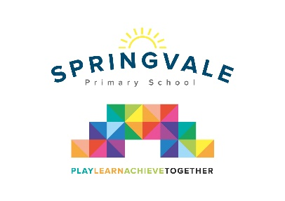

Dear Parents/Carers

I have organised a trip for our class to visit ‘The Moorland Discovery Centre’ on Thursday, 21st March. The children will be spending the whole day taking part in different fun activities linked to their science topic- Rocks and Fossils. We will spend most of the day outside so uniform won’t be required but please make sure that children are dressed appropriately in warm clothing and with sensible footwear such as wellies or walking boots.

We shall be leaving school at 9.00am and will return to school by 3.00pm. If the coach gets stuck in traffic then the school will be in contact via text message to let you know the new time of arrival. If you would like your child to go on this trip then can you please sign the consent form, and make a payment of £17 online. As we have two trips close together we ask that a combined payment be made online to cover the cost of both trips.

Thank You

Mrs Wildsmith

Consent form: I agree/disagree for my child __________________________ from Class 3 to go to The Moorland Discovery Centre.

Signed parent/guardian ________________________

I give a contribution of **£17.00** towards the coach and ticket into The Moorland Discovery centre.

Please tick your child’s lunch option and return by Tuesday, 19th March.

Child _______________________ Class ______ Date of trip _______________

Own sandwiches _____________ Grab a bag ____________

Grab a bag filling

Ham _________ Cheese _________ Tuna/mayo _________