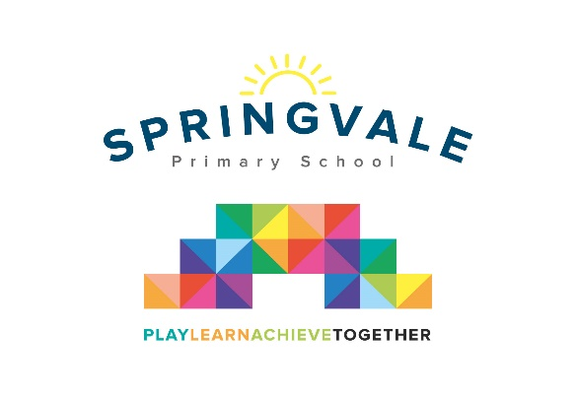

Dear Parents/Carers

I have organised a trip for our class to visit Murton Park in York on Monday, 25th March. The children will be spending the whole day taking part in different fun activities linked to the Stone Age. My hope is that the trip will be a fantastic and memorable visit for the children, as well as being highly educational and informative. We will spend most of the day outside so uniform won’t be required but please make sure that children as dressed appropriately in warm clothing and with sensible footwear such as wellies or walking boots.

We shall be leaving school at 9.00am and will return to school by 4.10pm. If the coach gets stuck in traffic then the school will be in contact via text message to let you know the new time of arrival. If you would like your child to go on this trip then can you please sign the consent form, and make a payment of £20 online. This trip is heavily subsidised by school fund, as the cost of £20 will not be enough to cover the full cost of the coach and entry. As we have two trips close together we ask that a combined payment be made online to cover the cost of both trips.

Thank You

Mrs Wildsmith

Consent form: I agree/disagree for my child __________________________ from Class 3 to go to Murton Park.

Signed parent/guardian ________________________

I give a contribution of **£20.00** towards the coach and ticket into Murton Park.

Please tick your child’s lunch option and return by Thursday 21st March.

Child _______________________ Class ______ Date of trip _______________

Own sandwiches _____________ Grab a bag ____________

Grab a bag filling

Ham _________ Cheese _________ Tuna/mayo _________