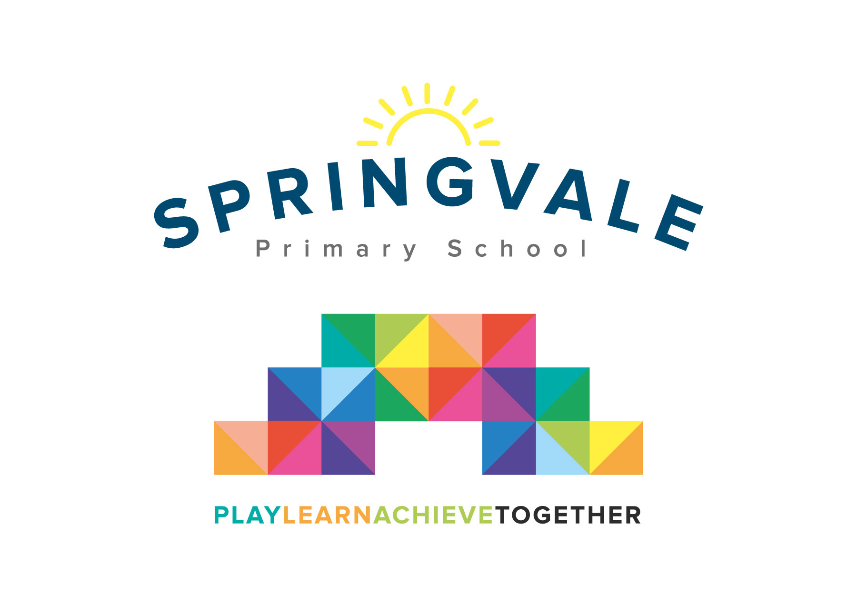

**SPRINGVALE PRIMARY SCHOOL**

**01226 760930**

**Headteacher: Mr L McClure**

**office@springvaleprimary.org**

**www.springvaleprimary.org**

@SpringvalePS

Dear Parent/Carer

During the Summer Term we have planned two ‘meet and greet’ sessions with animals, which we hope will be very exciting for the children, as well as informative and eye-opening.

On the afternoon of Tuesday 7th May we will be welcoming ‘Eggucation’ into school who will be bringing tame hens for us to meet and find out about. They will then leave eggs with us to incubate and watch hatch! The chicks will stay with us in school until Friday 17th May. Please could all morning children come in the afternoon on this day at 12.30 to 3.30pm.

On Monday 24th June Zoolab will also be visiting us, with a variety of animals for a workshop aimed at helping the children understand different animals and their habitats.

We would like to ask for a voluntary contribution of £9.50 towards the cost of both these exciting sessions.

You will receive an email & text notification shortly with information about how to pay for these activities on the ‘Schoolmoney’ system. Please follow the link on this message to login to your account. If you have any account login or payment queries, please do not hesitate to contact the school office. You will also be asked to give your parental consent online as well.

Kind Regards

Mrs. Exley, Mrs Honey and Mrs Parr

**­­­­­­­­­­­­­­­­­**