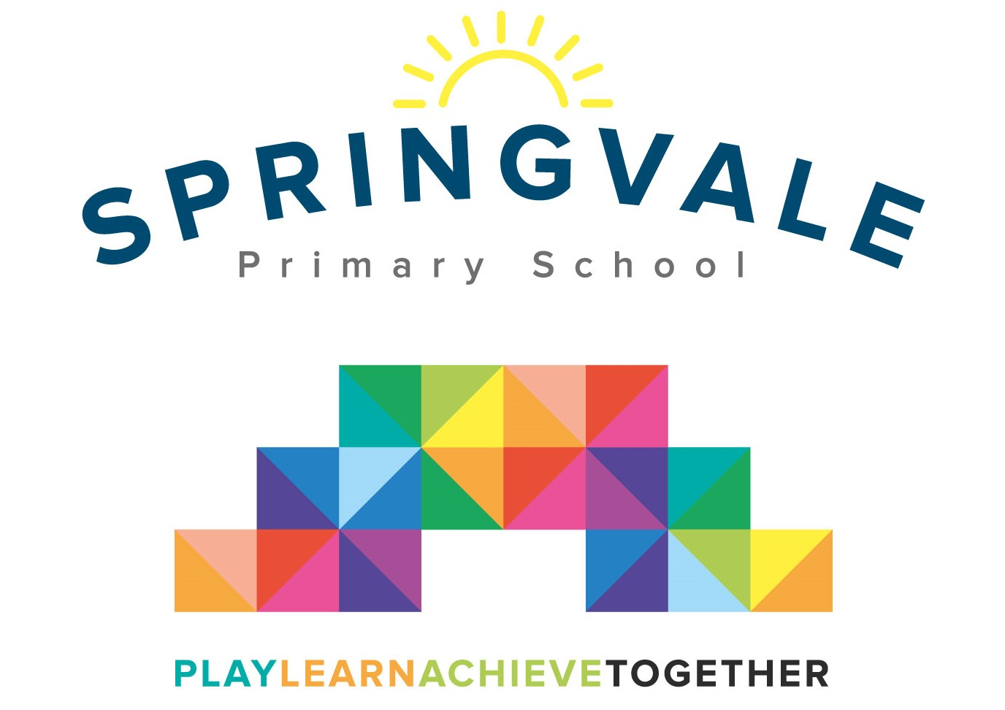

**SPRINGVALE PRIMARY SCHOOL**

**01226 760930**

**Headteacher: Mr L McClure**

**l.mcclure@springvaleprimary.org**

**www.springvaleprimary.org**

@SpringvalePS

**KS2 Girls Football Monday 30th September 2019**

**I am delighted to confirm that we have set up two football matches this Friday (4th October) against Churchfield on our home pitch**. **The matches will kick off at 2.00pm (Y3/4 team) and 2.45pm (Y5/6 team).** We will ensure that the playground gates are open so that parents/family members can come along and support the match! **The event will finish at approximately 3.30pm.** The permission slip below must be completed and returned for children to take part or a reply to the emailed version will suffice.

Please note the options below and make us aware of your preference.

Children require white or black shorts and socks, appropriate footwear, a t-shirt, a warm jacket and a water bottle. We strongly recommend shin pads are also worn but parents can give permission to play without (see below). We will give the children a school shirt which must be handed back at the end of the game. We ask for players to bring their own shorts and socks as they get lost easily and are costly to replace.

We hope that the children are enjoying football club and are looking forward to the next match! Please note that children will only represent their school in sporting fixtures if they attending school regularly, working hard and following our ‘Steps to Success’. I am sure the children will represent their school fantastically well!

#PlaytogetherLearntogetherAchievetogether

**Kind Regards**

**Mr L McClure/Mr L Crossfield**

**Springvale FC**

**My child can take part in the football match and: (please select one)**

1. **I will collect at 3.30pm**
2. **My child can walk home at 3.30pm**

**Also, please select either…**

**My child will wear shin-pads _______________**

**Or…**

**I give my child permission to play without shin-pads _____________**

**Name _______________________________ Class ___________________________**

**Signed by parent _____________________________________**